Appendix file
Manuscript name: Clinical Impact and Cost-Effectiveness of Rapid vs. Non-Rapid Initiation Antiretroviral Therapy Regimens in HIV-Positive Men Who Have Sex With Men in China: A Study Combining Modelling and 96-Week Multicenter Cohort Data
Kejia Zhou ^{1,2†}, Xi Wang ^{3†}, Dachaung Zhou ^{1,2}, Lili Dai ^{3*}, Wenxi Tang ^{1,2*}
† Contributed equally
1 Department of Pharmacoeconomics, School of International Pharmaceutical Business, China Pharmaceutical University, Nanjing, Jiangsu, China
2 Center for Pharmacoeconomics and Outcomes Research, China Pharmaceutical University, Nanjing, Jiangsu, China
3 Beijing Youan Hospital, Capital Medical University, Beijing, China

* Correspondence
Wenxi Tang, PhD, Center for Pharmacoeconomics and Outcomes Research & Department of Public Affairs Management, School of International Pharmaceutical Business, China Pharmaceutical University, Nanjing, Jiangsu, China.
Email: tokammy@cpu.edu.cn
Lili Dai PhD, Beijing Youan Hospital, Capital Medical University, No. 8 Xitoutiao, Youanmenwai, Fengtai District, Beijing, 100069, China.
Email: lilydaier@ccmu.edu.cn

Content
1 Detailed Study Flow 4
2 Derivation of Model Structure 12
3 Supplementary Data on Results 40
4 References 59

List of Tables
Appendix Table 1. Cohort Population Characteristics—Baseline CD4+ T-cell Count Distribution 17
Appendix Table 2. ART Effectiveness Indicators of Viral Suppression Rate 19
Appendix Table 3. ART Effectiveness Indicators of CD4+ T-cell Count Changes 20
Appendix Table 4. The Data on Age-Varying Natural Mortality 22
Appendix Table 5. HIV-Related Mortality and ADEs Incidence Rates for Different Health States 23
Appendix Table 6. Treatment Discontinuation Rates for Different ART Regimens 23
Appendix Table 7. Transmission-Related Behavioral Parameters 25
Appendix Table 8. Prices and Annual Costs of ART Regimens 27
Appendix Table 9. Annual Cost of ART Regimens and Testing Programs 27
Appendix Table 10. Utility Values for Each Health State 28
Appendix Table 11. Costs and Utilities for Various Types of ADEs 28
Appendix Table 12. AEs Incidence Rates, Costs, and Utilities for ART Regimens 30
Appendix Table 13. CPI, Discount and Exchange Rate Statistics Table 31
Appendix Table 14 Names and Explanations of Model Parameter 32
Appendix Table 15 Names and Explanations of Model States 34
Appendix Table 16 Patient Baseline Characteristics of PP Dataset 41
Appendix Table 17 Clinical outcomes of CD4+ T-cell Counts and Plasma HIV-1 RNA in ITT and PP datasets 43
Appendix Table 18 Cost-Effectiveness Results (PP dataset) 48
Appendix Table 19 Detailed Breakdown of QALYs and Costs (Incremental Values): Rapid vs. Non-Rapid Initiation by Treatment Regimen and Model 49

List of Figures
Appendix Figure 1 Study Flowchart 11
Appendix Figure 2 Disease Progression: Natunl History 13
Appendix Figure 3 Markov Model 14
Appendix Figure 4 Decision Tree Model 15
Appendix Figure 5 Infectious Disease Dynamics Model 17
Appendix Figure 6 Sensitivity Analysis Outcomes: BIC Group vs. EFV Group (Markov Model, ITT Dataset) 58
Appendix Figure 7 Sensitivity Analysis Outcomes: BIC Group vs. EFV Group (Infectious Disease Dynamic Model, ITT Dataset) 58
Appendix Figure 8 Sensitivity Analysis Outcomes: BIC Group vs. EFV Group (Markov Model, PP Dataset) 59
Appendix Figure 9 Sensitivity Analysis Outcomes: BIC Group vs. EFV Group (Infectious Disease Dynamic Model, PP Dataset) 60

Detailed Study Flow
This investigation was executed through a meticulously designed, multi-stage process that integrated real-world clinical data analysis with advanced health economic modeling. The sequential workflow encompassed four principal phases: (1) Data Sourcing, Cohort Curation, and Baseline Characterization; (2) Causal Inference Analysis for Comparative Clinical Effectiveness; (3) Health Economic Modeling for Cost-Effectiveness Evaluation; (4) Validation, Sensitivity and Scenario Analysis. The exhaustive methodology is delineated as follows.

Data Sourcing, Processing, and Cohort Establishment

Data Source and Participant Identification
The study leveraged a longitudinal, registry-based cohort derived from a maintained clinical database at Beijing Youan Hospital. We retrospectively screened adult, ART-naïve men who have sex with men (MSM) diagnosed with HIV-1 between March 2021 and March 2023. The inclusion criteria were: (1) initiation of first-line ART with either a BIC-based (BIC/FTC/TAF) or an EFV-based (EFV+3TC+TDF) regimen; (2) availability of complete baseline demographic information and clinical laboratory data; and (3) availability of at least one post-baseline follow-up data point at either week 48 or week 96. Exclusion criteria included co-existing severe immunodeficiency diseases, or significant missing baseline data. From an initial pool of 340 eligible patients, a final study population of N=301 individuals was established after applying the exclusion criteria, with patient flow detailed in Figure 2 of the main text.

Intervention Group Stratification and Baseline Characterization
Eligible participants were categorised into four mutually exclusive intervention groups based on two key factors: the timing of ART initiation (Rapid: ≤14 days from diagnosis; Non-Rapid: >14 days) and the initial treatment regimen. (1) G1: Rapid Initiation with BIC/FTC/TAF (n=74); (2) G2: Rapid Initiation with EFV+3TC+TDF (n=77); (3) G3: Non-Rapid Initiation with BIC/FTC/TAF (n=84); (4) G4: Non-Rapid Initiation with EFV+3TC+TDF (n=66).
A comprehensive set of baseline variables was systematically extracted. This included: (1) Demographics: Age; (2) Biochemical Profiles: AST, ALT, Total Cholesterol, HDL-C, LDL-C, Triglycerides, Fasting Blood Glucose, and Creatinine (with eGFR calculation); (3) HIV-Specific Disease Indicators: CD4+ T-cell count, CD8+ T-cell count, CD4/CD8 ratio, and plasma HIV-1 RNA viral load.

Data Preprocessing and Quality Control
The raw clinical data underwent rigorous preprocessing. This involved addressing missing values, identifying and reconciling outliers, and ensuring internal consistency across records. Incomplete or erroneous records were either corrected through cross-referencing with clinical notes or excluded to uphold data integrity. This process ensured a high-quality, analyzable dataset for subsequent statistical and economic modeling.

Causal Inference Framework and Clinical Endpoint Analysis

Emulation of a Target Trial using Cloning, Censoring, and Weighting (CCW)
To mitigate selection bias and time-varying confounding inherent in observational studies, we employed the cloning, censoring, and weighting (CCW) approach to emulate a hypothetical target randomized trial. (1) Cloning: At baseline (time zero), each of the 301 patients was artificially replicated into four identical copies, resulting in 1,204 clone-instances. Each copy was deterministically assigned to one of the four treatment strategies (G1-G4). (2) Censoring: Follow-up for each clone was dynamically censored at the precise time point its actual treatment trajectory deviated from its assigned strategy. Deviations included regimen switches, discontinuation, or initiation timing that contravened the assigned strategy. (3) Weighting (IPCW): To adjust for the selection bias introduced by this non-random censoring, we computed time-varying Inverse Probability of Censoring Weights (IPCW). Stabilized weights were calculated based on baseline covariates to create a re-weighted pseudopopulation in which the assignment to a treatment strategy was independent of measured confounders, thus approximating the conditional exchangeability of a randomized experiment.

Analysis Dataset Definition
Two distinct analysis datasets were constructed from the CCW-prepared data. (1) Intention-to-Treat (ITT) Dataset: Included all cloned participants, analyzed according to their initially assigned strategy, irrespective of subsequent deviations. This provides an unbiased estimate of the effectiveness of assigning a strategy in a real-world context. (2) Per-Protocol (PP) Dataset: A restricted dataset comprising only the clones who adhered to their assigned treatment strategy throughout the entire follow-up period. This estimates the efficacy of the strategy under ideal conditions and was used for scenario analysis to test the robustness of the primary findings.

Clinical Endpoint Assessment
The following endpoints were assessed at weeks 48 and 96 within both the ITT and PP datasets: (1) Primary Endpoint: Immunological recovery, operationalized as the absolute and relative change in CD4+ cell count (cells/μL) from baseline.(2) Secondary Endpoints: Virological suppression rate (proportion with plasma HIV-1 RNA <50 copies/mL). (3) Treatment persistence and patterns of discontinuation (categorised as reactive [e.g., toxicity, resistance] or proactive [e.g., patient preference]). (4) Incidence of adverse events (AEs), with a focus on regimen-specific profiles.

Statistical Analysis
Descriptive statistics summarized baseline characteristics. Continuous variables were reported as median and interquartile range (IQR) and compared using the Mann-Whitney U test or Kruskal-Wallis test, as appropriate. Categorical variables were presented as frequencies (percentages) and compared using the Chi-square test or Fisher's exact test. The change in CD4+ count and the difference in suppression rates between groups were reported with 95% confidence intervals (CIs). A two-sided p-value < 0.05 was deemed statistically significant. All statistical computations were performed using R software (version 4.3.3; The R Foundation for Statistical Computing).

Health Economic Evaluation

Model Framework Construction
A comprehensive economic evaluation was conducted from a healthcare system perspective, employing a hybrid model structure to capture both individual patient-level outcomes and population-level transmission dynamics.
Decision Tree-Markov Model: A short-term decision tree was used to stratify the simulated cohort into the four initial strategies. Individuals then entered a lifetime horizon, state-transition Markov model with monthly cycles. Health states were multidimensionally defined by: (1) Treatment Line: First-line regimen, Second-line regimen. (2) Virological Status: Suppressed (HIV-1 RNA <50 copies/mL), Non-suppressed. (3) Immunological Stage: Based on WHO CD4 count strata: stage 5 (>500 cells/μL), stage 4 (350–500), stage 3 (200–350), stage 2 (100–200), stage 1 (≤100 cells/μL). Transition probabilities governed movements between health states (e.g., CD4 cell count decline, virological failure, treatment switching, mortality).
Infectious Disease Dynamic Model: To account for the secondary transmission benefits of viral suppression, a compartmental dynamic transmission model was developed. This model projected the HIV epidemic among Chinese MSM over a 30-year time horizon using annual cycles. It incorporated parameters for population dynamics, disease progression, diagnosis rates, ART initiation (rapid vs. non-rapid), regimen-specific viral suppression, treatment discontinuation, and HIV transmission risk.

Model Parameterization
Input parameters were sourced from the most reliable available data.
Clinical and Epidemiological Parameters: Transition probabilities, discontinuation rates (stratified by reason), viral suppression rates and AE incidence were primarily derived from the 96-week clinical outcomes of the analyzed cohort, supplemented by published long-term studies where necessary.
Cost Parameters (2023 CNY): All costs were adjusted to a common year. Direct medical costs included: (1) Drug Acquisition: BIC/FTC/TAF, EFV+3TC+TDF, and common second-line regimens. (2) Monitoring: Routine laboratory tests (CD4 count, viral load, biochemistry) as per Chinese guidelines. (3) Event Management: Costs associated with managing AEs and AIDS-Defining Events (ADEs). Data were sourced from local hospital billing databases and national drug price lists.
Health State Utility Weights: Quality-of-life weights (utilities) for each CD4 health state and treatment line were assigned based on values published in the peer-reviewed literature, enabling the calculation of Quality-Adjusted Life-Years (QALYs).

Cost-Effectiveness Analysis
The primary economic outcome was the Incremental Cost-Effectiveness Ratio (ICER), calculated as the difference in total costs between strategies divided by the difference in total QALYs. Strategies were compared pairwise: Comparison A: BIC/FTC/TAF vs. EFV+3TC+TDF, separately for rapid and non-rapid initiation; Comparison B: Rapid vs. Non-Rapid initiation, separately for the BIC and EFV regimens.
Cost-effectiveness was assessed against a willingness-to-pay (WTP) threshold defined as one to three times China's 2023 per-capita GDP.

Uncertainty and Scenario Analysis:
The robustness of the base-case results was rigorously tested. One-Way Sensitivity Analysis (OWSA): Key model parameters (e.g., drug costs, utility values, key transition probabilities) were varied over their plausible ranges (±20% for costs/utilities, 95% CIs for clinical parameters). Results were presented as Tornado diagrams to identify the most influential drivers of uncertainty.
Probabilistic Sensitivity Analysis (PSA): To capture joint parameter uncertainty, a PSA was performed using 10,000 Monte Carlo simulations. Parameters were assigned appropriate probability distributions (e.g., Gamma for costs, Beta for probabilities and utilities). Results were used to generate Cost-Effectiveness Acceptability Curves (CEACs), illustrating the probability of each strategy being cost-effective across a spectrum of WTP thresholds.
Scenario Analyses: Multiple scenario analyses were conducted, including comparing results from the ITT vs. PP datasets, varying model time horizons, and contrasting outcomes from the Markov model versus the infectious disease dynamic model.

Outcome Synthesis, Model Validation, and Interpretation
The results from the clinical effectiveness analysis and the economic evaluation were synthesised to form a coherent and comprehensive evidence base. The extensive sensitivity and scenario analyses confirmed the robustness of the conclusions across a wide range of assumptions. This multi-faceted and methodologically rigorous approach ensured that the comparative clinical and economic outcomes of rapid versus non-rapid ART initiation with contemporary regimens were thoroughly and reliably evaluated. The findings provide robust, evidence-based guidance for clinical decision-making and health policy formulation regarding HIV care optimization in China. The overall study flow was summarized in Appendix Figure 1.
.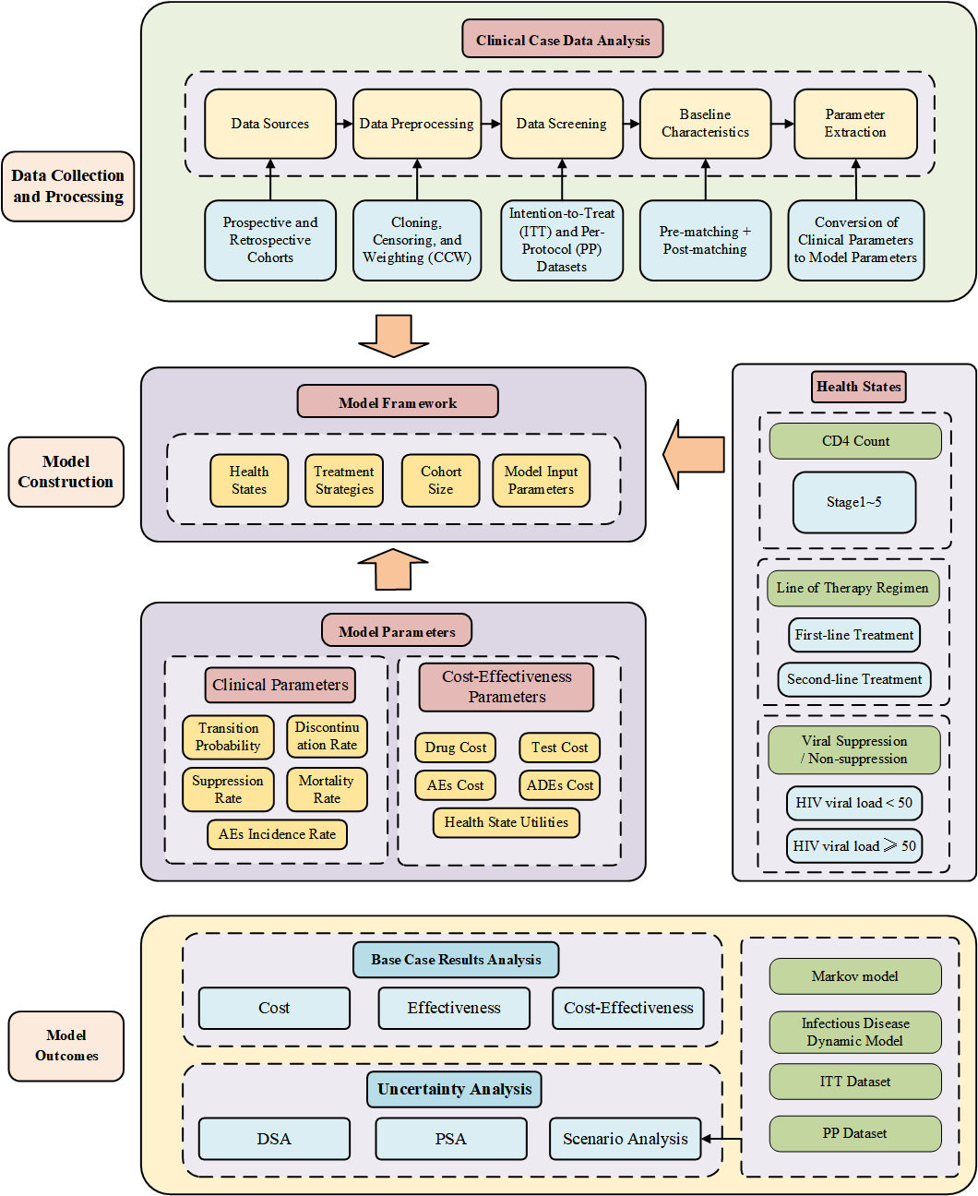
Appendix Figure 1 Study Flowchart

Derivation of Model Structure

Model Structure

Decision Tree - Markov Model
A Decision Tree–Markov model was employed in this study. Given that China's average life expectancy reached 77.93 years by the end of 2022, the model simulates outcomes from the starting point up to 80 years of age to fully capture lifetime health outcomes for patients.
The natural history of HIV infection was structured according to the WHO immunological classification system. HIV-infected individuals progress sequentially through five health states based on CD4 cell counts: State 1 (>500 cells/μL), State 2 (350–500 cells/μL), State 3 (200–350 cells/μL), State 4 (100–200 cells/μL), and State 5 (<100 cells/μL). Death was modeled as an absorbing state. Each health state is associated with distinct rates of AIDS-defining events (ADEs) and mortality. ADEs refer to specific cancers and opportunistic infections occurring in people living with HIV, which influence both cost and utility outcomes. A schematic of the HIV natural history is provided in the figure.
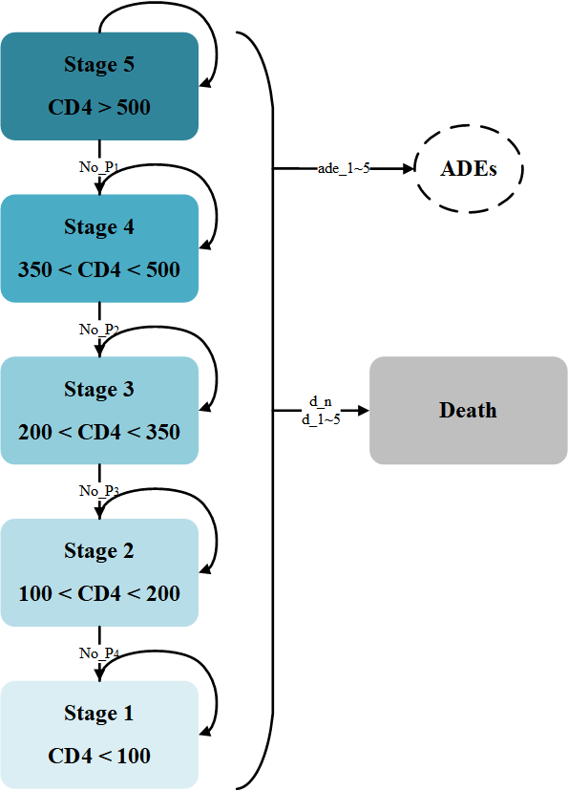
Appendix Figure 2 Disease Progression: Natunl History
Under ART intervention, transitions between HIV health states are illustrated in the left panel of the figure. Patients receiving ART may experience viral suppression (HIV RNA <50 copies/mL), leading to CD4 cell count recovery and transition to a better health state. Conversely, treatment discontinuation due to drug resistance or adverse events results in virologic failure (HIV RNA >50 copies/mL), CD4 cell count decline, and progression to a worse health state. Transitions between states depend on treatment response (on-treatment vs. off-treatment) and changes in CD4 cell counts: improvement occurs when a patient responds to treatment in a given state, while deterioration occurs upon treatment discontinuation. For instance, if a patient gains “n” CD4 cells per cycle, the probability of transitioning to a better state is calculated as “n” divided by the CD4 count difference between the two adjacent states.
Transitions within each HIV health state are shown in the right panel of the figure. Each health state includes the following substates: first-line treatment, first-line treatment discontinuation, second-line treatment (LPV/r+3TC+TDF), second-line treatment discontinuation, and treatment failure. All patients discontinuing first-line treatment transition to second-line treatment. Discontinuation is attributed to virologic failure leading to drug resistance (rate: First/Second-line_vd) or adverse events (rate: First/Second-line_nd). Each ART regimen is associated with a probability of adverse events (AE rate: ae_i), which affects both cost and utility.
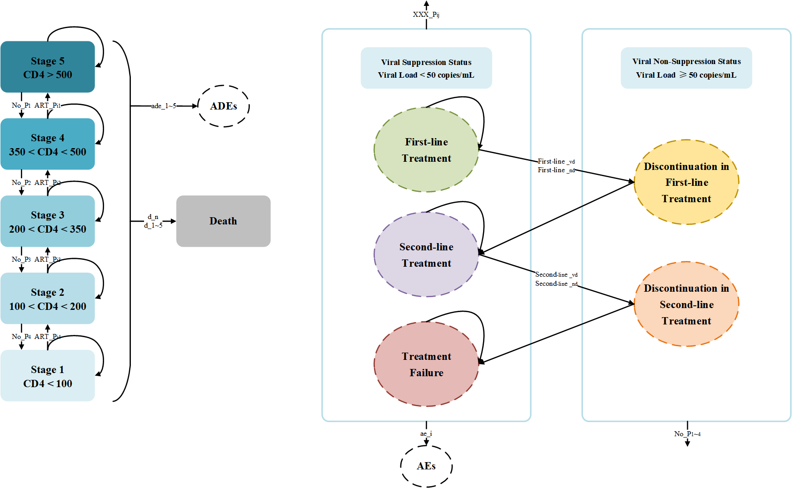
Appendix Figure 3 Markov Model
The decision process and algorithmic details are depicted in the accompanying diagram. At the initiation of first-line treatment, patients in the intervention group who achieve virologic suppression (with probability P, representing the response rate) continue the intervention regimen. Those who do not respond (1 – P) switch to the alternative treatment from the control group. Similarly, patients in the control group who respond to control treatment continue that regimen, while non-responders switch to the intervention regimen.
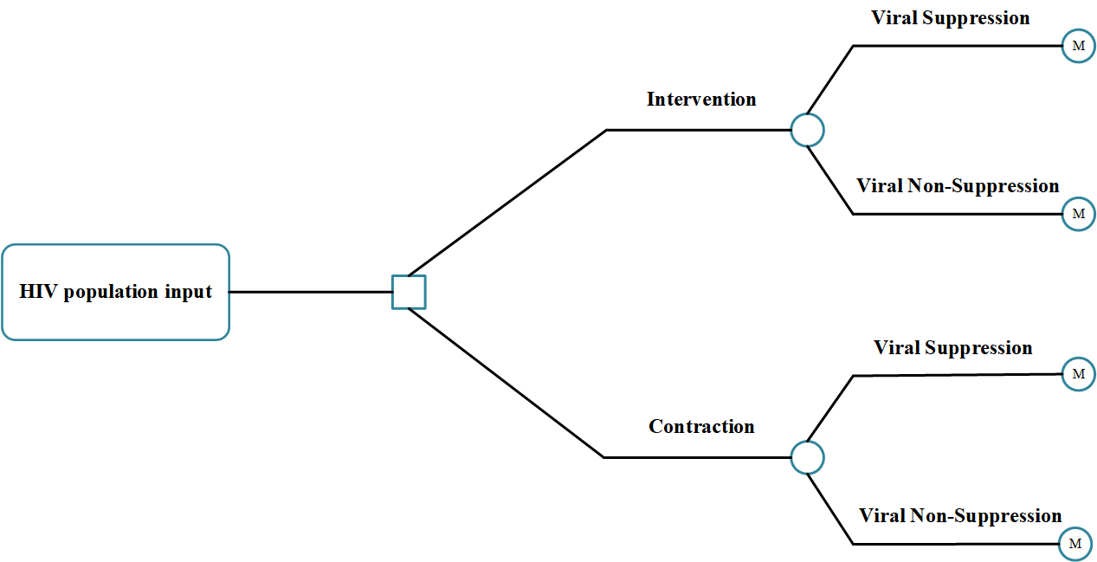
Appendix Figure 4 Decision Tree Model

Infectious Disease Dynamics Model
The dynamic model was constructed based on the classical Susceptible–Infectious–Removed (SIR) framework, commonly employed in infectious disease modeling and previously established in published literature[1]. The model assumed that susceptible individuals could acquire HIV infection through contact with infected individuals. Given that the average sexually active period in the Chinese population is approximately 30 years[2] and that sexual contact represents the primary transmission route for HIV, a 30-year time horizon was adopted, with annual cycles. While the model did not incorporate a detailed age structure, temporal changes in population distribution, or influx of new susceptible individuals.
Health states were categorized into 22 distinct compartments based on factors such as switching line, treatment discontinuation, CD4 count, and viral suppression status. These included five CD4 count stages (CD4>500, 350<CD4≤500, 200<CD4≤350, 100<CD4≤200, CD4≤100), as well as states for unsuppressed and suppressed viral load under first-line treatment (FU and FS, respectively), unsuppressed and suppressed viral load under switched regimen (SU and SS), susceptible (S), and deceased (R). The alternative treatment for the control group served as second-line treatment; for instance, if the intervention group received BIC group, the second-line treatment following first-line treatment discontinuation corresponded to the control EFV group.
In cases where treatment was ineffective (i.e., viral load unsuppressed), natural disease progression was modeled, with individuals transitioning from higher to lower CD4 count states. Upon diagnosis and initiation of effective treatment, some individuals achieved viral suppression (e.g., transition from FU to FS or SU to SS). Successful treatment also allowed for immune recovery, enabling transitions from lower to higher CD4 count states. However, treatment could be disrupted due to factors such as drug resistance, resulting in relapse from a suppressed to an unsuppressed state (e.g., transition from FS to SU).
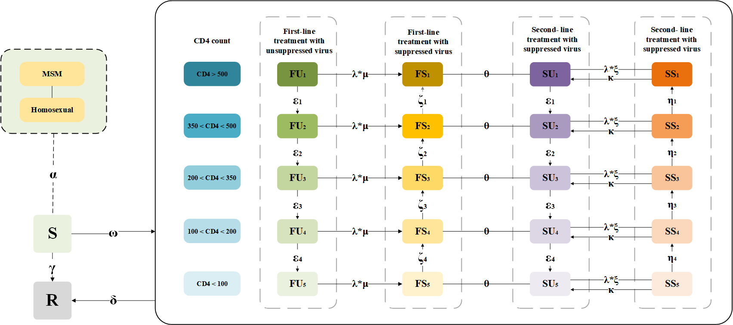
Appendix Figure 5 Infectious Disease Dynamics Model

Model Parameters

Demographic parameters
The Markov model cohort simulated a total of 100,000 individuals and the infectious disease dynamics model cohort comprised a total of 30,325,000 individuals, including of 3 million susceptible individuals MSM and 325,000 MSM living with HIV[3]. Based on published data, there were approximately 1.3 million HIV patients in China, with MSM accounting for about 25% of this population[4]. The initial health state distribution, defined by CD4 count strata, was derived from clinical data analysis (Appendix Table 1).
Appendix Table 1. Cohort Population Characteristics—Baseline CD4+ T-cell Count Distribution
(A) ITT
CD4+ cell counts | Rapid initiation BIC/FTC/TAF group Ratios | Rapid initiation EFV+TDF+3TC group Ratios | Non-rapid initiation BIC/FTC/TAF group Ratios | Non-rapid initiation EFV+TDF+3TC group Ratios
CD4>500 | 75.43% | 71.85% | 76.72% | 29.53%
CD4>350 | 14.26% | 21.98% | 12.36% | 56.71%
CD4>200 | 8.98% | 3.83% | 7.61% | 10.74%
CD4>100 | 1.33% | 2.34% | 3.31% | 3.02%
CD4<100 | 0.00% | 0.00% | 0.00% | 0.00%
- PP
CD4+ cell counts | Rapid initiation BIC/FTC/TAF group Ratios | Rapid initiation EFV+TDF+3TC group Ratios | Non-rapid initiation BIC/FTC/TAF group Ratios | Non-rapid initiation EFV+TDF+3TC group Ratios
CD4>500 | 76.79% | 75.61% | 74.07% | 25.35%
CD4>350 | 16.07% | 19.51% | 14.81% | 57.75%
CD4>200 | 7.14% | 4.88% | 7.41% | 12.68%
CD4>100 | 0.00% | 0.00% | 3.70% | 4.23%
CD4<100 | 0.00% | 0.00% | 0.00% | 0.00%

Transition Probabilities between Health Stages
The effectiveness of ART was assessed using two primary indicators: the viral suppression rate (proportion of patients with HIV-1 RNA<50 copies/mL) and the immune response (mean increase in CD4 count). Clinical parameters were derived from clinical data analysis (Appendix Table 2 and 3).
Health states were classified into five distinct categories based on CD4 count ranges. Transition probabilities between adjacent health states were calculated as the ratio of the monthly change in CD4 count attributable to ART and the width of the CD4 count range defining the state. For instance, during weeks 48-96 of receiving BIC/FTC/TAF regimen, the mean monthly increase in CD4 count was 67 cells/μL. The probability of transitioning from the state CD4≤100 cells/μL to the state 100 < CD4≤200 cells/μL was therefore calculated as 67÷100=0.67. Below are all the transition probabilities between adjacent states derived from the changes in CD4 count due to ART drug intervention.
Appendix Table 2. ART Effectiveness Indicators of Viral Suppression Rate
(A) ITT
ART regimens | Viral suppression rate
Rapid initiation BIC/FTC/TAF | 100.00%
Rapid initiation EFV+TDF+3TC | 98.23%
Non-rapid initiation BIC/FTC/TAF | 96.73%
Non-rapid initiation EFV+TDF+3TC | 97.71%
(B) PP
ART regimens | Viral suppression rate
Rapid initiation BIC/FTC/TAF | 100.00%
Rapid initiation EFV+TDF+3TC | 100.00%
Non-rapid initiation BIC/FTC/TAF | 97.79%
Non-rapid initiation EFV+TDF+3TC | 98.71%

Appendix Table 3. ART Effectiveness Indicators of CD4+ T-cell Count Changes
(A) ITT
Suppression status | ART regimens | Time | CD4 cell count changes, cells/μL
Viral suppression | Rapid initiation BIC/FTC/TAF | 48 weeks | 292.99
Viral suppression | Rapid initiation BIC/FTC/TAF | 96weeks | 281.49
Viral suppression | Rapid initiation EFV+TDF+3TC | 48 weeks | 233.00
Viral suppression | Rapid initiation EFV+TDF+3TC | 96weeks | 288.00
Viral suppression | Non-rapid initiation BIC/FTC/TAF | 48 weeks | 262.00
Viral suppression | Non-rapid initiation BIC/FTC/TAF | 96weeks | 289.00
Viral suppression | Non-rapid initiation EFV+TDF+3TC | 48 weeks | 153.50
Viral suppression | Non-rapid initiation EFV+TDF+3TC | 96weeks | 150.00
Viral suppression | all | 96+ weeks | 0.00
Viral no-suppression | all（decline） | all periods | 35.00
(B) PP
Suppression status | ART regimens | Time | CD4 cell count changes, cells/μL
Viral suppression | Rapid initiation BIC/FTC/TAF | 48 weeks | 293.50
Viral suppression | Rapid initiation BIC/FTC/TAF | 96weeks | 282.00
Viral suppression | Rapid initiation EFV+TDF+3TC | 48 weeks | 257.00
Viral suppression | Rapid initiation EFV+TDF+3TC | 96weeks | 312.00
Viral suppression | Non-rapid initiation BIC/FTC/TAF | 48 weeks | 275.00
Viral suppression | Non-rapid initiation BIC/FTC/TAF | 96weeks | 302.00
Viral suppression | Non-rapid initiation EFV+TDF+3TC | 48 weeks | 146.50
Viral suppression | Non-rapid initiation EFV+TDF+3TC | 96weeks | 151.00
Viral suppression | all | 96+ weeks | 0.00
Viral no-suppression | all（decline） | all periods | 35.00

Other clinical parameters
Discontinuation rate comprised both virological and non-virological components. Virological discontinuation rate, also referred to as treatment failure due to resistance, was estimated based on viral suppression rates during weeks 0-48 and 48-96. Non-virological discontinuation included treatment cessation attributable to adverse events, issues with drug availability or adherence, and other personal or clinical factors. Since the clinical data were expressed as annual rates, conversion to a monthly probability for Markov model cycles was performed using the formula: monthly rate = (1 + annual rate)^(1/12)-1, and owing to the nature of the PP dataset, these parameters were zero; only the parameters from the ITT dataset are presented.
ART regimens are associated with various adverse events (AEs), such as nausea, vomiting, diarrhea, rashes, muscle weakness, headaches, insomnia, and peripheral neuropathy, among others. The occurrence of AEs affected both costs and utilities. Patients were categorized into five health states based on CD4 count, which reflect differing levels of immune function and clinical status. The incidence of AIDS-defining events (ADEs) and mortality increased progressively with declining CD4⁺ counts, with data obtained from published sources[8, 9]. Mortality rates, including both HIV-related and natural mortality, were simplified to depend exclusively on CD4 count stratum. Data on age-specific natural mortality were sourced from the Global Burden of Disease (GBD) study and increased continuously with age[10]. Given that the baseline age of the cohort was 30 years, the model commenced at this age for the first cycle (Appendix Table 4-6).
Appendix Table 4. The Data on Age-Varying Natural Mortality
Age | Value （Annual rate） | Value （Monthly rate）
18 | 0.0260% | 0.0022%
19 | 0.0250% | 0.0021%
20 | 0.0280% | 0.0023%
21 | 0.0280% | 0.0023%
22 | 0.0300% | 0.0025%
23 | 0.0330% | 0.0028%
24 | 0.0340% | 0.0028%
25 | 0.0350% | 0.0029%
26 | 0.0350% | 0.0029%
27 | 0.0370% | 0.0031%
28 | 0.0360% | 0.0030%
29 | 0.0410% | 0.0034%
30 | 0.0440% | 0.0037%
31 | 0.0480% | 0.0040%
32 | 0.0490% | 0.0041%
33 | 0.0500% | 0.0042%
34 | 0.0600% | 0.0050%
35 | 0.0620% | 0.0052%
36 | 0.0660% | 0.0055%
37 | 0.0700% | 0.0058%
38 | 0.0750% | 0.0062%
39 | 0.0820% | 0.0068%
40 | 0.0960% | 0.0080%
41 | 0.0980% | 0.0082%
42 | 0.1150% | 0.0096%
43 | 0.1180% | 0.0098%
44 | 0.1320% | 0.0110%
45 | 0.1490% | 0.0124%
46 | 0.1510% | 0.0126%
47 | 0.1640% | 0.0137%
48 | 0.2010% | 0.0167%
49 | 0.2130% | 0.0177%
50 | 0.2410% | 0.0201%
51 | 0.2520% | 0.0210%
52 | 0.2640% | 0.0220%
53 | 0.2970% | 0.0247%
54 | 0.3410% | 0.0284%
55 | 0.3540% | 0.0295%
56 | 0.3880% | 0.0323%
57 | 0.4230% | 0.0352%
58 | 0.4730% | 0.0393%
59 | 0.5400% | 0.0449%
60 | 0.6080% | 0.0505%
61 | 0.6700% | 0.0557%
62 | 0.7550% | 0.0627%
63 | 0.8160% | 0.0677%
64 | 0.9640% | 0.0800%
65 | 1.0670% | 0.0885%
66 | 1.1070% | 0.0918%
67 | 1.3070% | 0.1083%
68 | 1.4200% | 0.1176%
69 | 1.6820% | 0.1391%
70 | 1.9830% | 0.1638%
71 | 2.1150% | 0.1746%
72 | 2.4560% | 0.2024%
73 | 2.6900% | 0.2214%
74 | 3.0040% | 0.2470%
75 | 3.3310% | 0.2734%
76 | 3.4510% | 0.2831%
77 | 4.1990% | 0.3434%
78 | 4.6720% | 0.3812%
79 | 5.2470% | 0.4271%
80 | 6.3400% | 0.5136%

Appendix Table 5. HIV-Related Mortality and ADEs Incidence Rates for Different Health States
Health states(based on CD4 cell counts) | HIV-related mortality[11] | ADEs incidence rates[12]
＞500 | 0.0250% | 0.06%
＞350 | 0.3274% | 0.34%
＞200 | 0.4868% | 0.88%
＞100 | 1.4600% | 3.00%
<100 | 2.9000% | 3.40%

Appendix Table 6. Treatment Discontinuation Rates for Different ART Regimens
Discontinuation rates | ART regimens | Time | Value （Annual rate）
Virological discontinuation rate (resistance rate) | Rapid initiation BIC/FTC/TAF | 96weeks | 1.39%
Virological discontinuation rate (resistance rate) | Rapid initiation EFV+TDF+3TC | 96weeks | 23.44%
Virological discontinuation rate (resistance rate) | Non-rapid initiation BIC/FTC/TAF | 96weeks | 7.50%
Virological discontinuation rate (resistance rate) | Non-rapid initiation EFV+TDF+3TC | 96weeks | 12.70%
Virological discontinuation rate (resistance rate) | BIC/FTC/TAF | 96+ weeks | 2.10%
Virological discontinuation rate (resistance rate) | EFV+TDF+3TC | 96+ weeks | 10.70%
Virological discontinuation rate (resistance rate) | Second-line treatment | 96+ weeks | 7.94%
Non-virological discontinuation rate (AEs, dependency, economic factors, and so on.) | Rapid initiation BIC/FTC/TAF | 96weeks | 20.83%
 | Rapid initiation EFV+TDF+3TC | 96weeks | 12.50%
 | Non-rapid initiation BIC/FTC/TAF | 96weeks | 3.75%
 | Non-rapid initiation EFV+TDF+3TC | 96weeks | 1.59%
 | BIC/FTC/TAF | 96+ weeks | 1.00%
 | EFV+TDF+3TC | 96+ weeks | 8.20%
 | Second-line treatment | 96+ weeks | 10.56%

Transmission-related parameters
Behavioral parameters related to HIV transmission were specific to the MSM population and homosexual transmission. These included the reduction in transmission reduction in viral suppressed populations, condom usage rate, average number of homosexual sexual encounters per year, and the average transmission probability per encounter during homosexual sex[1] (Appendix Table 7).
Appendix Table 7. Transmission-Related Behavioral Parameters
Transmission-related behavioral parameters | Value
Condom usage rate | 0.5628[15]
The probability of screening and treatment | 0.749262[15]
Average number of homosexual sexual encounters per year | 52[15]
The average transmission probability per encounter during homosexual sex | 0.015[15]
The rate of transmission reduction in virally suppressed populations | 100.00%[15]

Costs and Utilities
This economic evaluation was conducted from a healthcare system perspective. The model incorporated various cost components, including drug acquisition costs, monitoring and testing expenses, costs associated with managing AEs, and costs related to ADEs across different health states. Drug prices were sourced from Menet, with the BIC/FTC/TAF and EFV+TDF+3TC treatment regimens, each involving a single-tablet combination compared to a three-drug regimen. Testing costs, including HIV and CD4 count tests, were derived from the Jiangsu Province Medical Service Price List[9] (Appendix Table 8 and 9).
The occurrence of AEs led to changes in additional healthcare costs and reductions in health utility[16]. The weighted average annual AE-related costs were $27.37 and $27.47 for the BIC group and the EFV group, respectively. ADEs encompassed a broad spectrum of conditions. According to data from the Centers for Disease Control and Prevention, there were 20 types of ADEs, including various inflammations, infections, tumors, and cancers. The occurrence of ADEs necessitated treatment, leading to additional costs. The proportion and cost of each type of ADE are shown in Appendix Table 11, with a weighted average cost per ADE episode of $48,993.02[16, 17].
Health utility values were assigned according to CD4 count ranges, with higher utility values associated with higher CD4 count strata, reflecting better health-related quality of life[18] (Appendix Table 10). Both AEs and ADEs led to reductions in utility. The weighted average utility decrement per ADE was 0.2364[16, 17, 19] (Appendix Table 11). For AEs, the utility reductions were 0.0085 and 0.0061 for the two treatment regimens, respectively[9] (Appendix Table 12).
In accordance with the 2021 China Pharmacoeconomic Guidelines, both costs and health outcomes were discounted at an annual rate of 3%[20]. All costs and utilities were adjusted to 2023 USD using the Consumer Price Index (CPI) and annual exchange rates reported by the World Bank. Specifically,Cost data originally reported in other currencies (Euros for AEs, 2014 USD for ADEs) or Chinese Renminbi (for drugs and tests) were converted to 2023 USD values[19] (Appendix Table 13).
Appendix Table 8. Prices and Annual Costs of ART Regimens
Name | Price, $[21] | Conversion factor | Unit price, $ | Average daily dose, tablets | Annual cost, $
BIC/FTC/TAF | 159.65 | 30 | 5.32 | 1 | 1,942.40
EFV+3TC+TDF | 124.92 | 30 | 0 | 1 | 1,519.87
EFV | 85.15 | 30 | 2.84 | 1 | /
3TC | 1.22 | 30 | 0.04 | 1 | /
TAF | 38.55 | 120 | 0.32 | 4 | /

Appendix Table 9. Annual Cost of ART Regimens and Testing Programs
ART regimens/Testing Programs | Annual cost, $
BIC/FTC/TAF | 13,687.50
EFV+3TC+TDF | 10,710.07
HIV testing | 300.00
CD4 cell count testing | 70.00

Appendix Table 10. Utility Values for Each Health State
Health states (based on CD4 cell counts) | Value[22]
>500 | 1.0000
>350 | 0.9400
>200 | 0.9400
>100 | 0.8800
<100 | 0.8800

Appendix Table 11. Costs and Utilities for Various Types of ADEs
Types of ADEs[16, 17] | Proportion, %（pre-adjustment） | Proportion, %（post-adjustment） | Unit preice, $(pre-adjustmen) | Unit preice, $(post-adjustmen) | Disutility | Duration (months)
Acute AIDS-related events
Cryptosporidiosis | 0.0230 | 0.0231 | 3,441.69 | 8,625.81 | 0.1500 | 3.0000
Coccidiosis | 0.0020 | 0.0020 | 3,441.69 | 8,625.81 | 0.1500 | 3.0000
Oral esophageal candidiasis | 0.0900 | 0.0903 | 3,781.49 | 9,477.42 | 0.1500 | 3.0000
Histoplasmosis | 0.0030 | 0.0030 | 26,061.12 | 65,316.13 | 0.1500 | 3.0000
PCP | 0.2010 | 0.2016 | 3,654.07 | 9,158.06 | 0.1500 | 1.0000
Pneumonia | 0.1300 | 0.1304 | 8,097.12 | 20,293.55 | 0.1500 | 1.0000
Salmonella sepsis | 0.0020 | 0.0020 | 5,208.88 | 13,054.84 | 0.1500 | 4.0000
Tuberculosis | 0.0490 | 0.0491 | 32,446.40 | 81,319.35 | 0.1500 | 4.0000
Chronic AIDS-related events
AIDS dementia | 0.0320 | 0.0321 | 29,330.34 | 73,509.68 | 0.3900 | Lifelong
CMV retinitis | 0.0450 | 0.0451 | 154,451.51 | 387,096.77 | 0.1500 | Lifelong
CMV colitis/other | 0.0090 | 0.0090 | 6,502.41 | 16,296.77 | 0.1500 | Lifelong
Cryptococcal meningitis | 0.0120 | 0.0120 | 16,217.41 | 40,645.16 | 0.1500 | Lifelong
Kaposi’s sarcoma cutaneous | 0.0380 | 0.0381 | 8,649.28 | 21,677.42 | 0.1500 | Lifelong
Kaposi’s sarcoma visceral | 0.0090 | 0.0090 | 61,811.49 | 154,916.13 | 0.1500 | Lifelong
Lymphoma, central nervous system | 0.0240 | 0.0241 | 98,308.38 | 246,387.10 | 0.3900 | Lifelong
Lymphoma, other | 0.0060 | 0.0060 | 24,665.91 | 61,819.35 | 0.1500 | Lifelong
MAC | 0.0580 | 0.0582 | 105,181.48 | 263,612.90 | 0.3900 | Lifelong
PML | 0.0140 | 0.0140 | 58,073.77 | 145,548.39 | 0.3900 | Lifelong
Toxoplasmas’ encephalitis | 0.0190 | 0.0191 | 21,638.66 | 54,232.26 | 0.1500 | Lifelong
Wasting syndrome | 0.2310 | 0.2317 | 112,965.83 | 283,122.58 | 0.3900 | Lifelong
Total | 0.9970 | 1.0000
 | Annual cost and utility
Cost, $ | 48,993.02
Utility, QALY | 0.2364

Appendix Table 12. AEs Incidence Rates, Costs, and Utilities for ART Regimens
Types of AEs[9, 17] | Annual cost |  | Disutility | Annual incidence, % |  | Proportion, %
 | Value, € | Value, $ |  | BIC/FTC/TAF | EFV+3TC+TDF | BIC/FTC/TAF | EFV+3TC+TDF
Nausea | 26.9 | 149.44 | 0.008 | 2.54% | 2.04% | 6.00% | 4.12%
Vomiting | 26.9 | 149.44 | 0.005 | 0.00% | 1.53% | 0.00% | 3.09%
Diarrhea | 20.7 | 115 | 0.009 | 3.81% | 1.53% | 9.00% | 3.09%
Rashes | 22.7 | 126.11 | 0.01 | 5.51% | 5.61% | 13.00% | 11.34%
Muscle weakness, | 24.2 | 134.44 | 0.012 | 0.00% | 0.51% | 0.00% | 1.03%
Headaches | 20.7 | 115.00 | 0.033 | 7.63% | 6.12% | 18.00% | 12.37%
Insomnia, | 20.7 | 115.00 | 0 | 22.88% | 32.14% | 54.00% | 64.95%
Peripheral neuropathy | 24.2 | 134.44 | 0.012 | 0.00% | 0.00% | 0.00% | 0.00%
 |  |  |  | 42.37% | 49.49% | 100.00% | 100.00%
Annual cost, $ |  |  |  |  |  | 118.51 | 118.95
Annual utility, QALY |  |  |  |  |  | 0.00853 | 0.006103093

Appendix Table 13. CPI, Discount and Exchange Rate Statistics Table
Types of indicators[19] | Time | Country | Value
CPI | 2014-2023 | USA | 1.2870959
CPI | 2017-2023 | Italy | 1.1831478
Discount rate | all period in models | / | 3.00%
Currency exchange rate | 2023 | China | 7.0467
Currency exchange rate | 2023 | Italy | 0.92204

Parameters and Health Status
We structured the model description as follows: in Markov model Equations (state transitions) for each CD4 stage (1 to 5), we took the intervention program BIC group as an example and provided the equations for: (1) First-line regimen (BIC) without suppression; (2) First-line regimen (BIC) with suppression; (3) Second-line regimen (LPV) without suppression; (4) Second-line regimen (LPV) with suppression;(5) Treatment failure (TF).
In infectious disease dynamics model (transmission model), we provided equation for the susceptible population and the infected population in each CD4 stage (1 to 5) for: (1) First-line regimen (BIC) without suppression; (2) First-line regimen (BIC) with suppression; (3) Switching-line regimen (EFV) without suppression;(4) Switching-line regimen (EFV) with suppression.
We provided the equations in a clear and structured manner, using subscripts to denote the stage and suppression status, and using parameters that were clearly defined in Appendix Table 14.
Appendix Table 14 Names and Explanations of Model Parameter
Name | Explanations
t | time step (e.g., markov model: one month; infectious disease dynamics mode:one year)
dn_{age} | natural death rate (e.g., age group 18-80)
d_{i} | HIV-related death rate in stage i (i=1-5)
bic_{vd} | virological discontinuation rate (resistance rate) to the first-line regimen (BIC group)
bic_{nd} | non-virological discontinuation rate (e.g., AEs, dependency, economic factors) to the first-line regimen (BIC group)
bic_{Pij} | rate of progression from stage j to stage j-1 for the first-line regimen (BIC group), defined over discrete time intervals: the first year (i=1), second year (i=2), and third year or beyond (i=3)
bic_{si} | Rate of suppression for the first-line regimen (BIC group), defined over discrete time intervals: the first year (i=1), second year (i=2), and third year or beyond (i=3)
no_{Pj} | rate of progression from stage j to stage j-1 without treatment
pr_{i} | the distribution rate of MSM living with HIV across stages i (i=1-5).
note: the given equations use efv_{Pij}, lpv_{Pij}, all_{Pij} etc., which are stage transition rates with different treatments

Model Formulation
In markov model for HIV disease progression and treatment, we considered a model with five CD4 stages (stage 1: <100, stage 2: 100-200, stage 3: 200-350, stage 4: 350-500, stage 5: >500 cells/μL) and three treatment states: first-line regimen (BIC), second-line regimen (LPV), and treatment failure (TF). Each treatment state is further divided into suppressed and unsuppressed viral load, except for TF which is only unsuppressed.
BICi,n(t) and BICi,s(t) denoted the number of individuals in stage i (i=1-5) on first-line regimen (BIC) with unsuppressed and suppressed viral load, respectively. Similarly, LPVi,n(t) and LPVi,s(t) for second-line regimen (LPV), and TFi(t) for treatment failure.
We took the intervention program BIC group at first year (the initial 12 cycles) as an example, and the detailed counting formulas for each states were defined in Appendix Table 15.
Appendix Table 15 Names and Explanations of Model States
Name | Explanations
BIC_{i,n}(t) | the first-line regimen (BIC group) at stage i under no-suppression
BIC_{i,s}(t) | the first-line regimen (BIC group) at stage i under suppression
LPV_{i,n}(t) | the second-line regimen after failure of first-line regimen at stage i under no-suppression
LPV_{i,s}(t) | the second-line regimen after failure of first-line regimen at stage i under suppression
EFV_{i,n}(t) | the switch-line regimen after failure of first-line regimen at stage i under no-suppression
EFV_{i,s}(t) | the switch-line regimen after failure of first-line regimen at stage i under suppression
TF_{i}(t) | the treatment failure at stage i

(1) Stage 5 (CD4 cell counts >500):
BIC_{5,n}(t+1)=BIC_{5,n}(t)*(1-dn₁₈-d₅)*(1-bic_{nd})+BIC_{4,n}(t)*(1-dn₁₈-d₄)*bic_{P14}
BIC_{5,s}(t+1)=BIC_{5,n}(t)*(1-dn₁₈-d₅)*bic_{nd}
LPV_{5,n}(t+1)=LPV_{5,n}(t)*(1-dn₁₈-d₅)*(1-bic_{nd}-bic_{vd})+LPV_{4,n}(t)*(1-dn₁₈-d₄)*lpv_{P14}+BIC_{5,n}(t)*(1-dn₁₈-d₅)*(1-no_{P4})
LPV_{5,s}(t+1)=LPV_{5,n}(t)*(1-dn₁₈-d₅)*(lpv_{nd}+lpv_{vd})
TF₅(t+1)=TF₅(t)*(1-dn₁₈-d₅)*(1-drv_{nd}-drv_{vd})+TF₄(t)*(1-dn₁₈-d₄)*drv_{P14}+LPV_{5,s}(t)*(1-dn₁₈-d₅)*(1-no_{P4})

(2) Stage 4 (350< CD4 cell counts <500):
BIC_{4,n}(t+1)=BIC_{4,n}(t)*(1-dn₁₈-d₄)*(1-bic_{nd})-BIC_{4,n}(t)*(1-dn₁₈-d₄)*bic_{P14}+BIC_{3,n}(t)*(1-dn₁₈-d₃)*bic_{P13}
BIC_{4,s}(t+1)=BIC_{4,n}(t)*(1-dn₁₈-d₄)*bic_{nd}
LPV_{4,n}(t+1)=LPV_{4,n}(t)*(1-dn₁₈-d₄)*(1-lpv_{nd}-lpv_{vd}-lpv_{P14})+LPV_{3,n}(t)*(1-dn₁₈-d₃)*lpv_{P13}+BIC_{4,s}(t)*(1-dn₁₈-d₄)*(1-no_{P3})+BIC_{5,s}(t)*(1-dn₁₈-d₅)*no_{P4}
LPV_{4,s}(t+1)=LPV_{4,n}(t)*(1-dn₁₈-d₄)*(lpv_{nd}+lpv_{vd})
TF₄(t+1)=TF₄(t)*(1-dn₁₈-d₄)*(1-drv_{nd}-drv_{vd}-drv_{P14})+TF₃(t)*(1-dn₁₈-d₃)*drv_{P13}+LPV_{4,s}(t)*(1-dn₁₈-d₄)*(1-no_{P3})+LPV_{5,s}(t)*(1-dn₁₈-d₅)*no_{P4}

(3) Stage 3 (200< CD4 cell counts <350):
BIC_{3,n}(t+1)=BIC_{3,n}(t)*(1-dn₁₈-d₃)*(1-bic_{nd})-BIC_{3,n}(t)*(1-dn₁₈-d₃)*bic_{P13}+BIC_{2,n}(t)*(1-dn₁₈-d₂)*bic_{P12}
BIC_{3,s}(t+1)=BIC_{3,n}(t)*(1-dn₁₈-d₃)*bic_{nd}
LPV_{3,n}(t+1)=LPV_{3,n}(t)*(1-dn₁₈-d₃)*(1-lpv_{nd}-lpv_{vd}-lpv_{P13})+LPV_{2,n}(t)*(1-dn₁₈-d₂)*lpv_{P12}+BIC_{3,s}(t)*(1-dn₁₈-d₃)*(1-no_{P2})+BIC_{4,s}(t)*(1-dn₁₈-d₄)*no_{P3}
LPV_{3,s}(t+1)=LPV_{3,n}(t)*(1-dn₁₈-d₃)*(lpv_{nd}+lpv_{vd})
TF₃(t+1)=TF₃(t)*(1-dn₁₈-d₃)*(1-drv_{nd}-drv_{vd}-drv_{P13})+TF₂(t)*(1-dn₁₈-d₂)*drv_{P12}+LPV_{3,s}(t)*(1-dn₁₈-d₃)*(1-no_{P2})+LPV_{4,s}(t*)(1-dn₁₈-d₄)*no_{P3}

(4) Stage 4 (100< CD4 cell counts <200):
BIC_{2,n}(t+1)=BIC_{2,n}(t)*(1-dn₁₈-d₂)*(1-bic_{nd})-BIC_{2,n}(t)*(1-dn₁₈-d₂)*bic_{P12}+BIC_{1,n}(t)*(1-dn₁₈-d₁)*bic_{P11}
BIC_{2,s}(t+1)=BIC_{2,n}(t)*(1-dn₁₈-d₂)*bic_{nd}
LPV_{2,n}(t+1)=LPV__{2,n}(t)*(1-dn₁₈-d₂)*(1-lpv_{nd}-lpv_{vd}-lpv_{P12})+LPV_{1,n}(t)*(1-dn₁₈-d₁)*lpv_{P11}+BIC_{2,s}(t)*(1-dn₁₈-d₂)*(1-no_{P1})+BIC_{3,s}(t)*(1-dn₁₈-d₃)*no_{P2}
LPV_{2,s}(t+1)=LPV_{2,n}(t)*(1-dn₁₈-d₂)*(lpv_{nd}+lpv_{vd})
TF₂(t+1)=TF₂(t)*(1-dn₁₈-d₂)*(1-drv_{nd}-drv_{vd}-drv_{P12})+TF₁(t)*(1-dn₁₈-d₁)*drv_{P11}+LPV_{2,s}(t)*(1-dn₁₈-d₂)*(1-no_{P1})+LPV_{3,s}(t)*(1-dn₁₈-d₃)*no_{P2}

(5) Stage 5 (CD4 cell counts <100):
BIC_{1,n}(t+1)=BIC_{1,n}(t)*(1-dn₁₈-d₁)*(1-bic_{nd})-BIC_{1,n}(t)*(1-dn₁₈-d₁)*bic_{P11}
BIC_{1,s}(t+1)=BIC_{1,n}(t)*(1-dn₁₈-d₁)*bic_{nd}
LPV_{1,n}(t+1)=LPV_{1,n}(t)*(1-dn₁₈-d₁)*(1-lpv_{nd}-lpv_{vd}-lpv_{P11})+BIC_{1,s}(t)*(1-dn₁₈-d₁)+BIC_{2,s}(t)*(1-dn₁₈-d₂)*no_{P1}
LPV_{1,s}(t+1)=LPV_{1,n}(t)*(1-dn₁₈-d₁)*(lpv_{nd}+lpv_{vd})
TF₁(t+1)=TF₁(t)*(1-dn₁₈-d₁)*(1-drv_{nd}-drv_{vd}-drv_{P11})+LPV_{1,s}(t)*(1-dn₁₈-d₁)+LPV_{2,s}(t)*(1-dn₁₈-d₂)*no_{P1}

In infectious disease dynamics model, the transmission of HIV was modeled using a susceptible-infected (SI) framework. The susceptible population (MSM_{S}) became infected through contact with infected individuals in any of the treatment stages, with reduced infectiousness for those with suppressed viral load.
The force of infection is given by:
(1)
(2)
(3)
Note: c: condom usage rate; m: average number of homosexual sexual encounters per year; t: the average transmission probability per encounter during homosexual sex; w: rate of transmission reduction in virally suppressed populations.
(1) The susceptible:
MSM_{S}(t+1)=MSM_{S}(t)*(1-dn₁₈)-MSM_{S}(t)*(1-dn₁₈)*λ(t)

(2) Stage 5 (CD4 cell counts >500):
BIC_{5,n}(t+1)=BIC_{5,n}(t)*(1-dn₁₈-d₅)*(1-bic_{s1})+MSM_{S}(t)*(1-dn₁₈)*λ(t)*pr₁-BIC_{5,n}(t)*(1-dn₁₈-d₅)*no_{P4}
BIC_{5,s}(t+1)=BIC_{5,s}(t)*(1-dn₁₈-d₅)*(1-bic_{nd}-bic_{vd})+BIC_{5,n}(t)*(1-dn₁₈-d₅)*bic_{s1}+BIC_{4,s}(t)*(1-dn₁₈-d₄)*bic_{P14}
EFV_{5,n}(t+1)=EFV_{5,n}(t)*(1-dn₁₈-d₅)+BIC_{5,s}(t)*(1-dn₁₈-d₅)*(bic_{nd}+bic_{vd})+EFV_{5,s}(t)*(1-dn₁₈-d₅)*(efv_{nd}+efv_{vd})-EFV_{5,n}(t)*(1-dn₁₈-d₅)*efv_{s1}-EFV_{5,n}(t)*(1-dn₁₈-d₅)*no_{P4}
EFV_{5,s}(t+1)=EFV_{5,s}(t)*(1-dn₁₈-d₅)*(1-efv_{nd}-efv_{vd})+EFV_{5,n}(t)*(1-dn₁₈-d₅)*efv_{s1}+EFV_{4,s}(t)*(1-dn₁₈-d₄)*bic_{P14}

(3) Stage 4 (350< CD4 cell counts <500):
BIC_{4,n}(t+1)=BIC_{4,n}(t)*(1-dn₁₈-d₄)*(1-bic_{s1})+MSM_{S}(t)*(1-dn₁₈)*λ(t)*pr₂-BIC_{4,n}(t)*(1-dn₁₈-d₄)*no_{P3}+BIC_{5,n}(t)*(1-dn₁₈-d₅)*no_{P4}
BIC_{4,s}(t+1)=BIC_{4,s}(t)*(1-dn₁₈-d₄)*(1-bic_{nd}-bic_{vd})+BIC_{4,n}(t)*(1-dn₁₈-d₄)*bic_{s1}+BIC_{3,s}(t)*(1-dn₁₈-d₃)*bic_{P13}-BIC_{4,s}(t)*(1-dn₁₈-d₄)*bic_{P14}
EFV_{4,n}(t+1)=EFV_{4,n}(t)*(1-dn₁₈-d₄)+BIC_{4,s}(t)*(1-dn₁₈-d₄)*(bic_{nd}+bic_{vd})+EFV_{4,s}(t)*(1-dn₁₈-d₄)*(efv_{nd}+efv_{vd})-EFV_{4,n}(t)*(1-dn₁₈-d₄)*efv_{s1}-EFV_{4,n}(t)*(1-dn₁₈-d₄)*no_{P3}+EFV_{5,n}(t)*(1-dn₁₈-d₅)*no_{P4}
EFV_{4,s}(t+1)=EFV_{4,s}(t)*(1-dn₁₈-d₄)*(1-efv_{nd}-efv_{vd})+EFV_{4,n}(t)*(1-dn₁₈-d₄)*efv_{s1}+EFV_{3,s}(t)*(1-dn₁₈-d₃)*bic_{P13}-EFV_{4,s}(t)*(1-dn₁₈-d₄)*bic_{P14}

(4) Stage 3 (200< CD4 cell counts <350):
BIC_{3,n}(t+1)=BIC_{3,n}(t)*(1-dn₁₈-d₃)*(1-bic_{s1})+MSM_{S}(t)*(1-dn₁₈)*λ(t)*pr₃-BIC_{3,n}(t)*(1-dn₁₈-d₃)*no_{P2}+BIC_{4,n}(t)*(1-dn₁₈-d₄)*no_{P3}
BIC_{3,s}(t+1)=BIC_{3,s}(t)*(1-dn₁₈-d₃)*(1-bic_{nd}-bic_{vd})+BIC_{3,n}(t)*(1-dn₁₈-d₃)*bic_{s1}+BIC_{2,s}(t)*(1-dn₁₈-d₂)*bic_{P12}-BIC_{3,s}(t)*(1-dn₁₈-d₃)*bic_{P13}
EFV_{3,n}(t+1)=EFV_{3,n}(t)*(1-dn₁₈-d₃)+BIC_{3,s}(t)*(1-dn₁₈-d₃)*(bic_{nd}+bic_{vd})+EFV_{3,s}(t)*(1-dn₁₈-d₃)*(efv_{nd}+efv_{vd})-EFV_{3,n}(t)*(1-dn₁₈-d₃)*efv_{s1}-EFV_{3,n}(t)*(1-dn₁₈-d₃)*no_{P2}+EFV_{4,n}(t)*(1-dn₁₈-d₄)*no_{P3}
EFV_{3,s}(t+1)=EFV_{3,s}(t)*(1-dn₁₈-d₃)*(1-efv_{nd}-efv_{vd})+EFV_{3,n}(t)*(1-dn₁₈-d₃)*efv_{s1}+EFV_{2,s}(t)*(1-dn₁₈-d₂)*bic_{P12}-EFV_{3,s}(t)*(1-dn₁₈-d₃)*bic_{P13}

(5) Stage 2 (100< CD4 cell counts <200):
BIC_{2,n}(t+1)=BIC_{2,n}(t)*(1-dn₁₈-d₂)*(1-bic_{s1})+MSM_{S}(t)*(1-dn₁₈)*λ(t)*pr₄-BIC_{2,n}(t)*(1-dn₁₈-d₂)*no_{P1}+BIC_{3,n}(t)*(1-dn₁₈-d₃)*no_{P2}
BIC_{2,s}(t+1)=BIC_{2,s}(t)*(1-dn₁₈-d₂)*(1-bic_{nd}-bic_{vd})+BIC_{2,n}(t)*(1-dn₁₈-d₂)*bic_{s1}+BIC_{1,s}(t)*(1-dn₁₈-d₁)*bic_{P11}-BIC_{2,s}(t)*(1-dn₁₈-d₂)*bic_{P12}
EFV_{2,n}(t+1)=EFV_{2,n}(t)*(1-dn₁₈-d₂)+BIC_{2,s}(t)*(1-dn₁₈-d₂)*(bic_{nd}+bic_{vd})+EFV_{2,s}(t)*(1-dn₁₈-d₂)*(efv_{nd}+efv_{vd})-EFV_{2,n}(t)*(1-dn₁₈-d₂)*efv_{s1}-EFV_{2,n}(t)*(1-dn₁₈-d₂)*no_{P1}+EFV_{3,n}(t)*(1-dn₁₈-d₃)*no_{P2}
EFV_{2,s}(t+1)=EFV_{2,s}(t)*(1-dn₁₈-d₂)*(1-efv_{nd}-efv_{vd})+EFV_{2,n}(t)*(1-dn₁₈-d₂)*efv_{s1}+EFV_{1,s}(t)*(1-dn₁₈-d₁)*bic_{P11}-EFV_{2,s}(t)*(1-dn₁₈-d₂)*bic_{P12}

(6) Stage 1 (CD4 cell counts <100):
BIC_{1,n}(t+1)=BIC_{1,n}(t)*(1-dn₁₈-d₁)*(1-bic_{s1})+MSM_{S}(t)*(1-dn₁₈)*λ(t)*pr₅+BIC_{2,n}(t)*(1-dn₁₈-d₂)*no_{P1}
BIC_{1,s}(t+1)=BIC_{1,s}(t)*(1-dn₁₈-d₁)*(1-bic_{nd}-bic_{vd})+BIC_{1,n}(t)*(1-dn₁₈-d₁)*bic_{s1}-BIC_{1,s}(t)*(1-dn₁₈-d₁)*bic_{P11}
EFV_{1,n}(t+1)=EFV_{1,n}(t)*(1-dn₁₈-d₁)+BIC_{1,s}(t)*(1-dn₁₈-d₁)*(bic_{nd}+bic_{vd})+EFV_{1,s}(t)*(1-dn₁₈-d₁)*(efv_{nd}+efv_{vd})-EFV_{1,n}(t)*(1-dn₁₈-d₁)*efv_{s1}+EFV_{2,n}(t)*(1-dn₁₈-d₂)*no_{P1}
EFV_{1,s}(t+1)=EFV_{1,s}(t)*(1-dn₁₈-d₁)*(1-efv_{nd}-efv_{vd})+EFV_{1,n}(t)*(1-dn₁₈-d₁)*efv_{s1}-EFV_{1,s}(t)*(1-dn₁₈-d₁)*bic_{P11}

Supplementary Data on Results

Patient Baseline Characteristics (PP dataset)
The baseline characteristics for the Per-Protocol (PP) population are presented in Appendix Table 16. Consistent with the findings in the main analysis, the median age across all groups was approximately 31 years, with no significant differences observed (p = 0.958). As expected, the initiation time of antiretroviral therapy differed significantly among the groups (p < 0.001), with rapid initiation groups (G1 and G2) starting treatment within days (median: 3.00 days) and non-rapid initiation groups (G3 and G4) starting after several weeks (median: 24.00 and 25.00 days, respectively).
Regarding the biochemical profile in the PP cohort, none of the indicators—including AST, ALT, total cholesterol, HDL-C, LDL-C, triglycerides, blood glucose, and creatinine—showed statistically significant differences at baseline (all p > 0.05). Similarly, all HIV-specific indicators, including CD4+ cell count, CD4/CD8 ratio, and plasma HIV-1 RNA levels, were well-balanced across the four groups, showing no significant variation (all p > 0.05).
A comparison between the PP dataset (Appendix Table 16) and the matched ITT dataset from the main text (Table 1B) reveals a high degree of consistency. In both cohorts, the matching or selection procedure resulted in well-balanced groups for all demographic, biochemical, and HIV-related baseline characteristics, with no statistically significant differences. This concordance between the ITT and PP populations indicates that the baseline comparability achieved through matching in the primary analysis was robust and maintained in the protocol-adherent population, thereby strengthening the internal validity of the study findings by minimizing concerns of baseline confounding in both analytic sets. The fundamental conclusion regarding baseline equivalence remains unchanged.
Appendix Table 16 Patient Baseline Characteristics of PP Dataset
Characteristic, median (IQR) |  | G1: Rapid Initiation BIC group (n=54.54) | G2: Rapid Initiation EFV group (n=36.60) | G3: Non-Rapid Initiation BIC group (n=68.87) | G4: Non-Rapid Initiation EFV group (n=53.30) | P Value
Initiation time, day |  | 3.00 (2.00-7.00) | 3.00 (1.00-8.00) | 24.00 (18.00-33.00) | 25.00 (20.00-49.00) | <0.001***
Age, year |  | 30.08 (26.13-37.95) | 31.56 (25.42-38.75) | 30.01 (26.16-38.54) | 30.52 (27.65-36.35) | 0.958
Biochemical indicators | AST, U/L | 23.00 (20.00-28.00) | 21.00 (18.00-27.00) | 23.00 (20.00-27.00) | 24.00 (21.00-35.00) | 0.195
 | ALT,n | 22.00 (17.00-33.00) | 20.00 (16.00-25.00) | 20.00 (15.00-29.00) | 26.00 (18.00-35.00) | 0.093
 | Cholesterol, mmol/L | 4.21 (3.76-4.82) | 4.27 (3.86-4.81) | 4.21 (3.84-4.77) | 4.44 (3.74-4.90) | 0.913
 | HDL-C, mmol/L | 0.93 (0.79-1.01) | 0.96 (0.88-1.11) | 1.05 (0.86-1.17) | 1.02 (0.86-1.18) | 0.153
 | LDL-C, mmol/L | 2.68 (2.22-3.12) | 2.78 (2.32-3.12) | 2.68 (2.34-3.04) | 2.84 (2.35-3.17) | 0.276
 | Triglycerides, mmol/L | 1.41 (1.08-1.86) | 1.46 (1.00-1.86) | 1.37 (0.99-1.86) | 1.39 (0.95-1.82) | 0.7
 | Blood Glucose, mmol/L | 4.99 (4.69-5.49) | 5.07 (4.75-5.40) | 5.26 (4.99-5.78) | 5.45 (5.14-5.96) | 0.567
 | Creatinine, µmol/L | 71.00 (64.00-75.00) | 71.00 (64.00-75.00) | 68.00 (61.00-75.00) | 67.00 (61.00-73.00) | 0.959
HIV-related indicators | CD4 cell count at baseline, cells/μL | 350.00 (246.83-449.57) | 310.00 (248.13-461.00) | 327.00 (236.00-473.00) | 335.00 (208.00-490.00) | 1
 | CD4/CD8 ratio at baseline | 0.37 (0.22-0.48) | 0.31 (0.25-0.53) | 0.34 (0.24-0.55) | 0.32 (0.24-0.54) | 1
 | Plasma HIV-1 RNA at baseline, copies/mL | 17208.00 (4565.00-70656.00) | 15720.00 (4193.00-45673.00) | 10111.00 (5026.00-51142.00) | 21320.00 (3438.00-62045.00) | 0.222

Clinical Outcomes
(1) CD4+ Cell Count Recovery
Appendix Table 17 presented the longitudinal immunological and virological outcomes for both the Intention-to-Treat (ITT) and Per-Protocol (PP) populations. The analysis of CD4+ cell counts in the PP dataset (Table 17B) closely corroborated the findings from the primary ITT analysis (Table 17A). At baseline, no significant differences in median CD4+ counts were observed between rapid and non-rapid initiation groups within each regimen in the PP cohort.
By week 48, the numerical trends favored rapid initiation in both regimens, although these differences did not reach statistical significance, which was consistent with the ITT results. The between-regimen comparison at week 48 was significant, showing an advantage for BIC over EFV in the non-rapid initiation arm.
By week 96, the key findings from the ITT analysis were precisely replicated in the PP population. The difference in CD4+ recovery between rapid and non-rapid initiation became statistically significant and substantial in the EFV group, while the counts in the BIC groups remained nearly identical between initiation strategies. Furthermore, the significant advantage of BIC over EFV in the non-rapid initiation setting was confirmed in the PP analysis.
(2) Virologic Suppression
Virologic outcomes, as measured by the proportion with plasma HIV-1 RNA < 50 copies/mL, were detailed in Tables 17C (ITT) and 17D (PP). In both datasets, virologic suppression rates were high across all groups at weeks 48 and 96, with no statistically significant differences observed between rapid and non-rapid initiation within either regimen at any time point. Similarly, between-regimen comparisons showed no significant differences in suppression rates.
(3) Comparative Analysis
The results from the supplementary PP analysis in Appendix Table 17 demonstrated remarkable consistency with the primary ITT findings described in the main text. The central conclusions regarding immunological recovery were robustly supported across both analytic sets. The significant benefit of rapid initiation on CD4+ recovery at week 96 in the EFV group was identical in both the ITT and PP analyses, underscoring the robustness of this finding. The lack of a significant effect of initiation timing on CD4+ outcomes for the BIC regimen was confirmed in the protocol-adherent PP population. Furthermore, the significant superiority of BIC over EFV in the non-rapid initiation context was also perfectly replicated in the PP dataset. The high and comparable rates of virologic suppression across all groups were confirmed in the PP analysis.
This concordance between the ITT and PP datasets strengthened the validity of the study's conclusions, indicating that the observed effects on immunological recovery were not driven by protocol deviations and were a reliable reflection of the treatment strategies.

Appendix Table 17 Clinical outcomes of CD4+ T-cell Counts and Plasma HIV-1 RNA in ITT and PP datasets
(A) CD4+ Cell Counts, cells/μL (ITT dataset)
Baseline | Rapid Initiation  Median (95% CI) | Non-Rapid Initiation  Median (95% CI) | Difference (Rapid vs. Non-Rapid) | P-value
BIC Regimen | 350.51  (315.00-414.00) | 340.00  (313.00-393.00) | 10.51 | 0.966
EFV Regimen | 334.00  (294.00-428.80) | 328.00  (269.00-424.00) | 6 | 0.664
Difference (Between-Regimen) | 16.51 | 12 | 4.51
P-value | 0.859 | 0.692 |  | 0.6
48 Week | Rapid Initiation  Median (95% CI) | Non-Rapid Initiation  Median (95% CI) | Difference (Rapid vs. Non-Rapid) | P-value
BIC Regimen | 643.50  （589.00-697.00） | 602.00  （602.00-698.00） | 41.5 | 0.284
EFV Regimen | 567.00  （492.00-641.00） | 481.50  （481.50-581.00） | 85.5 | 0.122
Difference (Between-Regimen) | 76.5 | 120.5 | -44
P-value | 0.206 | <0.001*** |  | 0.0014**
96 Week | Rapid Initiation  Median (95% CI) | Non-Rapid Initiation  Median (95% CI) | Difference (Rapid vs. Non-Rapid) | P-value
BIC Regimen | 632.00  （632.00-693.00） | 629.00  （629.00-742.00） | 3 | 0.613
EFV Regimen | 622.00  （622.00-788.00） | 478.00  （478.00-627.00） | 144 | <0.001***
Difference (Between-Regimen) | 10 | 151 | -141
P-value | 0.488 | <0.001*** |  | <0.001***
(B) CD4+ Cell Counts, cells/μL (PP dataset)
Baseline | Rapid Initiation  Median (95% CI) | Non-Rapid Initiation  Median (95% CI) | Difference (Rapid vs. Non-Rapid) | P-value
BIC Regimen | 350.00  （301.36-414.00） | 327.00  （310.00-394.00） | 23 | 0.971
EFV Regimen | 310.00  （265.01-412.04） | 335.00  （273.00-424.00） | -25 | 0.938
Difference (Between-Regimen) | 40 | -8 | 48
P-value | 0.723 | 0.829 |  | 0.76
48 Week | Rapid Initiation  Median (95% CI) | Non-Rapid Initiation  Median (95% CI) | Difference (Rapid vs. Non-Rapid) | P-value
BIC Regimen | 643.50  (589.00-725.00) | 602.00  （602.00-698.00） | 41.5 | 0.183
EFV Regimen | 567.00  (434.00-705.00) | 481.50  （481.50-581.00） | 85.5 | 0.245
Difference (Between-Regimen) | 76.5 | 120.5 | -44
P-value | 0.171 | <0.001*** |  | 0.0014**
0 Week | Rapid Initiation  Median (95% CI) | Non-Rapid Initiation  Median (95% CI) | Difference (Rapid vs. Non-Rapid) | P-value
BIC Regimen | 632.00  (632.00-733.00) | 629.00  (629.00-689.00) | 3 | 0.444
EFV Regimen | 622.00  (622.00-850.00) | 478.00  （478.00-627.00） | 144 | <0.001***
Difference (Between-Regimen) | 10 | 151 | -141
P-value | 0.21 | <0.001*** |  | <0.001***
(C) Plasma HIV-1 RNA, copies/mL (ITT dataset)
Baseline | Rapid Initiation  Median (95% CI) | Non-Rapid Initiation  Median (95% CI) | Difference (Rapid vs. Non-Rapid) | P-value
BIC Regimen | 0.00%  (/) | 3.10%  (0.38%-10.77%) | -0.031 | 0.154
EFV Regimen | 3.02%  (0.62%-8.65%) | 4.60%  (1.16%-11.83%) | -0.0158 | 0.583
Difference (Between-Regimen) | -0.0302 | -0.015 | /
P-value | 0.086 | 0.646
48 Week | Rapid Initiation  Median (95% CI) | Non-Rapid Initiation  Median (95% CI) | Difference (Rapid vs. Non-Rapid) | P-value
BIC Regimen | 98.73%  (93.10%-99.97%) | 98.46%  (91.69%-99.96%) | 0.27% | 0.891
EFV Regimen | 98.56%  (92.22%-99.96%) | 96.83%  (90.97%-99.35%) | 1.73% | 0.480
Difference (Between-Regimen) | 0.17% | 1.63% | /
P-value | 0.931 | 0.521
96 Week | Rapid Initiation  Median (95% CI) | Non-Rapid Initiation  Median (95% CI) | Difference (Rapid vs. Non-Rapid) | P-value
BIC Regimen | 100.00%  (/) | 96.73%  (88.64%-99.61%) | 3.27% | 0.147
EFV Regimen | 98.23%  (90.50%-99.96%) | 97.71%  (91.94%-99.72%) | 0.52% | 0.833
Difference (Between-Regimen) | 1.77% | -0.98% | /
P-value | 0.266 | 0.719
(D) Plasma HIV-1 RNA, copies/mL (PP dataset)
Baseline | Rapid Initiation  Median (95% CI) | Non-Rapid Initiation  Median (95% CI) | Difference (Rapid vs. Non-Rapid) | P-value
BIC Regimen | 0.00%  (/) | 3.73%  (0..45%-12.89%) | -3.73% | 0.208
EFV Regimen | 3.09%  (0.35%-10.98%) | 5.43%  (1.42%-13.67%) | -2.34% | 0.485
Difference (Between-Regimen) | -3.09% | -1.70% | /
P-value | 0.317 | 0.616
48 Week | Rapid Initiation  Median (95% CI) | Non-Rapid Initiation  Median (95% CI) | Difference (Rapid vs. Non-Rapid) | P-value
BIC Regimen | 98.36%  (91.15%-99.96%) | 100.00%  (/) | -1.64% | 0.317
EFV Regimen | 98.30%  (90.78%-99.96%) | 98.79%  (93.44%-99.97%) | -0.49% | 0.915
Difference (Between-Regimen) | 0.06% | 1.21% | /
P-value | 0.992 | 0.418
96 Week | Rapid Initiation  Median (95% CI) | Non-Rapid Initiation  Median (95% CI) | Difference (Rapid vs. Non-Rapid) | P-value
BIC Regimen | 100.00%  (/) | 97.79%  (88.30%-99.94%) | 2.21% | 0.288
EFV Regimen | 100.00%  (/) | 98.71%  (93.00%-99.97%) | 1.29% | 0.168
Difference (Between-Regimen) | 0.00% | -0.92% | /
P-value | 1.000 | 0.875

Economic Outcomes
The base-case cost-effectiveness results from the per-protocol (PP) dataset were summarized in Appendix Table 18, while Appendix Table 19 provided a detailed breakdown of the incremental QALYs and costs that underpinned these calculations. In the Markov model analysis within the PP dataset, the comparison between the BIC and EFV regimens revealed that rapid initiation was associated with an extremely high incremental cost of $288,610.17 for a minimal effectiveness gain of 0.0022 QALYs, resulting in an ICER of $131,186,441.82 per QALY gained, which far exceeded the cost-effectiveness threshold. In contrast, non-rapid initiation of BIC versus EFV in the same dataset yielded an ICER of $64,822.42 per QALY gained, which represented 4.28 times GDP. When comparing initiation strategies within the Markov model, the BIC regimen showed an ICER of $29,983.92 per QALY gained, while the EFV regimen resulted in an ICER of $14,414.43 per QALY gained, both below 3 times GDP.
The results from the infectious disease dynamic model in the PP dataset presented a distinct pattern. The comparison of BIC versus EFV regimens showed ICERs of $3,604.00 and $39,217.27 per QALY gained for rapid and non-rapid initiation, respectively, both remaining below 3 times GDP. In the initiation strategy comparison, rapid initiation for the BIC regimen yielded an ICER of $20,231.75 per QALY gained, while for the EFV regimen, rapid initiation demonstrated an unusual profile where it was both more costly and less effective than non-rapid initiation, resulting in a negative ICER of -$133,767.36.
When compared with the primary ITT analysis described in the main text, the PP dataset results revealed both consistencies and notable divergences. The fundamental conclusion that non-rapid initiation of BIC versus EFV was cost-effective remained robust across both datasets in the Markov model, though the specific ICER values differed substantially. Similarly, the infectious disease dynamic model consistently showed favorable ICERs for the BIC versus EFV comparison in both analytical populations. However, the marked divergence occurred in the evaluation of rapid initiation strategies within the Markov model, where the PP dataset showed dramatically different ICER patterns compared to the ITT results, particularly for the BIC versus EFV comparison under rapid initiation. The detailed breakdown in Appendix Table 19 helped explain these differences by revealing substantially larger incremental QALY gains for EFV in the PP dataset compared to the ITT population, which significantly influenced the resulting ICER calculations. This comparative analysis indicated that while the fundamental cost-effectiveness conclusions remained consistent for several key comparisons, the specific findings regarding rapid initiation strategies demonstrated considerable sensitivity to the analytical population, suggesting that protocol adherence may have played an important role in modulating the economic outcomes of different initiation timing approaches.
Appendix Table 18 Cost-Effectiveness Results (PP dataset)
(A) Markov model-BIC Regimen vs EFV Regimen
ART regimens | IC, $ | IE, QALY | ICER | ICER/GDP
Rapid Initiation | 288610.17 | 2.20E-03 | 131186441.82 | 9757.27
Non-Rapid Initiation | 361514.61 | 5.58 | 64822.42 | 4.82
(B) Markov model-Rapid Initiation vs Non-Rapid Initiation
ART regimens | IC, $ | IE, QALY | ICER | ICER/GDP
BIC Regimen | 14353.30 | 0.48 | 29983.92 | 2.23
EFV Regimen | 87257.74 | 6.05 | 14414.43 | 1.07
(C) Infectious disease dynamic model-BIC Regimen vs EFV Regimen
ART regimens | IC, $ | IE, QALY | ICER | ICER/GDP
Rapid Initiation | 142.01 | 0.04 | 3604.00 | 0.27
Non-Rapid Initiation | 1050.72 | 0.03 | 39217.27 | 2.92
(D) Infectious disease dynamic model-Rapid Initiation vs Non-Rapid Initiation
ART regimens | IC, $ | IE, QALY | ICER | ICER/GDP
BIC Regimen | 102.23 | 5.05E-03 | 20231.75 | 1.50
EFV Regimen | 1010.95 | -0.01 | -133767.36 | -9.95

Appendix Table 19 Detailed Breakdown of QALYs and Costs (Incremental Values): Rapid vs. Non-Rapid Initiation by Treatment Regimen and Model
(A) Markov model-QALY (ITT dataset)
ART regimens | Rapid Initiation | Non-Rapid Initiation | Difference (Rapid vs. Non-Rapid)
BIC/FTC/TAF | 37.33 | 36.96 | 0.37
EFV+TDF+3TC | 37.32 | 34.23 | 3.09
Difference (Between-Regimen) | 0.01 | 2.73 | /
(B) Infectious disease dynamic model-QALY (ITT dataset)
ART regimens | Rapid Initiation | Non-Rapid Initiation | Difference (Rapid vs. Non-Rapid)
BIC/FTC/TAF | 15.03 | 15.02 | 0.01
EFV+TDF+3TC | 15.00 | 14.99 | 0.00
Difference (Between-Regimen) | 0.04 | 0.03 | /
(C) Markov model-COST (ITT dataset)
ART regimens | Rapid Initiation | Non-Rapid Initiation | Difference (Rapid vs. Non-Rapid)
BIC/FTC/TAF | 439294.85 | 405914.46 | 33380.40
EFV+TDF+3TC | 395324.28 | 394099.50 | 1224.78
Difference (Between-Regimen) | 43970.58 | 11814.96 | /
(D) Infectious disease dynamic model-COST (ITT dataset)
ART regimens | Rapid Initiation | Non-Rapid Initiation | Difference (Rapid vs. Non-Rapid)
BIC/FTC/TAF | 42187.04 | 42183.66 | 3.38
EFV+TDF+3TC | 42106.23 | 41918.61 | 187.62
Difference (Between-Regimen) | 80.81 | 265.05 | /
(E) Markov model-QALY (PP dataset)
ART regimens | Rapid Initiation | Non-Rapid Initiation | Difference (Rapid vs. Non-Rapid)
BIC/FTC/TAF | 37.41 | 36.93 | 0.48
EFV+TDF+3TC | 37.41 | 31.36 | 6.05
Difference (Between-Regimen) | 2.20E-03 | 5.58 | /
(F) Infectious disease dynamic model-QALY (PP dataset)
ART regimens | Rapid Initiation | Non-Rapid Initiation | Difference (Rapid vs. Non-Rapid)
BIC/FTC/TAF | 15.05 | 15.04 | 0.01
EFV+TDF+3TC | 15.01 | 15.02 | -0.01
Difference (Between-Regimen) | 0.04 | 0.03 | /
(G) Markov model-COST (PP dataset)
ART regimens | Rapid Initiation | Non-Rapid Initiation | Difference (Rapid vs. Non-Rapid)
BIC/FTC/TAF | 857162.74 | 842809.44 | 14353.30
EFV+TDF+3TC | 568552.57 | 481294.82 | 87257.74
Difference (Between-Regimen) | 288610.17 | 361514.61 | /
(H) Infectious disease dynamic model-COST (PP dataset)
ART regimens | Rapid Initiation | Non-Rapid Initiation | Difference (Rapid vs. Non-Rapid)
BIC/FTC/TAF | 42262.57 | 42160.33 | 102.23
EFV+TDF+3TC | 42120.56 | 41109.61 | 1010.95
Difference (Between-Regimen) | 142.01 | 1050.72 | /

Sensitivity Analyses
To assess the robustness of our cost-effectiveness results, we performed extensive sensitivity analyses, including OWSA and PSA, across both the Markov model and the infectious disease dynamic model, using both (ITT and PP datasets.
In the OWSA conducted under the Markov model framework using the ITT dataset for the rapid BIC versus EFV group comparison (Appendix Figure 2, Panel A), the top three most influential parameters were: (1) cost of BIC/FTC/TAF medicines (range: $2.5E+03-$4.5E+03), (2) cost of EFV+3TC+TDF medicines, and (3) virological discontinuation rate of BIC/FTC/TAF at weeks 96+. The tornado plot demonstrated that variation in these parameters caused the greatest fluctuation in the ICER value, although all outcomes remained within the acceptable WTP threshold.
For the non-rapid BIC versus EFV group comparison in the same model and dataset (Appendix Figure 2, Panel B), the most sensitive parameters included: (1) cost of BIC/FTC/TAF medicines, (2) cost of EFV+3TC+TDF medicines, and (3) virological discontinuation rate of EFV+3TC+TDF at weeks 0-48. The analysis revealed consistent patterns across different initiation timing groups, with drug costs consistently emerging as the primary driver of uncertainty.
Similar patterns were observed in the infectious disease dynamic model (Appendix Figure 3), where drug costs and discontinuation rates remained the most influential parameters in both rapid and non-rapid initiation groups.
In the PP dataset analyses (Appendix Figures 4,5), the sensitivity patterns were generally consistent with those observed in the ITT dataset, confirming the robustness of our findings across different analytical populations. Across all scenarios, the variation in outcomes remained within the pre-specified acceptable range defined by the willingness-to-pay threshold.
The PSA further substantiated the robustness of the model outcomes through 10,000 iterations in each scenario. For the rapid BIC versus EFV group comparison in the Markov model using ITT dataset (Appendix Figure 2, Panel C), the incremental cost-effectiveness scatterplot showed that the majority of ICERs clustered in the northeast quadrant, indicating higher costs but greater effectiveness for the BIC group. The cost-effectiveness acceptability curve (Appendix Figure 2, Panel E) demonstrated that at a WTP threshold of 1 time GDP per capita, the probability of the BIC regimen being cost-effective was 100%.
Similarly, for the non-rapid BIC versus EFV group comparison in the same model (Appendix Figure 2, Panel D), the scatterplot showed a wider distribution of ICERs, yet the CEAC (Appendix Figure 1, Panel F) still indicated 100% probability of cost-effectiveness for the BIC regimen at the 1 time GDP threshold.
Parallel analyses conducted in the infectious disease dynamic model (Appendix Figure 3) and using the PP dataset (Appendix Figures 4,5) yielded consistent results, with all CEACs showing the BIC group achieving 100% probability of cost-effectiveness at the 1 time GDP threshold across all scenarios.
In summary, both one-way and probabilistic sensitivity analyses confirmed that the cost-effectiveness conclusions are robust to parameter uncertainty, with the BIC group demonstrating a consistently favorable profile under varying assumptions and model structures. The consistent performance across different models, datasets, and initiation timing groups reinforces the reliability of our base-case results.
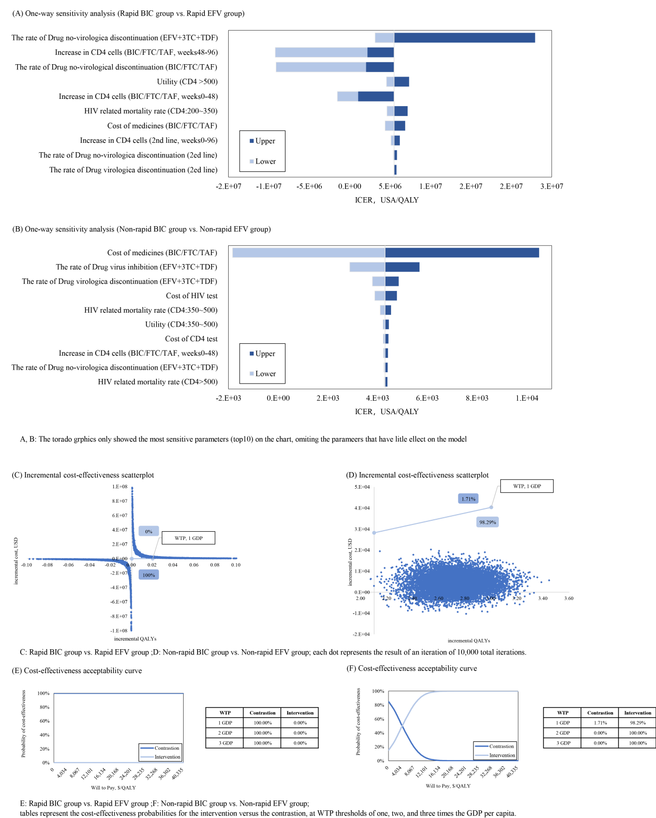
Appendix Figure 6 Sensitivity Analysis Outcomes: BIC Group vs. EFV Group (Markov Model, ITT Dataset)

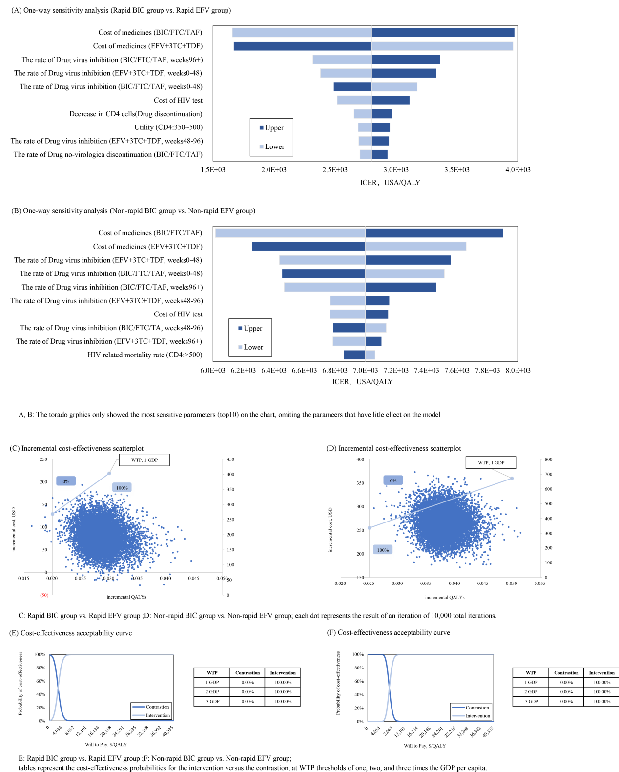
Appendix Figure 7 Sensitivity Analysis Outcomes: BIC Group vs. EFV Group (Infectious Disease Dynamic Model, ITT Dataset)

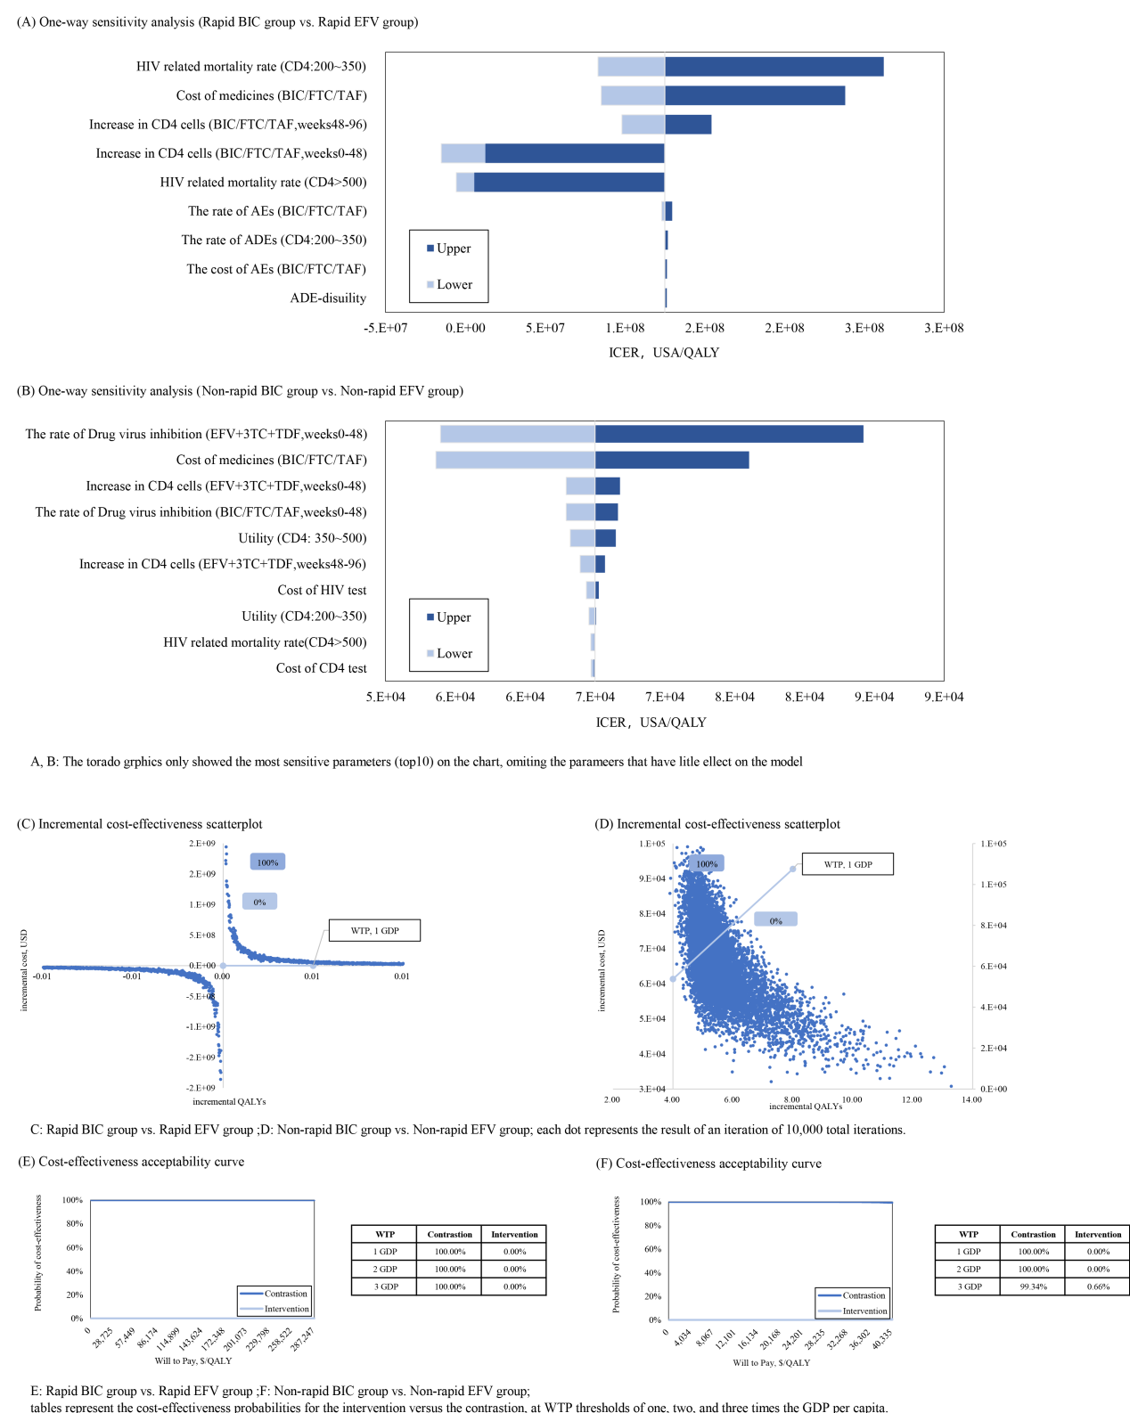
Appendix Figure 8 Sensitivity Analysis Outcomes: BIC Group vs. EFV Group (Markov Model, PP Dataset)

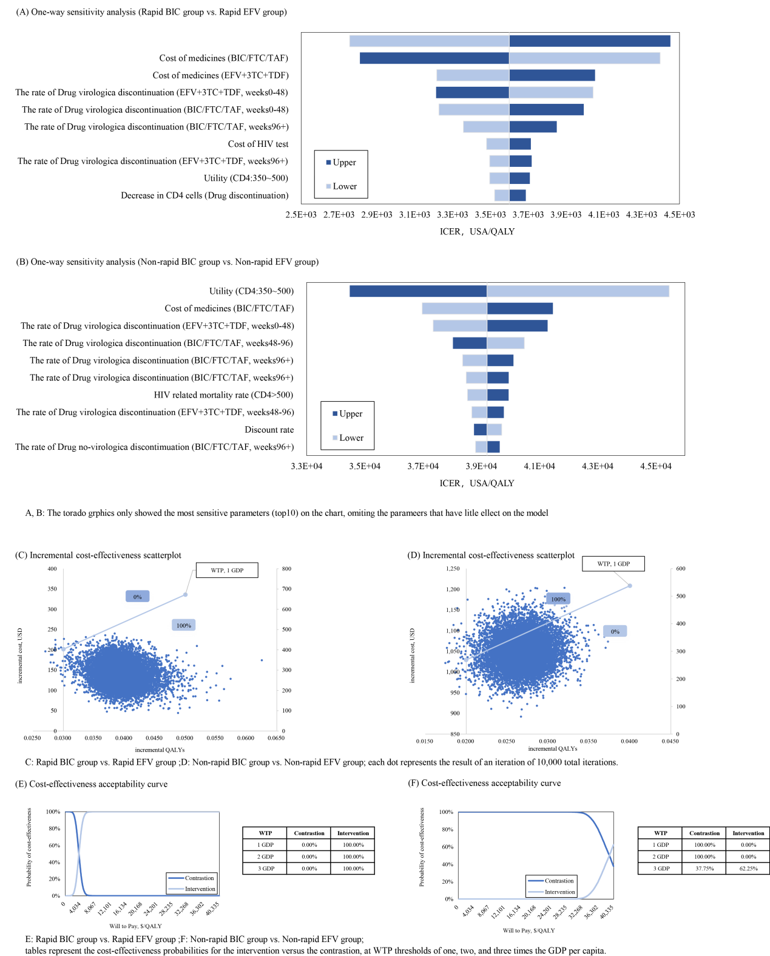
Appendix Figure 9 Sensitivity Analysis Outcomes: BIC Group vs. EFV Group (Infectious Disease Dynamic Model, PP Dataset)

References
[1]. Bai, W.L., Pan, S.M., & Wang, A.L., Sexual Behavior and Relationships of Contemporary Chinese People. Social Sciences Academic Press, 2004.(in Chinese).
[2]. AIDS, T.J.U.N., https://www.unaids.org/en/regionscountries/countries/china. 2023.
[3]. Zhao, R., et al., Optimising HIV pre-exposure prophylaxis and testing strategies in men who have sex with men in Australia, Thailand, and China: a modelling study and cost-effectiveness analysis. Lancet Glob Health, 2024. 12(2): p. e243-e256.
[4]. Broyles, L.N., et al., The risk of sexual transmission of HIV in individuals with low-level HIV viraemia: a systematic review. Lancet, 2023. 402(10400): p. 464-471.
[5]. Orkin, C., et al., Fixed-dose combination bictegravir, emtricitabine, and tenofovir alafenamide versus dolutegravir-containing regimens for initial treatment of HIV-1 infection: week 144 results from two randomised, double-blind, multicentre, phase 3, non-inferiority trials. Lancet HIV, 2020. 7(6): p. e389-e400.
[6]. Patrikar, S., et al., Rate of decline in CD4 count in HIV patients not on antiretroviral therapy. Med J Armed Forces India, 2014. 70(2): p. 134-8.
[7]. Girouard, M.P., et al., The Cost-effectiveness and Budget Impact of 2-Drug Dolutegravir-Lamivudine Regimens for the Treatment of HIV Infection in the United States. Clin Infect Dis, 2016. 62(6): p. 784-91.
[8]. Restelli, U., et al., Cost-effectiveness analysis of dolutegravir plus backbone compared with raltegravir plus backbone, darunavir+ritonavir plus backbone and efavirenz/tenofovir/emtricitabine in treatment naïve and experienced HIV-positive patients. Ther Clin Risk Manag, 2017. 13: p. 787-797.
[9]. Jiangsu Provincial Price Bureau, Notice on the Implementation Plan for the Comprehensive Reform of Medical and Drug Prices in Provincial (Ministry-Level) Public Hospitals (Su Jia Yi [2015] No. 284).(in Chinese).
[10]. GBD. 2023. https://vizhub.healthdata.org/gbd-results/. Accessed2023.
[11]. Girouard, M.P., et al., The Cost-effectiveness and Budget Impact of 2-Drug Dolutegravir-Lamivudine Regimens for the Treatment of HIV Infection in the United States. Clin Infect Dis, 2016. 62(6): p. 784-91.
[12]. Peng, S., et al., Cost-effectiveness of DTG+ABC/3TC versus EFV/TDF/FTC for first-line treatment of HIV-1 in the United States. J Int AIDS Soc, 2014. 17(4 Suppl 3): p. 19605.
[13]. Armenia, D., et al., Bictegravir/emtricitabine/tenofovir alafenamide ensures high rates of virological suppression maintenance despite previous resistance in PLWH who optimize treatment in clinical practice. J Glob Antimicrob Resist, 2022. 30: p. 326-334.
[14]. Orkin, C., et al., Doravirine/Lamivudine/Tenofovir Disoproxil Fumarate (TDF) Versus Efavirenz/Emtricitabine/TDF in Treatment-naive Adults With Human Immunodeficiency Virus Type 1 Infection: Week 96 Results of the Randomized, Double-blind, Phase 3 DRIVE-AHEAD Noninferiority Trial. Clin Infect Dis, 2021. 73(1): p. 33-42.
[15]. Wu, J., Constructing a Dynamic Model to Evaluate the Effectiveness of HIV/AIDS Prevention and Control in China. Chinese Center for Disease Control and Prevention, 2014.(in Chinese).
[16]. Rodger, A.J., et al., Sexual Activity Without Condoms and Risk of HIV Transmission in Serodifferent Couples When the HIV-Positive Partner Is Using Suppressive Antiretroviral Therapy. JAMA, 2016. 316(2): p. 171-81.
[17]. Simpson, K.N., et al., Lopinavir/ritonavir versus darunavir plus ritonavir for HIV infection: a cost-effectiveness analysis for the United States. Pharmacoeconomics, 2013. 31(5): p. 427-44.
[18]. Moreno, G.S., et al., Cost-utility analysis of the fixed-dose combination of dolutegravir/abacavir/lamivudine as initial treatment of HIV+ patients in Spain. Farm Hosp, 2017. 41(5): p. 601-610.
[19]. world development indicators2023. https://databank.worldbank.org/source/world-development-indicators(accessed 2013-2023External health expenditure per capita, PPP (current international $))..
[20]. Chinese Society of Infectious Diseases, AIDS and Hepatitis C Group, Chinese Center for Disease Control and Prevention, China HIV/AIDS Diagnosis and Treatment Guidelines (2021 Edition). Xiehe Medical Journal, 2022. 13(02): p. 203-226.(in Chinese).
[21]. MENET.https://www.menet.com.cn/data/.
[22]. Moreno, G.S., et al., Cost-utility analysis of the fixed-dose combination of dolutegravir/abacavir/lamivudine as initial treatment of HIV+ patients in Spain. Farm Hosp, 2017. 41(5): p. 601-610.

