Figure S1. PRISMA flowchart of included studies.

Identification of studies via other methods
Identification of studies via databases and registers

Records identified from:
Grey literature sources (n = 0)
Citation searching (n = 2)
Records removed before screening:
Duplicate records removed (n = 1725)
Records identified from databases and registers
(n = 4293)

Identification

Records screened
(n = 2568)
Records excluded
(n = 2531)

Reports not retrieved
(n = 0)
Reports sought for retrieval
(n = 2)
Reports sought for retrieval
(n = 37)
Reports not retrieved
(n = 0)

Screening

Reports assessed for eligibility
(n = 2)
Reports excluded (n = 2)
Reports assessed for eligibility
(n = 37)
Reports excluded (n=26):
Wrong study design (n = 19)
Wrong intervention or control (n = 7)

Studies included in review
(n = 8)
Reports of included studies
(n = 11)
Included

Figure S2. Quality assessment of included trials.

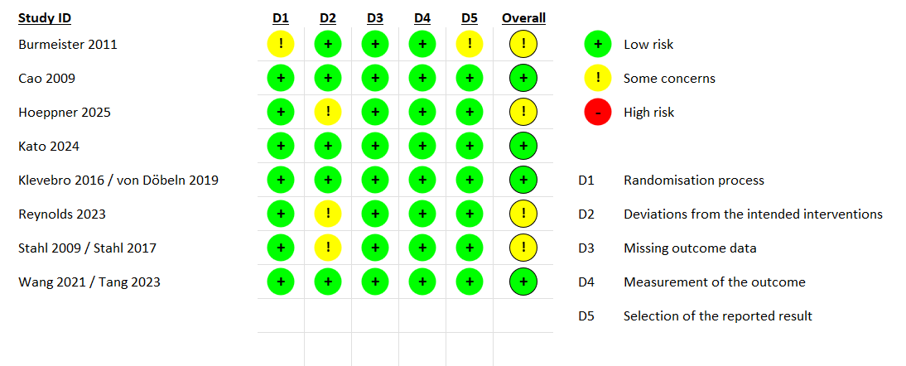

Figure S3. Subgroup analysis of overall survival (hazard ratios).

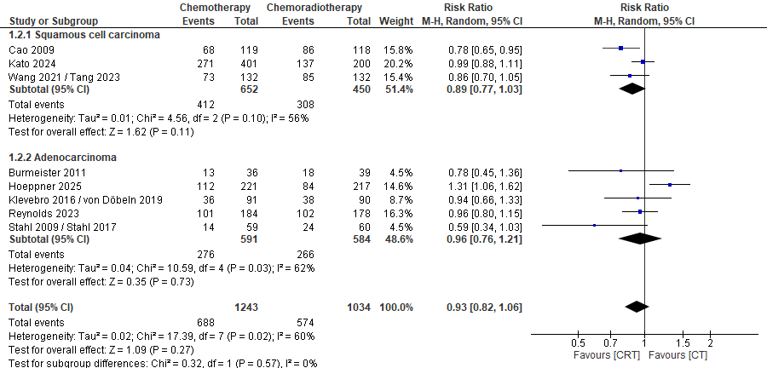

Figure S4. Subgroup analysis of overall survival (risk ratios).
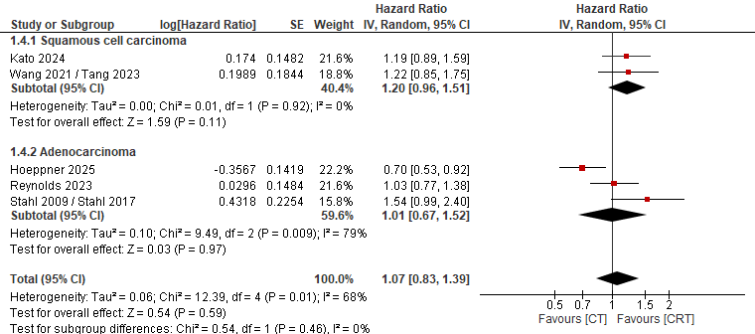

Figure S5. Forest plot of progression-free survival (hazard ratios).
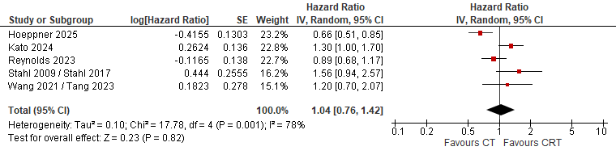

Figure S6. Subgroup analysis of progression-free survival (hazard ratios).
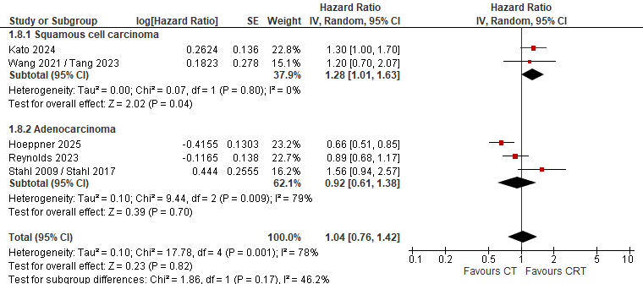

Figure S7. Forest plot of progression-free survival (risk ratios).
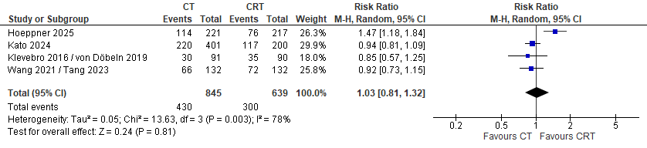

Figure S8. Subgroup analysis of progression-free survival (risk ratios).
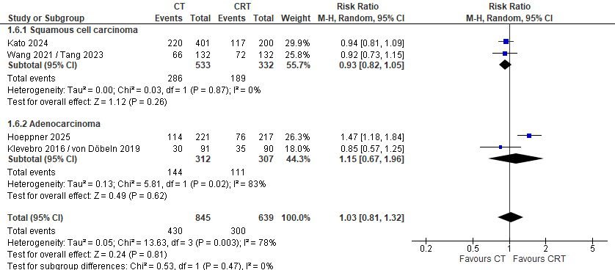

Figure S9. Forest plot for R0 resection rates.
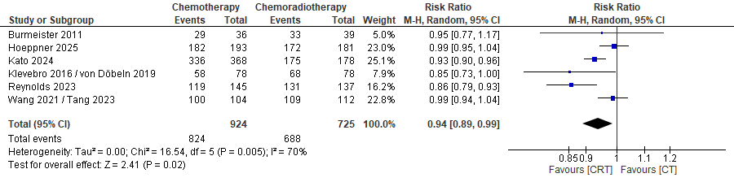

Figure S10. Subgroup analysis for R0 resection rates.
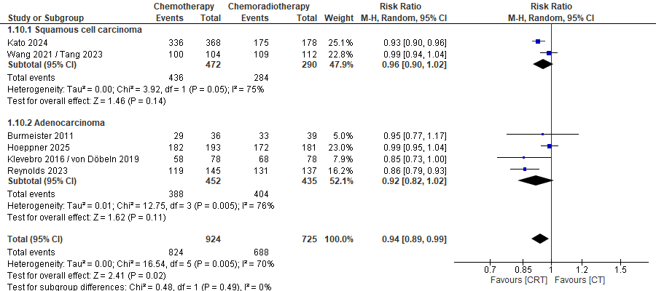

Figure S11. Forest plot for pathological complete response.
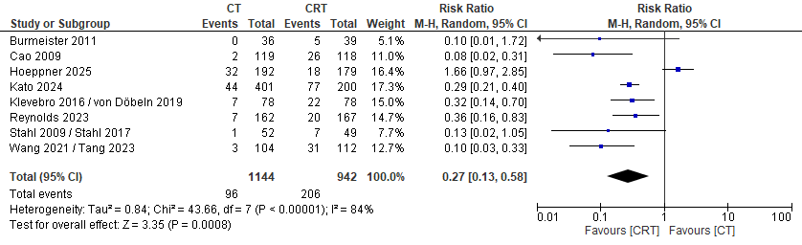

Figure S12. Subgroup analysis for pathological complete response.
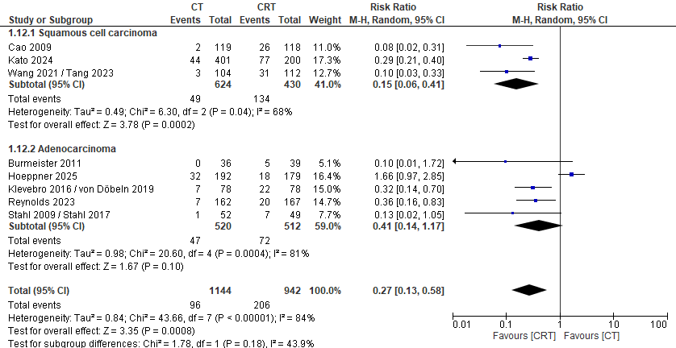

Figure S13. Forest plot for postoperative mortality.
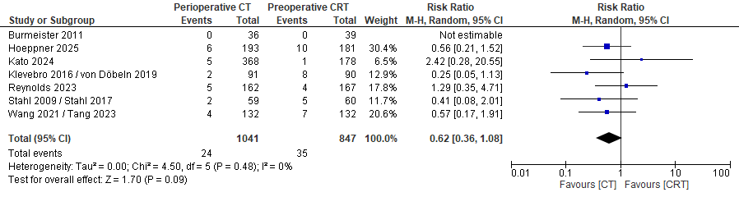

Figure S14. Forest plot for surgical complications.
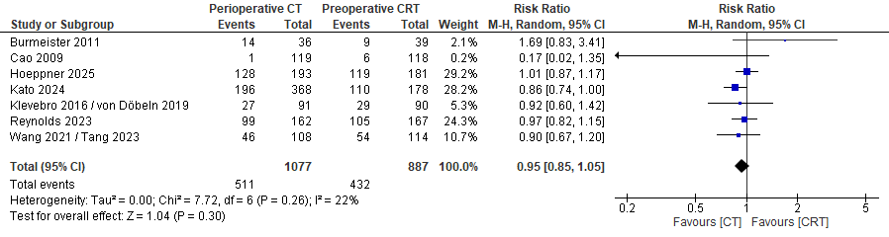

Figure S15. Forest plot for severe adverse events (Grade > 3).
