Table S1 Host range of the phage E212
Bacterial Species | Source and Strain ª | Spot test ^{b} | EOP ^{c}
Enterotoxigenic Escherichia coli K88 | CVCC 83902 | ＋ | 1 (host)
Escherichia coli | CVCC 208 | － | NT
Escherichia coli | CVCC 233 | － | NT
Escherichia coli | CVCC 236 | － | NT
Escherichia coli | CVCC 238 | － | NT
Escherichia coli | CVCC 239 | － | NT
Escherichia coli | CVCC 259 | － | NT
Shiga toxin-producing Escherichia coli | CGMCC 10668 | － | NT
Escherichia coli | BNCC 125988 | － | NT
Enteropathogenic Escherichia coli | BNCC 186732 | － | NT
Enterotoxigenic Escherichia coli | BNCC 186734 | ＋/－ | <0.001
Enterotoxigenic Escherichia coli | BNCC 186736 | － | NT
Enterotoxigenic Escherichia coli O126:K71 | BNCC 195622 | － | NT
Enterotoxigenic Escherichia coli | BNCC 337272 | ＋/－ | <0.001
Salmonella pullorum | CVCC 1795 | － | NT
Salmonella enteritidis | CVCC 3378 | － | NT
Salmonella choleraesuls | CVCC 3383 | － | NT
Salmonella typhimurium | ATCC 25241 | － | NT
Shigella sonnei | CGMCC 21535 | － | NT
Shigella dysenteriae | CGMCC 10983 | － | NT
Shigella boydii | BNCC 186201 | － | NT
Shigella flexneri | BNCC 186377 | － | NT
ª CVCC= China Veterinary Culture Collection Center; CGMCC= China General Microbiological Culture Collection Center; BNCC= Bena Culture Collection; ATCC= American Type Culture Collection
^{b} Spot test is used to determine the lytic capacity of the phage, ＋: clear plaque; －: no plaque; ＋/－: unclear results;
^{c} EOP is conducted only for the spot test positive strains; NT indicates EOP was not tested; EOP= phage titer on the test strain/phage titer on the host strain; EOP≥0.5 means high production efficiency, 0.1≤EOP≤0.5 means medium production efficiency, 0.001≤EOP≤0.1 means low production efficiency, and EOP≤0.001 means inefficiency of phage production.

Table S2 Predicted functions of phage E212
ORF | Nucleotide position | Putative function and best match | Identity (%) | E-value | Accession number
Phage structure
30 | 19102-19995 | scaffold protein gp8 [Bacteriophage APSE-6] | 29 | 4.2E-14 | ACJ10142.1
31 | 20014-21267 | capsid protein [Enterobacteria phage IME_EC2] | 69 | 4.5E-163 | AGZ17826.1
36 | 24068-24523 | head assembly protein [Enterobacteria phage IME10] | 97 | 8.0E-86 | YP_007004328.1
37 | 24526-25218 | injection protein [Salmonella phage vB_SemP_Emek] | 97 | 4.0E-113 | YP_006560561.1
45 | 31315-33156 | tail spike protein [Enterobacteria phage HK620] | 93 | 9.8E-58 | NP_112090.1
DNA packaging
8 | 5206-5502 | transcriptional activator/repressor protein [Enterobacteria phage YYZ-2008] | 99 | 1.6E-47 | YP_002274163.1
27 | 14848-15336 | terminase small subunit [Salmonella phage 118970_sal4] | 82 | 5.8E-73 | YP_009274688.1
28 | 15314-16810 | terminase large subunit [Enterobacteria phage IME10] | 94 | 6.8E-283 | YP_007004321.1
29 | 16807-19011 | portal protein [Enterobacteria phage Sf101] | 99 | 0 | YP_009153077.1
DNA metabolism
2 | 467-1369 | phage related recombination protein [Escherichia phage HK639] | 65 | 1.6E-109 | YP_004934069.1
7 | 4079-4774 | CI protein [Escherichia Stx1 converting phage] | 99 | 3.5E-133 | NP_859200.1
9 | 5535-6434 | Replication protein O | 99 | 1.6E-170 | P03688.1
10 | 6431-7132 | P protein [Enterobacteria phage H-19B] | 98 | 4.5E-128 | AAD04648.1
12 | 7493-7933 | NinB protein [Enterobacteria phage HK544] | 99 | 1.3E-80 | YP_007151657.1
13 | 7930-8457 | DNA methylase [Enterobacteria phage Sf101] | 99 | 1.7E-100 | YP_009153122.1
15 | 9027-9203 | NinF protein [Enterobacteria phage HK629] | 96 | 7.9E-26 | YP_007111830.1
16 | 9196-9918 | DNA-binding protein Roi [Enterobacteria phage HK620] | 99 | 1.9E-129 | NP_112063.1
18 | 10205-10567 | crossover junction endodeoxyribonuclease [Erwinia phage phiEt88] | 56 | 2.2E-30 | YP_004327365.1
19 | 10564-10752 | NinH [Salmonella phage vB_SemP_Emek] | 63 | 4.8E-13 | YP_006560611.1
20 | 10749-11372 | Q protein [Escherichia virus HK97] | 99 | 9.5E-114 | NP_037751.1
23 | 12865-13302 | Rz (i-spanin) [Enterobacteria phage Sf101] | 99 | 1.2E-70 | YP_009153134.1
25 | 13647-14168 | DNA-binding protein [Pseudomonas phage PS-1] | 47 | 1.9E-43 | YP_009222825.1
33 | 21478-21939 | phage DNA stabilization protein [Sodalis phage phiSG1] | 43 | 3.20E-26 | YP_516193.1
34 | 21949-23367 | DNA stabilization protein [Enterobacteria phage HK620] | 99 | 2.20E-275 | NP_112082.1
35 | 23367-24068 | DNA stabilization protein [Enterobacteria phage HK620] | 93 | 1.50E-112 | NP_112083.1
38 | 25229-26578 | DNA transfer protein [Salmonella phage SEN22] | 74 | 6.30E-187 | YP_009191466.1
39 | 26563-28686 | transglycosylase [Enterobacteria phage IME_EC2] | 28 | 1.30E-48 | AGZ17817.1
46 | 33999-35177 | integrase [Enterobacteria phage Sf101] | 99 | 4.3E-232 | YP_009153092.1
50 | 36846-37307 | Upf89.5 [Enterobacteria phage P7] | 52 | 9.7E-23 | AAQ07565.1
Host lysis
21 | 12085-12408 | holin [Enterobacteria phage HK446] | 99 | 5.3E-52 | YP_007112008.1
22 | 12392-12868 | lysin [Escherichia virus HK022] | 99 | 3.1E-88 | NP_037696.1

Fig.S1. Transmission electron micrograph of E212 negatively stained with 2% (w/v) uranyl acetate. The scale bar represents 20nm.
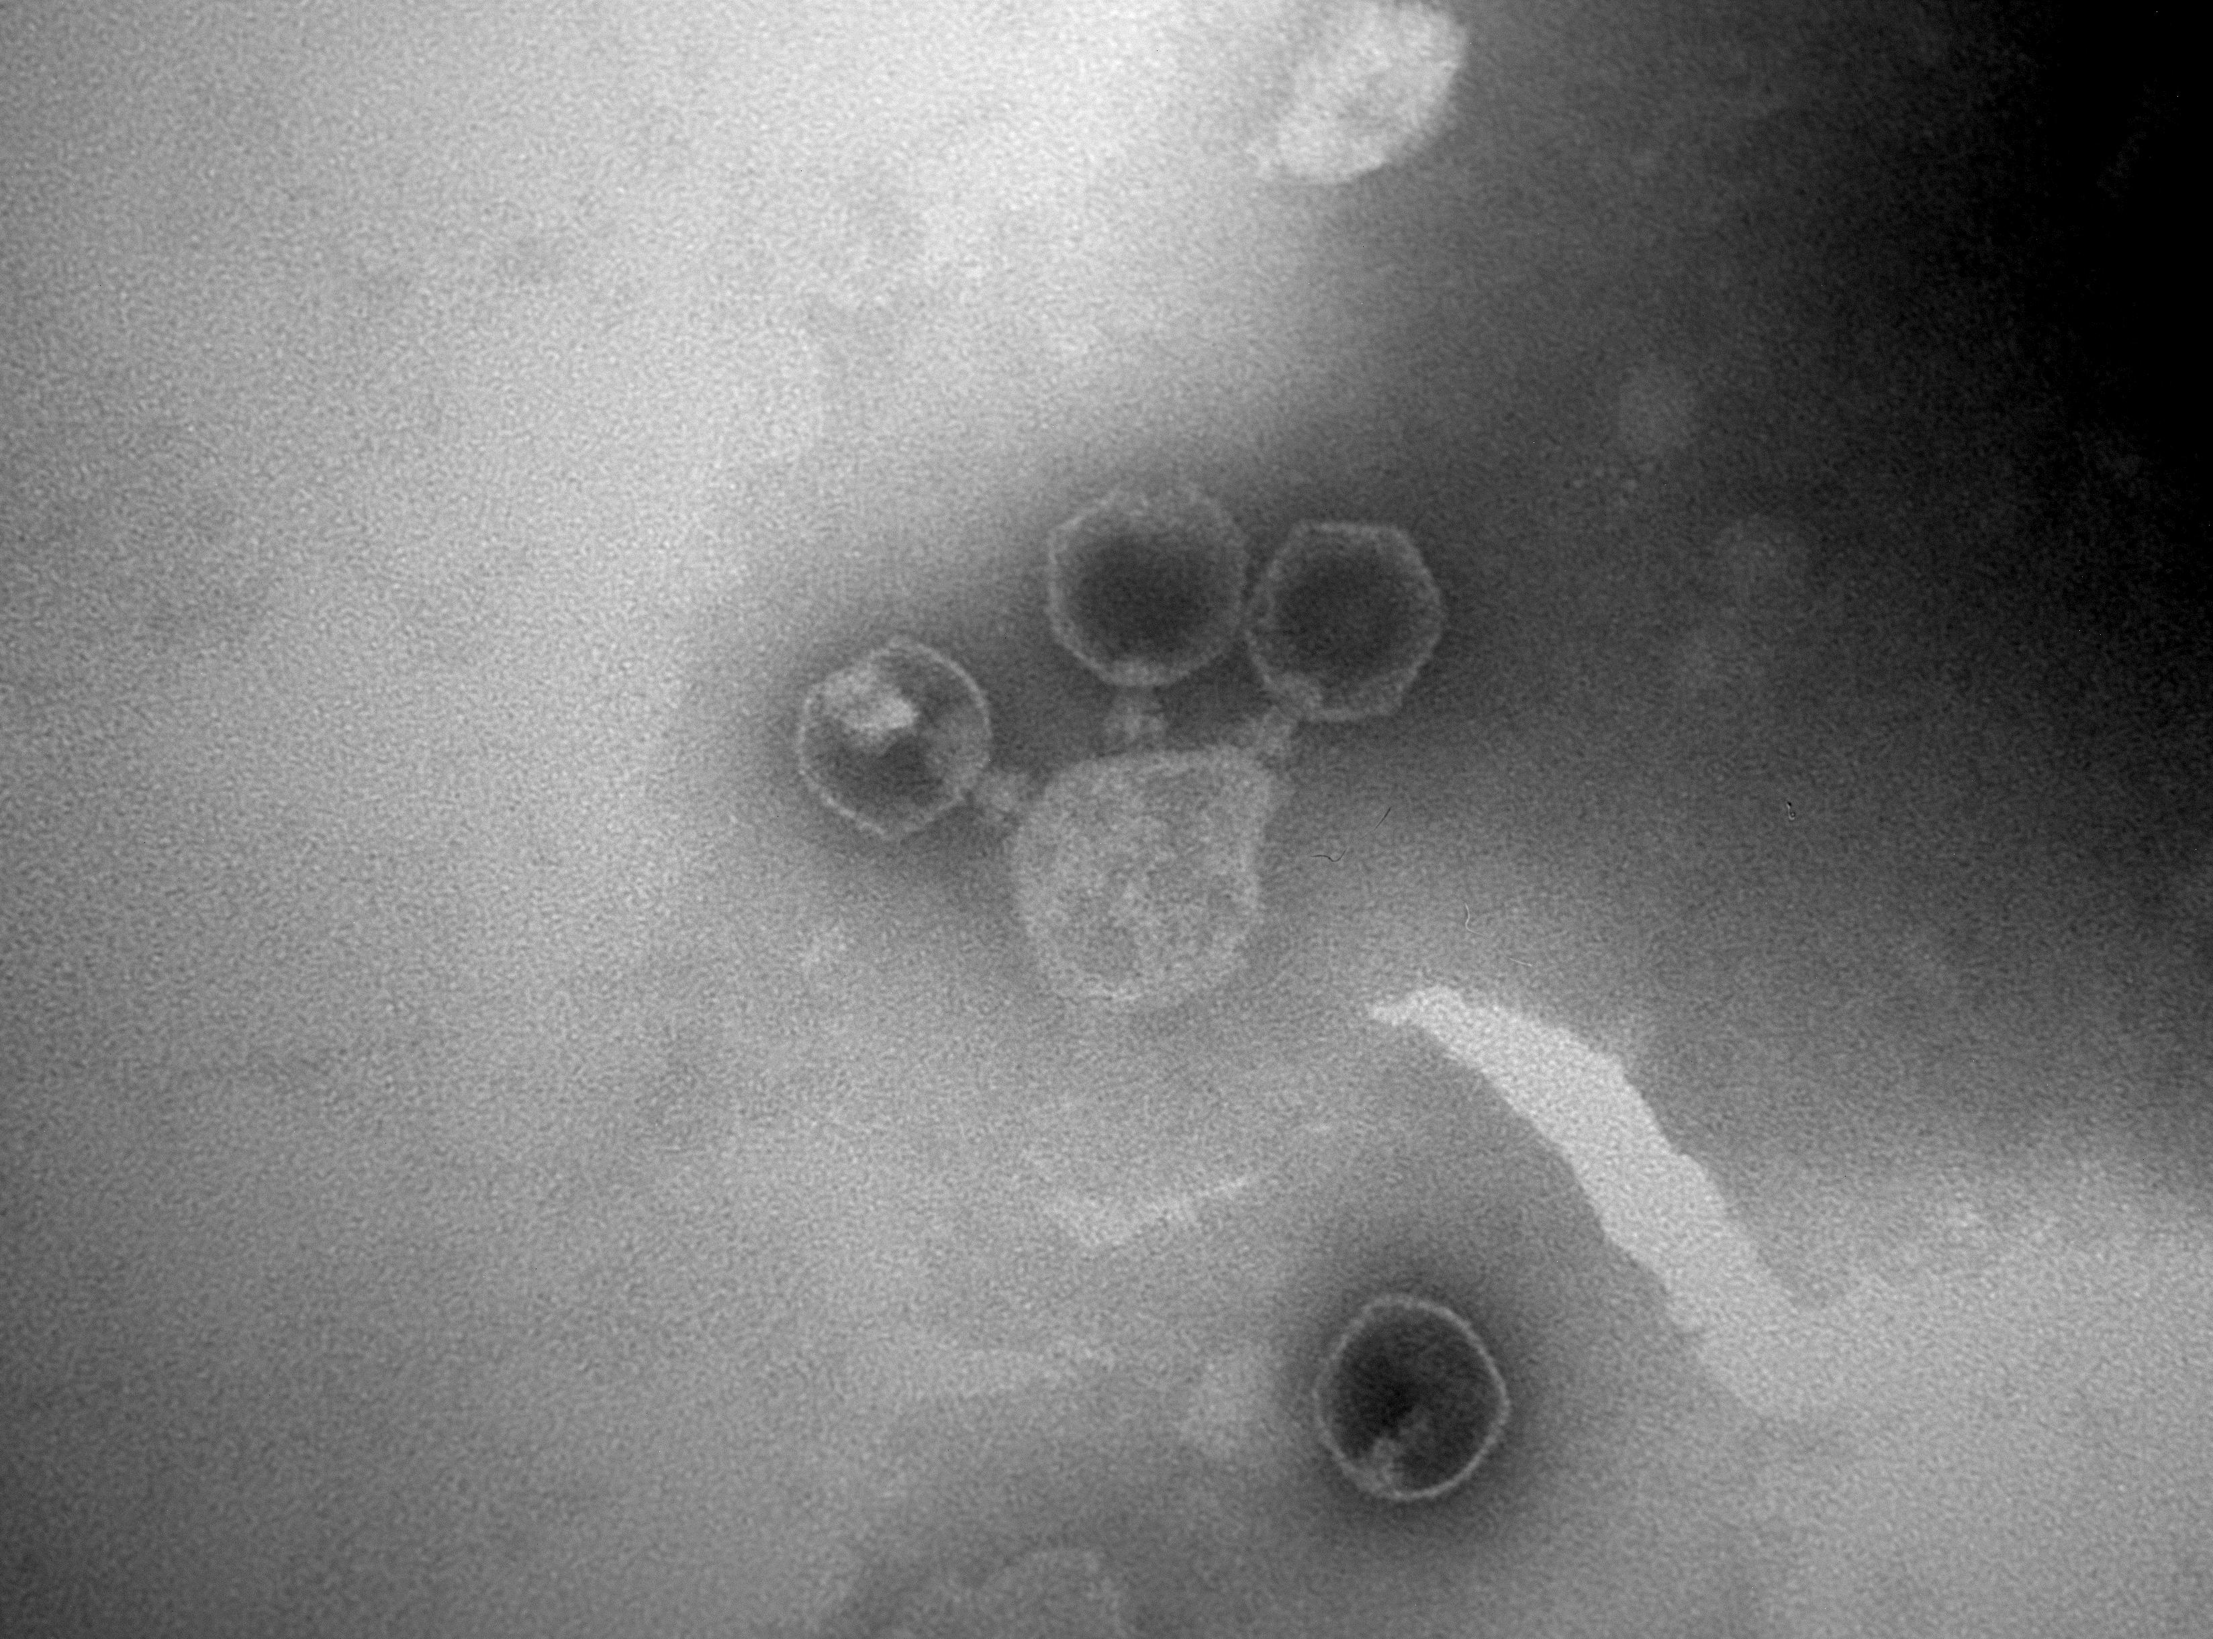
20nm

