Supplemental Figures 1 and 2
Supplemental Figure 1. Same-Day Discharge and Extended-Stay Surgeries Performed by Year
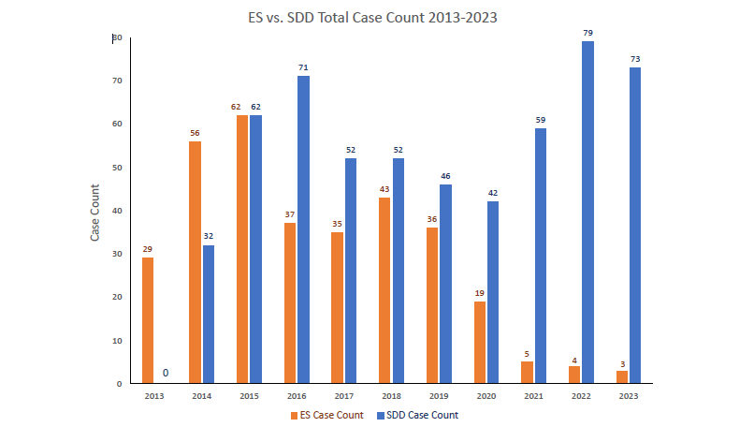
Supplemental Figure 2. Same-Day Discharge and Extended-Stay Surgeries by Surgery Type* 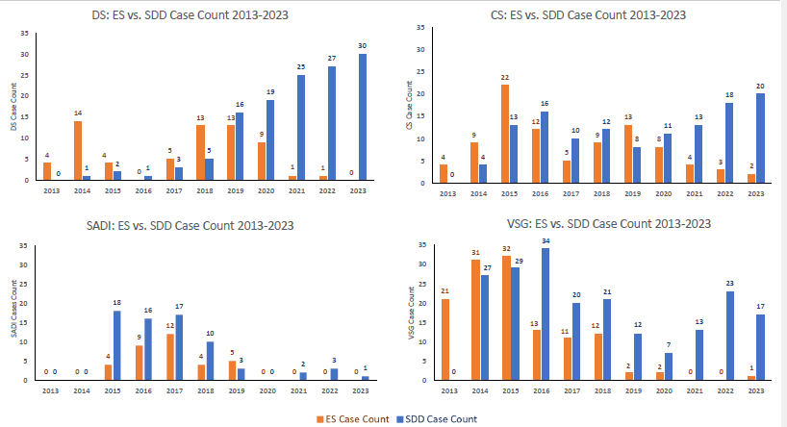
* PGBP and Others not shown due to small sample size.

