Supplementary information for
Reinforcement Learning-Driven Conversion Designed Minibinders to Small Molecules Targeting Porcine Nectin-1 IgV Domain for Anti-PRV Therapy
Lin Wei^{a,b,c,1}, Yang Hu^{a,1}, Peng Chen^{a,1}, Yuhua Chen^{a,1}, Keke Wangª, Jun Weng^{a,e}, Banbin Xingª, Ke Ming^{a,b,c}, Zhiyong Wuª, Miaomiao Gengª, Zhang Liuª, Guolin Wangª, Yun Youª, Yihe Fangª, Yanxia Liuª, Wenxia Zhangª, Haixia Xiangª, Zigong Wei^{a,b,c,d*}
ªState Key Laboratory of Biocatalysis and Enzyme Engineering, School of Life Sciences, Hubei University, Wuhan, Hubei, PR China
^{b}Animal Innovative Drug Research Center, School of Life Sciences, Hubei University, Wuhan, Hubei, PR China
^{c}Hubei Jiangxia Laboratory, Wuhan, Hubei, PR China
^{d}Hubei Province Key Laboratory of Biotechnology of Chinese Traditional Medicine, National & Local Joint Engineering Research Center of High-throughput Drug Screening Technology, School of life sciences, Hubei University, Wuhan, Hubei, PR China
^{e}Key Laboratory of Molecular Biophysics of Ministry of Education, College of Life Science and Technology, Huazhong University of Science and Technology, Wuhan, Hubei 430074, China
*Corresponding authors. Z. W., E-mail: weizigong@163.com; weizigong@hubu.edu.cn.
¹These authors contributed equally to this work
Table of Contents:
Part I: Figures and Tables S3
Part II. Computational and Experimental Section S19
2.1 Expression, purification of minibinders. S19
2.2 Expression, purification of Avi-tag labeled Nectin-1 IgV domain. S19
Part III. Chemistry. S23
SM1 S24
SM2 S26
SM3 S29
SM4 S31
SM5 S35
SM6 S38
Part IV. Pharmacokinetic study of compound SM1 in Kunming mice. S42
Part V. Details for AI-Driven Mini-Binder to Small-Molecule Conversion for PPI inhibitors. S46

Part I. Figures and Tables.
Fig. S1. Predicted binding modes by AlphaFold2. (A)Binding modes for B1 (chain A, similarly here in after), SER45, SER53, GLN60 forms a hydrogen bond with ASN97, GLN28, SER52 of Nectin-1, respectively. Hydrophobicity residues LEU17, ALA22, ILE23, ALA27, LEU31, ILE34, LEU35, ALA38, LEU41, ILE50, LEU54, PHE57 bind to hydrophobic in Nectin-1 (chain B, similarly here in after) comprising ILE44, MET49, PHE93, PRO94. (B) Binding modes for B2, GLU43, LYS11 forms hydrogen bonds and forms salt bridge with LYS25, GLU89, respectively. PHE54 forms a π-π stacking with PHE93 of Nectin-1. The hydrophobic surface consisting of LEU2, ALA39, PHE6, VAL47, LEU50, LEU51, ALA14, ILE13, ALA17, LEU55, PHE54, PHE3 combines with the hydrophobic surface consisting of ILE44, ALA48, MET49, LU54, PHE93, PRO94 of Nectin-1. (C) Binding modes for B3, GLU46, SER50, SER54 form hydrogen bonds with LEU221, ASN97, ASN97, respectively. The hydrophobic surface consisting of PHE58, ILE59, LEU20, ALA48, ALA55, MET25, LEU51, LEU47, ALA32, LEU44, LEU35, combines with the hydrophobic surface consisting of MET49, ALA48, LEU54, ILE45, ALA91, PHE93, PRO94 of Nectin-1. (D) Binding modes for B4, ASP49, ARG45, VAL13, HIS10 forms hydrogen bonds with ASN47, ALA95, GLN28, THR27 respectively, while LYS52 forms hydrogen bonds and forms salt bridge with GLU89. PHE9 forms a π-π stacking with PHE93 of Nectin-1. The hydrophobic surface consisting of ILE43, ALA5, LEU31, PHE9, ALA46 combines with the hydrophobic surface consisting of PHE93 of Nectin-1. (E) Binding modes for B5, SER47, TYP44, GLU43, forms hydrogen bonds with GLN28, THR27, ASN97 respectively, while SER51 forms hydrogen bonds with GLN28, ASN46. while GLU11 forms hydrogen bonds and forms salt bridge with LYS25. ARG50 forms salt bridge with GLU89. TYR44 forms a π-π stacking with PHE93 of Nectin-1. The hydrophobic surface consisting of LEU52, LEU14, combines with the hydrophobic surface consisting of ALA48 of Nectin-1. The hydrophobic surface consisting of ALA33, VAL6, LEU41, VAL3, TYR44 combines with the hydrophobic surface consisting of PHE93, PRO94 of Nectin-1.

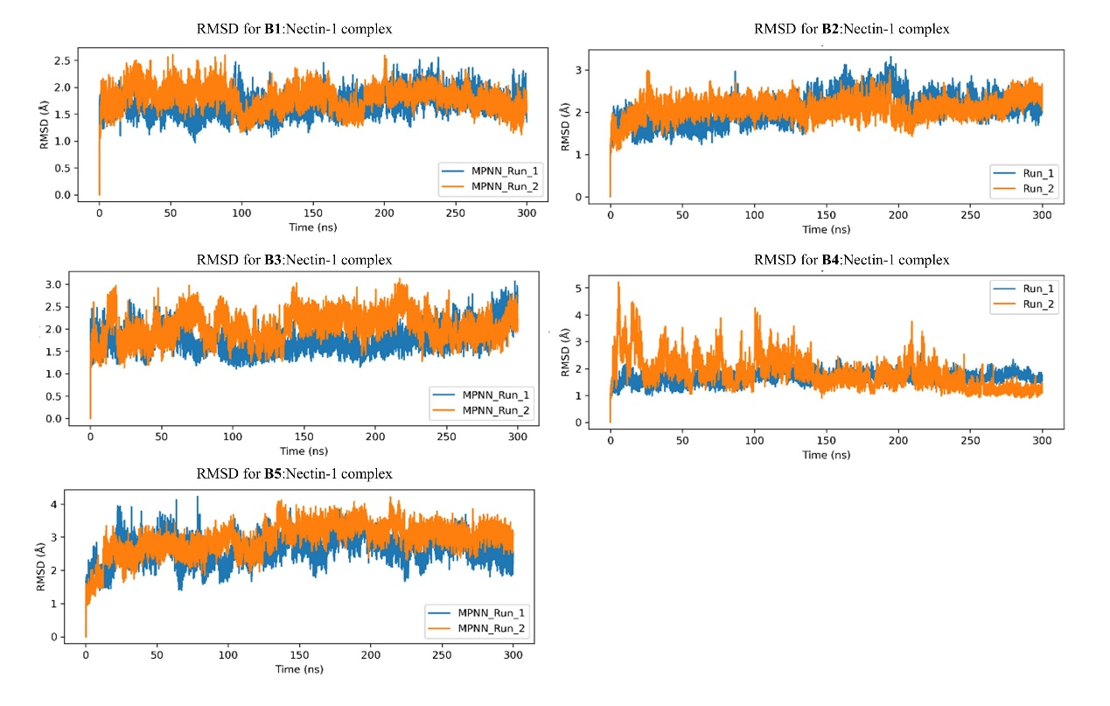
Fig. S2. Root-mean-square deviation (RMSD) for the MD simulations for all 5 minibinders.

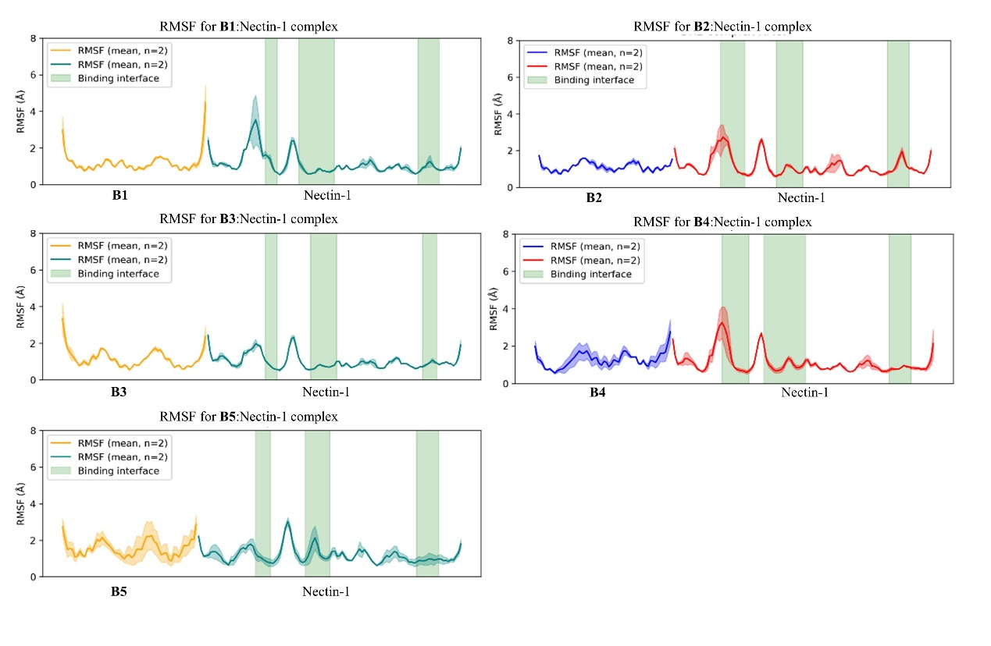
Fig. S3. Root-mean-square fluctuation (RMSF) for the MD simulations for all 5 minibinders.

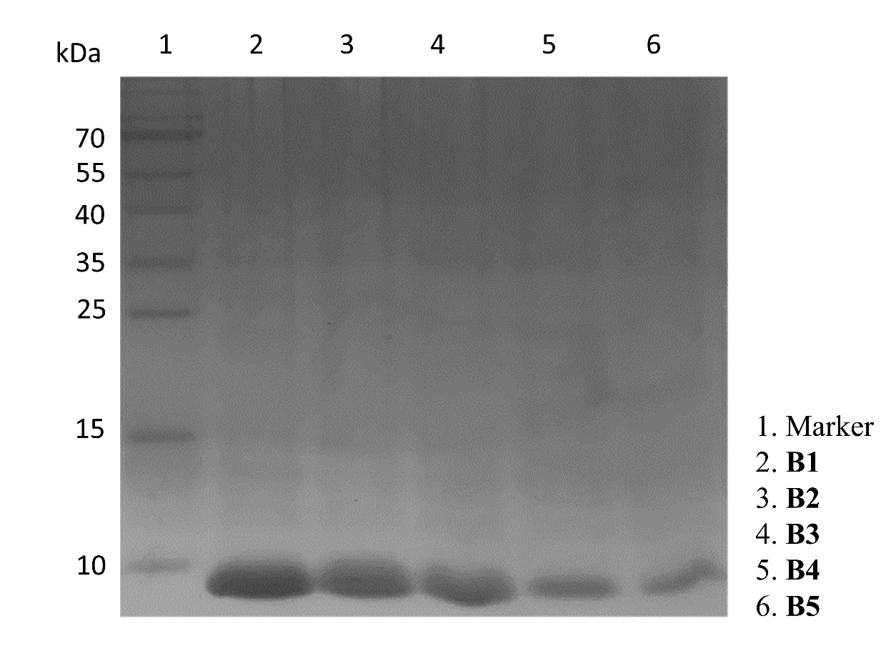
Fig. S4. SDS-PAGE confirming the expression and purification of B1–B5.

Table S1. Primers used in this work.
Primers | Sequence (5′ to 3′)
pET-22b F | cctgcggcaatcaataattt
pET-22b R | taagagctccgtcgacaagc
B1 F | aagaaggagaTATACATATGcaccatcatcatcatcatTCAGAAATAGAGGCTCTAGC
B1 R | gcttgtcgacggagctcTTAGCAGGCCTGCGCCACGAAGGTC
B2 F | aagaaggagaTATACATATGcaccatcatcatcatcatGATCTGTTCCACGAATTTGCC
B2 R | gcttgtcgacggagctcTTAGCAGCGCAGAAACTCTTCGAGTAATTTAAC
B3 F | aagaaggagaTATACATATGcaccatcatcatcatcatAACAAAGAAGAACTCAAGAAG
B3 R | gcttgtcgacggagctcTTAGCAAGAGTTGATAAACGTCTTTG
B4 F | aagaaggagaTATACATATGcaccatcatcatcatcatAGCCATGAAGAGGCGGAGCGC
B4 R | gcttgtcgacggagctcTTAGCAGAACTTCAGCAGCTTCTTAAG
B5 F | aagaaggagaTATACATATGcaccatcatcatcatcatGCCGCCGTTGAAGAAGTAGAG
B5 R | gcttgtcgacggagctcTTAGCAGAACAATTTCAGGGAACGTG
β-actin F | ACTGTCGAGTCGCGTCCA
β-actin R | GTCATCCATGGCGAACTGGT
IL1β F | GAAATGCCACCTTTTGACAGTG
IL1β R | TGGATGCTCTCATCAGGACAG
IL6 F | TCTATACCACTTCACAAGTCGGA
IL6 R | GAATTGCCATTGCACAACTCTTT
TNF-α F | CAGGCGGTGCCTATGTCTC
TNF-α R | CGATCACCCCGAAGTTCAGTAG
PRV gB F | GCGGCATCGCCAACTTCTTCC
PRV gB R | GCCTCGTCCACGTCGTCCTCTT

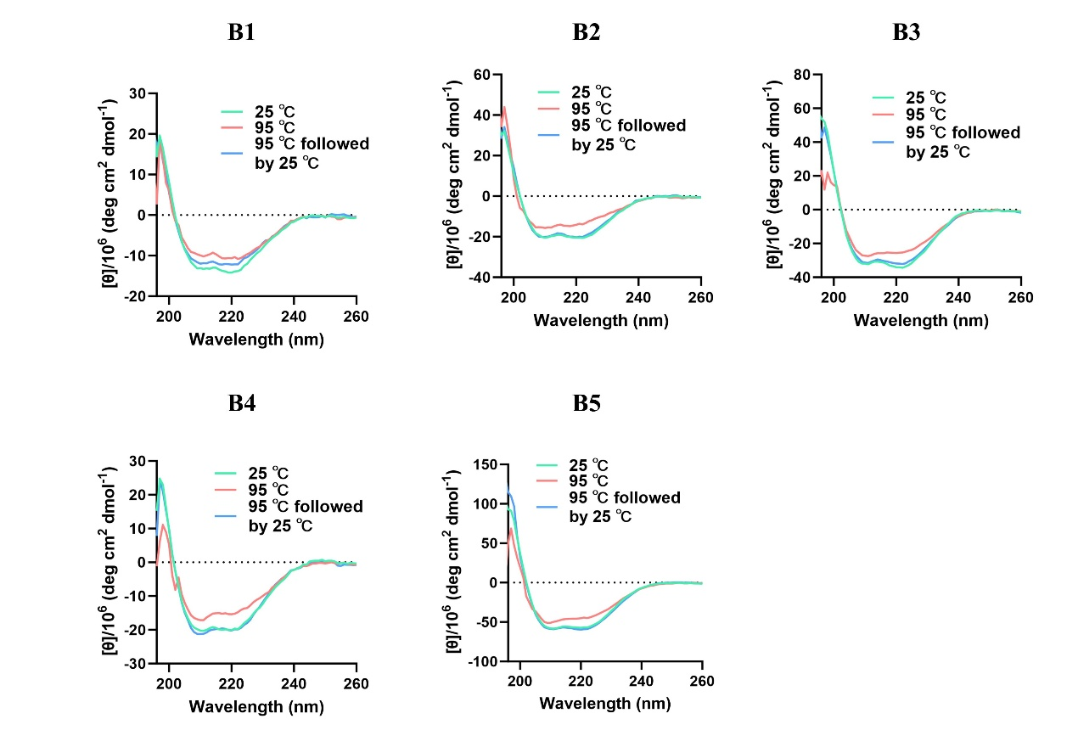
Fig. S5. Circular dichroism spectra of B1–B5 recorded at different temperatures.

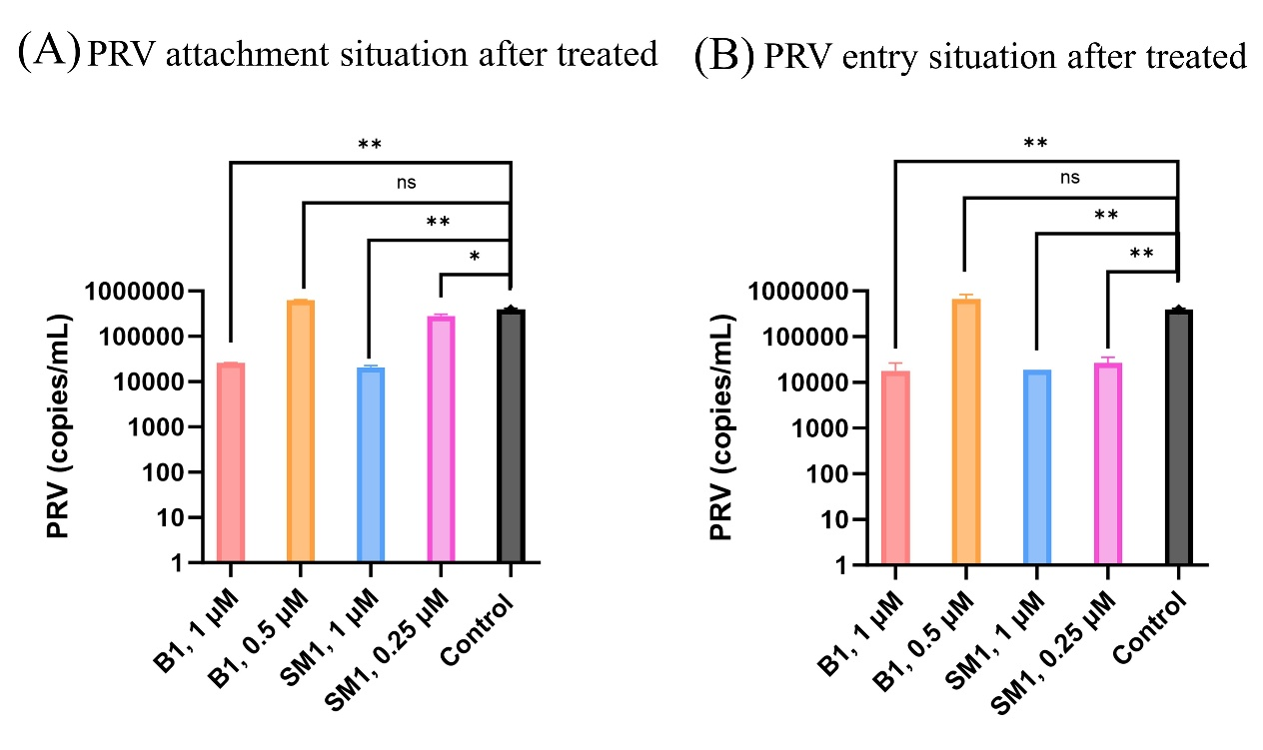
Fig. S6. (A) Effect of B1 or SM1 on PRV attachment to PK15 cells. (B) Effect of B1 or SM1 on PRV entry into PK15 cells. Statistical significance: **p <0.01. *p <0.05. ns = not significant (p > 0.05); determined by two-tailed Student's t-test assuming equal variance (GraphPad Prism 6).

Table S2. The details for PRV copies in brain after treated.
Agents | Mouse ID |  | PRV copies in Brain (copies/g)
B1-treated | Treat Group | A1 | 2.6 ×10⁴
B1-treated | Treat Group | A2 | 1.7 ×10³
B1-treated | Treat Group | A3 | 5.6 ×10³
B1-treated | Treat Group | A4 | 2.7 ×10³
B1-treated | Treat Group | A5 | 1.6 ×10⁴
B1-treated | Blank Group | B1 | 4.2 ×10⁶
B1-treated | Blank Group | B2 | 1.8 ×10⁶
B1-treated | Blank Group | B3 | 9.1 ×10⁶
B1-treated | Blank Group | B4 | 4.8 ×10⁷
B1-treated | Blank Group | B5 | 3.8 ×10⁵
SM1-treated | Treat Group | C1 | 1.2 ×10⁵
SM1-treated | Treat Group | C2 | 3.0 ×10⁴
SM1-treated | Treat Group | C3 | 4.7 ×10⁴
SM1-treated | Treat Group | C4 | 5.8 ×10³
SM1-treated | Treat Group | C5 | 7.2 ×10³
SM1-treated | Blank Group | D1 | 2.3 ×10⁶
SM1-treated | Blank Group | D2 | 3.5 ×10⁶
SM1-treated | Blank Group | D3 | 5.0 ×10⁵
SM1-treated | Blank Group | D4 | 1.2 ×10⁷
SM1-treated | Blank Group | D5 | 7.7 ×10⁶

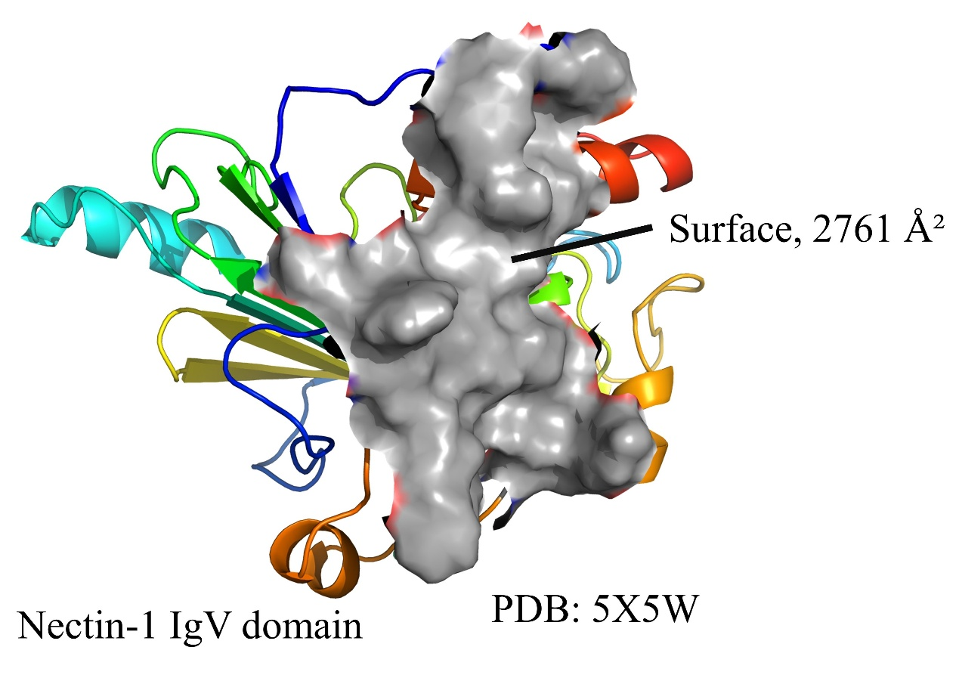Fig. S7. Solvent-accessible surface area of the Nectin-1 IgV domain interface.

Table S3. Per-residue binding free energy decomposition (MM/GBSA) for the B1:Nectin-1 complex.
Nectin-1 |  |  |  | BR1O2
Res. | ΔG  (kcal/mol) | Res. | ΔG  (kcal/mol) | Res. | ΔG  (kcal/mol) | Res. | ΔG  (kcal/mol)
LYS25 | -1.00±1.96 | SER52 | -2.48±0.32 | LEU14 | -0.19±0.33 | LEU41 | -0.55±0.32
ILE26 | 0.13±0.37 | VAL53 | -0.75±0.39 | LEU17 | -0.58±0.32 | ASN43 | 0.14±0.46
THR27 | 0.16±0.47 | LEU54 | -1.30±0.30 | VAL22 | -0.65±0.34 | LEU44 | -0.05±0.34
GLN28 | -1.01±0.44 | ALA55 | -0.04±0.25 | ILE23 | -2.21±0.34 | SER45 | 0.22±0.45
THR30 | 0.05±0.28 | ARG58 | -1.05±0.81 | SER24 | -0.16±0.38 | LEU46 | -2.45±0.32
GLN32 | 0.08±0.40 | GLU89 | 1.45±0.92 | ALA27 | -0.25±0.26 | VAL47 | -0.13±0.29
ASN41 | -1.07±0.41 | PHE90 | -0.04±0.35 | ALA28 | -0.13±0.26 | GLU48 | 0.38±0.75
ALA43 | -0.11±0.24 | ALA91 | -0.09±0.26 | GLU30 | -1.44±0.44 | SER49 | -1.30±0.39
ILE44 | -3.32±0.32 | THR92 | 0.01±0.34 | LEU31 | -0.93±0.35 | ILE50 | -1.92±0.34
TYR45 | -0.36±0.36 | PHE93 | -3.66±0.36 | ALA33 | 0.03±0.25 | GLN52 | -1.04±0.69
ASN46 | -0.42±0.41 | PRO94 | -2.54±0.29 | ILE34 | -2.35±0.35 | SER53 | -2.11±0.27
PRO47 | -0.01±0.28 | ALA95 | -0.22±0.29 | LEU35 | -0.13±0.32 | LEU54 | -0.77±0.33
ALA48 | -0.65±0.25 | GLY96 | -0.26±0.27 | GLU37 | -0.28±0.85 | THR56 | -2.19±0.37
MET49 | -5.30±0.32 | ASN97 | -1.02±0.55 | ALA38 | -0.19±0.26 | PHE57 | -6.62±0.36
GLY50 | -0.04±0.23 | ARG98 | -0.60±0.85 | ILE39 | -0.01±0.34 | ALA59 | -0.92±0.51
VAL51 | -0.44±0.33 |  |  | GLU40 | 0.15±0.82 | GLN60 | -1.87±0.59

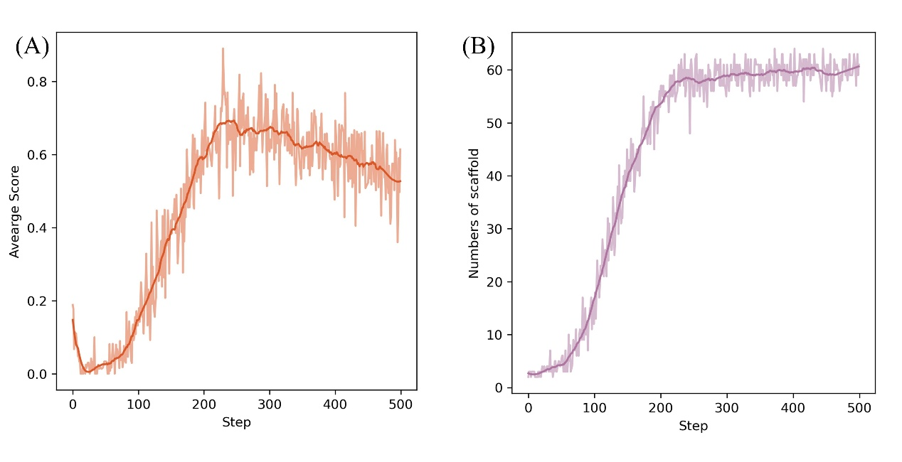
Fig. S8. (A) The average score in RL training steps. (B) Numbers of scaffolds in RL training steps.

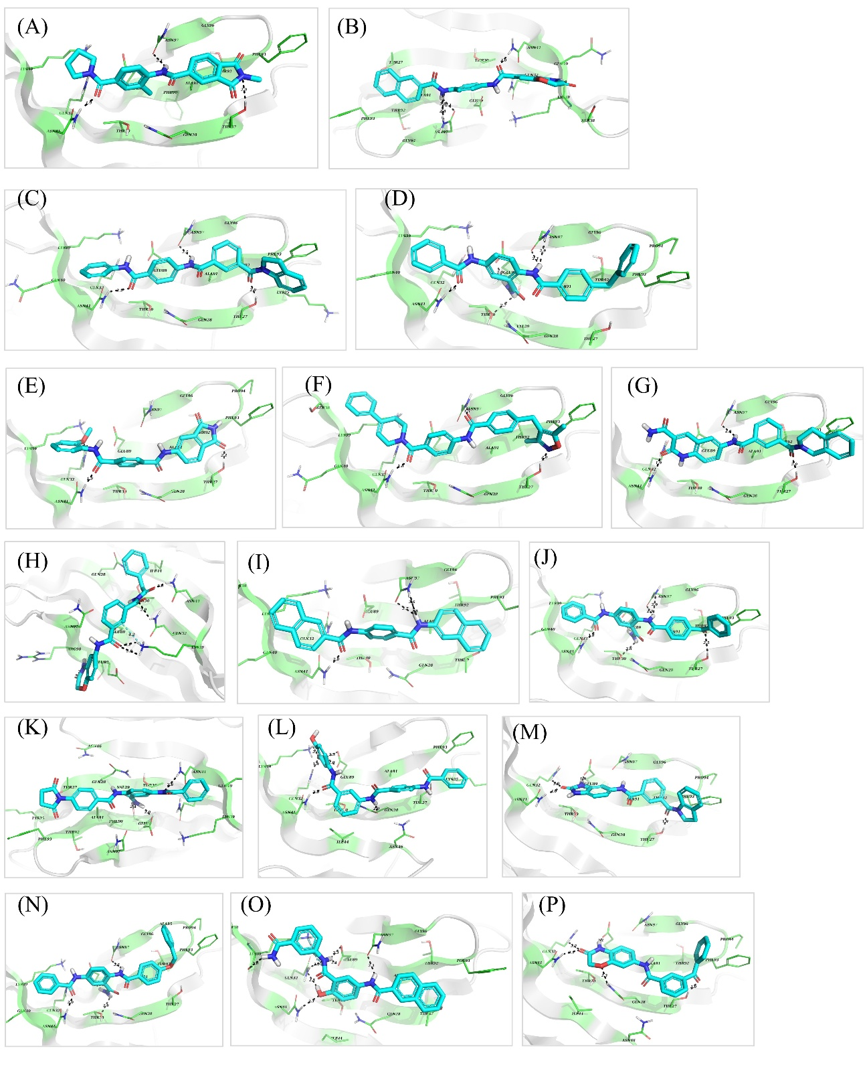
Fig. S9. The binding mode of h1-h28(A-AB), h30(AC) predicted by Autodock Vina. (To be Continued)

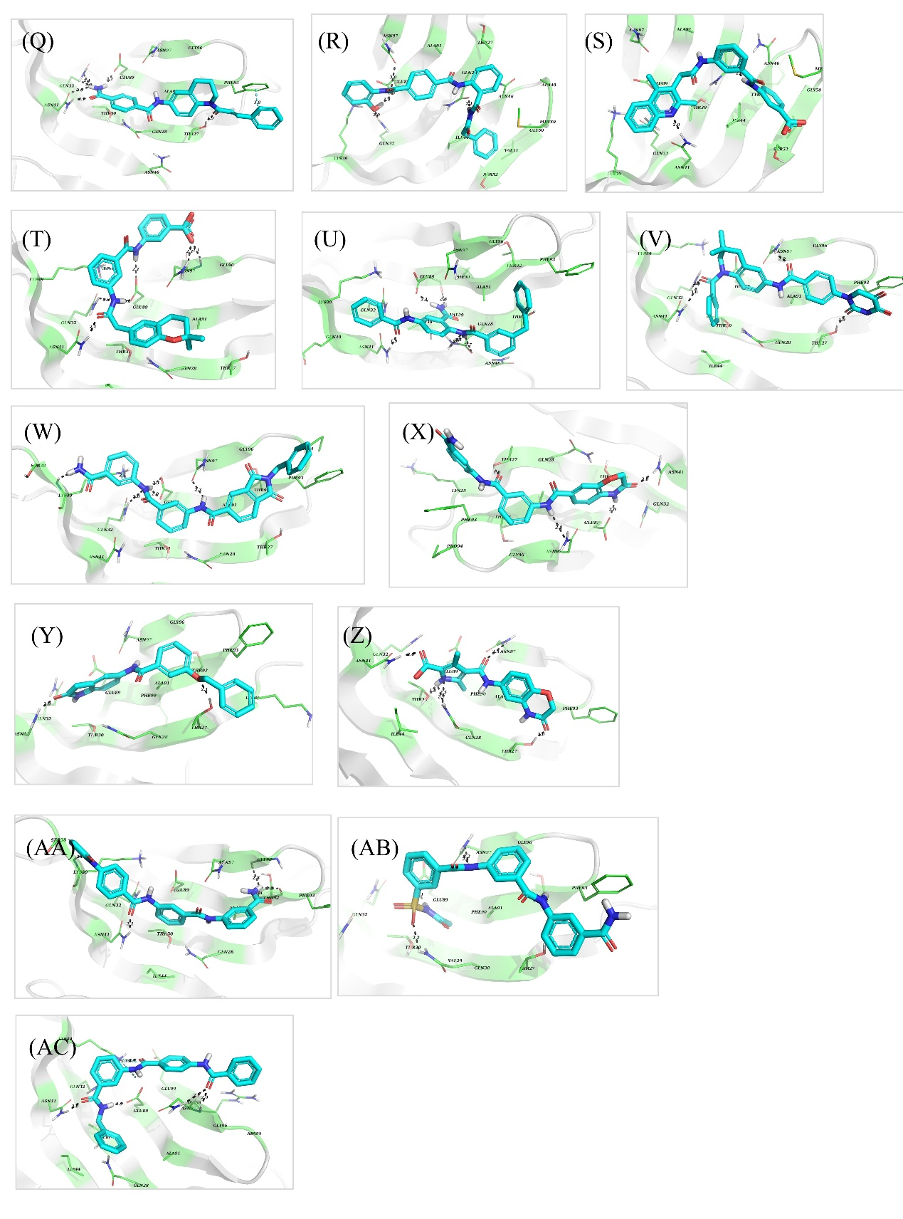
(Continued) Fig. S9. The binding mode of h1-h28(A-AB), h30(AC) predicted by Autodock Vina.

Part II. Computational and Experimental Section
2.1 Expression, purification of binders
The genes encoding the minibinders were cloned into a pET-22b vector with a C-terminal 6×His tag via infusion cloning. The constructs were transformed into E. coli BL21(DE3) competent cells, and protein expression was induced with IPTG at 18 °C for 20 hours. Cells were harvested by centrifugation (7,000 rpm, 10 min) and lysed by sonication. PMSF (100 mM) was added to inhibit proteolysis. The lysate was applied to a Ni-NTA affinity column, washed with buffer containing 30 mM imidazole, and eluted with 300 mM imidazole. Further purification was performed using an FPLC system equipped with a Superdex 75 Increase 10/300 column (Cytiva). Protein concentration was determined with a BCA assay kit (Biosharp, BL521A), and purity was verified by SDS-PAGE.

2.2 Expression, purification of Avi-tag labeled Nectin-1 IgV domain
Bacterial culture was centrifuged at 10,000 × g for 20 min to collect the pellet. The pellet was resuspended in lysis buffer (50 mM Tris, 5 mM EDTA, 150 mM NaCl, pH 8.0) at a 9:1 (v/w) ratio and lysed by double-pass homogenization at 300 bar and 700 bar, achieving >95% disruption. The lysate was centrifuged (10,000 × g, 30 min) to collect crude inclusion bodies. These were washed sequentially with: (1) 50 mM Tris, 5 mM EDTA, 150 mM NaCl, 1% Triton X-100, 2% sodium deoxycholate, pH 8.0; (2) the same buffer supplemented with 2 M urea; and (3) lysis buffer to remove detergents. The purified inclusion bodies were solubilized in denaturation buffer (50 mM Tris, 8 M urea, 80 mM Cys, pH 9.7) at a 9:1 (v/w) ratio. After centrifugation (10,000 × g, 10 min), the supernatant was adjusted to 7 mg/mL and refolded by 40-fold dilution into reconstitution buffer (50 mM Tris, 0.78 M urea, 10 mM MgSO₄, pH 9.7) with stirring at 4 °C for 40 h. The refolded protein was acid-precipitated (pH 5.0), centrifuged, and the supernatant was purified by SPFF cation-exchange chromatography. Purity was confirmed by SDS-PAGE (Fig. S10).
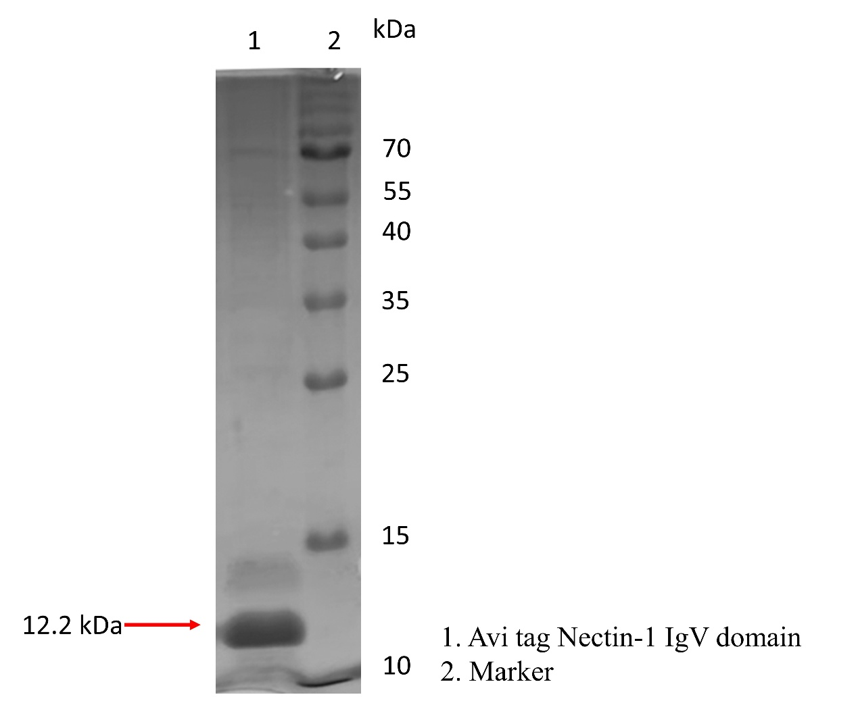
Fig. S10. SDS-PAGE analysis for Avi-tag Nectin-1 IgV domain.

Part III. Chemistry.
The synthetic procedures for WLN2 are as follows (Sheme 1). N,N,N',N'-tetramethylchloroformamidinium hexafluorophosphate(TCFH) (3.42 g, 12.18 mmol) was added to a solution of 2-amino-6-methylphenol (12.18 mmol), (tert-butoxycarbonyl) glycine (boc-GLY) (9.74 mmol) and N-methylimidazole (NMI) (1.69 g, 20.30 mmol) in acetonitrile (MeCN; 20 mL). The mixture was stirred for 5 hours at room temperature and monitored by TLC. The reaction mixture was diluted with a saturated aqueous solution of NaHCO₃, and the aqueous phase was extracted three times with ethyl acetate (EtOAc). The combined organic layers were then washed with brine, dried over anhydrous Mg₂SO₄, filtered, and concentrated under reduced pressure. The resulting residue was purified by silica gel column chromatography to yield tert-butyl (2-((2-hydroxy-3-methylphenyl)amino)-2-oxoethyl)carbamate (SM1b).
Trifluoroacetic acid (TFA) was added (10 mL) to a solution of SM1b in anhydrous dichloromethane (DCM) (15 mL). The reaction mixture was stirred for 3 h at room temperature, after which the solvent and excess reagent were removed under reduced pressure. The resulting residue was neutralized with a saturated aqueous solution of NaHCO₃ and the mixture was extracted with dichloromethane (3 × 15 mL). The combined organic layers were washed with brine (2 × 10 mL), dried over anhydrous Na₂SO₄, filtered, and concentrated under reduced pressure to yield 2-amino-N-(2-hydroxy-3-methylphenyl)acetamide (SM1c).
Triethylamine (TEA) was added to a solution of methyl (R)-2-aminobutanoate (0.60 g) in dichloromethane (20 mL). Benzoyl chloride was then added dropwise to the mixture at room temperature. The reaction was allowed to stir at room temperature until completion (monitored by TLC). Following the reaction, the mixture was concentrated under reduced pressure, and the resulting residue was purified directly by silica gel column chromatography to yield methyl (R)-2-benzamidobutanoate (SM1e).
SM1e (0.78 g) was dissolved in MeCN (8 mL), and then added water (164 μL), lithium bromide (3.0 g), and triethylamine (1.06 g) in it. The reaction mixture was stirred at room temperature for 12 h. Upon completion, the mixture was acidified to pH 2-3 with 1 M aqueous HCl and extracted with dichloromethane (3 × 15 mL). The combined organic layers were dried over anhydrous Na₂SO₄, filtered, and concentrated under reduced pressure. The resulting residue was then purified by silica gel column chromatography to afford (R)-2-benzamidobutanoic acid (SM1f).
TCFH (2.20 g, 7.86 mmol) was added to a solution of SM1c (5.24 mmol) , SM1f (6.29 mmol) and NMI (1.09 g, 13.10 mmol) in MeCN (15 mL). The mixture was stirred for 5 hours at room temperature and monitored by TLC. The reaction mixture was diluted with a saturated aqueous solution of NaHCO₃, and the aqueous phase was extracted three times with ethyl acetate (EtOAc). The combined organic layers were then washed with brine, dried over anhydrous Mg₂SO₄, filtered, and concentrated under reduced pressure. The resulting residue was purified by silica gel column chromatography to yield (R)-N-(1-((2-((2-hydroxy-3-methylphenyl)amino)-2-oxoethyl)amino)-1-oxobutan-2-yl)benzamide (SM1).
Compounds SM2-SM6 were synthesized according SM1, and SM1e, SM1f serve as common intermediates. All the yields shown is Table S4.

Table S4. The yields of SM1-SM6.
Compds. | Step 1 |  | Step 2 |  | Step 3 |  | Step 4 |  | Step 5
Compds. | Compds. | yield | Compds. | yield | Compds. | yield | Compd. | yield | Compds. | yield
SM1 | SM1b | 84.7% | SM1c | 86.1% | SM1e | 83.3% | SM1f | 70.5% | SM1 | 41.8%
SM2 | SM2b | 89.6% | SM2c | 94.2% |  |  |  |  | SM2 | 39.1%
SM3 | SM3b | 92.7% | SM3c | 90.1% |  |  |  |  | SM3 | 67.4%
SM4 | SM4b | 86.8% | SM4c | 82.3% |  |  |  |  | SM4 | 61.1%
SM5 | SM5b | 77.3% | SM5c | 87.4% |  |  |  |  | SM5 | 36.7%
SM6 | SM6b | 90.5% | SM6c | 92.5% |  |  |  |  | SM6 | 71.6%

The structures of the compounds SM1-SM6 were confirmed by ¹H NMR, ¹³C NMR, and HRMS analysis.
SM1
HPLC charomatogram
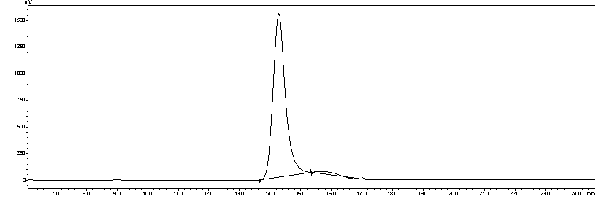
Peak | Retention(min) | Area | Area %
1 | 14.285 | 42973001 | 98.13
2 | 15.667 | 818261 | 1.87
¹H NMR
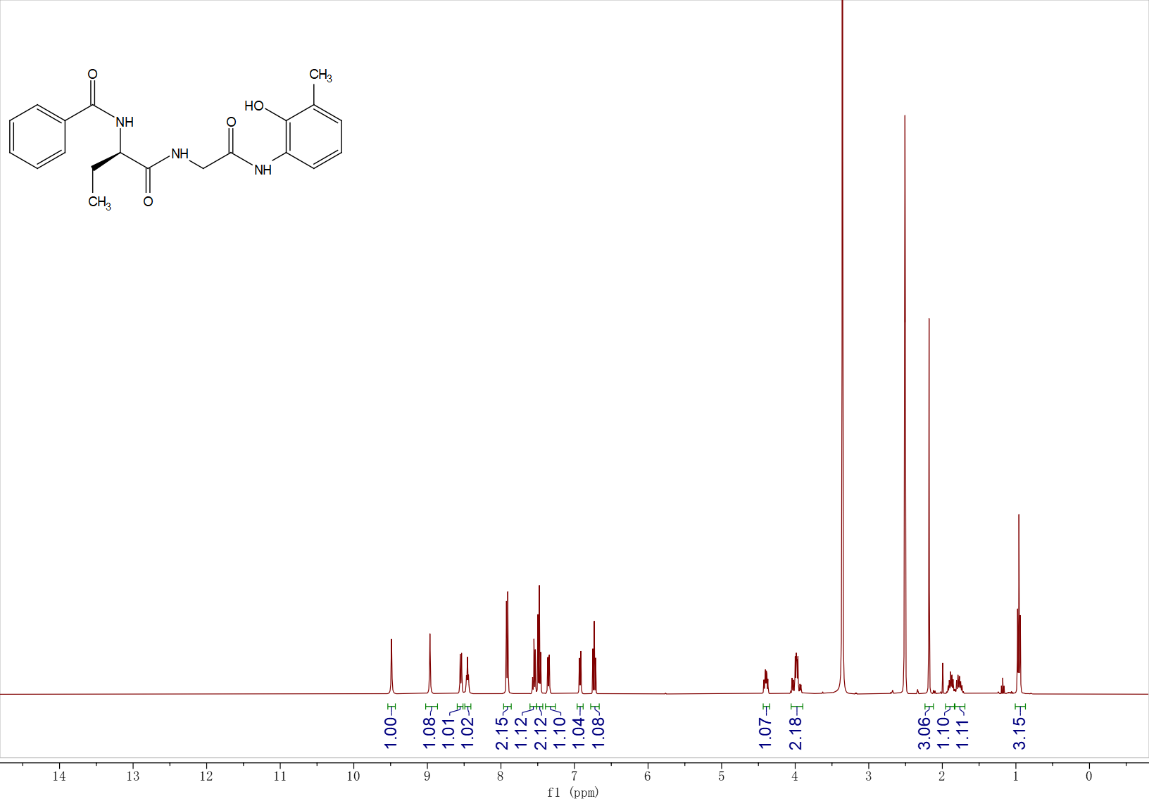
¹H NMR (400 MHz, DMSO-d₆, δ) 9.49 (s, 1H), 8.96 (s, 1H), 8.54 (d, J = 7.5 Hz, 1H), 8.45 (t, J = 5.8 Hz, 1H), 7.96 – 7.87 (m, 2H), 7.60 – 7.51 (m, 1H), 7.48 (dd, J = 8.2, 6.6 Hz, 2H), 7.39 – 7.31 (m, 1H), 6.92 (d, J = 7.3 Hz, 1H), 6.73 (t, J = 7.7 Hz, 1H), 4.40 (ddd, J = 9.0, 7.5, 5.4 Hz, 1H), 4.09 – 3.89 (m, 2H), 2.18 (s, 3H), 1.97 – 1.68 (m, 2H), 0.96 (t, J = 7.4 Hz, 3H).
¹³C NMR
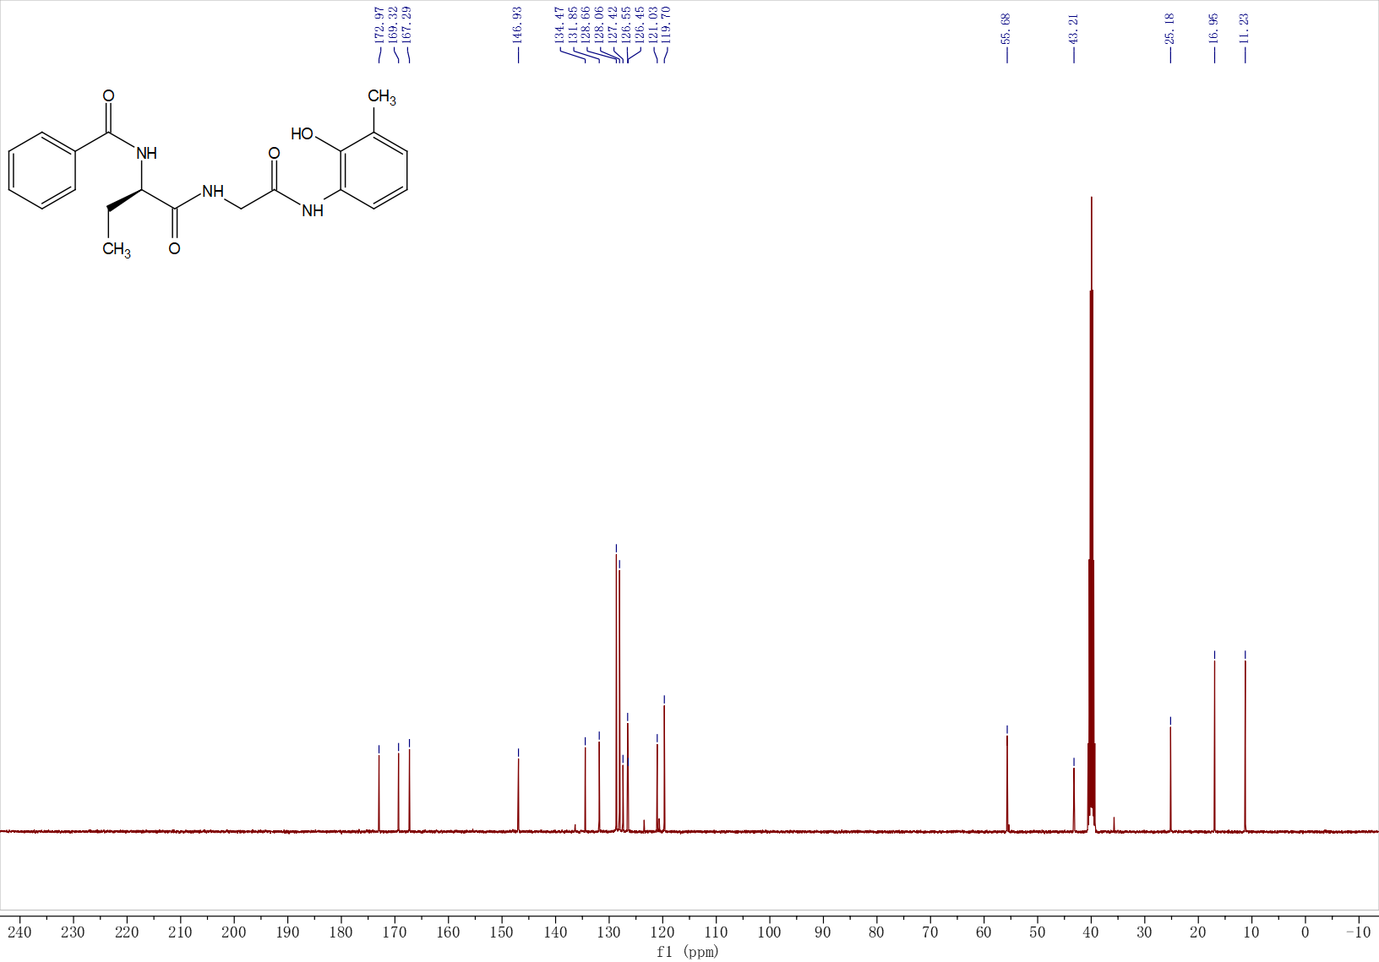
¹³C NMR (400 MHz, DMSO-d₆, δ) 172.97, 169.32, 167.29, 146.93, 134.47, 131.85, 128.66, 128.06, 127.42, 126.55, 126.45, 121.03, 119.70, 55.68, 43.21, 25.18, 16.95, 11.23.
HRMS
HRMS (ESI) m/z: [M + H]⁺ calcd for C₂₀H₂₄N₃O₄, 370.17613; found, 370.17742.
SM2
HPLC charomatogram
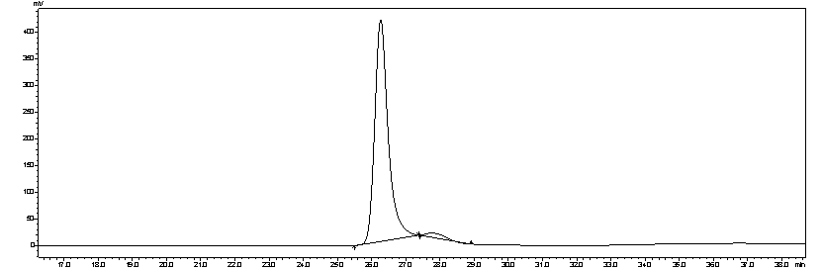
Peak | Retention(min) | Area | Area %
1 | 26.264 | 11368072 | 97.61
2 | 27.764 | 278167 | 2.39
¹H NMR
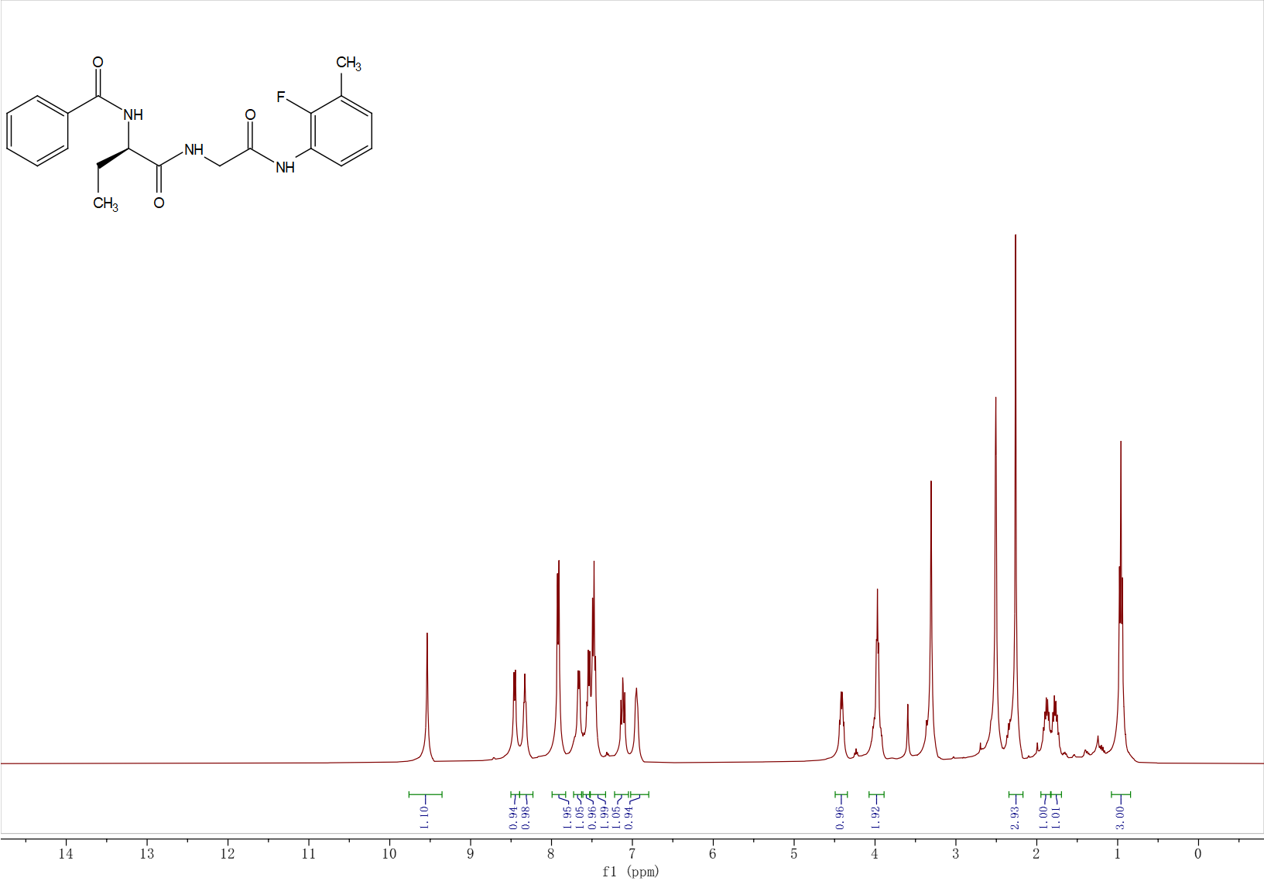
¹H NMR (400 MHz, DMSO-d₆, δ) 9.54 (s, 1H), 8.46 (d, J = 7.6 Hz, 1H), 8.33 (t, J = 5.9 Hz, 1H), 7.92 (d, J = 7.7 Hz, 2H), 7.66 (d, J = 7.5 Hz, 1H), 7.59 – 7.50 (m, 2H), 7.48 (d, J = 7.5 Hz, 1H), 7.11 (dq, J = 13.0, 4.2 Hz, 1H), 6.96 (d, J = 7.1 Hz, 1H), 4.41 (td, J = 8.3, 5.4 Hz, 1H), 3.98 (q, J = 8.0 Hz, 2H), 2.26 (s, 3H), 1.87 (dq, J = 13.9, 7.1 Hz, 1H), 1.82 – 1.69 (m, 1H), 0.96 (t, J = 7.4 Hz, 3H).
¹³C NMR
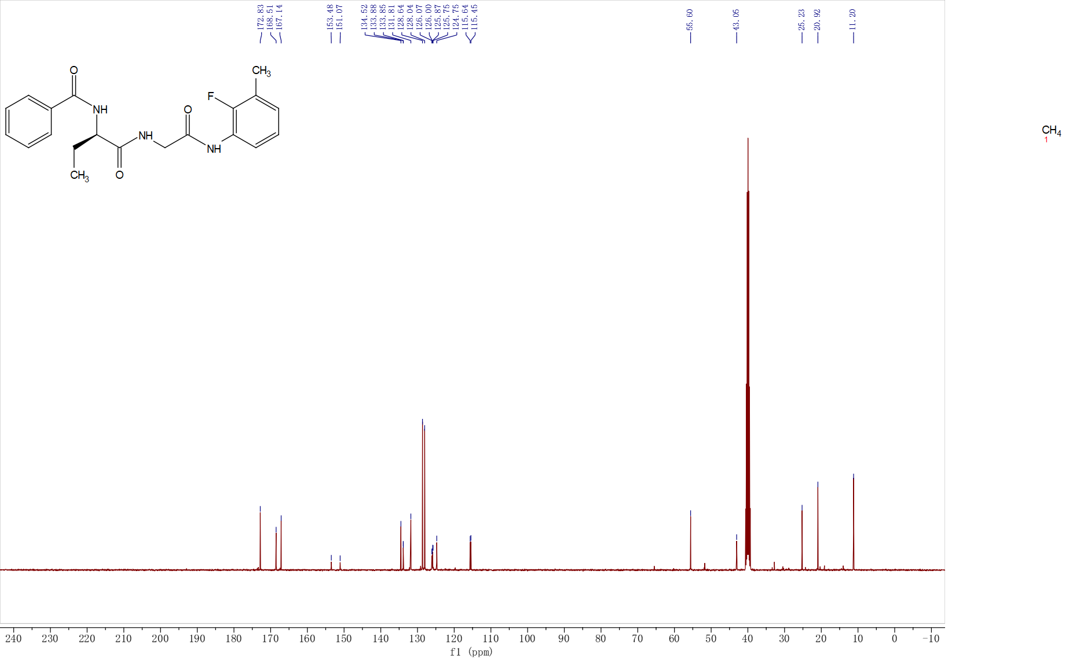
¹³C NMR (400 MHz, DMSO-d₆, δ) 172.83, 168.51, 167.14, 153.48, 151.07, 134.52, 133.88, 131.81, 128.64, 128.04, 125.75, 124.75, 115.64, 55.60, 43.05, 25.23, 20.92, 11.20.
HRMS
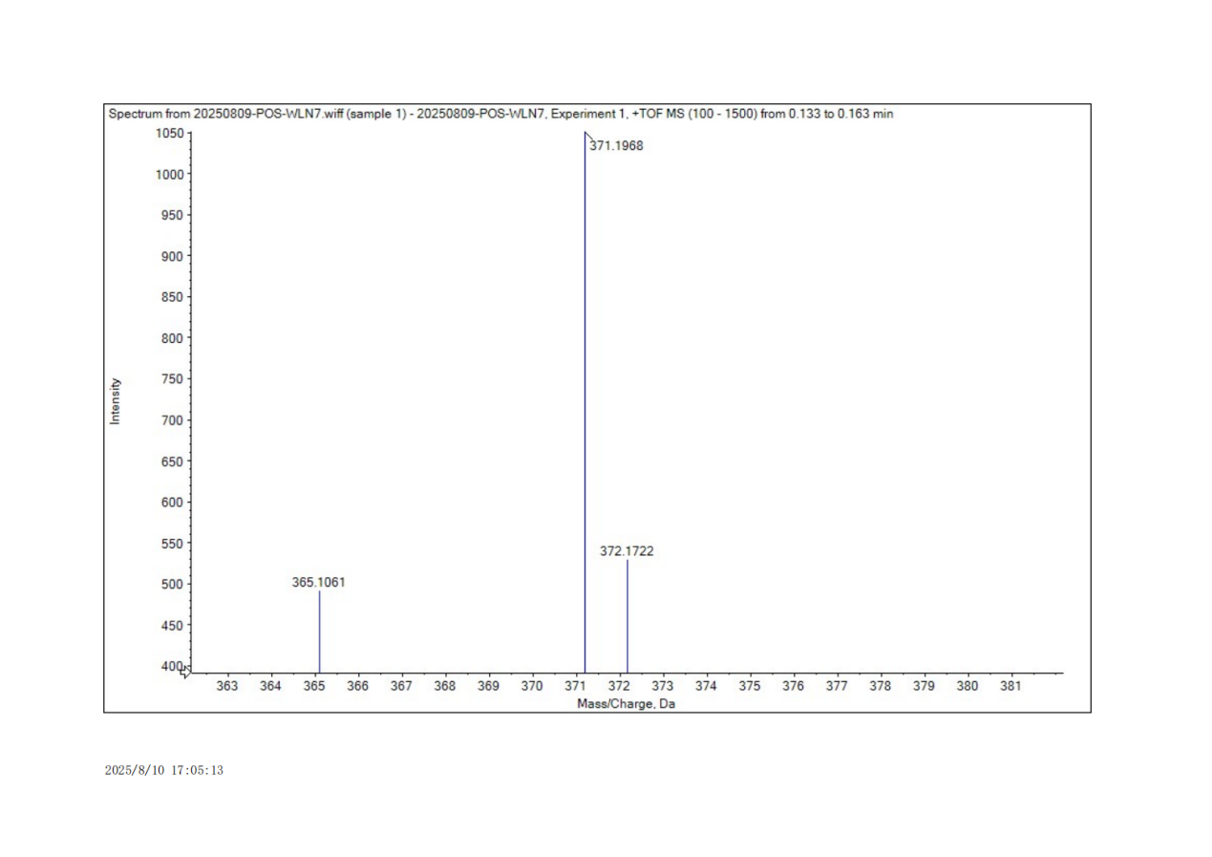
HRMS (ESI) m/z: [M + H]⁺ calcd for C₂₀H₂₃FN₃O₃, 372.1718; found, 371.1968.

SM3
HPLC charomatogram
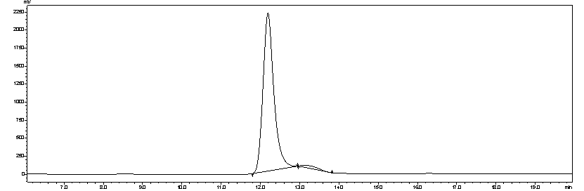
Peak | Retention(min) | Area | Area %
1 | 12.192 | 42165001 | 97.89
2 | 13.121 | 909548 | 2.11
¹H NMR
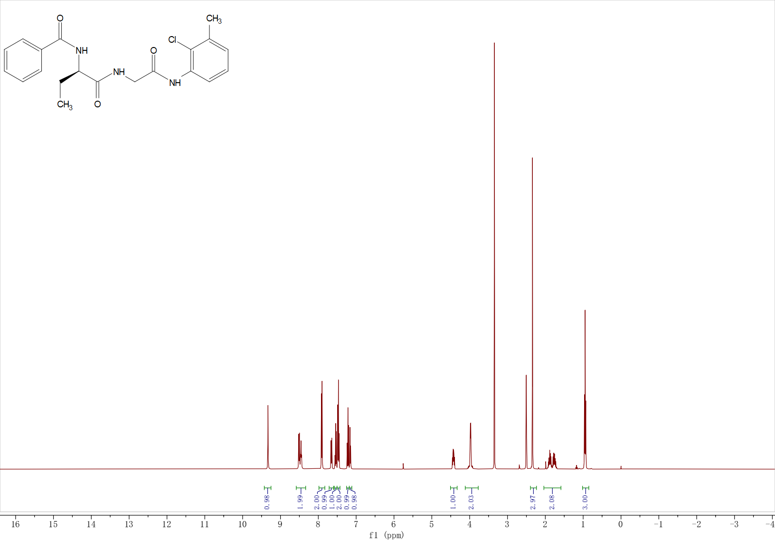
¹H NMR (400 MHz, DMSO-d₆, δ) 9.33 (s, 1H), 8.51 (d, J = 7.7 Hz, 1H), 8.46 (t, J = 5.8 Hz, 1H), 7.95 – 7.86 (m, 2H), 7.65 (dd, J = 8.1, 1.7 Hz, 1H), 7.60 – 7.51 (m, 1H), 7.51 – 7.39 (m, 2H), 7.22 (t, J = 7.8 Hz, 1H), 7.18 – 7.05 (m, 1H), 4.43 (ddd, J = 9.0, 7.6, 5.4 Hz, 1H), 3.98 (dd, J = 5.8, 2.1 Hz, 2H), 2.34 (s, 3H), 1.96 – 1.68 (m, 2H), 0.95 (t, J = 7.4 Hz, 3H).
¹³C NMR
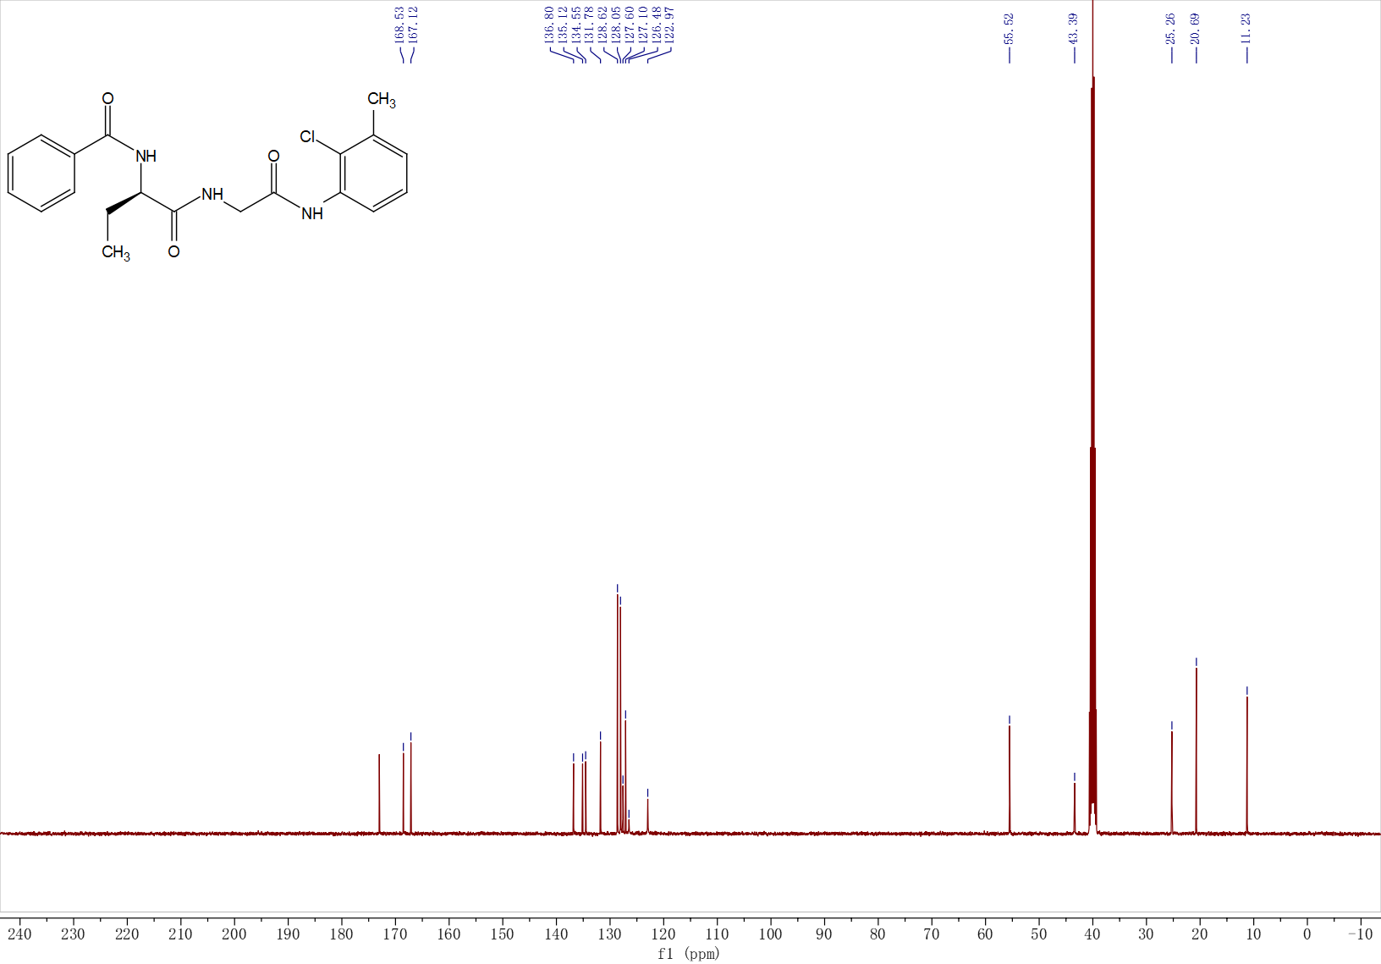
¹³C NMR (400 MHz, DMSO-d₆, δ) 173.02, 168.53, 167.12, 136.80, 135.13, 134.55, 131.78, 128.62, 128.05, 127.59, 127.10, 126.48, 122.97, 55.52, 43.39, 25.26, 20.69, 11.23.
HRMS
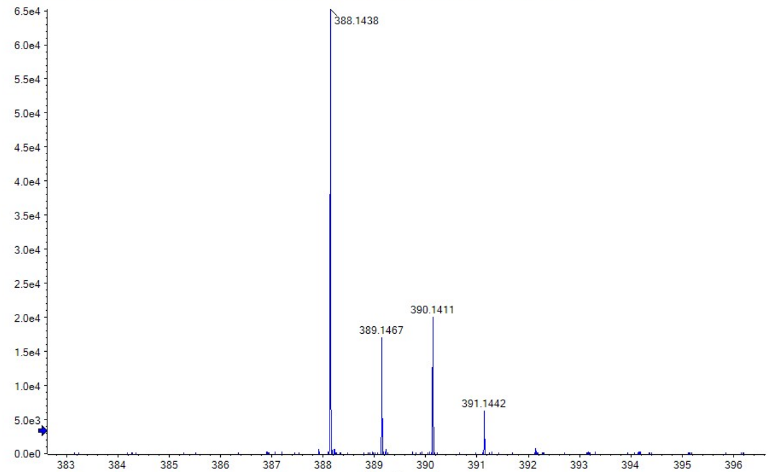
HRMS (ESI) m/z: [M + H]⁺ calcd for C₂₀H₂₃ClN₃O₃, 388.1423; found, 388.1438.

SM4
HPLC charomatogram
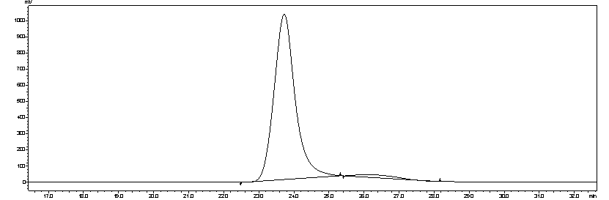
Peak | Retention(min) | Area | Area %
1 | 23.724 | 42736265 | 97.17
2 | 26.064 | 1243652 | 2.83
¹H NMR
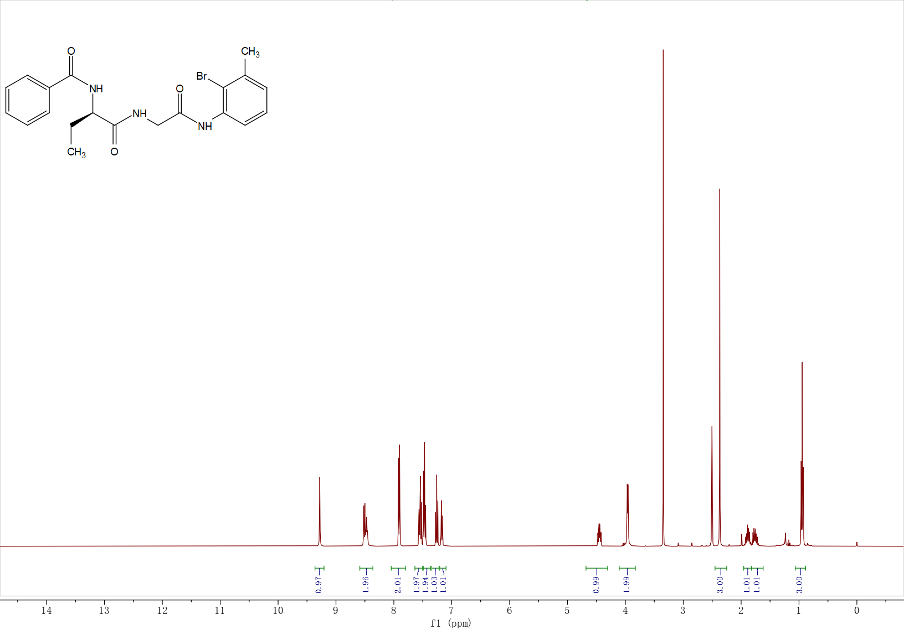
¹H NMR (400 MHz, DMSO-d₆, δ) 9.28 (s, 1H), 8.54 – 8.43 (m, 2H), 7.95 – 7.86 (m, 2H), 7.54 (ddt, J = 8.8, 6.4, 1.7 Hz, 2H), 7.50 – 7.40 (m, 2H), 7.26 (t, J = 7.8 Hz, 1H), 7.21 – 7.14 (m, 1H), 4.45 (ddd, J = 9.1, 7.8, 5.3 Hz, 1H), 3.96 (d, J = 5.8 Hz, 2H), 2.37 (s, 3H), 1.88 (tq, J = 12.8, 6.4 Hz, 1H), 1.76 (ddq, J = 14.4, 9.0, 7.3 Hz, 1H), 0.94 (t, J = 7.4 Hz, 3H).
¹³C NMR
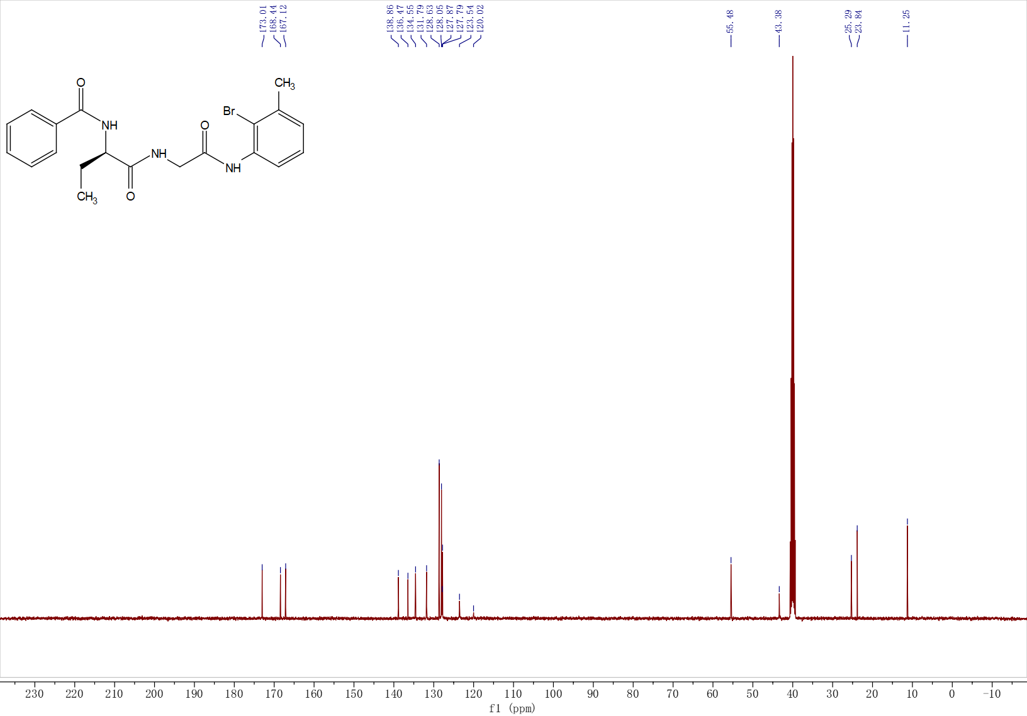
¹³C NMR (400 MHz, DMSO-d₆, δ) 173.01, 168.44, 167.12, 138.86, 136.47, 134.55, 131.79, 128.63, 128.05, 127.87, 127.79, 123.54, 120.02, 55.48, 43.38, 25.29, 23.84, 11.25.
HRMS
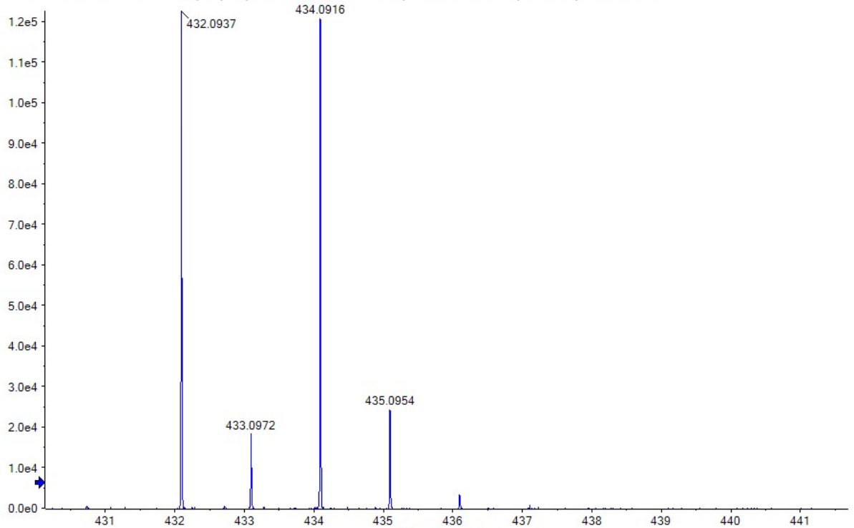
HRMS (ESI) m/z: [M + H]⁺ calcd for C₂₀H₂₃BrN₃O₃, 432.0918; found, 432.0937.

SM5
HPLC charomatogram
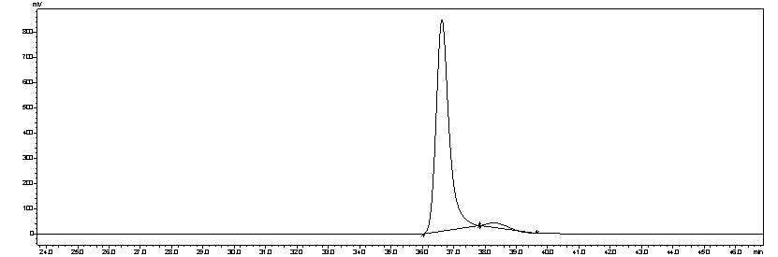
Peak | Retention(min) | Area | Area %
1 | 36.626 | 24320526 | 97.28
2 | 38.274 | 679921 | 2.72
¹H NMR
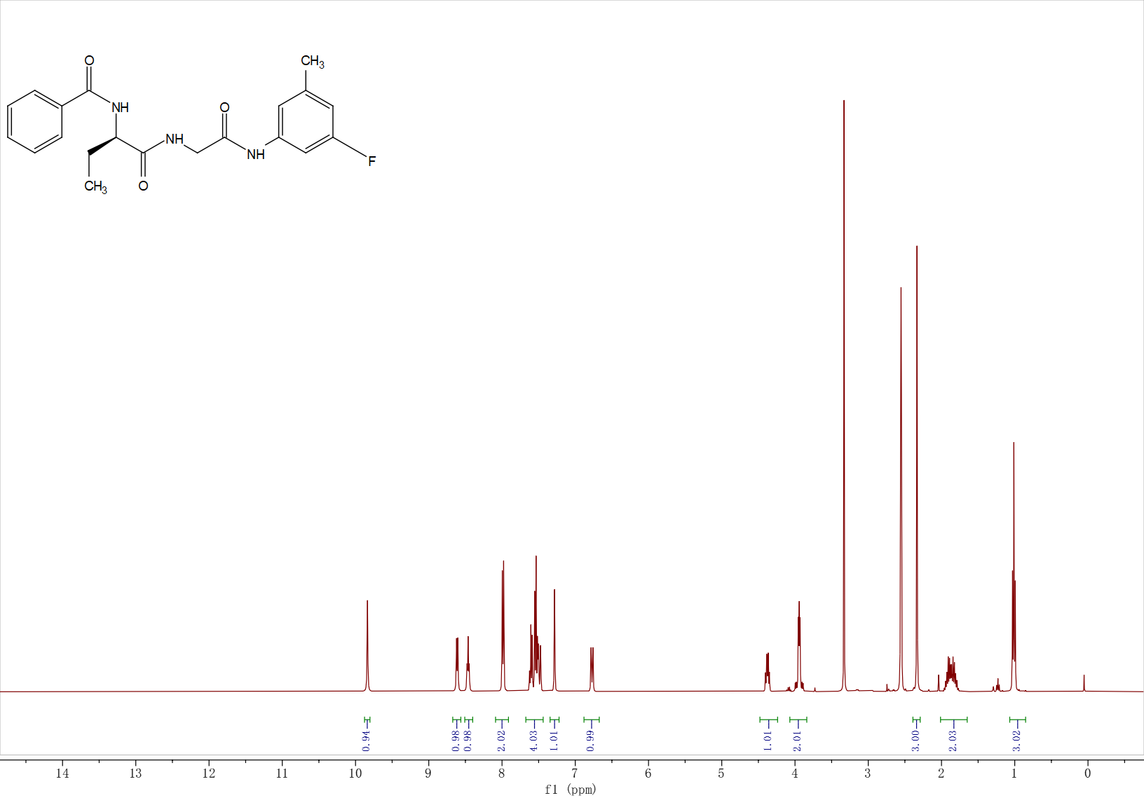
¹H NMR (400 MHz, DMSO-d₆, δ) 9.84 (s, 1H), 8.61 (d, J = 6.9 Hz, 1H), 8.46 (t, J = 5.9 Hz, 1H), 7.99 (dt, J = 7.0, 1.4 Hz, 2H), 7.65 – 7.45 (m, 4H), 7.28 (s, 1H), 6.84 – 6.73 (m, 1H), 4.38 (dt, J = 8.4, 6.2 Hz, 1H), 4.02 – 3.87 (m, 2H), 2.33 (s, 3H), 1.98 – 1.75 (m, 2H), 1.01 (t, J = 7.4 Hz, 3H).
¹³C NMR
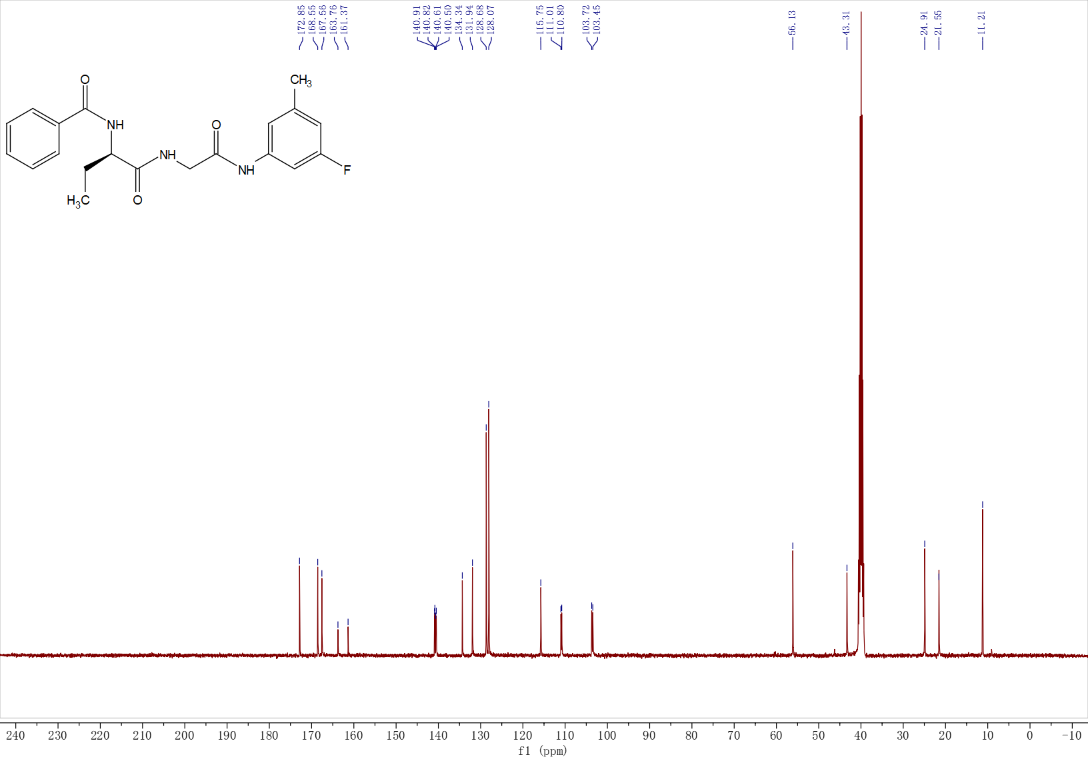
¹³C NMR (400 MHz, DMSO-d₆, δ) 172.85, 168.55, 167.56, 163.76, 161.37, 140.91, 140.62, 134.34, 131.94, 128.68, 128.07, 115.75, 110.80, 103.72, 56.12, 43.31, 24.91, 21.55, 11.21.
HRMS
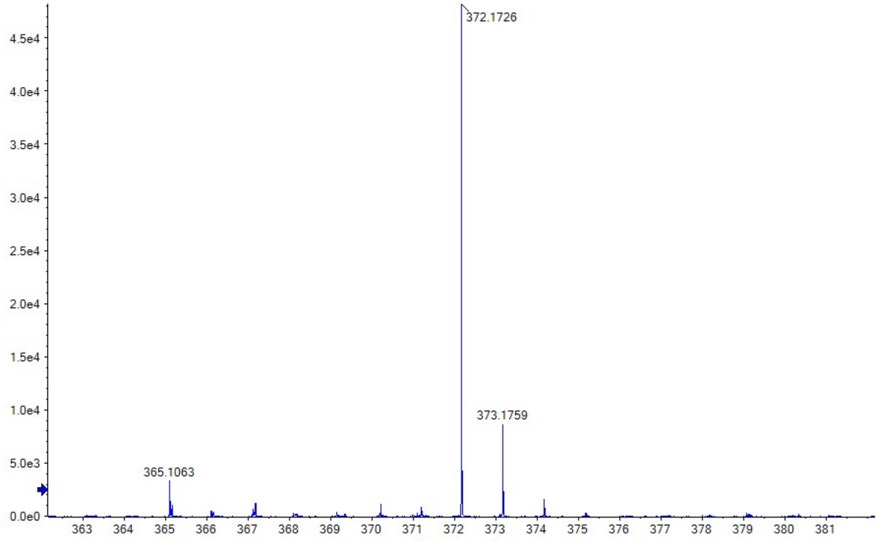HRMS (ESI) m/z: [M + H]⁺ calcd for C₂₀H₂₃FN₃O₃, 372.1718; found, 372.1726.

SM6
HPLC charomatogram
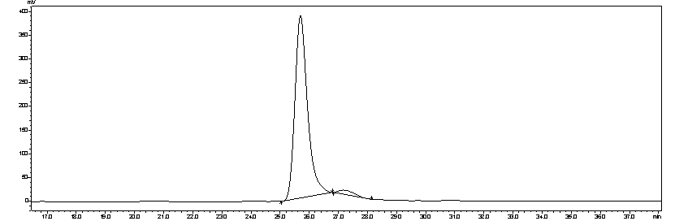
Peak | Retention(min) | Area | Area %
1 | 25.698 | 11520335 | 97.37
2 | 27.178 | 310926 | 2.63

¹H NMR
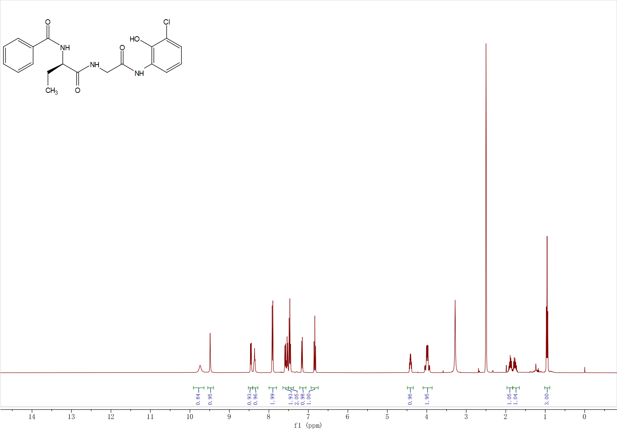
¹H NMR (400 MHz, DMSO-d₆, δ) 9.74 (s, 1H), 9.49 (s, 1H), 8.45 (d, J = 7.6 Hz, 1H), 8.36 (t, J = 5.8 Hz, 1H), 7.94 – 7.87 (m, 2H), 7.62 – 7.50 (m, 2H), 7.47 (dd, J = 8.2, 6.6 Hz, 2H), 7.16 (dd, J = 8.1, 1.5 Hz, 1H), 6.84 (t, J = 8.1 Hz, 1H), 4.41 (td, J = 8.4, 5.5 Hz, 1H), 4.07 – 3.90 (m, 2H), 1.89 (ddd, J = 13.2, 7.4, 5.6 Hz, 1H), 1.76 (ddd, J = 13.6, 8.9, 7.1 Hz, 1H), 0.95 (t, J = 7.4 Hz, 3H).

¹³C NMR
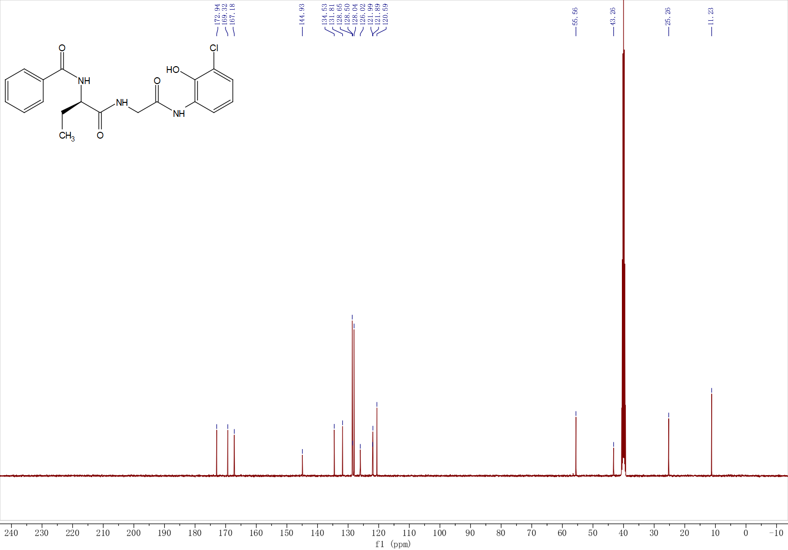
¹³C NMR (400 MHz, DMSO-d₆, δ) 172.94, 169.32, 167.18, 144.93, 134.53, 131.81, 128.65, 128.50, 128.04, 126.02, 121.99, 121.89, 120.59, 55.56, 43.26, 25.26, 11.23.
HRMS
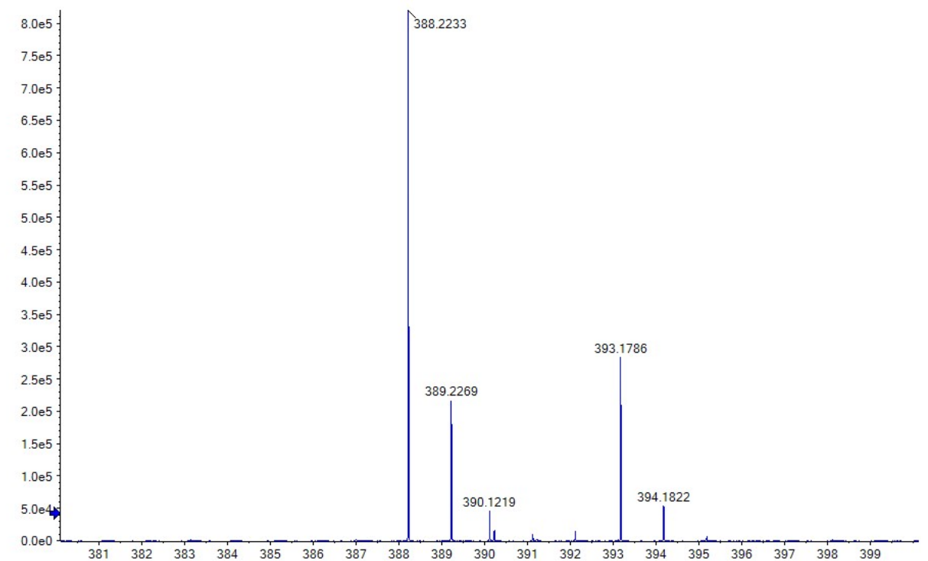
HRMS (ESI) m/z: [M + H]⁺ calcd for C₁₉H₂₂ClN₃O₃, 390.1216; found, 390.1219.

Part IV. Pharmacokinetic study of compound SM1 in Kunming mice.
4.1 Reagents.
DMSO (> 99.5%, cell culture grade, D8371, Solarbio); Methanol (HPLC grade, M116118-4L, Aladdin).

4.2 Equipment
SHIMADZU LCMS-8040; Centrifuge: D3024R, SCILO.

4.3 Samples processing
Plasma samples (50 μL) were mixed with 200 μL methanol. After mixing by pipetting and centrifuging for 10 min at 6,000 rpm, 2 μL of each supernatant was injected into LC-MS/MS system.

4.4 HPLC-MS/MS Conditions
Chromatographic Conditions:
Column: C18 (75 x 2.1 mm, 1.8um)
Mobile phase A: Water
Mobile phase B: Methanol
gradient: 90% B
Elution rate: 100 μL/min.
Column temperature: 30 ℃

MS/MS Detection:
Scan type: Positive MRM, lon source: Turbo spray, lonization mode: ESI
Nebulize gas: 3 L/min, Dry gas: 15 L/min
Ionspray voltage:3500 V, Temperature: 250°C
Parent,m/z :370.05
Daughter, m/z :105.10
Time: 10min

4.5 Preparation of calibration standards
A stock solution of SM1 (2 mg/mL in DMSO) was diluted in blank mouse plasma to concentrations of 10,000, 5,000, 1,000, 500, 100, and 10 ng/mL. These were processed as in Section 4.3.

4.6 Method validation results
Specificity: Mice blank plasma had no interference with compound SM1, as shown in Fig. S11.

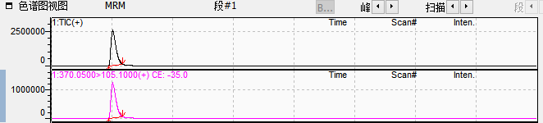
Fig. S11. Blank plasma sample spiked with compound SM1 (10 μg/mL).

4.7 Calibration curve
The regression analysis of compound SM1 was performed by plotting the peak area (y) against the concentration (x, μg/mL). The validity of the calibration curve (relationship between peak area ratio and compound concentration) is proved by the correlation coefficient (R) calculated for the linear regression (Fig. S12).

Fig. S12. Calibration curve for the quantification of compound SM1.

4.8 Results
Plasma concentrations of SM1 after intraperitoneal administration (30 mg/kg) are listed in Tables S5. PK Curve is performed automatically by DAS2.0.

Table S5. Plasma concentration of compound SM1 in male Kunming mice following intraperitoneal (30 mg/kg) administration.
Sample collection time point (h) | Plasma concentration (μg/mL)
Sample collection time point (h) | A | B | C | Mean | SD
0.25 | 7.37 | 4.07 | 4.12 | 5.19 | 1.89
0.5 | 4.17 | 4.19 | 2.97 | 3.78 | 0.70
0.75 | 1.92 | 1.21 | 0.94 | 1.46 | 0.50
1 | 0.62 | 0.60 | 0.84 | 0.68 | 0.13
1.5 | 0.42 | 0.59 | 0.84 | 0.62 | 0.21
2 | 0.43 | 0.22 | 0.27 | 0.31 | 0.11
4 | 0.42 | 0.25 | 0.23 | 0.30 | 0.10
6 | 0.24 | 0.24 | 0.27 | 0.25 | 0.02
8 | 0.43 | 0.39 | 0.39 | 0.40 | 0.02
12 | 0.19 | 0.19 | 0.18 | 0.18 | 0.01
24 | ND ^{a)} | ND ^{a)} | 0.15 | 0.05 | 0.09
^{a)}ND – Not detected
Part V. Details for AI-Driven Mini-Binder to Small-Molecule Conversion for PPI inhibitors.
We introduce a protocol integrating transfer learning and reinforcement learning to generate active small molecules from highly active mini-binders. The protocol comprises the following key steps.

5.1. Tripeptide Fragment Library Construction
Fig. S13A details the development of an active tripeptide fragment library derived from the high-activity mini-binder. Key amino acids (residues within 3.5 Å of the target protein) serve as the foundation for assembling the 3-peptide active structure database according to specific rules:
(i) Single-residue blocks: For an isolated key amino acid, it is flanked by one upstream and one downstream residue (or the same residue if adjacent residues are absent) to create a 3-peptide.
(ii) 2-residues blocks: Two adjacent key residues are extended by incorporating either the preceding or succeeding residue to generate a 3-peptide.
(iii) Three or More-residues blocks: Overlapping sets of three consecutive key residues directly constitute individual 3-peptides using a sliding window approach (residue 1-2-3, 2-3-4, etc.)
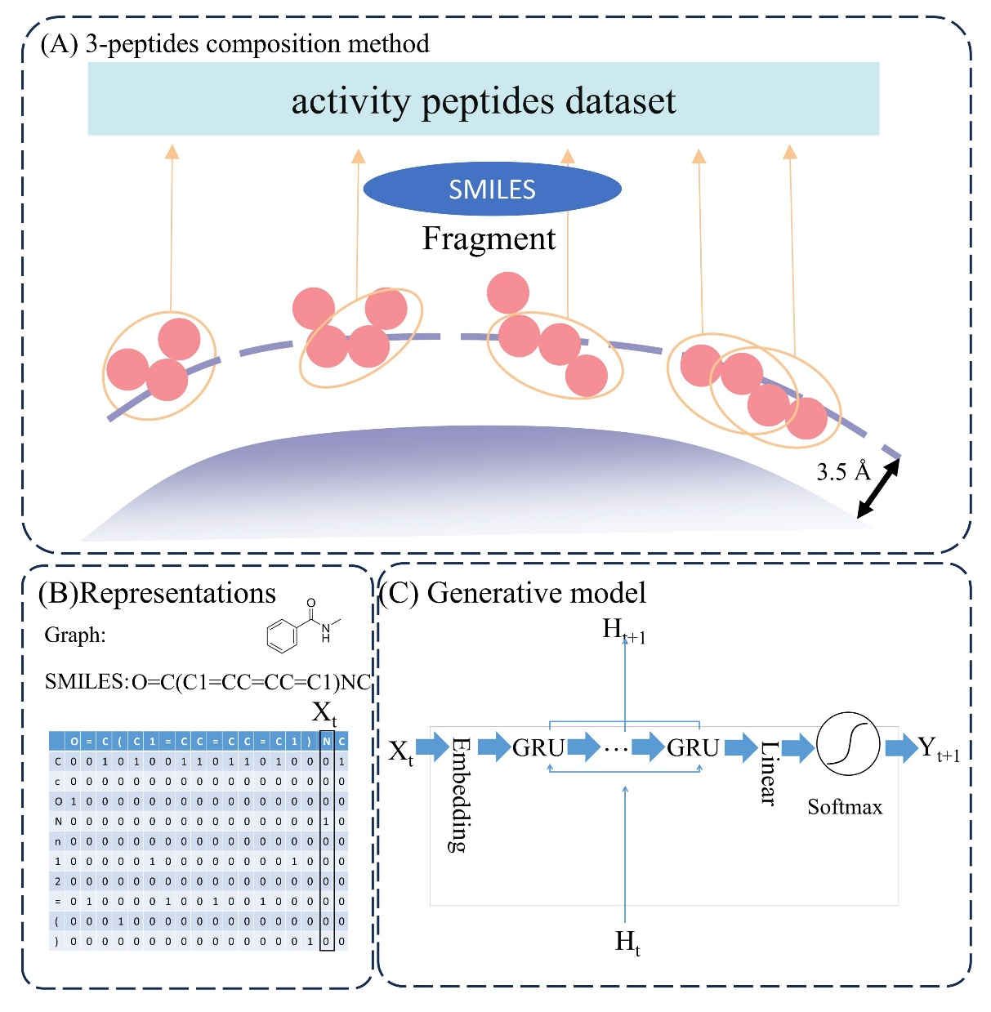
Fig. S13. (A) 3-peptides composition method (B) The molecules were represented by SMILES and one-hot encoding. (C) The generative model (GRU).

5.2. Molecular Representation and Encoding
Depicted in Fig. S13B, each 3-peptide is expressed as a SMILES string. This representation encodes constituent atoms and employs special characters to indicate ring openings/closures and branch points. These SMILES strings are subsequently converted into one-hot encoded vectors, with X_{t} signifying the input vector at processing step t.

5.3. Generative Model Construction
Illustrated in Fig. S13C, the generative model utilizes a Gated Recurrent Unit (GRU), a specific variant of Recurrent Neural Network (RNN). RNNs are inherently suited for sequential data processing due to their ability to retain relevant historical information. The architecture incorporates a configurable number of GRU layers, culminating in a final linear layer. The dimensionality of this output layer matches the vocabulary size, encompassing all unique tokens derived from the processed dataset. A softmax transformation follows the linear layer, producing a probability distribution across all possible tokens. Here, H_{t} corresponds to the hidden state vector at step t.

5.4. Transfer Learning
The model was pre-trained on a clustered ChEMBL subset, which equips the model to navigate a diverse chemical landscape. Subsequently, this pre-trained model undergoes fine-tuning using the Tripeptide Fragment Library. This fine-tuning process yields a "focused prior" model.

5.5. Reinforcement Learning (RL)
Within the RL framework (Fig. 2A), the "focused prior" model serves as the generative agent. Both the prior model and the RL agent possess identical network architectures and utilize the same vocabulary. Generated SMILES were evaluated using a multi-parameter objective (MPO) score.
Negative log-likelihood (NLL), defined as:
$NLL\left(S\right)=-\sum_{i=1}^{N}{\ln{P\left(X_{i}=T_{i} | X_{i-1}=T_{i-1}…X_{1}=T_{1}\right)}}$ (S1) where P(X_{i}=T_{i}|X_{i−1}, …) is the probability of sampling token Ti at step Xi given previously sampled tokens.
MPO scoring assesses SMILES strings, producing scores within the range [0, +∞). The MPO score is integrated with the prior model's likelihood to derive the augmented negative log-likelihood:
${NLL\left(S\right)}_{Augmented}={NLL\left(S\right)}_{Prior}+σ{MPO\left(S\right)}_{score}$ (S2)
Where σ is a scalar adjusting the MPO score's scale.

