Supplementary Figure 1 Alignment of conserved domain of the NbbZIP family proteins.
Supplementary Figure 2 Gel electrophoresis fragment amplified by PCR in this study.
Supplementary Figure 3 Relative expression of NbbZIP60 in different hormone treatments of jasmonic acid (JA) and salicylic acid (SA).
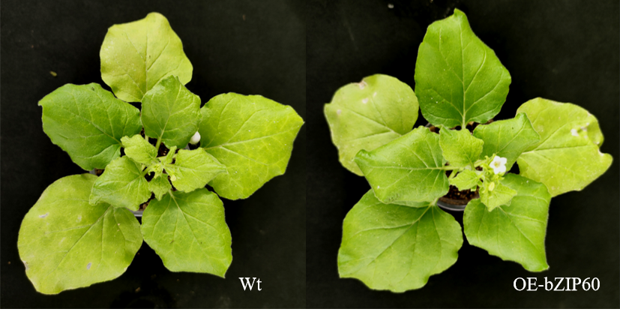
Supplementary Figure 4 Symptom differences between OE-bZIP60 plants and wild type at maturity.

