Supplementary information for
On-chip coexistence system for classical optical communication and quantum key distribution on etchless thin film lithium niobate

Mingrui Yuan^{1,†}, Boyu Xu^{2,†}, Xu Han³, Zhuofan Cai², Lantian Feng², Hao Li¹, Xudong Zhou¹, Mei Xian Low⁴, Thach Giang Nguyen^{4,5}, Guanghui Ren^{4,5,*}, Arnan Mitchell^{4,5}, Xifeng Ren^{2,*} & Yonghui Tian^{1,6,*}

¹ School of Physical Science and Technology, Lanzhou University, Lanzhou 730000, Gansu, China
² Laboratory of Quantum Information, University of Science and Technology of China, Hefei 230026, Anhui, China
³ School of Instrument Science and Opto-electronics Engineering, Hefei University of Technology, Hefei 230009, Anhui, China
⁴ Integrated Photonics and Applications Centre (InPAC), School of Engineering, RMIT University, Melbourne, VIC 3001, Australia
⁵ ARC Centre of Excellence in Optical Microcombs for Breakthrough Science (COMBS), School of Engineering, RMIT University, Melbourne, VIC 3001, Australia
⁶ School of Mathematics and Physics, North China Electric Power University, Beijing 102206, China

† These authors contributed equally.
*Corresponding authors: guanghui.ren@rmit.edu.au, renxf@ustc.edu.cn, tianyh@lzu.edu.cn

This supplementary information file includes:
Supplementary Note 1: Optical anisotropy and waveguide configuration of the TFLN platform.
Supplementary Note 2: Operating principle of the 1D‑PhCW.
Supplementary Note 3: Numerical optimization and parameter selection of the PSR.
Supplementary Note 4: Manufacturing tolerances analysis.
Supplementary Note 5: Performance comparison of TFLN-based devices.

Supplementary Note 1: Optical anisotropy and waveguide configuration of the TFLN platform.
Lithium niobate (LN) exhibits strong birefringence. At a wavelength of 1550 nm, light polarized along the crystallographic z-direction experiences an extraordinary refractive index (n_{e}) of approximately 2.138, while light polarized along the crystallographic x-and y-directions experiences an ordinary refractive index (n_{o}) of about 2.211. This intrinsic anisotropy directly affects the effective refractive index of guided modes propagating along different waveguide orientations. As a result, the choice of waveguide direction is a key consideration in the design of wavelength-polarization hybrid (de)multiplexers on the thin-film lithium niobate (TFLN) platform.
In this work, we use a 300 nm-thick x-cut TFLN platform, in which the LN thin-film plane is aligned with the crystallographic y-direction, as illustrated in Figure S1a. This configuration enables efficient access to the large electro-optic coefficient (r₃₃) and the strong second-order nonlinear coefficient (d₃₃) of LN, providing a solid basis for future high-speed modulation and nonlinear optical applications. For lateral optical confinement, a 300 nm-thick silicon nitride layer is employed as the loading layer. Finite element method simulations indicate that, for a silicon nitride waveguide width of 1 μm, the optical mode confinement factor in LN reaches approximately 60%.
To further elucidate the modal characteristics, we calculate the effective refractive index as a function of waveguide width along the crystallographic y-axis at 1550 nm using a full-vector eigenmode solver. The results are shown in Figure S1b.
Figure S1. a Cross-sectional schematic of the Si₃N₄-TFLN waveguide. b Effective indices of modes propagating along the y-direction versus waveguide width. The dashed line indicates the phase-matching condition for TE₀-to-TE₂ coupling.
Supplementary Note 2: Operating principle of the 1D‑PhCW.
The operating principle of the proposed one-dimensional photonic crystal waveguide (1D‑PhCW) can be described using contra-directional coupled‑mode theory ^{[1,2]}. Continuous‑wave light is launched into the input port in the higher‑order TE₂ mode. Because the TE₂ and TE₀ modes exhibit a large propagation‑constant mismatch under normal conditions, conventional co‑directional coupling is strongly suppressed. This intrinsic suppression improves modal selectivity and prevents unwanted power leakage. When the periodic perturbation introduced by the hole lattice satisfies the phase‑matching condition, a Bragg‑assisted contra‑directional coupling channel is opened, enabling efficient power transfer from the forward‑propagating TE₂ mode to the backward‑propagating TE₀ mode. This engineered “mode‑order conversion + direction reversal” mechanism is a key design feature, allowing compact on‑chip filtering while simultaneously achieving mode discrimination. The phase‑matching condition is:
$\frac{{\text{λ}}_{\text{c}}}{\text{Λ}}\text{=}{\text{n}}_{\text{1}}$+${\text{n}}_{\text{2}}$, (1)
where n₁ and n₂ are the effective refractive indices of the TE₀ and TE₂ modes, respectively, Λ is the hole period, and λ_{c} is the center wavelength. Under this contra-directional coupling condition, the through port exhibits a band‑stop response due to resonant back‑reflection, whereas the drop port collects the reflected TE₀ mode and shows a band‑pass response. The passband bandwidth is governed by the coupling strength:
$\text{Δ}\text{λ}\text{=}\frac{\text{2}{\text{λ}}_{\text{0}}^{\text{2}}}{\text{π(}{\text{n}}_{\text{1}}\text{+}{\text{n}}_{\text{2}}\text{)}}\left|\text{κ}\right|$, (2)
$\text{κ}\text{=}\frac{\text{ω}}{\text{4}}\iint{{\text{E}}_{\text{1}}^{\text{*}}\text{(}\text{x}\text{,}\text{y}\text{)∙Δ}}{\text{ε}}_{\text{1}}\text{(}\text{x}\text{,}\text{y}\text{)}{\text{E}}_{\text{2}}\text{(}\text{x}\text{,}\text{y}\text{)d}\text{x}\text{d}\text{y}$, (3)
where κ is the coupling coefficient, ω is the optical angular frequency, E₁ and E₂ are the modal field amplitudes of the two coupled modes, and Δε₁ is the first-order Fourier coefficient of the periodic dielectric perturbation.
To further suppress passband sidelobes and minimize inter‑channel crosstalk, we introduce a Gaussian apodization profile by gradually varying the hole radius along the propagation direction. Compared with a uniform lattice, the apodized perturbation smooths the effective coupling envelope, mitigates abrupt impedance transitions at the grating boundaries, and strongly reduces spectral ripples. The hole radius R is modulated as:
$\text{R}\text{=}{\text{R}}_{\text{0}}\text{exp}{\text{(-}\text{G}\text{(}\text{n}\text{-0.5}\text{N}\text{)}}^{\text{2}}\text{)/}{\text{(0.5}\text{N}\text{)}}^{\text{2}}$, (4)
where n is the hole index, N is the total number of holes, G is the apodization index, and R₀ is the nominal hole diameter.

Supplementary Note 3: Numerical optimization and parameter selection of the PSR.
To enable efficient mode manipulation in the polarization splitter‑rotator (PSR), we first optimize the conversion from the TE₀ mode to the TE₁ mode in the cross port of the asymmetric directional coupler (ADC)-based mode coupler. This step is essential to ensure high-purity mode excitation before polarization rotation. In the coupler design, the width of the narrower single-mode waveguide is fixed at W₃ = 1.2 μm to support only the fundamental mode, while the width of the adjacent multimode waveguide is calculated to be W₄ = 2.839 μm to satisfy the phase-matching condition between the TE₀ and TE₁ modes. The coupling gap between the two waveguides is set to W_{g} = 0.2 μm, providing sufficient evanescent field overlap while maintaining fabrication tolerance.
Considering the additional phase perturbation introduced by bent waveguides, the coupling length is further refined using the finite-difference time-domain (FDTD) method. An optimized value of L₄ = 29 μm is obtained to balance strong mode coupling and compact footprint. When the TE₀ mode is launched into the through and cross ports of the mode coupler, the simulated normalized transmission spectra of the output TE₀ and TE₁ modes over the wavelength range from 1500 to 1600 nm are shown in Figures S2a and 2b. At 1550 nm, as well as across the entire 100 nm bandwidth, the TE₀ mode injected from the through port propagates through the coupling region with negligible mode conversion. In contrast, TE₀ excitation from the cross port is efficiently converted into the TE₁ mode, achieving a conversion efficiency of −0.35 dB and remaining better than −0.43 dB across the full wavelength range.
Building on the efficient TE₀–TE₁ mode conversion, we then optimize the polarization rotation section of the PSR. Polarization rotation is realized by linearly tapering the width of the multimode waveguide from W₅ = 2.45 μm to W₆ = 1.75 μm. These widths correspond to the mode crossing point identified in Figure S1b, where the effective refractive index difference between the TM₀ and TE₁ modes is minimized, enabling strong mode hybridization. The length of the tapered multimode waveguide is optimized to L₆ = 450 μm to ensure adiabatic evolution of the optical modes.
When the TE₀ and TE₁ modes are injected into the polarization rotator, the simulated normalized transmission spectra of the output TE₀, TE₁, and TM₀ modes over the wavelength range from 1500 to 1600 nm are presented in Figures S2c and 2d. At 1550 nm and throughout the entire bandwidth, the TE₀ mode exhibits almost negligible transmission loss, confirming that it remains unaffected by the rotator. Meanwhile, the TE₁ mode is efficiently converted into the TM₀ mode, with a measured conversion efficiency of −0.08 dB and better than −0.54 dB over the full wavelength range.
Finally, to minimize transition loss between waveguides of different widths and to preserve modal purity, linear tapered waveguides with optimized lengths are employed throughout the device. As illustrated in the right inset of Figure 1b, the taper lengths from left to right are set to L₃ = 50 μm, L₅ = 20 μm, and L₇ = 50 μm, respectively. Together, these optimizations ensure broadband, low-loss, and highly efficient mode and polarization conversion, providing a robust foundation for the high-performance operation of the proposed PSR.
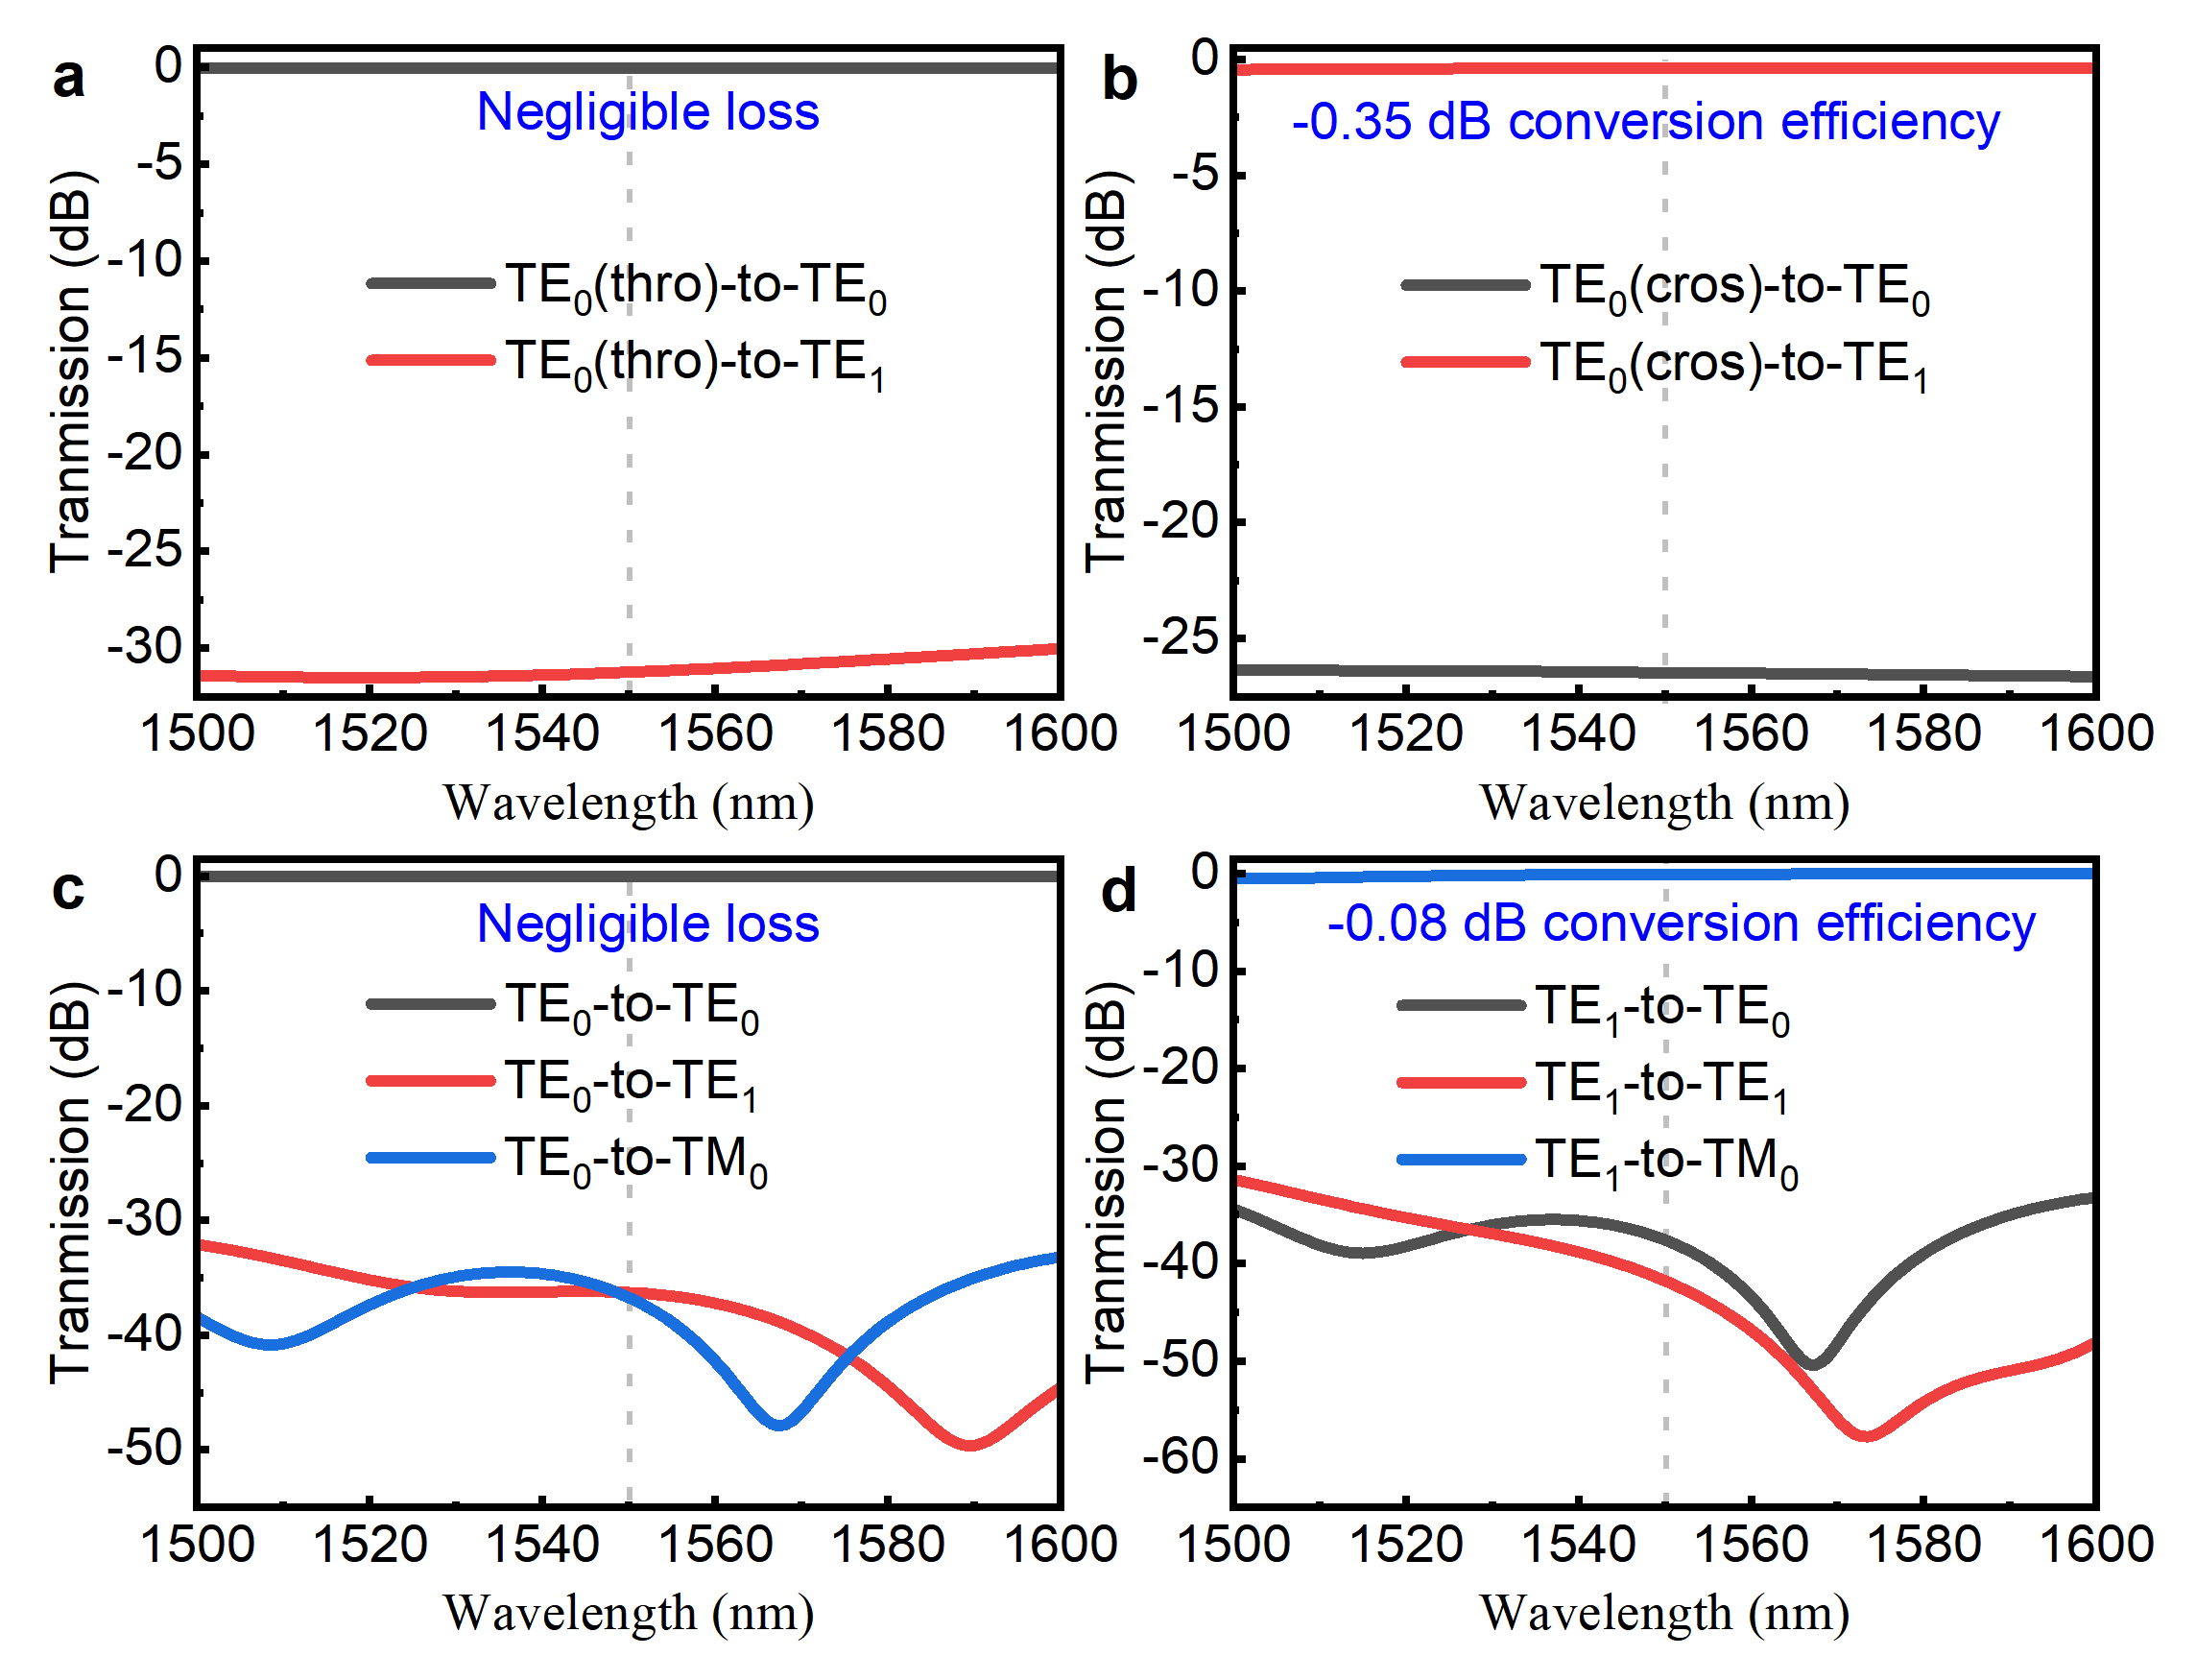
Figure S2. Simulated normalized transmission spectra of the mode-processing components. Spectra when TE₀ mode is input into the a through (thro) port and b cross (cros) port of the mode coupler. Spectra when c TE₀ and d TE₁ modes are input into the polarization rotator.

Supplementary Note 4: Manufacturing tolerances analysis.
Potential manufacturing tolerances can alter the MSB of 1D photonic crystal waveguides (1D-PhCWs), thereby affecting the operating wavelength of the wavelength division multiplexer. Here, we provide a discussion on the manufacturing tolerances of 1D-PhCWs. Although various structural parameters can be considered as influencing factors, such as the thickness of LN and silicon nitride films, etching depth of silicon nitride, and the duty cycle of 1D-PhCWs, for simplicity, we only consider the impact of variations in the multimode waveguide width W₂ on the operating wavelength. The transmission spectra of 1D-PhCW are simulated for variations in the multimode waveguide width W₂ at ΔW₂ = 0 nm, ±10 nm, and ±20 nm, as shown in Figure S3(a). It can be seen that the width variation has a negligible effect on the device performance, including insertion losse (IL) and 3 dB bandwidth, while the coupling wavelength is slightly shifted. As illustrated in Figure S3(b), the simulated central wavelength exhibits an almost linear displacement with a slope of 0.0196 nm/10 nm. Therefore, the proposed wavelength-polarization hybrid multiplexer demonstrates considerable tolerance to variations in waveguide width.
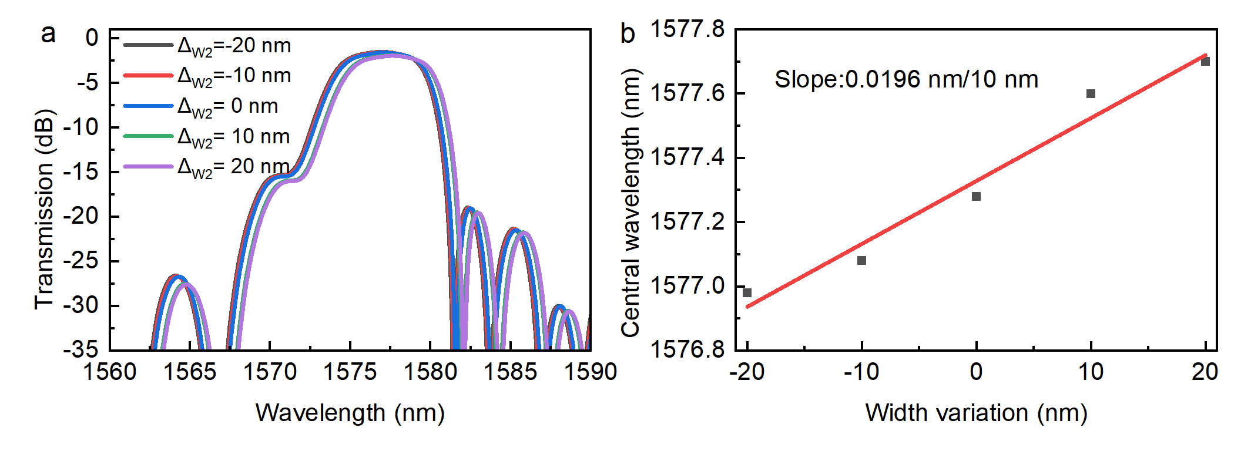
Figure S3. a Simulated transmission response of the 1D-PhCW to the waveguide width variations. b Simulated and fitted central wavelength shift.

Supplementary Note 5: Performance comparison of TFLN-based devices.
Table S1 summarizes representative wavelength-division multiplexer devices in the TFLN platform, highlighting trade-offs between channel spacing, IL, crosstalk, and footprint. Our 1D-PhCW wavelength-division multiplexer supports 4 channels with 12 nm spacing, −21 dB crosstalk, and 1.9 dB IL within a 2.1 × 0.3 mm² footprint. Notably, it achieves improved crosstalk compared to arrayed waveguide gratings (AWGs) and maintains 4 channels with narrower spacing than multimode waveguide (MWG)-based devices, while avoiding the excessive footprint of multimode interferometer (MMI) and Mach-Zehnder interferometer (MZI) designs. This balance of metrics enables dense wavelength packing without compromising signal integrity, critical for quantum-classical coexistence where adjacent classical channels must not overwhelm single-photon quantum signals.
Table S1. Wavelength‑division multiplexers in TFLN platform
Ref. | Structure | Wavelength Channel | Channel Spacing (nm) | IL (dB) | Crosstalk  (dB) | Footprint  (mm²)
3 | AWG | 8/16 | 9.6/3.7 | 6.60/8.40 | −19.30/−18.30 | ~1.1 × 0.7
4 | AWG | 4 | 0.8 | 2.30 | −20.00 | —
5 | AMMI+MZI | 4 | 8.0 | 0.90 | −18.20 | ~12.5 × 4.2
6 | MMI | 4 | 20.0 | 0.70 | −18.0 | 2.1 × 0.02
7 | Fabry-Perot cavities+filter | 4 | 7.0 | 0.80 | −22.00 | 2.8 × 0.3
8 | Bragg grating | 4 | 20.0 | 1.10 | −18.00 | ~2.0 × 0.2
9 | MWG | 3 | 30.0& 42.0 | 0.20 | −30.00 | 1.5 × 0.1
10 | Subwavelength grating | 3 | 3.2 | 2.50 | −20.00 | ~3.1 × 0.5
This work | 1D-PhCW | 4 | 12.0 | ~1.86 | -20.96 | 2.1 × 0.3
Note: AWG: arrayed waveguide grating, AMMI: asymmetric multimode interferometer; MZI: Mach-Zehnder interferometer; MMI: multimode interferometer; MWG: multimode waveguide; 1D-PhCW: 1D photonic crystal waveguide; IL: Insertion Loss.
Table S2 compares polarization performance metrics, including extinction ratio (ER), IL, bandwidth, and device length. Our polarization splitter-rotator (PSR) design achieves breakthrough polarization isolation: 50.05 dB (TE) and 44.83 dB (TM) ER, with 80 nm bandwidth for both polarizations. This represents improved ER compared to the best previous TFLN PSRs while maintaining compact length. The low IL ensures minimal quantum signal attenuation, critical for preserving single-photon states during coexistence with high-power classical channels.
Table S2. Polarization rotating beam splitters in TFLN platform
Ref. | ER (dB) | IL (dB) | Bandwidth (nm) | Length (μm)
11 | 17.8 (TE)  10.6 (TM) | 0.9 (TE)  1.5 (TM) | 40.0 | 620.0
12 | 8.0 | 2.0 | 130.0 | > 7000.0
13 | 20.0 | 0.7 | 80.0 | 431.0
14 | 19.6 | 1.0 | 60.0 | 440.0
15 | 15.0 | 0.5 | 165.0 | 1240.0
16 | 22.0 (TE)  11.0 (TM) | 1.0 (TE)  2.0 (TM) | 160.0 | 405.0
17 | 20.0 | 1.5 | 40.0 | > 1200.0
18 | 26.6 (TE)  19.6 (TM) | 1.0 | 60.0 | 440.0
19 | 20.0 (TE)  10.0 (TM) | 1.3 (TE)  1.5 (TM) | 126.0 (TE)  47.0 (TM) | 679.0
This work | 50.05 (TE)  44.83 (TM) | 1.55 (TE)  3.79 (TM) | 80.0 (TE)  80.0 (TM) | 640.0

Supplementary References:
- Wang, K., et al. Ultracompact bandwidth-tunable filter based on subwavelength grating-assisted contra-directional couplers. Frontiers of Optoelectronics 14, 374–380 (2021).
- Lifante, G. Integrated photonics: fundamentals. John Wiley & Sons.
- Yu, Y., et al. (2022). Wavelength-division multiplexing on an etchless lithium niobate integrated platform. ACS Photonics 9, 3253–3259 (2003).
- Wu, Q., et al. Reconfigurable AWGR based on LNOI with a tunable central wavelength and bandwidth used in elastic optical networking. Applied Optics 62, 6631–6638 (2023).
- Chen, K., et al. Four-channel CWDM transmitter chip based on thin-film lithium niobate platform. Journal of Semiconductors 43, 112301 (2022).
- Chen, G., et al. Four-channel CWDM device on a thin-film lithium niobate platform using an angled multimode interferometer structure. Photonics Research 10, 8–13 (2022).
- Liu, H., et al. Ultra-compact lithium niobate photonic chip for high-capacity and energy-efficient wavelength-division-multiplexing transmitters. Light: Advanced Manufacturing 4, 133–142 (2023).
- Liu, Y., et al. C-band four-channel CWDM (de-)multiplexers on a thin film lithium niobate–silicon rich nitride hybrid platform. Optics Letters 46, 4726–4729 (2021).
- He, J., et al. First realization of a three-channel lithium-niobate photonic filter for 50G passive optical networks. ACS Photonics 10, 3740–3747 (2023).
- Han, X., et al. Subwavelength grating-assisted contra-directional couplers in lithium niobate on insulator. Laser & Photonics Reviews 17, 2300203 (2023).
- Han, X. et al. Mode and polarization-division multiplexing based on silicon nitride loaded lithium niobate on insulator platform. Laser & Photonics Reviews 16, 2100529 (2022).
- Chen, Z., et al. Broadband adiabatic polarization rotator-splitter based on a lithium niobate on insulator platform. Photonics Research 9, 2319–2324 (2021).
- Luo, H., et al. High-performance polarization splitter-rotator based on lithium niobate-on-insulator platform. IEEE Photonics Technology Letters 33, 1423–1426 (2021).
- Lin, Z., et al. High-performance polarization management devices based on thin-film lithium niobate. Light: Science & Applications 11, 93 (2022).
- Gan, R., et al. Fabrication tolerant and broadband polarization splitter-rotator based on adiabatic mode evolution on thin-film lithium niobate. Optics Letters 47, 5200–5203 (2022).
- Shen, Y., et al. Broadband polarization splitter-rotator on a thin-film lithium niobate with conversion-enhanced adiabatic tapers. Optics Express 31, 1354–1366 (2023).
- Song, L., et al. Fully adiabatic polarization rotator-splitter based on thin-film lithium niobate platform. Optics Express 31, 19604–19612 (2023).
- Wang, X., et al. Efficient polarization splitter-rotator on thin-film lithium niobate. Optics Express 29, 38044–38052 (2021).
- Deng, C., et al. Broadband polarization splitter-rotator on lithium niobate-on-insulator platform. IEEE Photonics Technology Letters 35, 7–10 (2023).

