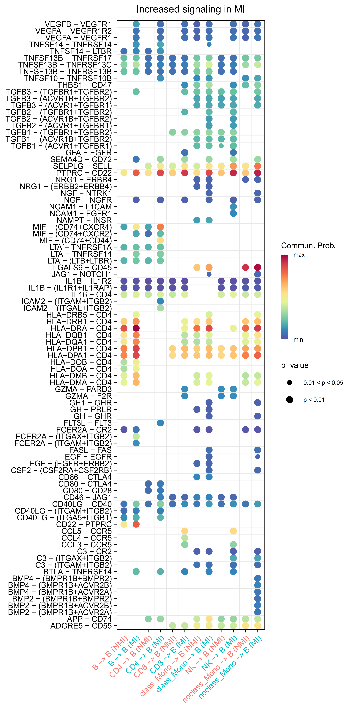
Fig. S1. Supplyments figures:Bubble plot showing differential ligand–receptor interactions between other cell types and B cells in MI and NMI samples. Bubble size represents interaction strength; color indicates differential magnitude.

