Supplementary figures

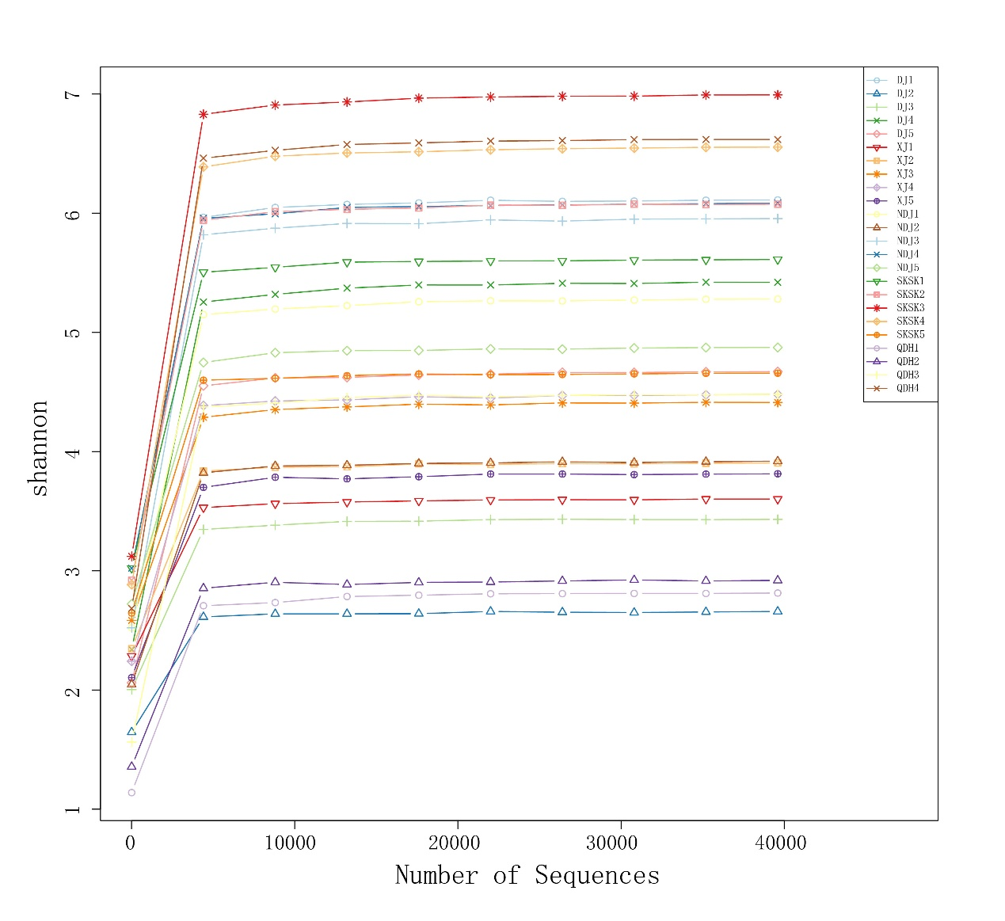
(a)
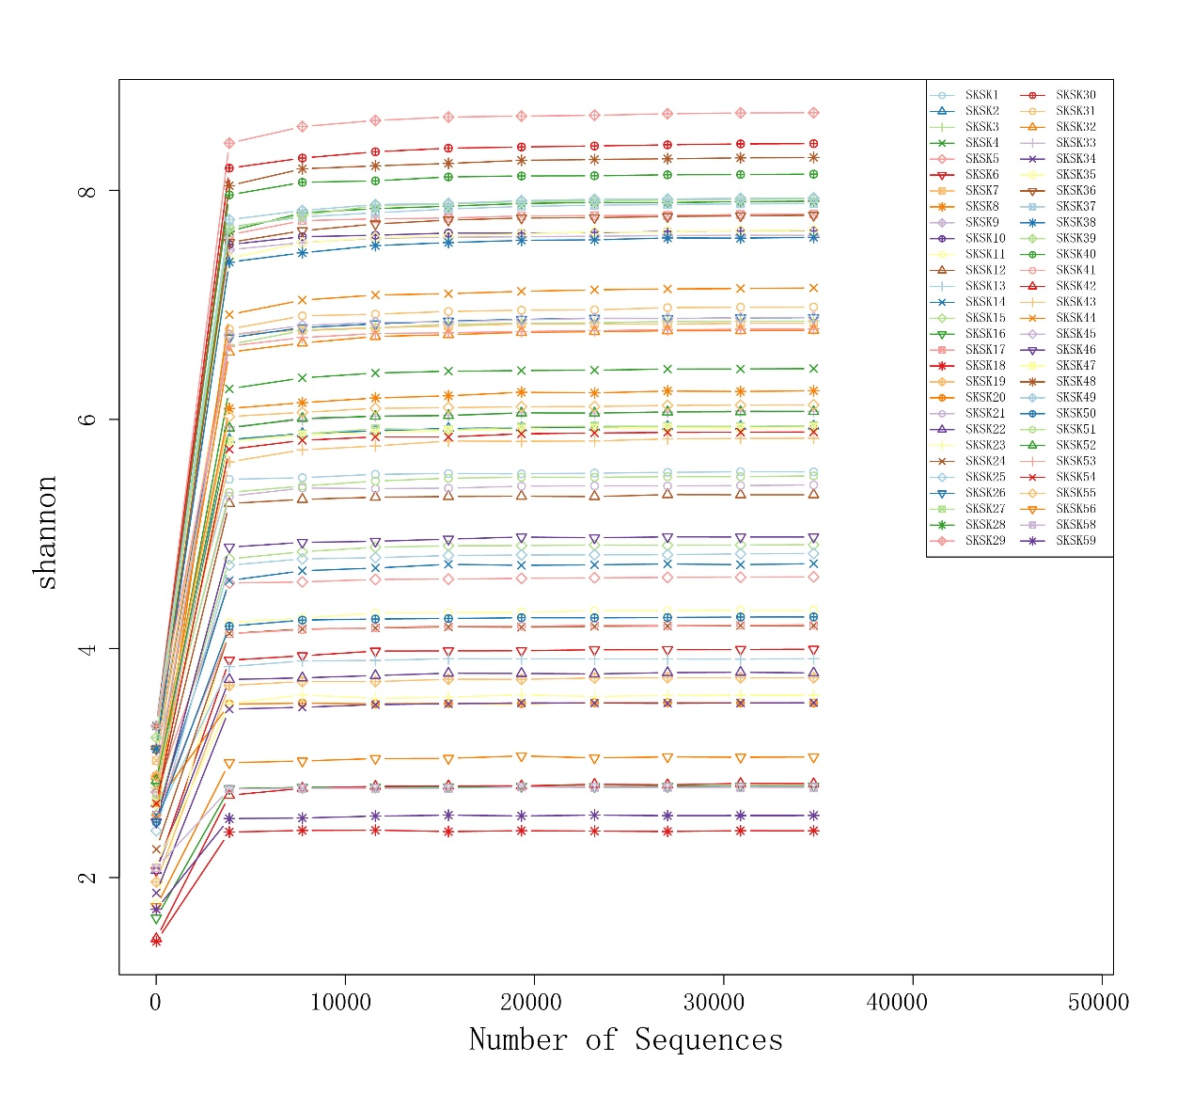
(b)
Figure S1 Shannon rarefaction curves of gut microbiota for each sample from five sampling locations (a) and in four seasons of SKSK (b). The horizontal axis denotes the amount of sequencing data for each sample, and the vertical axis denotes the Shannon-Wiener index. When the curve tends to be flat, it indicates that the amount of sequencing data is leveling off, and more data will not have a significant impact on the diversity index. The sample ID for five sampling locations and four seasons (spring, summer, autumn, and winter) of SKSK are shown in Table S3.

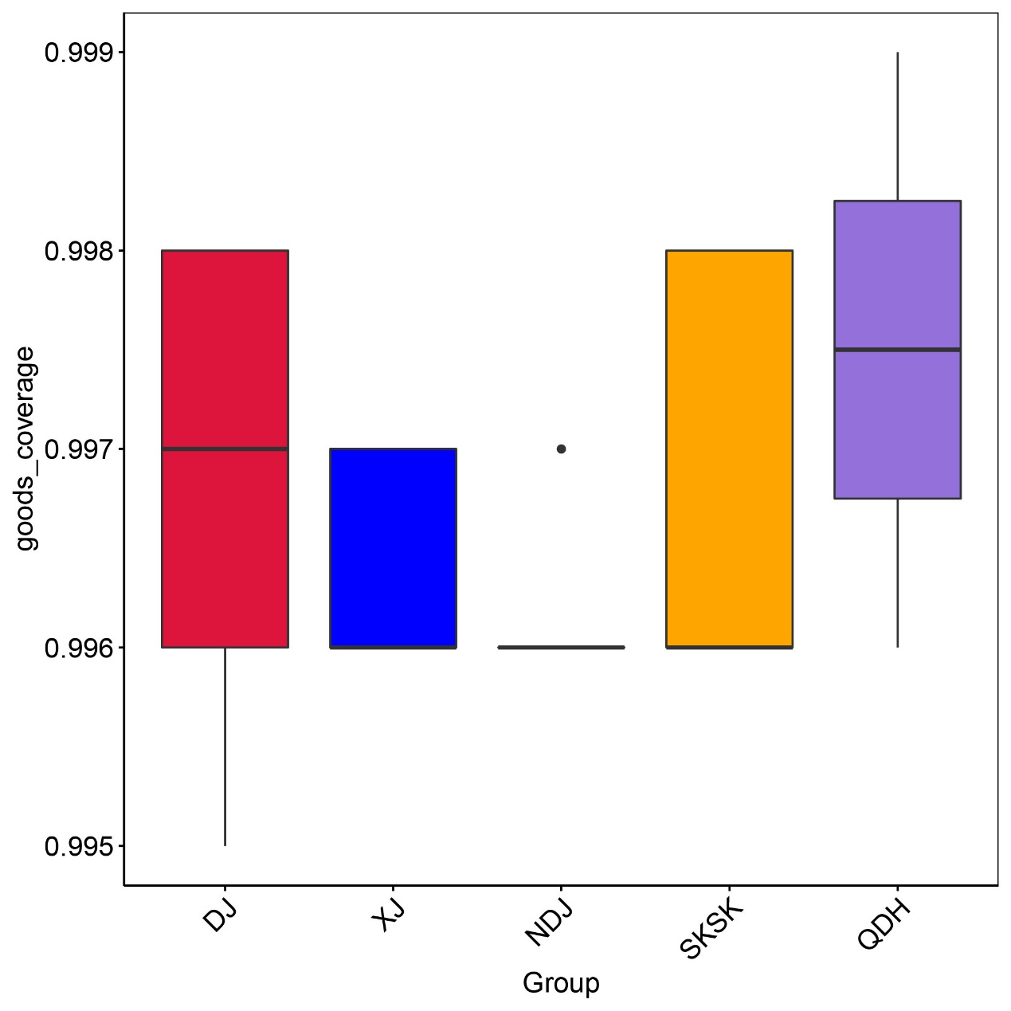
(a)
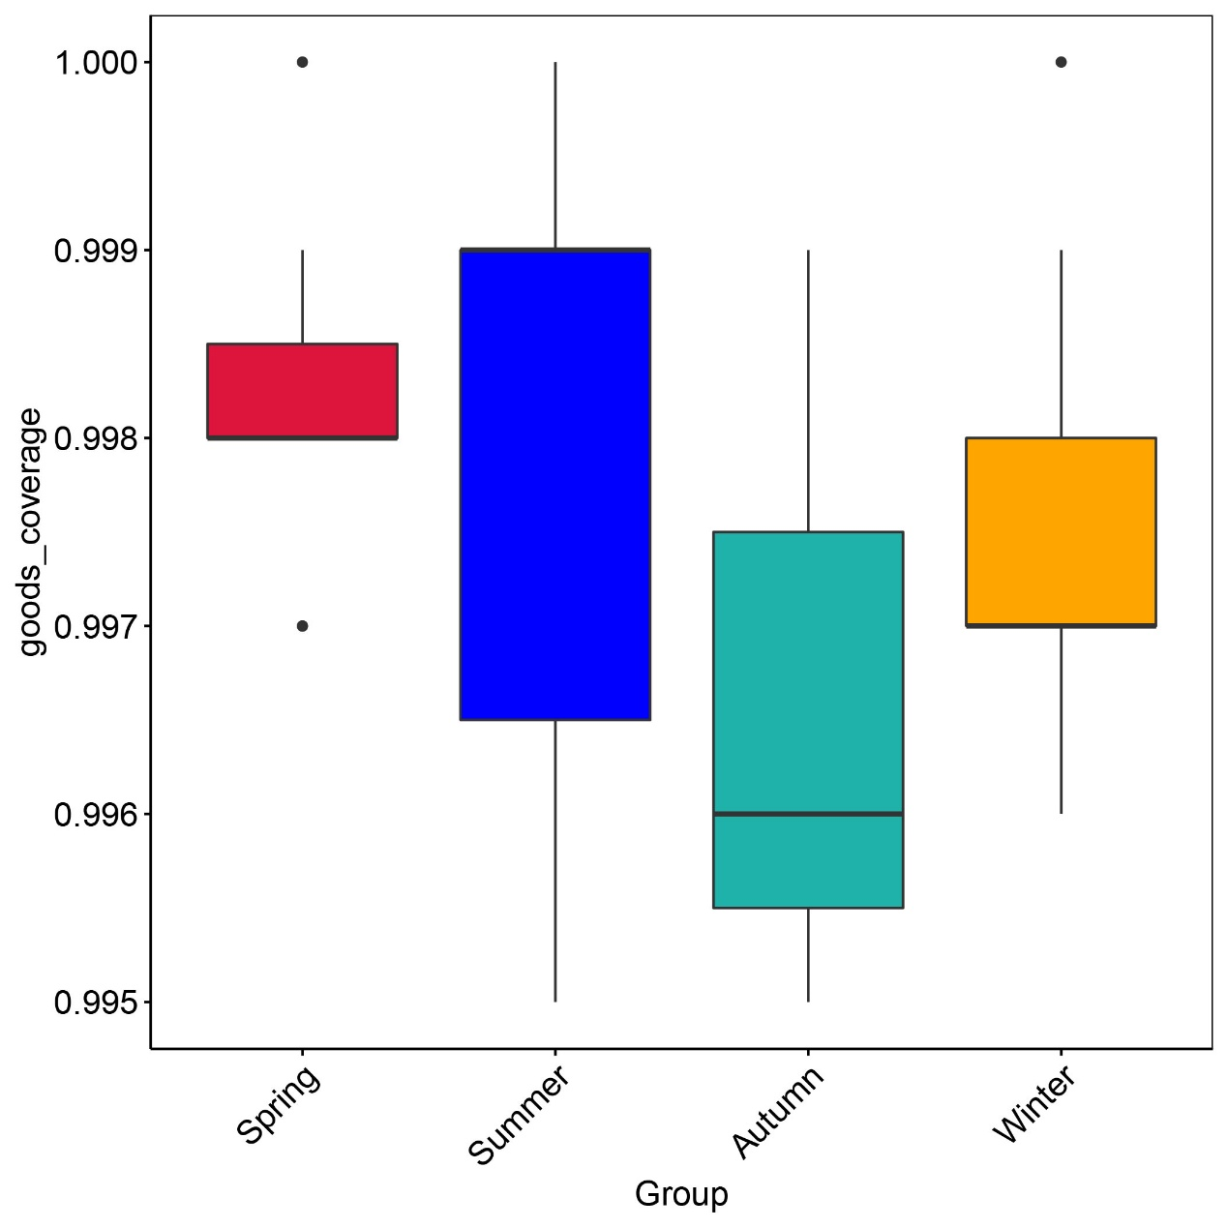
(b)
Figure S2 Boxplot showing the Good’s coverage index of gut microbiota across five sampling locations (a) and four seasons of SKSK (b). The coverage values range approximately from 0.995 to 0.999, reflecting high sequencing depth and satisfactory sample representativeness for each microbial community.

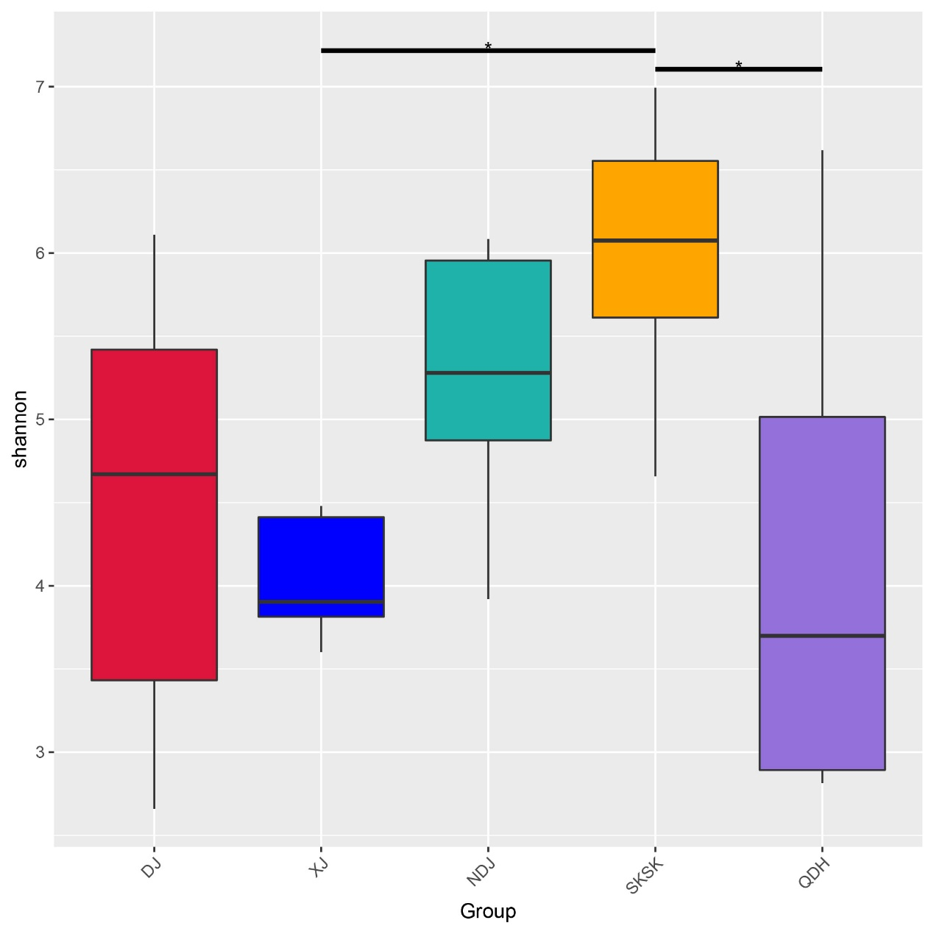
(a)
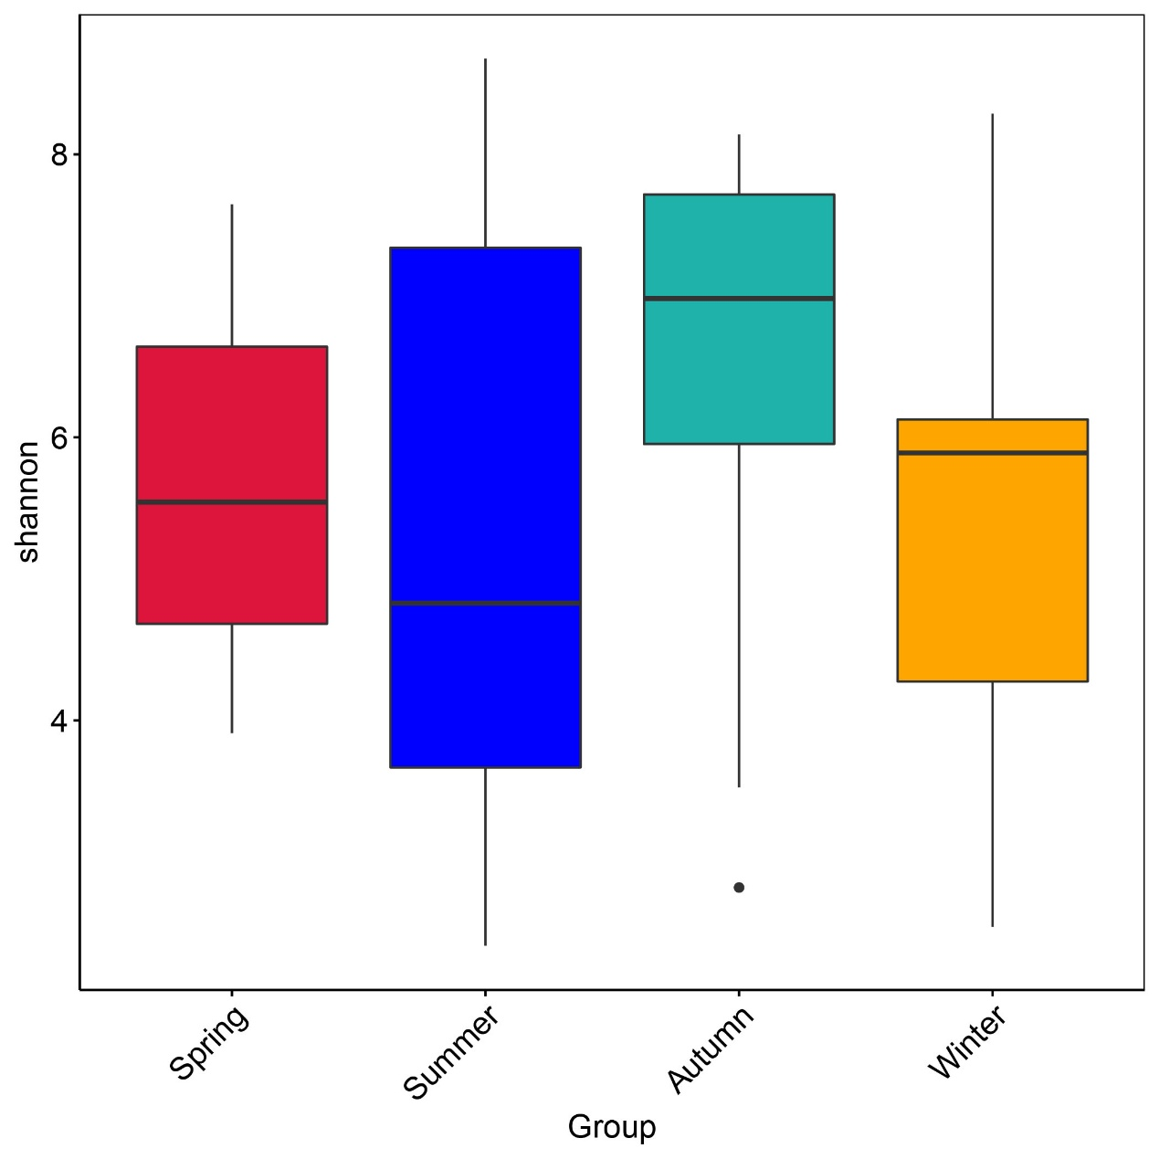
(b)
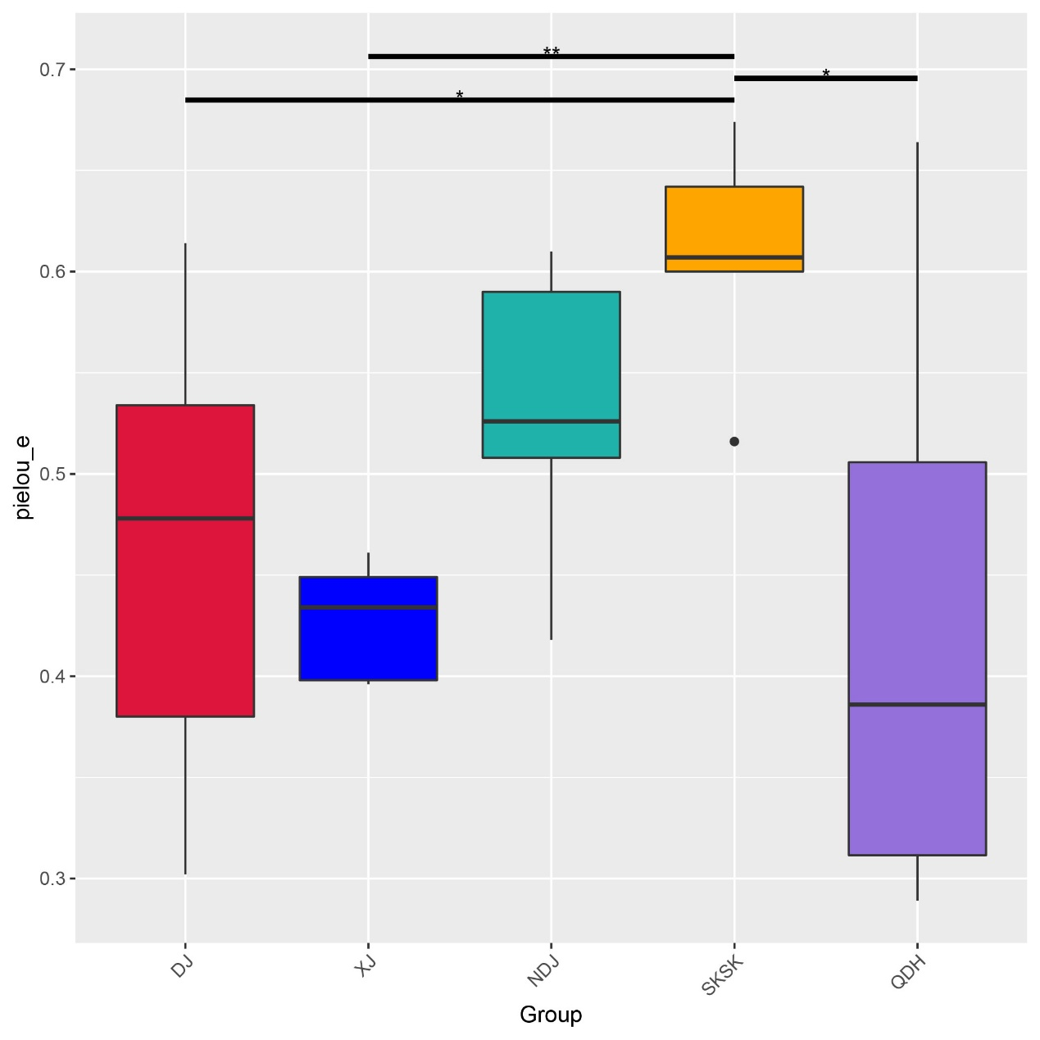
(c)
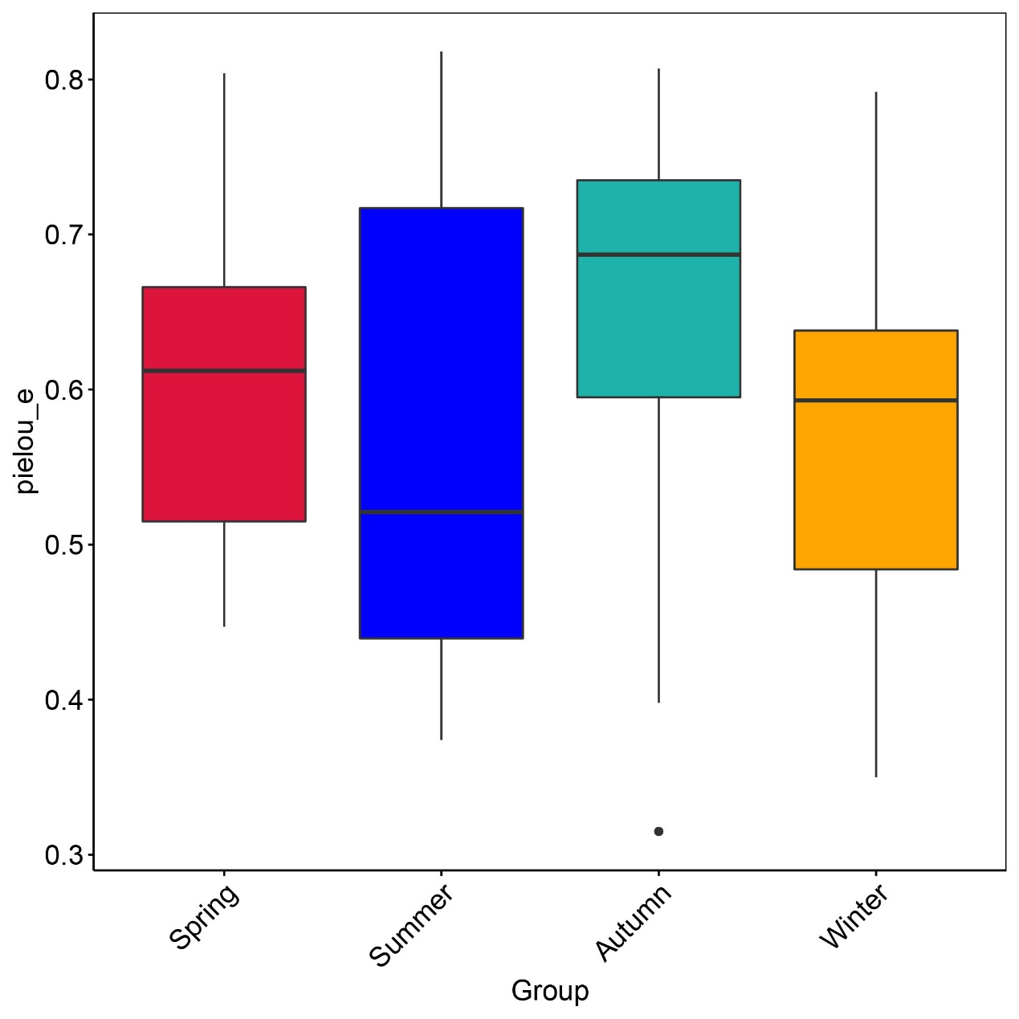
(d)
Figure S3 Box-plot of Alpha diversity indices of gut microbiota across sampling locations and seasons. (a) Shannon-Wiener index for five sampling locations; (b) Shannon-Wiener index for four seasons of SKSK; (c) Pielou’s evenness index for five sampling locations; (d) Pielou’s evenness index for four seasons of SKSK. In each panel, the abscissa is the group, and the ordinate is the value of Shannon-Wiener index (shannon) and Pielou’s evenness index (pielou_e), respectively. Asterisks indicate pairwise significance (***P < 0.001, **P < 0.01, *P < 0.05).

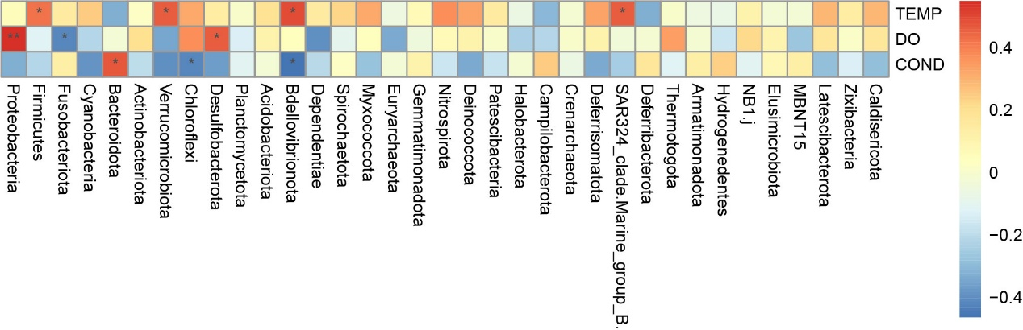
(a)
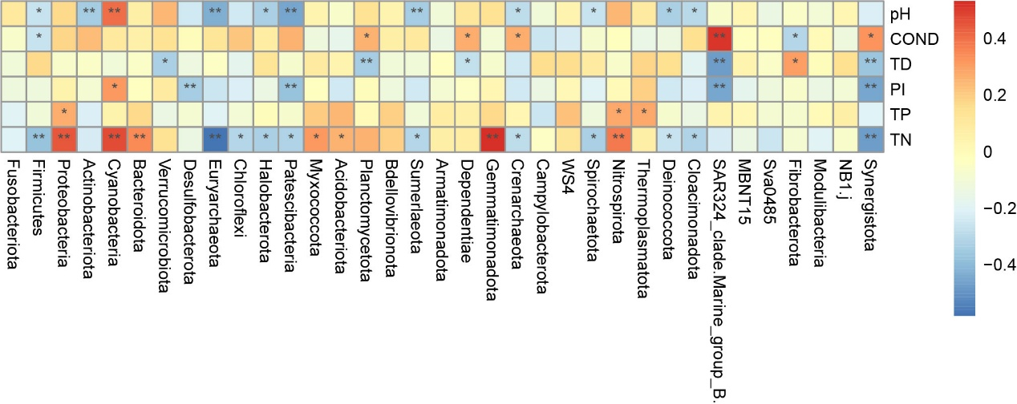
(b)
Figure S4 Heatmap of Spearman correlation analysis between gut microbiota at the phylum level and environmental factors across five sampling locations (a) and four seasons of SKSK (b). The vertical axis represents environmental factor information. The horizontal axis represents species information. And the value corresponding to the heatmap is the Spearman correlation coefficient r, which is between -1 and 1, r<0 indicates a negative correlation, r> 0 indicates a positive correlation, and * denotes P<0.05, ** denotes P<0.01. TEMP, DO, COND, TD, PI, TP, and TN represent water temperature, dissolved oxygen, conductivity, turbidity degree, permanganate index, total phosphorus, and total nitrogen, respectively.

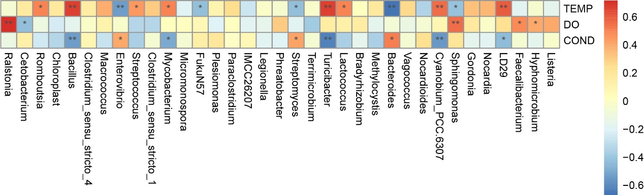
(a)
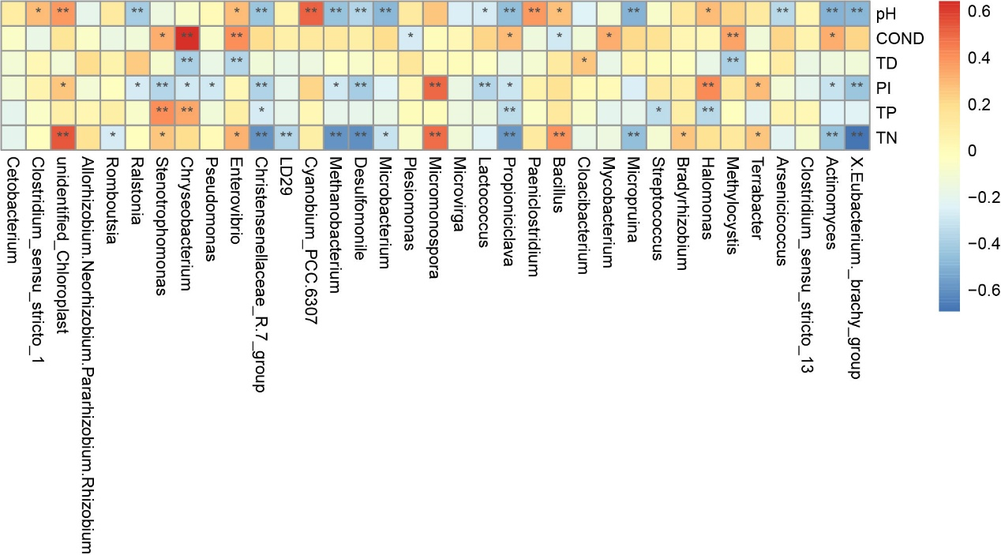
(b)
Figure S5 Heatmap of Spearman correlation analysis between gut microbiota at the genus level and environmental factors across five sampling locations (a) and four seasons of SKSK (b). The vertical axis represents environmental factor information. The horizontal axis represents species information. And the value corresponding to the heatmap is the Spearman correlation coefficient r, which is between -1 and 1, r<0 indicates a negative correlation, r> 0 indicates a positive correlation, and * denotes P<0.05, ** denotes P<0.01. TEMP, DO, COND, TD, PI, TP, and TN represent water temperature, dissolved oxygen, conductivity, turbidity degree, permanganate index, total phosphorus, and total nitrogen, respectively.

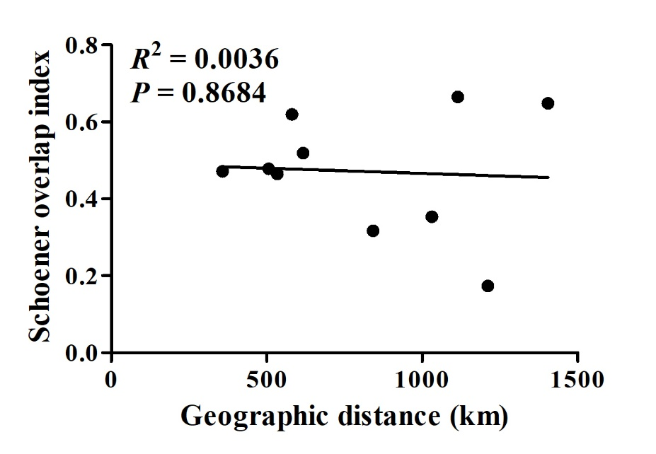
(a)
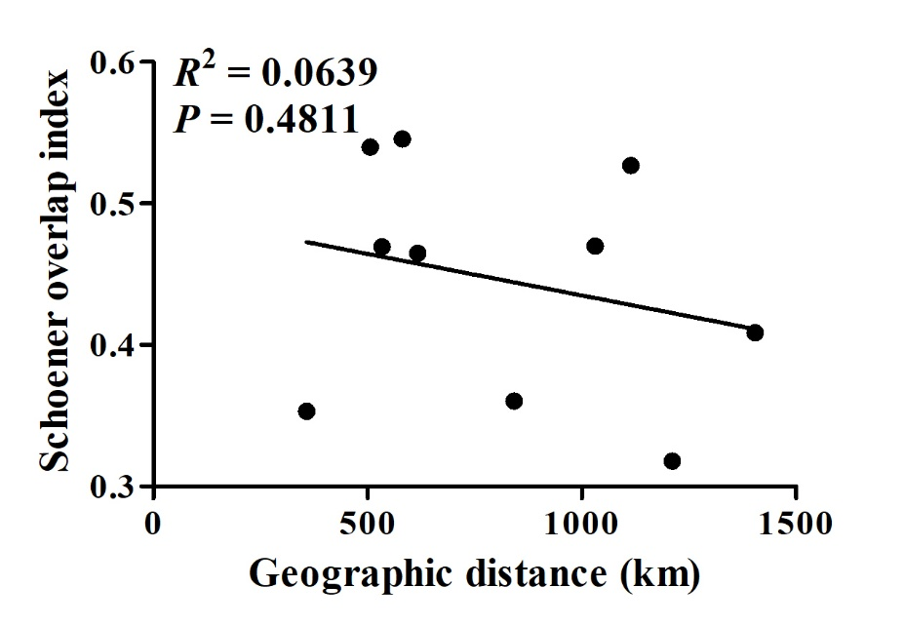
(b)
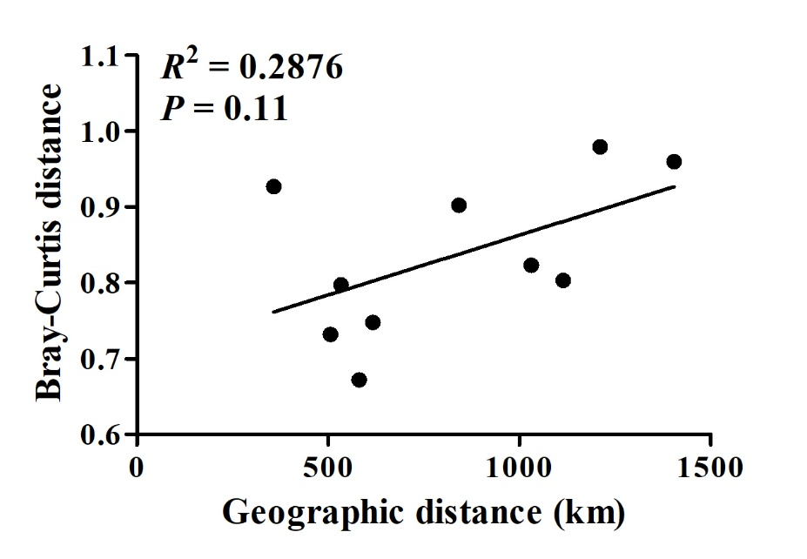
(c)
Figure S6 Correlation between geographic distances and gut microbiota differences between populations for C. zillii. (a) Correlation between geographic distances and phylum-level Schoener overlap index of gut microbiota between populations. The slope of the linear regression is (-2.675e-05) ± (1.564e-04), and the intercept is 0.4931 ± 0.1385. The correlation (y = -2.675e-05x + 0.4931, R² = 0.0036) was not significant (P = 0.8684). (b) Correlation between geographic distances and genus-level Schoener overlap index of gut microbiota between populations. The slope of the linear regression is (-5.878e-05) ± (7.956e-05), and the intercept is 0.4938 ± 0.0705. The correlation (y = -5.878e-05x + 0.4938, R² = 0.0639) was not significant (P = 0.4811). (c) Correlation between geographic distances and Bray-Curtis distance between populations. The slope of the linear regression is (1.578e-04) ± (8.782e-05), and the intercept is 0.7049 ± 0.0777. The correlation (y = 1.578e-04x + 0.7049, R² = 0.2876) was not significant (P = 0.11). Values of Mantel’s correlation test are provided at the top of the panel.

Figure S7 Assessing the adequacy of the neutral community model (NCM) for community assembly across different habitats. The solid red lines depict the optimal fit of the neutral community model, while the pink shaded area indicates the 95% confidence interval of the model predictions. OTUs falling within the predicted range are displayed in blue, while those occurring more (red) or less (green) than predicted by the NCM are shown in different colors. R² indicates the model's goodness of fit, whereas Nm is the result of multiplying community size by migration periods.

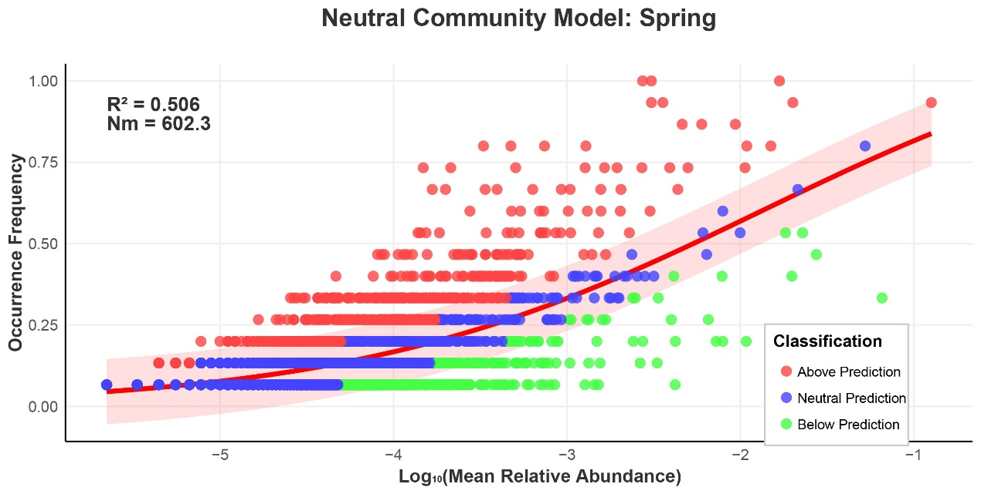
(a)
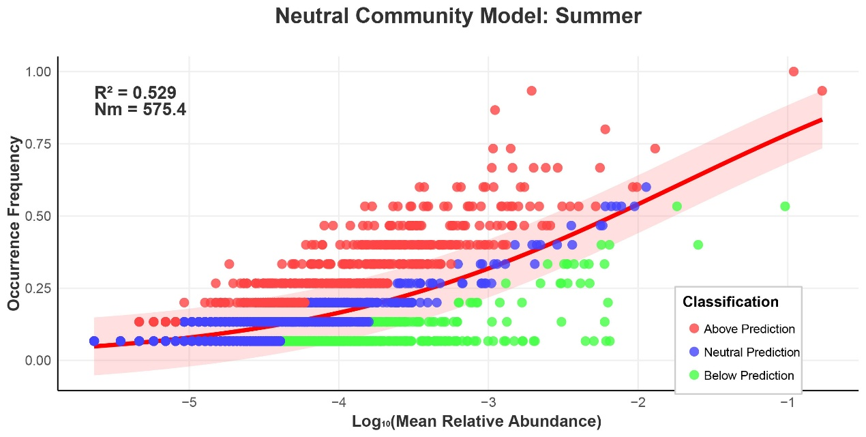
(b)
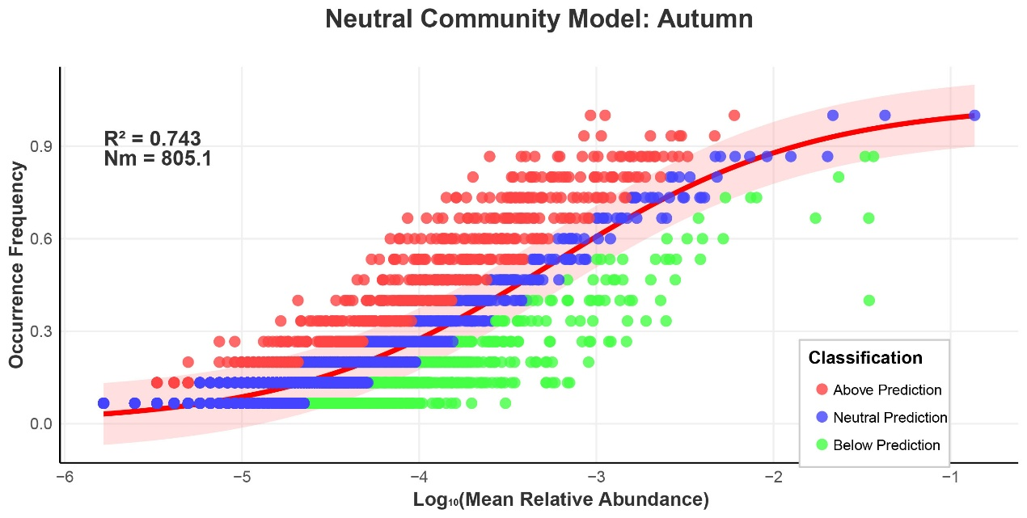
(c)
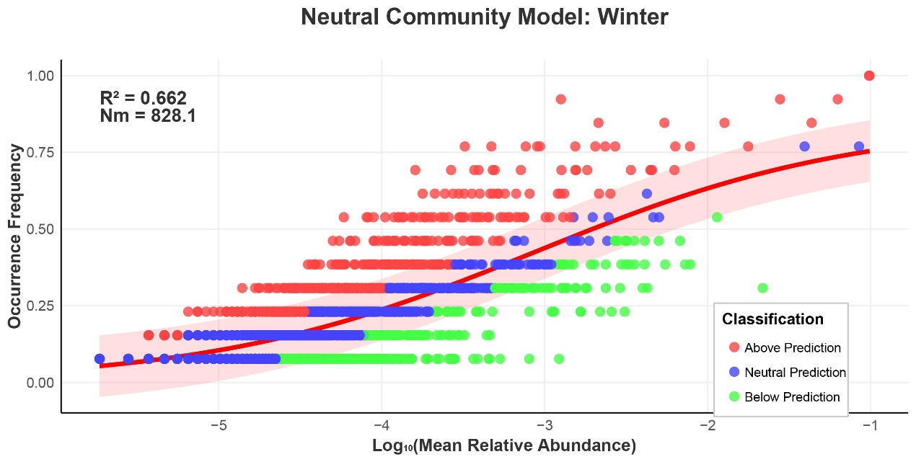
(d)
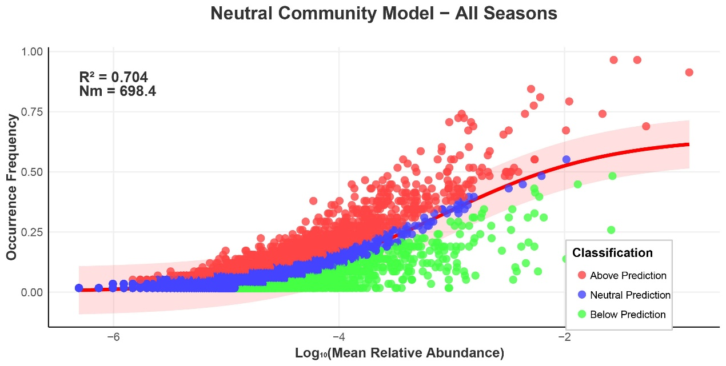
(e)
Figure S8 Assessing the adequacy of the neutral community model (NCM) for community assembly across different seasons (a: spring; b: summer; c: autumn; d: winter; e: all seasons). The solid red lines depict the optimal fit of the neutral community model, while the pink shaded area indicates the 95% confidence interval of the model predictions. OTUs falling within the predicted range are displayed in blue, while those occurring more (red) or less (green) than predicted by the NCM are shown in different colors. R² indicates the model's goodness of fit, whereas Nm is the result of multiplying community size by migration periods.

