Supplementary Materials for

Beyond the Pandemic Prism: Influence of COVID-19 Priming on Assessments of Child Mental Health
Hekmat Alrouh, Hannah Dorsman, Michiel Luijten, Hedy van Oers, Jacintha M. Tieskens, Emma Broek, Rowdy de Groot, Helen Klip, Arne Popma, Wouter Staal, Tinca J.C. Polderman, Meike Bartels, Josjan Zijlmans

Corresponding author: h.alrouh@vu.nl

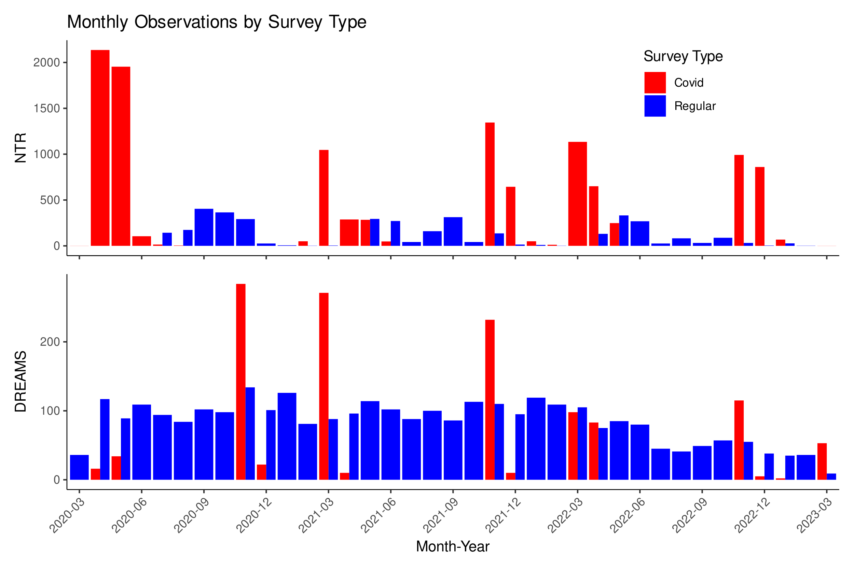

Fig. S1.
Data collection timeline.

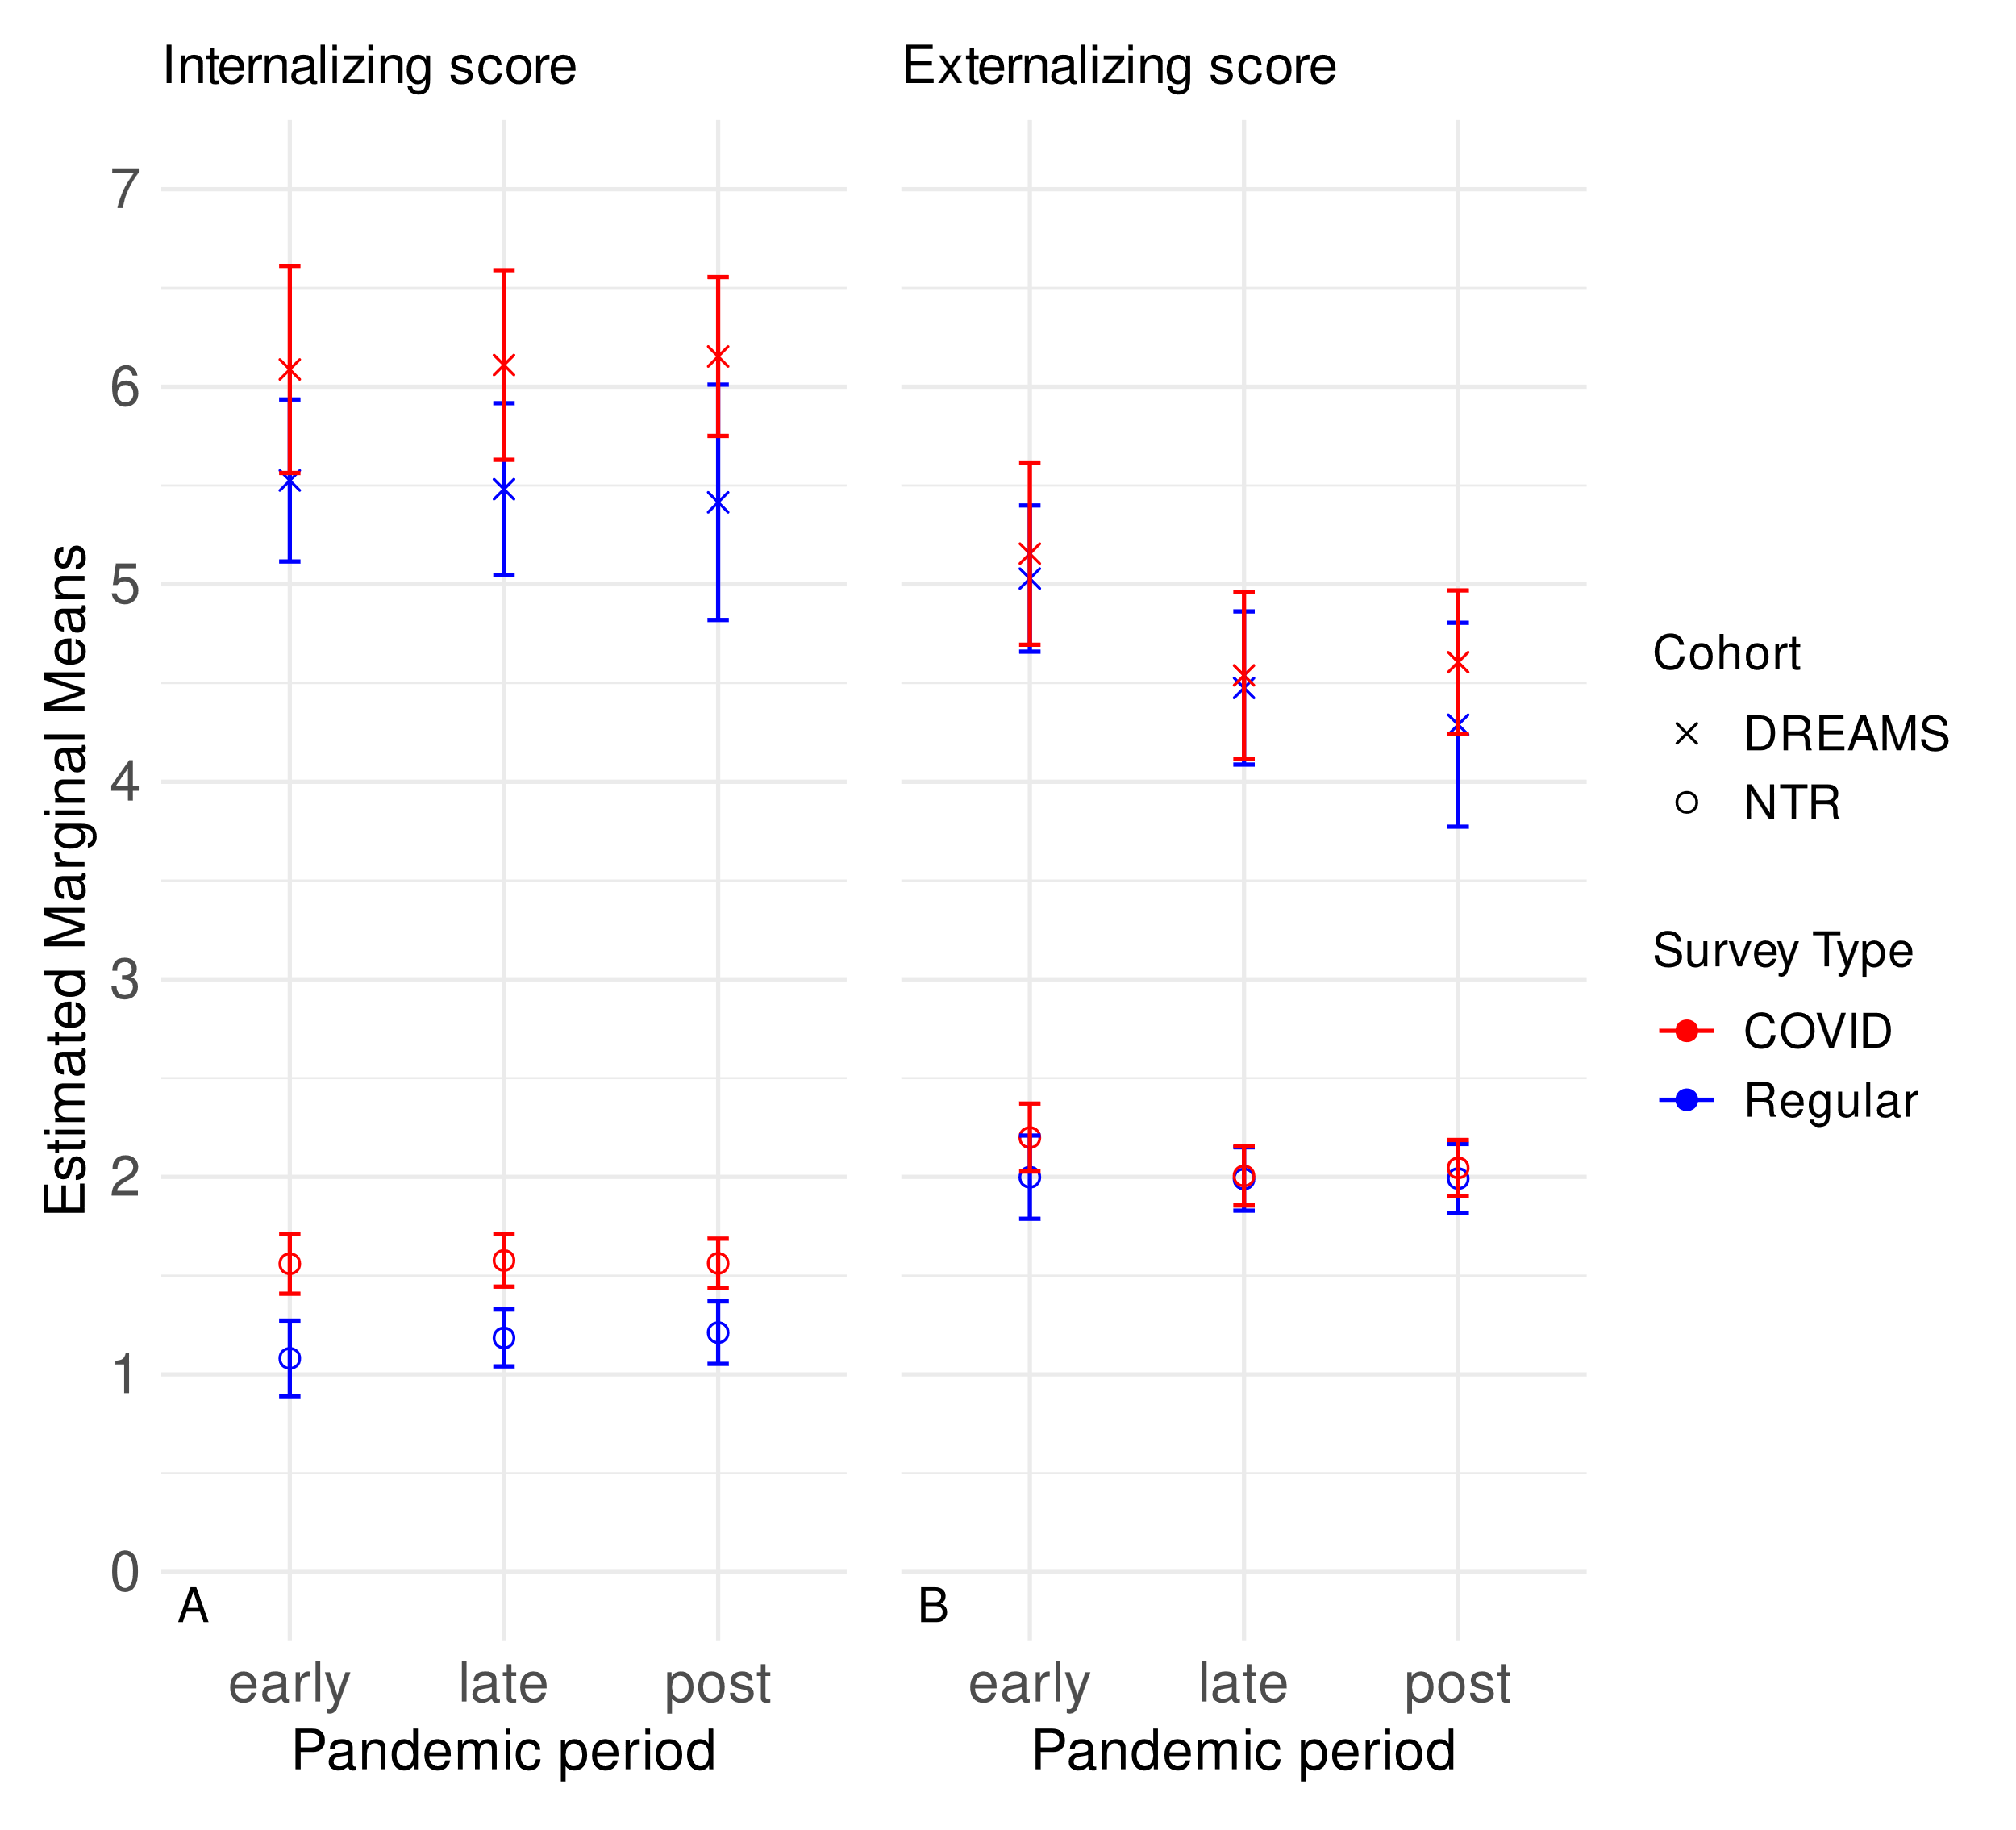

Fig. S2.
Sensitivity analysis results: Estimated marginal means for A) internalizing and B) externalizing scores by period, grouped by survey type for each cohort. Error bars: 95% CI.

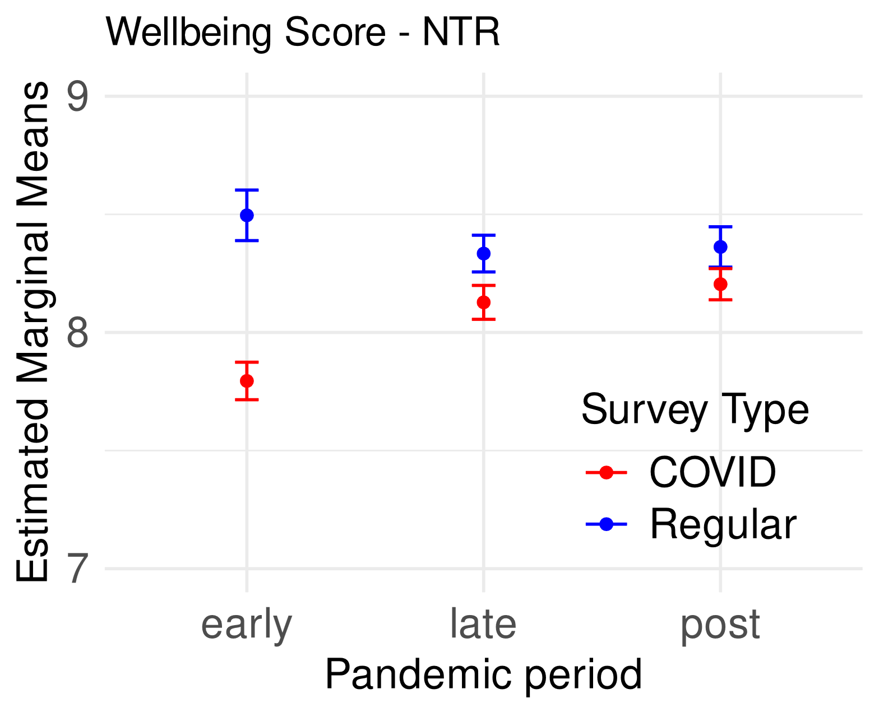

Fig. S3.
Sensitivity analysis results: Estimated marginal means for wellbeing scores (NTR cohort) by period, grouped by survey type. Error bars: 95% CI.

Table S1.
results of the linear mixed models sensitivity analysis.

NTR | Internalizing problems |  | Externalizing problems |  | Wellbeing
NTR | Estimate (95% CI) | p-value | Estimate (95% CI) | p-value | Estimate (95% CI) | p-value
Intercept | 0.84 (0.32 – 1.35) | 0.0016 | 3.09 (2.51 – 3.68) | <0.0001 | 8.95 (8.68 – 9.23) | <0.0001
Survey: COVID-19 | 0.48 (0.31 – 0.65) | <0.0001 | 0.2 (0.02 – 0.38) | 0.0267 | -0.7 (-0.8 – -0.6) | <0.0001
Period: late-pandemic | 0.1 (-0.09 – 0.29) | 0.283 | -0.01 (-0.21 – 0.19) | 0.93 | -0.16 (-0.27 – -0.05) | 0.0048
Period: post-pandemic | 0.13 (-0.08 – 0.34) | 0.2304 | -0.01 (-0.24 – 0.22) | 0.9523 | -0.13 (-0.26 – -0.01) | 0.0331
Sex: female | 0.17 (0 – 0.34) | 0.0478 | -0.38 (-0.57 – -0.18) | 0.0001 | 0.03 (-0.03 – 0.1) | 0.3039
Age (years) | 0.02 (-0.03 – 0.07) | 0.3871 | -0.08 (-0.13 – -0.03) | 0.0027 | -0.05 (-0.07 – -0.02) | 0.0002
Rater: father | -0.15 (-0.24 – -0.06) | 0.0015 | 0.04 (-0.06 – 0.14) | 0.457 | 0.1 (0.05 – 0.16) | 0.0003
Type: COVID-19*Period: late | -0.09 (-0.31 – 0.13) | 0.4359 | -0.19 (-0.42 – 0.05) | 0.1209 | 0.49 (0.36 – 0.63) | <0.0001
Type: COVID-19*Period: post | -0.13 (-0.35 – 0.09) | 0.2584 | -0.15 (-0.38 – 0.09) | 0.229 | 0.54 (0.41 – 0.68) | <0.0001
DREAMS | Internalizing problems |  | Externalizing problems
DREAMS | Estimate (95% CI) | p-value | Estimate (95% CI) | p-value
Intercept | 1.18 (0.05 – 2.31) | 0.0416 | 7.95 (6.85 – 9.05) | <0.0001
Survey: COVID-19 | 0.56 (0.05 – 1.07) | 0.0307 | 0.13 (-0.29 – 0.54) | 0.5502
Period: late-pandemic | -0.04 (-0.59 – 0.51) | 0.8748 | -0.55 (-1.02 – -0.09) | 0.0198
Period: post-pandemic | -0.11 (-0.8 – 0.58) | 0.7529 | -0.74 (-1.32 – -0.16) | 0.0131
Sex: female | 1.29 (0.72 – 1.86) | <0.0001 | -0.61 (-1.17 – -0.06) | 0.0307
Age (years) | 0.32 (0.22 – 0.42) | <0.0001 | -0.23 (-0.32 – -0.13) | <0.0001
Type: COVID-19*Period: late | 0.07 (-0.71 – 0.84) | 0.8662 | -0.06 (-0.7 – 0.58) | 0.8481
Type: COVID-19*Period: post | 0.18 (-0.62 – 0.97) | 0.6631 | 0.19 (-0.46 – 0.84) | 0.5655

