Oral Spatiotemporal Nanoassembly for Sequential Genetic Reprogramming from Gut to Periphery Organ
Juhyeong Hong^{1,2}, Seon-jeong Chang^{1,2}, Seung-Hwan joo^{1,2}, Han-Seok Lim^{1,2}, Juhyun Lee^{1,2}, Kyungdong Kim^{1,2}, Sangjin Kim^{1,2}, Minjoo Jang^{1,2}, Yong-Hee Kim^{1,2,3*}
¹Department of Bioengineering, Institute for Bioengineering and Biopharmaceutical Research Hanyang University, 04763 Seoul, South Korea, ²Education and Research Group for Biopharmaceutical Innovation Leader, Hanyang University, 04763 Seoul, South Korea, ³ Cursus Bio Inc., Icure Tower, Gangnam-gu, Seoul, 06170, Republic of Korea
*Correspondence.
Address. 222, Wangsimni-ro, Seongdong-gu, ITBT Building 908, Seoul, 04763
Phone. +82-2-2220-2345
Fax. +822-2220-4342
E-mail. yongheekim@hanyang.ac.kr

Supplementary Information
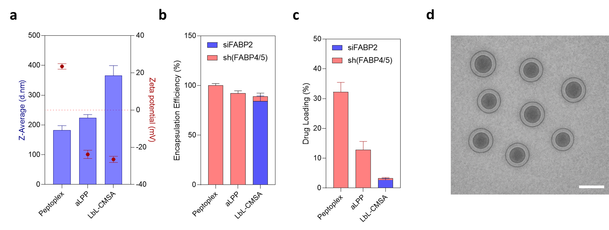
Supplementary Figure 1. Layer-by-Layer Chylomicron-mimicking self-assembly (LbL-CMSA, encapsulated with siRNA and apolipoprotein-coated lipopeptoplex (aLPP) . a, Zeta average (d.nm) and zeta potential (mV) of nanoparticles prepared in each step. b,c, Encapsulation efficiency (b) and drug loading (c) of pDNA (sh(FABP4/5)) and siRNA (siFABP2) at each step of formulation. d, Cryo-TEM image of LbL-CMSA. Data are presented as means ± SD.
Supplementary Figure 2. Physicochemical stability of LbL-CMSA (DCA-) in various pH. Z-average (d.nm) and zeta potential (mV) of LbL-CMSA (DCA-) after incubation in various pH conditioned PBS buffer was measured by dynamic light scattering system.
Supplementary Figure 3. FTIR spectra of LbL-CMSA before and after FaSSGF and FaSSIF incubation. All spectra were baseline corrected and normalized. C–H stretching (≈ 2850–2920 cm⁻¹), amide I/II (≈ 1650/1540 cm⁻¹), carbonyl/carboxylate stretches (≈ 1700–1750 cm⁻¹), and phosphate/C–O vibrations (≈ 1200–1000 cm⁻¹).

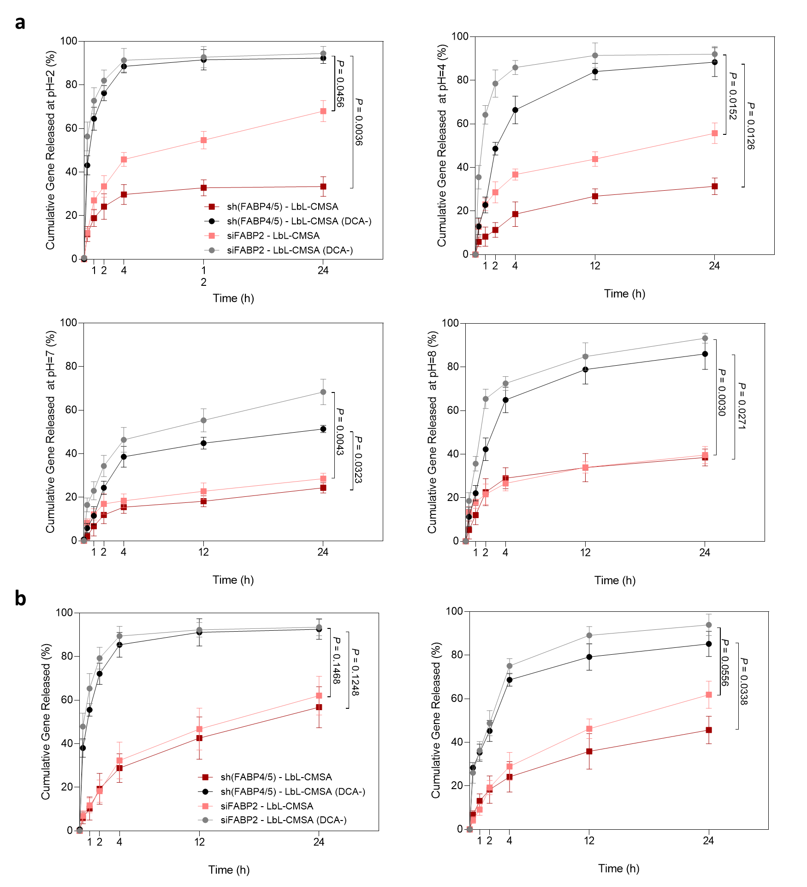
Supplementary Figure 4. Gene release profile of LbL-CMSA in gastrointestinal environment. a, Gene release profile from LbL-CMSA and LBL-CMSA (DCA-) in pH=2, 4, 7, and 8. sh(FABP4/5) and siFABP2 in the collected nanoparticles were quantified by Taqman-based qPCR with specific primers (n=3). b, Gene release profile from LbL-CMSA and LbL-CMSA (DCA-) in FaSSIF (left) and FaSSGF (right) (n=3).

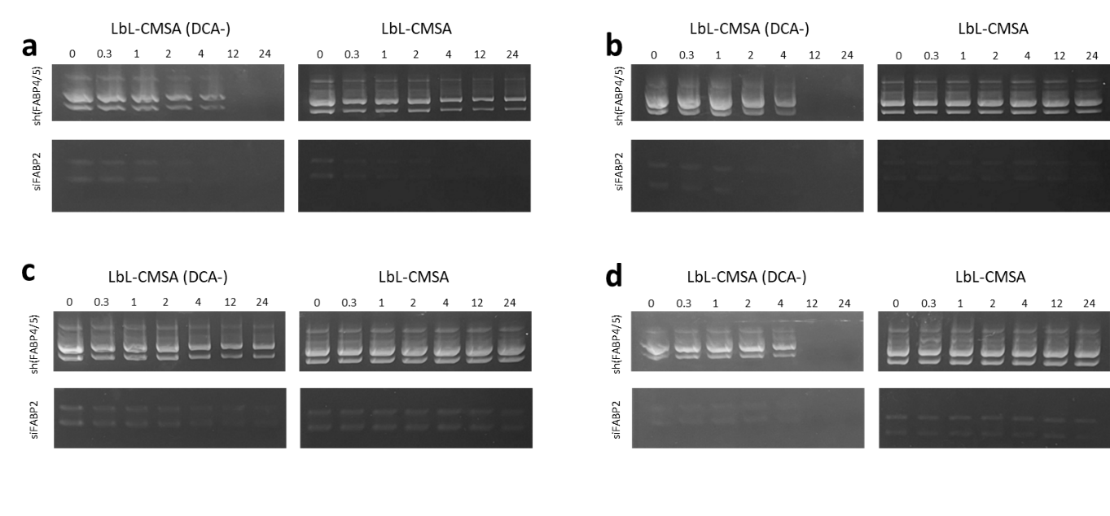
Supplementary Figure 5. Stability of LbL-CMSA in gastrointestinal environment. Gene release profile from LbL-CMSA and LbL-CMSA (DCA-) in pH=2 (a) 4 (b) 7 (c) and 8 (d). sh(FABP4/5) and siFABP2 in the collected nanoparticles were harvested and analyzed by gel electrophoresis.

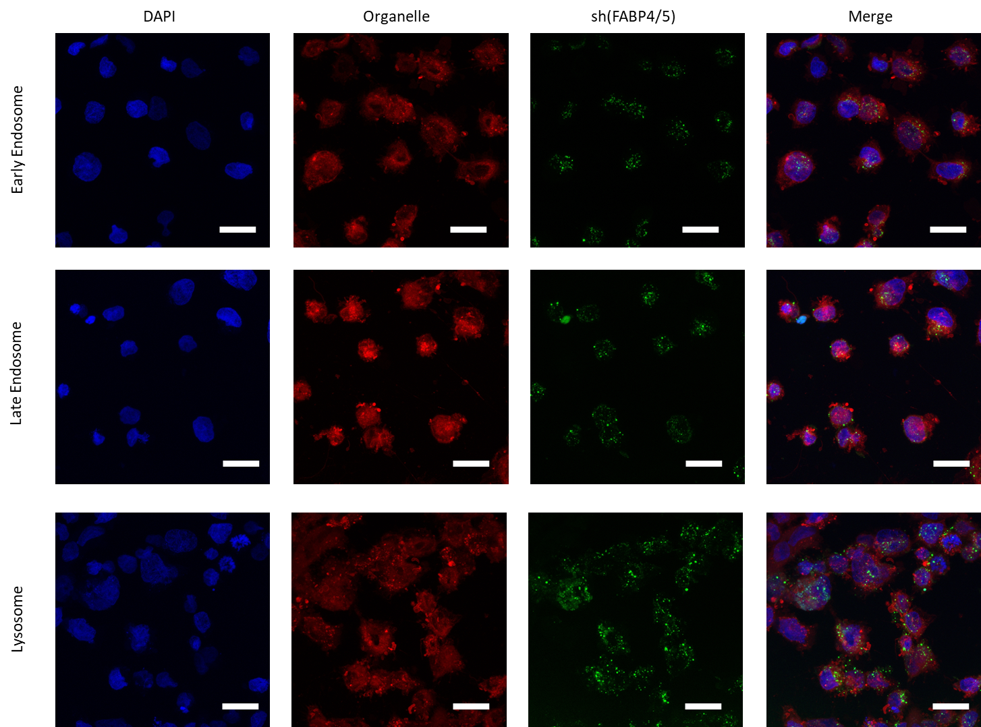
Supplementary Figure 6. Intracellular trafficking of sh(FABP4/5) in LbL-CMSA in caco-2 cells. Confocal laser microscope images of caco-2 cells with their intracellular organelles stained in red. sh(FABP4/5)-FITC were used to traffic location of aLPP in enterocytes after endocytosis. scale bar = 100 μm.

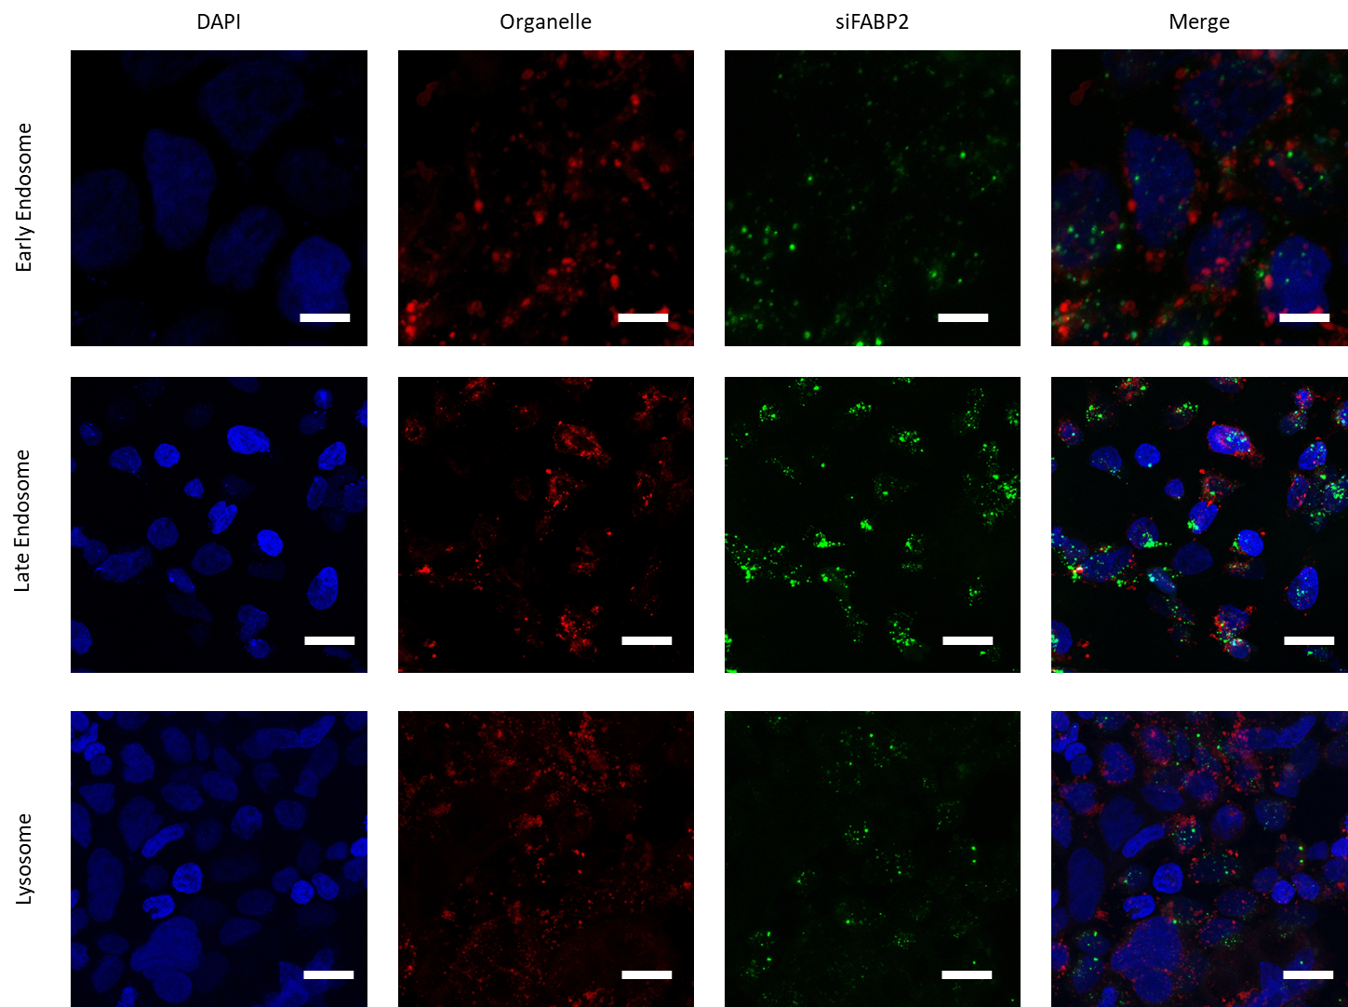
Supplementary Figure 7. Intracellular trafficking of sh(FABP4/5) in LbL-CMSA in caco-2 cells. Confocal laser microscope images of caco-2 cells with their intracellular organelles stained in red. siFABP2-FITC were used to traffic location of aLPP in enterocytes after endocytosis. scale bar = 100 μm.

Supplementary Figure 8. Intracellular trafficking of sh(FABP4/5) in LbL-CMSA in caco-2 cells. Scores for colocalization between the genetic materials and organelles were calculated as Pearsons’ coefficients.

Supplementary Figure 9. DCA-mediated endocytosis of LbL-CMSA in intestinal epithelium. Mean fluorescence intensity of the small intestines 4 h after oral administration of LbL-CMSA and LbL-CMSA (DCA-).

Supplementary Figure 10. Transcytosis of sh(FABP4/5) of aLPP in transwell model. Mean fluorescence intensity of PBS retrieved from the bottom chamber of a transwell plate, with caco-2/HT29 cells seeded in the upper chamber. Data are presented as means ± SD, and p-values were calculated by one-way ANOVA with Tukey's post-test. ns = not significant.

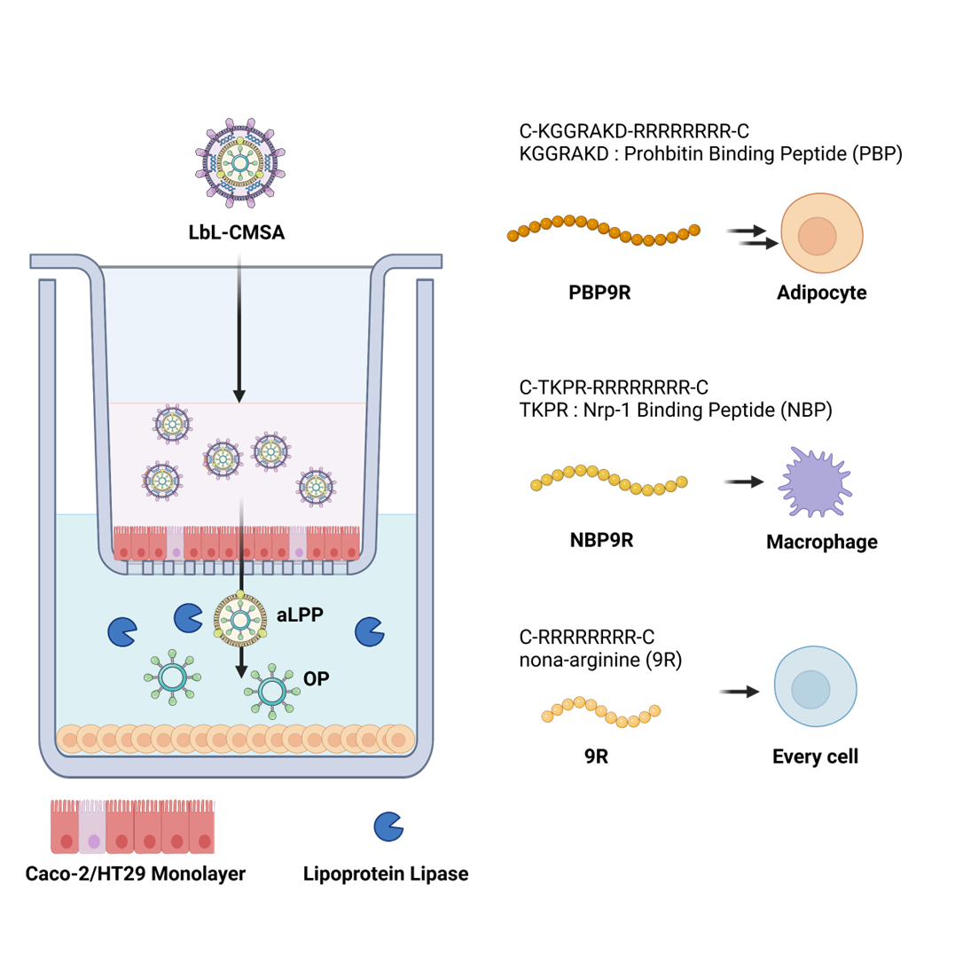
Supplementary Figure 11. in vitro transcytosis evaluation system of LbL-CMSA with altered peptide. Schematic illustration of in vitro transcytosis evaluation system with caco-2/HT29 cell layer in upper chamber of transwell and several cell lines including 3T3-L1, Raw264.7 and EO771 are seeded in bottom chamber with lipoprotein lipase are added in medium. Lipoprotein lipase were added to mediate uncoating of apolipoprotein shell of aLPP to release peptoplex consists of various oligopeptide. PBP9R target prohibitin on the surface of adipocytes and NBP9R target Nrp-1 on the surface of macrophages.

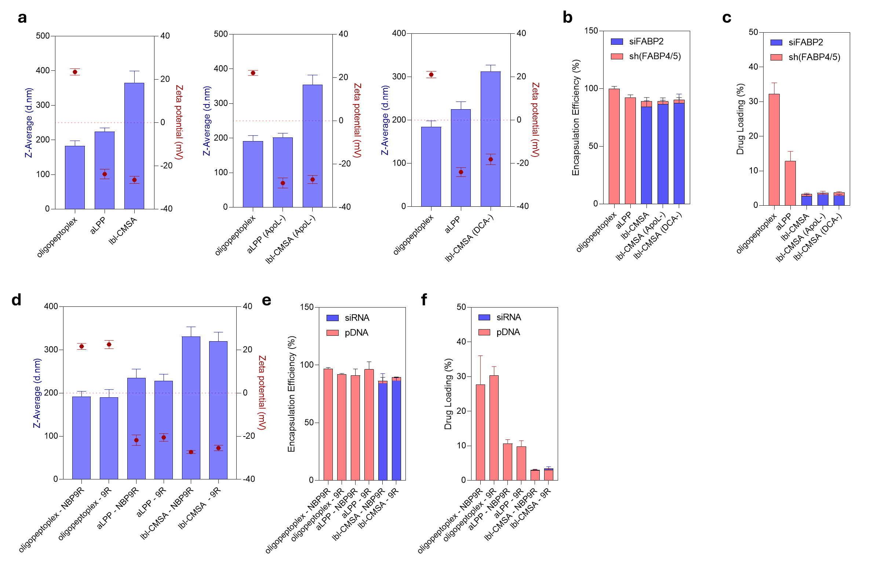

Supplementary Figure 12. Physicochemical analysis of LbL-CMSA and modified LbL-CMSA variants. a,b,c, Zeta average (d.nm) and zeta potential (mV) of nanoparticles prepared in each step (a) Encapsulation efficiency (b) and drug loading(c) of pDNA and siRNA in each step of formulation. d, Zeta average (d.nm) and zeta potential (mV) of nanoparticles prepared in LbL-CMSA with various oligopeptide. NBP9R (C-TKPR-RRRRRRRRR-C, are consisted with 9R and Nrp-1 binding peptide (NBP) capable of targeting macrophages. 9R (C- RRRRRRRRR-C, are consisted with bare nona-arginine capable of internalization in every cell lines. e,f, Encapsulation efficiency(e) and drug loading(f) of pDNA and siRNA in each step of formulation. Data are presented as means ± SD, and p-values were calculated by one-way ANOVA with Tukey's post-test.

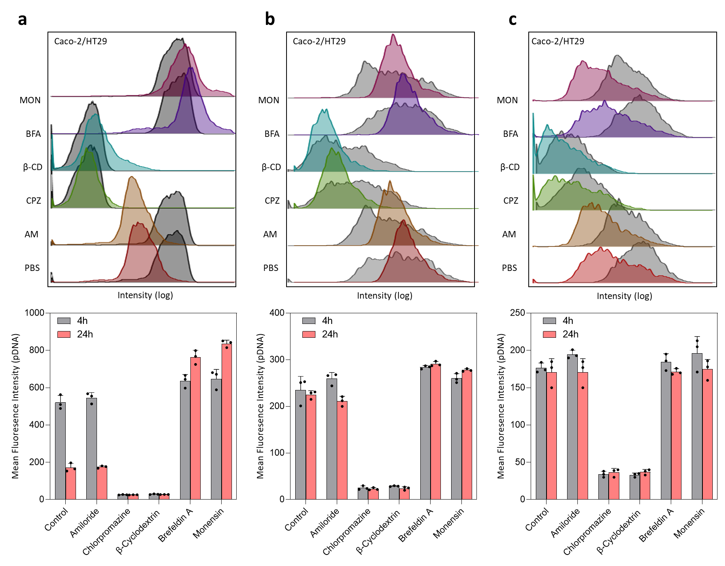
Supplementary Figure 13. Flow cytometry analysis of LbL-CMSA after treatment with endocytosis and transcytosis inhibitors in a transwell system. The upper chamber was coated with caco-2/HT29 cells, and differentiated 3T3-L1 cells were seeded in the bottom chamber. After incubation with inhibitors, LbL-CMSA (sh(FABP4/5)-FITC and siFABP2-Cy5.5) was administered, and the cells in each chamber were harvested after 4 and 24 h. Three different oligopeptide (PBP9R(a) NBP9R(b) 9R(c) were prepared to investigate difference occurred by targeting moieties and different cell lines were seeded in bottom chamber (3T3-L1(a), raw264.7(b), EO771(c). Mean fluorescence intensity of pDNA-FITC in caco-2/HT29 cell layer are analyzed by flow cytometry. Data are presented as means ± SD.

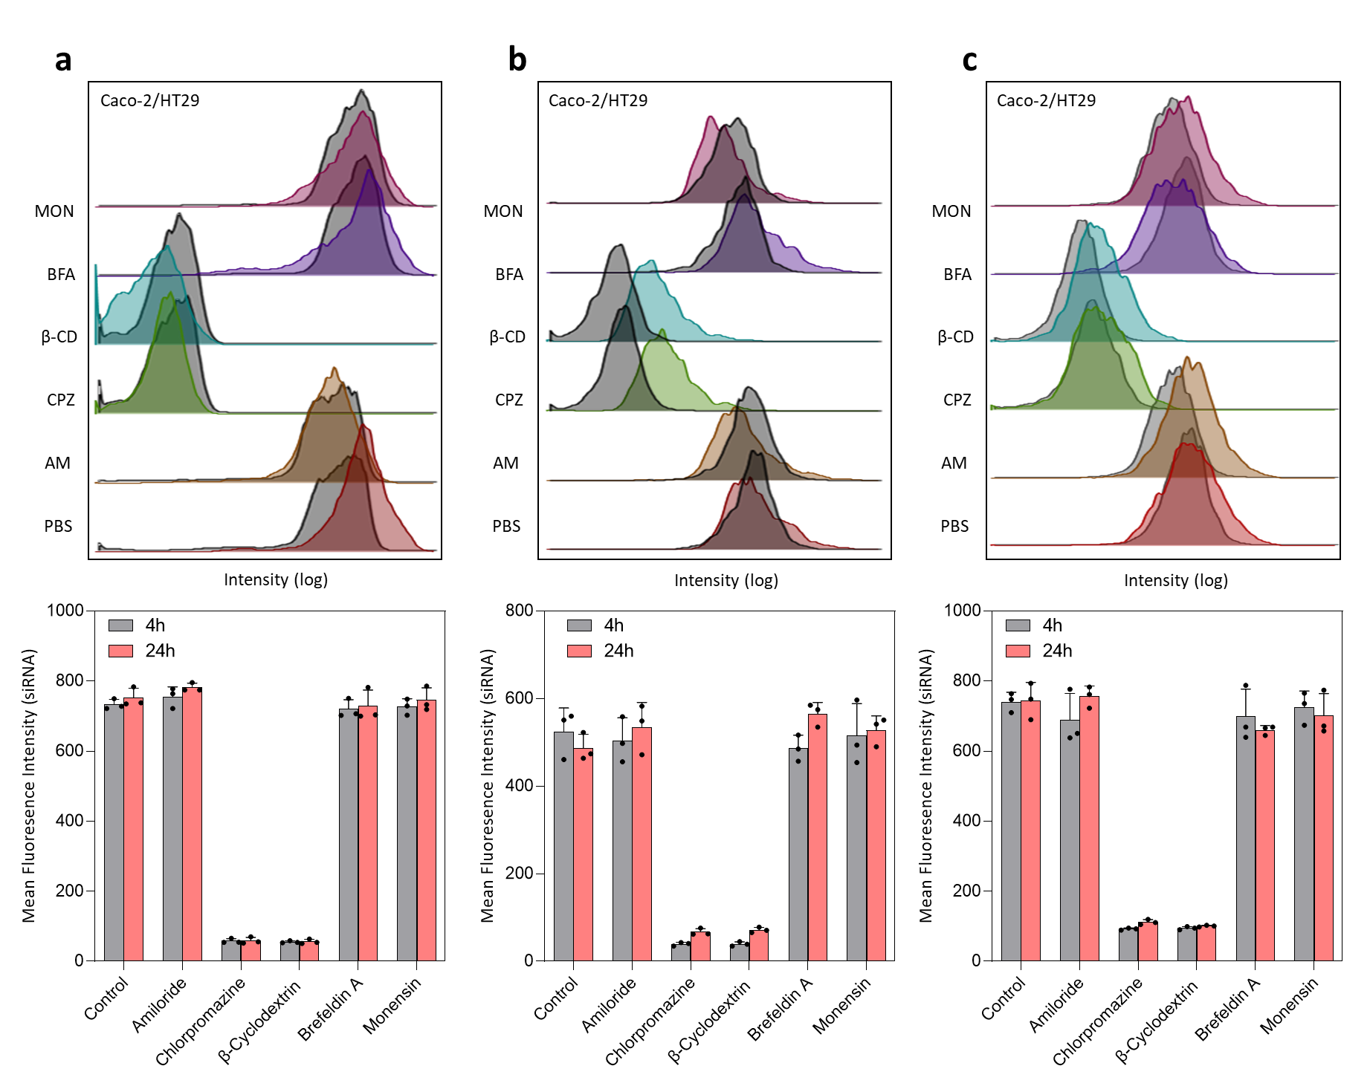
Supplementary Figure 14. Flow cytometry analysis of LbL-CMSA after treatment with endocytosis and transcytosis inhibitors in a transwell system. The upper chamber was coated with caco-2/HT29 cells, and differentiated 3T3-L1 cells were seeded in the bottom chamber. After incubation with inhibitors, LbL-CMSA (sh(FABP4/5)-FITC and siFABP2-Cy5.5) was administered, and the cells in each chamber were harvested after 4 and 24 h. Three different oligopeptide (PBP9R(a) NBP9R(b) 9R(c) were prepared to investigate difference occurred by targeting moieties and different cell lines were seeded in bottom chamber (3T3-L1(a), raw264.7(b), EO771(c). Mean fluorescence intensity of siRNA-Cy5.5 in caco-2/HT29 cell layer are analyzed by flow cytometry. Data are presented as means ± SD.
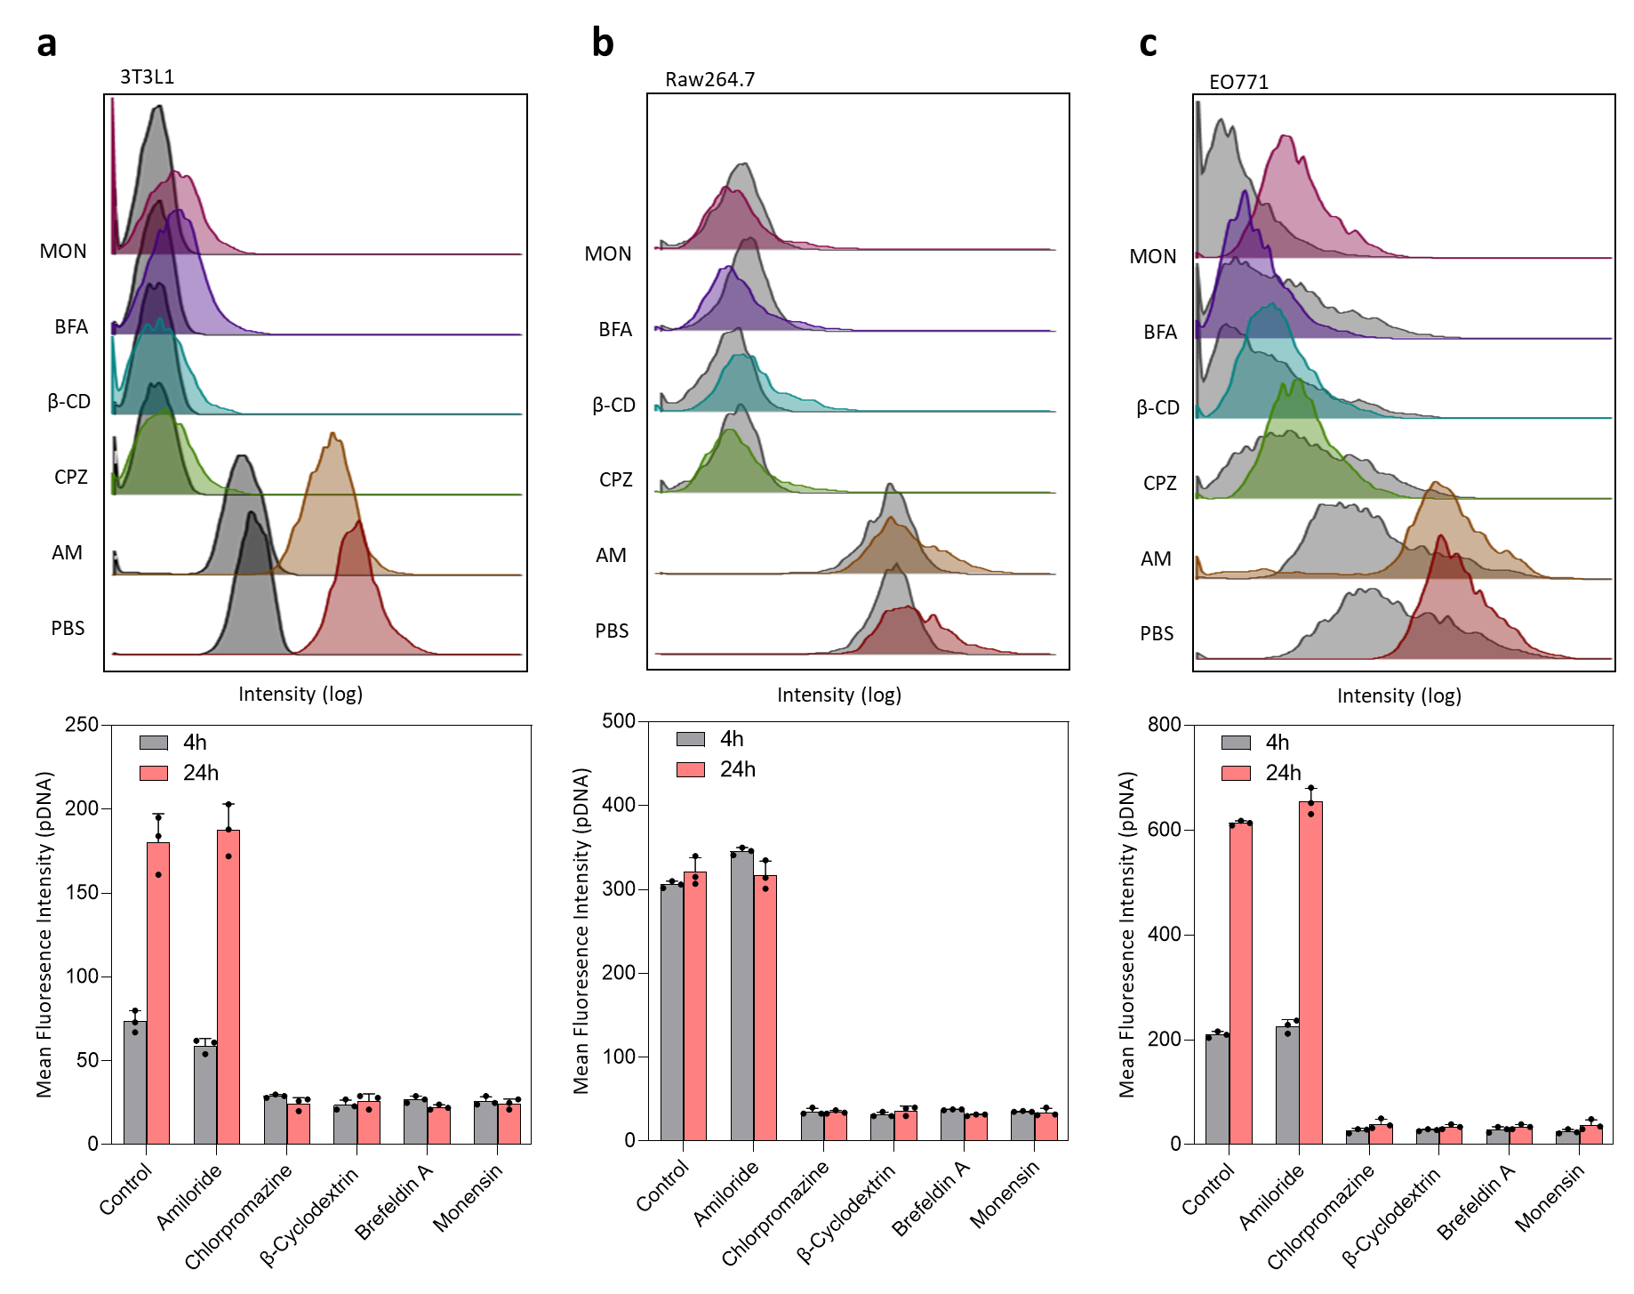
Supplementary Figure 15. Flow cytometry analysis of LbL-CMSA after treatment with endocytosis and transcytosis inhibitors in a transwell system. The upper chamber was coated with caco-2/HT29 cells, and differentiated 3T3-L1 cells were seeded in the bottom chamber. After incubation with inhibitors, LbL-CMSA (sh(FABP4/5)-FITC and siFABP2-Cy5.5) was administered, and the cells in each chamber were harvested after 4 and 24 h. Three different oligopeptide (PBP9R(a) NBP9R(b) 9R(c) were prepared to investigate difference occurred by targeting moieties and different cell lines were seeded in bottom chamber (3T3-L1(a), raw264.7(b), EO771(c). Mean fluorescence intensity of pDNA-FITC in bottom cell layer are analyzed by flow cytometry. Data are presented as means ± SD.

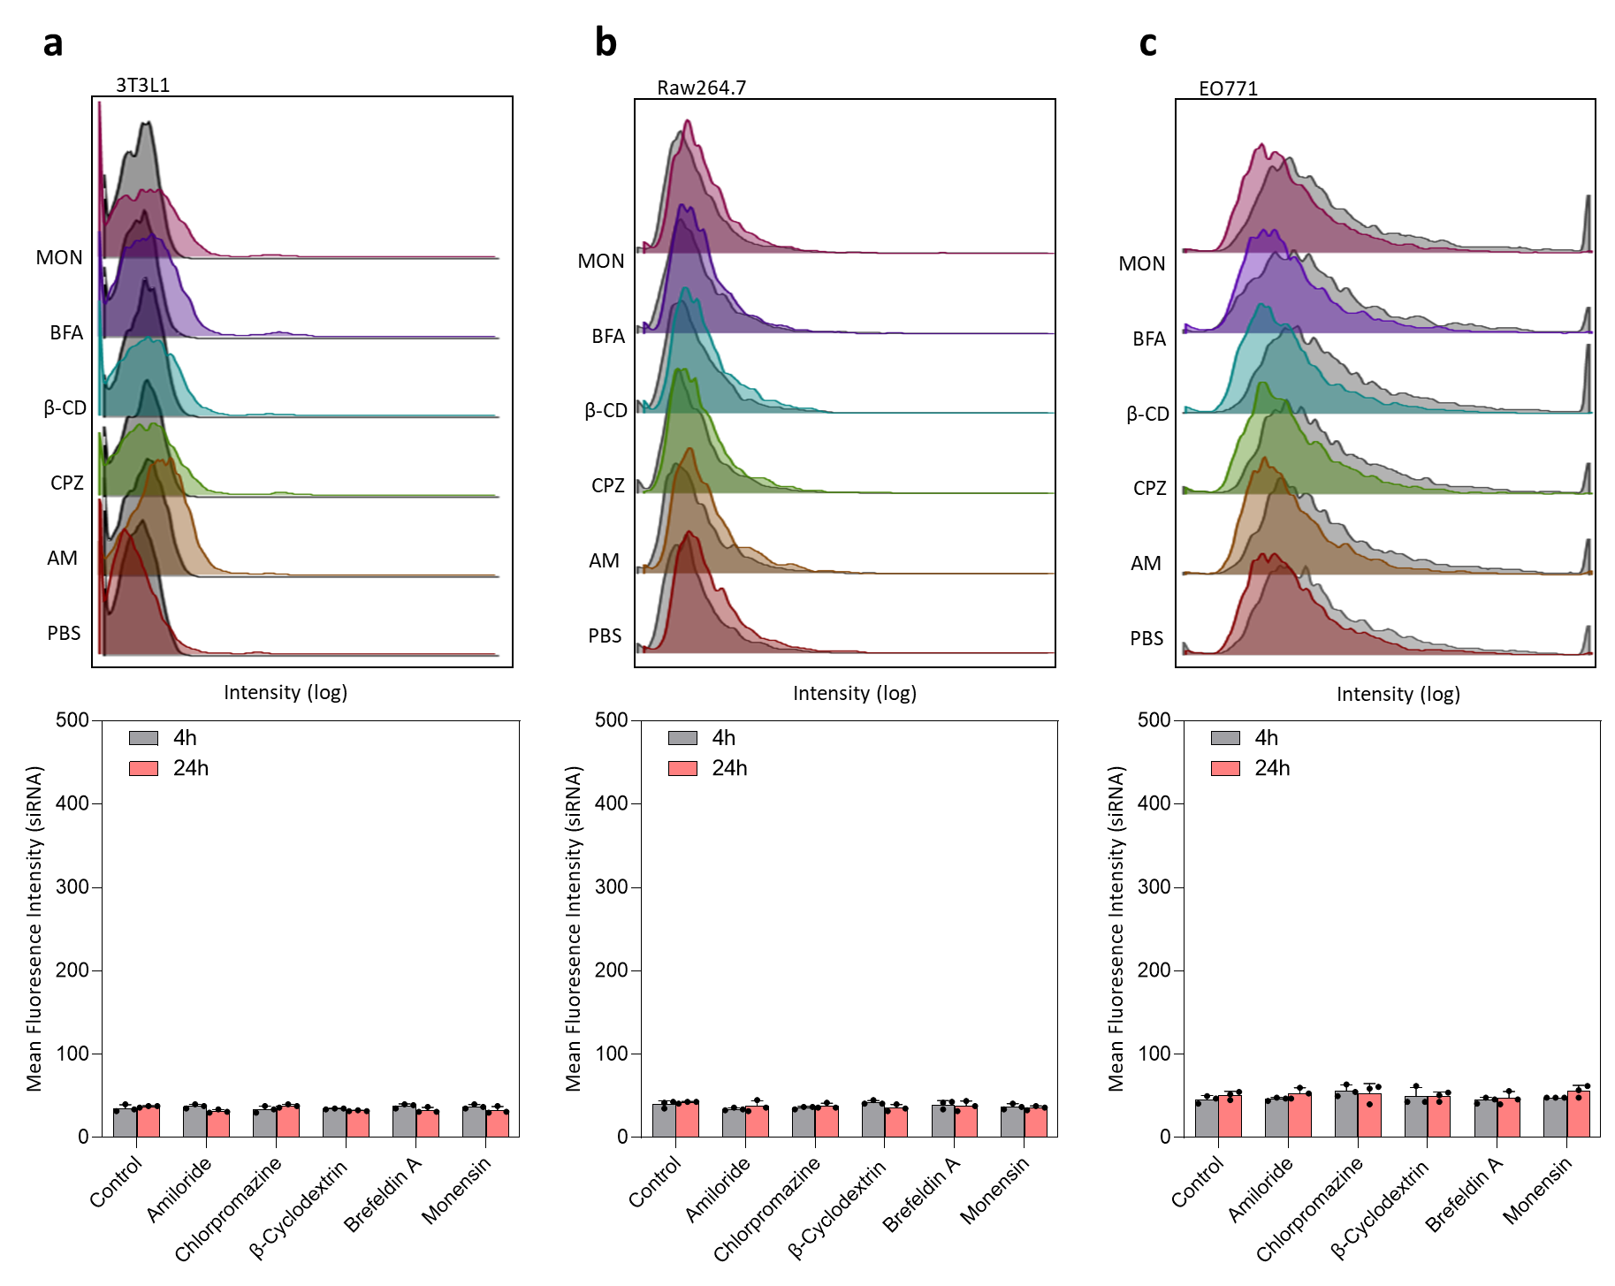
Supplementary Figure 16. Flow cytometry analysis of LbL-CMSA after treatment with endocytosis and transcytosis inhibitors in a transwell system. The upper chamber was coated with caco-2/HT29 cells, and differentiated 3T3-L1 cells were seeded in the bottom chamber. After incubation with inhibitors, LbL-CMSA (sh(FABP4/5)-FITC and siFABP2-Cy5.5) was administered, and the cells in each chamber were harvested after 4 and 24 h. Three different oligopeptide (PBP9R(a) NBP9R(b) 9R(c) were prepared to investigate difference occurred by targeting moieties and different cell lines were seeded in bottom chamber (3T3-L1(a), raw264.7(b), EO771(c). Mean fluorescence intensity of siRNA-Cy5.5 in bottom cell layer are analyzed by flow cytometry. Data are presented as means ± SD.
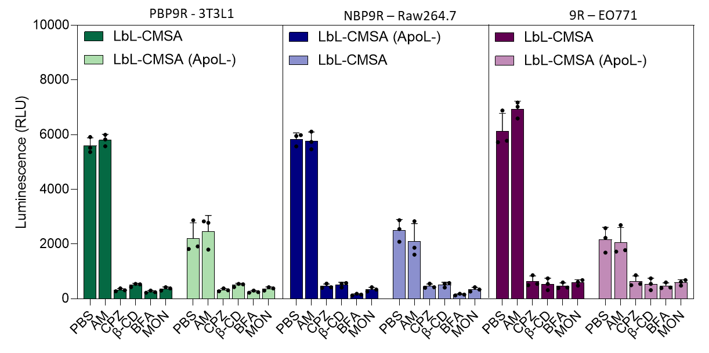
Supplementary Figure 17. Apolipoprotein mediated gene delivery of aLPP in LbL-CMSA. Luminescence of lysed cells in bottom chamber of a transwell plate after inhibitor-treated caco-2/HT29 cells in the upper chamber were treated with LbL-CMSA and LbL-CMSA (ApoL-) encapsulating pLuci. caco-2/HT29 cells were pre-incubated with inhibitors and nanoparticles were treated for 24h. Data are presented as means ± SD.

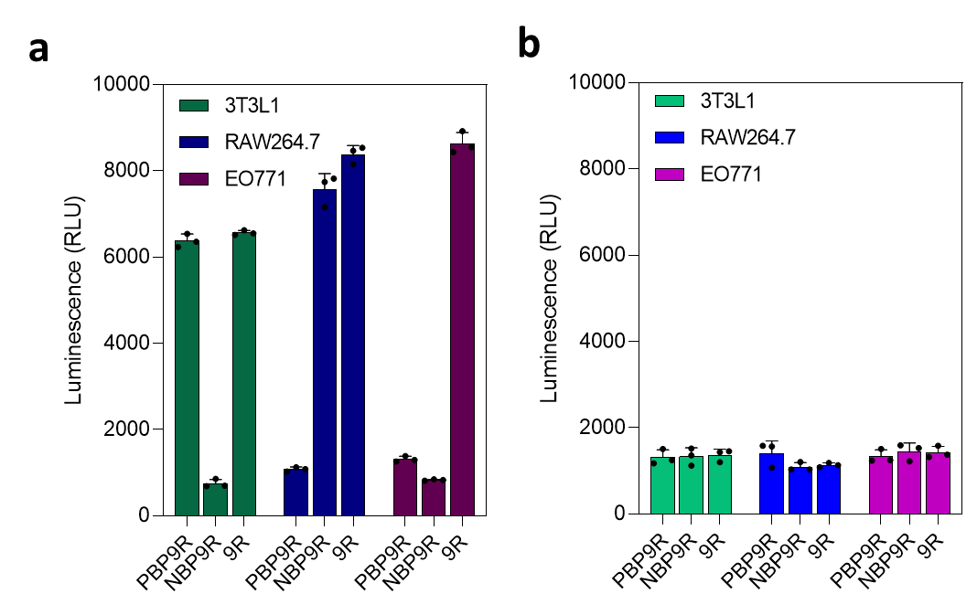
Supplementary Figure 18. Peptoplex release from aLPP via lipoprotein lipase. Luminescence levels of lysed 3T3-L1, Raw264.7, and EO771 cells in the bottom chamber of a transwell after caco-2/HT29 cells in the upper chamber were treated with LbL-CMSA consisting with different oligopeptide. Lipoprotein lipase was included (a, and excluded (b, in culture medium. Data are presented as means ± SD.

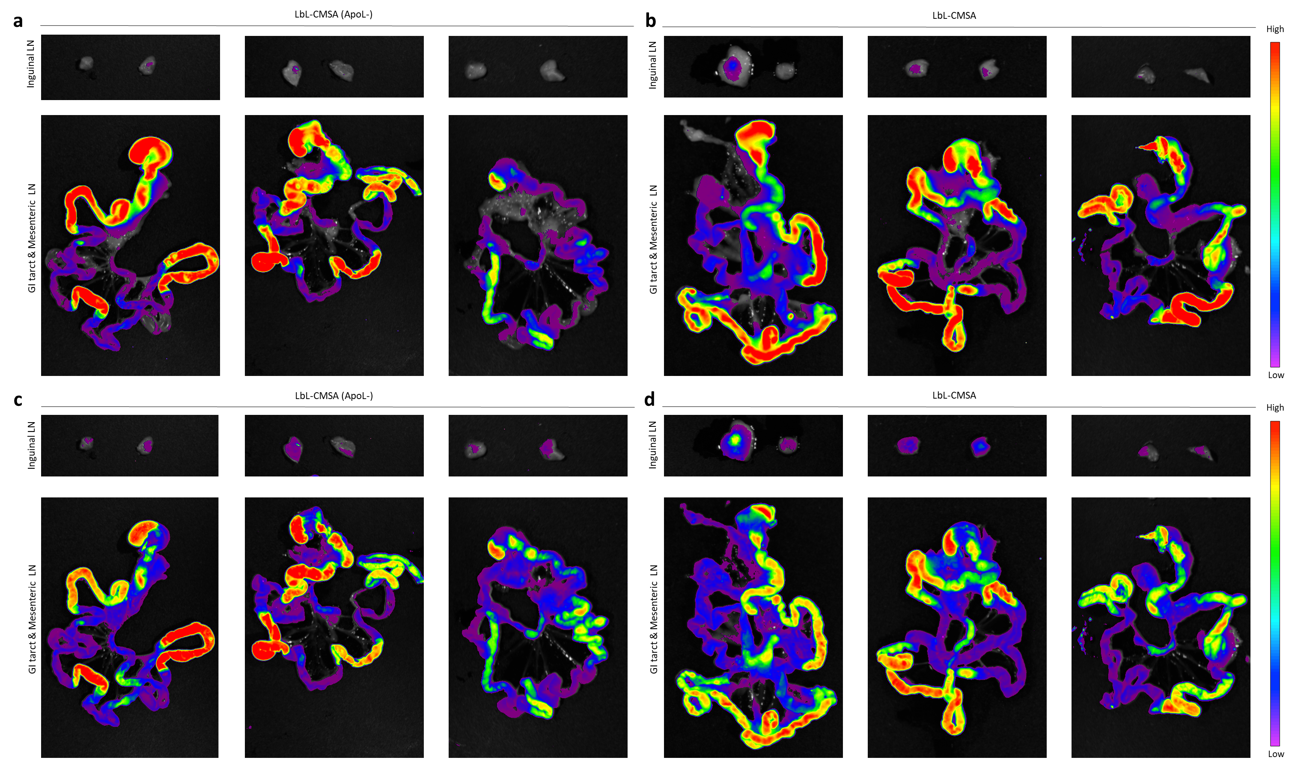
Supplementary Figure 19. High bioavailability of LbL-CMSA in GI tracts and lymph node draining of aLPP. fluorescence imaging of small intestines including mesenteric lymph node and inguinal lymph nodes after oral administration of LbL-CMSA and LbL-CMSA (ApoL-) for 4 h.
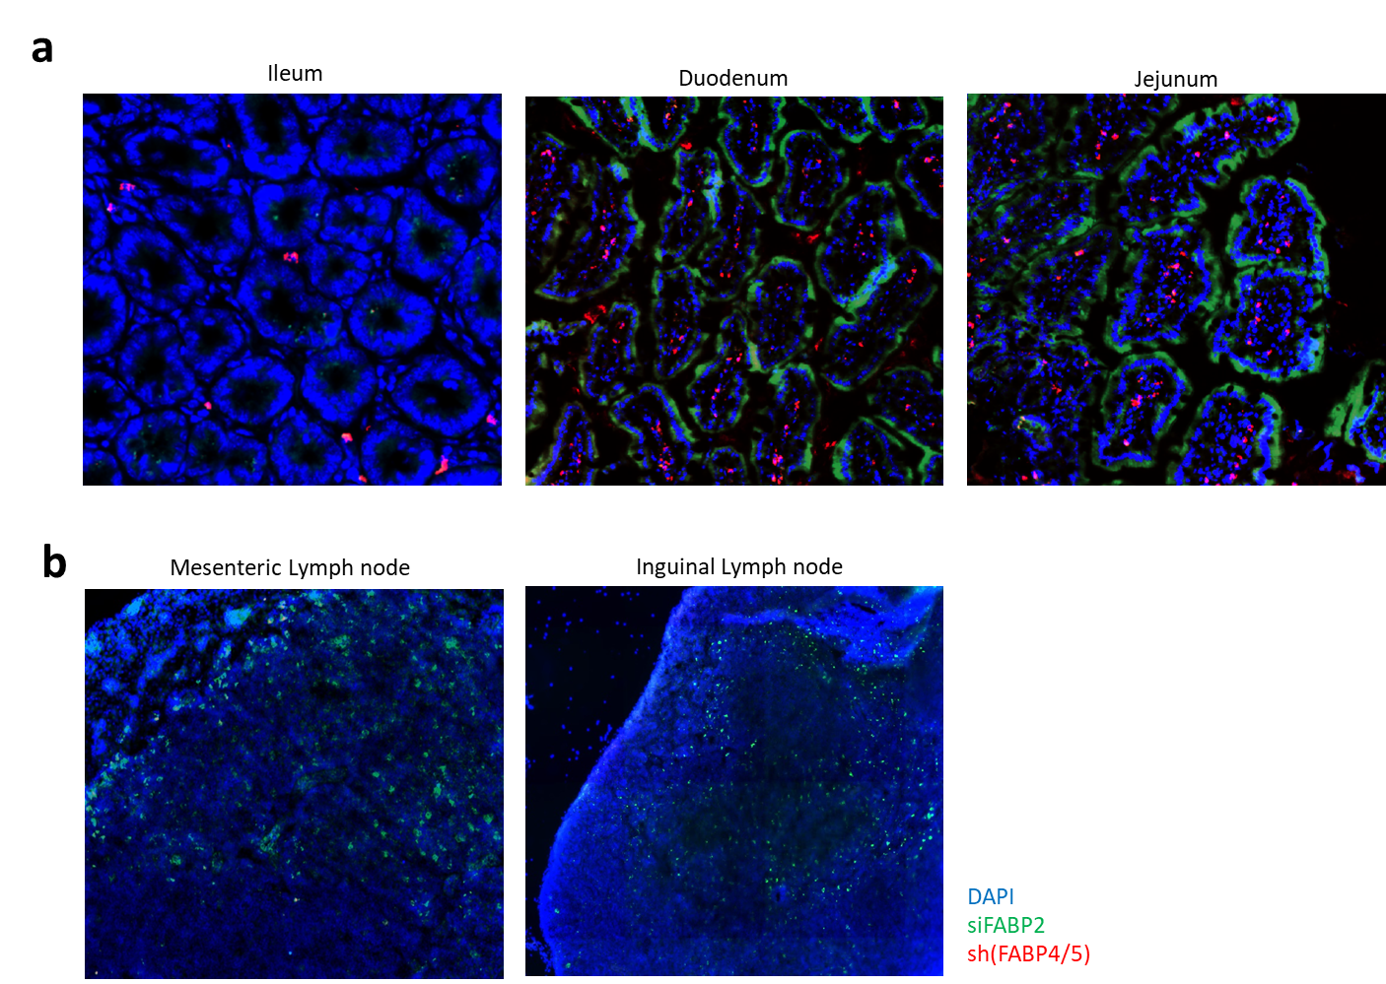

Supplementary Figure 20. Apolipoprotein mediated mesenteric lymph node draining of LbL-CMSA while siFABP2 are localized in small intestine. a,b, Fluorescence imaging of OCT preserved cryoblock of small intestines (a) and lymph nodes (b) after oral administration of LbL-CMSA. sh(FABP4/5) were labeled with FITC and siFABP2 were labeled with Cy5.5.
Supplementary Figure 21. Plasma stability assay for apolipoprotein coated aLPP. To evaluate plasma stability and the potential for protein corona mediated masking of apolipoprotein functionality, aLPP and aLPP (ApoL-) were incubated in humans serum at 37 °C under gentle agitation. Washed particle suspensions were lysed with 0.1% Triton X-100 in PBS for 10 minutes at room temperature to release surface associated protein for measurement. Lysates were clarified by centrifugation and assayed using commercial human ELISA kits. Standard curves were prepared using serial dilutions materials supplied by the kit manufacturer. (a, PDI and surface charge for pre-coated aLPP. Targeted ELISA of particle lysates following serum incubation demonstrates retention of ApoA-IV and ApoC-II on pre-coated aLPP and enrichment of ApoE and other proteins on aLPP (ApoL-).

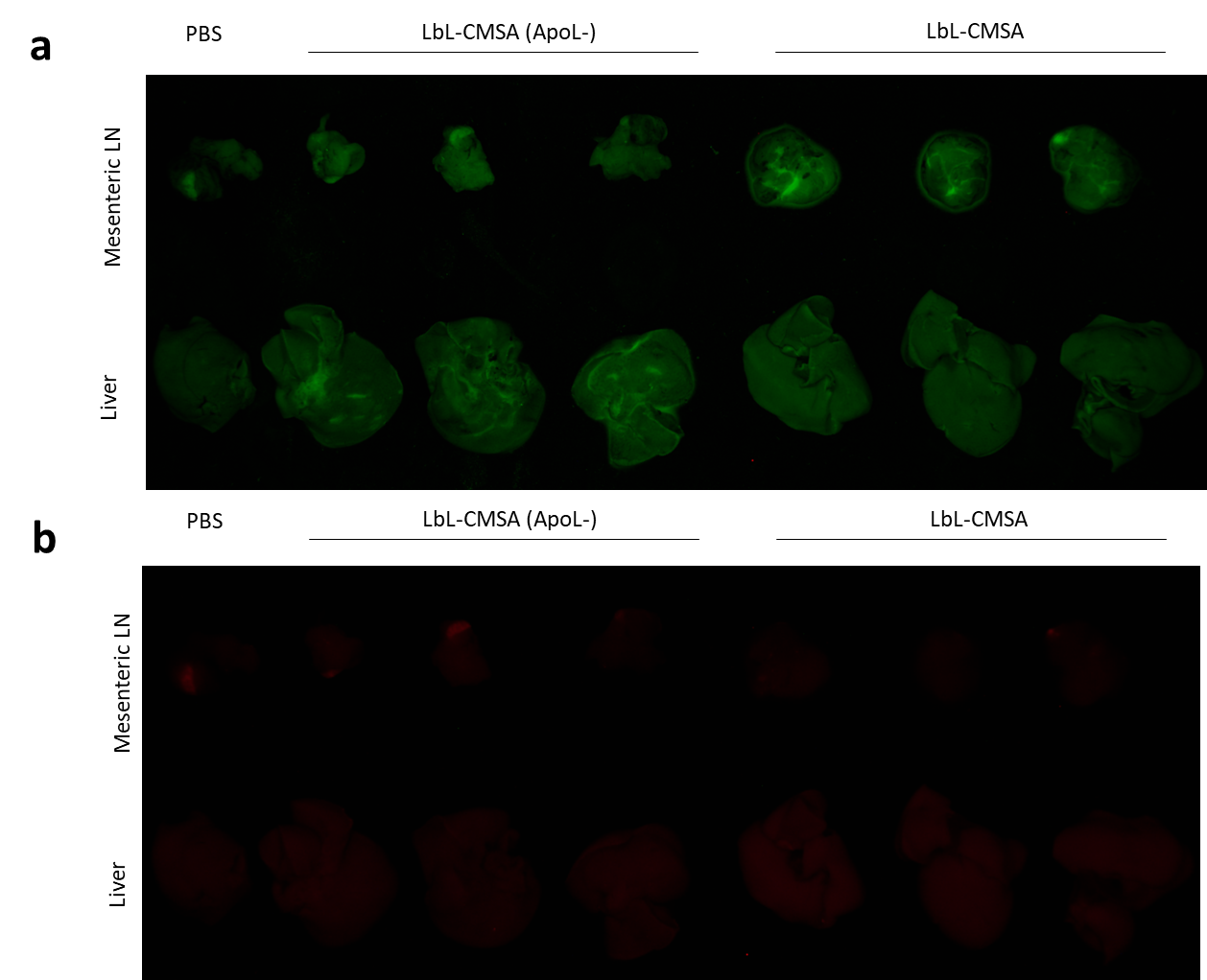
Supplementary Figure 22. Apolipoprotein mediated mesenteric lymph node draining of LbL-CMSA. a, b, Fluorescence imaging of liver and mesenteric lymph nodes 4 h after oral administration of LbL-CMSA and LbL-CMSA (ApoL-). sh(FABP4/5) were labeled with FITC (a) and siFABP2 were labeled with Cy5.5 (b)

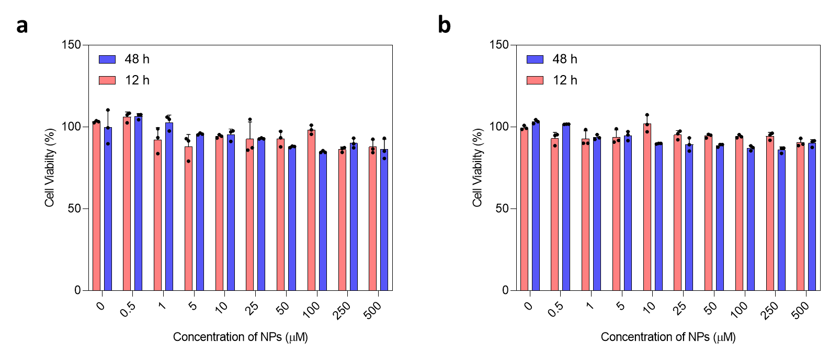
Supplementary Figure 23. in vitro cytotoxicity test of LbL-CMSA. Cell viability of caco-2 (a) and 3T3-L1 (b) were analyzed by CCK-8 assay after treatment of LbL-CMSA. Data are presented as means ± SD.
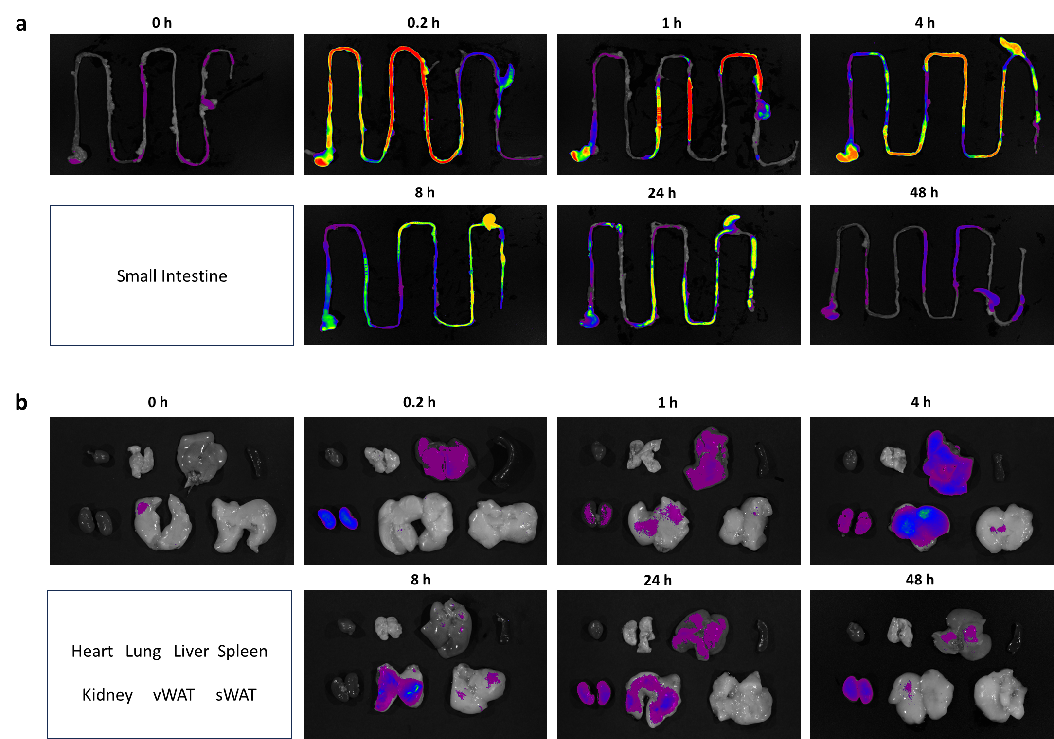
Supplementary Figure 24. siFABP2 and shFABP(4/5) target small intestine and adipose tissue via LbL-CMSA. Fluorescence image of siFABP2 in small intestines and major organs after oral administration of LbL-CMSA. sh(FABP4/5) were labeled with FITC and siFABP2 were labeled with Cy5.5.
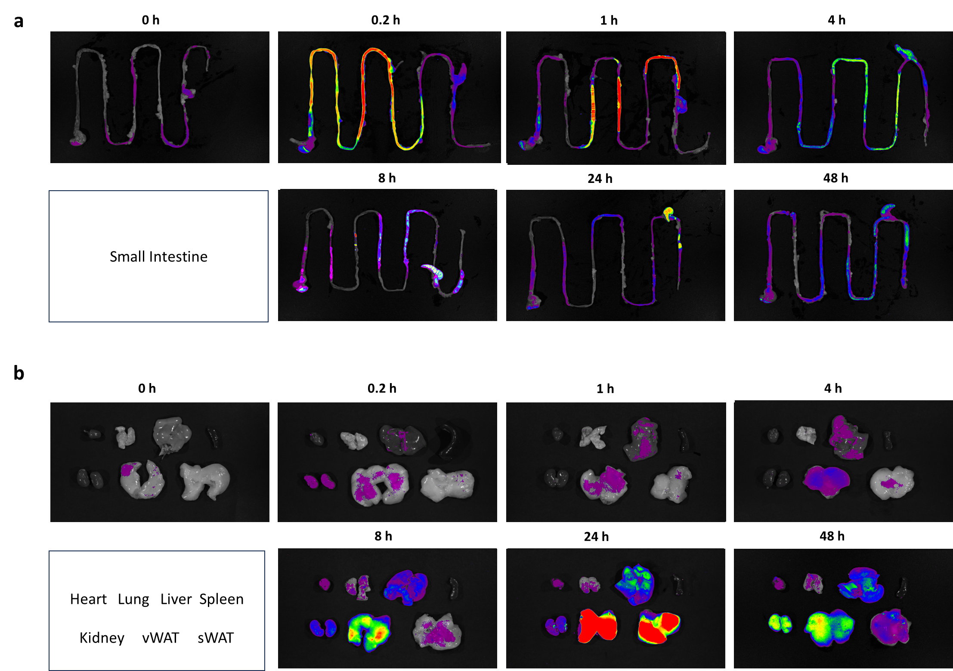
Supplementary Figure 25. siFABP2 and shFABP(4/5) target small intestine and adipose tissue via LbL-CMSA. Fluorescence image of sh(FABP4/5) in small intestines and major organs after oral administration of LbL-CMSA. sh(FABP4/5) were labeled with FITC and siFABP2 were labeled with Cy5.5..
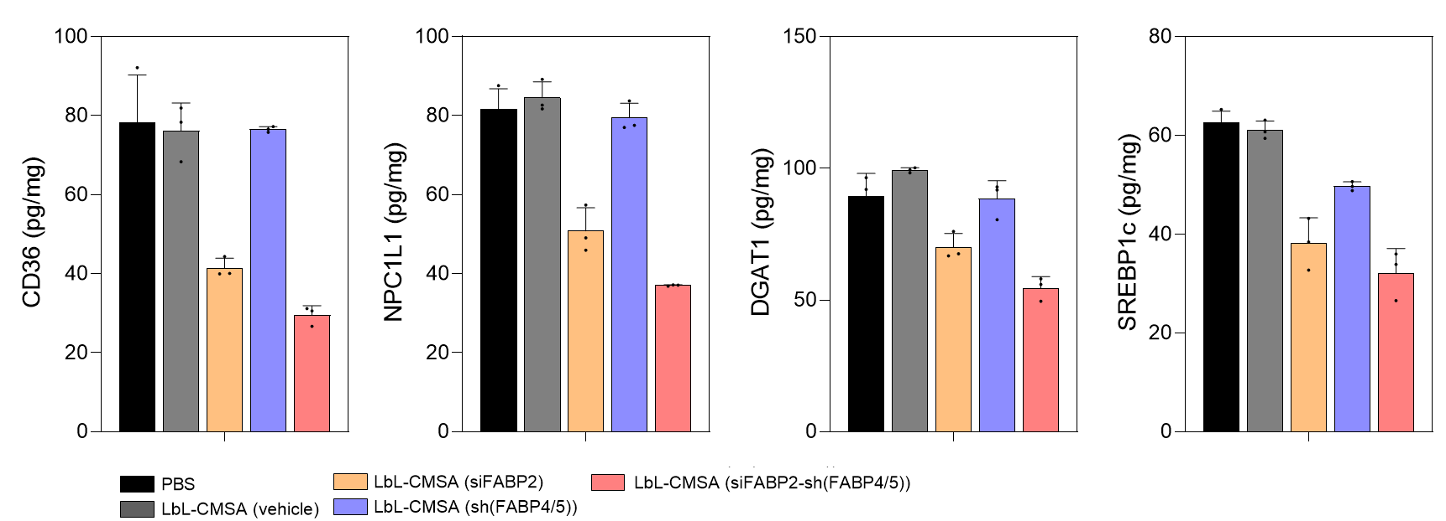

Supplementary Figure 26. FABP2 inhibition affects protein expression in small intestine. Relative protein expression levels of lipid metabolism-related genes (CD36, NPC1L1,DGAT1, and SREBP1c, in the small intestine. The protein levels measured by ELISA were normalized to that of total protein levels
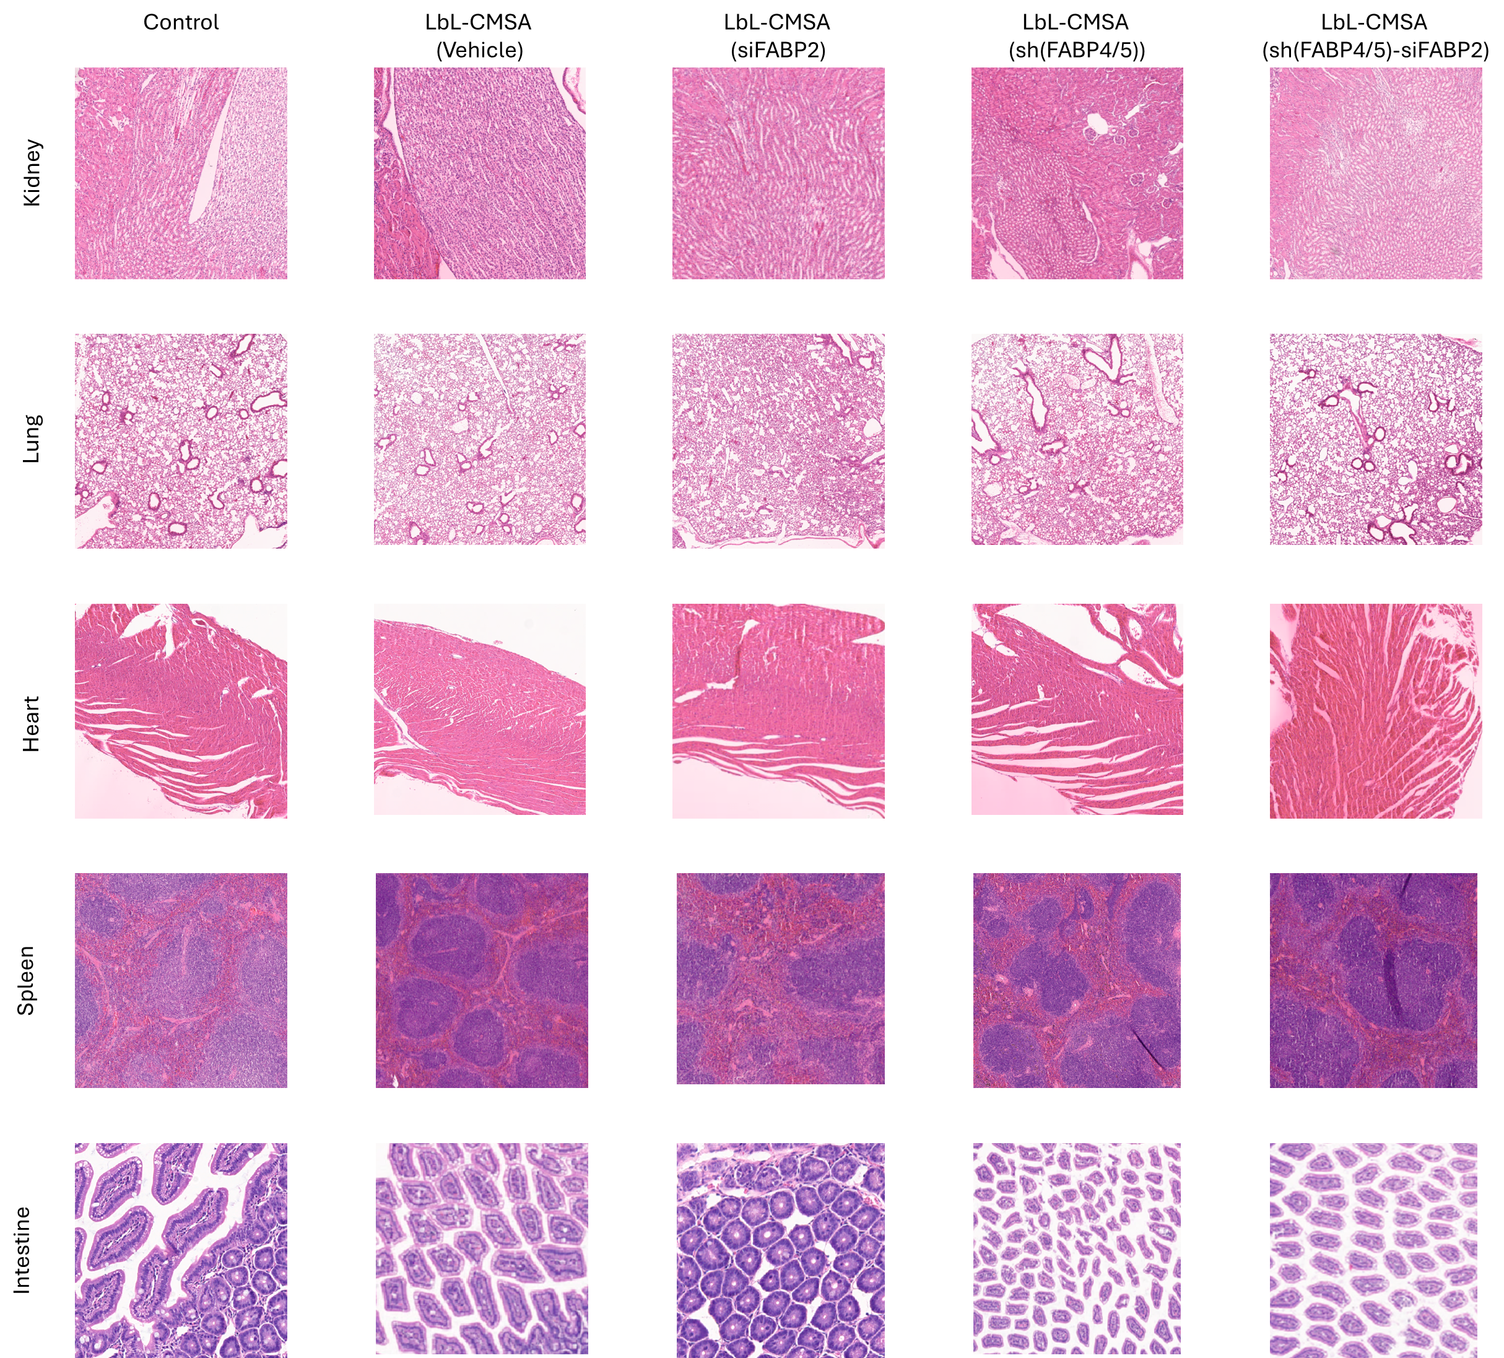
Supplementary Figure 27. Safety assessment after repeated oral administration of LbL-CMSA. At study termination animals were euthanized and heart, spleen, lung, kidney, liver and representative sections of the gastrointestinal tract were collected and fixed in 10 percent neutral buffered formalin. Fixed tissues were processed, paraffin embedded, sectioned at 4 µm and stained with hematoxylin and eosin.

Supplementary Figure 28. Layer-by-Layer Chylomicron-mimicking self-assembly (LbL-CMSA, encapsulated with pHO1 and siMLCK1. Zeta average (d.nm) and zeta potential (mV) of nanoparticles prepared in each step.

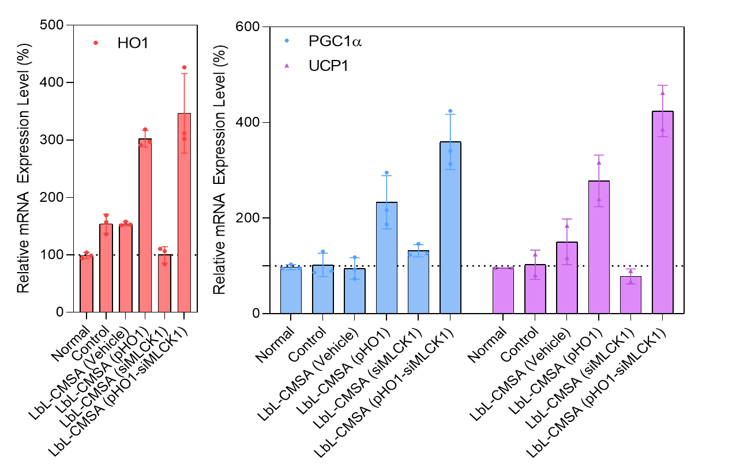
Supplementary Figure 29. Attenuation of adipose inflammation by LbL-CMSA carrying pHO-1 and siMLCK1 in a Transwell system. Quantification of RNA expression in LPS-induced differentiated adipocytes.

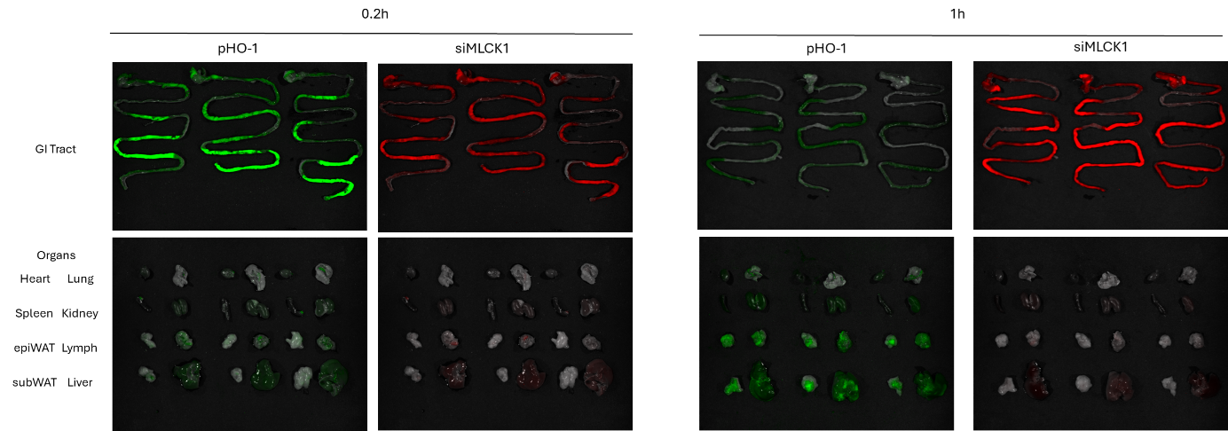
Supplementary Figure 30. siMLCK1 and pHO1 target small intestine and liver/adipose tissue via LbL-CMSA. Fluorescence image of genetic materials in small intestines and major organs after oral administration of LbL-CMSA. pHO1were labeled with FITC and siMLCK1 were labeled with Cy5.5
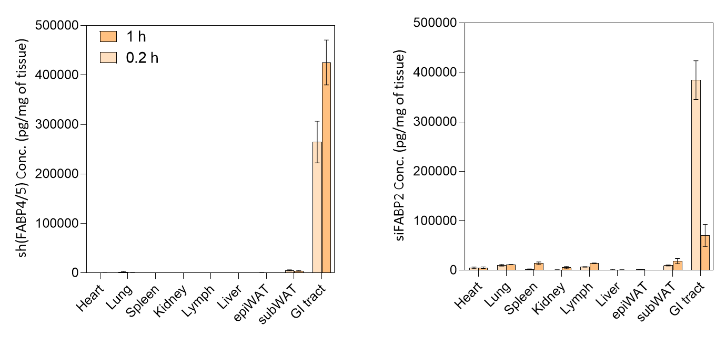
Supplementary Figure 31. siMLCK1 and pHO1 target small intestine and liver/adipose tissue via LbL-CMSA. Biodistribution kinetics of siMLCK1 and pHO1 analyzed via RT-qPCR after the oral administration of LbL-CMSA in MASLD model.
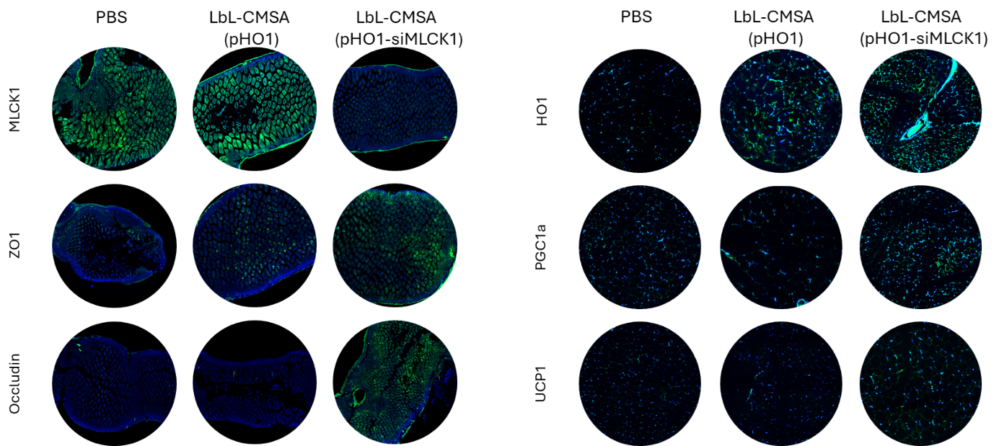
Supplementary Figure 32. Restoration of intestinal barrier function and attenuation of liver and adipose inflammation by oral LbL-CMSA carrying pHO-1 and siMLCK1 in a diet induced MASLD model. Immunofluorescence staining of MLCK1, ZO1 and Occludin in the small intestine, and HO1, PGC1a, and UCP1 in the visceral adipose tissue embedded in paraffin. Section thickness = 6 μm. Scale bar = 200 μm.
Supplementary Note 1 : To test whether LbL-CMSA can be repurposed to interrupt a pathogenic gut–liver axis in metabolic associated steatotic liver disease (MASLD), we replaced the therapeutic genes with an outer siMLCK1 layer and an inner pHO-1 plasmid core (Supplementary Fig. 28). MLCK1 regulates perijunctional actomyosin contraction and tight-junction opening, and its upregulation has been linked to diet-induced “leaky gut” and hepatic exposure to luminal endotoxin (Extended Data Fig.1a). In parallel, HO-1 is a cytoprotective, anti-fibrotic effector in liver and adipose tissue. Because PHB is overexpressed in damaged liver in MASLD, PBP9R-mediated targeting enables concurrent adipose and liver access, motivating a single oral scaffold that locally repairs barrier failure while systemically dampening oxidative stress and fibrogenic signaling.
Apical LPS treatment of Caco-2/HT29 Transwell cultures induced tight-junction disruption and epithelial inflammation, including downregulation of ZO-1 and occludin and promotes upregulation of pro-inflammatory mediators. Addition of siMLCK1-bearing LbL-CMSA restored tight-junction transcripts toward baseline and suppressed inflammatory genes, translating into reduced apical-to-basolateral endotoxin flux as measured by LAL assay (Extended Data Figs.1b,c). In a complementary hepatocyte model, pHO-1-containing LbL-CMSA attenuated LPS-driven fibrotic and inflammatory programs in HepG2 cells, consistent with restraint of TGF-β–linked extracellular matrix deposition and oxidative stress (Extended Data Figs.1d). pHO-1 delivery also increased HO-1 and brown-adipogenic markers in differentiated 3T3-L1 adipocytes, supporting a metabolically favorable, anti-inflammatory reprogramming of adipose tissue (Supplementary Fig. 29).
We next evaluated the reprogrammed formulation in a MASLD model with CCl₄ to augment fibrosis. Consistent with PHB-associated targeting, PBP9R-containing LbL-CMSA distributed to adipose tissue and liver (Supplementary Figs. 30–31). The combination regimen LbL-CMSA (pHO-1–siMLCK1) improved systemic indices, including reduced body-weight gain without food-corrected energy intake and lowered fasting blood glucose versus vehicle (Extended Data Figs.1e). We first focused on the intestine and quantified intestinal permeability and mucosal penetration to define the local effects on the gut barrier. Oral administration of FITC-dextran revealed that siMLCK1-containing regimens reduced FITC-dextran leakage into the circulation, with the combination group displaying the lowest permeability values (Extended Data Figs.1f). Small intestinal profiling revealed increased barrier markers (Zo1, Ocln and select claudins) together with decreased Mlck1 and inflammatory cytokines (Extended Data Figs.1g and Supplementary Fig. 32). Circulating biomarkers of microbial translocation and barrier failure (LBP, sCD14 and D-lactate) were elevated in MASLD controls and improved most prominently in the combination group, supporting reduced gut-derived inflammatory load reaching the liver (Extended Data Figs.1h).
In the liver, HFHFD feeding produced steatosis, lobular inflammation and collagen deposition. single-payload LbL-CMSA (pHO-1) mitigated aspects of pathology, whereas the combination group showed the most normalized hepatic architecture and the greatest reduction in fibrotic staining (Extended Data Figs.1i). Transcript analyses showed broad suppression of lipogenic (Srebp1c, Fasn), inflammatory (Tnf, Il1b) and fibrogenic (Tgfb1, Col1a1, Acta2) mediators, alongside increased HO-1 and antioxidant programs under combination therapy (Extended Data Figs.1j). Consistently, hepatic hydroxyproline was lower in the combination group than with single pHO-1, and serum ALT, AST and ASP were reduced, indicating attenuated hepatocellular injury (Extended Data Figs.1k,l). Flow cytometry further revealed reduced inflammatory macrophage burden and a shift toward a less pro-fibrogenic phenotype, accompanied by higher activities of anti-ROS enzymes (Extended Data Figs.1m,n) and larger decreases in circulating inflammatory/fibrogenic cytokines (Extended Data Figs.1o). Systemic lipid profiles (triglycerides and cholesterol fractions) improved in the combination group (Extended Data Figs.1p). Finally, WAT exhibited reduced inflammatory markers and increased brown-adipogenesis/mitochondrial gene expression, with adipokines normalized toward a less pro-diabetogenic pattern (Extended Data Figs.1q,r and Supplementary Fig. 32).
Collectively, substituting intestinal siMLCK1 and systemic pHO-1 for the original FABP payloads demonstrates that the same LbL-CMSA scaffold can be reprogrammed to reinforce the intestinal barrier while concurrently suppressing hepatic and adipose inflammation and fibrosis, highlighting a modular oral platform for targeting gut–organ axes in chronic metabolic and fibrotic disease.

