Supplementary Data

Quality assessment of Cranberry (Vaccinium macrocarpon) based food supplements:
TLC, HPLC and PAC quantification as effective tools for quality management

Alexa Brouns¹, Matthias Lechtenberg¹, Andreas Hensel¹*

Affiliation
¹ Institute of Pharmaceutical Biology and Phytochemistry, University of Münster, Corrensstraße 48, D-48149 Münster, Germany

*Corresponding author:
Prof. Dr. Andreas Hensel, University of Münster, Institute of Pharmaceutical Biology and Phytochemistry, Corrensstraße 48, D-48149 Münster, Germany. Tel.: +49 251 8333381; Fax: not available; Email: ahensel@uni-muenster.de

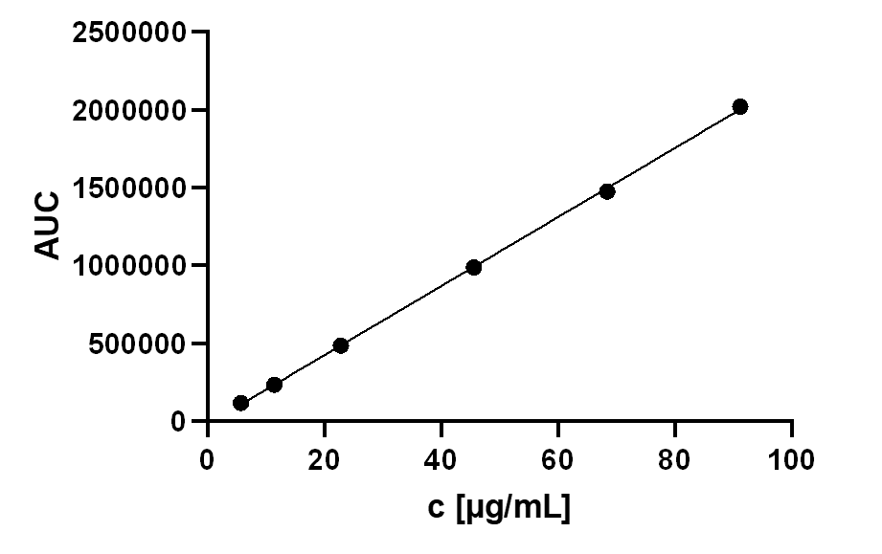
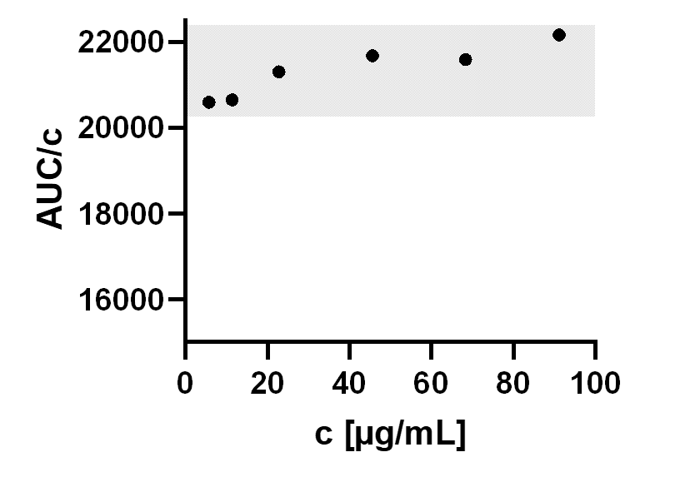

Calibration | Linearity between 5 to100 µg/mL  R² = 0.9997
System precision | Q [%] = 0.54 (n = 6)
Recovery rate | 100.7 ± 1.7 % (n = 3)

Figure S1: Validation data for HPLC protocol for determination of anthocyanins from Vaccinium macrocarpon fruits (cranberries) using Pn3Gal as representative analyte.
Left: Linearity of detection signals and regression for Pn3Gal;
Right: mean value ± 5 % shadowed in grey color.

Figure S2: Linearity of detection signals at λ = 620 nm and regression of procyanidin A2

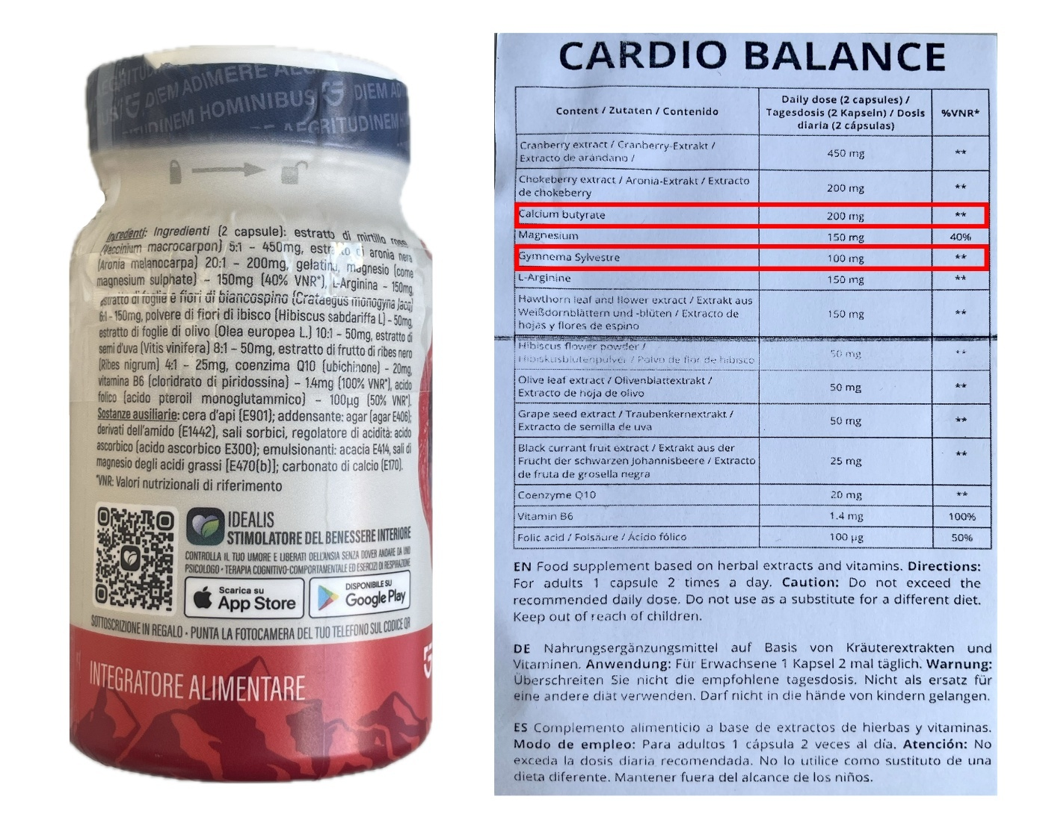Figure S3: Deficiency in product declaration of cranberry food supplements. Tests sample #10, which represents a combination of different plants extracts and other ingredients revealed strong differences in the declaration of the product concerning the information given on the primary packaging material and the information leaflet. The two marked ingredients, specified on the product leaflet, have not been specified on the capsules box. From this point of view product #10 does not meet the legal requirements concerning information of the consumer.

