Supplementary Table 1: Average change in minimum temperature (Tmin) during grain filling at the ESWYT nurseries test sites. Yield data represent the average nursery yield reported within a country, and yield losses are expressed as a percentage of the reported yield. The data cover 42 years, from 1979 until 2021.
 | Change in TMin | Yield | Yield loss | Yield loss
Country | grain filling (℃) | (t/ha) | (t/ha) | (%)
Afghanistan | 1.29 | 5.611 | 0.646 | 11.8
Argentina | 0.83 | 5.234 | 0.416 | 8.0
Bangladesh | 0.69 | 4.715 | 0.342 | 7.5
Bolivia (Plurinational State of) | 0.99 | 2.412 | 0.493 | 40.7
Brazil | 0.73 | 4.563 | 0.364 | 8.3
Canada | 0.09 | 4.830 | 0.043 | 0.9
Chile | 0.18 | 8.964 | 0.091 | 1.1
China | 1.81 | 6.126 | 0.902 | 15.4
Czechia | 2.71 | 7.294 | 1.352 | 18.5
Egypt | 1.36 | 8.020 | 0.680 | 8.9
Eswatini | 0.34 | 2.726 | 0.167 | 6.1
Ethiopia | 1.04 | 6.298 | 0.519 | 8.2
Greece | 2.20 | 6.133 | 1.098 | 17.9
India | 0.95 | 4.855 | 0.473 | 9.9
Indonesia | 0.29 | 3.398 | 0.146 | 4.3
Iran (Islamic Republic of) | 1.35 | 6.599 | 0.676 | 10.6
Iraq | 1.59 | 6.363 | 0.793 | 14.1
Israel | 1.10 | 6.550 | 0.550 | 8.4
Italy | 1.67 | 8.638 | 0.835 | 10.1
Japan | 0.95 | 3.548 | 0.473 | 13.3
Libya | 1.54 | 8.859 | 0.768 | 8.7
Madagascar | 0.61 | 6.794 | 0.306 | 4.5
Mauritius | 0.97 | 5.309 | 0.482 | 9.1
Mexico | 1.02 | 5.828 | 0.510 | 10.2
Mongolia | 1.36 | 2.907 | 0.680 | 23.4
Morocco | 2.04 | 7.301 | 1.021 | 15.2
Myanmar | 0.82 | 2.663 | 0.412 | 16.9
Nepal | 0.68 | 5.278 | 0.338 | 10.0
New Zealand | 0.60 | 9.422 | 0.301 | 3.2
Nigeria | 0.87 | 5.158 | 0.433 | 7.7
Pakistan | 1.53 | 4.713 | 0.765 | 16.6
Paraguay | 0.57 | 3.890 | 0.285 | 7.7
Poland | 2.48 | 6.486 | 1.238 | 19.8
Portugal | 1.68 | 6.815 | 0.837 | 12.3
Qatar | 1.66 | 5.321 | 0.831 | 15.6
Saudi Arabia | 1.94 | 6.257 | 0.968 | 17.9
Serbai | 1.61 | 6.497 | 0.807 | 12.4
South Africa | 1.05 | 6.747 | 0.526 | 7.8
Spain | 2.14 | 8.155 | 1.069 | 13.5
Sudan | 2.50 | 3.171 | 1.248 | 42.7
Syrian Arab Republic | 2.09 | 6.263 | 1.045 | 16.7
Tanzania | 0.36 | 2.823 | 0.181 | 6.4
Thailand | 0.28 | 2.352 | 0.140 | 5.5
Türkiye | 1.62 | 7.118 | 0.810 | 11.5
Zambia | 0.73 | 6.012 | 0.362 | 6.6
Zimbabwe | 0.66 | 7.161 | 0.331 | 4.7

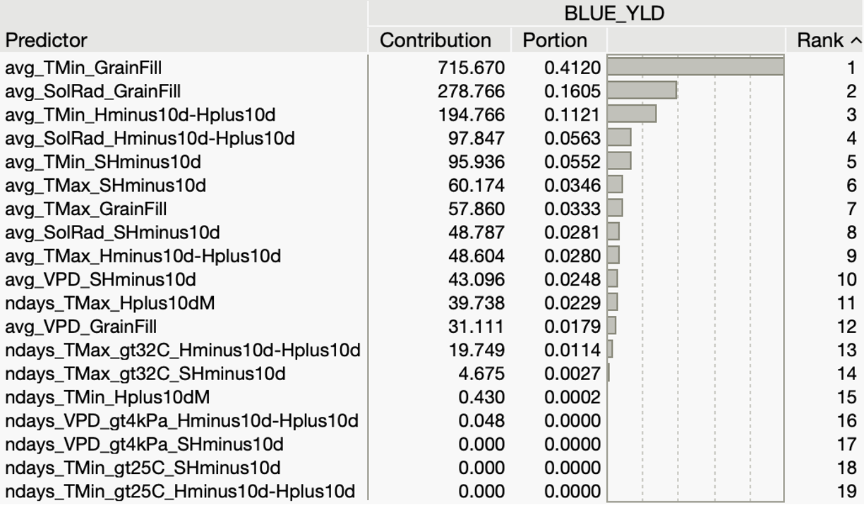
Supplementary Fig. 1: Prediction power of environmental variables to estimate grain yield at 850 site-years. Variables represent three periods: 1) sowing to heading minus 10 days (SHMinus10d), 2) heading minus 10 days to heading plus 10 days (HMinus10d-Hplus10d), and 3) heading plus 10 days to maturity (Hplus10dM). The last period represents grain filling.

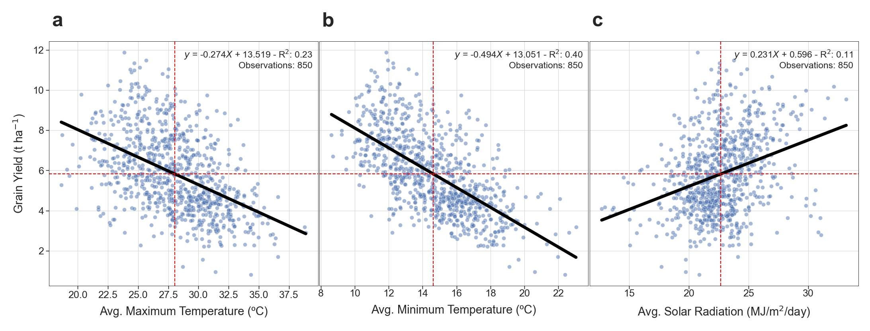
Supplementary Fig. 2: Prediction of wheat yield at 850 site-years as a function of a) daily average maximum temperature, b) minimum temperature and c) solar radiation observed during the grain filling period.

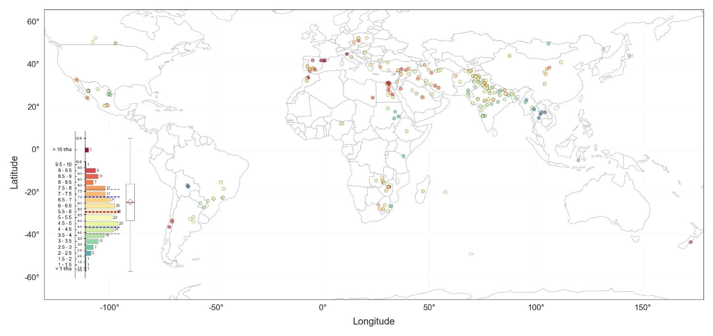
Supplementary Figure 3: Observed average yield at 255 spring wheat nursery test sites.

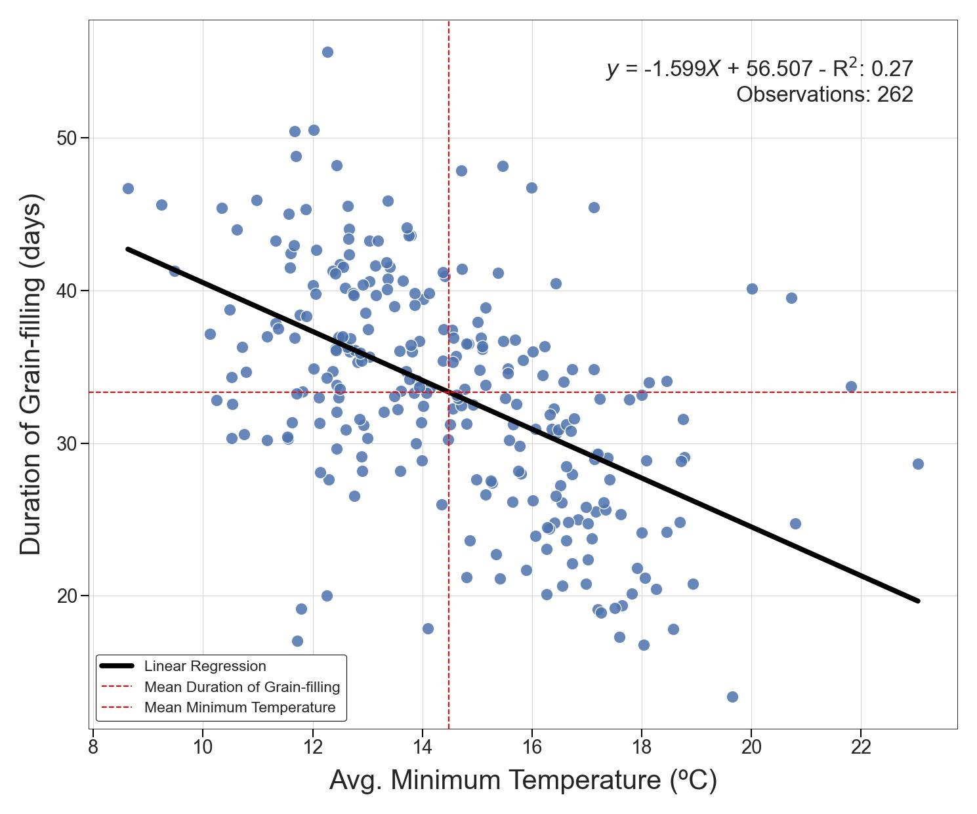
Supplementary Figure 4: Effect of minimum temperature during grainfilling on the number of reported days between heading and maturity at 262 site-years.

