Supporting Information for
Merging bioinspired incubation with supramolecular photocatalysis for Michaelis CO₂ reduction beyond enzymes
Xin Xu, Junkai Cai,* Qiaojia Guo, Peng Wang, and Chunying Duan*
State Key Laboratory of Coordination Chemistry, Nanjing University, Nanjing 210023, People’s Republic of China.
*Corresponding Authors. Email: jkcai@nju.edu.cn; cyduan@dlut.edu.cn.

Table of Contents
1. General Methods and Syntheses 3
1.1 Reagents and Materials 3
1.2 Experimental instruments 3
1.3 Experimental conditions and test methods 4
1.4 Experimental parameter computational formulas 5
1.5 Syntheses 6
2. Single-crystal X-ray crystallography 10
3. ¹H NMR Spectra 21
4. ESI-MS Spectra 27
5. Fluorescence spectra 32
6. UV−vis Spectra 46
7. Electrochemical Measurements 53
8. Photocatalytic Studies 60
8.1 Photocatalytic CO₂ reduction 60
8.2 Photocatalytic oxidative cyclization: General procedure and product characterization 91
9. Supplementary References 115

1. General Methods and Syntheses

1.1 Reagents and Materials
All reagents were purchased and used directly without further purification unless otherwise specified. 1,3-Dimethyl-2-phenyl-2,3-dihydro-1H-benzimidazole (BIH, 97.0%), tris(2-phenylpyridine)iridium (III) (Ir(ppy)₃, 98.0%), 2,2,2-trifluoroethanol, pyrrole (99.0%), benzaldehyde (99.0%) were all purchased from Energy Chemical Co., Ltd.. Methyl p-formylbenzoate (98.0%) was purchased from Bide Pharmatech Co., Ltd, bis(cyclo-pentadienyl) zirconium dichloride (98.0%) was purchased from Accela ChemBio Co., Ltd., hydrochloric acid (37.0%) and KOH (≥85.0%) were purchased from Sinopharm Chemical Reagent Co., Ltd., and iron(II) chloride tetrahydrate (FeCl₂·4H₂O, 98.0%) was purchased from Alfa Aesar Co., Ltd.. Propionic acid (≥99.5%), trichloromethane (99.0%), methanol (≥99.5%), ethanol (≥99.7%), diethyl ether (99.5%), and petroleum ether (99.5%) were all purchased from Nanjing Chemical Reagent Co., Ltd.. Tetrahydrofuran (THF, 99.9%), N, N-dimethylformamide (DMF, >99.5%), dichloromethane (99.9%), 1,3,5-trimethoxybenzene (98.0%), o-phenylenediamine (98.0%), 2-aminophenol (99.0%), 2-aminothiophenol (97.0%), acetonitrile (AR, ≥99.9%), 4-fluoro-benzaldehyde (98.0%), 4-chlorobenzaldehyde (97.0%), 4-(tert-butyl)benzaldehyde (97.0%), 4-methoxybenzaldehyde (99.0%), and 4-methylbenzaldehyde (98.0%) were purchased from Energy Chemical Co., Ltd.. CO₂ and Ar were purchased from Nanjing Special Gas Factory Co., Ltd.

1.2 Experimental instruments
The crystal data were collected on the Bruker D8 Venture X-ray diffractometer in Bruker AXS, Germany. The fluorescence spectra were measured on the Horiba FL-3 fluorescence spectrophotometer at room temperature. The fluorescence lifetimes were measured employing time correlated single photon counting on an Edinburgh FLS1000 instrument. Ultraviolet−visible (UV−vis) data were collected by Shimadzu UV3600 spectrometer. A typical three-electrode system was used to collect electrochemical data on CHI 760F electrochemical workstation. Nuclear magnetic resonance (NMR) data were obtained on Bruker Avance Ⅲ 400M spectrometer, and the peak frequency was based on the internal standard (tetramethylsilane, TMS) shift of 0.0 ppm. Electrospray ionization mass (ESI-MS) spectra were obtained by Thermo Fisher Q Exactive mass spectrometer, and methanol or acetonitrile was used as the mobile phase with a flow rate of 0.20 mL·min⁻¹. The gas chromatography data were obtained by Techcomp GC 7900 gas chromatograph. In situ FTIR experiments were conducted on a Nicolet IS50-FTIR spectrometer (Thermo Scientific) equipped with a mercury cadmium telluride detector and a custom-designed gas-tight reaction cell. Isotopically labeled reaction products were analyzed by gas chromatography-mass spectrometry (GC-MS, QP2020N, Shimadzu Corporation) equipped with a high-sensitivity quadrupole mass analyzer. The continuous-flow photoreactor system was engineered with technical support from Beijing Roger Tech, Ltd., featuring an integrated helical microfluidic module constructed from fluorinated ethylene propylene (FEP) tubing (standard o.d. 1.6 mm, i.d. 0.8 mm; residence volume: 8 mL).

1.3 Experimental conditions and test methods
General method of UV−vis absorption spectra and fluorescence spectra tests
UV−vis and fluorescence spectra were acquired in custom 1.0 cm × 1.0 cm quartz cuvettes sealed with a septum. The sample solution was saturated by bubbling with CO₂ or Ar for 10 min to rigorously exclude oxygen. A micro stir bar was placed inside the cuvette prior to measurements, followed by the addition of analytes via microsyringe.
General method of electrochemical measurements
Electrochemical measurements were performed in a standard three-electrode cell comprising a glassy carbon working electrode, an Ag/AgCl reference electrode (3.0 M KCl), and a Pt silk counter electrode (0.5 mm diameter). Prior to each measurement, the working electrode was thoroughly polished with 0.05 μm alumina powder on a polishing cloth. The electrolyte was a freshly prepared 0.10 M solution of TBAPF₆ in anhydrous DMF or CH₃CN, which was saturated by bubbling with CO₂ or Ar for 10 min. Gas flow was maintained throughout experiments, with bubbling between scans and solvent blanketing during scans. All cyclic voltammograms were recorded at a scan rate of 100 mV/s unless otherwise stated.
General method of gas phase test
Gas-phase analysis was performed using a Techcomp GC 7900 gas chromatograph to quantify carbon monoxide (CO) generated from the photocatalytic reduction of carbon dioxide (CO₂) in the photoreactor headspace. The system employed nitrogen as the carrier gas and a 0.6 m × 3.0 mm (i.d.) 5 Å molecular sieve column for separation. Hydrogen (H₂) was detected via a thermal conductivity detector (TCD) operated at 100℃, while CO and hydrocarbons were analyzed using a flame ionization detector (FID) coupled with a methane conversion unit. The injector port and chromatographic oven temperatures were maintained at 200℃ and 60℃, respectively.
In situ FTIR spectra experiment
The catalyst was uniformly dispersed as a thin film on a substrate mounted at the focal point of the reaction chamber. Prior to initiating catalysis, the system underwent rigorous purging with high-purity N₂ (30 mL·min⁻¹) to eliminate the gases in the cell and the adsorbed species on catalyst surface. Subsequently, a continuous CO₂ stream (99.999%) was introduced to establish a well-defined CO₂-dominated reactive atmosphere. Dynamic surface processes and transient intermediates were probed in real time by synchronizing mercury cadmium telluride detector-based time-resolved spectral acquisition with controlled photoexcitation conditions during photocatalytic reduction.

1.4 Experimental parameter computational formulas
Turnover number, turnover frequency, and product selectivity were calculated as follows:
$$\text{TON}\text{=}\frac{\text{n}\text{product}}{\text{n}\text{catalyst}}$$
Where $\text{n}\text{product}$ and $\text{n}\text{catalyst}$ represent the molar amounts of the target product and catalyst, respectively.
$$\text{TOF=}\frac{\text{TON}}{\text{t}}$$
TON represents turnover frequency, TON represents the turnover number, t represents the time of reactions.
$$\text{Selectivity=}\frac{\text{n}\text{target}}{\text{n}\text{total}}$$
Where $\text{n}\text{target}$ is the molar amount of the desired product, and $\text{n}\text{total}$ corresponds to the total molar amount of all products.
TON and TOF_{max} were determined under optimal conditions as follows: $$\text{TON=}\frac{\text{n}\text{CO}}{\text{n}\text{H1}}\text{=}\frac{\text{(2,072 μL)/(22.4 L·}{\text{mol}}^{-1}\text{)}}{\text{0.1 }\text{μ}\text{mol}\text{·}L^{-1}\text{ × 5 mL}}\text{=}\text{185,000}$$
(Note: Gas volume converted to moles via standard molar volume at STP; catalyst concentration scaled to total moles in 5 mL volume)
$$\text{TOF}\text{max}\text{=}\frac{\text{99,504}}{\text{10 min}}\text{=597,024 }h^{-1}$$
(Peak rate derived from initial 10-min activity; units standardized to h⁻¹)

1.5 Syntheses
Supplementary Scheme 1. The synthetic route of porphyrin ligand precursor compound 2.
Synthesis of compound 1
Compound 1 was prepared via a modified literature procedure.^{[1]} Under argon atmosphere, concentrated HCl (37.0%, 1.0 mL) was diluted in deionized water (112 mL), followed by the addition of distilled pyrrole (5.2 mL, 75.0 mmol) with vigorous stirring until a homogeneous solution formed. Benzaldehyde (2.6 mL, 25.0 mmol) was introduced dropwise over 10 min, and the reaction mixture was stirred at ambient temperature for 6 h. The resulting precipitate was isolated by vacuum filtration, washed extensively with deionized water (3 × 50 mL), and dried under reduced pressure. Purification via silica gel column chromatography (eluent: 1:1 petroleum ether/ dichloromethane) yielded compound 1 as a yellow solid (2.87 g, 51.7%). ¹H NMR (400 MHz, CDCl₃, ppm): δ 7.86 (s, 2H), 7.35–7.16 (m, 5H), 6.66 (q, J = 2.6 Hz, 2H), 6.14 (q, J = 2.8 Hz, 2H), 6.00–5.76 (m, 2H), 5.44 (s, 1H).
Synthesis of compound 2
Compound 1 (3.0 g, 13.5 mmol) was dissolved in propionic acid (100 mL). Methyl 4-formylbenzoate (2.2 g, 13.5 mmol) was added, and the reaction mixture was heated at 140°C for 2 h. After cooling to room temperature, the solvent was removed in vacuo. The crude product was washed with sat. aq. K₂CO₃ (3 × 50 mL) and brine (3 × 50 mL). The resulting solid was dissolved in CH₂Cl₂ and purified by flash column chromatography on silica gel to afford compound 2 as a purple solid (0.53 g, 10.7%). ¹H NMR (400 MHz, CDCl₃, ppm): δ 8.89–8.83 (m, 4H), 8.82–8.76 (m, 4H), 8.44 (d, J = 8.2 Hz, 4H), 8.30 (d, J = 8.2 Hz, 4H), 8.21 (d, J = 7.8 Hz, 4H), 7.76 (q, J = 7.2, 6.3 Hz, 6H), 4.11 (s, 6H), −2.79 (s, 2H). ESI-MS: calculated for C₄₈H₃₅N₄O₄ [2 + H]⁺, m/z = 731.27, found: 731.27.
Supplementary Scheme 2. The synthetic route of iron porphyrin ligand L^{Fe}.
Synthesis of compound L^{H}
Compound 2 (1.0 g, 1.37 mmol) was dissolved in a mixture of tetrahydrofuran and methanol (50 mL each). Aqueous KOH solution (40%, 40 mL) was added, and the reaction mixture was stirred at 90°C for 20 h. After cooling to room temperature, the solution was acidified to pH 3 with concentrated HCl, followed by addition of deionized water (100 mL). The aqueous layer was separated and extracted with chloroform (3 × 100 mL). The solvent was evaporated under reduced pressure to obtain purple solid product L^{H} with a yield of 32.3%. ¹H NMR (400 MHz, DMSO-d₆, ppm): δ 13.31 (s, 2H), 8.85 (s, 8H), 8.37 (q, J = 8.2 Hz, 8H), 8.23 (dd, J = 7.3, 1.7 Hz, 4H), 7.84 (q, J = 5.4 Hz, 6H), −2.93 (s, 2H). ESI-MS: calculated for C₄₆H₂₉N₄O₄ [L^{H} − H]⁻, m/z = 701.22, found: 701.22.
Synthesis of ligand L^{Fe}
Compound L^{H} (0.17 g, 0.24 mmol) and FeCl₂·4H₂O (0.48 g, 2.4 mmol) were dissolved in DMF (80 mL). The reaction mixture was heated at 130°C for 12 h under nitrogen atmosphere. After cooling to room temperature, the solvent was removed in vacuo. The crude product was washed with warm water (50°C) until the filtrate was colorless and dried in vacuo. The resulting purple solid was dissolved in methanol, filtered, and concentrated in vacuo to afford L^{Fe} as a purple solid (0.15 g, 78.3%). ESI-MS: calculated for C₄₆H₂₇ClFeN₄O₄ [L^{Fe} − H]⁻, m/z = 790.11, found: 790.11.
Synthesis of metal-organic capsule H1
Cp₂ZrCl₂ (0.04 mmol, 11.7 mg) was dissolved in H₂O (0.3 mL) under ultrasonic-cation for 10 min. To this solution was added a mixture of ligand L^{Fe} (0.02 mmol, 15.9 mg) in DMF (2.0 mL) and THF (1.0 mL). After additional ultrasonication (10 min), the reaction mixture was heated at 65°C for 12 h. Upon cooling to room temperature, the product was washed with DMF, affording purple block-shaped crystals H1. The crystals were subsequently washed with Et₂O and dried in vacuo for a yield of 60.6%. ESI-MS: calculated for C₁₆₈H₁₁₅N₁₂O₂₀Zr₆Fe₃Cl₃ [H1]²⁺, m/z = 1720.4902, found: 1720.4905.
Synthesis of substrate 1a and 3a
Supplementary Scheme 3. The synthetic route of substrate 1a and 3a.
Substrates for C–N coupling 1a and C–O coupling 3a were prepared using a similar method. In a 10 mL Schlenk flask purged with argon, o-phenylenediamine or 2-aminophenol (0.40 g, 3.70 mmol) was dissolved in anhydrous ethanol (4.0 mL) at 50°C. To this solution, benzaldehyde (0.20 g, 1.85 mmol) in ethanol (1.0 mL) was added dropwise with maintained heating. After stirring at 0°C for 1 h, the reaction mixture was warmed to ambient temperature. Purification by column chromatography on basic alumina with a hexane/ethyl acetate gradient eluent afforded 1a (0.25 g, 68.9%) as a yellow oil and 3a (0.30 g, 82.3%) as colorless crystals.
Synthesis of substrate 1b−1f
Supplementary Scheme 4. The synthetic route of substrate 1b−1f.
Imine derivatives 1b−1f were synthesized under green conditions using water as the sole solvent. Reactions were conducted in 50 mL round-bottom flasks charged with aldehyde (2.0 mmol), benzene-1,2-diamine (2.0 mmol, 0.23 g), and thiourea (0.29 mmol, 0.02 g) dissolved in deionized water (10 mL). The mixtures were sonicated in an ultrasonic bath at 60°C for optimized durations, with reaction progress monitored by thin-layer chromatography (TLC) using ethyl acetate/hexane (3:7 v/v) as the eluent system. Upon completion, sonication was terminated and the mixture was diluted with additional deionized water (10 mL). Subsequent stirring at ambient temperature for 5 min induced product precipitation, followed by isolation via filtration. The solid products were washed repeatedly with deionized water to remove residual reactants and dried thoroughly. This solvent-free protocol afforded target compounds 1b−1f as yellow solids in isolated yields exceeding 90%.

2. Single-crystal X-ray crystallography
X-ray single crystal diffraction data were collected on a Bruker D8 Venture CCD diffractometer. The available data were collected and integrated by the program APEX4, and the intensity data were corrected by Lp factor and empirical absorption. The structure was solved by the direct method of SHELXTL version5.1 and refined by full-matrix least-squares refinement on F² using SHELXL-2018/3.
Single-crystal X-ray analysis of H1 revealed dark purple rhomboidal blocks crystallizing in the monoclinic system. In the structural refinement of H1, all the non-hydrogen atoms were refined anisotropically. Hydrogen atoms within the ligand backbones, two DMF molecules were fixed geometrically at calculated distances and allowed to ride on the parent non-hydrogen atoms. To assist the stability of refinements, carbon, nitrogen, and oxygen atoms were restrained to be similar. In addition, the SQUEEZE subroutine in PLATON was used for refinements.^{[2]} Hydrogen atoms were placed in calculated positions and refined using a riding model. Full crystallographic parameters are provided in Supplementary Table 1.

Supplementary Fig. 1. An ORTEP plot of the coordination capsule H1, showing 30% probability displacement ellipsoids of non-hydrogen atoms. Hydrogen atoms, anions and solvents are omitted for clarity. Symmetry code: ¹1-x, +y, 1-z; ²1-x, +y, 2-z.
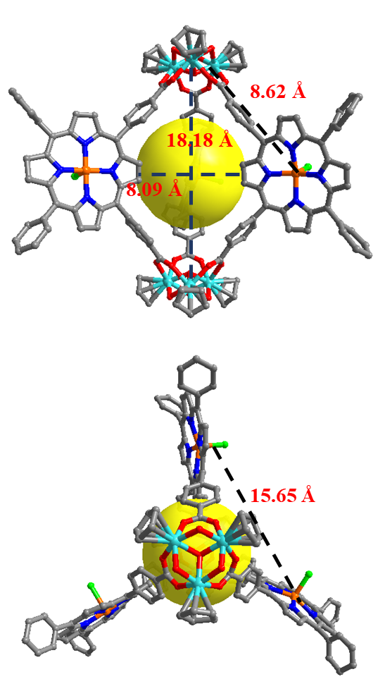
Supplementary Fig. 2. The structure of H1 displays the geometric shape of zirconium ion coordination and its potential pocket cavity (Zr cyan, Fe orange, Cl green, C gray, N blue, and O red).
Supplementary Fig. 3. The coordination configuration of iron core, showing 30% probability displacement ellipsoids of atoms. Selected bond distances (Å) and angles (°): Fe2-N4 2.014(13), Fe2-N5 2.098(11), Fe2-N6 2.107(13), Fe2-N7 2.113(10), Fe2-Cl1 2.229(5), N4-Fe2-Cl1 101.6(4), N5-Fe2-Cl1 103.4(4), N6-Fe2-Cl1 107.9(4), N7-Fe2-Cl1 102.5(4).
Supplementary Fig. 4. The coordination configuration of the Zr-oxo cluster, showing 30% probability displacement ellipsoids of atoms. Selected bond distances (Å) and angles (°): Zr4-O11 2.109(9), Zr4-O13 2.176(10), Zr4-O14 2.115(12), Zr4-O15 2.218(10), Zr4-O19² 2.198(11), O11-Zr4-O13 71.9(4), O11-Zr4-O14 73.4(4), O11-Zr4-O15 81.5(4), O11-Zr4-O19² 78.5(4), O11-Zr4-Zr5 35.7(3), O11-Zr4-Zr6 37.3(2), O13-Zr4-Zr5 36.7(3), O13-Zr4-Zr6 85.2(3), O19²-Zr4-Zr5 75.9(3), O19²-Zr4-Zr6 114.3(3), Zr5-Zr4-Zr6 59.98(4). Symmetry code: ¹1-x, +y, 1-z; ²1-x, +y, 2-z.
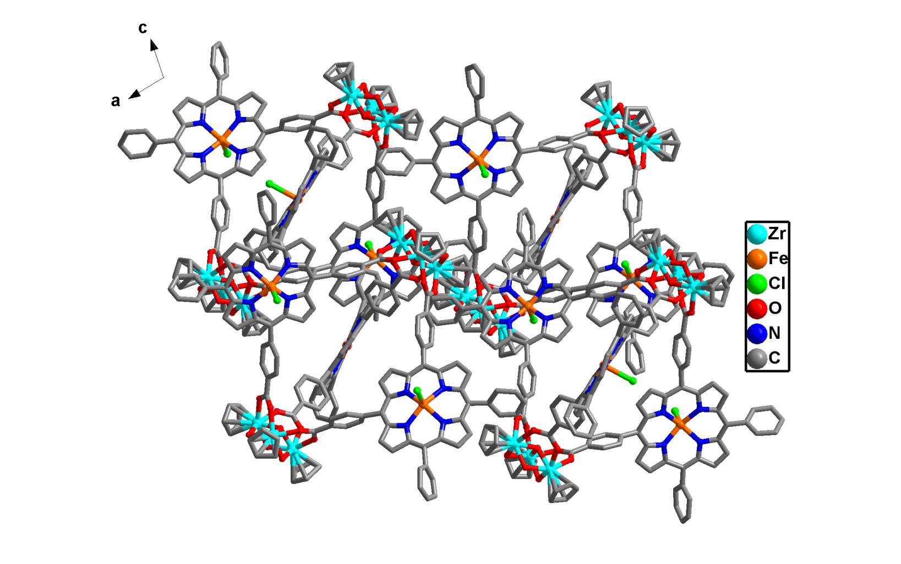
Supplementary Fig. 5. Crystal packing model of capsule H1 with counterions viewed from the b-axis. Hydrogen atoms and solvent molecules were omitted for clarity.
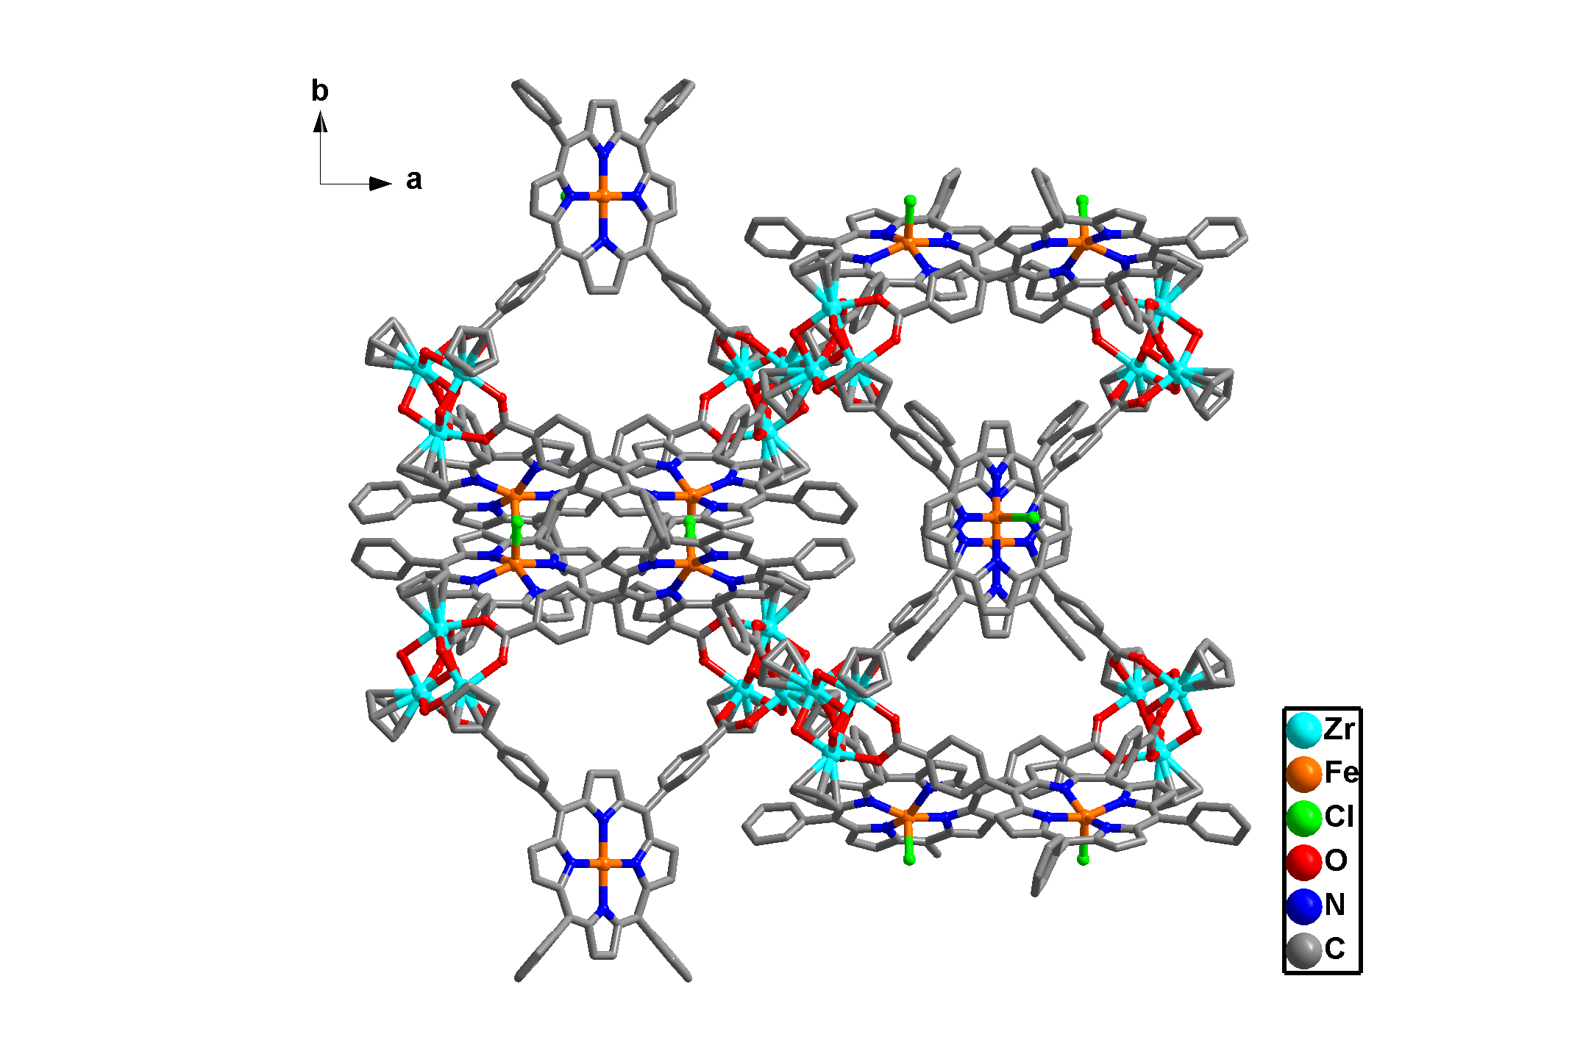
Supplementary Fig. 6. Crystal packing model of capsule H1 with counterions viewed from the c-axis. Hydrogen atoms and solvent molecules were omitted for clarity.
Supplementary Table 1. Crystal data and structure refinement details of H1
Compound | H1
CCDC number | 2454987
Formula | C₁₆₈H₁₁₅N₁₂O₂₀Zr₆Fe₃Cl₃
formula weight, fw | 7758.32
Temperature, T [K] | 193(2)
crystal system | monoclinic
space group | C2(5)
a [Å] | 37.098(2)
b [Å] | 29.5954(16)
c [Å] | 23.5807(13)
α [º] | 90
β [º] | 102.756(3)
γ [º] | 90
V [Å³] | 25251(2)
Z | 2
ρ [g cm⁻³] | 1.020
μ [mm⁻¹] | 4.196
θ range | 1.921 − 68.423
F(000) | 7852
Radiation | CuKα (λ = 1.54178)
Crystal size / mm³ | 0.25 × 0.23 × 0.21
Index ranges | −44 ≤ h ≤ 38, −35 ≤ k ≤ 35, −28 ≤ l ≤ 28
Independent reflections | 45636 [R_{int} = 0.0683, R_{sigma} = 0.0752]
Data/restraints/parameters | 45636/1424/2131
goodness-of-fit, GOF | 0.983
R₁ª [I> 2σ (I)] | 0.0754
wR₂ (all data) | 0.2253
ªR₁ = ||F_{o}| – |F_{c}||/|F_{o}|. ^{b}wR₂ = [ w(|F_{o}²| – |F_{c}²|²)/w|F_{o}²|²]^{1/2}.
Supplementary Table 2. Selected bond lengths [Å] for H1
Bond | Length [Å] | Bond | Length [Å]
Zr1-O1 | 2.041(11) | Zr3-O7 | 2.193(9)
Zr1-O2 | 2.073(10) | Zr3-C11 | 2.596(16)
Zr1-O3 | 2.188(11) | Zr3-C12 | 2.524(13)
Zr1-O8 | 2.164(8) | Zr3-C13 | 2.549(17)
Zr1-O9¹ | 2.242(9) | Zr3-C14 | 2.484(18)
Zr1-C1 | 2.493(16) | Zr3-C15 | 2.556(18)
Zr1-C2 | 2.486(17) | Zr4-O11 | 2.109(9)
Zr1-C3 | 2.565(19) | Zr4-O19² | 2.198(11)
Zr1-C4 | 2.498(14) | N5-C32 | 1.333(19)
Zr1-C5 | 2.467(14) | N3-C77¹ | 1.343(19)
Zr1-Zr3 | 3.3473(19) | O17-C86 | 1.274(18)
Zr1-Zr2 | 3.351(2) | N10-C109 | 1.328(18)
Zr2-O1 | 2.050(11) | O3-C62 | 1.240(19)
Zr2-O4 | 2.217(11) | Fe1-N1 | 2.08(2)
Zr2 O5 | 2.190(10) | Fe1-N2¹ | 1.998(15)
Zr2-O7 | 2.070(10) | Fe1-N3 | 2.04(2)
Zr2-O8 | 2.123(10) | Fe2-Cl1 | 2.229(5)
Zr2-C6 | 2.501(13) | Fe2-N4 | 2.014(13)
Zr2-C7 | 2.479(15) | Fe2-N5 | 2.098(11)
Zr2-C8 | 2.524(17) | Fe2-N6 | 2.107(13)
Zr2-C9 | 2.572(16) | Fe2-N7 | 2.113(10)
Zr2-C10¹ | 2.551(18) | Fe3-Cl2 | 2.218(6)
Zr2-Zr3 | 3.346(2) | Fe3-N8 | 2.077(14)
Zr3-O1 | 2.113(10) | Fe3-N9 | 2.010(13)
Zr3-O2 | 2.155(10) | Fe3-N10 | 2.104(12)
Zr3-O6 | 2.156(10) | Fe3-N11 | 2.038(11)
Symmetry code: ¹1-x, +y, 1-z; ²1-x, +y, 2-z.
Supplementary Table 3. Selected bond angles [°] for H1
Bond | Bond Angles [°] | Bond | Bond Angles [°]
Zr3-Zr1-Zr2 | 59.93(4) | O10¹-Zr3-O7 | 153.0(4)
O8-Zr1-O3 | 84.3(4) | O1-Zr3-O7 | 72.1(4)
O8-Zr1-Zr2 | 38.1(3) | O1-Zr3-O6 | 79.9(4)
O8-Zr1-Zr3 | 87.0(2) | O1-Zr3-O10¹ | 81.5(4)
O8-Zr1-O9¹ | 152.4(4) | O1-Zr3-O2 | 71.6(4)
O3-Zr1-O9¹ | 85.6(4) | O2-Zr3-O7 | 91.6(4)
O9¹-Zr1-C1 | 74.8(6) | O2-Zr3-O6 | 150.6(4)
O1-Zr1-O8 | 72.8(4) | O2-Zr3-O10¹ | 85.0(4)
O1-Zr1-O2 | 74.7(4) | N10-Fe3-Cl2 | 103.0(4)
O1-Zr1-O3 | 80.3(4) | N8-Fe3-Cl2 | 103.8(4)
O1-Zr1-O9¹ | 80.3(4) | N8-Fe3-N10 | 153.2(5)
O2-Zr1-O8 | 93.4(4) | N11-Fe3-Cl2 | 103.4(4)
O2-Zr1-O3 | 154.5(4) | N11-Fe3-N10 | 86.6(5)
O2-Zr1-C1 | 110.5(7) | N11-Fe3-N8 | 87.4(5)
O2-Zr1-C2 | 78.1(5) | N5-Fe2-Cl1 | 103.4(4)
O7-Zr2-O8 | 93.6(4) | N5-Fe2-N7 | 154.0(6)
O7-Zr2-O5 | 87.4(4) | N5-Fe2-N6 | 85.7(5)
O7-Zr2-O4 | 155.6(4) | N7-Fe2-Cl1 | 102.5(4)
O1-Zr2-O7 | 75.9(4) | N4-Fe2-Cl1 | 101.6(4)
O1-Zr2-O8 | 73.5(4) | N2¹-Fe1-N3 | 89.0(5)
O1-Zr2-O5 | 81.2(4) | N2-Fe1-N3 | 89.0(5)
O1-Zr2-O4 | 79.9(4) | N2¹-Fe1-N1 | 91.0(5)
O5-Zr2-O4 | 85.6(4) | N2-Fe1-N2¹ | 178.0(10)
O10¹-Zr3-O7 | 153.0(4) | N12²-Fe4-Cl3² | 89.1(5)
O6-Zr3-O7 | 86.4(4) | N12²-Fe4-N14 | 89.9(4)
O6-Zr3-O10¹ | 83.7(4) | N13-Fe4-Cl3² | 90.38(17)
Symmetry code: ¹1-x, +y, 1-z; ²1-x, +y, 2-z.
The DFT computation
All geometry optimizations were performed with the Gaussian 16 software, employing density functional theory (DFT) at the B3LYP/6-31G*(D3BJ) level in the gas phase. Initial binding modes for the host-guest complexes were explored with AutoDock 4.2.6, and the resulting structures underwent a final optimization at the same level of theory.
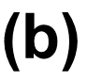
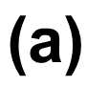
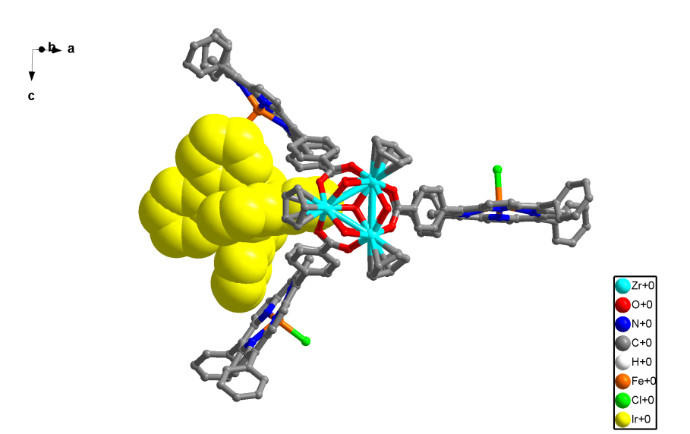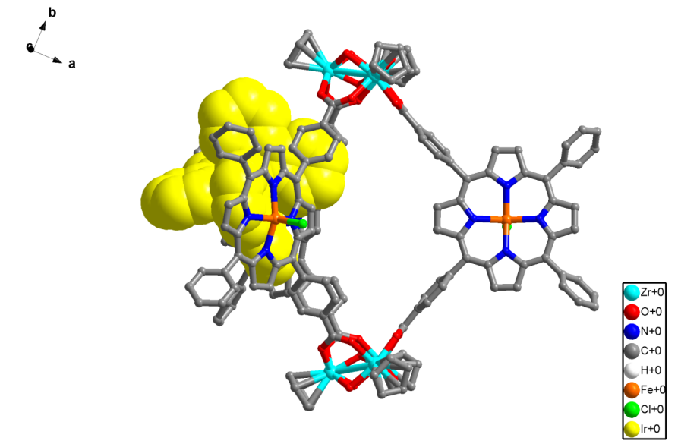
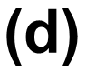

Supplementary Fig. 7. (a–d) DFT calculations of the H_{Ir} host-guest complex revealed that the Ir(ppy)₃ guest spontaneously positioned at cleft binding sites of the host, and was stabilized by π stacking interactions with the shortest interplanar separation of 3.26 Å and hydrogen bonding interactions with the C−H···O separation being 2.70 Å. Zr cyan, Fe orange, Cl green, C gray, N blue, O red, Ir yellow, H white.

3. ¹H NMR Spectra
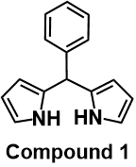
Supplementary Fig. 8. ¹H NMR (400 MHz) spectrum of compound 1 in CDCl₃. ¹H NMR (400 MHz, CDCl₃, ppm): δ 7.86 (s, 2H), 7.35–7.16 (m, 5H), 6.66 (q, J = 2.6 Hz, 2H), 6.14 (q, J = 2.8 Hz, 2H), 6.00–5.76 (m, 2H), 5.44 (s, 1H).

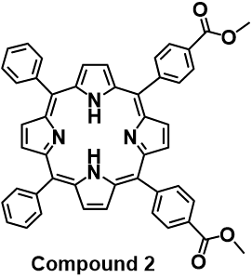
Supplementary Fig. 9. ¹H NMR (400 MHz) spectrum of compound 2 in CDCl₃. ¹H NMR (400 MHz, CDCl₃, ppm): δ 8.89–8.83 (m, 4H), 8.82–8.76 (m, 4H), 8.44 (d, J = 8.2 Hz, 4H), 8.30 (d, J = 8.2 Hz, 4H), 8.21 (d, J = 7.8 Hz, 4H), 7.76 (q, J = 7.2, 6.3 Hz, 6H), 4.11 (s, 6H), −2.79 (s, 2H).

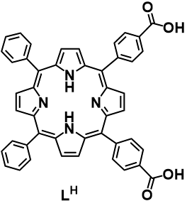
Supplementary Fig. 10. ¹H NMR (400 MHz) spectrum of precursor L^{H} in DMSO-d₆. ¹H NMR (400 MHz, DMSO-d₆, ppm): δ 13.31 (s, 2H), 8.85 (s, 8H), 8.37 (q, J = 8.2 Hz, 8H), 8.23 (dd, J = 7.3, 1.7 Hz, 4H), 7.84 (q, J = 5.4 Hz, 6H), −2.93 (s, 2H).

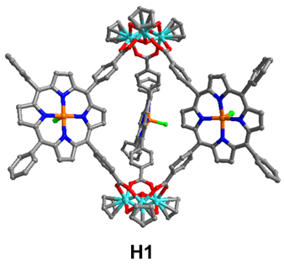
Supplementary Fig. 11. ¹H NMR spectrum (400 MHz, CD₃OD) of capsule H1, exhibiting paramagnetic broadening signals due to the existence of ferric iron on porphyrin units.

Supplementary Fig. 12. ¹H NMR spectral changes (400 MHz, CD₃CN) of a mixture of BIH (20.0 mM) and Ir(ppy)₃ (0.10 mM) under Ar upon 420 nm photo-incubation for 5 min. The signals marked in the green box are assigned to the oxidation of BIH to BI⁺.
Supplementary Fig. 13. ¹H NMR spectral changes (400 MHz, CD₃CN) of a mixture of 1a (10.0 mM) and Ir(ppy)₃ (0.10 mM) under Ar, upon photo-incubation at 420 nm for 3 min. The signals marked in the green box are assigned to the oxidized species generated on the pathway from 1a to 4a, specifically the non-dehydrogenated C–N coupled species.

4. ESI-MS Spectra
Supplementary Fig. 14. ESI-MS spectrum of ligand L^{Fe} (0.2 mM) in MeOH solution, showing the cationic species [L^{Fe}−Cl]⁺ at m/z = 756.1423 (calcd for C₄₆H₂₈N₄O₄Fe: 756.1455).

Supplementary Fig. 15. ESI-MS spectrum of capsule H1 [C₁₆₈H₁₁₅N₁₂O₂₀Zr₆Fe₃Cl₃] (0.2 mM) in MeOH solution.

Supplementary Fig. 16. Expansion of ESI-MS spectra for H1 showing the [H1−3Cl]⁵⁺ with a found mass: 667.0138, [H1−2Cl]⁴⁺ with a found mass: 842.0158, [H1−Cl]³⁺ with a found mass: 1134.6721, [H1]²⁺ with a found mass: 1720.4890.

Supplementary Table 4. ESI-MS spectrometry analysis of H1
Symbol | Formula | Charge (z) | Calculated mass (m/z) | Found
[H1−3Cl]⁵⁺ | C₁₆₈H₁₁₅N₁₂O₂₀Zr₆Fe₃ | 5 | 666.8141 | 667.0138
[H1−2Cl]⁴⁺ | C₁₆₈H₁₁₅N₁₂O₂₀Zr₆Fe₃Cl | 4 | 842.2600 | 842.0158
[H1−Cl]³⁺ | C₁₆₈H₁₁₅N₁₂O₂₀Zr₆Fe₃Cl₂ | 3 | 1134.6698 | 1134.6721
[H1]²⁺ | C₁₆₈H₁₁₅N₁₂O₂₀Zr₆Fe₃Cl₃ | 2 | 1719.4895 | 1720.4890

Supplementary Fig. 17. ESI-MS spectra of H1 (0.5 mM) and the equimolar mixture of H1 and Ir(ppy)₃ [H_{Ir}, C₂₀₁H₁₃₈N₁₅O₂₀Zr₆Fe₃IrCl₃] (0.5 mM) in MeOH solution. The inserts show the measured and simulated isotopic patterns of the peaks at m/z = 1720.4887 and 2047.0673.

5. Fluorescence spectra
Supplementary Fig. 18. (a) Emission spectra of Ir(ppy)₃ (50.0 µM) in CH₃CN solution upon addition of H1 (total [H1] = 1.0 µM). Spectra were recorded under Ar (λ_{ex} = 420 nm; λ_{em} = 525 nm). (b) The Hill-plot fitting of the titration curve showing a 1:1 host-guest behavior between H1 and Ir(ppy)₃ with an association constant calculated as 1.05 × 10⁵ M⁻¹.

Supplementary Fig. 19. Fluorescence spectra of Ir(ppy)₃ (50.0 μM) in CH₃CN solution under CO₂ atmosphere upon sequential addition of H1 (total 1.0 μM) and BIH (total 1.0 mM). Spectra were recorded with excitation at 420 nm and emission at 525 nm.

Supplementary Fig. 20. (a) The emission spectra of Ir(ppy)₃ (50.0 μM) in CH₃CN solution under CO₂ atmosphere upon addition of BIH (total 100 μM). (b) The Stern-Volmer fitting of the titration curve at 525 nm with an associated quenching constant calculated as 1.78 × 10⁴ M⁻¹. Spectra were recorded with excitation at 420 nm and emission at 525 nm.

Supplementary Fig. 21. Luminescence decay profiles in CH₃CN solution: Ir(ppy)₃ (0.10 mM), τ = 1.17 μs (red); H_{Ir} (0.10 mM Ir(ppy)₃ and 0.10 μM H1), τ = 1.05 μs (green); H_{Ir} with added BIH (50.0 mM), τ = 0.43 μs (orange); Ir(ppy)₃ with added BIH (50.0 mM), τ = 0.42 μs (purple). All decays were monitored at 525 nm upon excitation at 380 nm.

Supplementary Fig. 22. (a) The time-dependent fluorescence spectra of typical photocatalytic systems of BIH (50.0 mM), TFE (1.0 M), and Ir(ppy)₃ (0.10 mM) in CH₃CN solution under CO₂ atmosphere during photo-incubation, the fluorescence intensity was recorded at 525 nm and excited at 420 nm. (b) Fitting of the time-dependent fluorescence intensity at λ_{em} = 525 nm during photo-incubation.
Supplementary Fig. 23. (a) The emission spectra of Ir(ppy)₃ (50.0 μM) in CH₃CN solution under CO₂ atmosphere upon addition of ascorbic acid (AA, total 0.1 mM). (b) The Stern-Volmer fitting of the titration curve at 525 nm with an associated quenching constant calculated as 8.80 × 10³ M⁻¹. Spectra were recorded with excitation at 420 nm and emission at 525 nm.

Supplementary Fig. 24. (a) The emission spectra of Ir(ppy)₃ (50.0 μM) in CH₃CN solution under CO₂ atmosphere upon addition of sodium ascorbate (SA, total 0.1 mM). (b) The Stern-Volmer fitting of the titration curve at 525 nm with an associated quenching constant calculated as 1.19 × 10⁴ M⁻¹. Spectra were recorded with excitation at 420 nm and emission at 525 nm.
Supplementary Fig. 25. (a) The emission spectra of Ir(ppy)₃ (50.0 μM) in CH₃CN solution under CO₂ atmosphere upon addition of triethylamine (TEA, total 0.1 mM). (b) The Stern-Volmer fitting of the titration curve at 525 nm with an associated quenching constant calculated as 8.10 × 10³ M⁻¹. Spectra were recorded with excitation at 420 nm and emission at 525 nm.
Supplementary Fig. 26. (a) The emission spectra of Ir(ppy)₃ (50.0 μM) in CH₃CN solution under CO₂ atmosphere upon addition of triethanolamine (TEOA, total 0.1 mM). (b) The Stern-Volmer fitting of the titration curve at 525 nm with an associated quenching constant calculated as 1.10 × 10⁴ M⁻¹. Spectra were recorded with excitation at 420 nm and emission at 525 nm.

Supplementary Table 5. Quenching efficiency of various quenchers against photoexcited Ir(ppy)₃: Stern-Volmer constants (k_{q}) and derived pseudo-first-order rates (k_{q}[Q]) under catalytic conditions
Quencher (Q) | Quenching constant (k_{q}) | k_{q}[Q]
H1 | 7.21 × 10¹¹ M⁻¹·s⁻¹ | 7.21 × 10⁵ s⁻¹
BIH | 1.53 × 10¹⁰ M⁻¹·s⁻¹ | 1.53 × 10⁶ s⁻¹
AA | 7.55 × 10⁹ M⁻¹·s⁻¹ | 6.80 × 10⁵ s⁻¹
SA | 1.02 × 10¹⁰ M⁻¹·s⁻¹ | 5.10 × 10⁵ s⁻¹
TEA | 6.95 × 10⁹ M⁻¹·s⁻¹ | 6.95 × 10⁵ s⁻¹
TEOA | 9.44 × 10⁹ M⁻¹·s⁻¹ | 2.82 × 10⁵ s⁻¹

Supplementary Fig. 27. Comparison of emission lifetimes (τ) for Ir(ppy)₃ (0.1 mM in CH₃CN) under argon atmosphere: Without additive and with 50.0 mM additions of AA, SA, TEA, TEOA, or BIH. All decays were monitored at 525 nm with excitation at 380 nm.

Supplementary Fig. 28. (a–c) Fluorescence quenching spectra of photocatalytic systems containing 1a (10.0 mM), 2a (10.0 mM), or 3a (10.0 mM) with TFE (1.0 M) and Ir(ppy)₃ (0.10 mM) under CO₂ atmosphere during photo-incubation, monitored at 525 nm (λ_{ex} = 420 nm). (d) The fluorescence decay kinetics at 525 nm for substrates 1a, 2a, and 3a, respectively, during photo-incubation.

Supplementary Fig. 29. (a) Emission spectral changes of Ir(ppy)₃ (50.0 μM) upon addition of 1a (total 50.0 μM). (b) The Stern-Volmer fitting of the titration curve at 525 nm with an associated quenching constant calculated as 1.67 × 10⁴ M⁻¹. Spectra were recorded with excitation at 420 nm and emission at 525 nm.

Supplementary Fig. 30. Fluorescence titration experiments of H_{Ir} (H1/Ir(ppy)₃ = 1:1) and 1a in CH₃CN solution under CO₂ atmosphere. (a) Emission spectral changes of H_{Ir} (10.0 μM) upon addition of 1a (total 30.0 μM). (b) The Stern-Volmer fitting of the titration curve at 525 nm, providing an associated quenching constant calculated as 8.77 × 10⁴ M⁻¹ (1:1 binding model). Spectra were recorded with excitation at 420 nm and emission at 525 nm.

6. UV−vis Spectra
Supplementary Fig. 31. UV−vis absorption spectra of compound 2 (0.01 mM, green line), ligand L^{Fe} (0.01 mM, red line), capsule H1 (0.01 mM, orange line) and Cp₂ZrCl₂ (0.10 mM, blue line) in CH₃CN solution.

Supplementary Fig. 32. UV−vis titration experiments of H1 and Ir(ppy)₃ under Ar atmosphere. (a) UV−vis absorption difference spectra in CH₃CN solution containing H1 (5.0 μM) upon addition of Ir(ppy)₃ (total 3.0 μM), showing an isosbestic point at 420 nm. (b) The Hill plot of the titration curve of H1 at 412 nm after adding Ir(ppy)₃ showing the association constant calculated as 1.33 × 10⁵ M⁻¹ (1:1 binding model). (c) The differential titration spectra observed upon the addition of a pre-incubated Ir(ppy)₃ (from 0 to 0.4 μM) to H1 (3.0 μM) in CH₃CN, primarily corresponding to the host-guest complexation. (d) The differential titration spectra observed upon further addition of the pre-incubated Ir(ppy)₃ (from 1.0 to 20.0 μM), primarily reflecting the reduction of the Fe center from Fe^{III} to Fe^{I}.

Supplementary Fig. 33. UV−vis studies of a photocatalytic system containing Ir(ppy)₃ (0.10 mM), BIH (50.0 mM), and TFE (0.25 M) in CH₃CN solution under CO₂ atmosphere. (a) Time-dependent spectral changes during photo-incubation, showing an isosbestic point at 296 nm. (b) Spectral evolution during subsequent photocatalysis.

Supplementary Fig. 34. UV−vis spectral changes during direct photocatalysis (without incubation) of a system containing Ir(ppy)₃ (0.10 mM), BIH (50.0 mM), and TFE (0.25 M) in CH₃CN solution under CO₂ atmosphere, showing an isosbestic point at 296 nm.
Supplementary Fig. 35. UV−vis studies of a photocatalytic system containing Ir(ppy)₃ (0.10 mM), BIH (50.0 mM), and TFE (0.25 M) in CH₃CN solution under CO₂ atmosphere. (a) Kinetic traces of absorbance changes at 312 nm for incubation, post-incubation catalysis, and direct catalysis, respectively. (b) Comparison of UV−vis spectra for the incubated versus the non-incubated photocatalytic systems upon 420 nm LED irradiation for 6 min under CO₂ atmosphere.

Supplementary Fig. 36. UV−vis spectra recorded in photoaccumulation experiment with H1 (3.0 μM), BIH (30.0 mM), and Ir(ppy)₃ (10.0 μM) in CH₃CN solution under CO₂ atmosphere, blue LED (λ_{em} = 420 nm, 130 mW·cm⁻²), at room temperature.
Supplementary Fig. 37. UV−vis spectroscopic studies of substrate 1a in a typical photocatalytic system under CO₂ atmosphere during photo-incubation. (a) Time-dependent UV−vis spectra of a system containing 1a (10.0 mM), TFE (1.0 M), and Ir(ppy)₃ (0.10 mM) in CH₃CN solution during photo-incubation upon 420 nm LED irradiation, showing an isosbestic point at 318 nm. (b) Temporal changes of the absorbance at 380 nm.

7. Electrochemical Measurements
Supplementary Fig. 38. Cyclic voltammograms of H1 (0.25 mM) and L^{Fe} (0.75 mM) in DMF/MeOH (9:1 v/v) solution containing 0.10 M TBAPF₆. Scan Rate: 100 mV/s.
Supplementary Fig. 39. (a) Cyclic voltammograms of H1 (0.50 mM) upon addition of Et₃N·HCl in DMF/MeOH (9:1 v/v) solution containing 0.10 M TBAPF₆ under Ar atmosphere, showing the proton reduction catalytic peak. Scan rate: 100 mV/s. (b) The linear relationship between the current of Et₃N·HCl related proton reduction catalytic peaks and the concentration of Et₃N·HCl.

Supplementary Fig. 40. Cyclic voltammograms of CO₂ reduction catalyzed by H1 (0.25 mM) in DMF/MeOH (9:1 v/v) solution containing TBAPF₆ (0.10 M), recorded under CO₂ atmosphere. Scan rate: 100 mV/s.

Supplementary Fig. 41. Effect of CO₂ bubbling duration on linear sweep voltammograms of ligand L^{Fe} (0.75 mM) in DMF/MeOH (9:1 v/v) solution containing TBAPF₆ (0.10 M) under Ar atmosphere. Scan rate: 100 mV/s.

Supplementary Fig. 42. Effect of CO₂ bubbling duration on linear sweep voltammograms of H1 (0.25 mM) in DMF/MeOH (9:1 v/v) solution containing TBAPF₆ (0.10 M) under Ar atmosphere. Scan rate: 100 mV/s.
Supplementary Fig. 43. (a) Normalized square wave voltammograms of BIH and Ir(ppy)₃, respectively, in CH₃CN solution containing 0.10 M TBAPF₆, showing the different substrate-related proton reduction catalytic peaks. (b) Normalized square wave voltammograms of 0.20 mM 1a, 2a, and 3a, respectively, in CH₃CN solution containing 0.10 M TBAPF₆, showing the different substrate activated oxidation catalytic peaks. Scan rate: 100 mV/s.

Supplementary Fig. 44. Normalized square-wave voltammograms of (a) substrate 1a−1f and (b) substrate 2a−2f in CH₃CN solution containing TBAPF₆ (0.10 M), revealing the catalytic oxidation peaks of substrates. Scan rate: 100 mV/s.

8. Photocatalytic Studies

8.1 Photocatalytic CO₂ reduction
Photocatalytic CO₂ reduction experiments were performed in septum-sealed 15 mL quartz reactors equipped with a magnetic stir bar and water cooling. A standard reaction contained BIH (56.0 mg, 50.0 mM), trifluoroethanol (TFE, 90.0 μL, 0.25 M), and tris(2-phenylpyridine)iridium (III) (Ir(ppy)₃, 0.10 mM) in CH₃CN solution (4.91 mL). The reactor was sealed with a rubber plug and purged with CO₂ for 20 min. The mixture was then pre-irradiated (420 nm LED) under vigorous stirring at 25℃ for 15 min photoactivation prior to catalyst injection (named incubation). After activation, H1 (10.0 μL, 0.05 mM in methanol) was injected through the septum with a microsyringe. Headspace gas (100.0 μL aliquots) was periodically sampled using a gastight syringe and analyzed by GC-FID. Control experiments under identical conditions with Ar-purged systems confirmed CO₂ as the exclusive carbon source (no CO detected). Control experiments with ¹³CO₂ further confirmed the exclusive derivation of CO from carbon dioxide, as evidenced by the detection of ¹³CO (m/z = 29) via GC-MS.
Supplementary Fig. 45. Comparison of TON for CO production under different concentrations of H1. Standard photocatalysis conditions: Ir(ppy)₃ (0.10 mM), BIH (50.0 mM), and TFE (0.25 M) in CH₃CN solution with a preincubation time of 15 min and photocatalysis time of 30 min.

Supplementary Table 6. Photocatalytic activity under different catalytic conditionsª
Entry | BIH  (mM) | Cat  (μM) | TFE  (M) | Ir(ppy)₃  (mM) | CO  (μL) | H₂  (μL) | CH₄  (μL) | TON_{CO} | TOF_{CO}^{max}  (s⁻¹) | Sel_{CO}  (%)
1 | − | 0.10 | 0.25 | 0.10 | 0 | 0 | 0 | 0 | − | −
2 | 50.0 | − | 0.25 | 0.10 | 0 | 0 | 0 | 0 | − | −
3 | 50.0 | 0.10 | − | 0.10 | 24 | 0 | 0 | 2,160 | 1.81 | 99.9
4 | 50.0 | 0.10 | 0.25 | − | 22 | 0 | 0 | 1,920 | 1.75 | 99.9
5 | 50.0 | 0.10 | 0.25 | 0.10 | 1,630 | 0 | 0 | 145,520 | 165.84 | 99.9
6^{b} | 50.0 | 0.10 | 0.25 | 0.10 | 508 | 0 | 0 | 45,360 | 40.54 | 99.9
7^{c} | 50.0 | 0.10 | 0.25 | 0.10 | 0 | 0 | 0 | 0 | − | −
8^{d} | 50.0 | 0.30 | 0.25 | 0.10 | 492 | 0 | 0 | 14,652 | 21.47 | 99.9
ªReaction conditions: Ir(ppy)₃ (0.10 mM), BIH (50.0 mM), TFE (0.25 M) and H1 (0.10 μM) in CO₂-saturated CH₃CN under standard conditions for 30 min. ^{b}Non-incubation. ^{c}Ar atmosphere (CO₂-free). ^{d}Replacing H1 with ligand H₂L^{Fe} (0.30 μM).
Supplementary Fig. 46. Photocatalytic CO₂ reduction by H1 under standard catalytic conditions: Ir(ppy)₃ (0.10 mM), BIH (50.0 mM), TFE (0.25 M) and H1 (0.10 μM) in CH₃CN solution with a preincubation time of 15 min and photocatalysis time of 30 min.
Supplementary Table 7. Photocatalytic activity in different solventsª
Entry |  | Solvent | CO (μL) |  | H₂ (μL) |  | CH₄ (μL) | TON  (CO) | TON  (H₂) | Sel_{CO} (%)
1  2  3  4  5^{b}  6  7^{c}  8^{b}  9  10^{c} | MeCN  MeCN/H₂O (1:1)  MeCN/H₂O (1:4)  DMSO  DMSO  EtOH  EtOH  EtOH/H₂O (1:1)  DMF  DMF |  |  | 1,630  1.4  0  16.4  9.0  32.5  0.5  0  12.3  2.3 | 0  0.07  9.0  0  0  0  0  29.6  0  1.1 | 0  0  0  45.3  39.9  0  0  0  0.5  3.2 |  | 145,520  120  0  1,453  800  2,893  −  0  1,100  − | 0  6  201  0  0  0  −  2635  0  − | 99.9  95.2  0  26.6  18.4  99.9  −  0  96.1  −
ªReaction conditions: Ir(ppy)₃ (0.10 mM), BIH (50.0 mM), TFE (0.25 M) and H1 (0.10 μM) in CO₂-saturated CH₃CN under standard reaction conditions for 30 min. ^{b}TFE-free. ^{c}TFE and H1-free.

Supplementary Table 8. Photocatalysis under different concentrations of TFEª
Entry | TFE (M) | CO (μL) | H₂ (μL) | TON_{CO} | TON_{H2} | Sel_{CO} (%)
1  2  3  4  5  6  7  8 | 0.03  0.06  0.13  0.25  0.50  1.0  1.50  2.0 | 6.7  23.5  233  1,630  713  268  115  71 | 0  0  0  0  0  0  11.4  7.6 | 600  2,103  20,783  145,520  63,624  23,957  10,280  6,360 | 0  0  0  0  0  0  1,020  680 | 99.9  99.9  99.9  99.9  99.9  99.9  91.0  90.3
ªReaction conditions: Ir(ppy)₃ (0.10 mM) and BIH (50.0 mM) in CO₂-saturated CH₃CN, with TFE concentration varied (from 0.03 to 2.0 M) under standard reaction conditions for 30 min.

Supplementary Table 9. Photocatalysis under different concentrations of Ir(ppy)₃ª
Entry | Ir(ppy)₃ (mM) | CO (μL) | H₂ (μL) | TON_{CO} | TON_{H2} | Sel_{CO} (%)
1 | 0.05 | 912 | 0 | 81,400 | 0 | 99.9
2 | 0.08 | 1,231 | 0 | 109,880 | 0 | 99.9
3 | 0.10 | 1,630 | 0 | 145,520 | 0 | 99.9
4 | 0.15 | 883 | 0 | 78,820 | 0 | 99.9
5 | 0.20 | 683 | 0 | 61,002 | 0 | 99.9
ªReaction conditions: TFE (0.25 M) and BIH (50.0 mM) in CO₂-saturated CH₃CN, with Ir(ppy)₃ concentration varied (from 0.05 to 0.20 mM) under standard reaction conditions for 30 min.

Supplementary Table 10. Photocatalysis under different concentrations of electron donors BIHª
Entry | BIH (mM) | CO (μL) | H₂ (μL) | TON_{CO} | TON_{H2} | Sel_{CO} (%)
1 | 12.5 | 1,138 | 0 | 101,600 | 0 | 99.9
2 | 25.0 | 1,346 | 0 | 120,200 | 0 | 99.9
3 | 50.0 | 1,630 | 0 | 145,520 | 0 | 99.9
4 | 100.0 | 1,186 | 0 | 105,900 | 0 | 99.9
5 | 150.0 | 913 | 0 | 81,495 | 0 | 99.9
ªReaction conditions: TFE (0.25 M) and Ir(ppy)₃ (0.10 mM) in CO₂-saturated CH₃CN, with BIH concentration varied (from 12.5 to 150.0 mM) under standard conditions for 30 min.

Supplementary Table 11. Photocatalysis at different catalyst concentrationsª
Entry | Cat (μM) | CO (μL) | H₂ (μL) | TON_{CO} | TON_{H2} | Sel_{CO} (%)
1  2  3  4  5 | 0.025  0.05  0.10  0.20  0.40 | 137  324  1,630  2,489  4,075 | 0  0  0  0  0 | 48,880  57,920  145,520  111,110  90,950 | 0  0  0  0  0 | 99.9  99.9  99.9  99.9  99.9
ªReaction conditions: Ir(ppy)₃ (0.10 mM), BIH (50.0 mM) and TFE (0.25 M) in CO₂-saturated CH₃CN, with H1 concentration varied (from 0.025 to 0.40 μM) under standard conditions for 30 min.

Supplementary Table 12. Photocatalysis under various conditions without incubationª
Entry |  | Solvent | CO (μL) | H₂  (μL) |  | CH₄ (μL) |  | TON  (CO) |  | TON(H₂) | Sel_{CO} (%)
1  2^{b}  3^{c}  4^{d}  5  6  7^{b}  8^{d}  9^{b}  10  11  12  13^{d} | MeCN  MeCN  MeCN  MeCN  MeCN/H₂O (1:1)  MeCN/H₂O (1:4)  DMSO  DMSO  EtOH  EtOH  EtOH/H₂O (1:1)  DMF  DMF |  | 1.6  13.4  1.6  166  0.9  0  201  340  6.3  0.5  2.0  2.2  10.3 | 1.6  6.7  6.7  5.2  133  9.0  13.7  33.6  84.4  36.7  661  1.1  4.3 | 0  0  0  0  0  0  220  282  0  0  0  3.1  4.3 |  | 37  300  33  3,695  20  0  4,482  7,589  142  12  45  52  230 |  | 34  152  150  115  2,966  201  306  752  1,886  822  14,757  26  93 |  |  | 50.0  66.7  19.3  97.0  0.7  0  46.2  51.9  6.9  1.3  0.3  34.4  54.5
ªReaction conditions: All reactions were conducted non-incubation by direct addition of H1 (0.40 μM) to CO₂-saturated CH₃CN containing Ir(ppy)₃ (0.20 mM), BIH (50.0 mM), and TFE (0.20 M) for 30 min. ^{b}TFE-free. ^{c}H1-free. ^{d}TFE and H1-free.

Supplementary Table 13. Photocatalysis under different TFE concentrations without incubationª
Entry | TFE (M) | CO (μL) | H₂ (μL) | TON_{CO} | TON_{H2} | Sel_{CO} (%)
1  2  3  4  5  6  7  8 | 0.03  0.06  0.12  0.25  0.50  1.0  1.50  2.0 | 29.3  35.4  73.0  520  400  166  115  71.2 | 1.8  3.8  4.5  3.1  3.4  5.2  11.4  7.6 | 656  793  1,632  11,595  8,919  3,695  2,572  1,591 | 40  85  100  68  74  115  255  168 | 94.2  90.3  94.2  99.4  99.2  97.0  91.0  90.3
ªReaction conditions: All catalytic systems were employed non-incubation. Reactions were conducted in CO₂-saturated CH₃CN under the following conditions: Ir(ppy)₃ (0.20 mM), BIH (50.0 mM), and H1 (0.40 μM) for 30 min. The concentration of TFE was varied (0.03 to 2.0 M).

Supplementary Table 14. Photocatalysis under different Ir(ppy)₃ concentrations without incubationª
Entry | Ir(ppy)₃ (mM) | CO (μL) | H₂ (μL) | TON_{CO} | TON_{H2} | Sel_{CO} (%)
1 | 0.05 | 448 | 2.2 | 10,121 | 54 | 99.5
2 | 0.10 | 650 | 4.5 | 14,735 | 114 | 99.3
3 | 0.20 | 515 | 2.2 | 11,595 | 68 | 99.6
4 | 0.30 | 269 | 11.2 | 6,154 | 258 | 96.0
ªReaction conditions: All catalytic systems were employed non-incubation. Reactions were conducted in CO₂-saturated CH₃CN under the following conditions: TFE (0.25 M), BIH (50.0 mM), and H1 (0.40 μM) for 30 min. The concentration of Ir(ppy)₃ was varied (0.05 to 0.30 mM).

Supplementary Table 15. Photocatalysis under different BIH concentrations without incubationª
Entry | BIH (mM) | CO (μL) | H₂ (μL) | TON_{CO} | TON_{H2} | Sel_{CO} (%)
1 | 12.5 | 176 | 0.4 | 3,933 | 10 | 99.7
2 | 25.0 | 481 | 3.4 | 10,746 | 78 | 99.3
3 | 50.0 | 650 | 4.5 | 14,735 | 114 | 99.3
4 | 100.0 | 321 | 10.8 | 7,172 | 239 | 96.8
5 | 200.0 | 372 | 24.0 | 8,308 | 533 | 94.0
ªReaction conditions: All catalytic systems were employed non-incubation. Reactions were conducted in CO₂-saturated CH₃CN under the following conditions: TFE (0.25 M), Ir(ppy)₃ (0.10 mM), and H1 (0.40 μM) for 30 min. The concentration of BIH was varied (12.5 to 200.0 mM).

Supplementary Fig. 47. Comparison of TON and TOF for photocatalytic CO₂-to-CO conversions reported in the literature. Catalytic times are normalized to 1 h with the concentrations of catalysts more than 2.0 nM.

Supplementary Table 16. Catalytic systems for the light-driven CO₂-to-CO conversion reported with catalyst concentrations ≥ 2.0 nM
Catalyst | Photosensitizer | Electron donor | Solvent | Light source | Reaction time | TON_{CO} | TOF_{CO}^{max} (h⁻¹) | Sel_{CO} (%) | Reference
H1 | Ir(ppy)₃ | BIH | MeCN | blue LEDs  (λ = 420 nm) | 5 h | 362,723 | 597,024 | 99.9 | This work
CoCo | [Ru(phen)₃](PF₆)₂ | BIH | MeCN/H₂O/MeOH | Xe lamp  (λ > 420 nm) | 10 h | 14,457 | 1,440 | 95.0 | 3
FeTDHPP | CuPP | BIH | DMF | Xe lamp  (λ > 400 nm) | 23 h | 16,109 | 7,650 | 95.0 | 4
MnMes-  CO₂TFE | 4DPAIPN | BIH | DMSO | blue LEDs  (λ_{max} = 478 nm) | 48 h | 8770 | 361.8 | >99 | 5
CoTMPyP | Cu(P^P-(SO₃Na)₂)(N^N(SO₃Na)₂)]BF₄ | AscHNa | H₂O | Xe lamp  (λ > 400 nm) | 4 h | 2,680 | 2,600 | 77.0 | 6
Fe1 | PS1 | BIH | DMF | blue LEDs  (λ = 450 nm) | 10 h | 10,476 | 1,048 | 100 | 7
CoTPPS | CuInS₂ QD | NaAsc/  TCEP | H₂O | blue LEDs  (λ = 450 nm) | 95 h | 84,101 | 8,063 | >99 | 8
FePB-2(P) | Ir(ppy)₃ | BIH | MeCN | blue LEDs  (λ = 440 nm) | 1 h | 7,006 | 85,740 | 97.0 | 9
Ni(Cl)SN₃Por | [Ru(bpy)₃]Cl₂ | TEOA | MeCN/H₂O | blue LEDs  (λ = 465 nm) | 2 h | 71 | 36 | 96.4 | 10
Co(oTMPyP) | CuPS | AscHNa | H₂O | Xe lamp  (λ > 400 nm) | 12 h | 4,000 | 1170 | 90.0 | 11
Fe-NO/NC | [Ru(bpy)₃]Cl₂ | TEOA | MeCN/H₂O | Xe lamp  (λ > 400 nm) | 1 h | 1,494 | 1,494 | 70.0 | 12
Fe^{III}(L1)Cl | [Cu^{I}(bathocupoine)(x-antphos)](PF₆) | BIH | CH₃CN/  TEOA | Xe lamp  (λ > 400 nm) | 3 h | 1,500 | 989 | 96.0 | 13
Co(bpy)₂Cl₂ | BPEPy-100 | TEOA | MeCN/H₂O | Xe lamp  (λ > 420 nm) | 24 h | 2,980 | 188 | 90.0 | 14
[Fe(qpy)(OH₂)₂]²⁺ | Ir-6 | BIH | MeCN/H₂O | Xe lamp  (λ > 420 nm) | 30 h | 9150 | 341 | 98.0 | 15
CoFPc | CuBCP | BIH | MeCN/TEA | blue LEDs  (λ = 425 nm) | 2 h | 9,185 | 41,280 | ~100 | 16
Fe(II)-quaterpyridine | methylated Al(III) | BIH/  TEOA | MeCN | blue LEDs  (λ = 450 nm) | 4 h | 10,250 | 5,100 | 99.0 | 17
Co-complex | mpg-C₃N₄ | BIH/  PhOH | MeCN | Xe lamp  (λ > 400 nm) | 24 h | 128 | 5 | 98.0 | 18
NiFe | [Ru(bpy)₃]Cl₂ | BIH/TEOA | MeCN | blue LEDs  (λ = 450 nm) | 4 h | 670 | 525 | 93.0 | 19
1c | Ir(ppy)₃ | TEA | MeCN | Xe lamp | 7 h | 98,000 | 14,040 | 98.0 | 20

Data for photocatalysis
Supplementary Fig. 48. Comparison of (a) turnover number (TON_{CO}) and (b) turnover frequency (TOF_{CO}) for photocatalytic CO₂-to-CO conversion between systems with and without photo-incubation as a function of time under standard catalytic conditions: Ir(ppy)₃ (0.10 mM), BIH (50.0 mM), TFE (0.25 M), H1 (0.10 μM). Photo-incubation time: 15 min.

Supplementary Fig. 49. Comparison of TON for photocatalytic CO₂-to-CO conversion between systems with and without photo-incubation as a function of time under standard catalytic conditions with Ir(ppy)₃ (0.10 mM), BIH (50.0 mM), TFE (0.25 M), and H₂L^{Fe} (0.30 μM). Photo-incubation time: 15 min.

Supplementary Fig. 50. Photocatalytic kinetics studies of TFE concentration effects. (a) Photocatalytic CO₂ reduction experiment in CH₃CN solution as a function of the TFE concentration with Ir(ppy)₃ (0.10 mM), BIH (50.0 mM), and H1 (0.10 μM) remaining fixed. (b) Plot of initial TOF (initial 10 min) versus TFE concentration.
Supplementary Fig. 51. Photocatalytic kinetics studies of Ir(ppy)₃ concentration effects. (a) Photocatalytic CO₂ reduction experiment in CH₃CN solution as a function of the concentration of Ir(ppy)₃ with TFE (0.25 M), BIH (50.0 mM), and H1 (0.10 μM) remaining fixed. (b) Plot of initial TOF (initial 10 min) versus Ir(ppy)₃ concentration.

Supplementary Fig. 52. Photocatalytic kinetics studies of BIH concentration effects. (a) Photocatalytic CO₂ reduction experiment in CH₃CN solution as a function of the concentration of BIH with TFE (0.25 M), Ir(ppy)₃ (100 μM), and H1 (0.10 μM) remaining fixed. (b) Plot of initial TOF (initial 10 min) versus BIH concentration.
Supplementary Fig. 53. Photocatalytic kinetics studies of H1 concentration effects. (a) Photocatalytic CO₂ reduction experiment in CH₃CN solution as a function of the concentration of H1 with TFE (0.25 M), BIH (50.0 mM), and Ir(ppy)₃ (100 μM) remaining fixed. (b) Plot of initial TOF (initial 10 min) versus H1 concentration.

Supplementary Fig. 54. Kinetics of CO₂ photoreduction under varied TFE concentrations, showing pseudo-first-order rate fitting with ln(C₀/C_{t}) plotted as a function of time. C₀ represents the initial effective electron concentration, while C_{t} denotes the remaining effective electron concentration in solution after CO production. Catalytic conditions: Ir(ppy)₃ (0.10 mM), BIH (50.0 mM), TFE (0.25 M), H1 (0.10 μM) with a photo-incubation time of 15 min.

Supplementary Fig. 55. Photocatalytic kinetics of the Fe‑porphyrin monomer (H₂L^{Fe}) system under pre‑incubation conditions. (a) Photocatalytic CO₂ reduction experiment in CH₃CN as a function of Ir(ppy)₃ concentration, with fixed concentrations of TFE (0.25 M), BIH (50.0 mM), and H₂L^{Fe} (0.30 μM). (b) Plot of initial TOF (initial 10 min) versus Ir(ppy)₃ concentration. The observed first‑order dependence on photosensitizer concentration confirms that diffusion limitations remain dominant in the H₂L^{Fe} system rather than an enzymatic behavior.

Continuous-flow photoreactor system for CO₂ reduction
The continuous-flow photoreactor system was engineered with technical support from Beijing Roger Tech, Ltd., featuring an integrated helical microfluidic module constructed from fluorinated ethylene propylene (FEP) tubing (standard o.d. 1.6 mm, i.d. 0.8 mm; residence volume: 8 mL). Gas flow rates (0.8 mL·min^{–1}) were regulated by a mass flow controller, while liquid flow rates (2.0 mL·min^{–1}) were controlled via a peristaltic pump. An in-line dynamic gas-liquid mixer equipped with a micro stir bar generated segmented Taylor flow (liquid-gas-liquid) upstream of the photoreaction zone, thereby enhancing interfacial contact dynamics. A secondary peristaltic pump recirculated the post-reaction gas-liquid mixture to reactor A. Prior to irradiation, the system was purged with CO₂ for 30 min to eliminate atmospheric O₂. Under standard catalytic conditions (0.10 μM H1, 0.10 mM Ir(ppy)₃, 0.25 M TFE, and 50.0 mM BIH in 80 mL CH₃CN), the reaction mixture was pre-incubated for 15 min (420 nm LED) prior to catalysis. Unreacted CO₂ was removed through a scrubbing unit equipped with a saturated KOH aqueous solution. CO quantification was performed via water-displacement measurement using KOH-saturated solution to ensure maximal accuracy.

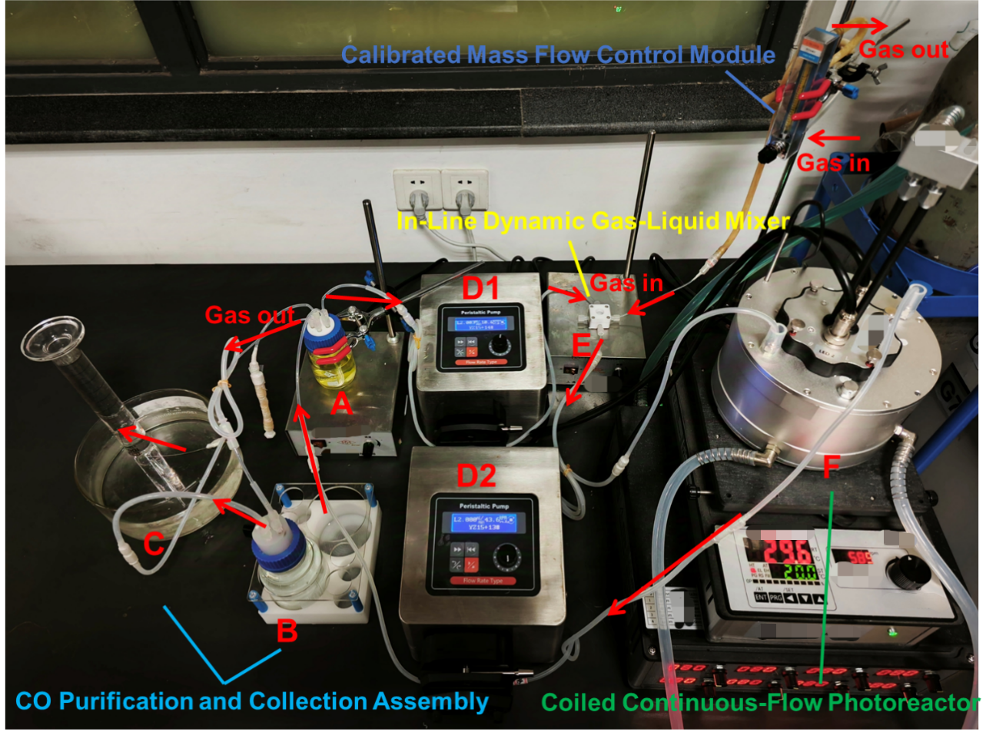
Supplementary Fig. 56. Schematic of a continuous-flow photoreactor for CO production. Photocatalytic CO₂-to-CO conversion was achieved in a coiled flow reactor upon 420 nm LED illumination. The reaction mixture contained 0.10 μM H1, 0.10 mM Ir(ppy)₃, 0.25 M TFE, 50.0 mM BIH in 80 mL CH₃CN. Gas and liquid flow rates were maintained at 0.8 mL·min^{–1} and 2.0 mL·min^{–1}, respectively, via mass flow controller and peristaltic pump.
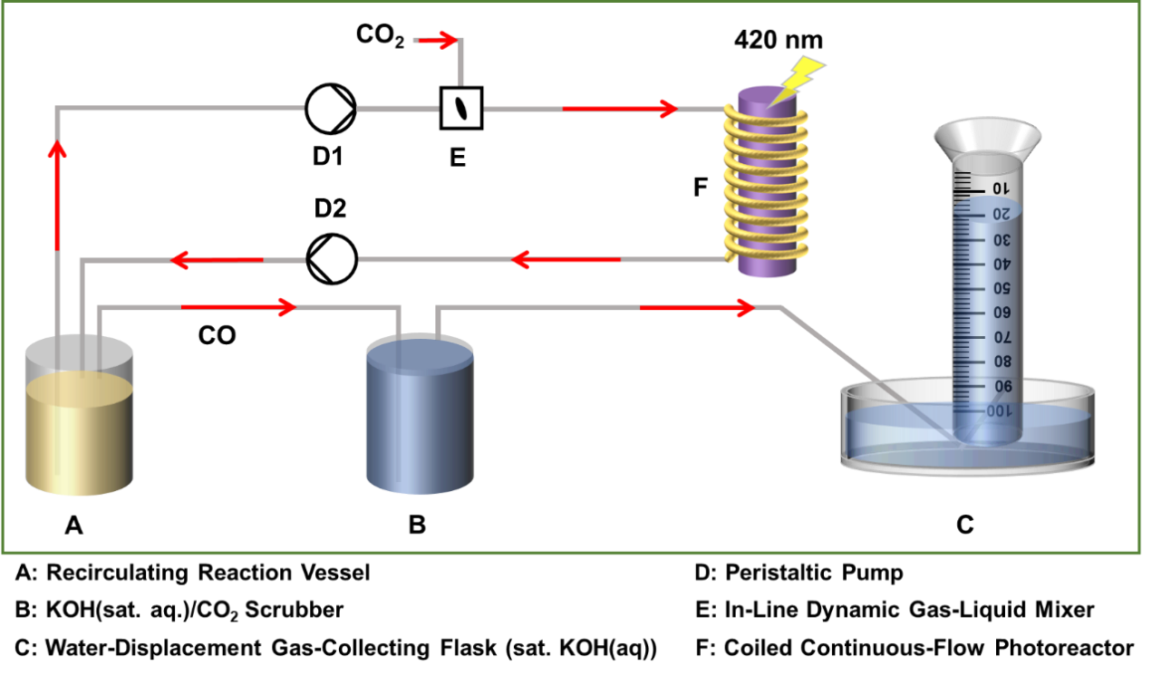
Supplementary Fig. 57. Schematic of a laboratory-scale continuous-flow photoreactor system for CO₂ reduction.
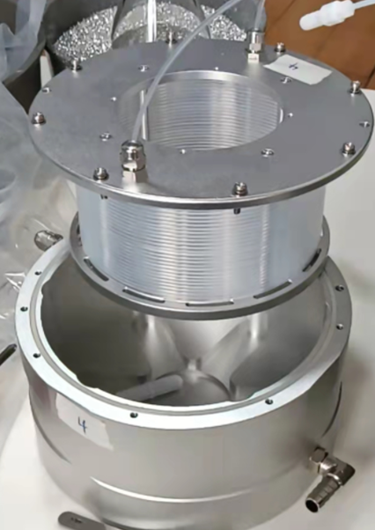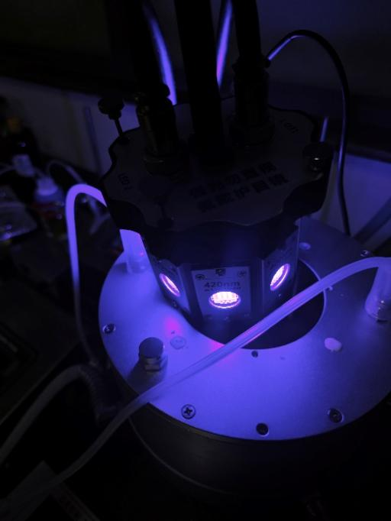
Supplementary Fig. 58. An integrated helical microfluidic module fabricated from fluorinated ethylene propylene (FEP) tubing (standard o.d. 1.6 mm, i.d. 0.8 mm; residence volume: 8.0 mL) assembled with a light source consisting of eight identical blue LED chips (λ = 420 nm).
Supplementary Fig. 59. In situ FTIR spectra of the H1-driven photocatalytic CO₂ reduction under standard reaction conditions. All subsequent spectra were corrected by background subtraction to eliminate solvent-derived interference.
Supplementary Fig. 60. GC-MS spectrum of CO yielded from the ¹³CO₂ isotope experiment under standard reaction conditions. This result unequivocally identifies CO₂ as the carbon source.

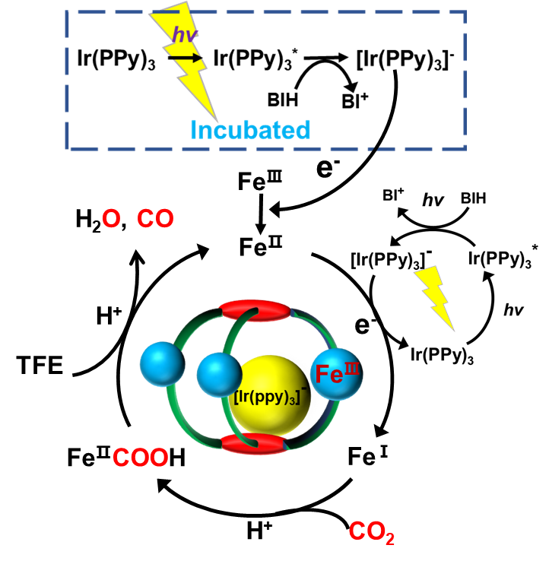
Supplementary Fig. 61. Proposed mechanistic diagram for photocatalytic CO₂ reduction, illustrating key pathways involving photoexcitation, electron transfer, and photo-incubation.

8.2 Photocatalytic oxidative cyclization: General procedure and product characterization
General procedure for photocatalytic oxidative cyclization
All photocatalytic reactions were conducted under irradiation from blue LEDs (λ = 420 nm) and maintained at 25℃ through a circulating water bath. Reaction progress was quantitatively monitored by ¹H NMR spectroscopy (400 MHz) with periodic sampling (200 μL aliquots withdrawn at 20 min intervals) using 1,3,5-trimethoxy-benzene as an internal standard. Spectral analysis enabled the determination of oxidative cyclization product formation efficiency, with all ¹H NMR measurements performed immediately after sample collection to ensure analytical fidelity.
The C–X (X = O, N) coupling reaction was conducted in septum-sealed 15 mL quartz reactors equipped with a magnetic stir bar and water cooling. A solution of 2-substituted imine derivatives (10.0 mM, −OH or −NH₂), Ir(ppy)₃ (0.10 mM) and TFE (0.25 M) in CH₃CN solution (5.0 mL) was degassed by CO₂ purging 20 min. The mixture was photo-incubated upon 420 nm LED irradiation (15 min, vigorous stirring). H1 was then injected, and the irradiation was continued for 2 h. The C–S coupling reaction followed the above procedure using substituted 2-aminothiophenol (10.0 mM) and benzaldehyde derivative (10.0 mM) as substrates. After the mixture was photo-incubated (15 min, vigorous stirring), H1 was subsequently injected, and continuously irradiated for 2 h.
Supplementary Fig. 62. Photocatalytic kinetics of substrate intramolecular C–N (1a), C–S (2a), and C–O (3a) cross-coupling reactions under optimized conditions: H1 (1.0 μM), Ir(ppy)₃ (0.10 mM), TFE (0.25 M) and substrate (10.0 mM) in CH₃CN solution.

Supplementary Fig. 63. Linear free-energy relationship analysis of reaction kinetics versus Hammett σ_{p} parameters with isolated product yields.
Supplementary Fig. 64. Temporal evolution of photocatalytic C–N coupling product 4a yield under varied irradiation intensities (λ_{em} = 420 nm, 250 and 125 mW·cm⁻²). Reaction system: Ir(ppy)₃ (0.10 mM), 1a (10.0 mM), TFE (0.25 M) and H1 (0.10 μM) in CH₃CN solution under CO₂ atmosphere, at room temperature.

Supplementary Fig. 65. The pre-organization of photocatalyst within the coordination capsule and the concomitant thermodynamic activation of the substrate for the unique two-photon-driven oxidative cyclization reaction.

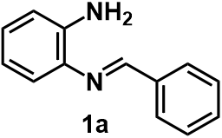
¹H NMR (400 MHz) spectrum of 1a in CDCl₃. ¹H NMR (400 MHz, CDCl₃, ppm): δ 8.54 (s, 1H), 7.91 (dt, J = 7.6, 3.2 Hz, 2H), 7.51–7.39 (m, 3H), 7.07 (t, J = 7.7 Hz, 2H), 6.81–6.67 (m, 2H), 4.09 (s, 2H).

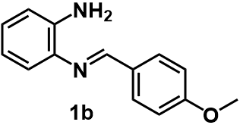
¹H NMR (400 MHz) spectrum of 1b in CDCl₃. ¹H NMR (400 MHz, CDCl₃, ppm): δ 8.49 (s, 1H), 7.89 (d, J = 8.7 Hz, 2H), 7.07 (dd, J = 13.6, 7.7 Hz, 2H), 7.01 (d, J = 8.6 Hz, 2H), 6.84–6.74 (m, 2H), 3.90 (s, 3H).
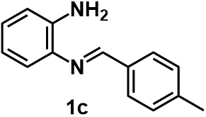
¹H NMR (400 MHz) spectrum of 1c in CDCl₃. ¹H NMR (400 MHz, CDCl₃, ppm): δ 8.50 (s, 1H), 7.80 (d, J = 8.1 Hz, 2H), 7.28–7.23 (m, 2H), 7.05 (t, J = 8.9 Hz, 2H), 6.81–6.68 (m, 2H), 4.23 (s, 2H), 2.41 (s, 3H).
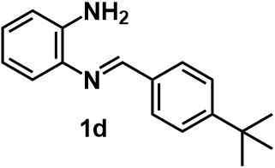
¹H NMR (400 MHz) spectrum of 1d in CDCl₃. ¹H NMR (400 MHz, CDCl₃, ppm): δ 8.51 (s, 1H), 7.83 (dd, J = 11.9, 8.4 Hz, 2H), 7.49 (d, J = 8.3 Hz, 2H), 7.04 (dd, J = 8.2, 4.5 Hz, 2H), 6.84–6.65 (m, 2H), 1.36 (s, 9H).
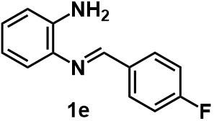
¹H NMR (400 MHz) spectrum of 1e in CDCl₃. ¹H NMR (400 MHz, CDCl₃, ppm): δ 8.50 (s, 1H), 7.98–7.82 (m, 2H), 7.21–7.10 (m, 2H), 7.10–6.98 (m, 2H), 6.83–6.65 (m, 2H), 4.30 (s, 2H).

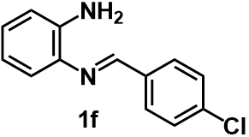
¹H NMR (400 MHz) spectrum of 1f in CDCl₃. ¹H NMR (400 MHz, CDCl₃, ppm): δ 8.53 (s, 1H), 7.87 (d, J = 8.4 Hz, 2H), 7.46 (d, J = 8.4 Hz, 2H), 7.22–7.00 (m, 2H), 6.87–6.71 (m, 2H), 4.19 (s, 2H).

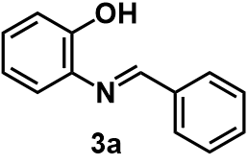
¹H NMR (400 MHz) spectrum of 3a in CDCl₃. ¹H NMR (400 MHz, CDCl₃, ppm): δ 8.70 (s, 1H), 7.92 (dd, J = 7.2, 2.4 Hz, 2H), 7.61–7.40 (m, 3H), 7.31 (dd, J = 7.9, 1.3 Hz, 1H), 7.27–7.13 (m, 2H), 7.02 (dd, J = 8.1, 1.2 Hz, 1H), 6.91 (td, J = 7.9, 1.3 Hz, 1H).

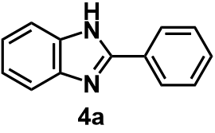
¹H NMR (400 MHz) spectrum of the product after photocatalysis of substrate 4a in DMSO-d₆. The product is obtained as white solid. ¹H NMR (400 MHz, DMSO-d₆): δ 12.90 (s, 1H), 8.19 (dt, J = 8.3, 1.9 Hz, 2H), 7.67 (d, J = 7.3 Hz, 1H), 7.64–7.42 (m, 4H), 7.21 (q, J = 5.7 Hz, 2H).

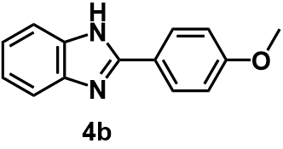
¹H NMR (400 MHz) spectrum of the product after photocatalysis of substrate 4b in DMSO-d₆. The product is obtained as white solid. ¹H NMR (400 MHz, DMSO-d₆): δ 12.73 (s, 1H), 8.12 (d, J = 8.8 Hz, 2H), 7.62 (d, J = 7.1 Hz, 1H), 7.49 (d, J = 6.9 Hz, 1H), 7.18 (q, J = 6.7, 6.2 Hz, 2H), 7.12 (d, J = 8.8 Hz, 2H), 3.85 (s, 3H).

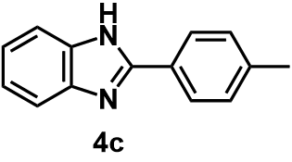
¹H NMR (400 MHz) spectrum of the product after photocatalysis of substrate 4c in DMSO-d₆. The product is obtained as white solid. ¹H NMR (400 MHz, DMSO-d₆): δ 12.82 (s, 1H), 8.08 (d, J = 8.2 Hz, 2H), 7.58 (s, 2H), 7.36 (d, J = 7.9 Hz, 2H), 7.20 (dt, J = 6.0, 3.6 Hz, 2H), 2.38 (s, 3H).

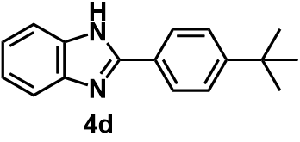
¹H NMR (400 MHz) spectrum of the product after photocatalysis of substrate 4d in DMSO-d₆. The product is obtained as white solid. ¹H NMR (400 MHz, DMSO-d₆): δ 12.86 (s, 1H), 8.12 (d, J = 8.5 Hz, 2H), 7.58 (t, J = 6.9 Hz, 4H), 7.20 (dd, J = 6.0, 3.2 Hz, 2H), 1.34 (s, 9H).

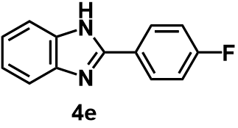
¹H NMR (400 MHz) spectrum of the product after photocatalysis of substrate 4e in DMSO-d₆. The product is obtained as white solid. ¹H NMR (400 MHz, DMSO-d₆): δ 12.91 (s, 1H), 8.23 (dd, J = 8.3, 5.7 Hz, 2H), 7.60 (d, J = 45.7 Hz, 2H), 7.41 (t, J = 8.7 Hz, 2H), 7.26–7.14 (m, 2H).

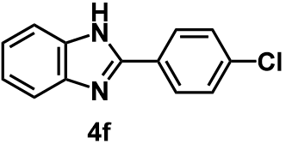
¹H NMR (400 MHz) spectrum of the product after photocatalysis of substrate 4f in DMSO-d₆. The product is obtained as white solid. ¹H NMR (400 MHz, DMSO-d₆): δ 12.99 (s, 1H), 8.30–8.04 (m, 2H), 7.64 (dd, J = 9.0, 2.2 Hz, 4H), 7.23 (d, 2H).

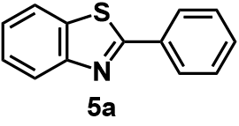
¹H NMR (400 MHz) spectrum of 5a in CDCl₃. The product is obtained as white solid. ¹H NMR (400 MHz, CDCl₃): δ 8.21–8.06 (m, 3H), 7.94 (d, J = 8.0 Hz, 1H), 7.53 (q, J = 7.0, 5.3 Hz, 4H), 7.43 (d, J = 8.0 Hz, 1H).

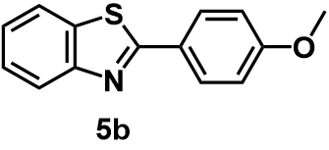
¹H NMR (400 MHz) spectrum of 5b in CDCl₃. The product is obtained as white solid. ¹H NMR (400 MHz, CDCl₃): δ 7.96 (d, J = 8.8 Hz, 3H), 7.79 (d, J = 7.9 Hz, 1H), 7.39 (t, J = 7.7 Hz, 1H), 7.27 (t, J = 7.6 Hz, 1H), 6.92 (d, J = 8.8 Hz, 2H), 3.80 (s, 3H).

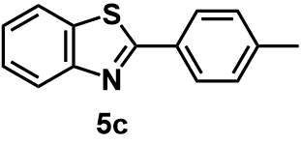
¹H NMR (400 MHz) spectrum of 5c in CDCl₃. The product is obtained as white solid. ¹H NMR (400 MHz, CDCl₃): δ 8.12 (d, J = 8.2 Hz, 1H), 8.03 (d, J = 8.2 Hz, 2H), 7.90 (d, J = 7.9 Hz, 1H), 7.51 (t, J = 7.7 Hz, 1H), 7.40 (t, J = 8.0 Hz, 1H), 7.32 (d, J = 7.9 Hz, 2H), 2.44 (s, 3H).

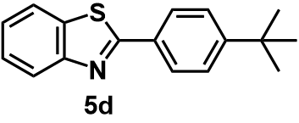
¹H NMR (400 MHz) spectrum of 5d in CDCl₃. The product is obtained as white solid. ¹H NMR (400 MHz, CDCl₃): δ 7.97 (dd, J = 15.8, 8.1 Hz, 3H), 7.81 (d, J = 7.7 Hz, 1H), 7.47–7.40 (m, 3H), 7.29 (s, 1H), 1.29 (s, 9H).

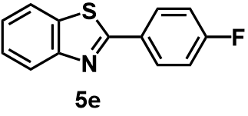
¹H NMR (400 MHz) spectrum of 5e in CDCl₃. The product is obtained as white solid. ¹H NMR (400 MHz, CDCl₃): δ 8.22–8.03 (m, 3H), 7.91 (d, J = 7.5 Hz, 1H), 7.54–7.48 (m, 1H), 7.41 (t, J = 7.6 Hz, 1H), 7.20 (t, J = 8.7 Hz, 2H).

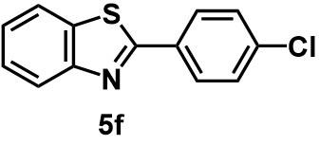
¹H NMR (400 MHz) spectrum of 5f in CDCl₃. The product is obtained as white solid. ¹H NMR (400 MHz, CDCl₃): δ 8.10 (d, J = 8.2 Hz, 1H), 8.08–8.03 (m, 2H), 7.92 (d, J = 8.0 Hz, 1H), 7.55–7.46 (m, 3H), 7.44–7.39 (m, 1H).

9. Supplementary References
1. Lou, Z., Hou, Y., Chen, K., Zhao, J., Ji, S., Zhong, F., Dede, Y., Dick, B. Different quenching effect of intramolecular rotation on the singlet and triplet excited states of bodipy. J. Phys. Chem.C 122, 185−193 (2018).
2. Dolomanov, O. V., Bourhis, L. J., Gildea, R. J., Howard, J. A. K., Puschmann, H. OLEX2: a complete structure solution, refinement and analysis program. J. Appl. Cryst. 42, 339−341 (2009).
3. Gong, Y., Zhao, S., Wang, H., Ge, Z., Liao, C., Tao, K., Zhong, D., Sakai, K., Lu, T. A Planar-Structured Dinuclear Cobalt(II) Complex with Indirect Synergy for Photocatalytic CO₂-to-CO Conversion. Angew. Chem. Int. Ed. 63, e202411639 (2024).
4. Yuan, H., Cheng, B., Lei, J., Jiang, L., Han, Z. Promoting photocatalytic CO₂ reduction with a molecular copper purpurin chromophore. Nat. Commun. 12, 1835 (2021).
5. Kamogawa, K., Koizumi, H., Ishitani, O. Efficient and Selective Photocatalytic Conversion of Low-Concentration CO₂ to CO Using Mn-Complex Catalysts. J. Am. Chem. Soc. 147, 39284–39297 (2025).
6. Zhang, X., Cibian, M., Call, A., Yamauchi, K., Sakai, K. Photochemical CO₂ reduction driven by water-soluble copper(I) photosensitizer with the catalysis accelerated by multi-electron chargeable cobalt porphyrin. ACS Catal. 9, 11263–11273 (2019).
7. Yuan, H., Yu, Y., Yang, S., Lei, Q., Yang, Z., Lan, B., Han, Z. Photocatalytic CO₂ reduction with iron porphyrin catalysts and anthraquinone dyes. Chem. Commun. 60, 6292−6295 (2024).
8. Arcudi, F., Đorđević, L., Nagasing, B., Stupp, S. I., Weiss, E. A. Quantum Dot-Sensitized Photoreduction of CO₂ in Water with Turnover Number > 80,000. J. Am. Chem. Soc. 143, 18131–18138 (2021).
9. An, L., Torre, P. D. L., Smith, P. T., Narouz, M. R., Chang, C. J. Synergistic Porosity and Charge Effects in a Supramolecular Porphyrin Cage Promote Efficient Photocatalytic CO₂ Reduction. Angew. Chem. Int. Ed. 62, e202209396 (2023).
10. Zhong, Y., Wang, Y., Zhao, S., Xie, Z., Chung, L., Liao, W., Yu, L., Wong, W., He, J. Regulating the Electronic Configuration of Ni Sites by Breaking Symmetry of Ni-Porphyrin to Facilitate CO₂ Photocatalytic Reduction. Adv. Funct. Mater. 34, 2316199 (2024).
11. Zhang, X., Yamauchi, K., Sakai, K. Earth-Abundant Photocatalytic CO₂ Reduction by Multielectron Chargeable Cobalt Porphyrin Catalysts: High CO/H₂ Selectivity in Water Based on Phase Mismatch in Frontier MO Association. ACS Catal. 11, 10436–10449 (2021).
12. Li, Y., Wang, S., Wang, X., He, Y., Wang, Q., Li, Y., Li, M., Yang, G., Yi, J., Lin, H., Huang, D., Li, L., Chen, H., Ye, J. Facile Top-Down Strategy for Direct Metal Atomization and Coordination Achieving a High Turnover Number in CO₂ Photoreduction. J. Am. Chem. Soc. 142, 19259–19267 (2020).
13. Cocosila, I., Solé-Daura, A., Gotico, P., Forte, J., Li, Y., Fontecave, M. Visible-Light-Driven Carbon Dioxide Reduction Catalyzed by Iron Schiff-Base Complexes. ACS Catal. 14, 9618–9627 (2024).
14. Jiang, Z., Wang, P., Liang, G., Wen, X., Huang, G., Song, H., Jiang, B., Jin, S., Xu, F., Ding, X., Kim, T. K., Chen, H., Yu, J., Ye, J., Wang, S. Homogeneous–Heterogeneous Hybrid Artificial Photosynthesis Induced by Organic Semiconductors with Controlled Surface Architectures. Adv. Funct. Mater. 33, 2303335 (2023).
15. Wang, P., Guo, S., Zhao, Q., Xu, S., Lv, H., Lu, T., Zhang, Z. Identification of Crucial Photosensitizing Factors to Promote CO₂-to-CO Conversion. Angew. Chem. Int. Ed. 63, e202312450 (2024).
16. Li, Z., Wang, J., Huang, Y., Ouyang, G. Enhancing CO₂ photoreduction via the perfluorination of Co(II) phthalocyanine catalysts in a noble-metal-free system. Chin. J. Catal. 49, 160−167 (2023).
17. Wang, J., Ma, F., Jin, T., He, P., Luo, Z., Kupfer, S., Karnahl, M., Zhao, F., Xu, Z., Jin, T., Lian, T., Huang, Y., Jiang, L., Fu, L., Ouyang, G., Yi, X. Homoleptic Al(III) Photosensitizers for Durable CO₂ Photoreduction. J. Am. Chem. Soc. 145, 676–688 (2023).
18. Ma, B., Chen, G., Fave, C., Chen, L., Kuriki, R., Maeda, K., Ishitani, O., Lau, T., Bonin, J., Robert, M. Efficient Visible-Light-Driven CO₂ Reduction by a Cobalt Molecular Catalyst Covalently Linked to Mesoporous Carbon Nitride. J. Am. Chem. Soc. 142, 6188–6195 (2020).
19. Xiao, Y., Zhang, H., Zhang, M. Heterobimetallic NiFe Complex for Photocatalytic CO₂ Reduction: United Efforts of NiFe Dual Sites. J. Am. Chem. Soc. 146, 28832–28844 (2024).
20. Thoi, V. S., Kornienko, N., Margarit, C. G., Yang, P., Chang, C. J. Visible-Light Photoredox Catalysis: Selective Reduction of Carbon Dioxide to Carbon Monoxide by a Nickel N-Heterocyclic Carbene–Isoquinoline Complex. J. Am. Chem. Soc. 135, 14413–14424 (2013).

