Supplementary Materials for
Bio-organic fertilizers manipulate abundance patterns of rhizosphere soil microbial community structure to improve tomato productivity

Bintao Li ª, Luodi Guo ª, Haoming Wang ^{b,c}, Yulong Li ª, Hangxian Lai ª, Xudong Wang ^{a*}, Xiaomin Wei ^{a*}

ª College of Natural Resources and Environment, Northwest A&F University, Yangling, 712100, China
^{b} College of Plant Protection, Northwest A&F University, Yangling, 712100, China
^{c} State Key Laboratory of Crop Stress Biology for Arid Areas, Purdue-NWAFU Joint Research Center, Yangling, 712100, China

*Corresponding author: Xiaomin Wei (18292458103@163.com) and Xudong Wang (wangxudong01@126.com)
Post address: College of Natural Resources and Environment, Northwest A&F University, Yangling 712100, China.

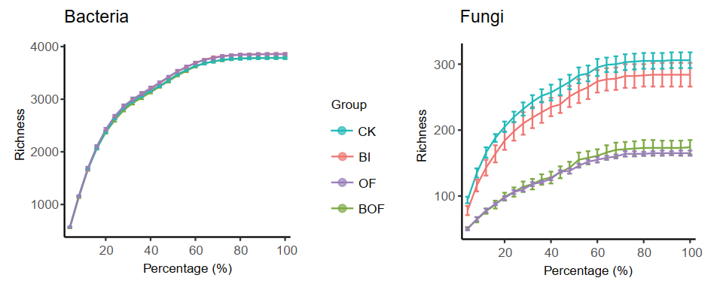
Fig. S1. Rarefaction curves of microbial bacteria and fungi richness per treatment (Rarefaction from 1% to 100% in observed ASVs). Rarefaction curves of detected ASVs of the root microbiota from different treatment reach saturation stage with increasing sequencing depth. Each vertical bar represents standard error. The abscissa represents the percentage of the number of sequences randomly selected. The ordinate represents the number of ASVs observed.

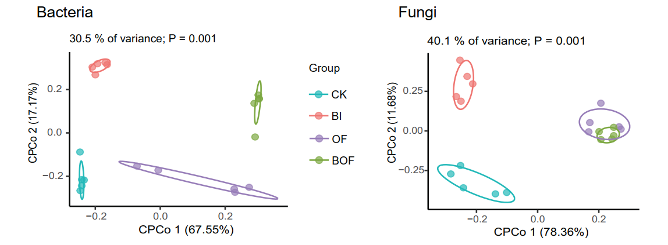
Fig. S2 Constrained PCoA (CPCoA) plot of bacteria and fungi based on Bray-Curtis distances between samples. The percentage of variation indicated in each axis corresponds to the fraction of the total variance explained by the projection. Each point corresponds to a different sample colored by compartment.

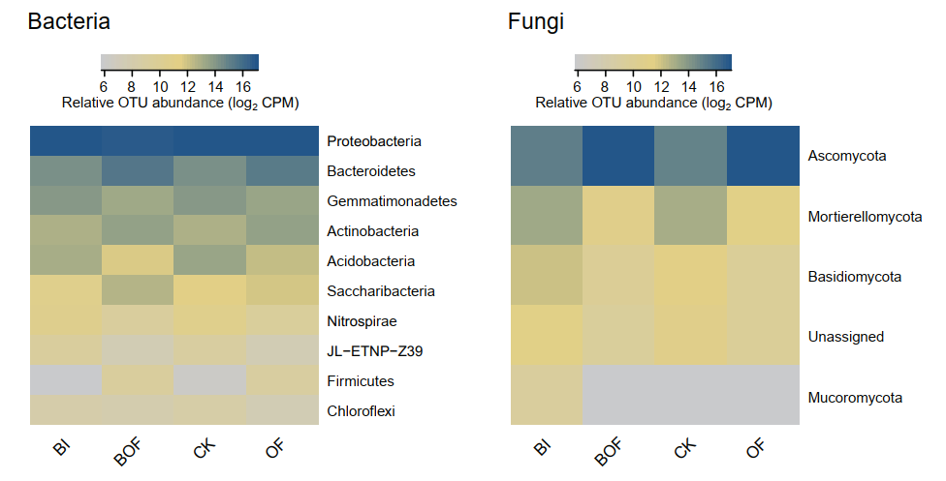
Fig. S3 Mean relative abundances (counts per million, CPM; log2 scale) of fertilization sensitive ASVs (as defined in Fig. 3c-d, summarized at phylum level) across fertilization systems for rhizosphere soil bacteria and fungi.

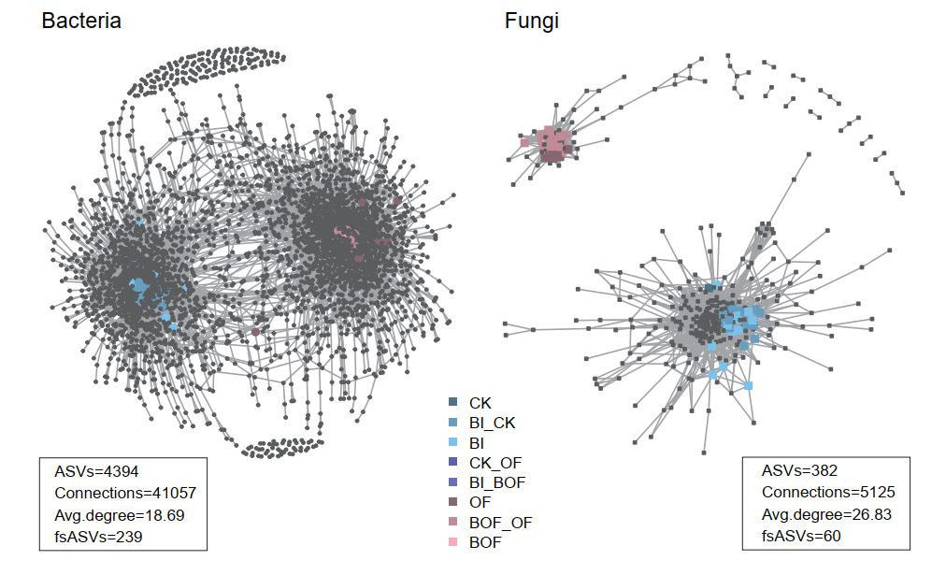
Fig. S4 Co-occurrence networks visualizing significant correlations (ρ>0.7, p<0.001; indicated with grey lines) between ASV pairs in the rhizosphere soil bacterial and fungal communities. Circles and square represent bacteria and fungi ASVs, respectively. ASVs were colored by their association to the different fertilization systems (as defined in Fig. 3c-d, gray ASVs are insensitive to fertilization practices). General network properties are indicated under each network and including number of ASVs, number of connections, average number of connections between ASVs (Avg. degree) and the number of fertilization sensitive ASVs (fsASVs).

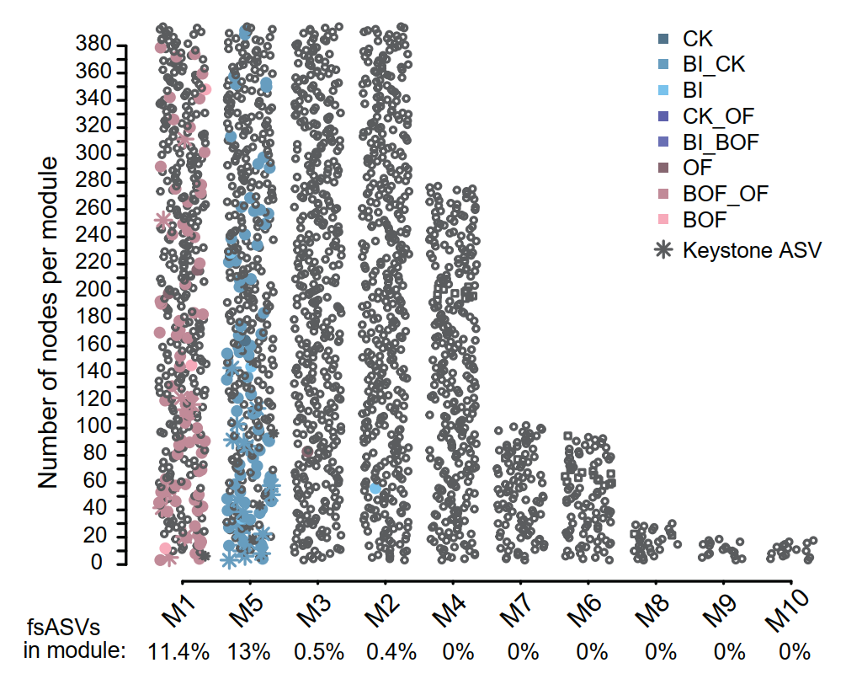
Fig. S5 Defining network modules. Plots showing the number of ASVs in the top 10 most populated modules for the rhizosphere soil meta co-occurrence networks. Circles and square represent bacteria and fungi ASVs, respectively. ASVs were colored by their association to the different fertilization systems (as defined in Fig. 3c-d, gray ASVs (open symbols) are insensitive to fertilization practices). Percentages on the x-axis indicate the proportion of fsASVs present in each module.

