1. Methods
1.1 Chemical compounds analysis
Before analysis, an internal standard (IS) of 10 µL of 2-octanol (10 mg/L stock in dH₂O) was added to each sample. All the mixed samples were heated at 60 °C for 15 min, and then samples were extracted for 30 min by headspace solid-phase microextraction (SPME) with 50/30 µm DVB/CAR/PDMS SPME fiber coating. Prior to use, the SPME fiber was pre-conditioned according to the manufacturer’s instructions: it was heated at 270 °C in the GC injector port for 30 min under a constant flow of helium to remove any residual contaminants and activate the fiber coating. After the extraction, the adsorbed compounds were desorbed from the SPME fiber coating and then inserted directly into the injector port at 250 °C.
The gas chromatography–mass spectrometry (GC-MS) analysis was conducted using an Agilent 7890 gas chromatograph system connected to an Agilent 5977 mass spectrometer with an EI ion source (70 eV). A DB-Wax capillary column (30 m × 250 µm inner diameter and 0.25-µm film thickness; Agilent) was utilized with helium (at 1 ml/min) as the carrier gas. 1-µL sample was injected in 1:1 split mode. The purge flow rate of the front inlet septum was 3 mL/min. The column temperature was held at 40 °C for 4 min, then increased to 245 °C at the rate of 5 °C/min and then held at 245 °C for another 5 min. The temperature of the ion source, front injection and transfer line was 230, 250 and 260 °C, respectively. The mass spectrometer was performed in the mode of full scan with an m/z range from 20 to 500 and a solvent delay of 0 min.
All chromatographic data, including measurement of raw peak, filtration of the data baseline, correction for baseline shift, analysis of deconvolution, peak alignment, identification, integration and spectrum match, was pre-processed in Chroma TOF version 4.3X and the National Institute of Standards and Technology (NIST) database (Kind et al., 2009). Here, "category" refers to compound classes grouped by their chemical functional groups (e.g., esters, alcohols, ketones, etc.), which is a standard classification method for volatile organic compounds in scent gland secretion studies. To improve the accuracy of volatile compound identifications, we implemented three measures: (1) volatile compounds with < 80% similarity compared with compounds in the NIST database and the relative peak area < 0.01% were excluded from subsequent analyses, (2) we ran a control blank sample and removed the compounds that were considered as contaminants or exogenous compounds if the concentration of compounds in the blank sample is similar or higher than that in the gland secretion sample and (3) we eliminated the compounds extremely rare in natural products.

1.2 Bacterial DNA extraction, processing and sequencing
Total genomic DNA was extracted from bacterial swab samples using the MagPure Soil DNA KF Kit (MD5116, Magen, China) according to the manufacturer’s guidelines. Extracted genomic DNA was examined by 1% agarose gels electrophoresis. The V3-V4 region of the bacteria 16S ribosomal RNA gene were amplified by PCR (95 °C for 3 min, followed by 30 cycles at 95 °C for 30 s, 55 °C for 30 s, and 72 °C for 45 s and a final extension at 72 °C for 5 min) using primers 338F 5′-ACTCCTACGGGAGGCAGCA-3′ and 806R 5′-GGACTACHVGGGTWTCTAAT-3′, where barcode is an eight-base sequence unique to each sample. PCR reactions were performed in triplicate 25 μL mixture containing 5 μL of 5 × FastPfu Buffer, 2.5 μL of 2.5 mM dNTPs, 1 μL of each primer (5 μM), 0.5 μL of FastPfu Polymerase, 1 μL of reverse primer (5 μM) and 10 ng of template DNA. Amplicons were extracted from 2% agarose gels and purified using the AxyPrep DNA Gel Extraction Kit (Axygen Biosciences, Union City, CA, USA) according to the manufacturer’s instructions.
Sequencing libraries were generated using NEB Next®Ultra™DNA Library Prep Kit for Illumina (NEB, USA) following manufacturer’s recommendations and index codes were added. The library quality was assessed on the Qubit@ 2.0 Fluorometer (Thermo Scientific) and Agilent Bioanalyzer 2100 system. At last, the library was sequenced on an Illumina NovaSeq 6000 PE250 platform paired-end reads were generated. All 16S rRNA sequencing was performed by Shanghai Origin-gene Biotechnology Co. Ltd (Shanghai, China).
In this study, the total number of raw sequences generated from HZ, SG and SM colony was 1,751,600 [average 218,950 reads/sample [range from 147,574 to 352,600)], 1,354,127 [average 169,266 reads/sample [range from 57,251 to 353,762)] and 1,408,019 [average 176,002 reads/sample [range from 90,291 to 261,170)], respectively. The adapter sequences added in the process of sequencing were first removed by cutadapt v1.2.1 (Martin, 2011). Forward and reverse reads were formed into contigs using QIIME v1.9.1 pipeline based on the base overlap length of at least 10 bp and no mismatch allowed (Caporaso et al., 2010). High-quality reads were obtained using the following criteria: no presence of ambiguous bases (N), no errors in barcode sequence were allowed, a minimum of five consecutive high-quality base pairs (Q ≥ 20) and a maximum of three consecutive low-quality base paired were allowed. After quality processing, a total of 1,424,341 (average 178,043 reads/sample) from HZ, a total of 1,081,151 (average 135,144 reads/sample) from SG, and a total of 1,148,857 (average 143,607 reads/sample) from SM colony were obtained, respectively. Unique sequences were identified and clustered into OTUs at a sequence similarity threshold of 97% based on the UPARSE method, with singletons and chimeric sequences exclude during this process (Edgar, 2013). Taxonomic information was provided for each OTU against the Greengenes database and assigned taxonomy using Ribosomal Database Project Classifier (McDonald et al., 2012; Wang et al., 2007). Furthermore, phylogenetic tree files were also created in the QIIME pipeline. To avoid interferences from rare OTUs, which may be errors, the OTUs were removed based on < 0.001% of total reads (Bokulich et al., 2013). The OTUs classified as mitochondrial and chloroplastic were removed. Finally, to standardize sampling effort across samples, the OTU table was rarefied according to the lowest number of reads, that is, the remaining reads for each sample are 40,087 (Fig. S5). The original OTU data can be find in Research Data 3.

1.3 Habituation–discrimination tests
In June–September 2023, we captured 72 adult males of H. armiger with mist nets from 3 localities, including HZ (41 males), SM (17 males), and SG (15 males). Captured bats from each colony were housed in one or two large flight cages (4 m long × 2.5 m wide × 1.8 m high) in a local husbandry room with a regulated temperature of about 23℃, relative humidity of around 60%, and a 12-h dark/light cycle (dark: 1900–0700 h, light: 0700–1900 h). Bats were marked using 5.2 mm numbered aluminium alloy bands (Porzana Ltd, East Sussex, UK) on the left forearm for individual identification. All bats received Zophobas morio larvae and water enriched with vitamins and mineral supplements ad libitum.
After a period of acclimation, we collected the forehead gland secretion from each individual between 19:00 and 20:00 hr using the method described in the main text. Samples were collected every three to five days for each bat. All samples were stored immediately on dry ice and then transported back to the laboratory for storage at –80 °C until analysis. See supplementary materials Table S7 for detailed sample information.
After the glandular secretions were collected, all bats were released in good health at their original site of capture. Before the bats were released, we removed the bands of bats from SM and SG colonies but not from the HZ colony. This is because the males from the HZ colony were used for colony odor discrimination tests the following year and it is appropriate to ensure that there is no overlap between the bats used for colony odor discrimination and the bats used for gland secretion collection.
Twenty adult male H. armiger from the HZ colony were captured with mist nets from the Yu cave on July 2, 2024. Captured bats were housed in a large flight cage (length × width × height: 4 × 2.5 × 1.8 m) in a husbandry room. Bats were marked using 5.2 mm numbered aluminium alloy bands on the left forearm for individual identification. The husbandry method of bats was the same as above.
All tests were performed between 19:00 and 22:00. The experiments were conducted in a scentless plastic box without a top (length × width × height: 0.56 × 0.40 × 0.32 m; Fig. 4c, 4b) in a room with dimensions 5 × 3 × 3 m (length × width × height). The top of the box was covered with a wire mesh (length × width: 0.76 × 0.60 m), which enabled the males to hang from the roof. The two odor sources were presented through 1-cm diameter holes in the side of the box. The holes were placed 15 cm from the wire mesh, which is the average distance from a bat’s head to toe. The distance between the two holes was also 15 centimeters. The wire mesh on the roof could be rotated so that the bats were facing directly toward the camera and were equidistant from the position of the odor sources. An infrared camera (FDR-AX60; Sony Corp., Tokyo, Japan) was placed 0.3 m in front of the box to monitor bat behavior. Each experiment lasted 5 minutes.
Odor detection was defined as the bat moving its head toward the swab up to a distance of ≤ 1 cm and spending at least 1 s on it at a time. The duration of detection was defined as the total time spent interacting with the odor. Each odor sample was used only once. After each trial, we cleaned the plastic box using 75% ethyl alcohol to remove volatile compounds, and we ventilated the room by opening a set of windows. The time interval between two consecutive trials was at least 10 minutes.
"Habituation odors" and "novel odors" were created by preparing fresh mixtures daily and randomly mixing forehead gland secretions from three different individuals which belonged to the same colony. Specifically, 5 mg of glandular secretion from each individual was placed on the tip of a cotton swab using a sterile pipette tip to ensure no cross-contamination and consistent dosage of secretions per individual. At least one of the three individuals was different between any two "habituation odors" or any two "novel odors" (Table S8, S9).
To test whether the bats could distinguish differences between colonies in the odor of the gland secretions, we adopted habituation–discrimination tests similar to the procedures used in our previous experiment on individual odor discrimination in this bat species (Zhang et al., 2022). In short, in a habituation phase, the subject was presented with two swabs (20 cm in length and 2.8 mm in diameter; Xinxiang Huaxi Medical Materials Co., Ltd, China) once a day for 3 days. One odor was from a single colony ("habituation odor") and the other odor was from an odorless swab. The odorless swab was used as a control to verify that the tested bats habituated to the odor instead of the swab. The bats spent a certain amount of time detecting the swabs when they were first presented. We considered the bats to be habituated to the odor if the duration of detection of the odorous swab was significantly longer than the duration of the odorless swab in the first habituation trial and if the duration of detection decreased significantly in each habituation trial. Significance was determined using a paired-sample t-test. We also considered the bats to be habituated if there was no significant difference in the duration of detection between the odorous swab and odorless swab during the final habituation trial.
The discrimination phase was conducted on the fourth day. This phase involved presenting the bat with two odors, one was the habituation odor and the second was an odor from another colony ("novel odor"). This phase was used to determine whether the tested subject could discriminate between the two odors. If the duration of detection of the novel odor for the tested subject was significantly longer than the habituation odor based on a paired-sample t-test, we assumed that the tested subject could discriminate the two odors. The side on which each sample was placed was randomly selected. Each male participated in the discrimination experiment once for the HZ vs. SM colonies and once for the HZ vs. SG colonies, respectively.

1.4 Two-choice tests
In the two-choice tests, the tested female bats were from Dafo cave of the HZ colony and the male odour stimulus donors were from the Yu cave of the HZ colony.
On August 4, 2024, forty adult female bats from the HZ colony occupying the Dafo cave were collected with mist nets. The Dafo cave is about 5 km away from the Yu cave, and both caves are occupied by the HZ colony. Because the male odor stimulus donors were from the Yu cave, we captured females from Dafo cave to exclude the potential effect of familiarity. We randomly divided 40 individuals into two groups of twenty. Each group was housed in a large cage (length × width × height: 4 × 2.5 × 1.8 m) in the centre of separate rooms (length × width × height: 5 × 3 × 3 m). Bats were marked using 5.2 mm numbered aluminium alloy bands on the left forearm for individual identification. The husbandry method of bats was the same as above.
All two-choice tests were performed between 19:00 and 3:00. The experiments were conducted in a scentless plastic bucket without a top (volume: 380 L, height: 87 cm, upper width: 70 cm, lower width: 56 cm; Fig. 5a) in a 5 × 3 × 3 m (length × width × height) room. The top of the bucket was covered with a wire mesh (length × width: 1 × 1 m), which enabled the females to hang from the roof. There were two small air fans (diameter: 9 cm, wind speed: 2 m/s; Lexue No.1, Kumor Electronics Co., Ltd, Shenzhen, China) facing upward on each side of the bottom of the bucket. This controlled airflow standardized the distribution of the two scents, reducing bias from uneven odor diffusion and making the female’s choice dependent on the scent itself. The two odor sources were presented through 1-cm diameter holes in the side of the bucket. The holes were placed 10 cm from the air fans. We divided the bat movement area into three zones. There were two response zones above the odors including one for local-male odors and the other for foreign-male odors. These zones were about 1200 cm² large. The third zone was a neutral zone between these response zones that was about 1400 cm². An infrared camera was placed 0.8 m above the bat to monitor bat behavior. We also set up an infrared fill light (SMT-2022-06; Aoshimingtong Technology Co., Ltd., Guangdong, China) which was mounted 1.0 m away from the bucket and 0.10 m above the ground, to provide sufficient illumination for the infrared camera.
After placing the tested female in the centre of the neutral zone, we switched on the two fans and gave the bat at least 5 min of acclimation time until it calmed down (i.e., remained motionless). Prior to the trial, we placed vials (ANPEL Laboratory Technology Co., Ltd, Shanghai, China) containing the gland secretions on ice until the secretions were thawed completely (usually 10–20 min). We then attached the gland secretions of a local male ("local odors") to one swab (20 cm in length and 2.8 mm in diameter) and the gland secretion of a foreign male ("foreign odors") to the other swab. "Local odors" and "foreign odors" presented to any given female were generated by randomly mixing forehead gland secretions from three different individuals belonging to the same colony. Considering all local and foreign odors used in the experiment, at least one of the 3 gland secretion donors was different between any pair of local or foreign stimuli (Table S10, S11). After the bat became motionless, we inserted two swabs into two pieces of foam to stabilize them. We then moved both swabs slowly and simultaneously above the air fans at a constant rate. The duration of each experiment was 10 minutes. We recorded the amount of time the female spent in each of two response zones of the bucket. After the trial, we cleaned the bucket using 75% ethyl alcohol to eliminate the potential influence of scent on the next trial, and the room was well-ventilated to remove residual odors. Each female was tested only once.

References
Bokulich, N. A., Subramanian, S., Faith, J. J., Gevers, D., Gordon, J. I., Knight, R., Mills, D. A., & Caporaso, J. G. (2013). Quality-filtering vastly improves diversity estimates from Illumina amplicon sequencing. Nature Methods, 10(1): 57–59. https://doi.org/10.1038/nmeth.2276
Caporaso, J. G., Kuczynski, J., Stombaugh, J., Bittinger, K., Bushman, F. D., Costello, E. K., Fierer, N., Gonzalez Peña, A., Goodrich, J. K., Gordon, J. I., et al., (2010). QIIME allows analysis of high-throughput community sequencing data. Nature Methods, 7(5): 335–336. https://doi.org/10.1038/nmeth.f.303
Edgar, R. C. (2013). UPARSE: highly accurate OTU sequences from microbial amplicon reads. Nature Methods, 10(10): 996–998. https://doi.org/10.1038/nmeth.2604
Kind, T., Wohlgemuth, G., Lee, D. Y., Lu, Y., Palazoglu, M., Shahbaz, S., & Fiehn, O. (2009). FiehnLib: mass spectral and retention index libraries for metabolomics based on quadrupole and time-of-flight gas chromatography/mass spectrometry. Analytical Chemistry, 81(24): 10038–10048. https://doi.org/10.1021/ac9019522
Martin, M. (2011). Cutadapt removes adapter sequences from high-throughput sequencing reads. EMBnet Journal, 17(1): 10–12. https://doi.org/10.14806/ej.17.1.200
McDonald, D., Price, M. N., Goodrich, J., Nawrocki, E. P., DeSantis, T. Z., Probst, A., Andersen, G. L., Knight, R., & Hugenholtz, P. (2012). An improved Greengenes taxonomy with explicit ranks for ecological and evolutionary analyses of bacteria and archaea. The ISME Journal, 6(3): 610–618. https://doi.org/10.1038/ismej.2011.139
Wang, Q., Garrity, G. M., Tiedje, J. M., & Cole, J. R. (2007). Naive Bayesian classifier for rapid assignment of rRNA sequences into the new bacterial taxonomy. Applied and Environmental Microbiology, 73(16): 5261–5267. https://doi.org/10.1128/AEM.00062-07

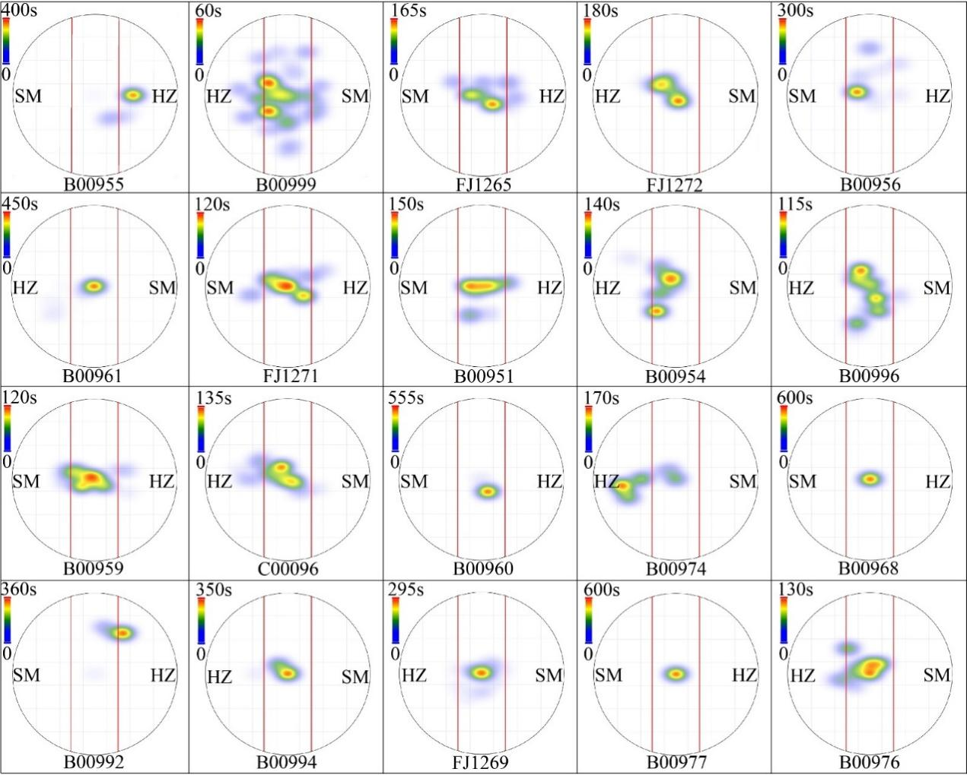
Fig. S1 Heatmaps showing the time spent by 20 females at different locations within the plastic bucket over a 10-minute period. The area between the two red lines indicates the neutral zone. The area beyond the two red lines is the response zone. The number below the circle represents the bat identity. "HZ" represents Hanzhong colony. "SM" represents Simao colony.

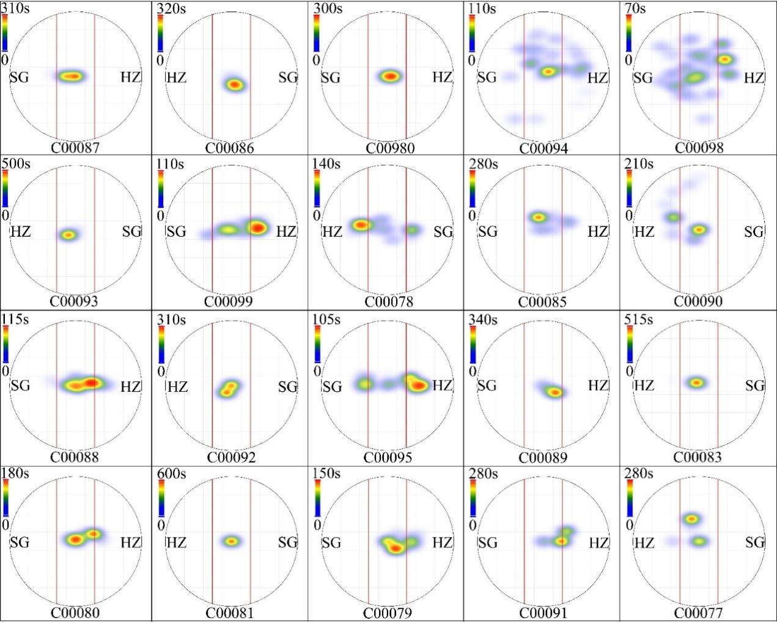
Fig. S2 Heatmaps showing the time spent by 20 females at different locations within the plastic bucket over a 10-minute period. The area between the two red lines indicates the neutral zone. The area beyond the two red lines is the response zone. The number below the circle represents the bat identity. "HZ" represents Hanzhong colony. "SG" represents shaoguan colony.

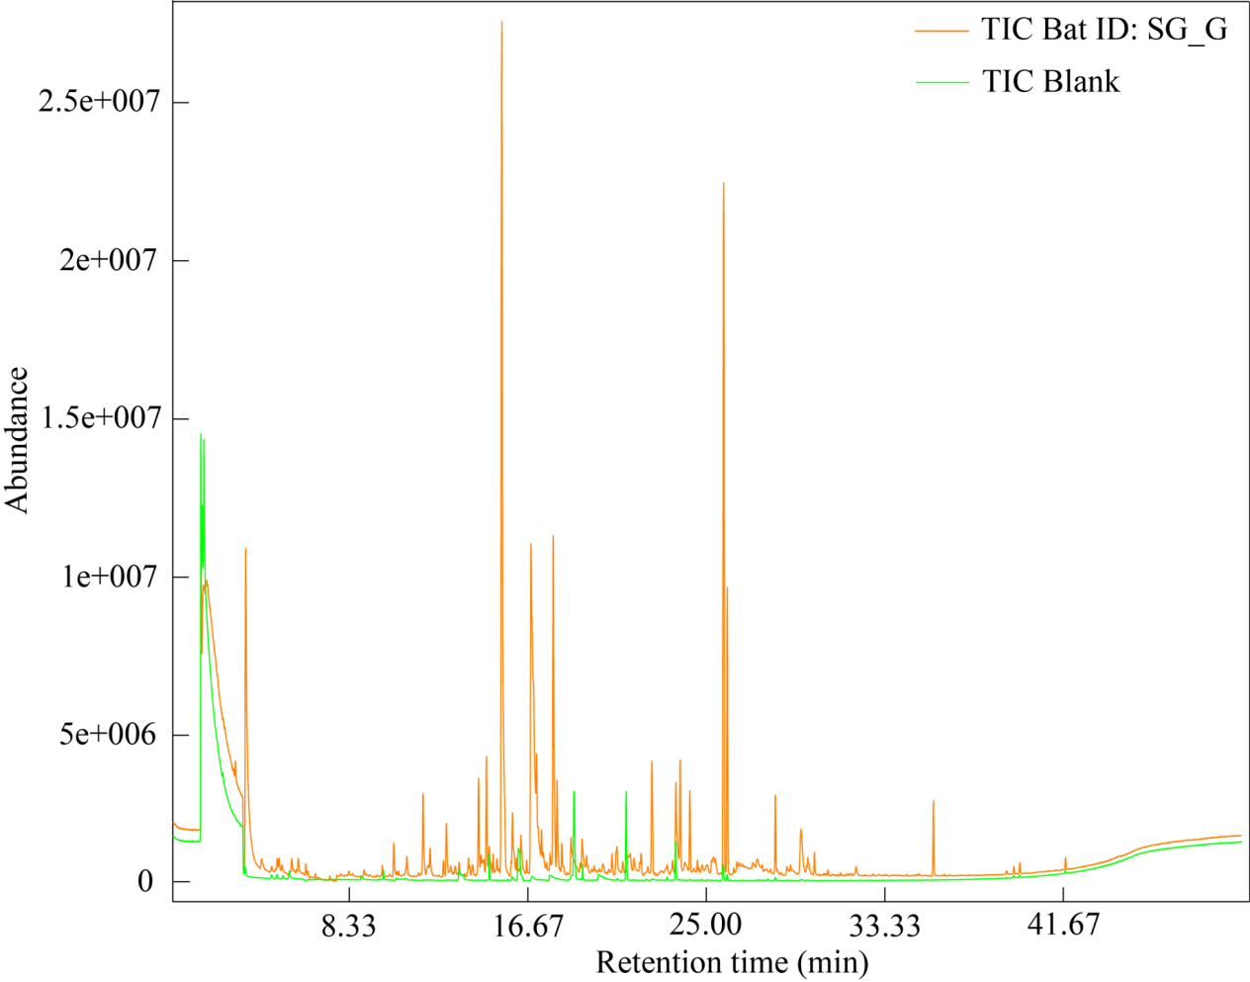
Fig. S3 A total ion chromatogram (TIC) of samples from the forehead gland secretions of a bat (SG_G) (orange line) and the blank sample (green line).

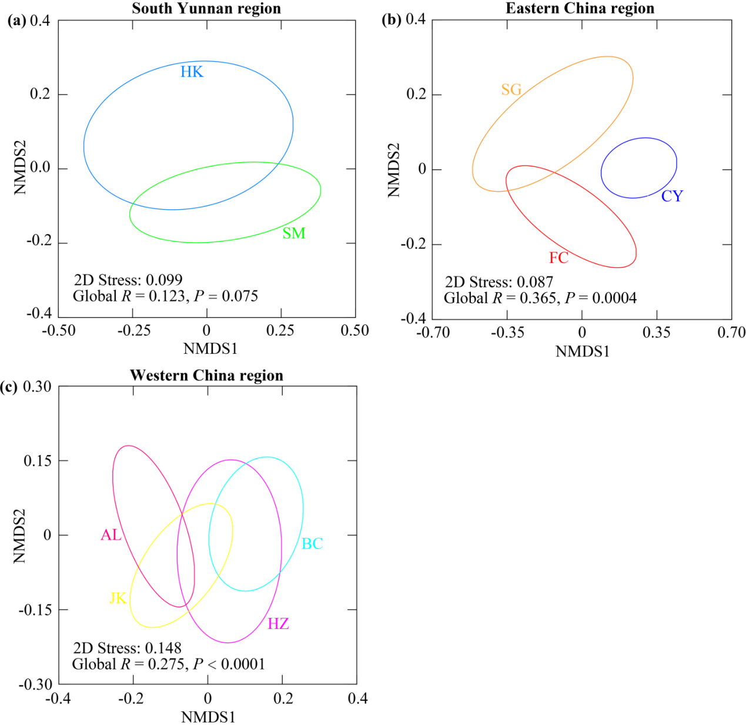
Fig. S4 NMDS plots show the compound categories with chemical similarity for (a) 20 individuals from the two colonies within South Yunnan region, (b) 27 individuals from the three colonies within Eastern China region, and (c) 40 individuals from the three colonies within Western China region. Ellipses showing the 50% confidence interval.

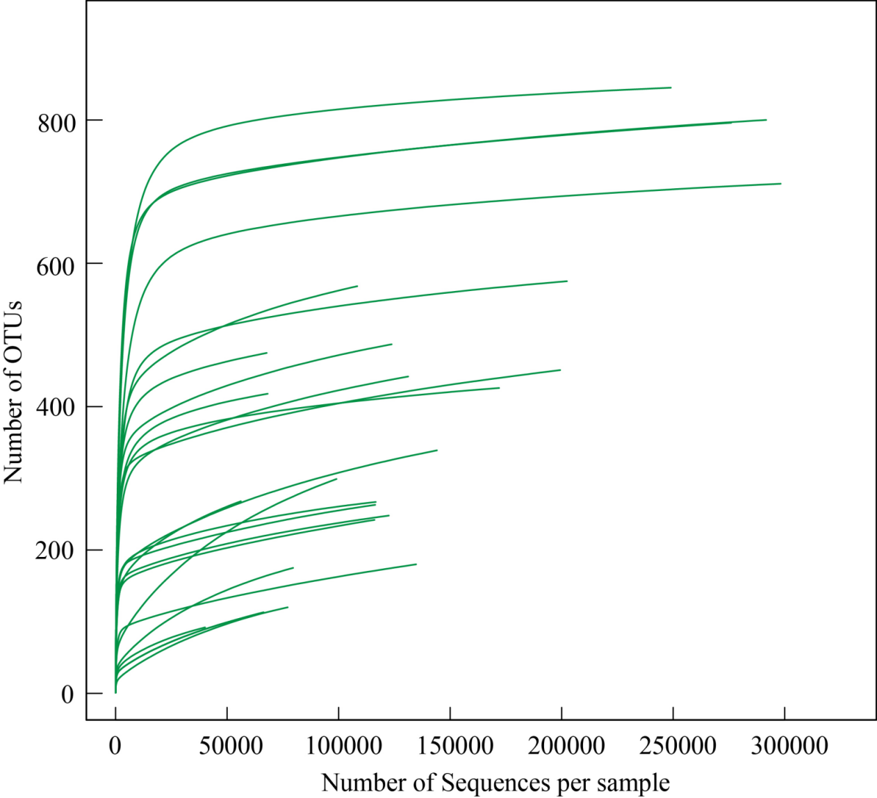
Fig. S5 Rarefaction curves for number of OTUs of gland microbial communities in each sample.

Table S1. Latitude and longitude for each colony and corresponding climatic data.
Region | Colony | Cave | Longitude(°) | Latitude(°) | N | MAT(°C) | MARH(%)
Eastern China  (EC) | Fanchang (FC) | Xianren cave | 118.30 | 31.05 | 10 | 16.44±0.62 | 78.28±2.17
Eastern China  (EC) | Chongyi (CY) | Shiyan cave | 114.10 | 24.50 | 7 | 20.57±0.53 | 77.75±2.26
Eastern China  (EC) | Shaoguan (SG) | Pan cave | 113.56 | 24.77 | 10 | 20.61±0.50 | 76.55±2.14
Western China  (WC) | Hanzhong (HZ) | Yu cave | 107.0266 | 32.85 | 10 | 13.54±0.56 | 78.30±1.69
Western China  (WC) | Hanzhong (HZ) | Dafo cave | 107.0323 | 32.85 | - | 16.09±0.56 | 78.30±1.69
Western China  (WC) | Beichuan (BC) | Bat cave | 104.40 | 31.63 | 10 | 16.53±0.49 | 77.41±1.97
Western China  (WC) | Jiangkou (JK) | Baishui cave | 108.83 | 27.68 | 10 | 16.82±0.50 | 79.74±1.98
Western China  (WC) | Anlong (AL) | Huangyan cave | 105.54 | 25.28 | 10 | 21.28±0.51 | 79.97±2.03
Southern Yunnan  (SY) | Hekou (HK) | Huayu cave | 103.91 | 22.74 | 10 | 19.50±0.52 | 82.16±1.50
Southern Yunnan  (SY) | Simao (SM) | Shenxian cave | 100.71 | 22.61 | 10 | 16.44±0.55 | 75.83±2.08
MARH: mean annual relative humidity. MAT: mean annual temperature. N: the number of male individuals sampled. MAT and MARH data are given as mean ± SD.
Table S2. Estimates of genetic difference derived from both mtDNA and nDNA
 | FC | CY | SG | HZ | BC | JK | AL | HK | SM
FC | 0 | 0.931 | 2.761 | 7.415 | 8.639 | 9.601 | 6.598 | 9.176 | 5.918
CY | 0.063 | 0 | 0.284 | 2.632 | 2.443 | 2.783 | 2.463 | 3.413 | 2.698
SG | 0.080 | 0.046 | 0 | 5.246 | 5.535 | 6.294 | 4.563 | 6.174 | 4.254
HZ | 0.146 | 0.052 | 0.010 | 0 | 0.143 | 0.391 | 0.438 | 11.183 | 7.069
BC | 0.249 | 0.085 | 0.215 | 0.036 | 0 | 0.051 | 0.857 | 13.233 | 7.225
JK | 0.188 | 0.063 | 0.113 | 0.029 | 0.015 | 0 | 1.215 | 14.957 | 8.141
AL | 0.149 | 0.030 | 0.065 | 0.014 | 0.034 | 0.017 | 0 | 9.165 | 6.112
HK | 0.127 | 0.020 | 0.322 | 0.037 | 0.045 | 0.029 | 0.003 | 0 | 5.530
SM | 0.239 | 0.133 | 0.156 | 0.032 | 0.080 | 0.058 | 0.061 | 0.094 | 0
Above the diagonal are F_{ST} values from mtDNA (partial mitochondrial control region (358 bp) and complete cytochrome b (1140 bp)). Below the diagonal are F_{ST} values of nDNA. Site abbreviations are defined in Table 1.

Table S4. Description of the number of gland secretion compounds in each colony of Hipposideros armiger
Colony | Mean number of  compounds per  colony ± SE | Number of compounds  occurring in all samples  from the colony | Colony-specific  compounds in  samples | N
FC | 76 ± 1.7 | 29 | 3 | 10
CY | 72 ± 2.7 | 39 | 0 | 7
SG | 66 ± 3.1 | 21 | 2 | 10
HZ | 74 ± 1.1 | 41 | 0 | 10
BC | 79 ± 1.7 | 55 | 0 | 10
JK | 72 ± 1.4 | 41 | 0 | 10
AL | 75 ± 1.4 | 38 | 0 | 10
HK | 75 ± 2.7 | 33 | 0 | 10
SM | 74 ± 2.1 | 36 | 0 | 10
Note: N indicates the number of samples from each colony. Definitions of locality abbreviations are provided in Table 1. SE: standard error.

Table S5. Percentage of the total variance in categories of compounds of Hipposideros armiger explained by region, colony within region, individuals within colonies (*P < 0.05, **P < 0.008, ***P < 0.0001)
Categories of  compounds | Percentage of total variance
Categories of  compounds | Between  regions | Colonies within  regions | Individuals within  colonies
Aromatic compound | 0 | 35*** | 65
Aldehyde | 25 | 11* | 64
Alkane | 14 | 17** | 69
Ketone | 0 | 9 | 91
Alcohol | 0 | 46*** | 54
Ester | 6 | 16* | 78
Carboxylic acid | 0 | 24** | 76
Alkene | 15 | 16** | 69
Furan | 10 | 0 | 90
Thiol | 0 | 44*** | 56

Table S6. Mantel correlations between chemical distance of Hipposideros armiger forehead gland secretions and pairwise distances of environmental and genetic factors across colonies.
Variables | r | P
MAT | 0.122 | 0.561
MARH | -0.133 | 0.613
nSSR | 0.272 | 0.189
mtDNA | 0.046 | 0.838
MAT: mean annual temperature. MARH: mean annual relative humidity. nSSR: nuclear microsatellite markers. mtDNA: mitochondrial DNA sequences.

Table S7. The stimulus donors of habituation odor and of novel odor for each testing bat in habituation–discrimination tests and the stimulus donors of local odor and of foreign odor for each testing bat in two-choice tests. "HZ" represents Hanzhong colony. "SM" represents Simao colony. "SG" represents Shaoguan colony.
Colony | Bat ID | Code | Number of gland secretions used in this experiment
HZ | FJ1273 | HZ_01 | 12
HZ | FJ1441 | HZ_02 | 16
HZ | FJ1426 | HZ_03 | 16
HZ | C00100 | HZ_04 | 16
HZ | C00097 | HZ_05 | 16
HZ | FJ1419 | HZ_06 | 16
HZ | FJ1424 | HZ_07 | 16
HZ | FJ1425 | HZ_08 | 16
HZ | FJ1301 | HZ_09 | 16
HZ | FJ1421 | HZ_10 | 16
HZ | FJ1417 | HZ_11 | 16
HZ | FJ1415 | HZ_12 | 16
HZ | FJ1442 | HZ_13 | 16
HZ | FJ1420 | HZ_14 | 16
HZ | FJ1423 | HZ_15 | 16
HZ | C00777 | HZ_16 | 16
HZ | FJ1422 | HZ_17 | 16
HZ | FJ1416 | HZ_18 | 16
HZ | FJ1427 | HZ_19 | 16
HZ | FJ1302 | HZ_20 | 16
HZ | FJ1443 | HZ_21 | 16
HZ | FJ1430 | HZ_22 | 16
HZ | FJ1432 | HZ_23 | 16
HZ | FJ1434 | HZ_24 | 16
HZ | FB0123 | HZ_25 | 16
HZ | FB0126 | HZ_26 | 16
HZ | FJ1438 | HZ_27 | 16
HZ | FA0812 | HZ_28 | 16
HZ | FA0813 | HZ_29 | 16
HZ | FA0814 | HZ_30 | 12
HZ | FA0815 | HZ_31 | 8
HZ | FA0816 | HZ_32 | 12
HZ | FA0817 | HZ_33 | 12
HZ | FA0818 | HZ_34 | 12
HZ | FA0819 | HZ_35 | 12
HZ | FA0820 | HZ_36 | 12
HZ | FA0821 | HZ_37 | 12
HZ | FA0822 | HZ_38 | 12
HZ | FA0823 | HZ_39 | 12
HZ | FA0824 | HZ_40 | 12
HZ | FA0825 | HZ_41 | 12
SM | C00773 | SM_01 | 7
SM | C00776 | SM_02 | 7
SM | C00371 | SM_03 | 7
SM | FJ1412 | SM_04 | 7
SM | FB0167 | SM_05 | 7
SM | C00174 | SM_06 | 7
SM | C00960 | SM_07 | 7
SM | FJ1413 | SM_08 | 7
SM | FJ1266 | SM_09 | 8
SM | C00082 | SM_10 | 7
SM | FB0139 | SM_11 | 7
SM | FJ1274 | SM_12 | 7
SM | C00084 | SM_13 | 7
SM | FB0222 | SM_14 | 7
SM | C00770 | SM_15 | 7
SM | FJ1414 | SM_16 | 7
SM | FJ1418 | SM_17 | 7
SG | FJ1439 | SG_01 | 8
SG | FJ1448 | SG_02 | 8
SG | FJ1437 | SG_03 | 8
SG | FJ1433 | SG_04 | 8
SG | FJ1431 | SG_05 | 8
SG | FA0712 | SG_06 | 8
SG | FA0718 | SG_07 | 8
SG | FA0720 | SG_08 | 8
SG | FA0721 | SG_09 | 8
SG | FA0741 | SG_10 | 8
SG | FA0745 | SG_11 | 8
SG | FA0746 | SG_12 | 8
SG | FA0747 | SG_13 | 8
SG | FA0748 | SG_14 | 8
SG | FA0749 | SG_15 | 8

Table S8. The stimulus donors of habituation odor and of novel odor for each testing male Hipposideros armiger in habituation–discrimination tests for Hanzhong (HZ) vs Simao (SM) colony
Bat ID | Testing bat | Stimulus donors of  habituation odor | Stimulus donors of  novel odor
B00978 | Male_01 | HZ_15, HZ_16, HZ_17 | SM_15, SM_16, SM_17
B00957 | Male_02 | HZ_06, HZ_07, HZ_08 | SM_06, SM_07, SM_08
B00952 | Male_03 | HZ_01, HZ_02, HZ_03 | SM_01, SM_02, SM_03
B00987 | Male_04 | HZ_23, HZ_24, HZ_25 | SM_05, SM_06, SM_08
B00970 | Male_05 | HZ_11, HZ_12, HZ_13 | SM_11, SM_12, SM_13
B00958 | Male_06 | HZ_01, HZ_02, HZ_04 | SM_01, SM_02, SM_04
B00975 | Male_07 | HZ_18, HZ_19, HZ_20 | SM_05, SM_07, SM_09
B00962 | Male_08 | HZ_12, HZ_13, HZ_14 | SM_12, SM_13, SM_14
B00953 | Male_09 | HZ_05, HZ_06, HZ_07 | SM_05, SM_06, SM_07
B00964 | Male_10 | HZ_26, HZ_27, HZ_28 | SM_08, SM_09, SM_11
B00969 | Male_11 | HZ_09, HZ_10, HZ_11 | SM_09, SM_10, SM_11
B00990 | Male_12 | HZ_21, HZ_22, HZ_23 | SM_03, SM_04, SM_08
B00963 | Male_13 | HZ_29, HZ_30, HZ_31 | SM_14, SM_15, SM_17
B00972 | Male_14 | HZ_14, HZ_15, HZ_16 | SM_14, SM_15, SM_16
B00965 | Male_15 | HZ_27, HZ_28, HZ_29 | SM_11, SM_12, SM_14
B00979 | Male_16 | HZ_20, HZ_21, HZ_22 | SM_01, SM_02, SM_06
FJ1300 | Male_17 | HZ_08, HZ_09, HZ_10 | SM_08, SM_09, SM_10
B00991 | Male_18 | HZ_17, HZ_18, HZ_19 | SM_09, SM_11, SM_17
B00971 | Male_19 | HZ_03, HZ_04, HZ_05 | SM_03, SM_04, SM_05
B00989 | Male_20 | HZ_24, HZ_25, HZ_26 | SM_06, SM_07, SM_09

Table S9. The stimulus donors of habituation odor and of novel odor for each testing male Hipposideros armiger in habituation–discrimination tests for Hanzhong (HZ) vs. Shaoguan (SG) colony
Bat ID | Testing bat | Stimulus donors of  habituation odor | Stimulus donors of  novel odor
B00978 | Male_01 | HZ_02, HZ_03, HZ_05 | SG_01, SG_02, SG_04
B00957 | Male_02 | HZ_12, HZ_13, HZ_20 | SG_11, SG_12, SG_13
B00952 | Male_03 | HZ_21, HZ_22, HZ_30 | SG_03, SG_09, SG_10
B00987 | Male_04 | HZ_27, HZ_28, HZ_31 | SG_08, SG_09, SG_11
B00970 | Male_05 | HZ_07, HZ_08, HZ_09 | SG_06, SG_07, SG_08
B00958 | Male_06 | HZ_02, HZ_03, HZ_04 | SG_01, SG_02, SG_03
B00975 | Male_07 | HZ_15, HZ_16, HZ_29 | SG_12, SG_14, SG_15
B00962 | Male_08 | HZ_14, HZ_24, HZ_25 | SG_05, SG_06, SG_08
B00953 | Male_09 | HZ_19, HZ_20, HZ_21 | SG_05, SG_07, SG_08
B00964 | Male_10 | HZ_01, HZ_08, HZ_26 | SG_01, SG_14, SG_15
B00969 | Male_11 | HZ_04, HZ_05, HZ_06 | SG_03, SG_04, SG_05
B00990 | Male_12 | HZ_16, HZ_17, HZ_18 | SG_01, SG_02, SG_15
B00963 | Male_13 | HZ_22, HZ_23, HZ_24 | SG_04, SG_08, SG_11
B00972 | Male_14 | HZ_09, HZ_10, HZ_23 | SG_08, SG_09, SG_10
B00965 | Male_15 | HZ_13, HZ_14, HZ_15 | SG_12, SG_13, SG_14
B00979 | Male_16 | HZ_28, HZ_29, HZ_30 | SG_11, SG_12, SG_14
FJ1300 | Male_17 | HZ_11, HZ_18, HZ_19 | SG_03, SG_04, SG_06
B00991 | Male_18 | HZ_25, HZ_26, HZ_27 | SG_06, SG_07, SG_09
B00971 | Male_19 | HZ_06, HZ_07, HZ_17 | SG_05, SG_06, SG_07
B00989 | Male_20 | HZ_10, HZ_11, HZ_12 | SG_09, SG_10, SG_11

Table S10. The stimulus donors of local odor and of foreign odor for each testing female Hipposideros armiger in two-choice tests for Hanzhong (HZ) vs. Simao (SM) colony
Bat ID | Testing bat | Stimulus donors of  local odor | Stimulus donors of  foreign odor
B00955 | Female_01 | HZ_34, HZ_35, HZ_36 | SM_02, SM_07, SM_08
B00999 | Female_02 | HZ_39, HZ_40, HZ_41 | SM_01, SM_04, SM_07
FJ1265 | Female_03 | HZ_34, HZ_36, HZ_37 | SM_06, SM_09, SM_12
FJ1272 | Female_04 | HZ_38, HZ_40, HZ_41 | SM_10, SM_13, SM_16
B00956 | Female_05 | HZ_36, HZ_37, HZ_38 | SM_13, SM_14, SM_15
B00961 | Female_06 | HZ_33, HZ_34, HZ_41 | SM_13, SM_16, SM_17
FJ1271 | Female_07 | HZ_32, HZ_33, HZ_34 | SM_01, SM_03, SM_04
B00951 | Female_08 | HZ_32, HZ_33, HZ_41 | SM_01, SM_03, SM_06
B00954 | Female_09 | HZ_36, HZ_38, HZ_39 | SM_10, SM_14, SM_16
B00996 | Female_10 | HZ_32, HZ_33, HZ_40 | SM_12, SM_15, SM_17
B00959 | Female_11 | HZ_33, HZ_34, HZ_35 | SM_01, SM_02, SM_05
C00096 | Female_12 | HZ_38, HZ_39, HZ_40 | SM_09, SM_13, SM_15
B00960 | Female_13 | HZ_33, HZ_35, HZ_36 | SM_03, SM_05, SM_11
B00974 | Female_14 | HZ_37, HZ_39, HZ_40 | SM_03, SM_12, SM_15
B00968 | Female_15 | HZ_35, HZ_37, HZ_38 | SM_07, SM_10, SM_13
B00992 | Female_16 | HZ_32, HZ_40, HZ_41 | SM_02, SM_05, SM_08
B00994 | Female_17 | HZ_32, HZ_39, HZ_41 | SM_14, SM_16, SM_17
FJ1269 | Female_18 | HZ_37, HZ_38, HZ_39 | SM_04, SM_16, SM_17
B00977 | Female_19 | HZ_35, HZ_36, HZ_37 | SM_10, SM_11, SM_12
B00976 | Female_20 | HZ_32, HZ_34, HZ_35 | SM_02, SM_04, SM_10

Table S11. The stimulus donors of local odor and of foreign odor for each testing female Hipposideros armiger in two-choice tests for Hanzhong (HZ) vs. Shaoguan (SG) colony
Bat ID | Testing bat | Stimulus donors of  local odor | Stimulus donors of  foreign odor
C00087 | Female_21 | HZ_34, HZ_37, HZ_38 | SG_03, SG_06, SG_07
C00086 | Female_22 | HZ_33, HZ_34, HZ_40 | SG_05, SG_07, SG_13
C00980 | Female_23 | HZ_36, HZ_40, HZ_41 | SG_02, SG_12, SG_15
C00094 | Female_24 | HZ_34, HZ_34, HZ_40 | SG_04, SG_10, SG_14
C00098 | Female_25 | HZ_37, HZ_40, HZ_41 | SG_06, SG_12, SG_13
C00093 | Female_26 | HZ_33, HZ_37, HZ_38 | SG_04, SG_05, SG_12
C00099 | Female_27 | HZ_32, HZ_35, HZ_36 | SG_01, SG_12, SG_13
C00078 | Female_28 | HZ_32, HZ_33, HZ_38 | SG_02, SG_10, SG_14
C00085 | Female_29 | HZ_34, HZ_38, HZ_39 | SG_06, SG_10, SG_13
C00090 | Female_30 | HZ_32, HZ_38, HZ_41 | SG_03, SG_07, SG_15
C00088 | Female_31 | HZ_35, HZ_38, HZ_39 | SG_04, SG_08, SG_09
C00092 | Female_32 | HZ_32, HZ_36, HZ_37 | SG_02, SG_14, SG_15
C00095 | Female_33 | HZ_33, HZ_34, HZ_39 | SG_03, SG_11, SG_15
C00089 | Female_34 | HZ_33, HZ_36, HZ_37 | SG_02, SG_04, SG_05
C00083 | Female_35 | HZ_32, HZ_37, HZ_41 | SG_01, SG_09, SG_13
C00080 | Female_36 | HZ_32, HZ_33, HZ_39 | SG_01, SG_03, SG_08
C00081 | Female_37 | HZ_35, HZ_39, HZ_40 | SG_07, SG_11, SG_14
C00079 | Female_38 | HZ_35, HZ_36, HZ_41 | SG_09, SG_13, SG_15
C00091 | Female_39 | HZ_36, HZ_39, HZ_40 | SG_05, SG_10, SG_11
C00077 | Female_40 | HZ_34, HZ_35, HZ_41 | SG_01, SG_02, SG_10

