Supplementary material
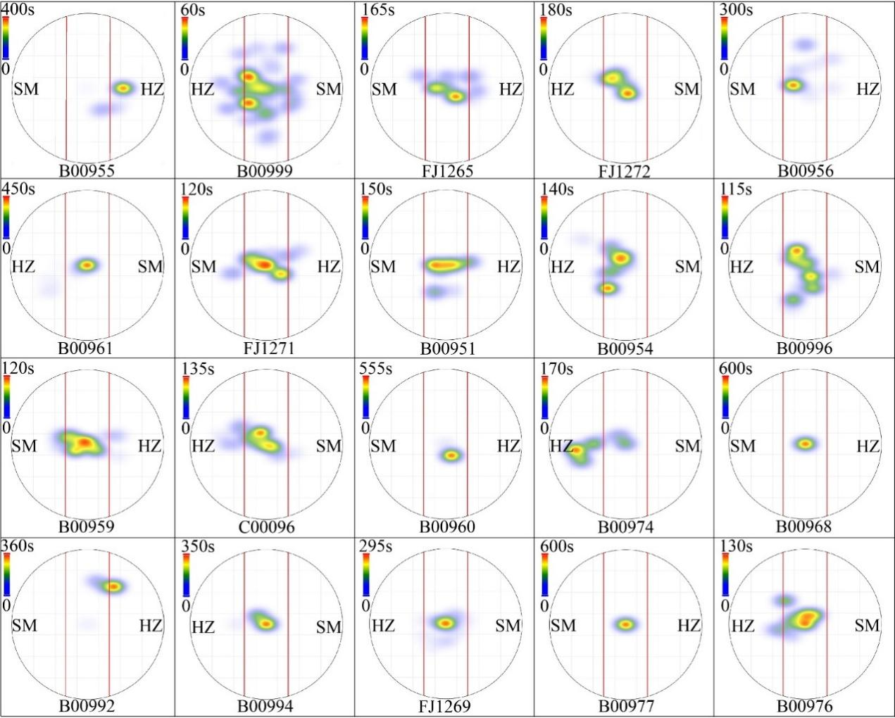
Fig. S1 Heatmaps showing the time spent by 20 females at different locations within the plastic bucket over a 10-minute period. The area between the two red lines indicates the neutral zone. The area beyond the two red lines is the response zone. The number below the circle represents the bat identity. "HZ" represents Hanzhong colony. "SM" represents Simao colony.

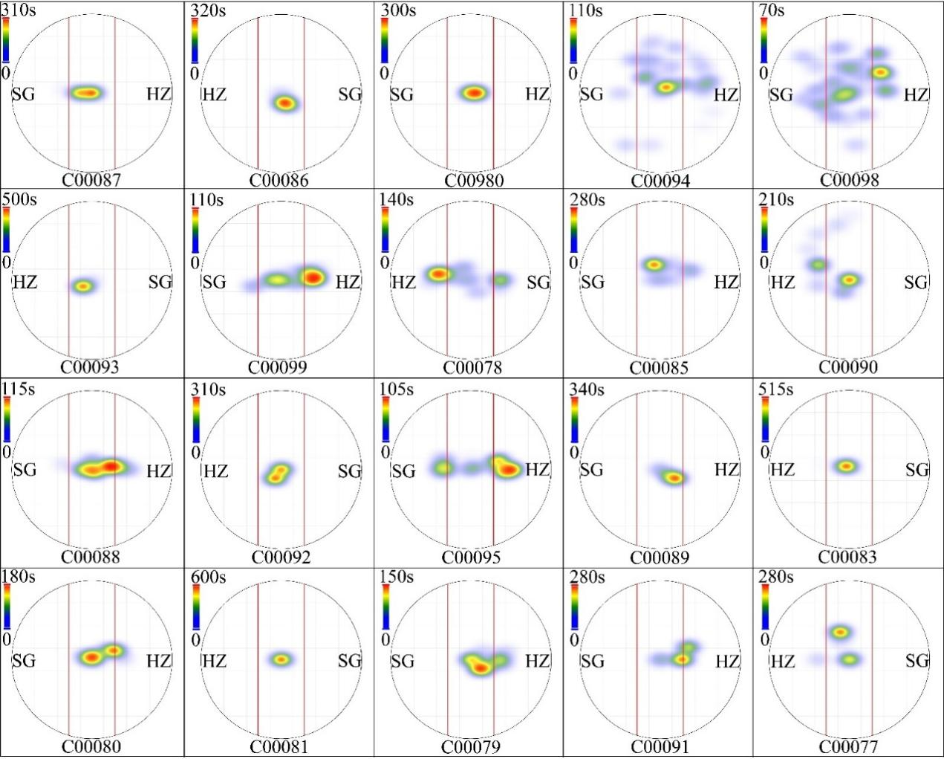
Fig. S2 Heatmaps showing the time spent by 20 females at different locations within the plastic bucket over a 10-minute period. The area between the two red lines indicates the neutral zone. The area beyond the two red lines is the response zone. The number below the circle represents the bat identity. "HZ" represents Hanzhong colony. "SG" represents shaoguan colony.

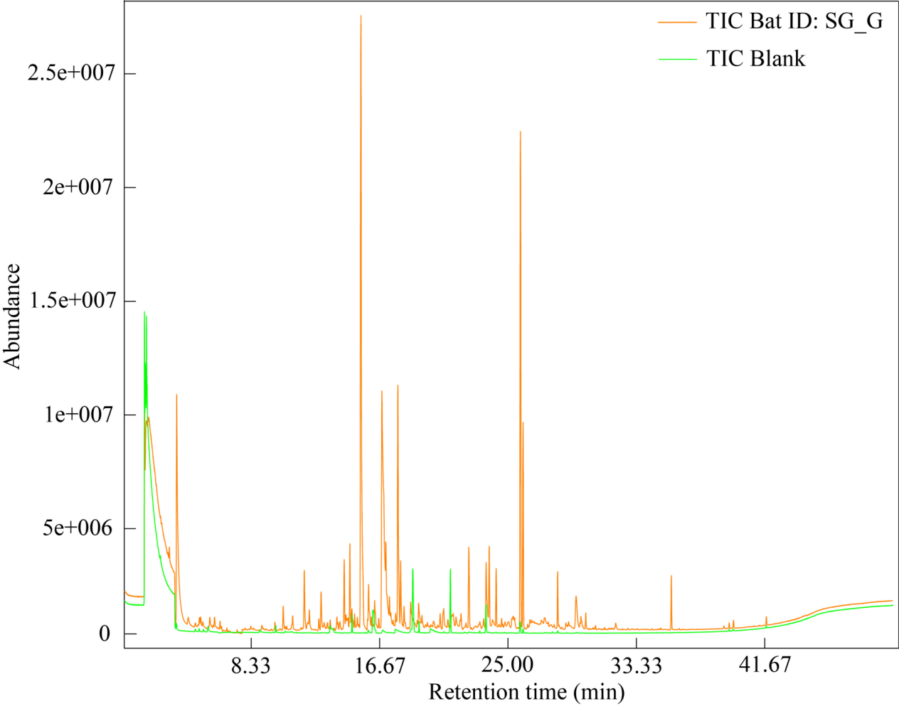
Fig. S3 A total ion chromatogram (TIC) of samples from the forehead gland secretions of a bat (SG_G) (orange line) and the blank sample (green line).

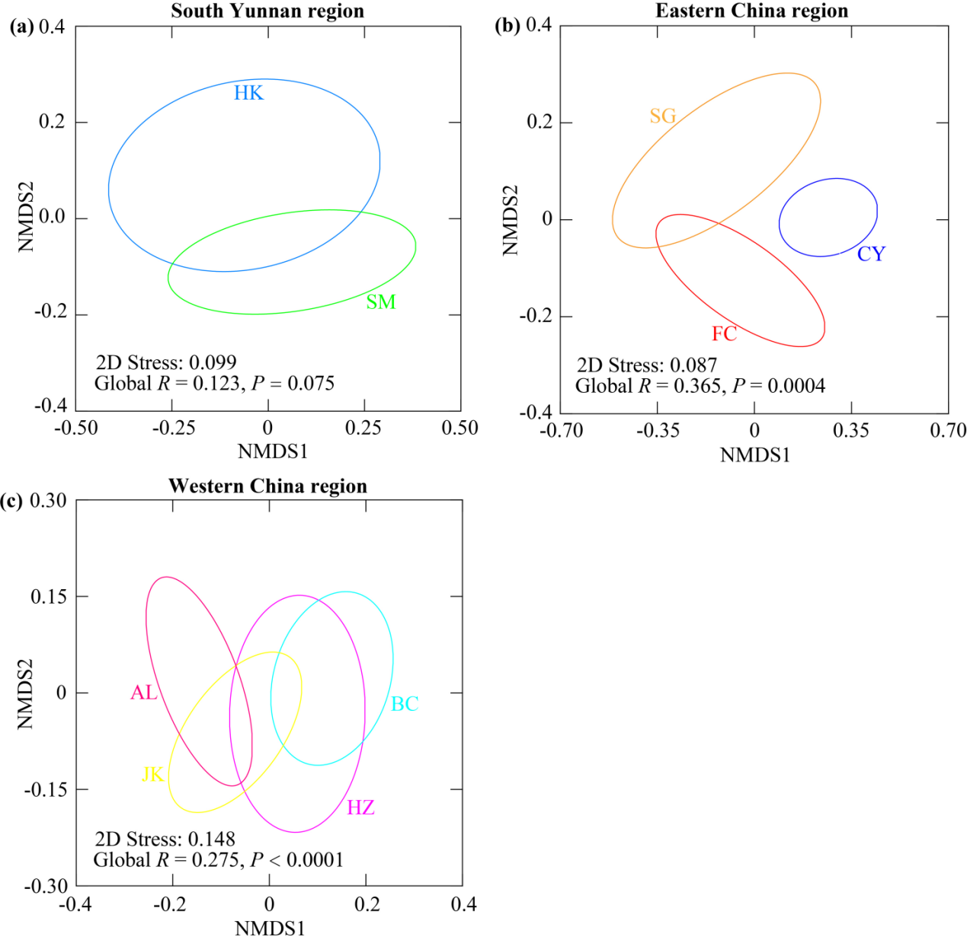
Fig. S4 NMDS plots show the compound categories with chemical similarity for (a) 20 individuals from the two colonies within South Yunnan region, (b) 27 individuals from the three colonies within Eastern China region, and (c) 40 individuals from the three colonies within Western China region. Ellipses showing the 50% confidence interval.

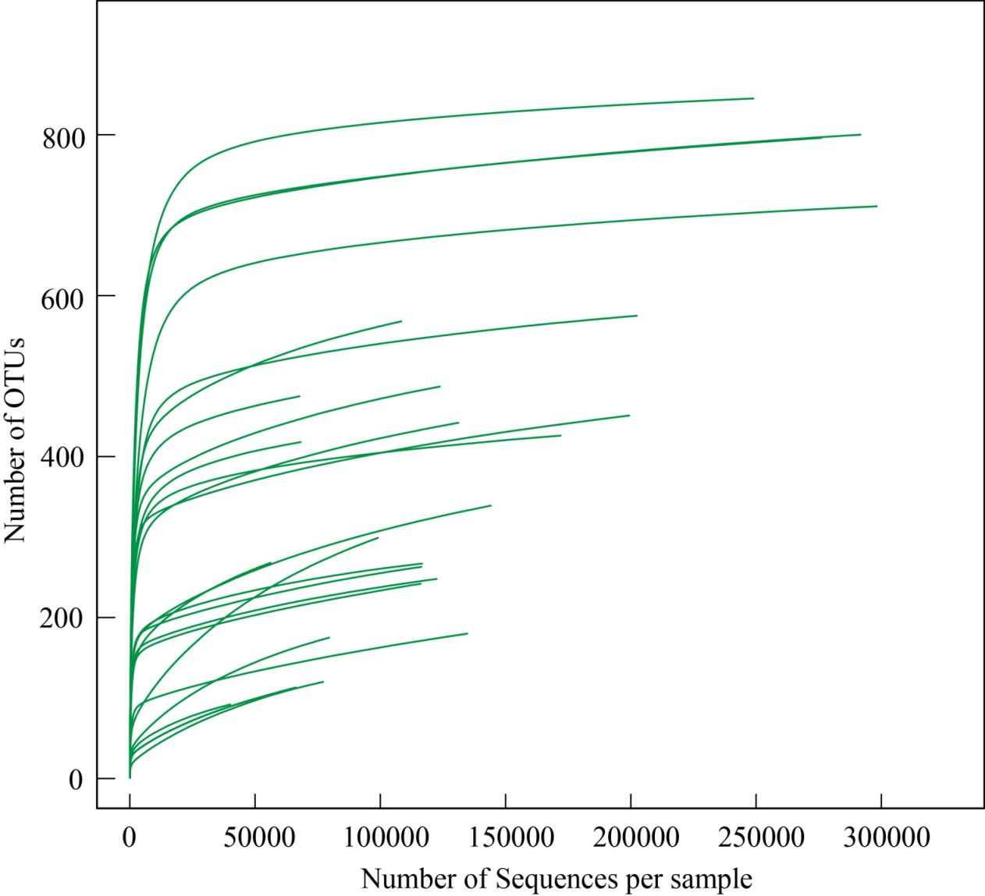
Fig. S5 Rarefaction curves for number of OTUs of gland microbial communities in each sample.

Table S1. Latitude and longitude for each colony and corresponding climatic data.
Region | Colony | Cave | Longitude(°) | Latitude(°) | N | MAT(°C) | MARH(%)
Eastern China  (EC) | Fanchang (FC) | Xianren cave | 118.30 | 31.05 | 10 | 16.44±0.62 | 78.28±2.17
Eastern China  (EC) | Chongyi (CY) | Shiyan cave | 114.10 | 24.50 | 7 | 20.57±0.53 | 77.75±2.26
Eastern China  (EC) | Shaoguan (SG) | Pan cave | 113.56 | 24.77 | 10 | 20.61±0.50 | 76.55±2.14
Western China  (WC) | Hanzhong (HZ) | Yu cave | 107.0266 | 32.85 | 10 | 13.54±0.56 | 78.30±1.69
Western China  (WC) | Hanzhong (HZ) | Dafo cave | 107.0323 | 32.85 | - | 16.09±0.56 | 78.30±1.69
Western China  (WC) | Beichuan (BC) | Bat cave | 104.40 | 31.63 | 10 | 16.53±0.49 | 77.41±1.97
Western China  (WC) | Jiangkou (JK) | Baishui cave | 108.83 | 27.68 | 10 | 16.82±0.50 | 79.74±1.98
Western China  (WC) | Anlong (AL) | Huangyan cave | 105.54 | 25.28 | 10 | 21.28±0.51 | 79.97±2.03
Southern Yunnan  (SY) | Hekou (HK) | Huayu cave | 103.91 | 22.74 | 10 | 19.50±0.52 | 82.16±1.50
Southern Yunnan  (SY) | Simao (SM) | Shenxian cave | 100.71 | 22.61 | 10 | 16.44±0.55 | 75.83±2.08
MARH: mean annual relative humidity. MAT: mean annual temperature. N: the number of male individuals sampled. MAT and MARH data are given as mean ± SD.

Table S2. Estimates of genetic difference derived from both mtDNA and nDNA.
 | FC | CY | SG | HZ | BC | JK | AL | HK | SM
FC | 0 | 0.931 | 2.761 | 7.415 | 8.639 | 9.601 | 6.598 | 9.176 | 5.918
CY | 0.063 | 0 | 0.284 | 2.632 | 2.443 | 2.783 | 2.463 | 3.413 | 2.698
SG | 0.080 | 0.046 | 0 | 5.246 | 5.535 | 6.294 | 4.563 | 6.174 | 4.254
HZ | 0.146 | 0.052 | 0.010 | 0 | 0.143 | 0.391 | 0.438 | 11.183 | 7.069
BC | 0.249 | 0.085 | 0.215 | 0.036 | 0 | 0.051 | 0.857 | 13.233 | 7.225
JK | 0.188 | 0.063 | 0.113 | 0.029 | 0.015 | 0 | 1.215 | 14.957 | 8.141
AL | 0.149 | 0.030 | 0.065 | 0.014 | 0.034 | 0.017 | 0 | 9.165 | 6.112
HK | 0.127 | 0.020 | 0.322 | 0.037 | 0.045 | 0.029 | 0.003 | 0 | 5.530
SM | 0.239 | 0.133 | 0.156 | 0.032 | 0.080 | 0.058 | 0.061 | 0.094 | 0
Above the diagonal are F_{ST} values from mtDNA (partial mitochondrial control region (358 bp) and complete cytochrome b (1140 bp)). Below the diagonal are F_{ST} values of nDNA. Site abbreviations are defined in Table 1.

Table S3. Eigenvalues, variance components, and compound component loadings for a principal component analysis of chemical components of gland secretions in Hipposideros armiger. Bold values indicate the highest loadings associated with a particular component (P < 0.05).

Table S4. Description of the number of gland secretion compounds in each colony of Hipposideros armiger
Colony | Mean number of  compounds per  colony ± SE | Number of compounds  occurring in all samples  from the colony | Colony-specific  compounds in  samples | N
FC | 76 ± 1.7 | 29 | 3 | 10
CY | 72 ± 2.7 | 39 | 0 | 7
SG | 66 ± 3.1 | 21 | 2 | 10
HZ | 74 ± 1.1 | 41 | 0 | 10
BC | 79 ± 1.7 | 55 | 0 | 10
JK | 72 ± 1.4 | 41 | 0 | 10
AL | 75 ± 1.4 | 38 | 0 | 10
HK | 75 ± 2.7 | 33 | 0 | 10
SM | 74 ± 2.1 | 36 | 0 | 10
Note: N indicates the number of samples from each colony. Definitions of locality abbreviations are provided in Table 1. SE: standard error.

Table S5. Percentage of the total variance in categories of compounds of Hipposideros armiger explained by region, colony within region, individuals within colonies (*P < 0.05, **P < 0.008, ***P < 0.0001)
Categories of  compounds | Percentage of total variance
Categories of  compounds | Between  regions | Colonies within  regions | Individuals within  colonies
Aromatic compound | 0 | 35*** | 65
Aldehyde | 25 | 11* | 64
Alkane | 14 | 17** | 69
Ketone | 0 | 9 | 91
Alcohol | 0 | 46*** | 54
Ester | 6 | 16* | 78
Carboxylic acid | 0 | 24** | 76
Alkene | 15 | 16** | 69
Furan | 10 | 0 | 90
Thiol | 0 | 44*** | 56

Table S6. Mantel correlations between chemical distance of Hipposideros armiger forehead gland secretions and pairwise distances of environmental and genetic factors across colonies.
Variables | r | P
MAT | 0.122 | 0.561
MARH | -0.133 | 0.613
nSSR | 0.272 | 0.189
mtDNA | 0.046 | 0.838
MAT: mean annual temperature. MARH: mean annual relative humidity. nSSR: nuclear microsatellite markers. mtDNA: mitochondrial DNA sequences.

Table S7. The stimulus donors of habituation odor and of novel odor for each testing bat in habituation–discrimination tests and the stimulus donors of local odor and of foreign odor for each testing bat in two-choice tests. "HZ" represents Hanzhong colony. "SM" represents Simao colony. "SG" represents Shaoguan colony.
Colony | Bat ID | Code | Number of gland secretions used in this experiment
HZ | FJ1273 | HZ_01 | 12
HZ | FJ1441 | HZ_02 | 16
HZ | FJ1426 | HZ_03 | 16
HZ | C00100 | HZ_04 | 16
HZ | C00097 | HZ_05 | 16
HZ | FJ1419 | HZ_06 | 16
HZ | FJ1424 | HZ_07 | 16
HZ | FJ1425 | HZ_08 | 16
HZ | FJ1301 | HZ_09 | 16
HZ | FJ1421 | HZ_10 | 16
HZ | FJ1417 | HZ_11 | 16
HZ | FJ1415 | HZ_12 | 16
HZ | FJ1442 | HZ_13 | 16
HZ | FJ1420 | HZ_14 | 16
HZ | FJ1423 | HZ_15 | 16
HZ | C00777 | HZ_16 | 16
HZ | FJ1422 | HZ_17 | 16
HZ | FJ1416 | HZ_18 | 16
HZ | FJ1427 | HZ_19 | 16
HZ | FJ1302 | HZ_20 | 16
HZ | FJ1443 | HZ_21 | 16
HZ | FJ1430 | HZ_22 | 16
HZ | FJ1432 | HZ_23 | 16
HZ | FJ1434 | HZ_24 | 16
HZ | FB0123 | HZ_25 | 16
HZ | FB0126 | HZ_26 | 16
HZ | FJ1438 | HZ_27 | 16
HZ | FA0812 | HZ_28 | 16
HZ | FA0813 | HZ_29 | 16
HZ | FA0814 | HZ_30 | 12
HZ | FA0815 | HZ_31 | 8
HZ | FA0816 | HZ_32 | 12
HZ | FA0817 | HZ_33 | 12
HZ | FA0818 | HZ_34 | 12
HZ | FA0819 | HZ_35 | 12
HZ | FA0820 | HZ_36 | 12
HZ | FA0821 | HZ_37 | 12
HZ | FA0822 | HZ_38 | 12
HZ | FA0823 | HZ_39 | 12
HZ | FA0824 | HZ_40 | 12
HZ | FA0825 | HZ_41 | 12
SM | C00773 | SM_01 | 7
SM | C00776 | SM_02 | 7
SM | C00371 | SM_03 | 7
SM | FJ1412 | SM_04 | 7
SM | FB0167 | SM_05 | 7
SM | C00174 | SM_06 | 7
SM | C00960 | SM_07 | 7
SM | FJ1413 | SM_08 | 7
SM | FJ1266 | SM_09 | 8
SM | C00082 | SM_10 | 7
SM | FB0139 | SM_11 | 7
SM | FJ1274 | SM_12 | 7
SM | C00084 | SM_13 | 7
SM | FB0222 | SM_14 | 7
SM | C00770 | SM_15 | 7
SM | FJ1414 | SM_16 | 7
SM | FJ1418 | SM_17 | 7
SG | FJ1439 | SG_01 | 8
SG | FJ1448 | SG_02 | 8
SG | FJ1437 | SG_03 | 8
SG | FJ1433 | SG_04 | 8
SG | FJ1431 | SG_05 | 8
SG | FA0712 | SG_06 | 8
SG | FA0718 | SG_07 | 8
SG | FA0720 | SG_08 | 8
SG | FA0721 | SG_09 | 8
SG | FA0741 | SG_10 | 8
SG | FA0745 | SG_11 | 8
SG | FA0746 | SG_12 | 8
SG | FA0747 | SG_13 | 8
SG | FA0748 | SG_14 | 8
SG | FA0749 | SG_15 | 8

Table S8. The stimulus donors of habituation odor and of novel odor for each testing male Hipposideros armiger in habituation–discrimination tests for Hanzhong (HZ) vs Simao (SM) colony
Bat ID | Testing bat | Stimulus donors of  habituation odor | Stimulus donors of  novel odor
B00978 | Male_01 | HZ_15, HZ_16, HZ_17 | SM_15, SM_16, SM_17
B00957 | Male_02 | HZ_06, HZ_07, HZ_08 | SM_06, SM_07, SM_08
B00952 | Male_03 | HZ_01, HZ_02, HZ_03 | SM_01, SM_02, SM_03
B00987 | Male_04 | HZ_23, HZ_24, HZ_25 | SM_05, SM_06, SM_08
B00970 | Male_05 | HZ_11, HZ_12, HZ_13 | SM_11, SM_12, SM_13
B00958 | Male_06 | HZ_01, HZ_02, HZ_04 | SM_01, SM_02, SM_04
B00975 | Male_07 | HZ_18, HZ_19, HZ_20 | SM_05, SM_07, SM_09
B00962 | Male_08 | HZ_12, HZ_13, HZ_14 | SM_12, SM_13, SM_14
B00953 | Male_09 | HZ_05, HZ_06, HZ_07 | SM_05, SM_06, SM_07
B00964 | Male_10 | HZ_26, HZ_27, HZ_28 | SM_08, SM_09, SM_11
B00969 | Male_11 | HZ_09, HZ_10, HZ_11 | SM_09, SM_10, SM_11
B00990 | Male_12 | HZ_21, HZ_22, HZ_23 | SM_03, SM_04, SM_08
B00963 | Male_13 | HZ_29, HZ_30, HZ_31 | SM_14, SM_15, SM_17
B00972 | Male_14 | HZ_14, HZ_15, HZ_16 | SM_14, SM_15, SM_16
B00965 | Male_15 | HZ_27, HZ_28, HZ_29 | SM_11, SM_12, SM_14
B00979 | Male_16 | HZ_20, HZ_21, HZ_22 | SM_01, SM_02, SM_06
FJ1300 | Male_17 | HZ_08, HZ_09, HZ_10 | SM_08, SM_09, SM_10
B00991 | Male_18 | HZ_17, HZ_18, HZ_19 | SM_09, SM_11, SM_17
B00971 | Male_19 | HZ_03, HZ_04, HZ_05 | SM_03, SM_04, SM_05
B00989 | Male_20 | HZ_24, HZ_25, HZ_26 | SM_06, SM_07, SM_09

Table S9. The stimulus donors of habituation odor and of novel odor for each testing male Hipposideros armiger in habituation–discrimination tests for Hanzhong (HZ) vs. Shaoguan (SG) colony
Bat ID | Testing bat | Stimulus donors of  habituation odor | Stimulus donors of  novel odor
B00978 | Male_01 | HZ_02, HZ_03, HZ_05 | SG_01, SG_02, SG_04
B00957 | Male_02 | HZ_12, HZ_13, HZ_20 | SG_11, SG_12, SG_13
B00952 | Male_03 | HZ_21, HZ_22, HZ_30 | SG_03, SG_09, SG_10
B00987 | Male_04 | HZ_27, HZ_28, HZ_31 | SG_08, SG_09, SG_11
B00970 | Male_05 | HZ_07, HZ_08, HZ_09 | SG_06, SG_07, SG_08
B00958 | Male_06 | HZ_02, HZ_03, HZ_04 | SG_01, SG_02, SG_03
B00975 | Male_07 | HZ_15, HZ_16, HZ_29 | SG_12, SG_14, SG_15
B00962 | Male_08 | HZ_14, HZ_24, HZ_25 | SG_05, SG_06, SG_08
B00953 | Male_09 | HZ_19, HZ_20, HZ_21 | SG_05, SG_07, SG_08
B00964 | Male_10 | HZ_01, HZ_08, HZ_26 | SG_01, SG_14, SG_15
B00969 | Male_11 | HZ_04, HZ_05, HZ_06 | SG_03, SG_04, SG_05
B00990 | Male_12 | HZ_16, HZ_17, HZ_18 | SG_01, SG_02, SG_15
B00963 | Male_13 | HZ_22, HZ_23, HZ_24 | SG_04, SG_08, SG_11
B00972 | Male_14 | HZ_09, HZ_10, HZ_23 | SG_08, SG_09, SG_10
B00965 | Male_15 | HZ_13, HZ_14, HZ_15 | SG_12, SG_13, SG_14
B00979 | Male_16 | HZ_28, HZ_29, HZ_30 | SG_11, SG_12, SG_14
FJ1300 | Male_17 | HZ_11, HZ_18, HZ_19 | SG_03, SG_04, SG_06
B00991 | Male_18 | HZ_25, HZ_26, HZ_27 | SG_06, SG_07, SG_09
B00971 | Male_19 | HZ_06, HZ_07, HZ_17 | SG_05, SG_06, SG_07
B00989 | Male_20 | HZ_10, HZ_11, HZ_12 | SG_09, SG_10, SG_11

Table S10. The stimulus donors of local odor and of foreign odor for each testing female Hipposideros armiger in two-choice tests for Hanzhong (HZ) vs. Simao (SM) colony
Bat ID | Testing bat | Stimulus donors of  local odor | Stimulus donors of  foreign odor
B00955 | Female_01 | HZ_34, HZ_35, HZ_36 | SM_02, SM_07, SM_08
B00999 | Female_02 | HZ_39, HZ_40, HZ_41 | SM_01, SM_04, SM_07
FJ1265 | Female_03 | HZ_34, HZ_36, HZ_37 | SM_06, SM_09, SM_12
FJ1272 | Female_04 | HZ_38, HZ_40, HZ_41 | SM_10, SM_13, SM_16
B00956 | Female_05 | HZ_36, HZ_37, HZ_38 | SM_13, SM_14, SM_15
B00961 | Female_06 | HZ_33, HZ_34, HZ_41 | SM_13, SM_16, SM_17
FJ1271 | Female_07 | HZ_32, HZ_33, HZ_34 | SM_01, SM_03, SM_04
B00951 | Female_08 | HZ_32, HZ_33, HZ_41 | SM_01, SM_03, SM_06
B00954 | Female_09 | HZ_36, HZ_38, HZ_39 | SM_10, SM_14, SM_16
B00996 | Female_10 | HZ_32, HZ_33, HZ_40 | SM_12, SM_15, SM_17
B00959 | Female_11 | HZ_33, HZ_34, HZ_35 | SM_01, SM_02, SM_05
C00096 | Female_12 | HZ_38, HZ_39, HZ_40 | SM_09, SM_13, SM_15
B00960 | Female_13 | HZ_33, HZ_35, HZ_36 | SM_03, SM_05, SM_11
B00974 | Female_14 | HZ_37, HZ_39, HZ_40 | SM_03, SM_12, SM_15
B00968 | Female_15 | HZ_35, HZ_37, HZ_38 | SM_07, SM_10, SM_13
B00992 | Female_16 | HZ_32, HZ_40, HZ_41 | SM_02, SM_05, SM_08
B00994 | Female_17 | HZ_32, HZ_39, HZ_41 | SM_14, SM_16, SM_17
FJ1269 | Female_18 | HZ_37, HZ_38, HZ_39 | SM_04, SM_16, SM_17
B00977 | Female_19 | HZ_35, HZ_36, HZ_37 | SM_10, SM_11, SM_12
B00976 | Female_20 | HZ_32, HZ_34, HZ_35 | SM_02, SM_04, SM_10

Table S11. The stimulus donors of local odor and of foreign odor for each testing female Hipposideros armiger in two-choice tests for Hanzhong (HZ) vs. Shaoguan (SG) colony
Bat ID | Testing bat | Stimulus donors of  local odor | Stimulus donors of  foreign odor
C00087 | Female_21 | HZ_34, HZ_37, HZ_38 | SG_03, SG_06, SG_07
C00086 | Female_22 | HZ_33, HZ_34, HZ_40 | SG_05, SG_07, SG_13
C00980 | Female_23 | HZ_36, HZ_40, HZ_41 | SG_02, SG_12, SG_15
C00094 | Female_24 | HZ_34, HZ_34, HZ_40 | SG_04, SG_10, SG_14
C00098 | Female_25 | HZ_37, HZ_40, HZ_41 | SG_06, SG_12, SG_13
C00093 | Female_26 | HZ_33, HZ_37, HZ_38 | SG_04, SG_05, SG_12
C00099 | Female_27 | HZ_32, HZ_35, HZ_36 | SG_01, SG_12, SG_13
C00078 | Female_28 | HZ_32, HZ_33, HZ_38 | SG_02, SG_10, SG_14
C00085 | Female_29 | HZ_34, HZ_38, HZ_39 | SG_06, SG_10, SG_13
C00090 | Female_30 | HZ_32, HZ_38, HZ_41 | SG_03, SG_07, SG_15
C00088 | Female_31 | HZ_35, HZ_38, HZ_39 | SG_04, SG_08, SG_09
C00092 | Female_32 | HZ_32, HZ_36, HZ_37 | SG_02, SG_14, SG_15
C00095 | Female_33 | HZ_33, HZ_34, HZ_39 | SG_03, SG_11, SG_15
C00089 | Female_34 | HZ_33, HZ_36, HZ_37 | SG_02, SG_04, SG_05
C00083 | Female_35 | HZ_32, HZ_37, HZ_41 | SG_01, SG_09, SG_13
C00080 | Female_36 | HZ_32, HZ_33, HZ_39 | SG_01, SG_03, SG_08
C00081 | Female_37 | HZ_35, HZ_39, HZ_40 | SG_07, SG_11, SG_14
C00079 | Female_38 | HZ_35, HZ_36, HZ_41 | SG_09, SG_13, SG_15
C00091 | Female_39 | HZ_36, HZ_39, HZ_40 | SG_05, SG_10, SG_11
C00077 | Female_40 | HZ_34, HZ_35, HZ_41 | SG_01, SG_02, SG_10

Video S1. Response of Hipposideros armiger to playback of odors from its own colony (top swab) and those of foreign colony (bottom swab) over a 10-minute period. The heatmap depicting the time spent at different locations within the plastic bucket over a 10-minute period. "HZ" represents Hanzhong colony. "SM" represents Simao colony. Note: the 10-minute period is compressed into 1 minute.

