Psychometric properties of the Armenian and Georgian versions of the PHQ-9, GAD-7, and WHO-5 Well-Being Index

Supplementary Materials 3 – Supporting tables and figures

Packages used in R for analyses: lavaan, survey, semTools, semPlot, psych, jtools, and Hmisc (1–7).

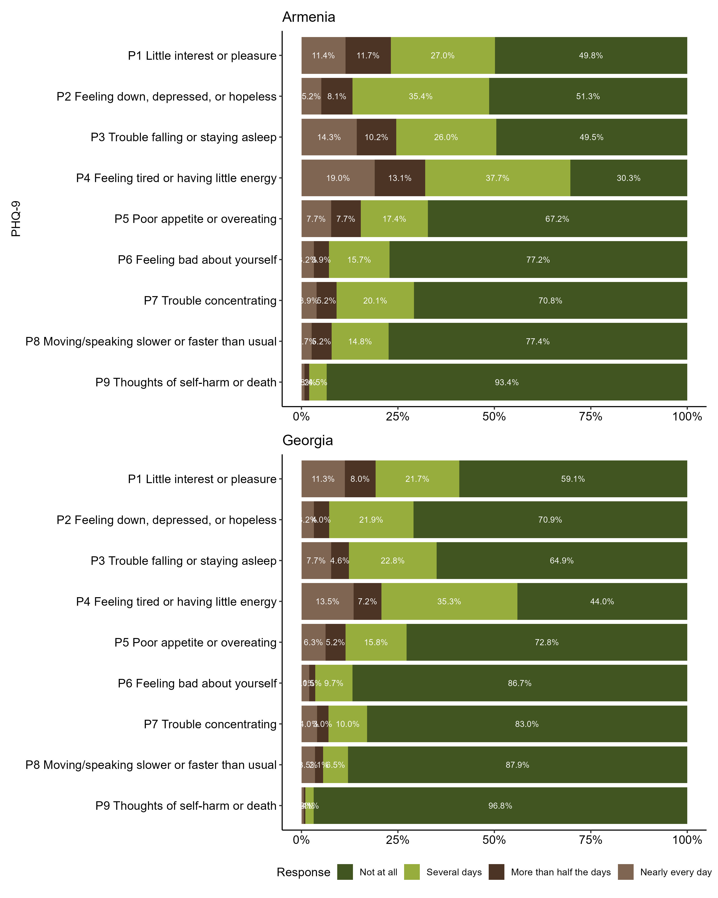
Figure S1.1. Caption: Response distribution for each item of the PHQ-9. Alt text: A two-panel figure displaying bar graphs representing the proportion of responses to each individual item of the PHQ-9. The top plot corresponds to Armenia and shows a trend for lower scoring responses (Corresponding to “Not at all”), being around 50% or more of the total responses. The bottom plot corresponds to Georgia and shows an even stronger trend. “Several days” is the second most frequent response but is significantly lower in proportion.
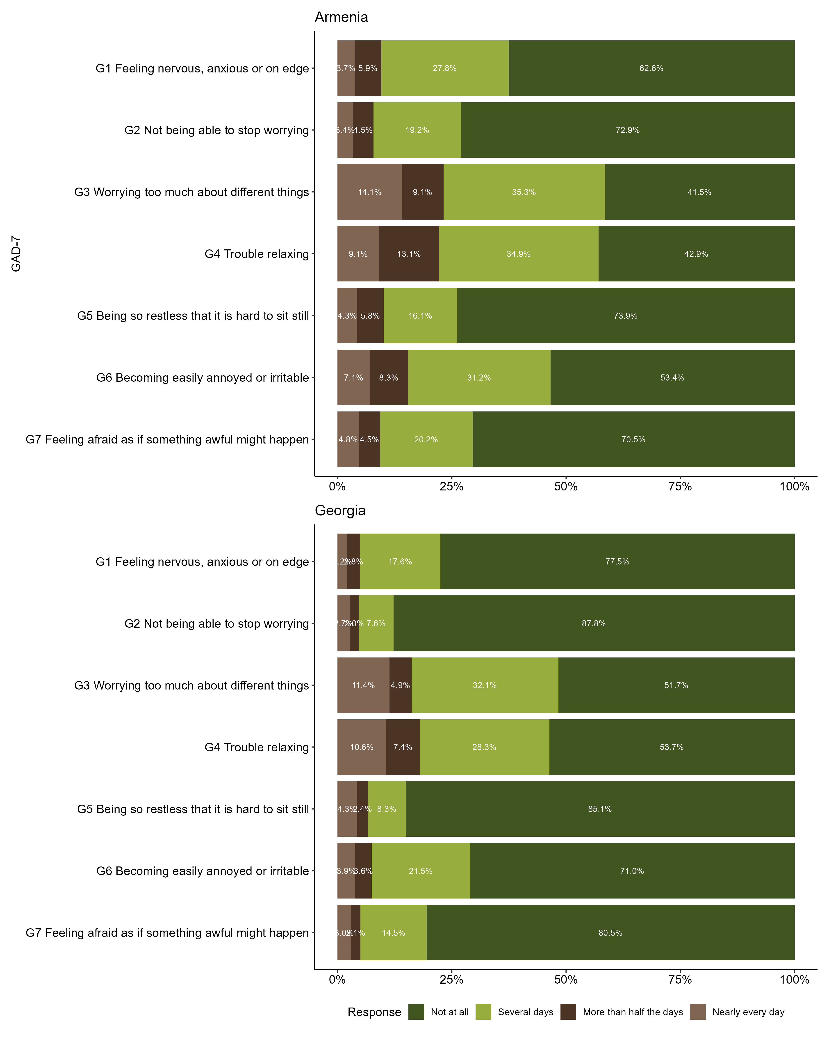
Figure S1.2. Caption: Response distribution for each item of the GAD-7. Alt text: A two-panel figure displaying bar graphs representing the proportion of responses to each individual item of the GAD-7. The top plot corresponds to Armenia and shows a trend for lower scoring responses (Corresponding to “Not at all”), with at least 40% or more of the total responses. The bottom plot corresponds to Georgia and shows an even stronger trend. The second most frequent response is “Several days” but account for one third of the total at most.
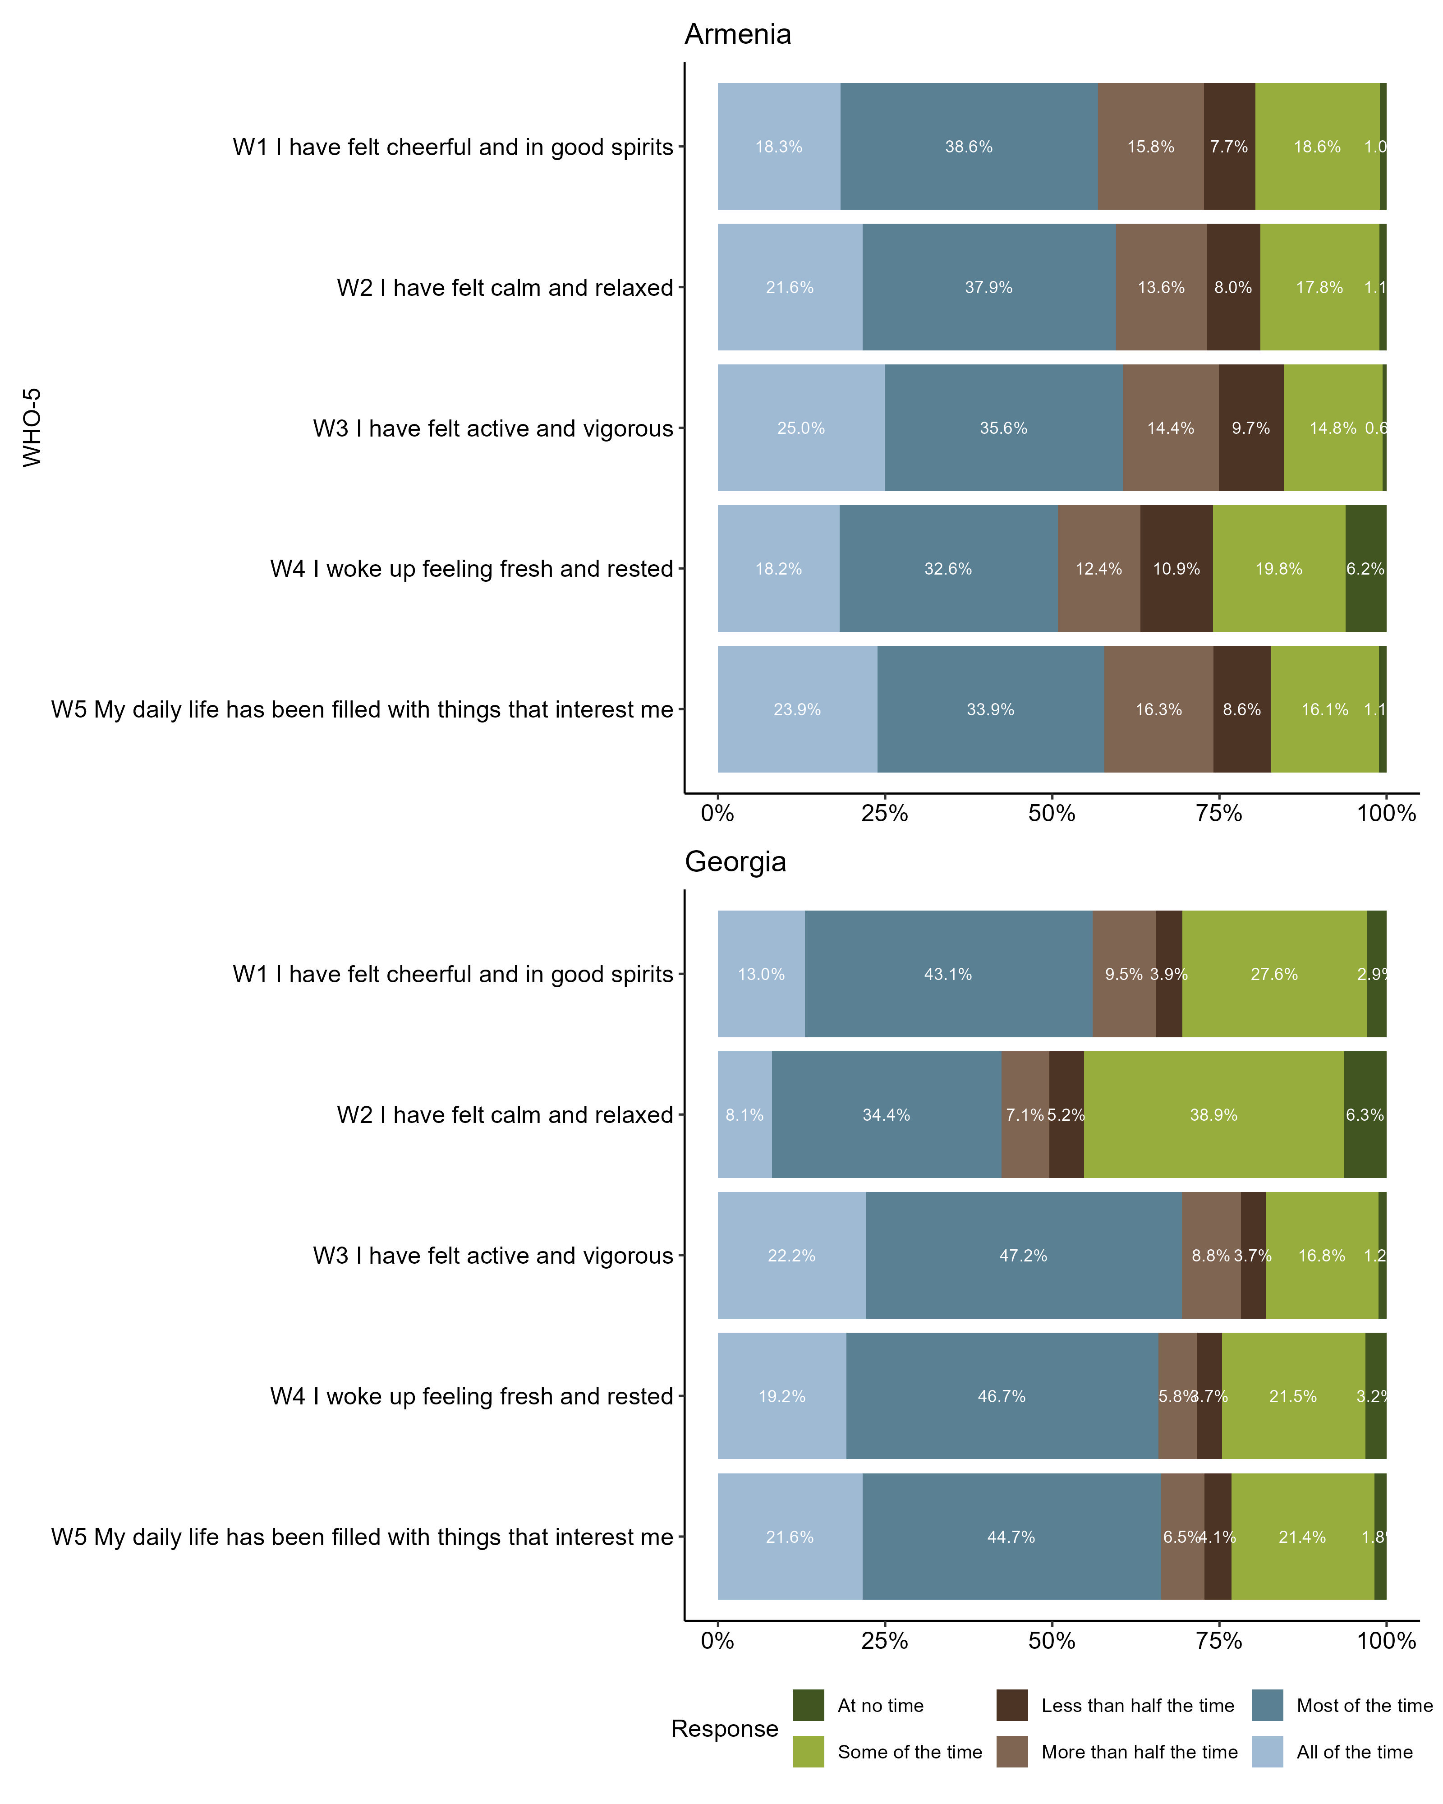
Figure S1.3. Caption: Response distribution for each item of the WHO-5. Alt text: Bar graph displaying the proportion of responses to each individual item of the WHO-5. A two-panel figure displaying bar graphs representing the proportion of responses to each individual item of the WHO-5. The top plot corresponds to Armenia and shows a trend for “Most of the time” responses, representing around one third of the total responses. The bottom plot corresponds to Georgia and shows an even stronger trend. The second most frequent response is “All of the time”, which ranges from 8% to 25%.
Figure S2.1. Caption: Inter-item correlation matrices for the PHQ-9, GAD-7 and WHO-5 in Armenia. Alt text: A three-panel figure of correlation matrix heatmaps for psychometric data collected in Armenia. The left panel shows inter-item correlations for the PHQ-9; the middle panel shows the GAD-7; the right panel shows the WHO-5. In all three lower-triangular matrices, numerical correlation coefficients are displayed in cells shaded red, indicating positive associations. Asterisks next to the numbers indicate statistical significance, with three of these indicating a p value < 0.001. A colour legend at the bottom indicates a scale from -1.0 (blue) to 1.0 (red). The data shows moderate to strong positive, statistically significant correlations between all items within each of the three respective scales.
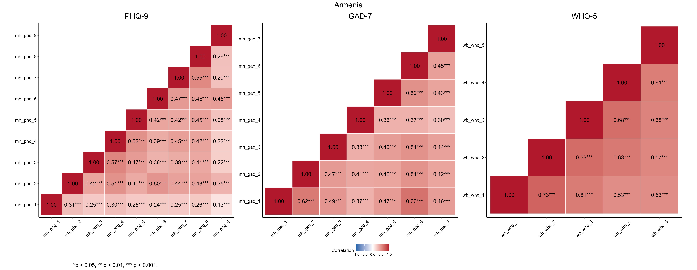

Figure S2.2. Caption: Inter-item correlation matrices for the PHQ-9, GAD-7 and WHO-5 in Georgia. Alt text: A three-panel figure of correlation matrix heatmaps for psychometric data collected in Georgia. The left panel shows inter-item correlations for the PHQ-9; the middle panel shows the GAD-7; the right panel shows the WHO-5. In all three lower-triangular matrices, numerical correlation coefficients are displayed in cells shaded red, indicating positive associations. Asterisks next to the numbers indicate statistical significance, with three of these indicating a p value < 0.001. A colour legend at the bottom indicates a scale from -1.0 (blue) to 1.0 (red). The data shows moderate to strong positive, statistically significant correlations between all items within each of the three respective scales.
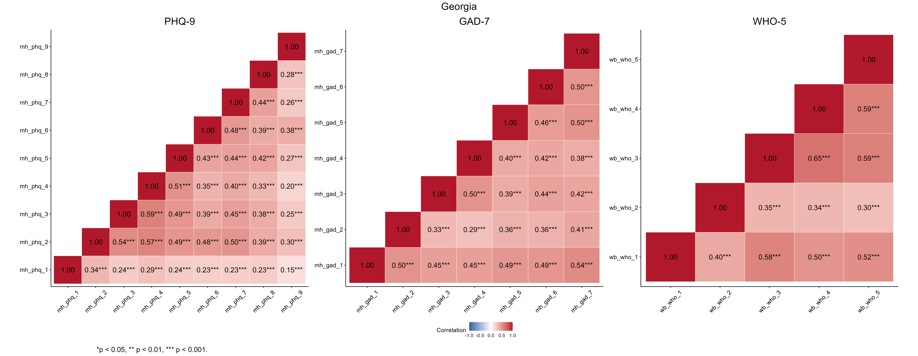

It is accepted to aim for coefficients between 0.15 and 0.50 to determine good internal consistency while avoiding redundancy (8).

Table S1. Kaiser-Meyer-Olkin (KMO) and Bartlett's sphericity tests. The KMO assess data suitability for factor analysis, indicating the proportion of variance in the variables likely caused by underlying factors. The Bartlett test checks redundancy between variables, with the null hypothesis stating that these are not correlated.
 | Armenia |  |  |  | Georgia
 | KMO | Bartlett's | df | p-value | KMO | Bartlett's | df | p-value
PHQ-9 | 0.89 | 3,985 | 36 | < 0.001 | 0.90 | 5,561 | 36 | < 0.001
GAD-7 | 0.89 | 3,561 | 21 | < 0.001 | 0.89 | 4,459 | 21 | < 0.001
WHO-5 | 0.86 | 3,863 | 10 | < 0.001 | 0.83 | 3,551 | 10 | < 0.001
Note. KMO = Kaiser-Meyer-Olkin test value; df = degrees of freedom.

These KMO results are considered “meritorious” by the authors in the original publication of the method, thus making them suitable for factor analysis. Bartlett’s sphericity tests (9,10) with p-values < 0.001 suggest that the correlation between items exists and is sufficiently strong.
Table S2.1. Exploratory Factor Analyses (EFA) for the PHQ-9, GAD-7 and WHO-5 in Armenia. Maximum Likelihood (ML) is used as the extraction method with Direct Oblimin rotation to allow for correlations between factors.
Item | ML1 | ML2 | ML3 | ML4 | h² (Communality) | % Var | Eigen
PHQ-9
P1 Little interest or pleasure | 0.05 | 0.11 | 0.25 | 0.04 | 0.15 | 0.58 | 4.08
P2 Feeling down, depressed, or hopeless | 0.01 | 0.99 | 0.01 | 0.01 | 1.00 | 0.58 | 0.99
P3 Trouble falling or staying asleep | 0.03 | -0.01 | 0.68 | 0.02 | 0.49 | 0.58 | 0.83
P4 Feeling tired or having little energy | -0.03 | 0.06 | 0.82 | -0.05 | 0.67 | 0.58 | 0.72
P5 Poor appetite or overeating | 0.08 | -0.08 | 0.54 | 0.20 | 0.46 | 0.58 | 0.58
P6 Feeling bad about yourself | 0.00 | 0.02 | 0.02 | 0.81 | 0.69 | 0.58 | 0.51
P7 Trouble concentrating | 0.28 | 0.03 | 0.25 | 0.24 | 0.44 | 0.58 | 0.46
P8 Moving/speaking slower or faster than usual | 1.00 | 0.01 | 0.00 | -0.01 | 1.00 | 0.58 | 0.45
P9 Thoughts of self-harm or death | 0.00 | 0.07 | -0.07 | 0.55 | 0.31 | 0.58 | 0.38
GAD-7
G1 Feeling nervous, anxious or on edge | 0.93 | 0.02 | 0.02 |  | 0.90 | 0.54 | 3.75
G2 Not being able to stop worrying | 0.34 | 0.16 | 0.43 |  | 0.61 | 0.54 | 0.73
G3 Worrying too much about different things | -0.02 | 0.64 | 0.11 |  | 0.48 | 0.54 | 0.64
G4 Trouble relaxing | -0.04 | 0.40 | 0.27 |  | 0.32 | 0.54 | 0.59
G5 Being so restless that it is hard to sit still | -0.06 | 0.75 | -0.03 |  | 0.48 | 0.54 | 0.53
G6 Becoming easily annoyed or irritable | 0.28 | 0.59 | -0.08 |  | 0.61 | 0.54 | 0.46
G7 Feeling afraid as if something awful might happen | 0.04 | 0.55 | 0.06 |  | 0.38 | 0.54 | 0.31
WHO-5
W1 I have felt cheerful and in good spirits | 0.89 | -0.06 |  |  | 0.70 | 0.68 | 3.47
W2 I have felt calm and relaxed | 0.79 | 0.12 |  |  | 0.77 | 0.68 | 0.55
W3 I have felt active and vigorous | 0.39 | 0.48 |  |  | 0.67 | 0.68 | 0.44
W4 I woke up feeling fresh and rested | -0.03 | 0.91 |  |  | 0.78 | 0.68 | 0.30
W5 My daily life has been filled with things that interest me | 0.26 | 0.49 |  |  | 0.50 | 0.68 | 0.25
Note. ML: Factor loadings through Maximum-Likelihood method estimation (For 1, 2, 3 or 4 factor-models); % Var: Variance explained by the item (%); Eigen: Eigenvalue.

The parallel analyses suggested two and even three factors measured for the PHQ-9 and GAD-7, but the eigenvalues did not reach one, which is an accepted value for retaining components (11). The distribution of loadings may indicate subdimensions; such has been addressed elsewhere (12).
Table S2.2. Exploratory Factor Analyses (EFA) for the PHQ-9, GAD-7 and WHO-5 in Georgia. Maximum Likelihood (ML) is used as the extraction method with Direct Oblimin rotation to allow for correlations between factors.
Item | ML1 | ML2 | ML3 | ML4 | h² (Communality) | % Var | Eigen
PHQ-9
P1 Little interest or pleasure | 0.06 | 0.27 | 0.10 |  | 0.14 | 0.52 | 4.06
P2 Feeling down, depressed, or hopeless | 0.01 | 0.55 | 0.29 |  | 0.58 | 0.52 | 0.95
P3 Trouble falling or staying asleep | 0.05 | 0.66 | 0.08 |  | 0.54 | 0.52 | 0.85
P4 Feeling tired or having little energy | -0.02 | 0.88 | -0.09 |  | 0.67 | 0.52 | 0.72
P5 Poor appetite or overeating | 0.11 | 0.47 | 0.20 |  | 0.46 | 0.52 | 0.61
P6 Feeling bad about yourself | 0.00 | 0.01 | 0.76 |  | 0.60 | 0.52 | 0.52
P7 Trouble concentrating | 0.13 | 0.25 | 0.39 |  | 0.44 | 0.52 | 0.48
P8 Moving/speaking slower or faster than usual | 1.00 | 0.00 | -0.01 |  | 1.00 | 0.52 | 0.43
P9 Thoughts of self-harm or death | 0.06 | -0.03 | 0.47 |  | 0.23 | 0.52 | 0.38
GAD-7
G1 Feeling nervous, anxious or on edge | 0.16 | 0.53 | 0.14 |  | 0.55 | 0.58 | 3.61
G2 Not being able to stop worrying | 1.00 | 0.00 | 0.00 |  | 1.00 | 0.58 | 0.80
G3 Worrying too much about different things | 0.03 | 0.15 | 0.54 |  | 0.46 | 0.58 | 0.66
G4 Trouble relaxing | 0.00 | -0.02 | 0.76 |  | 0.56 | 0.58 | 0.54
G5 Being so restless that it is hard to sit still | -0.02 | 0.64 | 0.06 |  | 0.46 | 0.58 | 0.50
G6 Becoming easily annoyed or irritable | -0.02 | 0.56 | 0.16 |  | 0.46 | 0.58 | 0.48
G7 Feeling afraid as if something awful might happen | 0.00 | 0.81 | -0.08 |  | 0.57 | 0.58 | 0.42
WHO-5
W1 I have felt cheerful and in good spirits | 0.00 | 0.93 | -0.01 |  | 0.86 | 0.65 | 2.96
W2 I have felt calm and relaxed | 0.07 | 0.31 | 0.13 |  | 0.21 | 0.65 | 0.78
W3 I have felt active and vigorous | 0.93 | 0.00 | 0.00 |  | 0.87 | 0.65 | 0.50
W4 I woke up feeling fresh and rested | 0.00 | -0.01 | 0.92 |  | 0.83 | 0.65 | 0.43
W5 My daily life has been filled with things that interest me | 0.22 | 0.21 | 0.35 |  | 0.48 | 0.65 | 0.33
Note. ML: Factor loadings through Maximum-Likelihood method estimation (For 1, 2, 3 or 4 factor-models); % Var: Variance explained by the item (%); Eigen: Eigenvalue.

Table S3. Item factor loadings, item-total correlation coefficients, and Cronbach's alpha if deleted. Armenia and Georgia are shown side-to-side with every scale included for direct comparison. The alpha value when deleting a specific item is used to assess internal consistency, and factor loadings show item discrimination.
 | Armenia |  |  | Georgia
Item | Item-total correlation | α if deleted | Factor loading | Item-total correlation | α if deleted | Factor loading
PHQ-9
P1 Little interest or pleasure | 0.36 | 0.84 | 0.39 | 0.35 | 0.84 | 0.38
P2 Feeling down, depressed, or hopeless | 0.62 | 0.81 | 0.68 | 0.70 | 0.79 | 0.76
P3 Trouble falling or staying asleep | 0.59 | 0.81 | 0.64 | 0.64 | 0.80 | 0.71
P4 Feeling tired or having little energy | 0.66 | 0.80 | 0.71 | 0.63 | 0.80 | 0.70
P5 Poor appetite or overeating | 0.61 | 0.81 | 0.66 | 0.62 | 0.80 | 0.68
P6 Feeling bad about yourself | 0.59 | 0.81 | 0.66 | 0.56 | 0.81 | 0.62
P7 Trouble concentrating | 0.59 | 0.81 | 0.67 | 0.59 | 0.80 | 0.66
P8 Moving/speaking slower or faster than usual | 0.60 | 0.81 | 0.67 | 0.52 | 0.81 | 0.57
P9 Thoughts of self-harm or death | 0.39 | 0.83 | 0.44 | 0.35 | 0.83 | 0.40
GAD-7
G1 Feeling nervous, anxious or on edge | 0.70 | 0.81 | 0.80 | 0.67 | 0.80 | 0.75
G2 Not being able to stop worrying | 0.64 | 0.82 | 0.72 | 0.49 | 0.82 | 0.57
G3 Worrying too much about different things | 0.62 | 0.83 | 0.66 | 0.59 | 0.81 | 0.63
G4 Trouble relaxing | 0.48 | 0.85 | 0.51 | 0.57 | 0.81 | 0.60
G5 Being so restless that it is hard to sit still | 0.60 | 0.83 | 0.64 | 0.59 | 0.80 | 0.66
G6 Becoming easily annoyed or irritable | 0.69 | 0.81 | 0.78 | 0.61 | 0.80 | 0.68
G7 Feeling afraid as if something awful might happen | 0.56 | 0.83 | 0.60 | 0.63 | 0.80 | 0.71
WHO-5
W1 I have felt cheerful and in good spirits | 0.70 | 0.87 | 0.78 | 0.64 | 0.77 | 0.70
W2 I have felt calm and relaxed | 0.78 | 0.85 | 0.86 | 0.42 | 0.84 | 0.45
W3 I have felt active and vigorous | 0.77 | 0.86 | 0.82 | 0.71 | 0.76 | 0.82
W4 I woke up feeling fresh and rested | 0.72 | 0.87 | 0.76 | 0.67 | 0.77 | 0.78
W5 My daily life has been filled with things that interest me | 0.67 | 0.88 | 0.70 | 0.64 | 0.77 | 0.73

Coefficients with a value ≥0.3 are considered to define a discriminating item and correlation with the total score (11). All items were specified as indicators of a single factor, with diverse results for the factor loadings. The PHQ-9 loadings ranged showed its lowest loadings in items 1 and 9, suggesting a second and third dimension. For item 2 of the WHO-5, the value was just above 0.4, the rest of items on every scale were > 0.5. Factor loadings above 0.30 or 0.40 are considered meaningful in explaining the measured variable (13).

Table S4. Multiple factor confirmatory factor analysis (CFA). Goodness-of-fit indices are reported for competing structural models in both Armenia and Georgia: Single and Two-factor models for the GAD-7, and Single, Two-, and Three-factor models for the PHQ-9. The absolute (χ², SRMR) and comparative fits (CFI, TLI), along with their parsimony and information criteria (RMSEA, BIC), are included. Model improvement can be seen through difference testing (Δχ², ΔCFI, ΔRMSEA, ΔBIC).
 | Model | χ² | Df | Δχ² | CFI | ΔCFI | TLI | RMSEA | ΔRMSEA | SRMR | BIC | ΔBIC
Armenia
GAD-7 | Single factor | 127.25*** | 14 |  | 0.967 |  | 0.951 | 0.077 |  | 0.029 | 20,461.86
 | Two-factor | 124.58*** | 13 | 2.67·  df = 1 | 0.968 | 0.000 | 0.948 | 0.080 | 0.002 | 0.029 | 20,466.40 | 4.54
PHQ-9 | Single factor | 371.29*** | 27 |  | 0.912 |  | 0.883 | 0.096 |  | 0.048 | 26,056.62
 | Two-factor | 288.97*** | 26 | 82.32***  df = 1 | 0.933 | 0.021 | 0.907 | 0.086 | -0.011 | 0.043 | 25,981.52 | -75.10
 | Three-factor | 262.56*** | 25 | 26.41***  df = 1 | 0.939 | 0.006 | 0.913 | 0.083 | -0.003 | 0.040 | 25,962.34 | -19.18
Georgia
GAD-7 | Single factor | 170.75*** | 14 |  | 0.964 |  | 0.946 | 0.076 |  | 0.034 | 26,139.60
 | Two-factor | 169.19*** | 13 | 1.56·  df = 1 | 0.964 | 0.000 | 0.942 | 0.079 | 0.003 | 0.034 | 26,145.61 | 6.01
PHQ-9 | Single factor | 366.85*** | 27 |  | 0.938 |  | 0.917 | 0.081 |  | 0.041 | 32,290.54
 | Two-factor | 345.43*** | 26 | 21.42***  df = 1 | 0.942 | 0.004 | 0.919 | 0.080 | -0.001 | 0.040 | 32,276.69 | -13.85
 | Three-factor | 334.70*** | 25 | 10.73**  df = 1 | 0.943 | 0.002 | 0.918 | 0.080 | 0.000 | 0.039 | 32,273.52 | -3.16
Note. ·p>0.05, *p<0.05, **p<0.01, ***p<0.001; df = degrees of freedom; Δχ2 = change in χ2; CFI = comparative fit index; ΔCFI = change in CFI; TLI: Tucker-Lewis Index; RMSEA = root-mean-square error of approximation; ΔRMSEA = change in RMSEA; SRMR: standardized root-mean-square residual; BIC: Bayesian Information Criterion; ΔBIC: change in BIC.

No model was shown to be better than the one-dimensional models, except for the two-factor model for the PHQ-9. which showed a change in CFI > 0.01 and enhanced the RMSEA (14).

S5 Appendix. Multi-Group CFA (MG-CFA)
Metric invariance did not comply with the ΔCFI < 0.01 criterion (14) of the PHQ-9 in Armenia or the GAD-7 in Georgia for exposure to violence; this was also the case for both scales in Georgia for different age groups. When evaluating scalar invariance for the remaining models, only those for age groups for the WHO-5 in Georgia failed to satisfy the criteria.
If the ΔRMSEA < 0.015 criterion (15) is applied, the WHO-5 does not comply with metric invariance in Armenia for any group, and the same scale fails to be fulfilled in Georgia for age groups.

Table S5.1. Multi-Group CFA (MG-CFA) for the PHQ-9.
PHQ-9 | Armenia |  |  |  |  |  |  |  | Georgia
PHQ-9 | n | χ2 | df | Δχ2 | CFI | ΔCFI | RMSEA | ΔRMSEA | n | χ2 | df | Δχ2 | CFI | ΔCFI | RMSEA | ΔRMSEA
Gender
Configural | 1,362 | 406.02*** | 54 |  | 0.908 |  | 0.098 |  | 1,948 | 419.1*** | 54 |  | 0.934 |  | 0.083
Metric | 1,362 | 423.57*** | 62 | 17.55 | 0.906 | -0.002 | 0.093 | -0.005 | 1,948 | 472.19*** | 62 | 53.09 | 0.925 | -0.008 | 0.082 | -0.001
Scalar | 1,362 | 442.35*** | 70 | 17.55 | 0.903 | -0.003 | 0.088 | -0.004 | 1,948 | 492.49*** | 70 | 53.09 | 0.923 | -0.002 | 0.079 | -0.004
Age <55/≥55
Configural | 1,372 | 435.02*** | 54 |  | 0.902 |  | 0.101 |  | 1,950 | 394.37*** | 54 |  | 0.927 |  | 0.080
Metric | 1,372 | 472.55*** | 62 | 37.52 | 0.895 | -0.008 | 0.098 | -0.003 | 1,950 | 540.56*** | 62 | 146.19 | 0.897 | -0.030 | 0.089 | 0.009
Scalar | 1,372 | 503.97*** | 70 | 37.52 | 0.889 | -0.006 | 0.095 | -0.003 | 1,950 | 562.74*** | 70 | 146.19 | 0.894 | -0.003 | 0.085 | -0.004
Has children
Configural | 1,358 | 405.78*** | 54 |  | 0.910 |  | 0.098 |  | 1,947 | 371.79*** | 54 |  | 0.938 |  | 0.078
Metric | 1,358 | 417.7*** | 62 | 11.92 | 0.909 | -0.001 | 0.092 | -0.006 | 1,947 | 416.39*** | 62 | 44.60 | 0.931 | -0.007 | 0.077 | -0.001
Scalar | 1,358 | 426.4*** | 70 | 11.92 | 0.909 | 0.000 | 0.087 | -0.005 | 1,947 | 427.73*** | 70 | 44.60 | 0.931 | -0.001 | 0.072 | -0.004
Makes ends meet financially
Configural | 1,367 | 422*** | 54 |  | 0.907 |  | 0.100 |  | 1,951 | 511.88*** | 54 |  | 0.916 |  | 0.093
Metric | 1,367 | 447.99*** | 62 | 25.99 | 0.903 | -0.005 | 0.095 | -0.004 | 1,951 | 521.93*** | 62 | 10.05 | 0.916 | 0.000 | 0.087 | -0.006
Scalar | 1,367 | 463.88*** | 70 | 25.99 | 0.901 | -0.002 | 0.091 | -0.005 | 1,951 | 541.72*** | 70 | 10.05 | 0.914 | -0.002 | 0.083 | -0.004
Exposure to violence
Configural | 1,369 | 400.27*** | 54 |  | 0.908 |  | 0.097 |  | 1,943 | 404.18*** | 54 |  | 0.930 |  | 0.082
Metric | 1,369 | 457.01*** | 62 | 56.73 | 0.895 | -0.013 | 0.096 | 0.000 | 1,943 | 452.26*** | 62 | 48.08 | 0.922 | -0.008 | 0.080 | -0.001
Scalar | 1,369 | 462.29*** | 70 | 56.73 | 0.896 | 0.001 | 0.090 | -0.006 | 1,943 | 474.45*** | 70 | 48.08 | 0.919 | -0.003 | 0.077 | -0.003
Note. ·p>0.05, *p<0.05, **p<0.01, ***p<0.001; df = degrees of freedom; Δχ2 = change in χ2; CFI = comparative fit index; ΔCFI = change in CFI; RMSEA = root-mean-square error of approximation; ΔRMSEA = change in RMSEA.

Table S5.2. Multi-Group CFA (MG-CFA) for the GAD-7.
GAD-7 | Armenia |  |  |  |  |  |  |  | Georgia
GAD-7 | n | χ2 | df | Δχ2 | CFI | ΔCFI | RMSEA | ΔRMSEA | n | χ2 | df | Δχ2 | CFI | ΔCFI | RMSEA | ΔRMSEA
Gender
Configural | 1,365 | 142.96*** | 28 |  | 0.967 |  | 0.078 |  | 1,947 | 208.07*** | 28 |  | 0.959 |  | 0.081
Metric | 1,365 | 155.78*** | 34 | 12.82 | 0.965 | -0.002 | 0.072 | -0.005 | 1,947 | 216.04*** | 34 | 7.98 | 0.959 | 0.000 | 0.074 | -0.007
Scalar | 1,365 | 165.12*** | 40 | 12.82 | 0.964 | -0.001 | 0.068 | -0.005 | 1,947 | 216.71*** | 40 | 7.98 | 0.960 | 0.001 | 0.067 | -0.007
Age <55/≥55
Configural | 1,375 | 180.05*** | 28 |  | 0.957 |  | 0.089 |  | 1,950 | 192.32*** | 28 |  | 0.956 |  | 0.078
Metric | 1,375 | 188.44*** | 34 | 8.39 | 0.956 | -0.001 | 0.081 | -0.008 | 1,950 | 280.76*** | 34 | 88.44 | 0.934 | -0.022 | 0.086 | 0.009
Scalar | 1,375 | 202.88*** | 40 | 8.39 | 0.954 | -0.002 | 0.077 | -0.004 | 1,950 | 304.87*** | 40 | 88.44 | 0.929 | -0.005 | 0.082 | -0.004
Has children
Configural | 1,361 | 147.99*** | 28 |  | 0.965 |  | 0.079 |  | 1,947 | 201.49*** | 28 |  | 0.960 |  | 0.080
Metric | 1,361 | 173.6*** | 34 | 25.61 | 0.960 | -0.006 | 0.078 | -0.002 | 1,947 | 230.44*** | 34 | 28.95 | 0.954 | -0.005 | 0.077 | -0.003
Scalar | 1,361 | 190.19*** | 40 | 25.61 | 0.957 | -0.003 | 0.074 | -0.003 | 1,947 | 245.8*** | 40 | 28.95 | 0.952 | -0.002 | 0.073 | -0.004
Makes ends meet financially
Configural | 1,370 | 154.37*** | 28 |  | 0.964 |  | 0.081 |  | 1,951 | 190.53*** | 28 |  | 0.963 |  | 0.077
Metric | 1,370 | 158.23*** | 34 | 3.86 | 0.965 | 0.001 | 0.073 | -0.008 | 1,951 | 214.5*** | 34 | 23.96 | 0.958 | -0.004 | 0.074 | -0.003
Scalar | 1,370 | 162.43*** | 40 | 3.86 | 0.965 | 0.001 | 0.067 | -0.006 | 1,951 | 245.7*** | 40 | 23.96 | 0.953 | -0.006 | 0.073 | -0.001
Exposure to violence
Configural | 1,370 | 145.01*** | 28 |  | 0.966 |  | 0.078 |  | 1,941 | 175.82*** | 28 |  | 0.962 |  | 0.074
Metric | 1,370 | 165.46*** | 34 | 20.46 | 0.961 | -0.004 | 0.075 | -0.003 | 1,941 | 274.13*** | 34 | 98.31 | 0.939 | -0.023 | 0.085 | 0.012
Scalar | 1,370 | 172.61*** | 40 | 20.46 | 0.961 | 0.000 | 0.070 | -0.006 | 1,941 | 293.67*** | 40 | 98.31 | 0.936 | -0.003 | 0.081 | -0.004
Note. ·p>0.05, *p<0.05, **p<0.01, ***p<0.001; df = degrees of freedom; Δχ2 = change in χ2; CFI = comparative fit index; ΔCFI = change in CFI; RMSEA = root-mean-square error of approximation; ΔRMSEA = change in RMSEA.

Table S5.3. Multi-Group CFA (MG-CFA) for the WHO-5.
WHO-5 | Armenia |  |  |  |  |  |  |  | Georgia
WHO-5 | n | χ2 | df | Δχ2 | CFI | ΔCFI | RMSEA | ΔRMSEA | n | χ2 | df | Δχ2 | CFI | ΔCFI | RMSEA | ΔRMSEA
Gender
Configural | 1,347 | 159.89*** | 10 |  | 0.960 |  | 0.149 |  | 1,911 | 89.97*** | 10 |  | 0.977 |  | 0.091
Metric | 1,347 | 163.35*** | 14 | 3.46 | 0.960 | 0.000 | 0.126 | -0.023 | 1,911 | 92.14*** | 14 | 2.16 | 0.977 | 0.001 | 0.076 | -0.015
Scalar | 1,347 | 174.76*** | 18 | 3.46 | 0.958 | -0.002 | 0.114 | -0.012 | 1,911 | 96.89*** | 18 | 2.16 | 0.977 | 0.000 | 0.068 | -0.009
Age <55/≥55
Configural | 1,357 | 178.3*** | 10 |  | 0.956 |  | 0.157 |  | 1,914 | 73.76*** | 10 |  | 0.981 |  | 0.082
Metric | 1,357 | 191.17*** | 14 | 12.87 | 0.954 | -0.002 | 0.137 | -0.021 | 1,914 | 78.35*** | 14 | 4.58 | 0.981 | 0.000 | 0.069 | -0.012
Scalar | 1,357 | 215.29*** | 18 | 12.87 | 0.948 | -0.005 | 0.127 | -0.009 | 1,914 | 119.56*** | 18 | 4.58 | 0.970 | -0.011 | 0.077 | 0.007
Has children
Configural | 1,342 | 168.94*** | 10 |  | 0.957 |  | 0.154 |  | 1,911 | 82.99*** | 10 |  | 0.979 |  | 0.087
Metric | 1,342 | 171.27*** | 14 | 2.33 | 0.958 | 0.000 | 0.129 | -0.025 | 1,911 | 86.89*** | 14 | 3.90 | 0.979 | 0.000 | 0.074 | -0.014
Scalar | 1,342 | 182.09*** | 18 | 2.33 | 0.956 | -0.002 | 0.117 | -0.013 | 1,911 | 92.29*** | 18 | 3.90 | 0.978 | 0.000 | 0.066 | -0.008
Makes ends meet financially
Configural | 1,351 | 174.47*** | 10 |  | 0.956 |  | 0.156 |  | 1,915 | 80.88*** | 10 |  | 0.979 |  | 0.086
Metric | 1,351 | 177.71*** | 14 | 3.23 | 0.956 | 0.000 | 0.132 | -0.024 | 1,915 | 82.93*** | 14 | 2.05 | 0.980 | 0.001 | 0.072 | -0.014
Scalar | 1,351 | 191.97*** | 18 | 3.23 | 0.954 | -0.003 | 0.120 | -0.012 | 1,915 | 90.98*** | 18 | 2.05 | 0.978 | -0.001 | 0.065 | -0.007
Exposure to violence
Configural | 1,349 | 172.2*** | 10 |  | 0.956 |  | 0.155 |  | 1,902 | 77.32*** | 10 |  | 0.980 |  | 0.084
Metric | 1,349 | 175.82*** | 14 | 3.62 | 0.956 | 0.000 | 0.131 | -0.024 | 1,902 | 84.08*** | 14 | 6.76 | 0.979 | -0.001 | 0.073 | -0.012
Scalar | 1,349 | 179.52*** | 18 | 3.62 | 0.956 | 0.000 | 0.115 | -0.016 | 1,902 | 89.65*** | 18 | 6.76 | 0.979 | 0.000 | 0.065 | -0.008
Note. ·p>0.05, *p<0.05, **p<0.01, ***p<0.001; df = degrees of freedom; Δχ2 = change in χ2; CFI = comparative fit index; ΔCFI = change in CFI; RMSEA = root-mean-square error of approximation; ΔRMSEA = change in RMSEA.

We assessed changes in the CFI and RMSEA, because chi-square statistics are highly sensitive to sample size (16). Most models exhibited a ΔCFI <0.01 and a ΔRMSEA < 0.015 with progressively stronger constraints.

S6 Appendix. SEM Models of the CFA
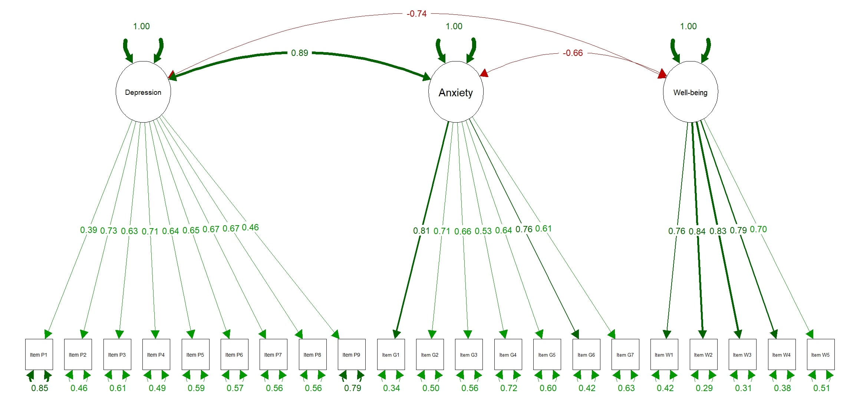
Figure S6.1. Caption: SEM Plot for Armenian versions of the PHQ-9, GAD-7 and WHO-5. Alt text: A Structural Equation Modeling path diagram for Armenia showing three latent variables corresponding to each scale: Depression, Anxiety, and Well-being. Depression is measured by 9 observed items (P1–P9), Anxiety by 7 items (G1–G7), and Well-being by 5 items (W1–W5). The diagram shows a strong positive correlation between Depression and Anxiety (Value of 0.89, represented by a green line) and strong negative correlations between Well-being and both Depression and Anxiety (Value of at least -0.66, shown by a red line). Factor loadings for all individual items are positive, ranging from 0.39 to 0.84.
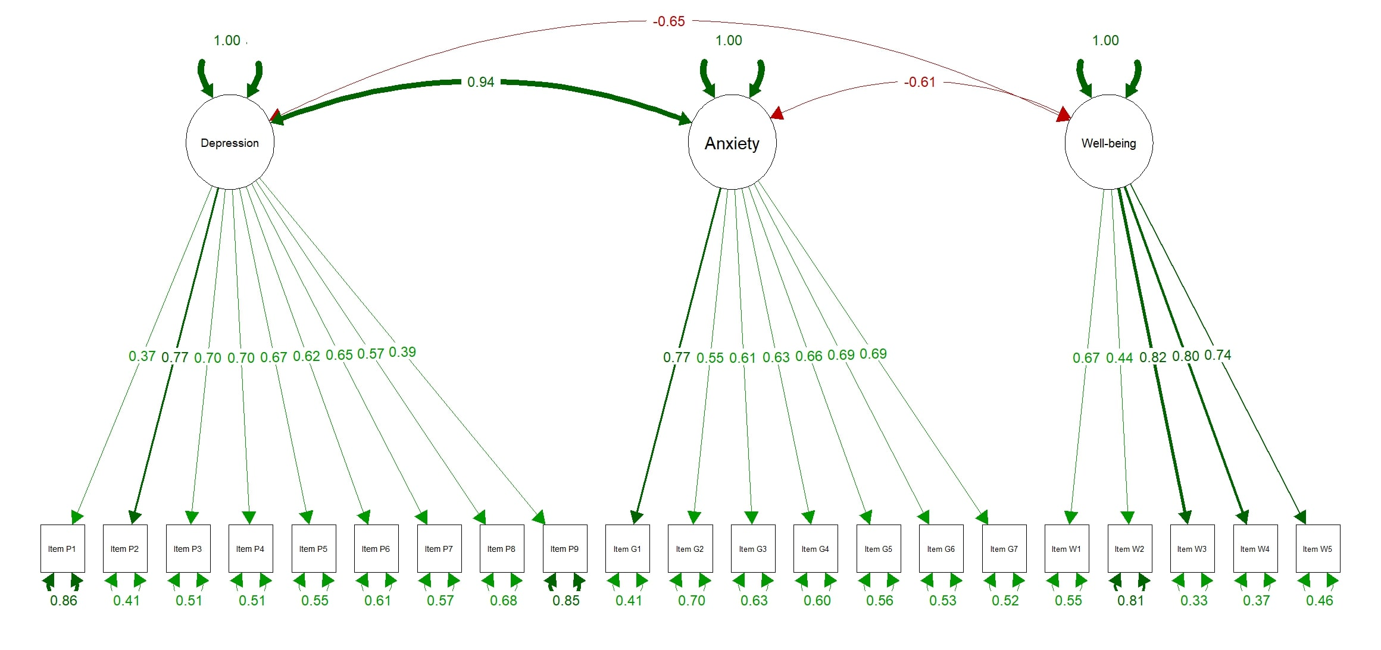
Figure S6.2. Caption: SEM Plot for Georgian versions of the PHQ-9, GAD-7 and WHO-5. Alt text: A Structural Equation Modeling path diagram for Georgia showing three latent variables corresponding to each scale: Depression, Anxiety, and Well-being. Depression is measured by 9 observed items (P1–P9), Anxiety by 7 items (G1–G7), and Well-being by 5 items (W1–W5). The diagram shows a strong positive correlation between Depression and Anxiety (Value of 0.94, represented by a green line) and strong negative correlations between Well-being and both Depression and Anxiety (Value of at least -0.61, shown by a red line). Factor loadings for all individual items are positive, ranging from 0.37 to 0.82.

References
1. Rosseel Y. lavaan: An R Package for Structural Equation Modeling. Journal of Statistical Software. 2012;48(2): 1–36. https://doi.org/10.18637/jss.v048.i02.
2. Lumley T. survey: analysis of complex survey samples. 2024.
3. Jorgensen TD, Pornprasertmanit S, Schoemann AM, Rosseel Y. \textttsemTools: Useful tools for structural equation modeling. 2025. https://CRAN.R-project.org/package=semTools
4. Epskamp S. semPlot: Path Diagrams and Visual Analysis of Various SEM Packages’ Output. 2022. https://doi.org/10.32614/CRAN.package.semPlot.
5. William Revelle. psych: Procedures for Psychological, Psychometric, and Personality Research. Evanston, Illinois: Northwestern University; 2025. https://CRAN.R-project.org/package=psych
6. Long JA. jtools: Analysis and Presentation of Social Scientific Data. 2022. https://cran.r-project.org/package=jtools
7. Jr FEH. Hmisc: Harrell Miscellaneous. 2025. https://doi.org/10.32614/CRAN.package.Hmisc.
8. Clark LA, Watson D. Constructing validity: Basic issues in objective scale development. Psychological Assessment. 1995;7(3): 309–319. https://doi.org/10.1037/1040-3590.7.3.309.
9. Bartlett MS. Properties of Sufficiency and Statistical Tests. Proceedings of the Royal Society of London. Series A, Mathematical and Physical Sciences. 1937;160(901): 268–282.
10. Kaiser HF. An Index of Factorial Simplicity. Psychometrika. 1974;39(1): 31–36. https://doi.org/10.1007/BF02291575.
11. Nunnally JC, Bernstein IH. Psychometric theory.. 3. ed., [Nachdr.]. New York, NY: McGraw-Hill; 20.
12. Boothroyd L, Dagnan D, Muncer S. PHQ-9: One factor or two? Psychiatry Research. 2019;271: 532–534. https://doi.org/10.1016/j.psychres.2018.12.048.
13. Floyd FJ, Widaman KF. Factor analysis in the development and refinement of clinical assessment instruments. Psychological Assessment. 1995;7(3): 286–299. https://doi.org/10.1037/1040-3590.7.3.286.
14. Cheung GW, Rensvold RB. Evaluating Goodness-of-Fit Indexes for Testing Measurement Invariance. Structural Equation Modeling. 2002; https://doi.org/10.1207/S15328007SEM0902_5.
15. Chen FF. Sensitivity of Goodness of Fit Indexes to Lack of Measurement Invariance. Structural Equation Modeling: A Multidisciplinary Journal. 2007;14(3): 464–504. https://doi.org/10.1080/10705510701301834.
16. Tanaka JS. ‘How Big Is Big Enough?’: Sample Size and Goodness of Fit in Structural Equation Models with Latent Variables. Child Development. 1987;58(1): 134. https://doi.org/10.2307/1130296.

