Role of adenosine kinase in sphingosine-1-phosphate receptor 1 induced mechano-hypersensitivities

Filomena Lauro^{1,2}, Luigino Antonio Giancotti^{1,2}, Grant Kolar^{2,3}, Caron Mitsue Harada^{1,2}, Taylor A. Harmon⁴, Timothy J Garrett⁵, Daniela Salvemini^{1,2*}

¹Department of Pharmacology and Physiology, ²Henry and Amelia Nasrallah Center for Neuroscience, and ³Department of Pathology, Saint Louis University School of Medicine, 1402 South Grand Blvd. 63104, St. Louis, Missouri, USA.
⁴Department of Chemistry and ⁵Department of Pathology, Immunology, and Laboratory Medicine, University of Florida, Gainesville, FL 32610, USA.

*Corresponding author: E-mail address: daniela.salvemini@health.slu.edu. Address: 1402 South Grand Blvd, St. Louis, MO 63104, USA, Phone: 1-314-977-6430, Fax: 1-314- 977-6411

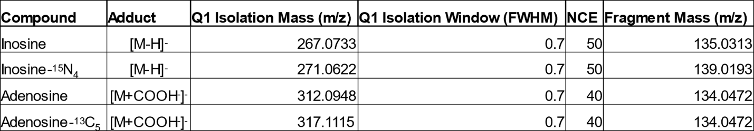
Table 1. MS/HRMS parameters for detection of inosine, inosine ¹⁵N₄, adenosine, and adenosine-¹³C₅.

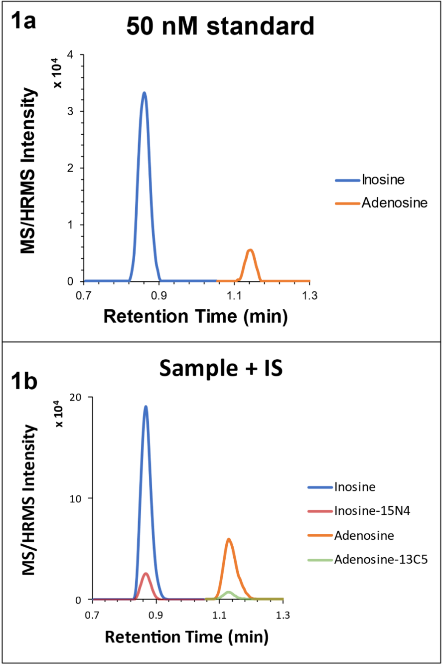

Figure 1. Representative EICs. All isolation windows were 5 ppm. Inosine: 267.1 → 135.0313 m/z; adenosine: 312.1 m/z → 134.0472 m/z. 1a) LLOQ standard (50 nM). 1b) Sample with labeled internal standard peaks overlaid. Inosine-¹⁵N₄: 271.1 m/z → 139.0193 m/z; Adenosine ¹³C₅: 317.1 → 134.0472 m/z.

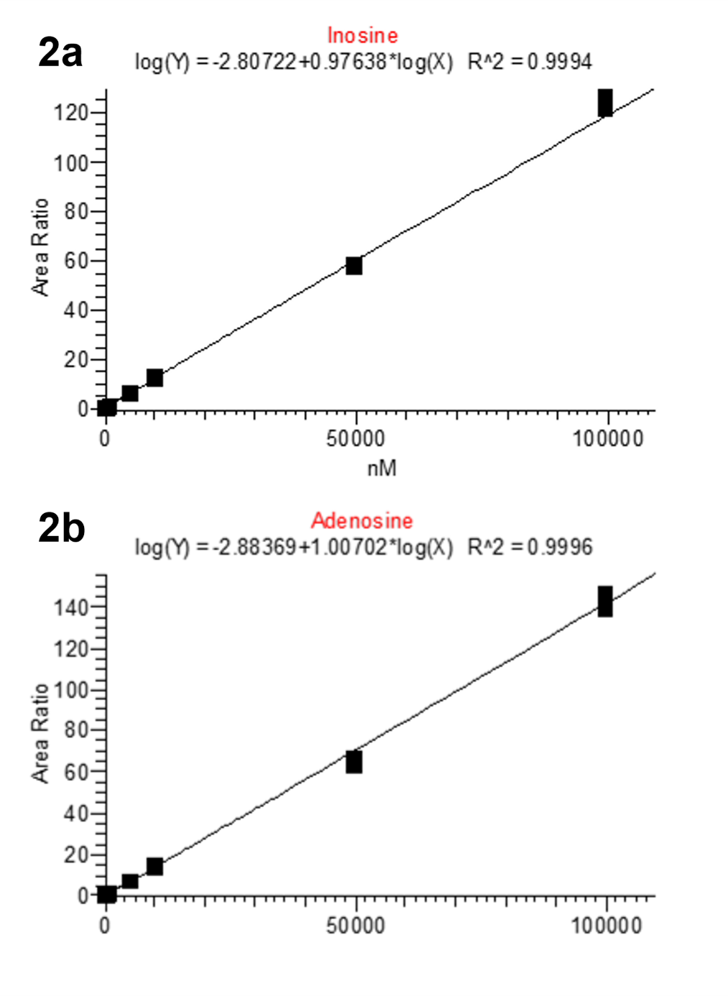
Figure 2. Linear log-log plots for inosine and adenosine standard calibration curves (50 nM to 100 µM). 2a) Inosine displays acceptable linearity (R² >0.999) across the concentration range assayed. 2b) Adenosine displays acceptable linearity (R² >0.999) across the concentration range assayed.

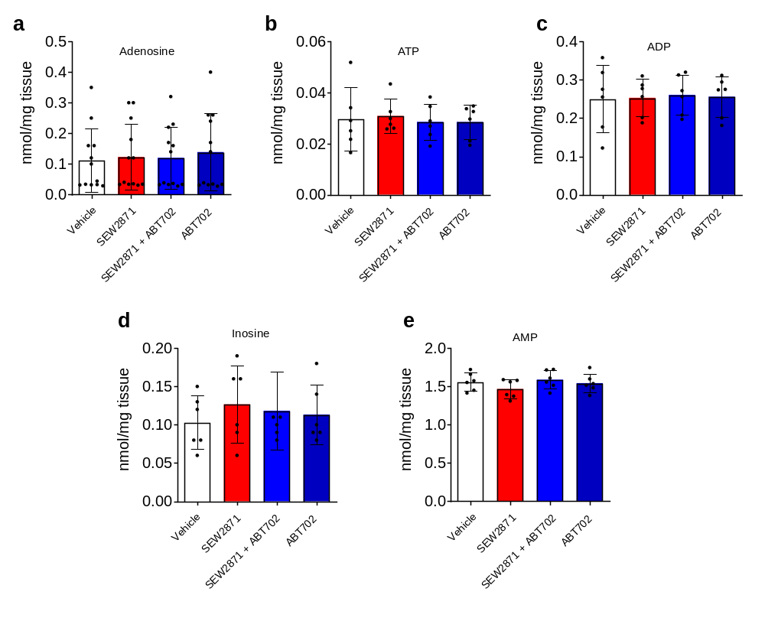Figure 3. Mass spectrometry analyses did not show any significant change in adenosine, AMP, ADP, ATP and inosine levels in the DH-SC of SEW2871-treated animals compared to the vehicle. Results are expressed as mean ± SD for 6 rats (a-e).

