Unveiling the molecular mechanism of Qing Wen Bai Du decoction against dengue fever: An integrated study of bioinformatic analysis, machine learning and network pharmacology

Yan Xiao¹, Zhanchen Liu¹, Shengjie Hu, Peng Yao, Yajun Liu*, Maosheng Cheng*
Affiliation:
Key Laboratory of Structure-Based Drug Design & Discovery of Ministry of Education, Key Laboratory of Intelligent Drug Design and New Drug Discovery of Liaoning Province, and School of Pharmaceutical Engineering, Shenyang Pharmaceutical University, Shenyang 110016, China
¹ These authors contribute equally to this work.
* Corresponding Authors.
Yajun Liu (liuyajun@syphu.edu.cn); Maosheng Cheng (mscheng@syphu.edu.cn)

Figure S1.
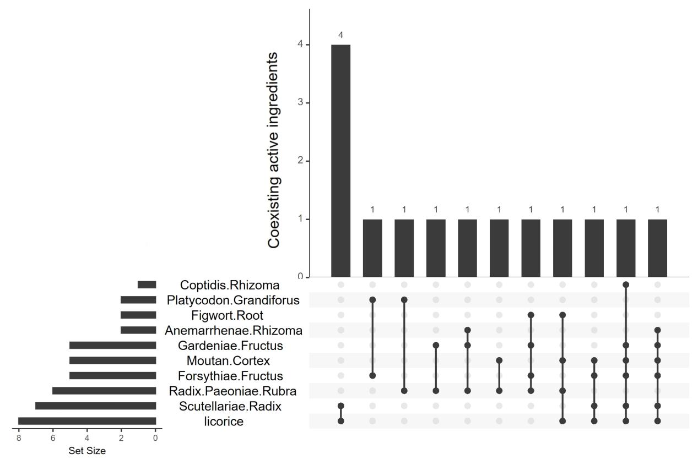
Common Chemical Components in QBD. Universal Natural Products in Individual Chinese Medicinal Herbs.

Table S1.
Major cell types identified by single-cell RNA sequencing and their marker gene expression
0 | Monocytes | CXCL12 | ZBP1 | LGALS2 | ART3 | TGM1 | AXL | TIMD4 | EDN1 | TMEM171 | WNT5A
1 | B Cells | ANKH | LDLRAD4 | BNC2 | NEK10 | MIR99AHG | PCSK6 | CCSER1 | LINC00854 | FOSB | TSPAN15
2 | Proliferating B cells | HIST1H1B | FAM111B | AC016205.1 | ZNF367 | CCNE2 | WDR76 | E2F2 | E2F8 | CDC6 | HIST1H3B
3 | M2 | S100A9 | F13A1 | STAB1 | MS4A6A | IGF1 | GAPLINC | SLC40A1 | LILRB5 | CDA | S100A8
4 | NK Cells | CCNB1 | HMMR | ASPM | DLGAP5 | CDC20 | KIF20A | DEPDC1 | NEK2 | PIMREG | PIF1
5 | pDCs | RANBP3L | IL31RA | DENV2neg | IGFBP6 | SCG3 | DENV2 | FAM124A | AFAP1 | AC092327.2 | LAMP5
6 | M1 | CHIT1 | LINC01010 | CHI3L1 | AC015660.2 | CRABP2 | FABP4 | TIMP3 | MMP7 | USP2 | GAL
7 | cDCs | CCL19 | PRAME | HMSD | SERPINB10 | LINC01894 | CDHR3 | LINC00158 | ENTHD1 | CST7 | AL357992.1
8 | CD8+ T | CD3E | TRBC2 | CD2 | CD3G | CD3D | GZMA | LCK | LINC00861 | TRAT1 | GNLY
9 | Monocytes | AC068234.1 | AL136298.1 | ITGB3 | DIRAS2 | LINC02454 | HSPB7 | FOLR3 | PAGE2 | AP005436.2 | SPNS2
0-9: Cluster IDs for single-cell clustering groups.

Table S2.
Molecular docking binding energies (kcal/mol) of natural compounds with target proteins
id | CXCL10 | EZH2 | EPHB2 | E | C | NS2B-NS3 | NS4B | NS5
Dehydroglyasperins C | -7.31 | 0 | -5.98 | -6.23 | -5.56 | -5.05 | -5.82 | -6.75
Lactiflorin | -7.13 | -3.86 | -5.79 | -6.29 | -6.08 | -5.02 | -5.5 | -4.93
Benzoyl Paeoniflorin | -7.07 | 0 | -6 | -5.75 | -7 | -6.03 | -6.25 | -6.13
Glyasperin B | -7.07 | 0 | -6.43 | -7.6 | -6.23 | -5.28 | -5.24 | -5.22
(+)-catechin | -6.94 | -8.63 | -6.88 | -6.88 | -6.61 | -5.95 | -5.96 | -5.39
Rehmaglutin C | -5.24 | -7.21 | -5.69 | -6.78 | -6.01 | -5.33 | -4.41 | -4.47
Rehmaglutin A | -6.01 | -7.02 | -5.93 | -7.34 | -6.62 | -5.28 | -5 | -4.96
Berlambine | -5.39 | -6.93 | -4.72 | -5.33 | -6.61 | -3.64 | -5.19 | -4.44
Magnograndiolide | -5.78 | 0 | -5.91 | -5.91 | -5.94 | -5.25 | -4.49 | -5.22
8-prenylated eriodictyol | -5.81 | 0 | -7.16 | -6.5 | -6.43 | -4.65 | -4.56 | -4.74
Glepidotin B | -5.95 | -6.2 | -6.95 | -6.57 | -6.04 | -4.35 | -4.75 | -4.71
Glabranin | -5.64 | 0 | -6.88 | -6.02 | -5.81 | -4.17 | -4.58 | -3.87
Glepidotin A | -4.99 | 0 | -6.79 | -6.05 | -4.53 | -4.3 | -3.6 | -4.18
Glutinoside | -5.82 | -6.5 | -6.2 | -6.69 | -7.25 | -5.84 | -5.13 | -5.41
Paeoniflorin | -6.19 | -4.58 | -5.83 | -6.48 | -6.97 | -5.57 | -5.02 | -5.98
Inflacoumarin A | -6.32 | 0 | -5.06 | -6 | -5.72 | -4.92 | -4.7 | -3.96
FA | -6.06 | 0 | -5.6 | -6.31 | -6.75 | -7.03 | -6.49 | -5.53
Glycyrin | -5.3 | 0 | -4.86 | -6.09 | -6.12 | -5.32 | -6.26 | -3.89
Baicalin | -6.62 | 0 | -6.43 | -7.16 | -6.96 | -6.61 | -6.25 | -6.06
PHILLYRIN | -6.36 | 0 | -5.76 | -7.89 | -5.44 | -5.94 | -5.77 | -5.41
Rehmaglutin B | -6.47 | -6.91 | -6.07 | -7.76 | -6.67 | -5.53 | -4.85 | -5.41
isoflavanone | -6.01 | 0 | -6.19 | -7.67 | -6.65 | -4.9 | -4.77 | -5.14
Vestitol | -6.55 | 0 | -6.41 | -7.59 | -6.71 | -5.04 | -5.65 | -4.76
Crocetin | -5.94 | 0 | -2.55 | -5.56 | -8.22 | -2.21 | -2.95 | -3.45
15976101 | -6.66 | 0 | -4.08 | -5.45 | -8.05 | -4.61 | -4.49 | -4.86
Icariin I | -6.93 | 0 | -6.25 | -7.3 | -7.51 | -6.91 | -5.97 | -6.4
P-cymene | -5.63 | -6.57 | -4.55 | -5.14 | -7.5 | -3.75 | -4.09 | -4.61
Thymol | -6.54 | -6.85 | -6.2 | -5.78 | -7.48 | -5.42 | -4.87 | -4.94
Daucosterol | -5.83 | 0 | -4.56 | -6.21 | 0 | -4.24 | -6.06 | -4.77
MLS001049043 | -5.87 | 0 | -6 | -6.49 | -6.55 | -5.63 | -6.41 | -5.37
Lower scores indicate stronger binding interactions; "0" represents no detectable binding activity.

