Supplementary Figures

Supplementary Figure 1. Forest Plot of Mendelian Randomization Analysis for ApoB and Alzheimer’s Disease. 3
Supplementary Figure 2. Forest Plot of Mendelian Randomization Analysis for PCSK9 and Alzheimer’s Disease. 4
Supplementary Figure 3. Funnel Plot of Mendelian Randomization Analysis for ApoB and Alzheimer’s Disease. 5
Supplementary Figure 4. Funnel Plot of Mendelian Randomization Analysis for PCSK9 and Alzheimer’s Disease. 6
Supplementary Figure 5. Leave-One-Out Sensitivity Analysis of Mendelian Randomization for ApoB and Alzheimer’s Disease. 7
Supplementary Figure 6. Leave-One-Out Sensitivity Analysis of Mendelian Randomization for PCSK9 and Alzheimer’s Disease. 8
Supplementary Figure 7. Scatter Plot of SNP Associations and Mendelian Randomization Estimates for ApoB and Alzheimer’s Disease. 9
Supplementary Figure 8. Scatter Plot of SNP Associations and Mendelian Randomization Estimates for PCSK9 and Alzheimer’s Disease. 10
Supplementary Figure 9. HKO of PCSK9 does not impair learning and memory in APP/PS1 mice 11
Supplementary Figure 10. PCSK9 mAb does not impair cognitive function in a mouse line with human-like lipid profile 12

Supplementary Figure 1. Forest Plot of Mendelian Randomization Analysis for ApoB and Alzheimer’s Disease.

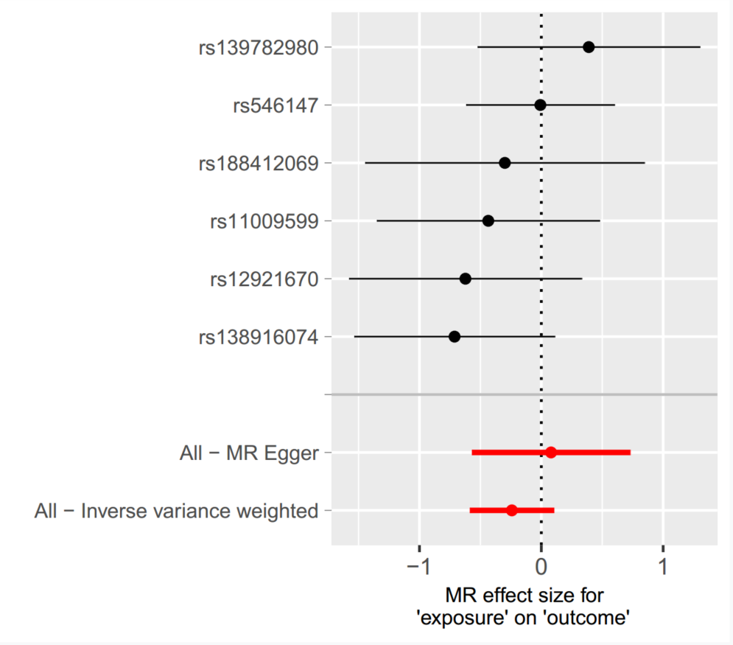

Supplementary Figure 2. Forest Plot of Mendelian Randomization Analysis for PCSK9 and Alzheimer’s Disease.

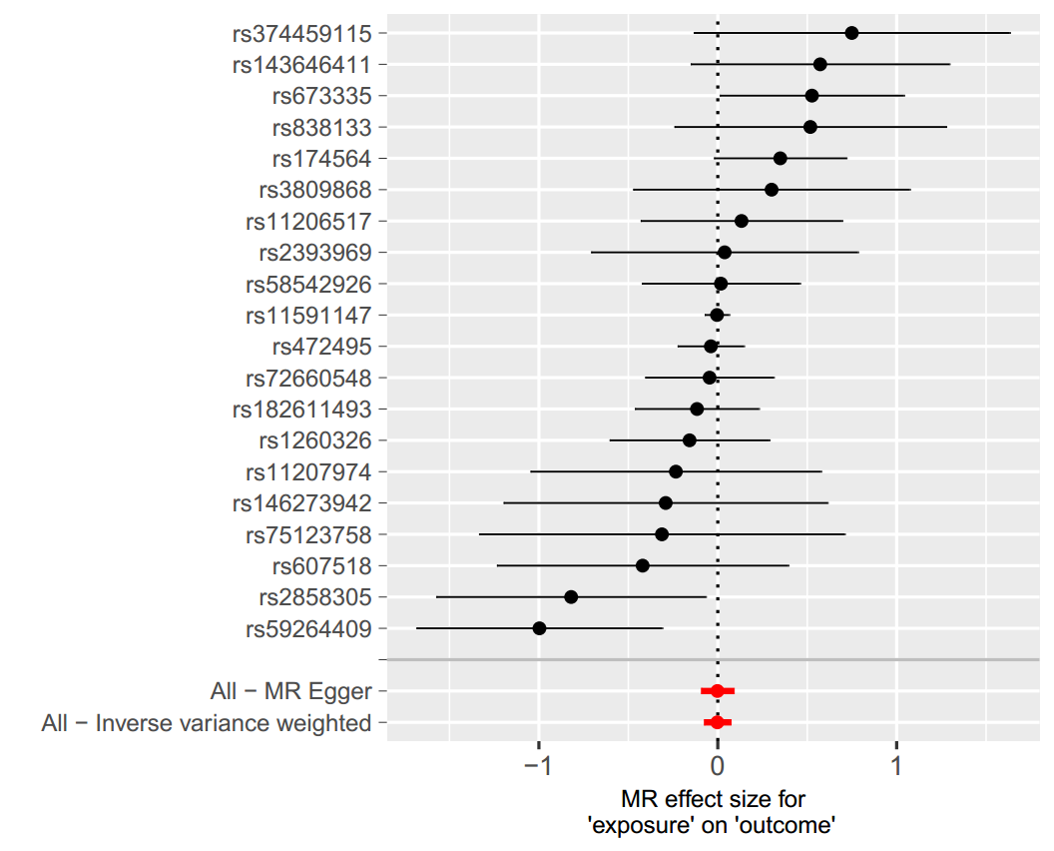

Supplementary Figure 3. Funnel Plot of Mendelian Randomization Analysis for ApoB and Alzheimer’s Disease.
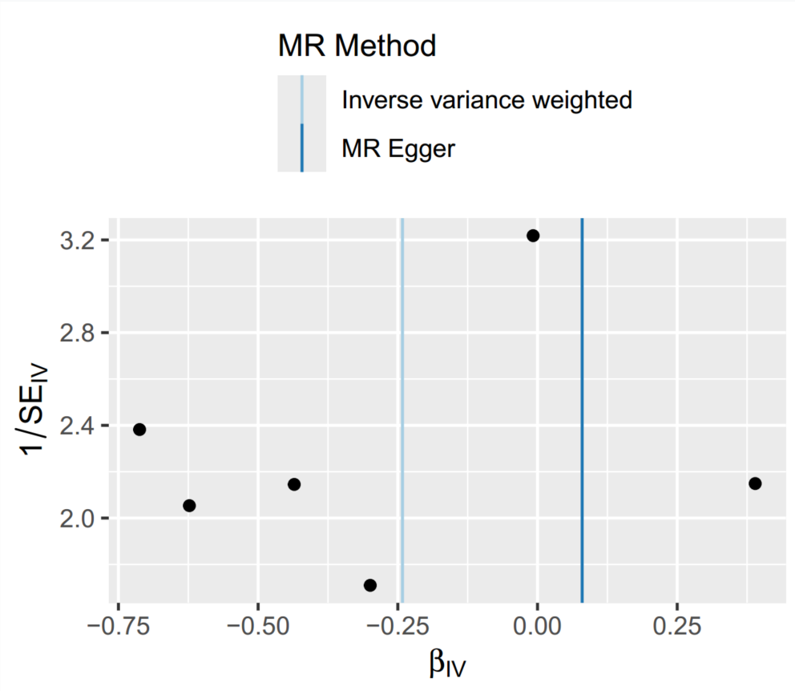

Supplementary Figure 4. Funnel Plot of Mendelian Randomization Analysis for PCSK9 and Alzheimer’s Disease.
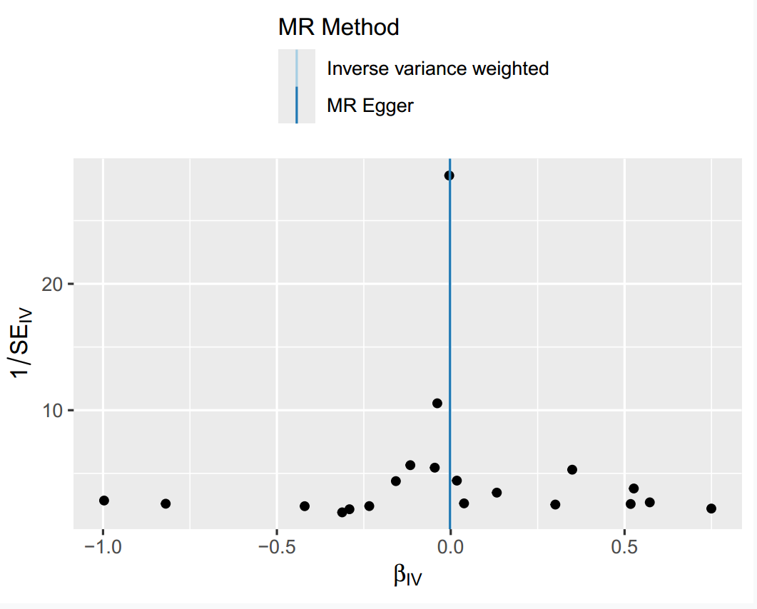

Supplementary Figure 5. Leave-One-Out Sensitivity Analysis of Mendelian Randomization for ApoB and Alzheimer’s Disease.
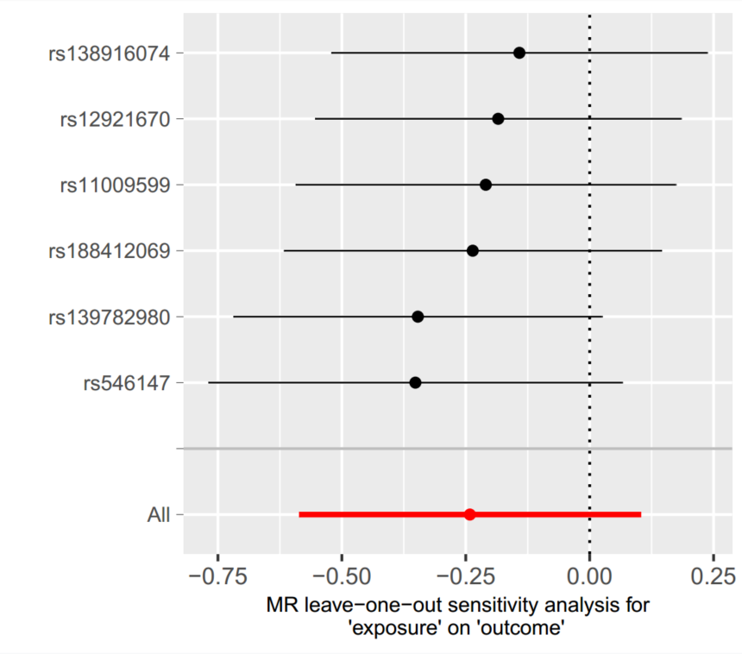

Supplementary Figure 6. Leave-One-Out Sensitivity Analysis of Mendelian Randomization for PCSK9 and Alzheimer’s Disease.
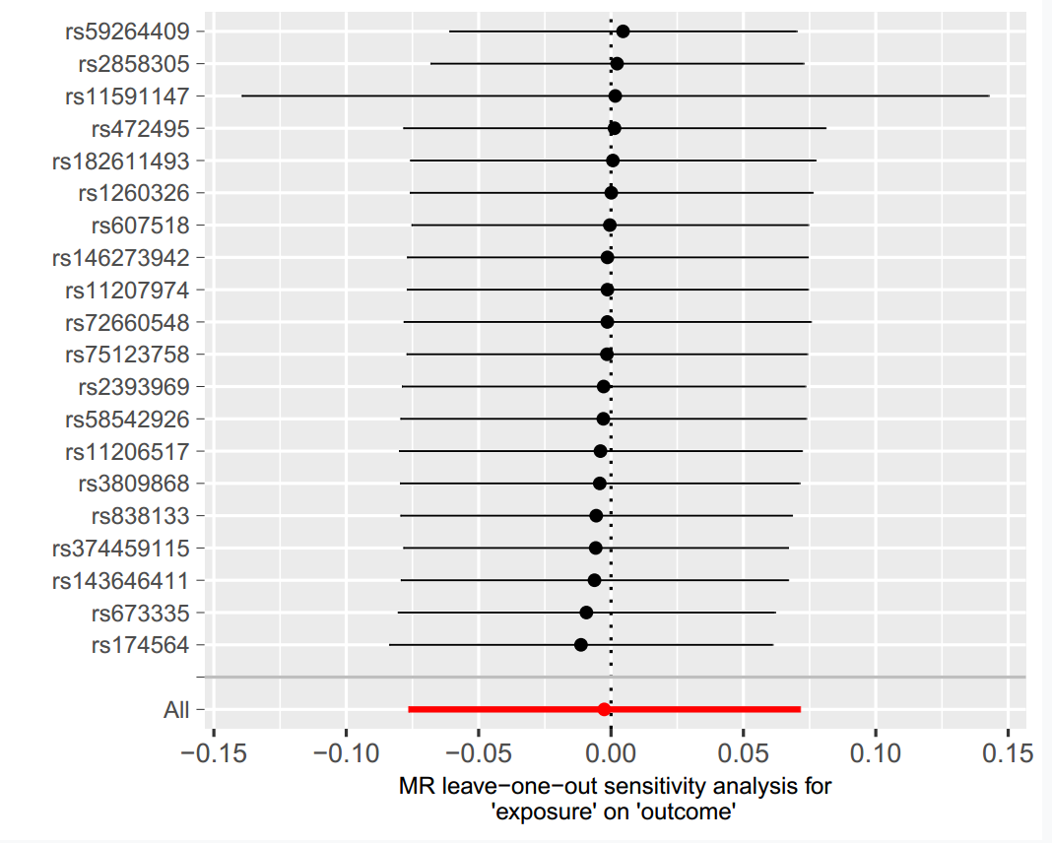

Supplementary Figure 7. Scatter Plot of SNP Associations and Mendelian Randomization Estimates for ApoB and Alzheimer’s Disease.
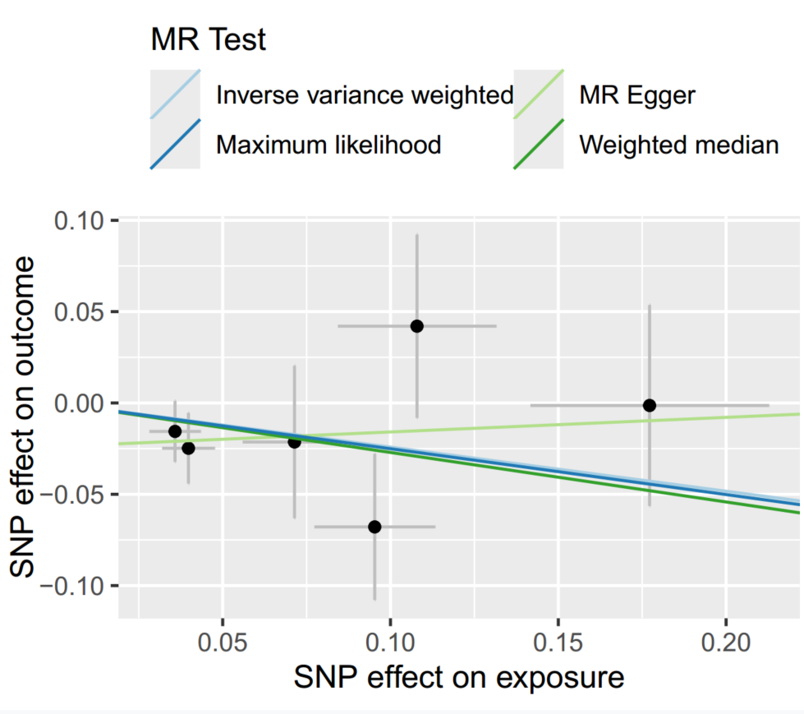

Supplementary Figure 8. Scatter Plot of SNP Associations and Mendelian Randomization Estimates for PCSK9 and Alzheimer’s Disease.
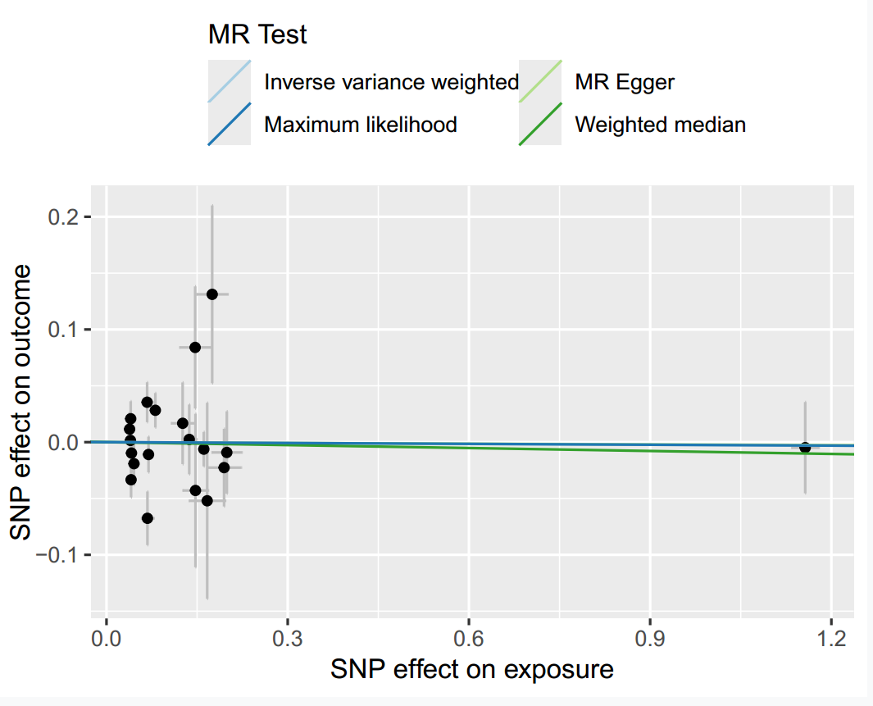

Supplementary Figure 9. HKO of PCSK9 does not impair learning and memory in APP/PS1 mice
(A) Western blotting of APP/PS1-PCSK9^{HKO} and its littermates mouse tissues was performed using anti-PCSK9 antibody. GAPDH was applied for internal control. (B-D) The serum lipid profiles of mice were detected by an automatic biochemistry analyzer. TC, total cholesterol; LDL-C, low-density lipoprotein cholesterol; non-HDL-C, non-high-density lipoprotein cholesterol. (E) Mean escape latencies across 4 consecutive days during the water maze training. Mean speed (F), platform crossing numbers (G) and percentage of time spent (H) in target quadrant during the probe trials of water maze test. (I) The total number of arm entry times during the Y maze test. n = 9-10 mice/group for water maze and n = 12 mice/group for Y maze. The Mann‒Whitney U test for (B, I), Welch’s t test for (C-D, F), two-tailed unpaired Student’s t-test for (G-H) and multiple unpaired t-test for (E).

Supplementary Figure 10. PCSK9 mAb does not impair cognitive function in a mouse line with human-like lipid profile
(A) A schematic diagram showing after being fed a HFHCD for 12 weeks, APP/PS1-ApoB mice were switched to a standard chow diet and treated with PCSK9 mAb (30 mg/kg) or vehicle. Cognitive performance tests were then performed, followed by euthanasia and tissue collection. The diagram was created by FigDraw (authorization code: SUROTb6bb6). SC, subcutaneous injection; HFHCD, high-fat high-cholesterol diet. (B) Weight changes of HFHCD-fed APP/PS1-ApoB mice. n.s., no significance. (C) Serum human ApoB contents of APP/PS1-ApoB mice after PCSK9 mAb or vehicle treatment were detected by ELISA. (D-F) The serum lipid profiles of mice were detected by an automatic biochemistry analyzer. (G-K) The movement trajectories of APP/PS1-ApoB mice in the water maze test. (G) Mean escape latencies across 4 consecutive days during the water maze training. Heap maps of mouse’s center point (H), mean speed (I), percentage of time spent (J) and mean escape latencies (K) for the entire duration in the spatial probe test of water maze test. The color scale represents the average search time (B). Heap maps of mouse’s center point (L), total number of arm entry times (M) and Spontaneous alterations (N) during the Y maze test. The movement trajectories of APP/PS1-ApoB mice in the open field test (O-R). (O) Plot shows a heat map of the animal's centre point for the entire duration of open field test, and the color scale represents the average search time. (P) The total movement distance, center entry numbers (Q) and time spent (R) in the central zone within the open field test. The fall mice percentage (S) and fall number (T) in the rotarod test. Nissl staining (U), Aβ⁺ plaques (V) and GFAP⁺ astrocytes (W) within the hippocampal regions of mouse brain. Scale bar = 200 μm for (U-W). n = 9 mice/group for water maze, n = 12 mice/group for Y maze, open field test and rotarod test. Multiple unpaired t-test for (B, G), Welch’s t test for (C), two-tailed unpaired Student’s t-test for (D-F, I-J, N, P, R), Mann-Whitney U test for (K, M, Q, T) and Gehan-Breslow-Wilcoxon test for (S) were performed.

