Extended Data:

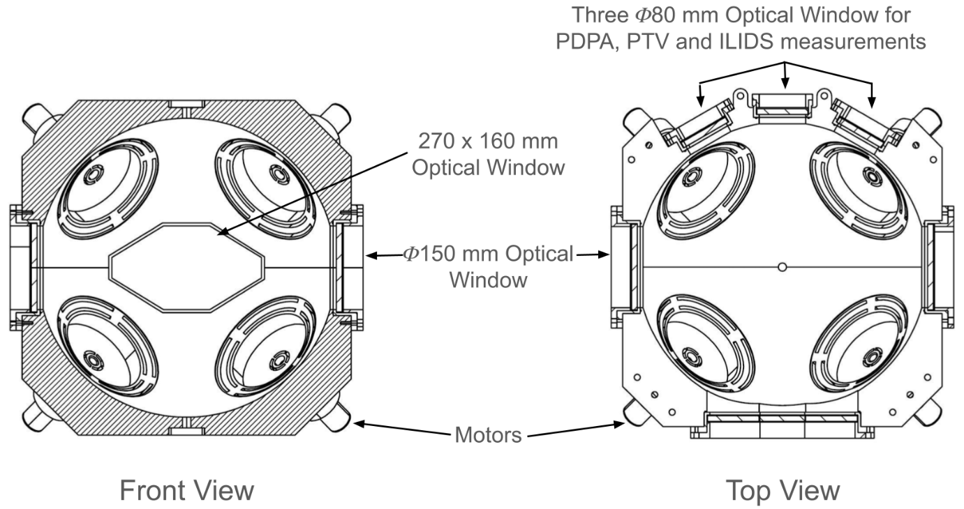
Extended Data Fig. 1: Schematic shows the turbulence chamber dimensions (in mm). The inside of the chamber has a spherical shape with an inner diameter of 500 mm, and the outside of the chamber is of a truncated cuboid shape. The chamber has six optical windows made of 10 mm-thick quartz for performing various optical diagnostic techniques. Eight 150 mm fans, coupled with 180 W brushless DC motors, were mounted symmetrically opposite to each other to drive the turbulence inside the chamber. Servo-motor speeds were regulated using digital controllers, ensuring operation in the same direction at closely matched speeds (within ±1% variation), thereby generating homogeneous, isotropic turbulence with zero-mean flow.

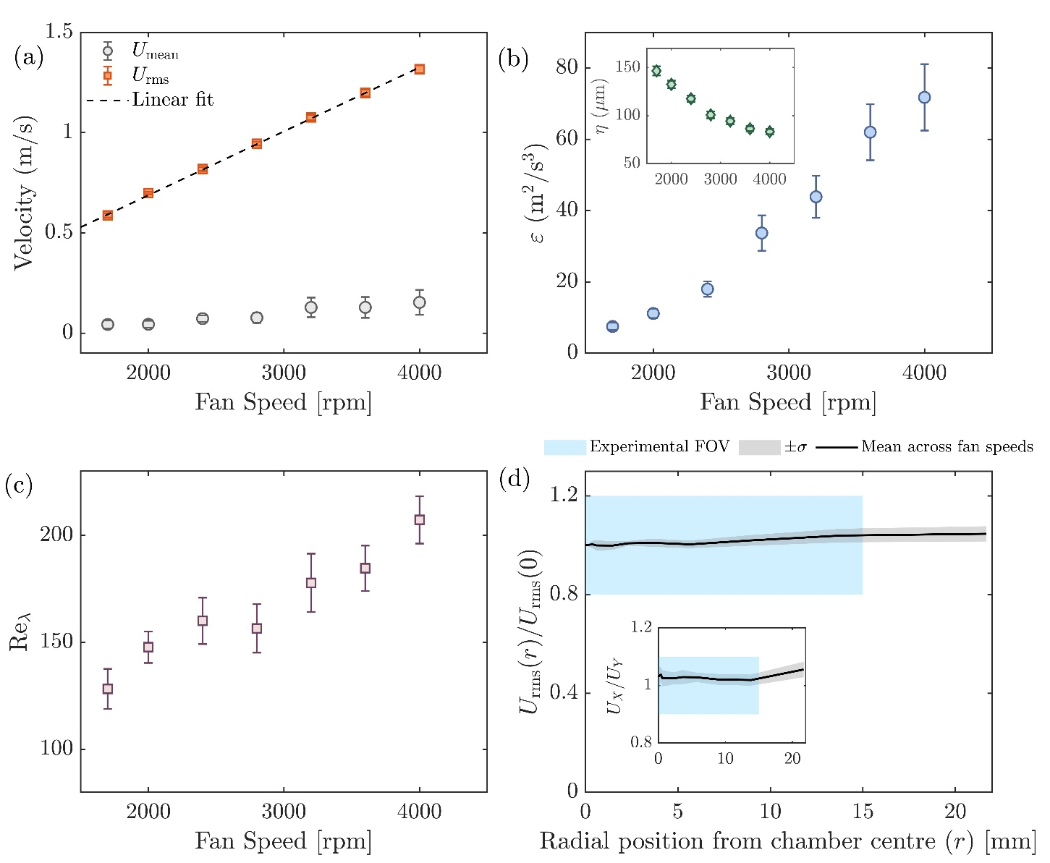
Extended Data Fig. 2: Characterization of turbulence in the chamber. (a) Root-mean-square velocity ($U_{rms}$) and mean velocity ($U_{mean}$) as a function of the fan speed. $U_{rms}$ increases approximately linearly with the fan speed, while $U_{mean}$ remains close to zero across all conditions. (b) Dissipation rate (ϵ) as a function of fan speed (inset: corresponding Kolmogorov length scale η). (c) Variation of the Taylor-scale Reynolds number (${Re}_{λ}$) with fan speeds. (d) Radial profiles of $U_{rms}$ and the velocity anisotropy ratio $U_{rms_X}/U_{rms_Y}$ demonstrate that the flow remains spatially homogeneous and near-isotropic (variations <10%) within the central 25 mm measurement region. The cyan shaded band marks the field of view used for the laser imaging of droplets.

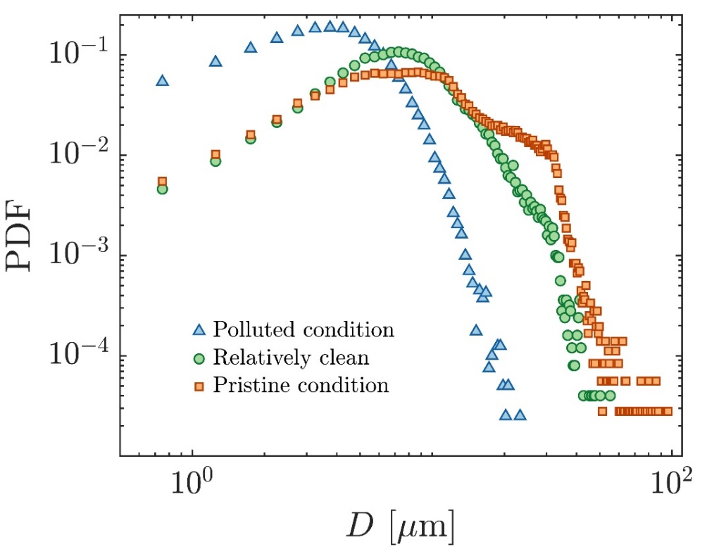
Parameter | Polluted condition | Relatively clean | Pristine condition
Mean diameter (D10) µm | 4.3 | 9.4 | 12.8
Relative dispersion (σ/D10) | 0.52 | 0.56 | 0.66
Number concentration per cc | O (1000) | O (300) | O (100)

Extended Data Fig. 3: Three characteristic droplet size distributions representing clouds originating from different environmental conditions. Droplet size distribution (PDF) and parameters measured at the lower turbulence intensity ($Re_{λ}=136)$ are listed. Blue points correspond to polluted-cloud conditions, which exhibit a narrow distribution with high droplet number concentrations. Green points represent relatively clean-cloud conditions, showing a broader distribution at moderate concentrations. Red points denote pristine-cloud conditions, characterised by the broadest distributions and the lowest droplet concentrations.

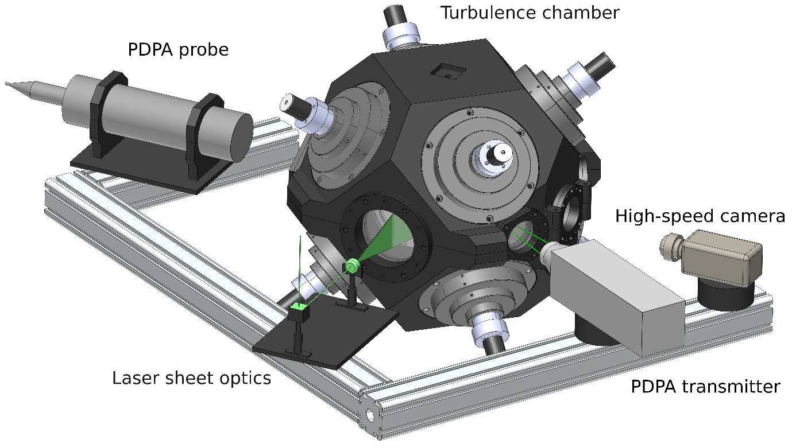
Extended Data Fig. 4: Schematic of the experimental arrangement. Diagram illustrating the overall configuration of the experimental facility, inducing the turbulence chamber, Phase Doppler Particle Analyzer (PDPA) system and the imaging system. The PDPA transmitter and receiver optics are aligned at a 33° off-axis scattering angle. The droplet field was illuminated using a laser sheet and imaged with a high-speed camera positioned orthogonally to the illumination plane.

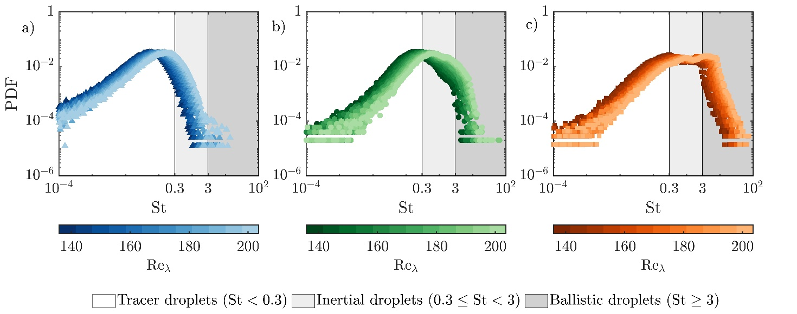
Extended Data Fig. 5: Broad size distribution in pristine conditions produces droplets with wide range of St. Plots (a), (b), and (c) show the distribution of $St$ at different turbulence intensities for polluted, relatively clean, and pristine conditions respectively. An increase in turbulence intensity is marked by a decrease in the hue of the color. We group the droplets as tracers ($St≤0.3$), inertial ($0.3<St≤3$), and ballistic droplets ($St>3$). Case (3) has a wide range of $St$ increasing interactions between droplets with disparate $St$. Also, increasing $Re_{λ}$ increases the St.

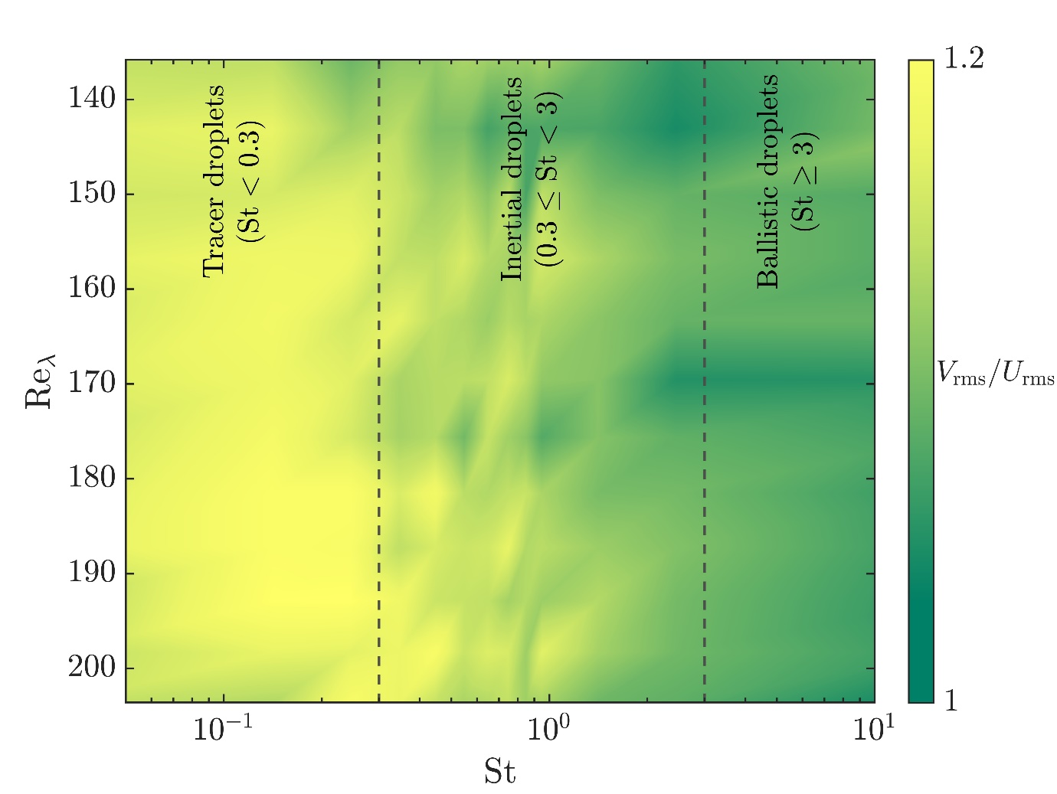
Extended Data Fig. 6: Droplets with higher St move slower than rest, thereby enhancing caustic formation. For droplets in pristine condition, we observe droplets with higher St move slower than rest, indicating a possibility of enhanced caustic formation, under the influence of turbulence.

