Orbital coupling nanozymes with enhanced peroxidase-like activity mediate deep thermal ablation/chemodynamic therapy to boost immune response

Figure S1. TEM of Pt nanozymes.

Figure S2. Time and absorbance curves with and without IPA as ·OH quenching agents.

Figure S3. Fluorescence detection of different nanozymes.
Figure S4. Durability of the PtSn nanozymes and HRP treated with 0.1 M KOH and 0.1 M HCl.

Figure S5. Stability of POD-like of PtSn nanozymes.

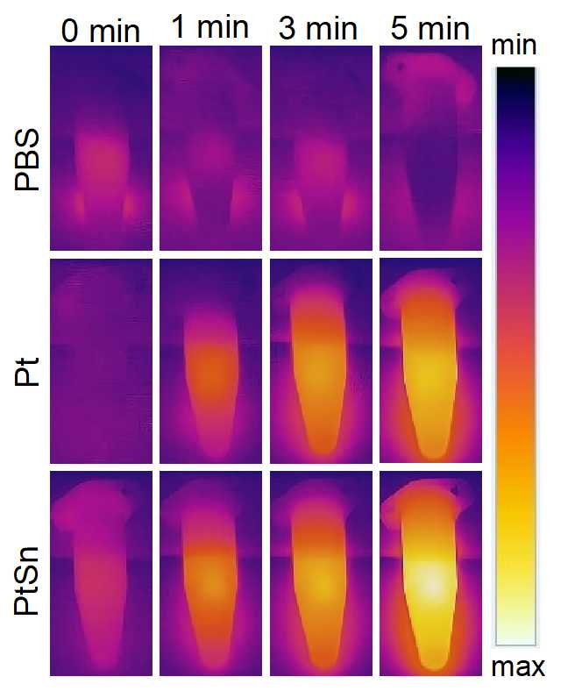
Figure S6. Infrared thermal images of Pt and PtSn nanozymes under 1064 nm laser irradiation.
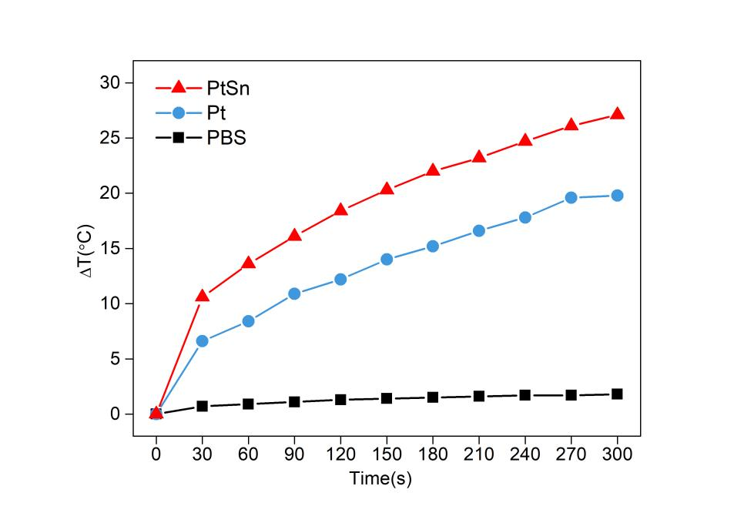
Figure S7. Temperature variation of Pt and PtSn nanozymes under 1064 nm laser irradiation.

Figure S8. Flow cytometric analysis of ROS levels in 4T1 cells cultured with H₂O₂ (20 μM) under different treatments for 4 h.

Figure S9. A) Infrared thermal images of tumor sites with PtSn nanozymes under 1064 nm laser. B) Temperature elevation curves of tumors site after laser irradiation. C) Digital images of the tumors collected from different groups after therapy. D) Growth curve of tumor volume in each group during the treatment.
Figure S10. A) Digital images of the tumors collected from different groups after therapy. B) Ex vivo tumor weights of mice in different treatment groups on the 16th day.
Figure S11. A) Typical flow cytometry of CD8⁺ and CD4⁺ T cell and B) their summation in spleen from each group. ***p<0.001, **p<0.01, *p<0.05.
Figure S12. A) Flow cytometry plots of M1 macrophages (gated on CD11b⁺F4/80⁺) and B) corresponding percentages of each group in the blood. ***p<0.001, **p<0.01, *p<0.05.

