Supplementary Material
Fe/Cu Bimetallic Particles for TCAL Dechlorination: From Parameter Effects to Reusable Catalysis with Mechanistic Insights

Text S1. Dchlorination rate calculation
The calculation for dchlorination rate η can be obtained the following Equation 1.

$$η=\frac{\left[{Cl}_{t}\right]-\left[{Cl}_{0}\right]}{3\left[TCA\right]}×100\%$$ | (1)

Where：
η is the dechlorination rate of trichloroacetaldehyde,
C_{l0} is the initial concentration of chloride ions,
C_{lt} is the concentration of chloride ions at time t,
TCA is the initial concentration of trichloroacetaldehyde.

Text S2. the reaction of TCAL in the Fe/Cu bimetallic system can be obtained the following Equation 2-8.

$$Fe⁰ + H⁺ → Fe²⁺ + H•$$ | (2)
$$C{Cl}_{3}CHO+H•→CH{Cl}_{2}CHO+H^{+}+{Cl}^{-}$$ | (3)
$$CH{Cl}_{2}CHO+H•→CH_{2}ClCHO+H^{+}+{Cl}^{-}$$ | (4)
$$CH_{2}ClCHO+H•→CH_{3}CHO+{Cl}^{-}$$ | (5)
$${2Fe}^{2+}+C{Cl}_{3}CHO+H^{+}→{2Fe}^{3+}+CH{Cl}_{2}CHO+{Cl}^{-}$$ | (6)
$${2Fe}^{2+}+CH{Cl}_{2}CHO+H^{+}→{2Fe}^{3+}+CH_{2}ClCHO+{Cl}^{-}$$ | (7)
$${2Fe}^{2+}+CH_{2}ClCHO+H^{+}→{2Fe}^{3+}+CH_{3}CHO+{Cl}^{-}$$ | (8)

Table S1. Kinetic fitting results of Fe/Cu to TCAL removal process
Number of uses | Reaction rate equation | k (h⁻¹) | R²
1 | -ln(C_{t}/C₀)=0.1096t+1.6244 | 0.1096 | 0.9474
2 | -ln(C_{t}/C₀)= 0.1092t+1.6244 | 0.1092 | 0.9652
3 | -ln(C_{t}/C₀)= 0.099t+1.6244 | 0.099 | 0.9591
4 | -ln(C_{t}/C₀)= 0.0951t+1.6244 | 0.0951 | 0.9604
5 | -ln(C_{t}/C₀)= 0.0963t+1.6244 | 0.0963 | 0.9651

Table S2. Kinetic fitting results of ZVI to TCAL removal
Number of uses | Reaction rate equation | k (h⁻¹) | R²
1 | -ln(C_{t}/C₀)= 0.0537t+1.6244 | 0.0537 | 0.9355
2 | -ln(C_{t}/C₀)= 0.0482t+1.6244 | 0.0482 | 0.9612
3 | -ln(C_{t}/C₀)= 0.0419t+1.6244 | 0.0419 | 0.9551
4 | -ln(C_{t}/C₀)= 0.0364t+1.6244 | 0.0364 | 0.978
5 | -ln(C_{t}/C₀)= 0.0352t+1.6244 | 0.0352 | 0.9341

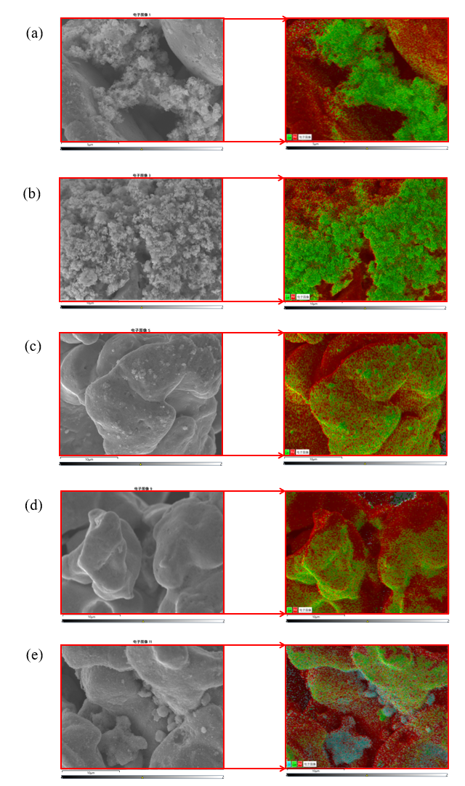

Fig. S1. Original, full-frame SEM images corresponding to Figure 2. (a) Original for Fig. 2a, (b) Original for Fig. 2b, (c) Original for Fig. 2c, (d) Original for Fig. 2d, (e) Original for Fig. 2e.

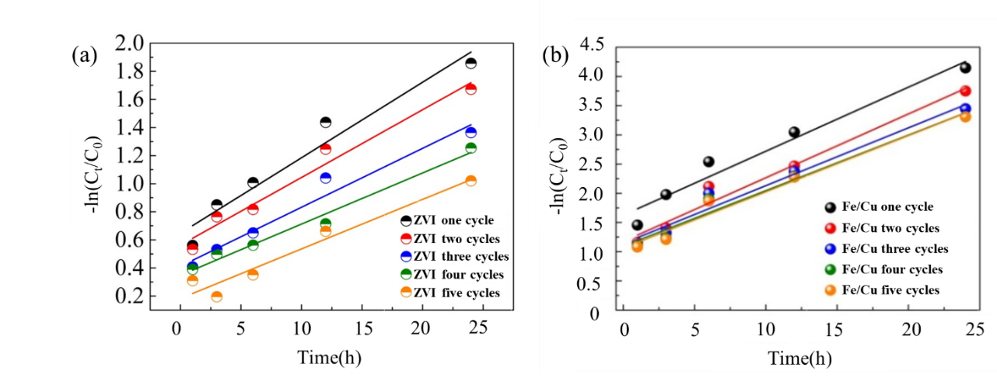

Fig. S2. Kinetic fitting of TCAL removal process during ZVI (a) and Fe/Cu (b) reuse

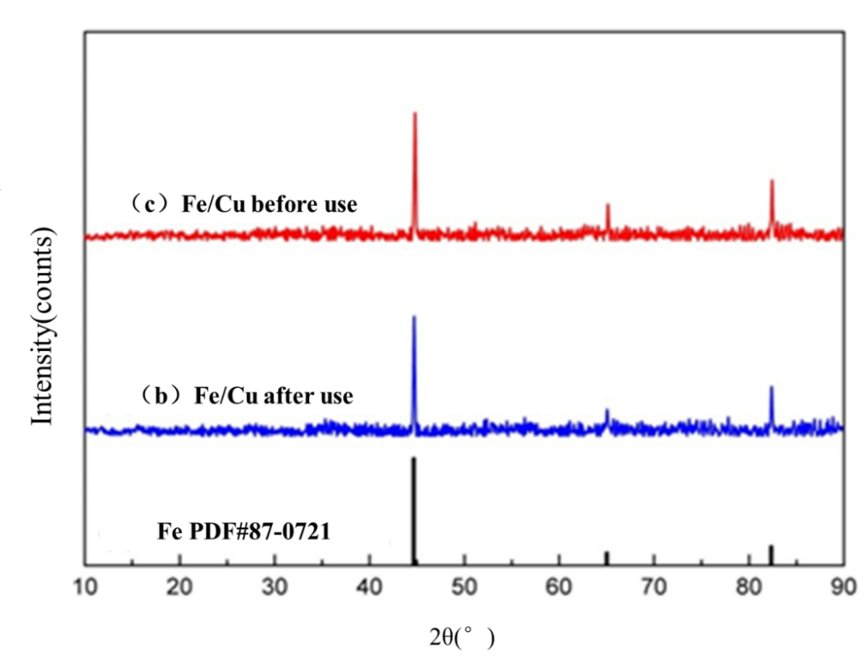

Fig. S3. XRD pattern of Fe/Cu before and after reaction

