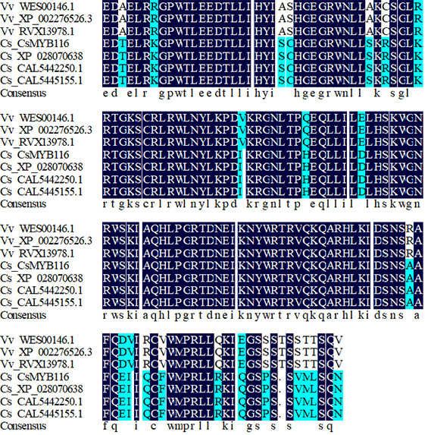
Fig.S1 Multiple sequence alignment of the CsMYB116 protein with homologous proteins.

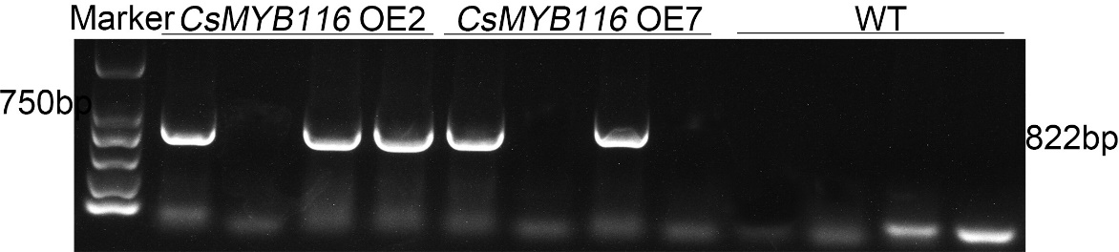
Fig.S2 DNA gel electrophoresis verification of integration of CsMYB116 gene in overexpressed Arabidopsis thaliana.

