SUPPLEMENTARY FILES
Table of Content: Figure
- Characterization of products (3a-5k)
- ¹H NMR spectrum of 3a S1
- ¹H NMR spectrum of 3b S2
- ¹H NMR spectrum of 3c S3
- ¹H NMR spectrum of 3d S4
- ¹H NMR spectrum of 3e S5
- ¹H NMR spectrum of 3f S6
- ¹H NMR spectrum of 3g S7
- ¹H NMR spectrum of 3h S8
- ¹H NMR spectrum of 3i S9
- ¹H NMR spectrum of 3j S10
- ¹H NMR spectrum of 3k S11
- ¹H NMR spectrum of 5a S12
- ¹H NMR spectrum of 5b S13
- ¹H NMR spectrum of 5c S14
- ¹H NMR spectrum of 5d S15
- ¹H NMR spectrum of 5e S16
- ¹H NMR spectrum of 5f S17
- ¹H NMR spectrum of 5g S18
- ¹H NMR spectrum of 5h S19
- ¹H NMR spectrum of 5i S20
- ¹H NMR spectrum of 5j S21
- ¹H NMR spectrum of 5k S22
- The BET plot for GO S23
- The BET plot for CoFe@rGO nanohybrid S24
- Typical FT-IR spectra of CoFe@rGO nanohybrid prepared by hydrothermal route (Spent Catalyst) S25
- Typical Powder XRD pattern of CoFe@rGO nanohybrid prepared by
hydrothermal route (Spent Catalyst) S26

Characterization of products
The ¹HNMR data of obtained products from Fig. S1-S22 is given below:
General procedure for the synthesis of benzenesulfonamides (3a-3k):
A mixture of aromatic amine (1 mmol), N-tosylaziridine (1 mmol) and CoFe₂O₄/GO/CoFe@rGO (10 mg) was heated at 80 ºC for 10 to 24 minutes. After the completion of reaction, as monitored by TLC, the reaction mixture was cooled to room temperature, and the magnetic nanoparticles were removed from the reaction mixture by an external magnet. The obtained residue was purified by silica gel column chromatography (5-10% EtOAc in hexane) to afford the corresponding pure products.
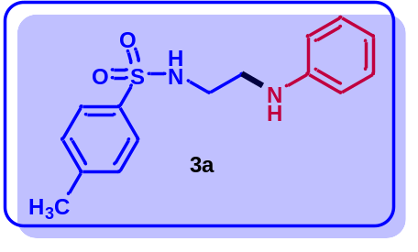
4-Methyl-N-(2-(phenylamino)ethyl)benzenesulfonamide (3a): ¹HNMR (δ in ppm, CDCl₃, 400 MHz): δ 7.72 (d, J = 8.0 Hz, 2H), 7.25 (d, J = 8.4 Hz, 2H), 7.12 (t, J = 7.6 Hz, 2H), 6.70 (t, J = 7.2 Hz, 1H), 6.51 (d, J = 8.0 Hz, 2H), 5.24 (t, J = 6.0 Hz, 1H), 3.50 (br, s, 1H), 3.22 (t, J = 11.2 Hz, 2H), 3.13 (q, J = 6.0 Hz, 2H), 2.39 (s, 3H).

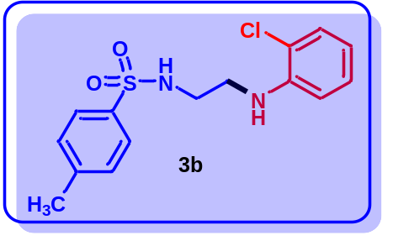
N-(2-((2-chlorophenyl)amino)ethyl)-4-methylbenzenesulfonamide (3b): ¹HNMR (δ in ppm, CDCl₃, 400 MHz): δ 7.73 (d, J = 6.8 Hz, 2H), 7.26-7.20 (m, 3H), 7.07 (dt, J = 1.6, 8.0 Hz, 1H), 6.62 (dt, J = 1.6, 7.6 Hz, 1H), 6.53 (dd, J = 1.2, 8.4 Hz, 1H), 3.91 (br, s, 1H), 3.30 (t, J = 5.6 Hz, 2H), 3.17 (q, J = 12.4 Hz, 2H), 2.39 (s, 3H).

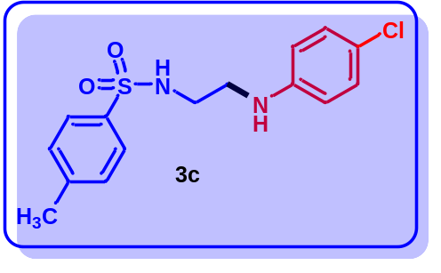
N-(2-((4-chlorophenyl)amino)ethyl)-4-methylbenzenesulfonamide (3c): ¹HNMR (δ in ppm, CDCl₃, 400 MHz): δ 7.72 (d, J = 8.4 Hz, 2H), 7.26 (t, J = 3.6 Hz, 2H), 7.07 (dd, J = 3.2, 5.2 Hz, 2H), 6.43 (dd, J = 2.0, 6.8 Hz, 2H), 5.22 (t, J = 6.0 Hz, 1H), 3.22-3.11 (m, 5H), 2.41 (s, 3H).
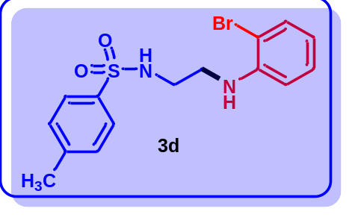
N-(2-((2-bromophenyl)amino)ethyl)-4-methylbenzenesulfonamide (3d): ¹HNMR (δ in ppm, CDCl₃, 400 MHz): δ 7.74 (d, J = 8.4 Hz, 2H), 7.38 (dd, J = 1.6, 8.0 Hz, 1H), 7.24 (d, J = 8.4 Hz, 2H), 7.10 (dt, J = 1.6, 8.4 Hz, 1H), 6.56 (dt, J = 1.2, 7.6 Hz, 1H), 6.51 (dd, J = 1.2, 8.4 Hz, 1H), 5.19 (t, J = 6.0 Hz, 1H), 4.12 (br, s, 1H), 3.29 (t, J = 5.6 Hz, 2H), 3.17 (t, J = 6.4 Hz, 2H), 2.38 (s, 3H).
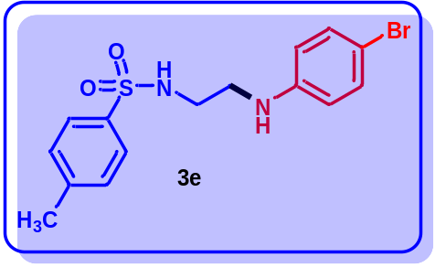
N-(2-((4-bromophenyl)amino)ethyl)-4-methylbenzenesulfonamide (3e): ¹HNMR (δ in ppm, CDCl₃, 400 MHz): δ 7.72 (d, J = 8.4 Hz, 2H), 7.27 (d, J = 9.2 Hz, 2H), 7.20 (d, J = 8.8 Hz, 2H), 6.40 (d, J = 8.8 Hz, 2H), 5.02 (t, J = 6.0 Hz, 1H), 3.22 (t, J = 4.8 Hz, 2H), 3.15 (t, J = 6.4 Hz, 2H), 2.58 (br, s, 1H), 2.42 (s, 3H).
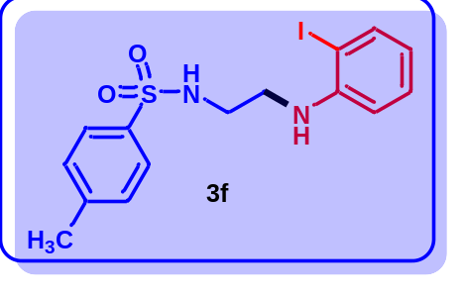
N-(2-((2-iodophenyl)amino)ethyl)-4-methylbenzenesulfonamide (3f): ¹HNMR (δ in ppm, CDCl₃, 400 MHz): δ 7.74 (dd, J = 1.6, 6.4 Hz, 2H), 7.28 (dd, J = 0.4, 8.0 Hz, 2H), 7.23 (dd, J = 1.2, 7.6 Hz, 1H), 7.09 (dt, J = 1.6, 7.6 Hz, 1H), 6.65 (dt, J = 1.6, 7.6 Hz, 1H), 6.56 (dd, J = 1.2, 8.4 Hz, 1H), 4.81 (t, J = 6.0 Hz, 1H), 3.33 (t, J = 5.6 Hz, 2H), 3.20 (q, J = 12.0 Hz, 2H), 2.93 (br, s, 1H), 2.41 (s, 3H).
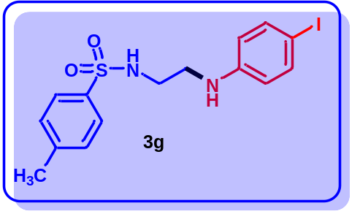
N-(2-((4-iodophenyl)amino)ethyl)-4-methylbenzenesulfonamide (3g): ¹HNMR (δ in ppm, CDCl₃, 400 MHz): δ 7.75 (d, J = 1.6 Hz, 2H), 7.40 (dd, J = 1.6, 8.0 Hz, 1H), 7.28 (d, J = 13.6 Hz, 2H), 7.12 (dt, J = 1.6, 7.6 Hz, 1H), 6.60-6.52 (m, 2H), 4.91 (t, J = 6.0 Hz, 1H), 3.32 (t, J = 5.6 Hz, 3H), 3.19 (q, J = 12.4 Hz, 2H), 2.40 (s, 3H).
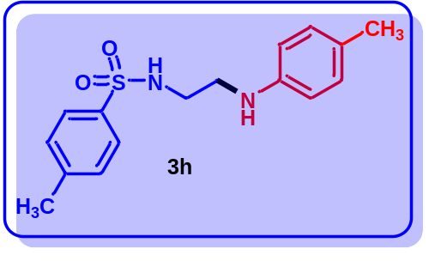
4-Methyl-N-(2-(p-tolylamino)ethyl)benzenesulfonamide (3h): ¹HNMR (δ in ppm, CDCl₃, 400 MHz): δ 7.71 (d, J = 8.4 Hz, 2H), 7.23 (d, J = 8.0 Hz, 2H), 6.92 (d, J = 8.0 Hz, 2H), 6.42 (d, J = 8.4 Hz, 2H), 3.54 (br, s, 1H), 3.17 (t, J = 10.8 Hz, 2H), 3.10 (t, J = 6.8 Hz, 2H), 2.38 (s, 3H), 2.21 (s, 3H).
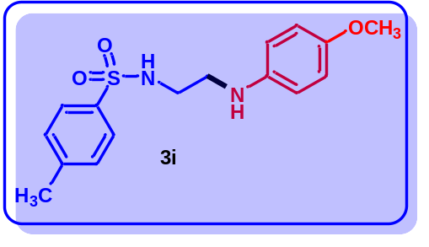
N-(2-((4-methoxyphenyl)amino)ethyl)-4-methylbenzenesulfonamide (3i): ¹HNMR (δ in ppm, CDCl₃, 400 MHz): δ 7.72 (d, J = 8.4 Hz, 2H), 7.26 (t, J = 2.4 Hz, 2H), 6.72 (d, J = 8.8 Hz, 2H), 6.48 (d, J = 8.8 Hz, 2H), 3.72 (s, 3H), 3.26 (br, s, 1H), 3.16 (t, J = 1.6 Hz, 2H), 3.11 (t, J = 5.6 Hz, 2H), 2.40 (s, 3H).
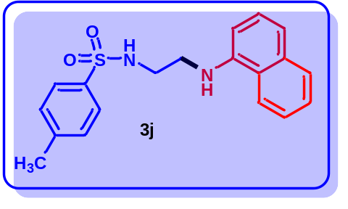
4-Methyl-N-(2-(naphthalen-1-ylamino)ethyl)benzenesulfonamide (3j): ¹HNMR (δ in ppm, CDCl₃, 500 MHz): δ 7.76 (t, J = 8.0 Hz, 2H), 7.70 (d, J = 6.5 Hz, 2H), 7.44-7.36 (m, 2H), 7.25-7.22 (m, 2H), 7.16-7.14 (m, 2H), 6.44 (d, J = 7.5 Hz, 1H), 5.26 (t, J = 6.0 Hz, 1H), 3.36-3.25 (m, 5H), 2.33 (s, 3H).
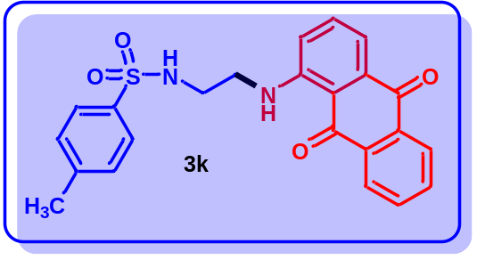
N-(2-((9,10-dioxo-9,10-dihydroanthracen-1-yl)amino)ethyl)-4-methylbenzenesulfonamide (3k): ¹H NMR (δ in ppm, CDCl₃, 500 MHz): δ 9.73 (s, 1H), 8.22-8.18 (m, 2H), 7.77-7.69 (m, 4H), 7.57 (dd, J = 1.0, 7.5 Hz, 1H), 7.49 (t, J = 8.5 Hz, 1H), 7.23 (d, J = 7.5 Hz, 2H), 6.98 (d, J = 8.5 Hz, 1H), 5.03 (t, J = 6.5 Hz, 1H), 3.51 (q, J = 12.5 Hz, 2H), 3.31 (q, J = 12.5 Hz, 2H), 2.34 (s, 3H).
General procedure for the synthesis of chiral benzenesulfonamides (5a-5k):
A mixture of aromatic amine (1 mmol), (S)-(+)-2-Benzyl-1-(p-tolylsulfonyl)aziridine (1 mmol) and CoFe₂O₄/GO/CoFe@rGO (10 mg) was heated at 80 ºC for 9 to 22 minutes. After the completion of reaction, as monitored by TLC, the reaction mixture was cooled to room temperature, and the magnetic nanoparticles were removed from the reaction mixture by external magnet. The obtained residue was purified by silica gel column chromatography (5-10% EtOAc in hexane) to afford the corresponding pure products.
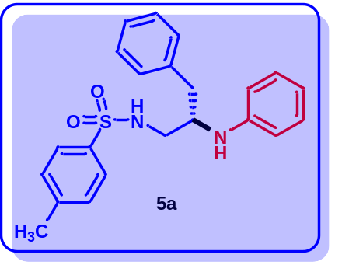
4-Methyl-N-(3-phenyl-2-(phenylamino)propyl)benzenesulfonamide (5a): ¹HNMR (δ in ppm, CDCl₃, 400 MHz): δ 7.59 (d, J = 8.0 Hz, 2H), 7.19-7.07 (m, 7H), 6.99 (t, J = 3.2 Hz, 2H), 6.67 (t, J = 7.2 Hz, 1H), 6.40 (d, J = 8.0 Hz, 2H), 5.01 (d, J = 7.2 Hz, 1H), 3.57 (qnt, J = 7.2, 4.8, 12.0 Hz, 1H), 3.33 (br, s, 1H), 3.17 (dd, J = 4.8, 13.2 Hz, 1H), 3.06 (dd, J = 7.2, 13.2 Hz, 1H), 2.77 (dd, J = 3.6, 6.8 Hz, 2H), 2.37 (s, 3H).
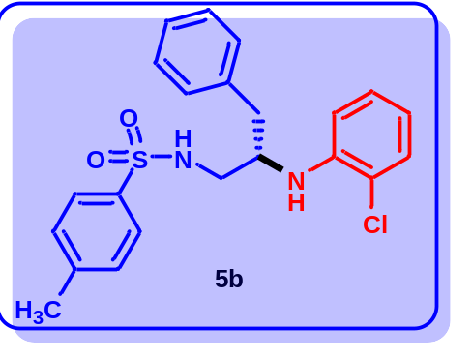
N-(2-((2-chlorophenyl)amino)-3-phenylpropyl)-4-methylbenzenesulfonamide (5b): ¹HNMR (δ in ppm, CDCl₃, 400 MHz): δ 7.58 (d, J = 8.4 Hz, 2H), 7.34 (dd, J = 1.6, 8.0 Hz, 1H), 7.23-7.01 (m, 8H), 6.52 (dt, J = 1.6, 8.0 Hz, 1H), 6.36 (dd, J = 1.2, 8.4 Hz, 1H), 5.11 (d, J = 6.8 Hz, 1H), 4.53 (t, J = 5.6 Hz, 1H), 3.61 (q, J = 13.2 Hz, 1H), 3.17 (t, J = 4.8 Hz, 2H), 2.82 (d, J = 6.4 Hz, 2H), 2.33 (s, 3H).
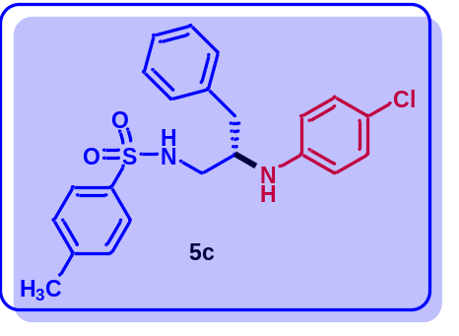
N-(2-((4-chlorophenyl)amino)-3-phenylpropyl)-4-methylbenzenesulfonamide (5c): ¹HNMR (δ in ppm, CDCl₃, 500 MHz): δ 7.56 (d, J = 8.0 Hz, 2H), 7.18 (dd, J = 3.5, 6.5 Hz, 3H), 7.15-7.12 (m, 4H), 7.00-6.97 (m, 2H), 6.25 (dd, J = 2.0, 7.0 Hz, 2H), 5.03 (d, J = 7.0 Hz, 1H), 3.55 (qnt, J = 5.0, 2.5, 7.5 Hz, 1H), 3.35 (br, s, 1H), 3.14 (dd, J = 5.0, 13.5 Hz, 1H), 3.02 (dd, J = 7.5, 13.5 Hz, 1H), 2.75 (d, J = 6.5 Hz, 2H), 2.39 (m, 3H).
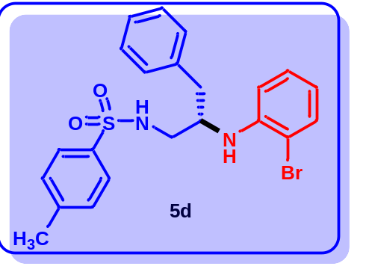
N-(2-((2-bromophenyl)amino)-3-phenylpropyl)-4-methylbenzenesulfonamide (5d): ¹HNMR (δ in ppm, CDCl₃, 400 MHz): δ 7.58 (d, J = 8.4 Hz, 2H), 7.33 (dd, J = 1.6, 8.0 Hz, 1H), 7.22-7.01 (m, 8H), 6.51 (dt, J = 1.2, 7.6 Hz, 1H), 6.34 (dd, J = 1.2, 8.4 Hz, 1H), 5.20 (d, J = 7.2 Hz, 1H), 4.55 (t, J = 5.6 Hz, 1H), 3.60 (q, J = 12.8 Hz, 1H), 3.16 (t, J = 4.4 Hz, 2H), 2.81 (d, J = 6.8 Hz, 2H), 2.32 (s, 3H).
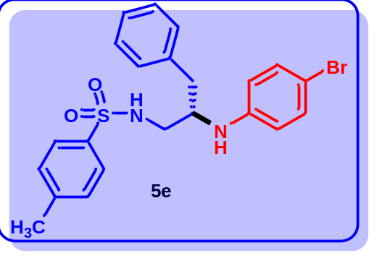
N-(2-((4-bromophenyl)amino)-3-phenylpropyl)-4-methylbenzenesulfonamide (5e): ¹HNMR (δ in ppm, CDCl₃, 400 MHz): δ 7.56 (d, J = 8.4 Hz, 1H), 7.19-7.10 (m, 7H), 6.99-6.96 (m, 2H), 6.24 (dd, J = 2.0, 6.8 Hz, 2H), 5.14 (d, J = 7.2 Hz, 1H), 3.58-3.52 (m, 2H), 3.13 (dd, J = 4.8, 13.2 Hz, 1H), 3.01 (dd, J = 7.6, 13.2 Hz, 1H), 2.75 (d, J = 6.8 Hz, 2H), 2.38 (s, 3H).
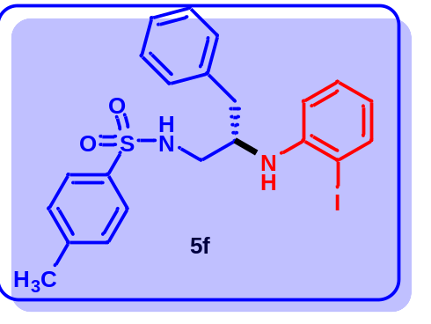
N-(2-((2-iodophenyl)amino)-3-phenylpropyl)-4-methylbenzenesulfonamide (5f): ¹HNMR (δ in ppm, CDCl₃, 500 MHz): δ 7.58 (d, J = 8.5 Hz, 2H), 7.34 (dd, J = 1.5, 8.0 Hz, 1H), 7.21-7.18 (m, 3H), 7.09 (d, J = 8.5 Hz, 2H), 7.06-7.02 (m, 3H), 6.52 (dt, J = 1.5, 8.0 Hz, 1H), 6.36 (dd, J = 1.5, 8.5 Hz, 1H), 5.08 (d, J = 7.5 Hz, 1H), 4.32 (br, s, 1H), 3.64-3.58 (m, 1H), 3.18-3.16 (m, 2H), 2.83-2.81 (m, 2H), 2.33 (s, 3H).
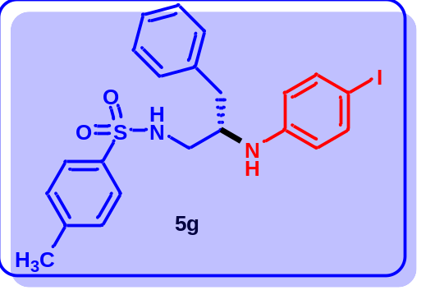
N-(2-((4-iodophenyl)amino)-3-phenylpropyl)-4-methylbenzenesulfonamide (5g): ¹HNMR (δ in ppm, CDCl₃, 400 MHz): δ 7.56 (d, J = 8.0 Hz, 2H), 7.30 (dd, J = 3.2, 12.0 Hz, 2H), 7.20-7.16 (m, 3H), 7.11 (d, J = 8.0 Hz, 2H), 6.99-6.96 (m, 2H), 6.14 (dd, J = 3.2, 12.0 Hz, 2H), 5.17 (d, J = 7.2 Hz, 1H), 3.56-3.51 (m, 2H), 3.13 (dd, J = 4.8, 13.6 Hz, 1H), 3.00 (dd, J = 7.6, 13.2 Hz, 1H), 2.74 (d, J = 6.8 Hz, 2H), 2.38 (s, 3H).
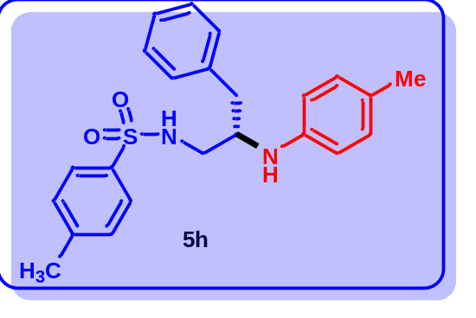
4-Methyl-N-(3-phenyl-2-(p-tolylamino)propyl)benzenesulfonamide (5h): ¹HNMR (δ in ppm, CDCl₃, 400 MHz): δ 7.59 (d, J = 8.0 Hz, 2H), 7.18-7.11 (m, 5H), 6.99 (dd, J = 3.6, 7.2 Hz, 2H), 6.89 (d, J = 8.4 Hz, 2H), 6.32 (d, J = 8.4 Hz, 2H), 5.07 (d, J = 7.2 Hz, 2H), 3.56 (q, J = 6.8 Hz, 1H), 3.43 (br, s, 1H), 3.13 (dd, J = 4.8, 13.2 Hz, 1H), 3.02 (dd, J = 7.2, 13.2 Hz, 1H), 2.76 (d, J = 6.8 Hz, 2H), 2.37 (s, 3H), 2.22 (s, 3H).
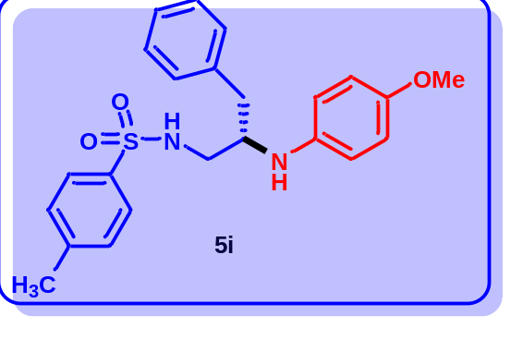
N-(2-((4-methoxyphenyl)amino)-3-phenylpropyl)-4-methylbenzenesulfonamide (5i): ¹HNMR (δ in ppm, CDCl₃, 400 MHz): δ 7.51 (d, J = 8.4 Hz, 2H), 7.12-7.05 (m, 5H), 6.91 (t, J = 3.6 Hz, 2H), 6.62 (dd, J = 3.6, 5.6 Hz, 2H), 6.28 (dd, J = 2.0, 6.4 Hz, 2H), 5.04 (d, J = 7.2 Hz, 1H), 3.64 (s, 3H), 3.48-3.47 (m, 1H), 3.30 (br, s, 1H), 3.03 (dd, J = 4.8, 13.2 Hz, 1H), 2.91 (dd, J = 7.2, 12.8 Hz, 2H), 2.68 (d, J = 6.8 Hz, 2H), 2.30 (s, 3H).
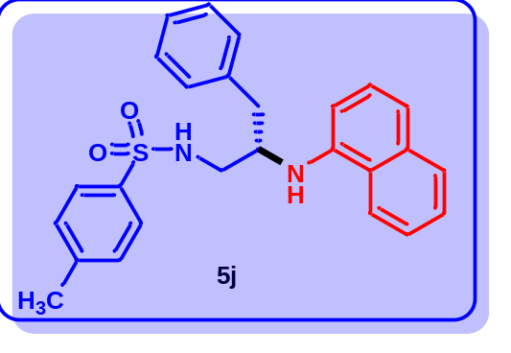
4-Methyl-N-(2-(naphthalen-1-ylamino)-3-phenylpropyl)benzenesulfonamide (5j): ¹HNMR (δ in ppm, CDCl₃, 500 MHz): δ 7.78 (d, J = 7.0 Hz, 1H), 7.70 (d, J = 8.5 Hz, 1H), 7.68 (d, J = 58.0 Hz, 2H), 7.45 (t, J = 7.0 Hz, 1H), 7.39 (t, J = 7.0 Hz, 1H), 7.28-7.15 (m, 6H), 7.08-7.05 (m, 4H), 6.33 (dd, J = 1.5, 7.0 Hz, 1H), 5.07 (d, J = 7.5 Hz, 1H), 3.85-3.78 (m, 1H), 3.36 (dd, J = 0.5, 18.0 Hz, 1H), 3.19-3.15 (m, 1H), 2.93-2.83 (m, 2H), 2.32 (s, 3H).
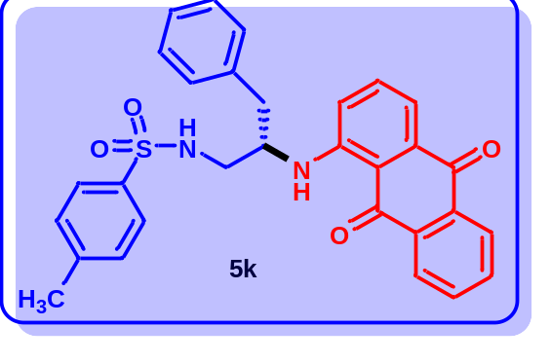
N-(2-((9,10-dioxo-9,10-dihydroanthracen-1-yl)amino)-3-phenylpropyl)-4-methylbenzenesulfonamide (5k): ¹HNMR (δ in ppm, CDCl₃, 500 MHz): δ 9.90 (t, J = 6.0 Hz, 1H), 8.27 (d, J = 7.5 Hz, 2H), 7.78 (dt, J = 1.4, 7.5 Hz, 2H), 7.64-7.60 (m, 2H), 7.54-7.47 (m, 3H), 7.25-7.22 (m, 2H), 7.12-7.10 (m, 2H), 7.04-7.00 (m, 2H), 6.92 (d, J = 8.0 Hz, 1H), 4.72 (d, J = 7.0 Hz, 1H), 3.72 (q, J = 13.0 Hz, 1H), 3.46 (t, J = 6.0 Hz, 2H), 3.00-2.90 (m, 2H), 2.19 (s, 3H).

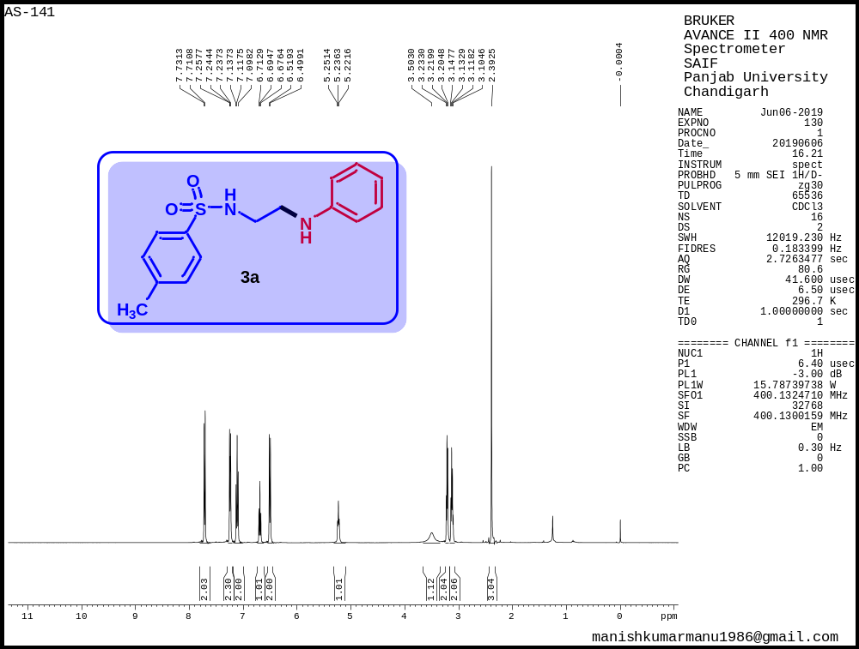
Figure S1. ¹H NMR spectrum of 4-methyl-N-(2-(phenylamino)ethyl)benzenesulfonamide (3a)

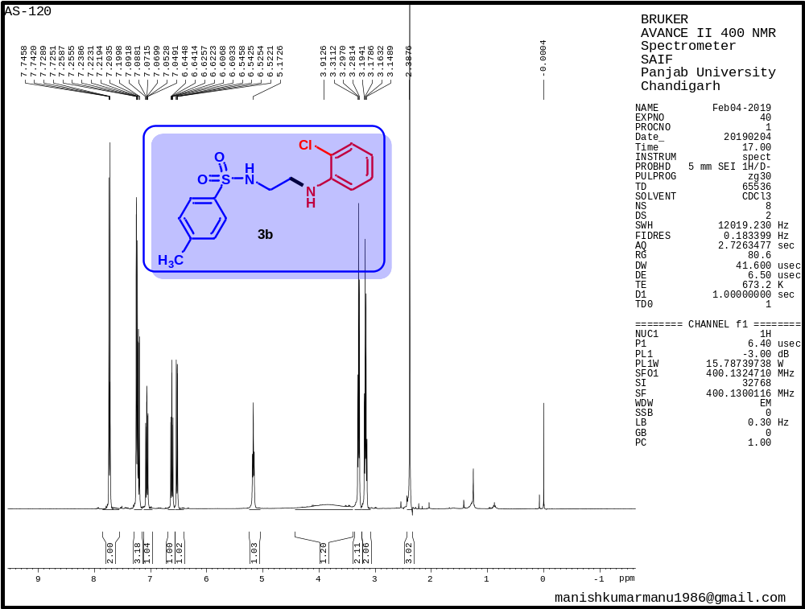
Figure S2. ¹H NMR spectrum of N-(2-((2-chlorophenyl)amino)ethyl)-4-methylbenzenesulfonamide (3b)

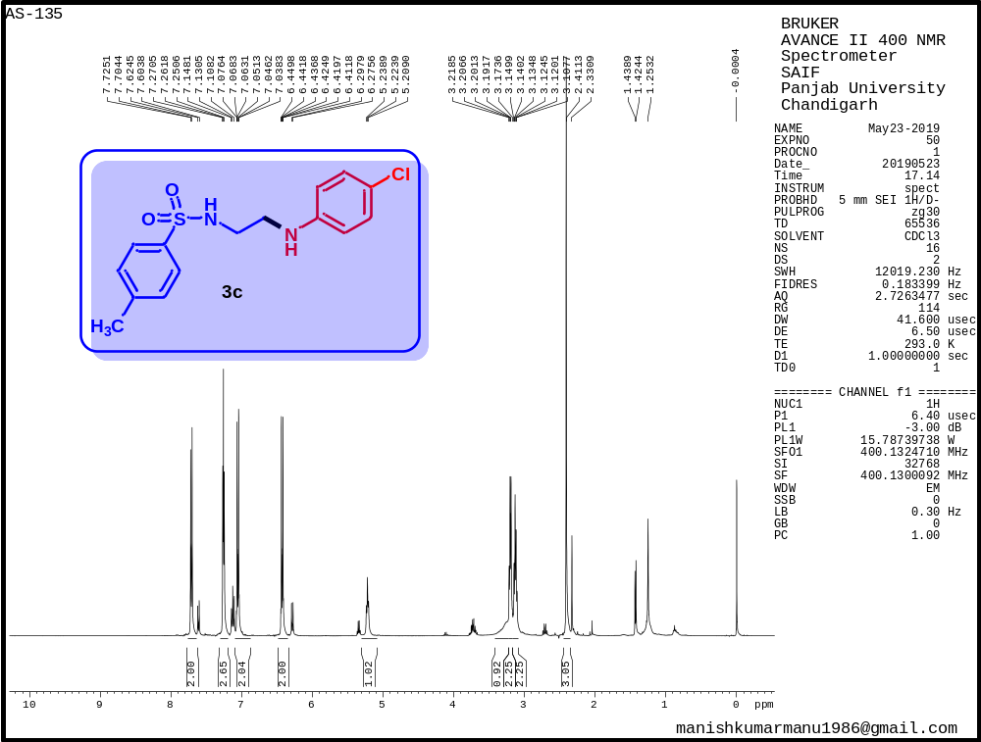
Figure S3. ¹H NMR spectrum of N-(2-((4-chlorophenyl)amino)ethyl)-4-methylbenzenesulfonamide (3c)

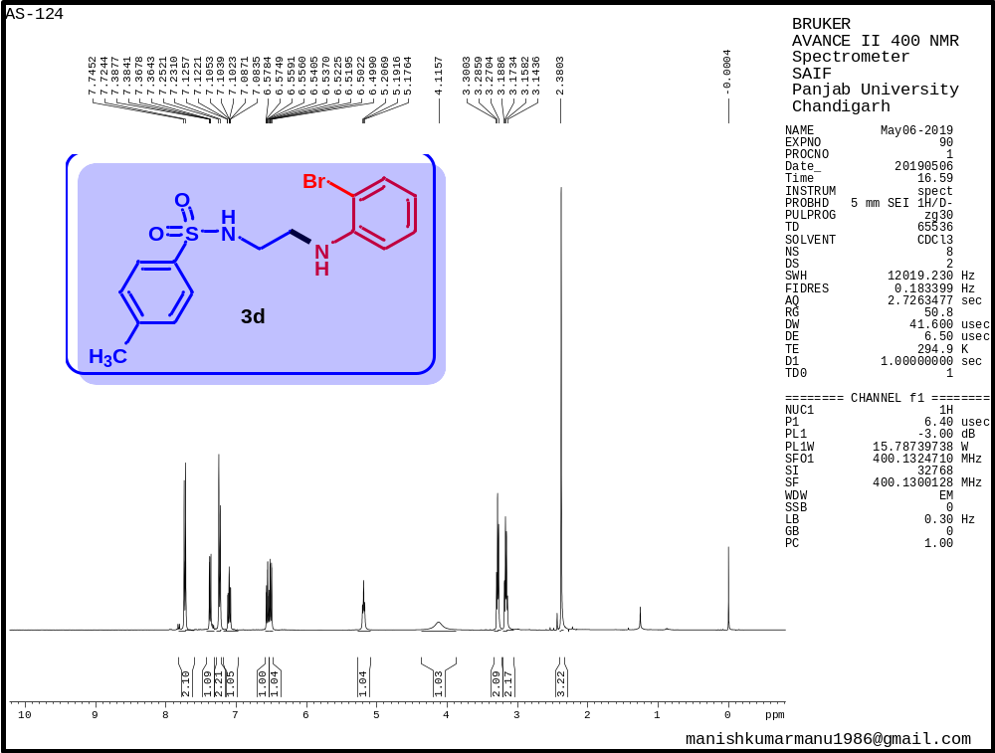
Figure S4. ¹H NMR spectrum of N-(2-((2-bromophenyl)amino)ethyl)-4-methylbenzenesulfonamide (3d)

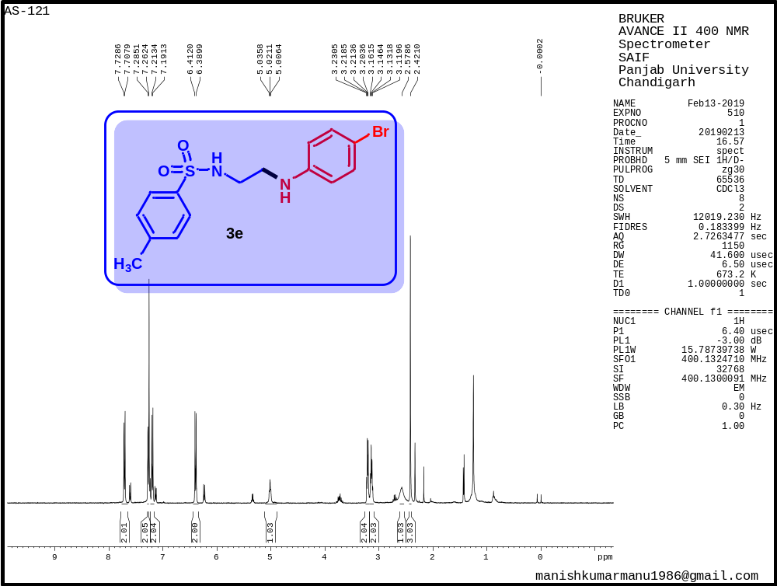
Figure S5. ¹H NMR spectrum of N-(2-((4-bromophenyl)amino)ethyl)-4-methylbenzenesulfonamide (3e)

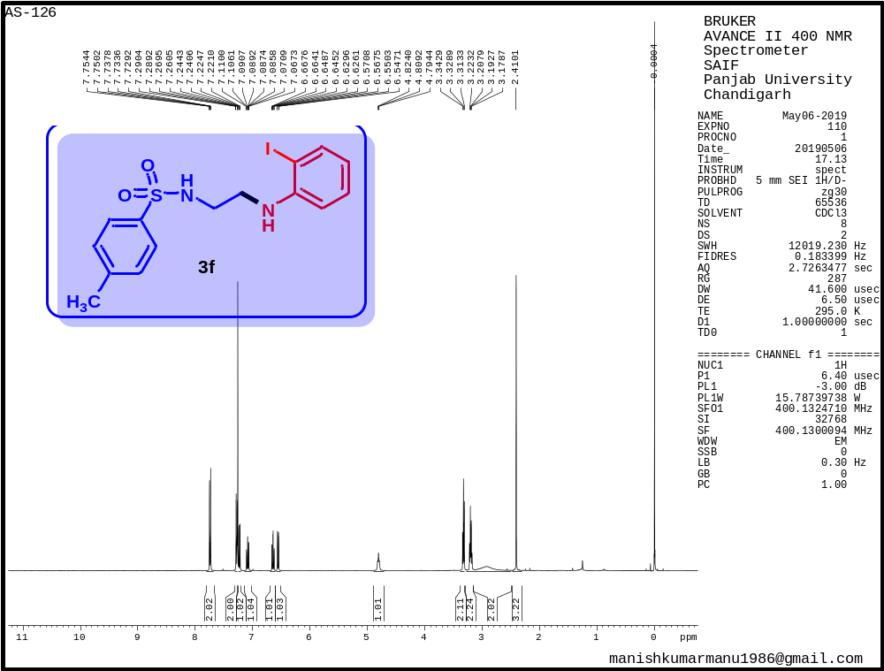
Figure S6. ¹H NMR spectrum of N-(2-((2-iodophenyl)amino)ethyl)-4-methylbenzenesulfonamide (3f)

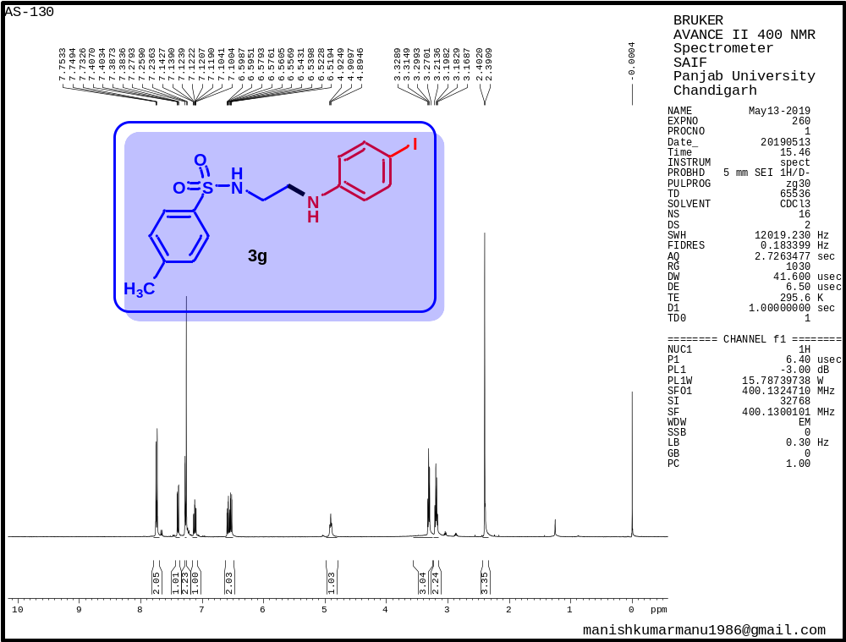
Figure S7. ¹H NMR spectrum of N-(2-((4-iodophenyl)amino)ethyl)-4-methylbenzenesulfonamide (3g)

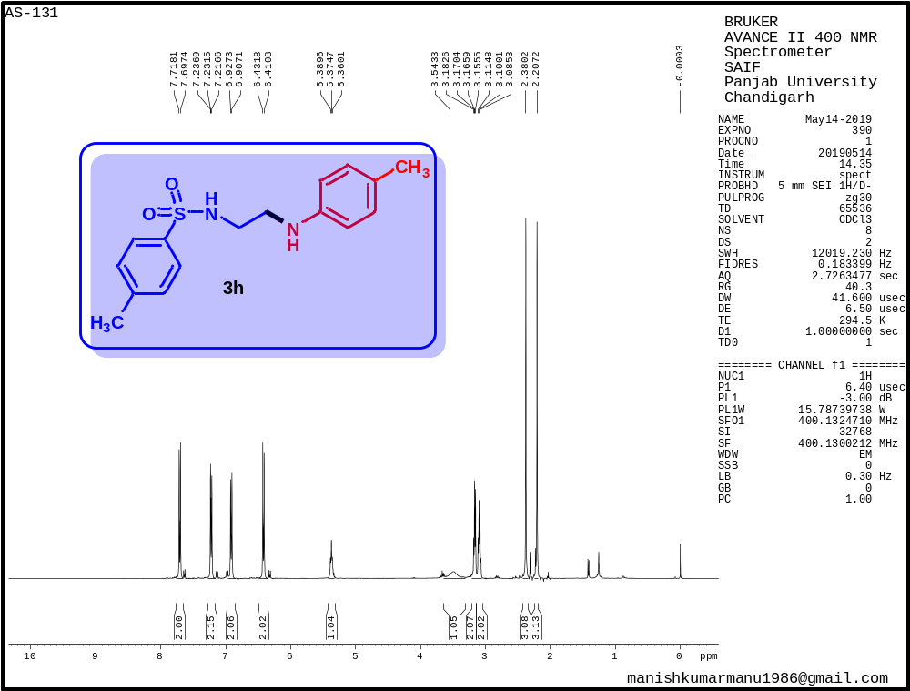

Figure S8. ¹H NMR spectrum of 4-methyl-N-(2-(p-tolylamino)ethyl)benzenesulfonamide (3h)

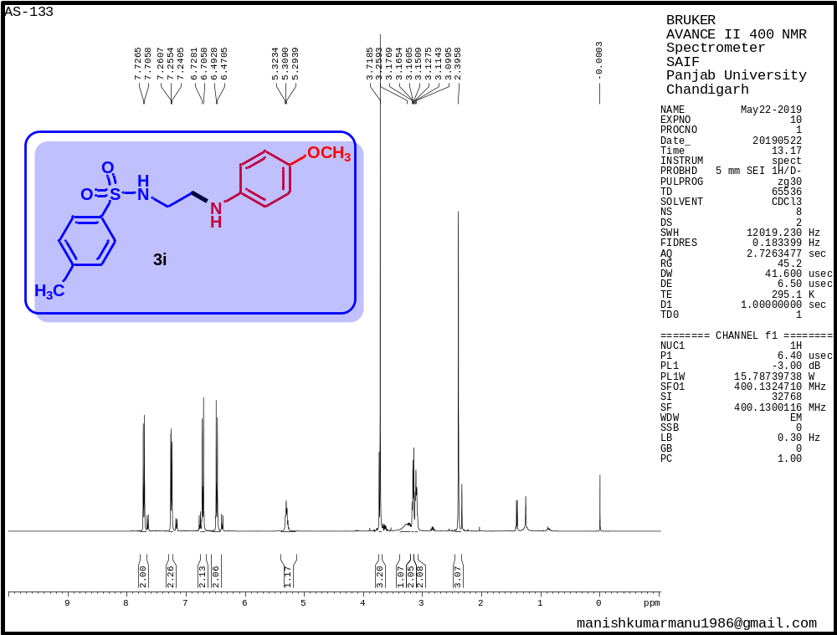
Figure S9. ¹H NMR spectrum of N-(2-((4-methoxyphenyl)amino)ethyl)-4-methylbenzenesulfonamide (3i)

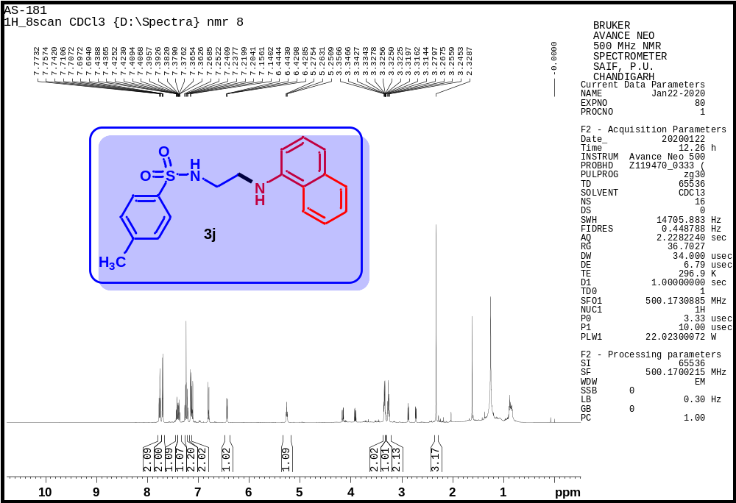
Figure S10. ¹H NMR spectrum of 4-methyl-N-(2-(naphthalen-1-ylamino)ethyl)benzenesulfonamide (3j)

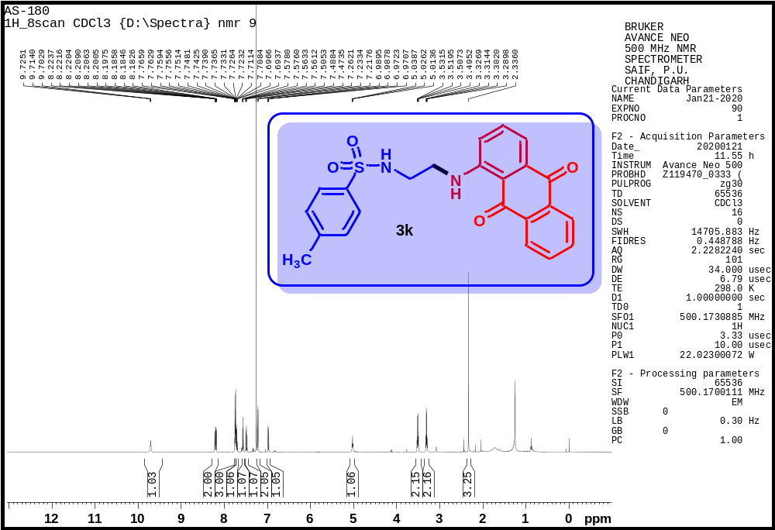
Figure S11. ¹H NMR spectrum of N-(2-((9,10-dioxo-9,10-dihydroanthracen-1-yl)amino)ethyl)-4-methylbenzenesulfonamide (3k)

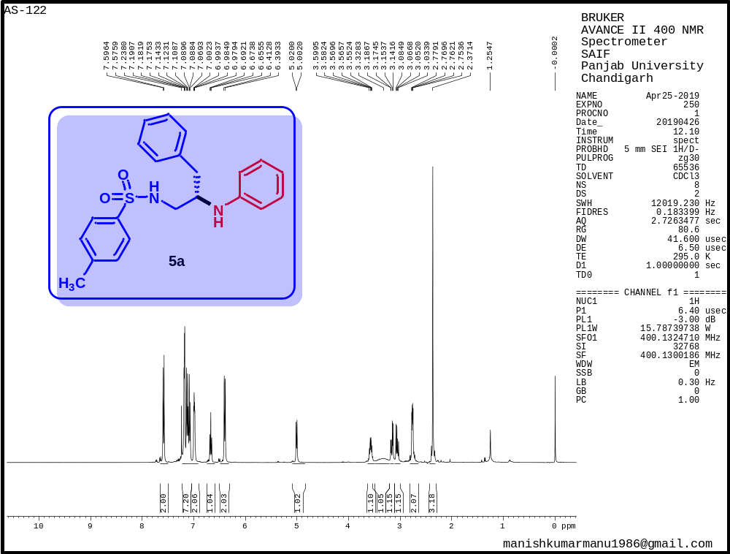
Figure S12. ¹H NMR spectrum of 4-methyl-N-(3-phenyl-2-(phenylamino)propyl)benzenesulfonamide (5a)

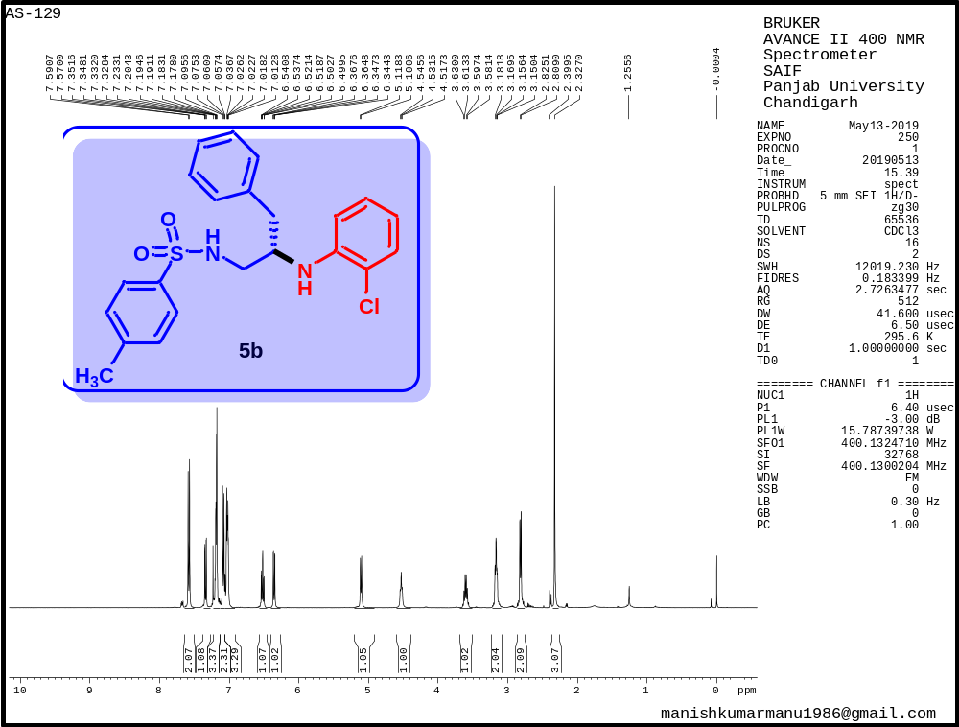
Figure S13. ¹H NMR spectrum of N-(2-((2-chlorophenyl)amino)-3-phenylpropyl)-4- methylbenzenesulfonamide (5b)

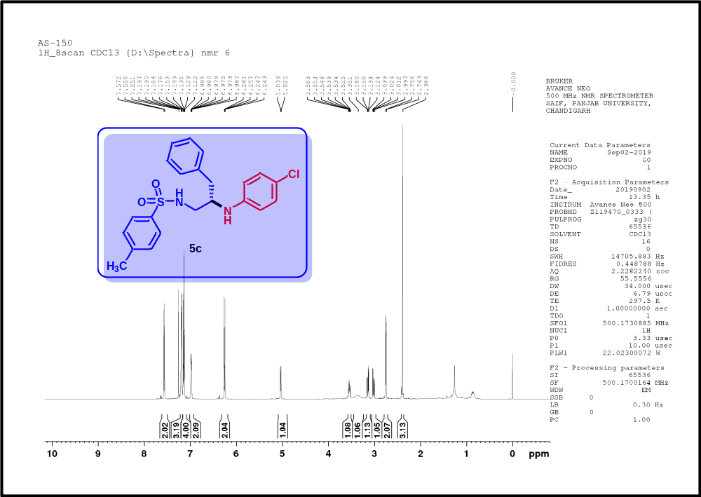
Figure S14. ¹H NMR spectrum of N-(2-((4-chlorophenyl)amino)-3-phenylpropyl)-4-methylbenzenesulfonamide (5c)

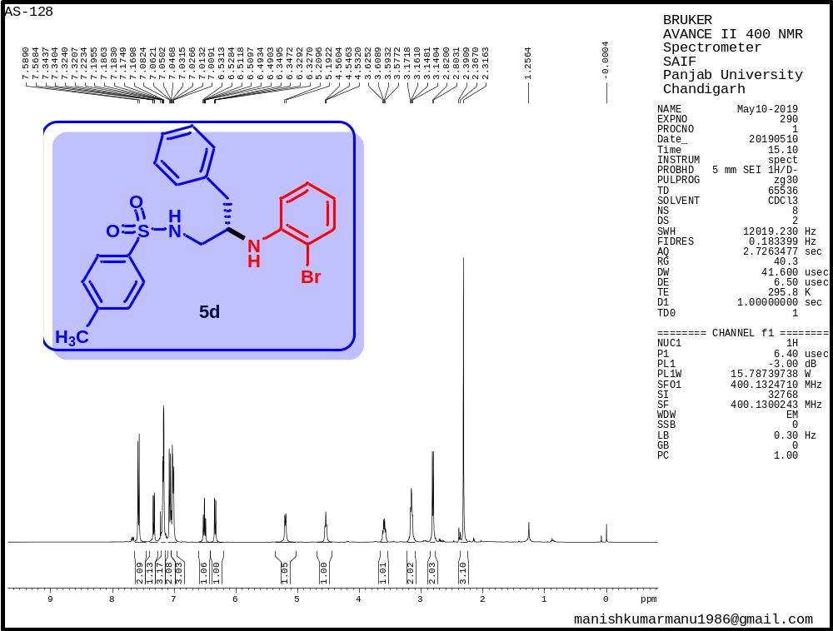
Figure S15. ¹H NMR spectrum of N-(2-((2-bromophenyl)amino)-3-phenylpropyl)-4-methylbenzenesulfonamide (5d)

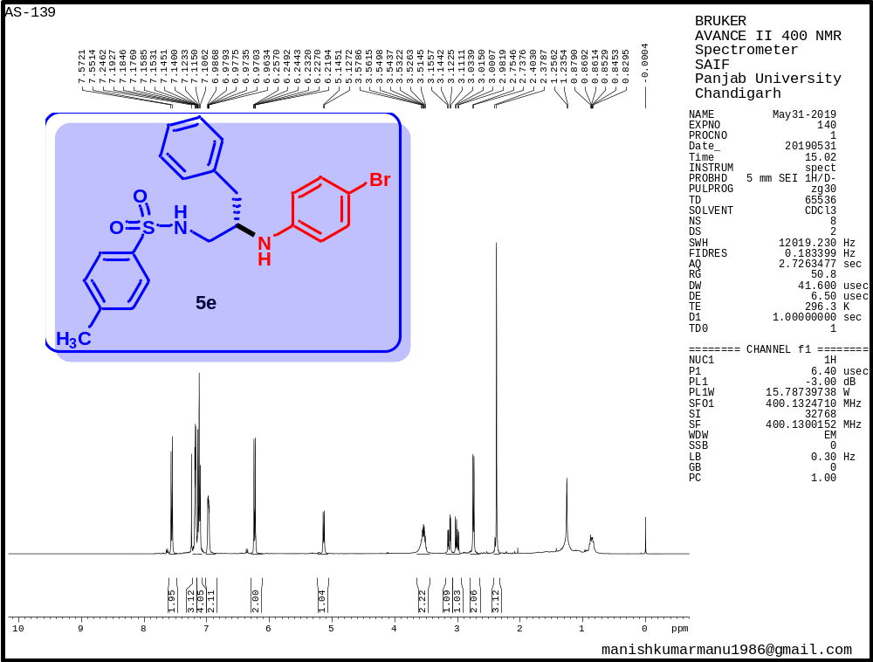
Figure S16. ¹H NMR spectrum of N-(2-((4-bromophenyl)amino)-3-phenylpropyl)-4-methylbenzenesulfonamide (5e)

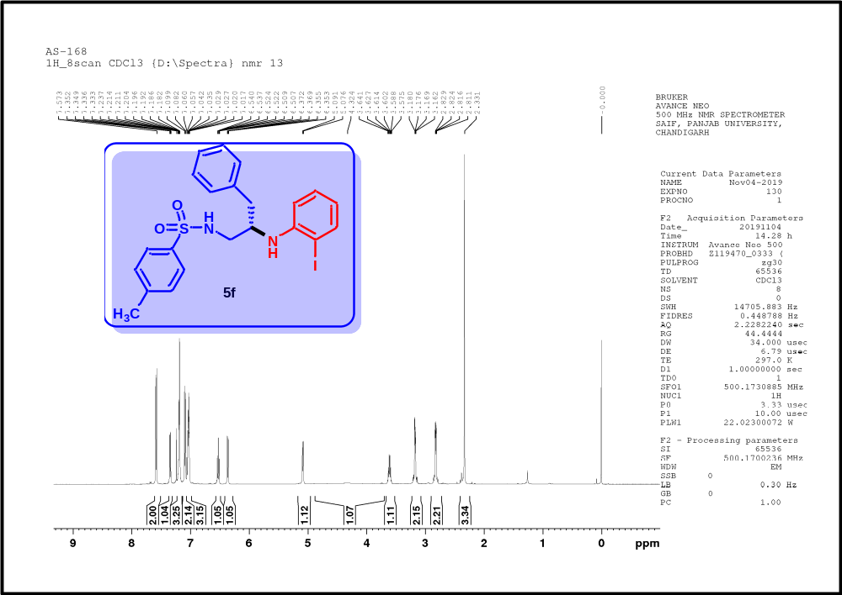
Figure S17. ¹H NMR spectrum of N-(2-((2-iodophenyl)amino)-3-phenylpropyl)-4- methylbenzenesulfonamide (5f)

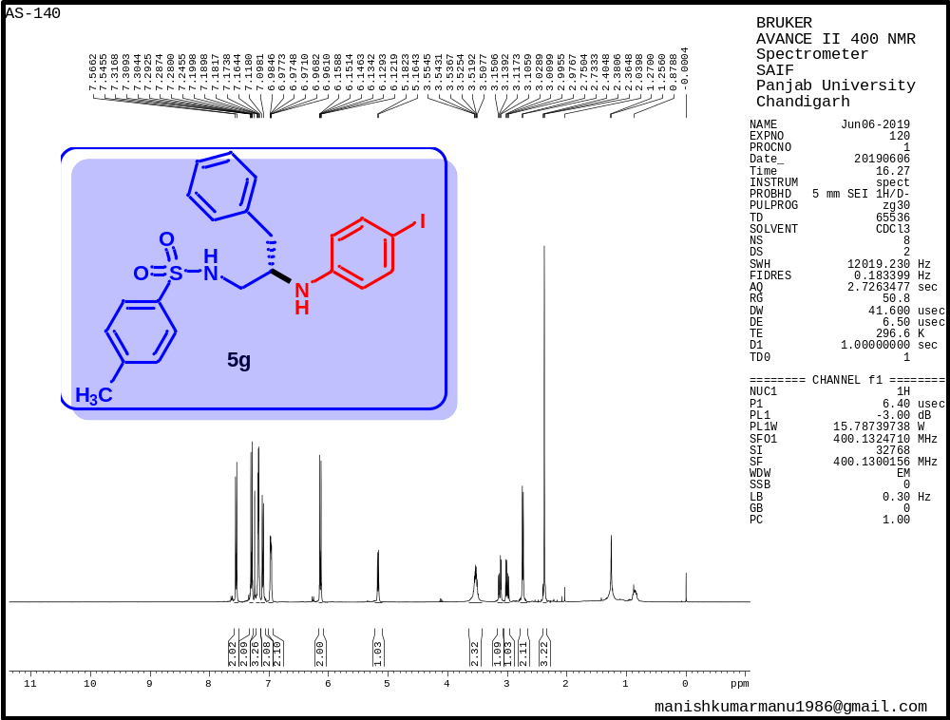
Figure S18. ¹H NMR spectrum of N-(2-((4-iodophenyl)amino)-3-phenylpropyl)-4-methylbenzenesulfonamide (5g)

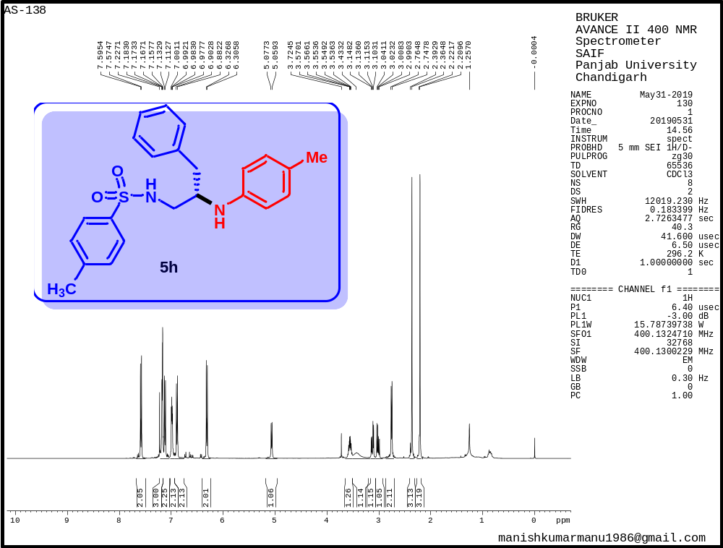
Figure S19. ¹H NMR spectrum of 4-methyl-N-(3-phenyl-2-(p-tolylamino)propyl)benzenesulfonamide (5h)

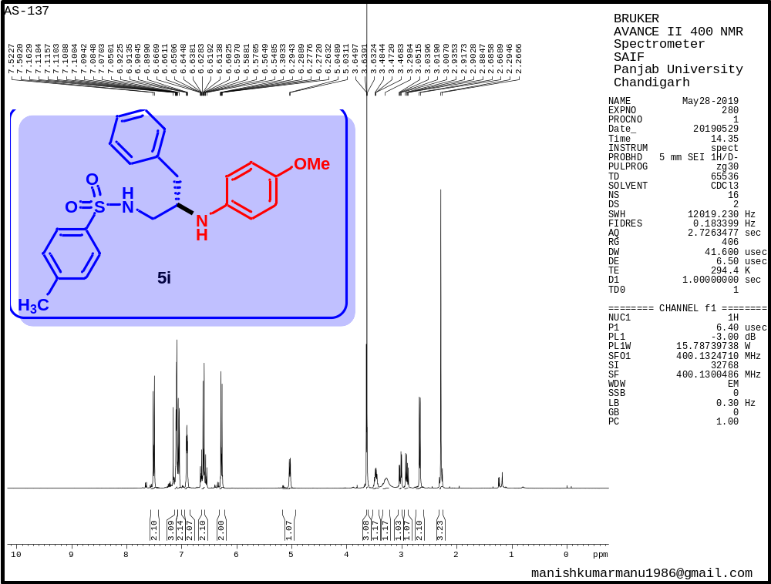
Figure S20. ¹H NMR spectrum of N-(2-((4-methoxyphenyl)amino)-3-phenylpropyl)-4-methylbenzenesulfonamide (5i)

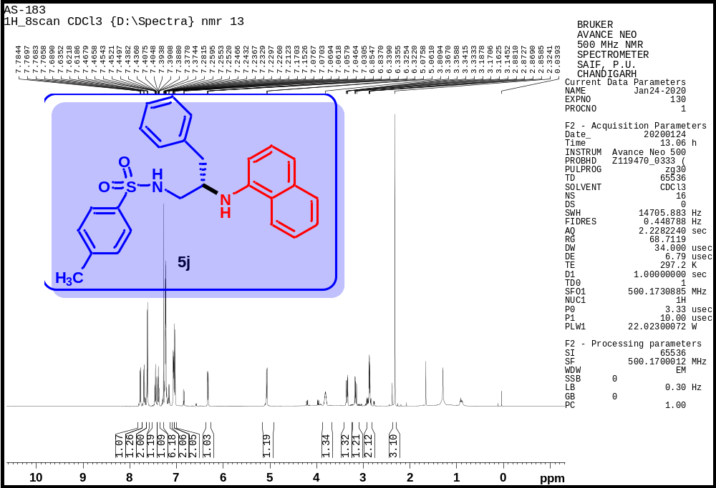
Figure S21. ¹H NMR spectrum of 4-methyl-N-(2-(naphthalen-1-ylamino)-3-phenylpropyl)benzenesulfonamide (5j)

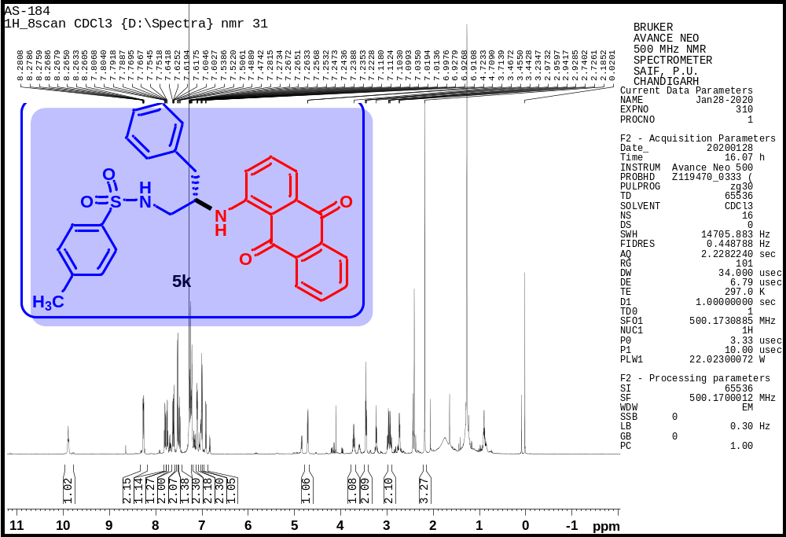
Figure S22. ¹H NMR spectrum of N-(2-((9,10-dioxo-9,10-dihydroanthracen-1-yl)amino)-3-phenylpropyl)-4 methylbenzenesulfonamide (5k)

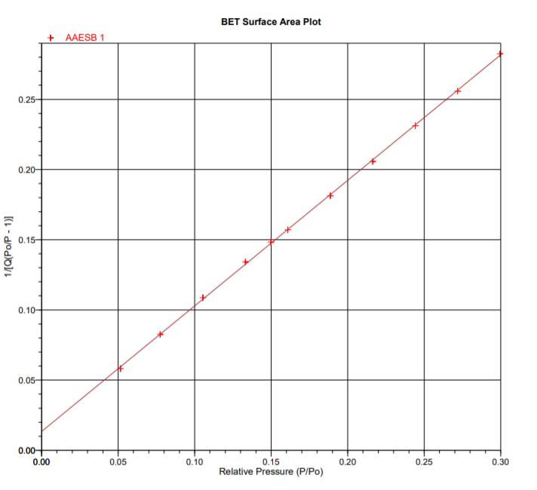
Figure S23. The BET plot for GO.
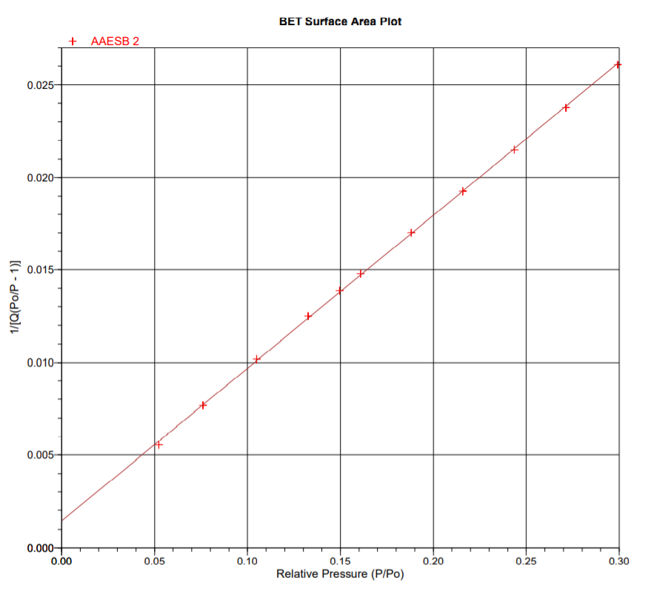
Figure S24. The BET plot for CoFe@rGO nanohybrid.

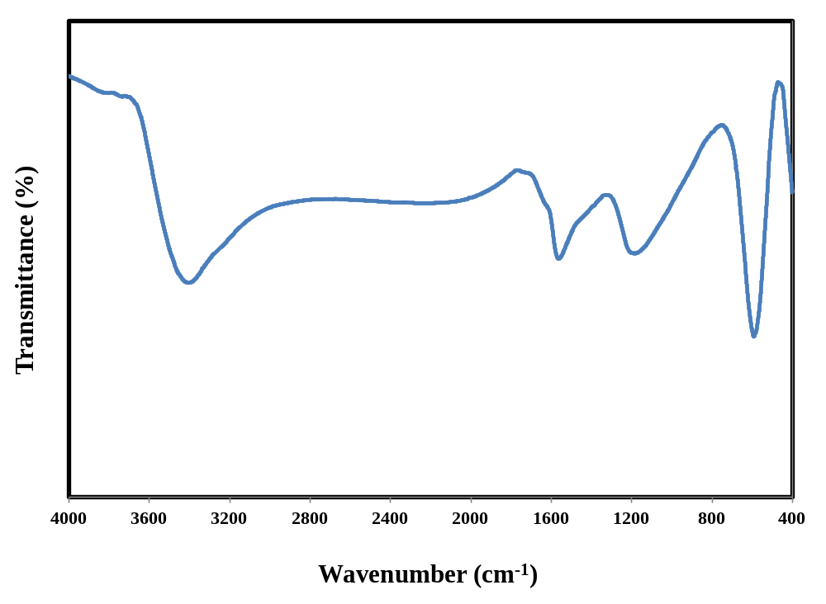Figure S25. Typical FT-IR spectra of CoFe@rGO nanohybrid prepared by hydrothermal route (Spent Catalyst).

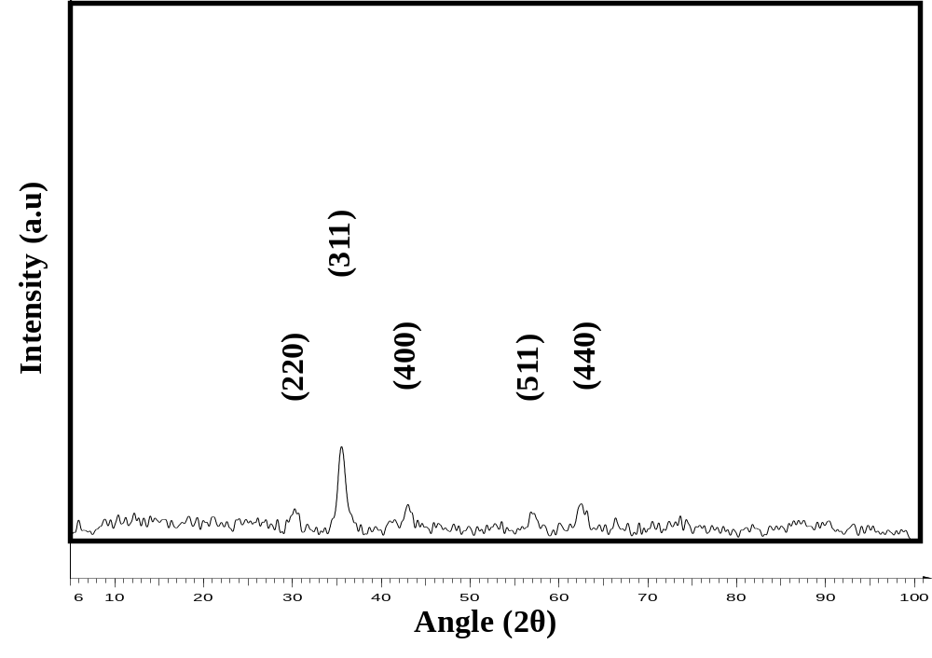
Figure S26. Typical Powder XRD pattern of CoFe@rGO nanohybrid prepared by hydrothermal route (Spent Catalyst).

