Supporting Information

Constructing a Biomimetic ECM Protective Barrier: A Strategic Interface Design for Urethral Repair to Mitigate Foreign Body Reaction

¹ School of Life and Health Technology, Dongguan University of Technology, Dongguan, 523808, China
² Department of Pediatric Surgery, Guangdong Provincial Key Laboratory of Research in Structural Birth Defect Disease, Guangzhou Women and Children's Medical Center, Guangzhou Medical University, Guangzhou 510623, Guangdong, PR China

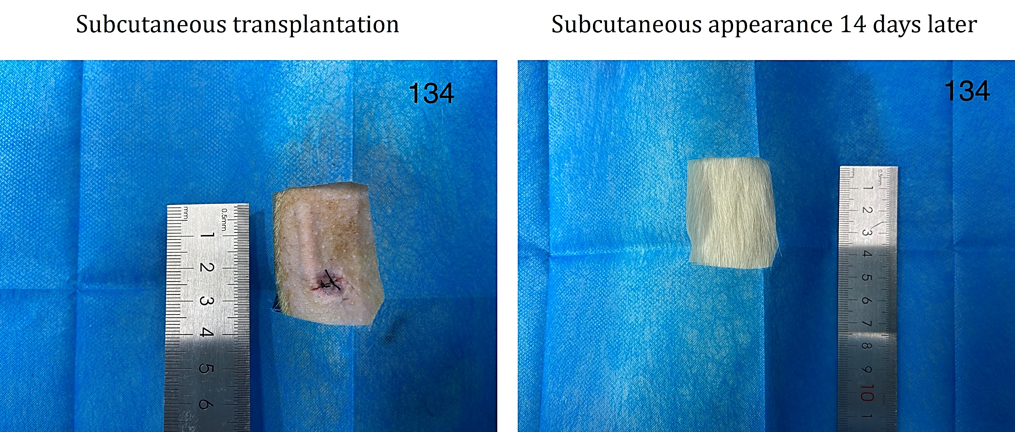
Figure S1. Representative images of the incision site before (left panel) and 14 days after (right panel) subcutaneous implantation of the PLA scaffold.

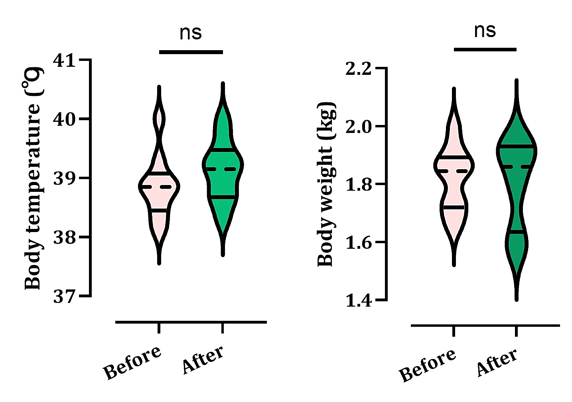
Figure S2. Body weight and body temperature in animals before and after PLA scaffold implantation (violin plot; n = 10). Data were analyzed by Student’s t-test. ns, not significant.
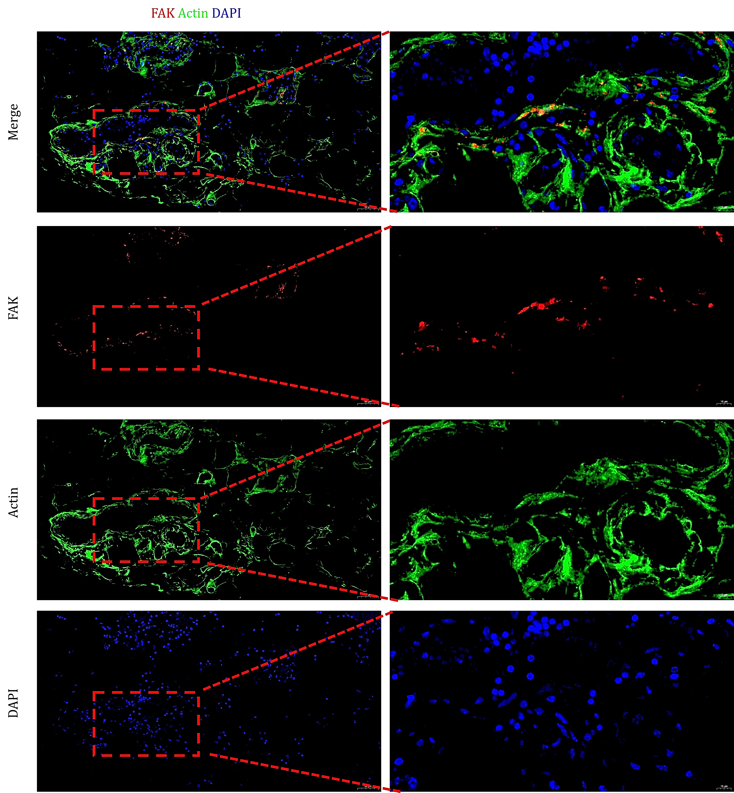
Figure S3. Immunofluorescence staining of UECs cultured on the TEUG for 168 hours. Images show merged channels and individual signals for FAK (red), actin (green), and DAPI-stained nuclei (blue), displayed from top to bottom.
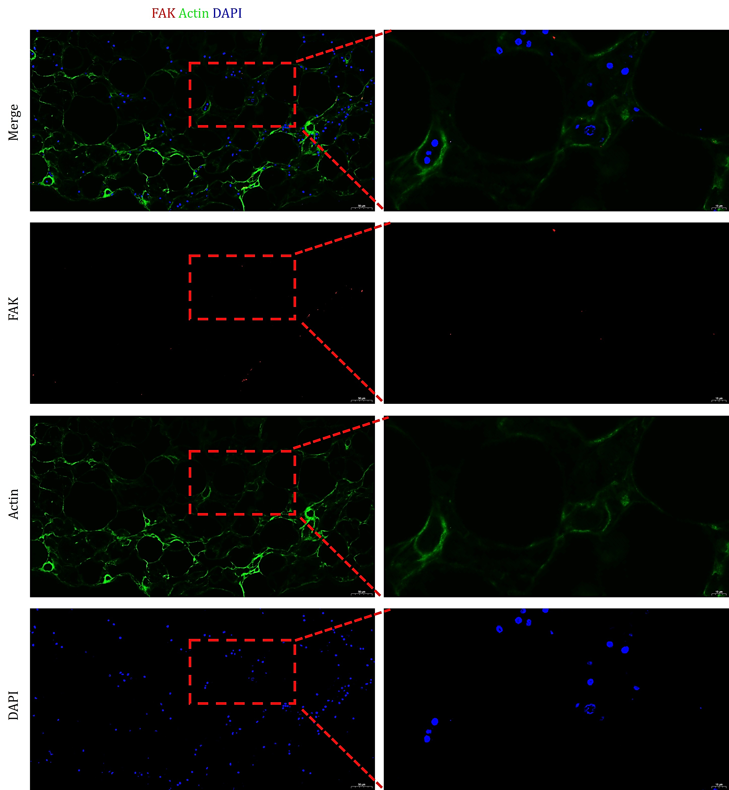
Figure S4. Immunofluorescence staining of UECs cultured on the SIS for 168 hours. Images show merged channels and individual signals for FAK (red), actin (green), and DAPI-stained nuclei (blue), displayed from top to bottom.

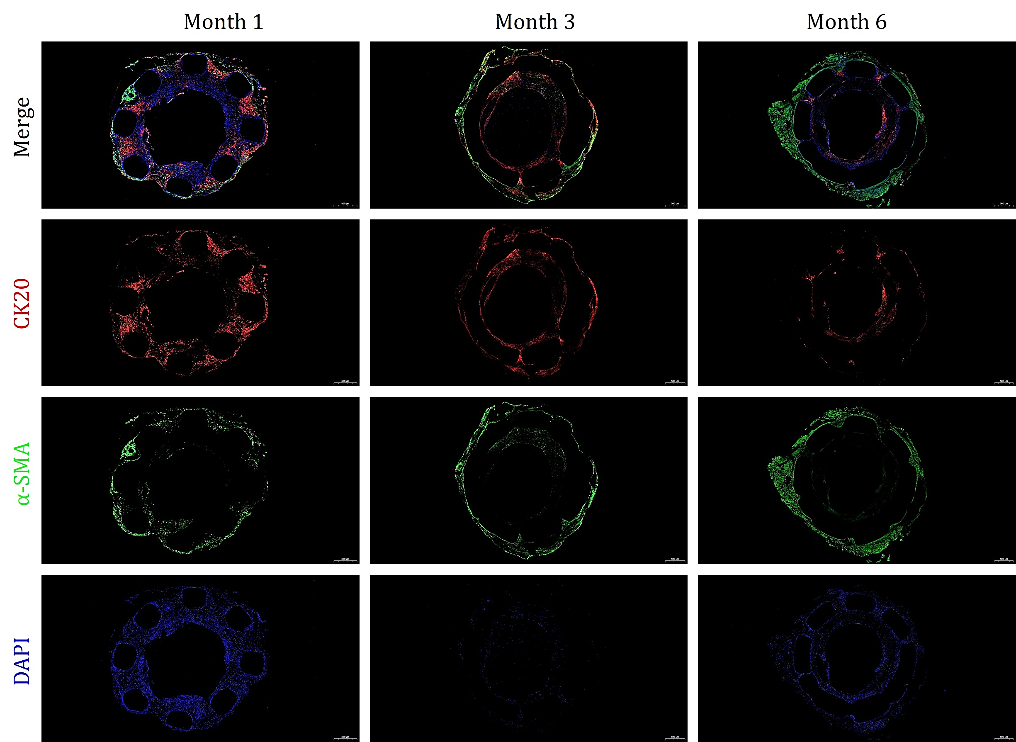
Figure S5. Immunofluorescence staining for CK20 (epithelium, red), α-SMA (smooth muscle, green), and DAPI (nuclei, blue) on TEUG sections over time. Images are shown from top to bottom: merged channels, and individual signals for CK20 (red), α-SMA (green), and DAPI-stained nuclei (blue).

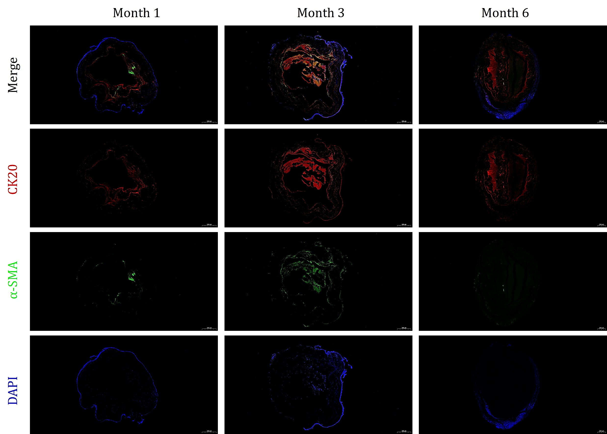
Figure S6. Immunofluorescence staining for CK20 (epithelium, red), α-SMA (smooth muscle, green), and DAPI (nuclei, blue) on SIS sections over time. Images are shown from top to bottom: merged channels, and individual signals for CK20 (red), α-SMA (green), and DAPI-stained nuclei (blue).

