Viridibacillus soil sp.nov., isolated from forest soil in Ailaoshan National Nature Reserve
Yan Xu†, Jiang-Yuan Zhao†, Yu Geng, Hui-Ren Yuan, Le-Le Li, Meng-Liang Wen, Ming-Gang Li*, Shu-Kun Tang*
Yunnan Institute of Microbiology, Key Laboratory for Conservation and Utilization of Bio-resource, and Key Laboratory for Microbial Resources of the Ministry of Education, School of Life Sciences, Yunnan University, Kunming, 650091, PR China
Fatty acid | YIM B01967^{T} | Viridibacillus arvi DSM 16317^{T}
Straight-chain saturated
C_{14:0} | 0.79 | 1.5
C_{16:0} | 2.21 | 1.84
Branched saturated
iso-C_{14:0} | 3.68 | 5.51
iso-C_{15:0} | 34.64 | 38.27
iso-C_{16:0} | 6.02 | 4.72
iso-C_{17:0} | 2.94 | 3.89
anteiso-C_{15:0} | 12.72 | 19.58
anteiso-C_{17:0} | 6.15 | 7.62
Unsaturated
C_{16:1} ω7c alcohol | 8.95 | 5.17
C_{16:1}ω11c | 11.53 | 5.17
iso-C_{17:1}ω10c | 3.06 | 2.62
Summed Feature 4 | 5.02 | 3.59

Note: Summed Feature 4,17:1 iso I/anteiso B
Table S1. Cellular fatty acid contents (>1%) of strain YIM B01967^{T} and reference strain Viridibacillus arvi DSM 16317^{T}. All data are from the present study. Values are presented as the percentages of total fatty acids. Major components (>10 %) are shown in bold type.

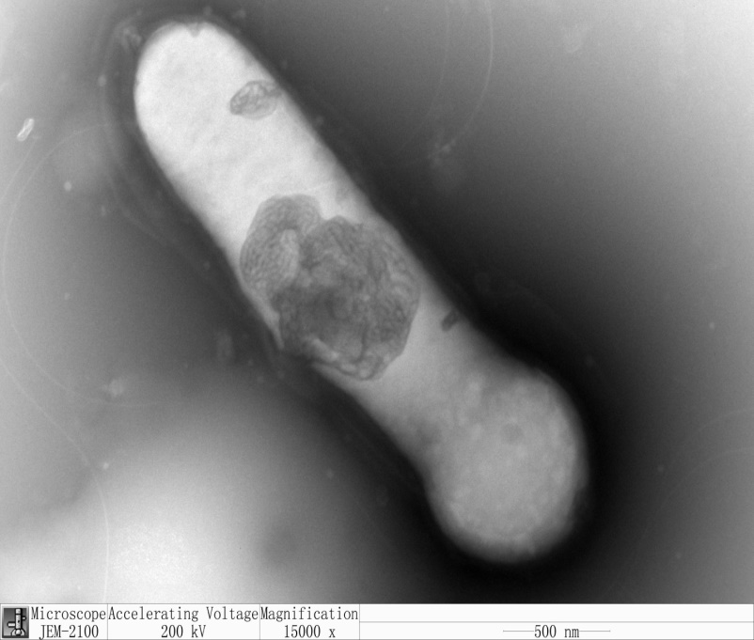
Fig S1 Transmission electron micrograph of strain YIM B01967^{T} grown on PCA at 30 °C for 4 d. Bar, 1um
Rummeliibacilluspycnus NBRC 101231^{T}(AB271739)
Rummeliibacillussuwonensis G20^{T} (KC677630)
Rummeliibacillusstabekisii KSC-SF6g^{T} (DQ870754)
Kurthiasibirica DSM 4747^{T} (AJ605774)
Kurthiazopfii NBRC 101529^{T} (AB271740)
Kurthiagibsonii NCIMB 9758^{T} (X70320)
Viridibacillus soil YIM B01967^{T} (MW386301)
Viridibacillusarvi DSM 16317^{T} (LILB01000018)
Viridibacillusarenosi LMG 22166^{T} (AJ627212)
Viridibacillusneidei NRRL BD-87^{T} (AF169520)
Bhargavaeacecembensis DSM 22132^{T} (AM286423)
92
97
62
63
54
61
82
84
Fig S2 Maximum-parsimony tree (MEGA 7.0) based on 16S rRNA gene sequences showing the relationships between strain YIM B01967^{T} and some members of the family Planococcaceae Bootstrap values (> 50%) based on 1000 replicates are shown at the branch nodes. Asterisks indicate that the corresponding branches were also recovered in trees generated with the maximum parsimony and maximum likelihood methods. Bhargavaeacecembensis DSM 22132^{T} was used as an outgroup.
RummeliibacilluspycnusNBRC 101231^{T}(AB271739)
Rummeliibacillussuwonensis G20^{T} (KC677630)
Rummeliibacillusstabekisii KSC-SF6g^{T} (DQ870754)
KurthiasibiricaDSM 4747^{T} (AJ605774)
KurthiagibsoniiNCIMB 9758^{T} (X70320)
Kurthiazopfii NBRC 101529^{T} (AB271740)
Viridibacillusarenosi LMG 22166^{T} (AJ627212)
Viridibacillusarvi DSM 16317^{T} (LILB01000018)
Viridibacillusneidei NRRL BD-87^{T} (AF169520)
Viridibacillus soil YIM B01967^{T} (MW386301)
Bhargavaeacecembensis DSM 22132^{T} (AM286423)
97
96
81
93
46
86
55
0.0100
Fig S3 Maximum-likelihood tree (MEGA 7.0) based on 16S rRNA gene sequences showing the relationships between strain YIM B01967^{T} and some members of the family Planococcaceae. Bootstrap values (> 50%) based on 1000 replicates are shown at the branch nodes. Asterisks indicate that the corresponding branches were also recovered in trees generated with the maximum parsimony and maximum likelihood methods. Bhargavaeacecembensis DSM 22132^{T} (AM286423) was used as an outgroup.

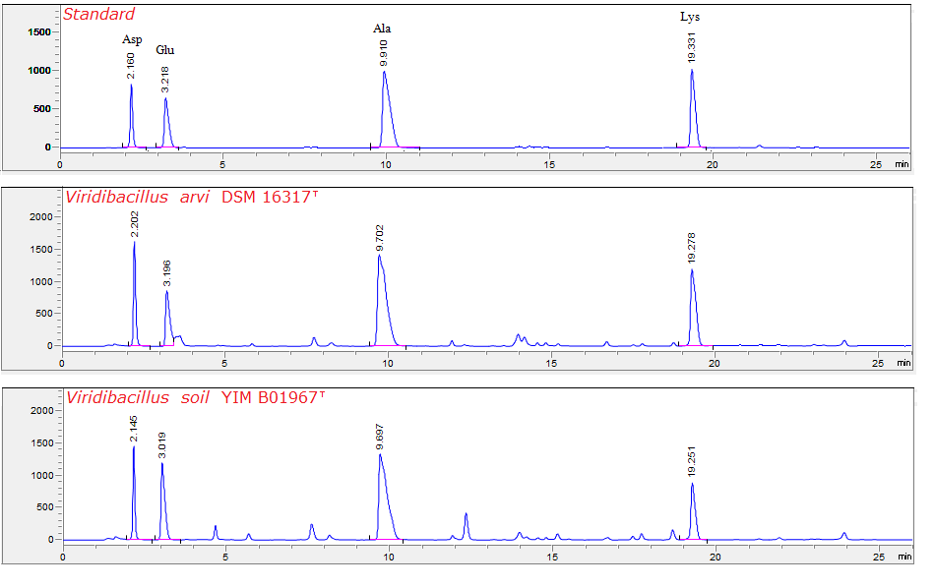
Fig S4 HPLC analysis of cell wall amino acids and peptidoglycan of strain YIM B01967^{T} and reference strain Viridibacillus arvi DSM 16317^{T}. Standard: HPLC analysis results of amino acid standards; Viridibacillus arvi DSM 16317^{T}: HPLC analysis results of cell wall amino acids and peptidoglycan of reference strain Viridibacillus arvi DSM 16317^{T}; Viridibacillus soil YIM B01967^{T} HPLC analysis results of cell wall amino acids and peptidoglycan of strain YIM B01967^{T}.

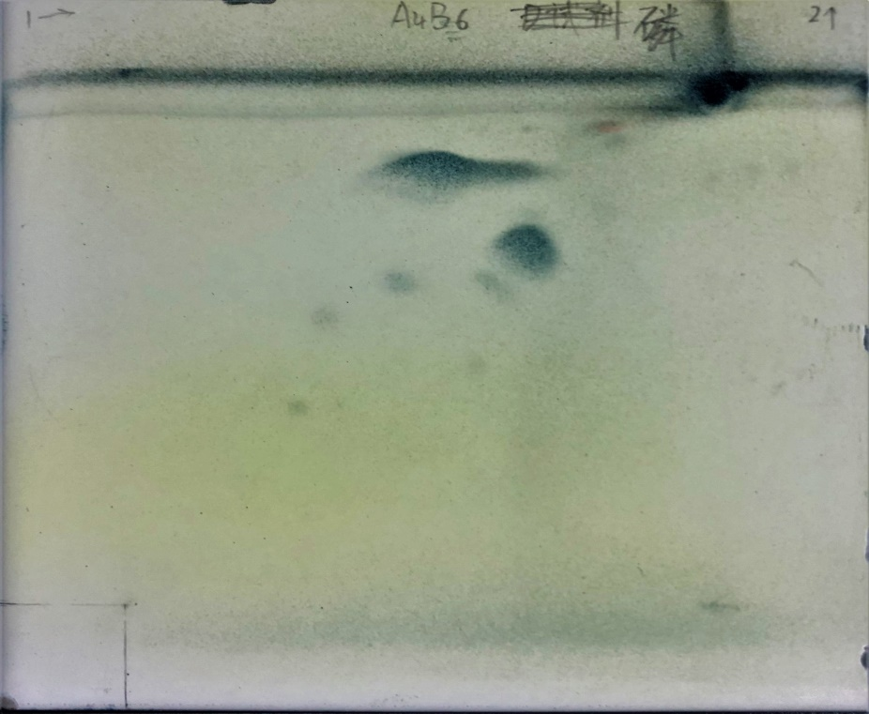
DPG
PME
PE
PG
PL1
PL2

Fig S5 Polar lipid profile of strain YIM B01967^{T} by two-dimensional TLC. The spray reagent is molybdatophosphoric acid. DPG, Diphosphatidylglycerol; PME, Phosphatidylmethylethanolamine; PG, Phosphatidylglycerol; PE, Phospdhatidylethanolamine and two unidentified phospholipids (PL1, PL2).

