S1: Xi’an Center for Disease Control and Prevention Ethical Review Application Form (Approved No: 2025012)
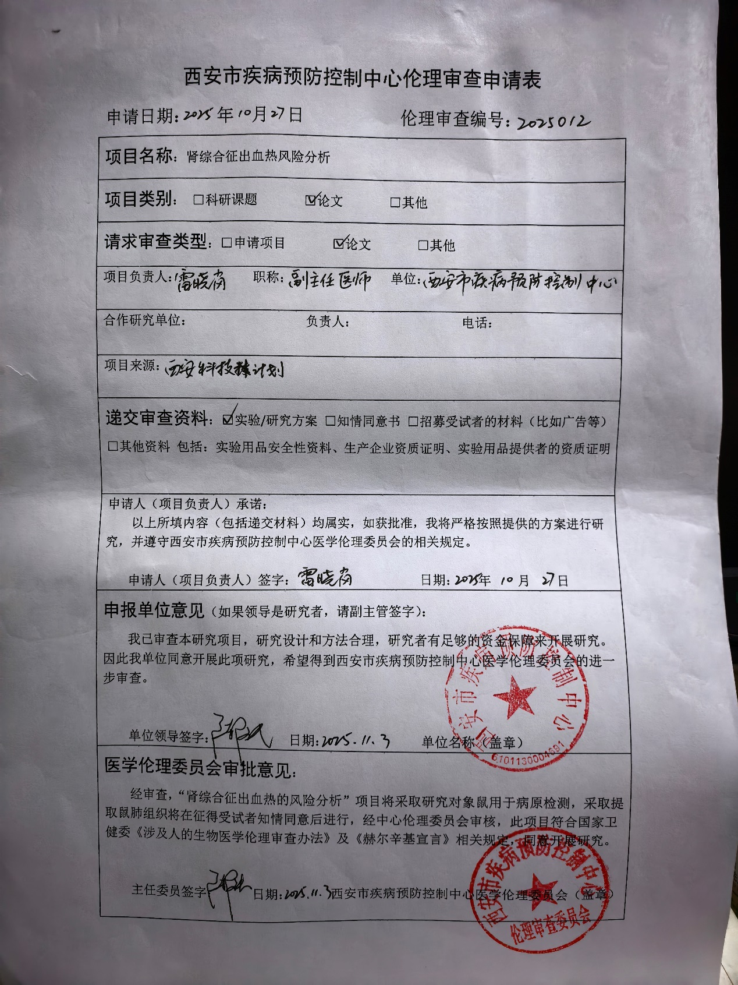

S1: English Copy of Ethical Review Application Table (Approved No: 2025012)

