Engineering of Komagataella phaffii for efficient secretory expression of highly hydrophilic recombinant type III human-like collagen
Wanting Wu¹, Junhao Yue¹, Yixuan Jia¹, Chuang Xing¹, Yu Deng², Changjiang Lyu^{1,3*}
¹ School of Biological and Chemical Engineering, Zhejiang University of Science and Technology, Hangzhou 310023, China
² School of Biotechnology, Jiangnan University, Wuxi 214122, China
³ Hangzhou Xizi Biotech Co., Ltd., Hangzhou 310030, China
* Corresponding author: yangtzelv@zju.edu.cn
Section: Bioprocessing and Bioengineering

Fig. S1 SDS-PAGE analysis of fermentation supernatants from recombinant K. phaffii strains expressing human-like type III collagen (HLCOl3). Lane M: Protein marker; Lanes 2–7: Culture supernatants from independent transformants. A distinct band at approximately 120 kDa is observed in all samples, corresponding to the expected molecular weight of HLCol3 under denaturing conditions. The anomalous migration of highly hydrophilic collagenous proteins results in a higher apparent molecular mass than predicted.
Fig. S2 Deconvoluted mass spectrum of recombinant human-like type III collagen (HLCOl3). The single peak at 55,019.04 Da corresponds to the monomeric protein and matches its theoretical molecular mass, confirming high purity and structural homogeneity.
Fig. S3 Morphology of L929 cells exposed to HLCOl3 extracts at 100%, 50%, 25%, and 12.5% concentrations. All treated groups displayed normal growth and morphology comparable to the untreated and negative controls. The positive control showed severe cell death, validating assay responsiveness. All samples scored cytotoxicity grade 0, confirming excellent biocompatibility.
Table S1 qPCR reaction program.
Table S2 Primer sequences used for qPCR.

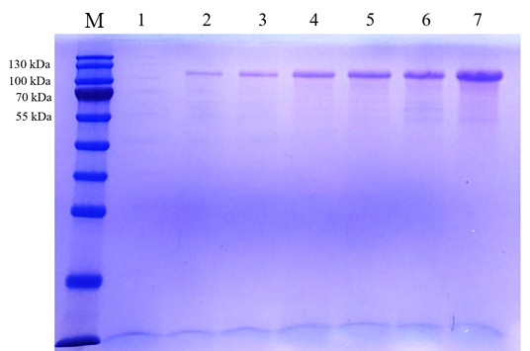
Fig. S1 SDS-PAGE analysis of fermentation supernatants from recombinant K. phaffii strains expressing human-like type III collagen (HLCOl3). Lane M: Protein marker; Lanes 2–7: Culture supernatants from independent transformants. A distinct band at approximately 120 kDa is observed in all samples, corresponding to the expected molecular weight of HLCol3 under denaturing conditions. The anomalous migration of highly hydrophilic collagenous proteins results in a higher apparent molecular mass than predicted.

Fig. S2 Deconvoluted mass spectrum of recombinant human-like type III collagen (HLCOl3). The single peak at 55,019.04 Da corresponds to the monomeric protein and matches its theoretical molecular mass, confirming high purity and structural homogeneity.
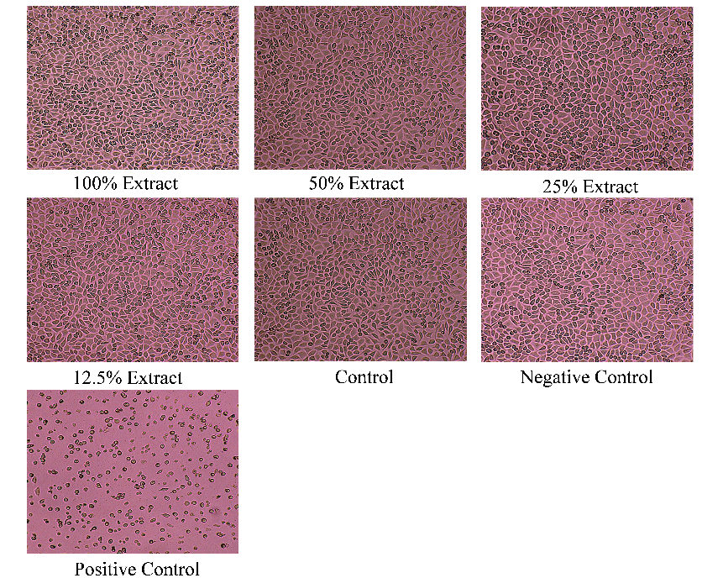
Fig. S3 Morphology of L929 cells exposed to HLCOl3 extracts at 100%, 50%, 25%, and 12.5% concentrations. All treated groups displayed normal growth and morphology comparable to the untreated and negative controls. The positive control showed severe cell death, validating assay responsiveness. All samples scored cytotoxicity grade 0, confirming excellent biocompatibility.

Table S1 qPCR reaction program
Step | Temperature(℃) | Time | Cycles
1 | 95 | 4 min | 1
2 | 95 | 15 s | 40
3 | 60 | 30 s | 40
4 | 95 | 15 s | 1
5 | 60 | 1 min | 1
6 | 37 | 1 min | 1

Table S2 Primer sequences used for qPCR
Gene | Forward (5′→3′) | Reverse (5′→3′)
KRT1 | ATCAACTACCAGCGCAGGAC | GTTGGTCCACTCTCCTTCGG
KRT5 | GTCTTGCCGGAGGTAGCAG | AAGAGGCAATCTCCATGGGC
KRT10 | GACAAAGTTCGGGCTCTGGA | CCCCTGATGTGAGTTGCCAT
KRT14 | CCAGTTCTCCTCTGGATCGC | TCCAGTGGGATCTGTGTCCA
TNF-α | TTGGCGTTTGAGTCAGCAAA | CATGGAGTGGGCCATAGCTT
IL-1β | AACCTCTTCGAGGCACAAGG | AGATTCGTAGCTGGATGCCG
IVL-1 | CAGGCCAGGTCCAAGACATT | GGATTGGGGTCATTGGGGTT
LOR | GTGAGCTCAGACTTGGTGCT | CAAGGGCCCAGATGTCCAAT
FLG | ATCTGAGGGCACTGAAAGGC | CACTTCCGTGCTGAGAGTGT
COL1A1 | TCCCAGGGTGGCTTCTGATA | GAGTCGGGGACACTTACAGC
COL3A1 | CACGTCTACATTAAGGAACTCCA | GTCCAGTATGTCCCACAGGG
TIMP1 | TTGGCTGTGAGGAATGCACA | GTCCACAAGCAATGAGTGCC

