SUPPLEMENTARY MATERIAL
S1 Specific Modifications to the Frailty Criteria
Modified Fried’s Frailty Criteria (Fried et al., 2001) | Modifications from the Positive Brain Health Now dataset | Responses
Self-reported exhaustion | “How much of the time during the past 4 weeks did you feel worn out?” | "None of the Time"; "A little of the time"; "Some of the time"; "A Good Bit of the Time"; "Most of the time"; "All of the time"
Low physical activity (< 150 m/week) | What best describes your physical activity level in the past 6 months? | "Vigorously active for at least 30 minutes, 3 times per week"; "Moderately active at least 3 times per week"; "Seldom active, preferring sedentary activities"
Weakness (measured by grip strength) | “Does your health now limit you in lifting and carrying groceries?” | "No, not limited at all"; "Yes, limited a little"; "Yes, limited a lot"
Slowness (measured by the gait speed test “ | “Does your health now limit you in walking several blocks?” | "No, not limited at all"; "Yes, limited a little"; "Yes, limited a lot"
Unintentional weight loss ([(> 4.5 kg or 10lbs in past year]) | Body mass index (BMI) | "Normal", "Underweight", "Overweight", "Obese"

S2 Standardized Factor Loadings from the Two-Factor CFA Model
Domain | Indicator | β | SE | p-value | R²
Cognitive Difficulty
 | Attention | 0.903 | 0 | - | 0.815
 | Retrospective Memory | 0.888 | 0.024 | 0 | 0.789
 | Prospective Memory | 0.859 | 0.026 | 0 | 0.737
 | Planning | 0.859 | 0.025 | 0 | 0.737
Physical Frailty
 | Exhaustion | 0.671 | 0 | - | 0.45
 | Gait Speed | 0.430 | 0.064 | 0 | 0.24
 | Grip Strength | 0.492 | 0.083 | 0 | 0.26
 | Physical activity | 0.511 | 0.08 | 0 | 0.18
Note. β = standardized factor loading; SE = standard error; R² = proportion of variance explained. Reference indicators (first per factor) have SE and p-value fixed for identification.
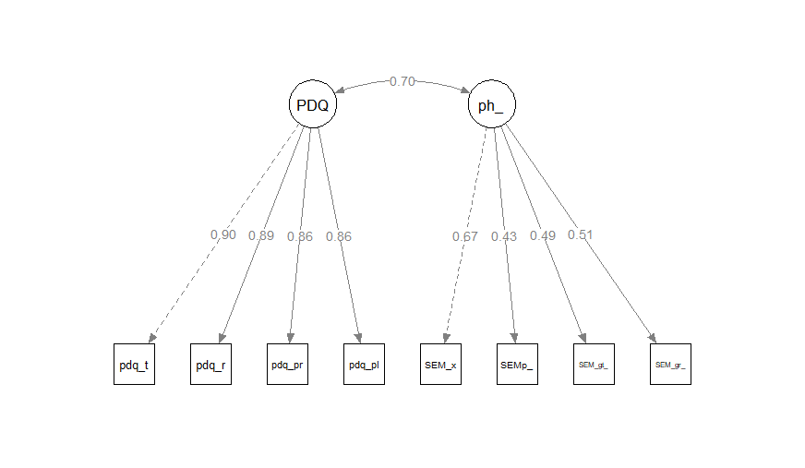
Figure S2: Two-factor CFA of cognitive difficulty (PDQ) and physical frailty: standardized loadings and factor correlation

Abbreviation: PDQ = Perceived Deficits Questionnaire (cognitive difficulty latent factor); ph_ = physical frailty latent factor; pdq_t = PDQ Attention; pdq_r = PDQ Retrospective Memory; pdq_pr = PDQ Prospective Memory; pdq_pl = PDQ Planning or Organization; SEM_x = self-reported Exhaustion; SEMp_ = Physical Activity; SEM_gt = gait speed limitation; SEM_gr = grip strength limitation.
S3 Standardized Factor Loadings from the Two-Factor ESEM Model
Indicator | Cognitive factor | Physical factor | R²
PDQ Attention | 0.9*** |  | 0.81
PDQ Retrospective memory | 0.881*** |  | 0.777
PDQ Prospective memory | 0.851*** |  | 0.724
PDQ Planning/organization | 0.855*** |  | 0.731
Exhaustion | 0.455*** | 0.131 | 0.271
Physical activity |  | 0.401*** | 0.16
Gait speed |  | 0.72*** | 0.518
Grip strength |  | 0.695*** | 0.483

Note : PDQ = Perceived Deficit Questionnaire ; R² = proportion of variance explained; *** p < .001.

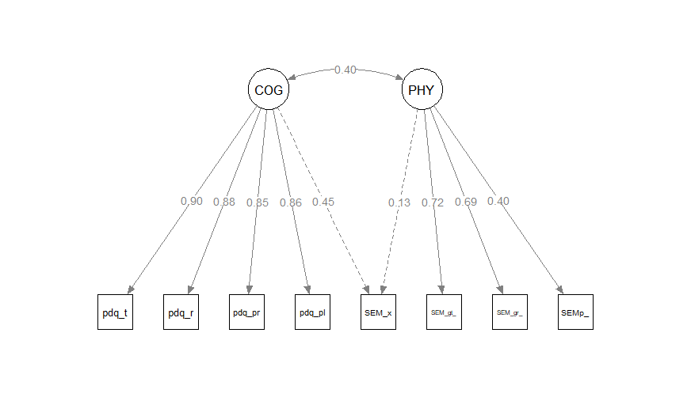
Figure S3: Two-Factor ESEM of cognitive difficulty (PDQ) and physical frailty: standardized loadings and factor correlation.
Abbreviation:COG = Cognitive difficulty latent factor; PHY = physical frailty latent factor; pdq_t = PDQ Attention; pdq_r = PDQ Retrospective Memory; pdq_pr = PDQ Prospective Memory; pdq_pl = PDQ Planning or Organization; SEM_x = self-reported Exhaustion; SEMp_ = Physical Activity; SEM_gt = gait speed limitation; SEM_gr = grip strength limitation.

S4 Standardized Factor Loadings from the Bifactor-CFA Model
Indicator | General (G) | Cognitive factor (COG) | Physical factor (PHYS) | R²
PDQ Attention | 0.864 | 0.233 |  | 0.800
PDQ Retrospective memory | 0.770 | 0.598 |  | 0.950
PDQ Prospective memory | 0.787 | 0.312 |  | 0.717
PDQ Planning/organization | 0.904 | 0.064# |  | 0.822
Exhaustion | 0.614 |  | 0.133 | 0.395
Physical activity | 0.283 |  | 0.296 | 0.167
Gait speed | 0.238 |  | 0.773 | 0.653
Grip strength | 0.276 |  | 0.583 | 0.417
Note. G = general reversible cognitive frailty factor; target specific factor loadings shown in bold. All loadings p < .01 except #Planning on Cognitive-Specific factor (p = 0.29).

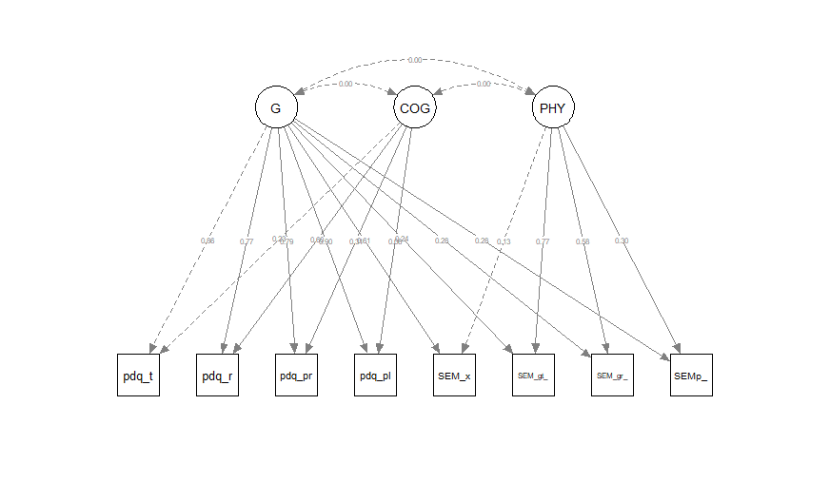
Figure S4: Bifactor-CFA of general cognitive frailty, cognitive difficulty (PDQ), physical frailty: standardized loadings and factor correlation.
Abbreviation:COG = Cognitive difficulty latent factor; PHY = physical frailty latent factor; G = General cognitive frailty factor; pdq_t = PDQ Attention; pdq_r = PDQ Retrospective Memory; pdq_pr = PDQ Prospective Memory; pdq_pl = PDQ Planning or Organization; SEM_x = self-reported Exhaustion; SEMp_ = Physical Activity; SEM_gt = gait speed limitation; SEM_gr = grip strength limitation.

S5 Regression Models Predicting Adjusted Health-Related Quality of Life from Bifactor-ESEM Factors
Outcome | Model | R² | Adj. R² | F statistic
Mental Health (MCS_adjusted)
 | General Only | 0.512 | 0.51 | F(3, 820) = 286.31
 | Specific Only | 0.122 | 0.118 | F(4, 819) = 28.57
 | Combined | 0.53 | 0.527 | F(5, 818) = 184.58
Physical Health (PCS_adjusted)
 | General Only | 0.388 | 0.386 | F(3, 820) = 173.26
 | Specific Only | 0.179 | 0.175 | F(4, 819) = 44.50
 | Combined | 0.478 | 0.474 | F(5, 818) = 149.52
Note. Adjusted composites exclude overlapping RAND-36 subscales (see Methods). All models control for age and sex.

S6 Combined Model Unstandardized Regression Coefficients Predicting Adjusted Health-Related Quality of Life Composites
Outcome | Predictor | b | SE | p
Mental Health (MCS_adjusted)
 | (Intercept) | 36.399 | 1.947 | < .001
 | General_Factor | −9.583 | 0.342 | < .001
 | Cognitive_Specific | −1.833 | 0.333 | < .001
 | Physical_Specific | 0.796 | 0.363 | 0.028
 | Age | 0.148 | 0.036 | < .001
 | Sex (Male) | −1.075 | 0.81 | 0.185
Physical Health (PCS_adjusted)
 | (Intercept) | 48.006 | 1.5 | < .001
 | General_Factor | −6.937 | 0.263 | < .001
 | Cognitive_Specific | −0.771 | 0.256 | 0.003
 | Physical_Specific | −5.822 | 0.279 | < .001
 | Age | −0.063 | 0.028 | 0.021
 | Sex (Male) | 0.035 | 0.624 | 0.956
Note. b = unstandardized regression coefficient; SE = standard error

S7 PLS-SEM Path Coefficients for Hierarchical and Additive Models
Model | Path | β | SE | 95% CI
Hierarchical Model | CogDys → CogF | 0.72 | 0.01 | [0.70, 0.74]
 | PhysF → CogF | 0.39 | 0.01 | [0.37, 0.41]
 | CogF → HRQoL | −0.75 | 0.02 | [−0.78, −0.72]
Additive Model
 | CogDys → HRQoL | −0.36 | 0.03 | [−0.40, −0.31]
 | PhysF → HRQoL | −0.51 | 0.02 | [−0.55, −0.46]
Note. CogDys = self-reported cognitive difficulty (reflective); PhysF = physical frailty (formative); CogF = higher-order reversible cognitive frailty construct; HRQoL = health-related quality of life (adjusted composites). β = standardized path coefficient; SE = bootstrap standard error (5,000 resamples); CI = confidence interval.

S8 Variance Explained in Health-Related Quality of Life: PLS-SEM Models
Model | R² for HRQoL
Hierarchical (CogF → HRQoL) | 0.561
Additive (CogDys + PhysF → HRQoL) | 0.389

Note. HRQoL defined by adjusted mental and physical health composites. CogDys = self-reported cognitive difficulty (reflective); PhysF = physical frailty (formative); CogF = higher-order reversible cognitive frailty construct; HRQoL = health-related quality of life (adjusted composites).

