Fig. S1 Integrative analysis of CD45- SVF cells from BAT
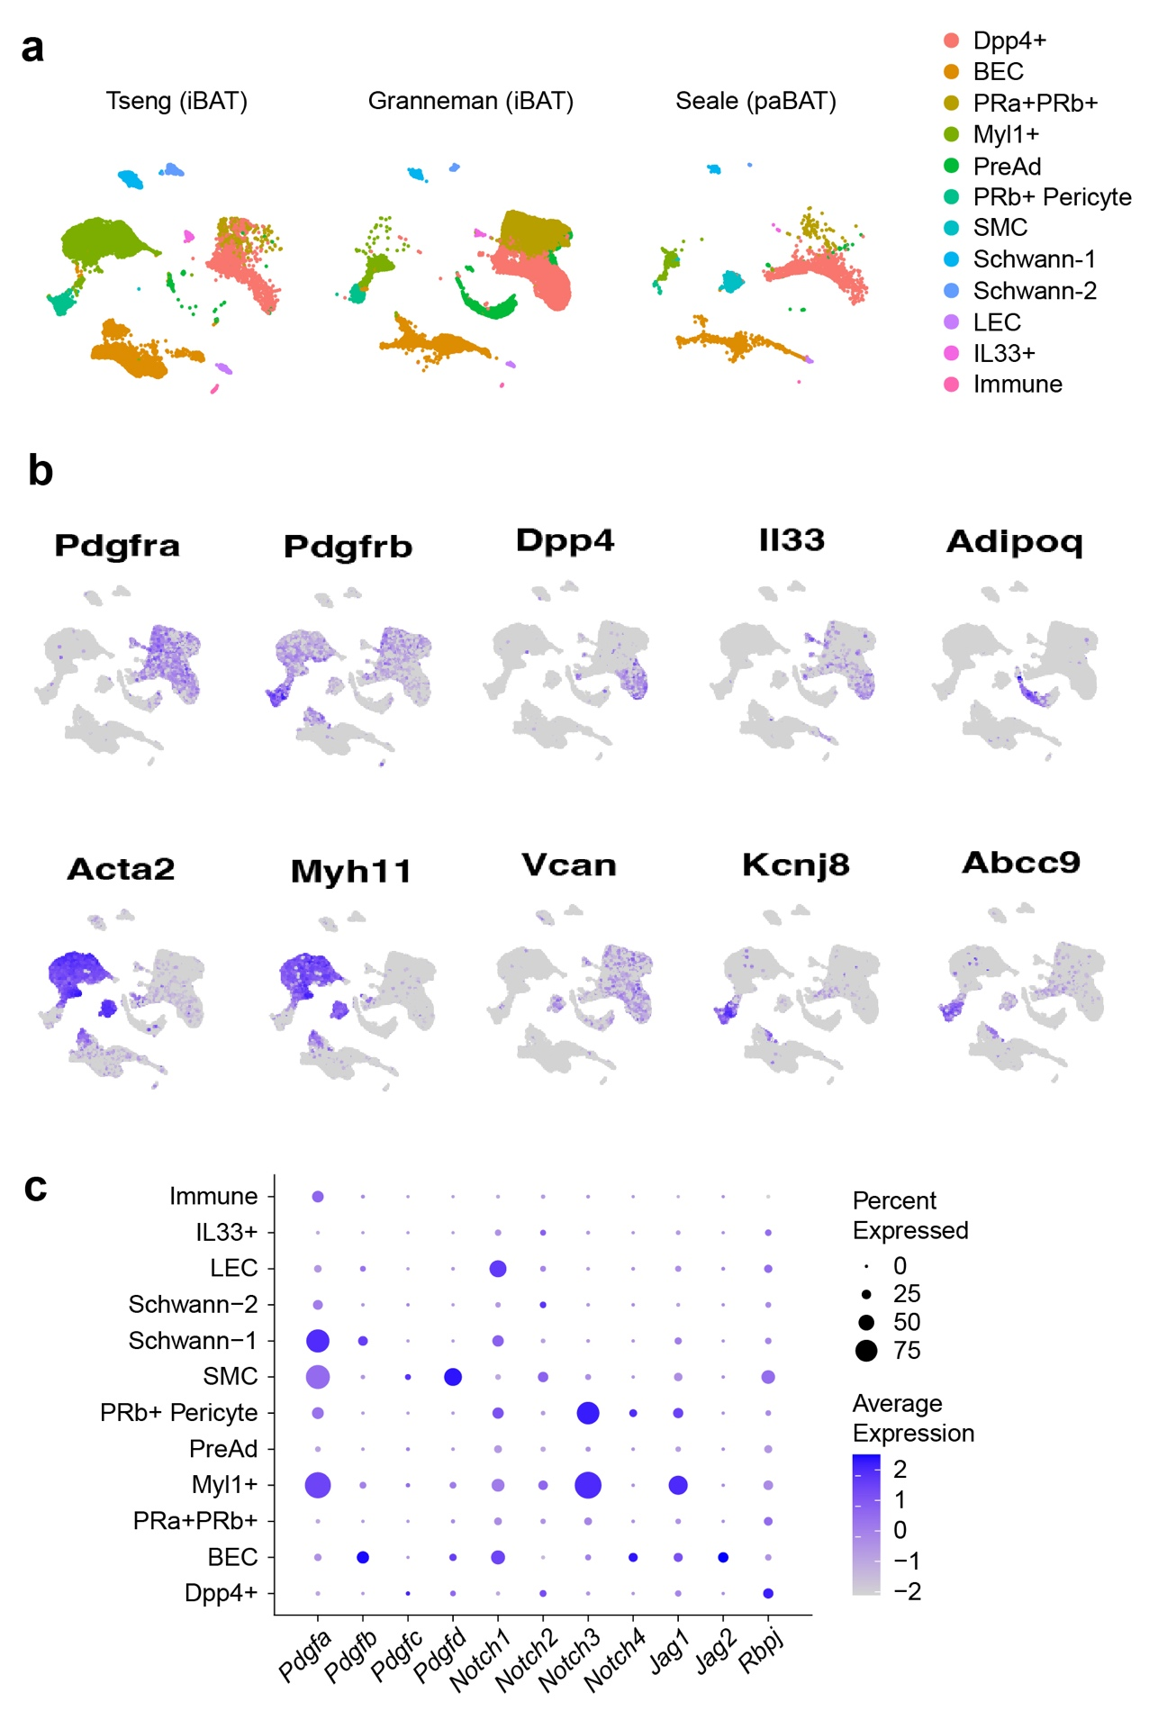
a, The distribution of SVF populations across three studies by Granneman, Tseng, and Seale groups. b, UMAP plots showing gene expression at single-cell level. c, Dot plot for the expression of selected niche factors that inhibit adipogenesis from Pdgfra⁺ APCs.
Fig. S2 Absence of Myl1⁺ APCs in WAT
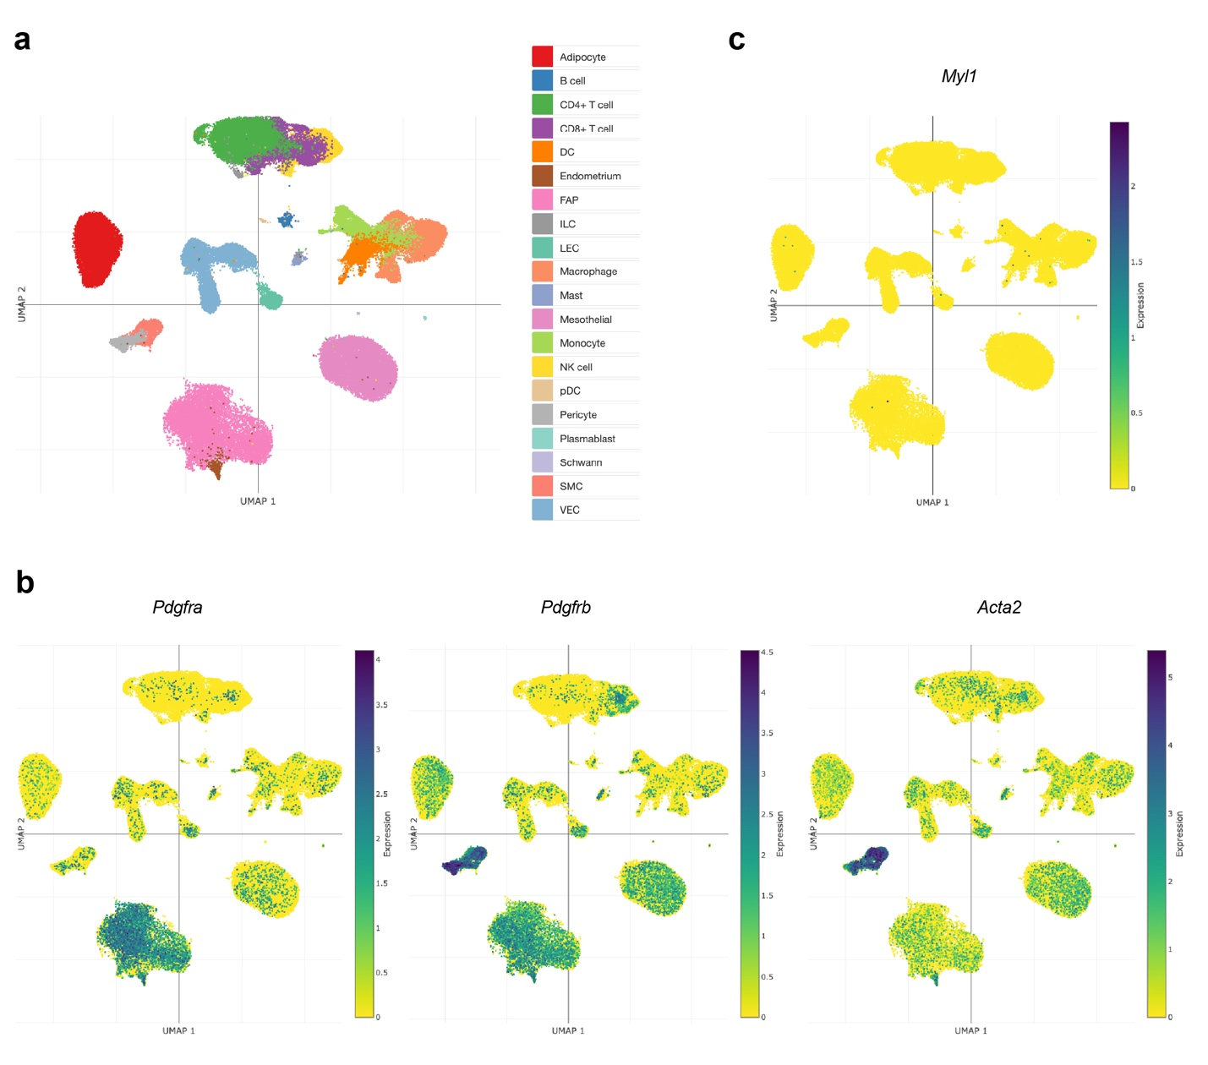
a, Cell populations identified by an integrated scRNA-seq and snRNA-seq WAT atlas (WATLAS), accessed at https://singlecell.broadinstitute.org/single_cell/study/SCP2289/an-integrated-single-cell-and-single-nucleus-rna-seq-white-adipose-tissue-atlas-watlas#study-visualize. b, c, UMAP plots of Pdgfra, Pdgfrb, Acta2 (b) and Myl1 (c) expression.

Fig. S3 Myl1 expression and lineage tracing.
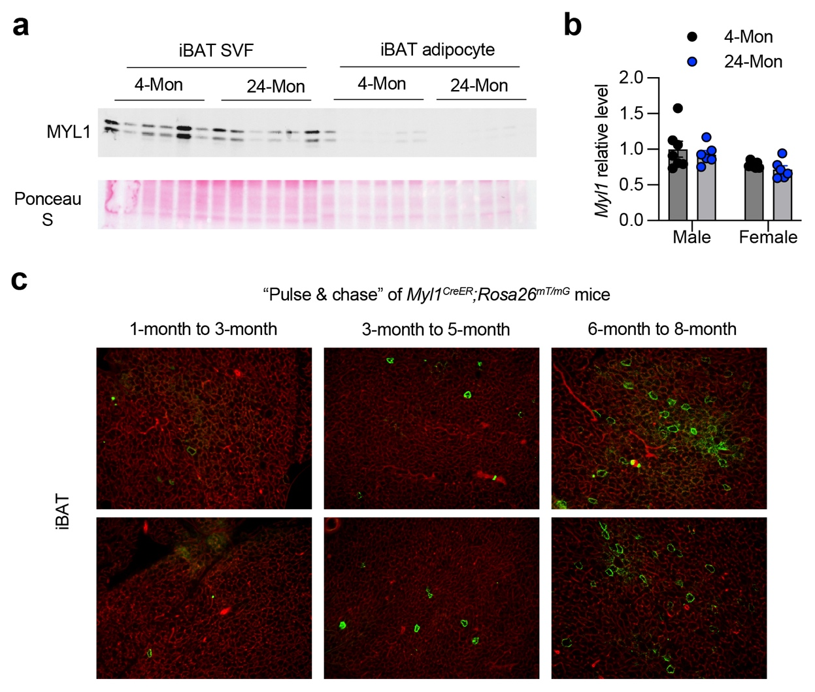
a, SVF and mature adipocytes were isolated from iBAT of 4- and 24-month-old male mice. Protein was extracted for Western blotting with anti-MYL1 antibody. b, Total iBAT from 4- and 24-month-old mice was collected for RNA extraction and RT-qPCR for Myl1 gene expression. c, Representative fluorescent images of iBAT frozen section from Myl1^{CreERT2}Rosa26^{mT/mG} mice pulsed at 1-, 3-, or 6-month of age and chased for 6-8 weeks. mGFP, green; mTdTomato, red

Fig. S4 Body and tissue weight of Myl1^{Cre}Adipoq^{iDTR} mice
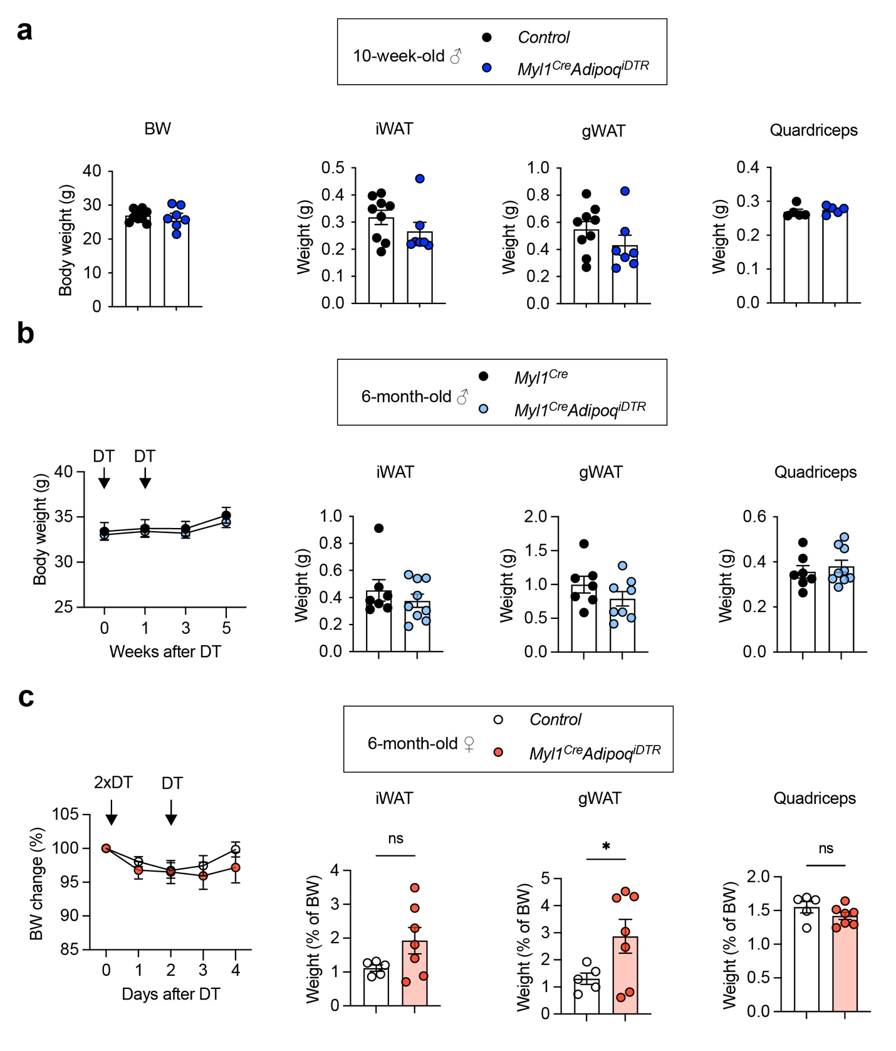
a-c, 10-week-old male (a), 6-month-old male (b), and 6-month-old female (c) Myl1^{Cre}Adipoq^{iDTR} mice were treated as described in text and Fig. 5. Body mass and weights of iWAT, gWAT, and quadriceps were measured. Data are mean ± SEM. P values were calculated by a two-tailed unpaired Student’s t-test. *P < 0.05, ns, not significant.
Fig. S5 Ribosomal RNA-seq of RiboTag^{Myl1-Cre} and RiboTag^{Ucp1-Cre} BAT
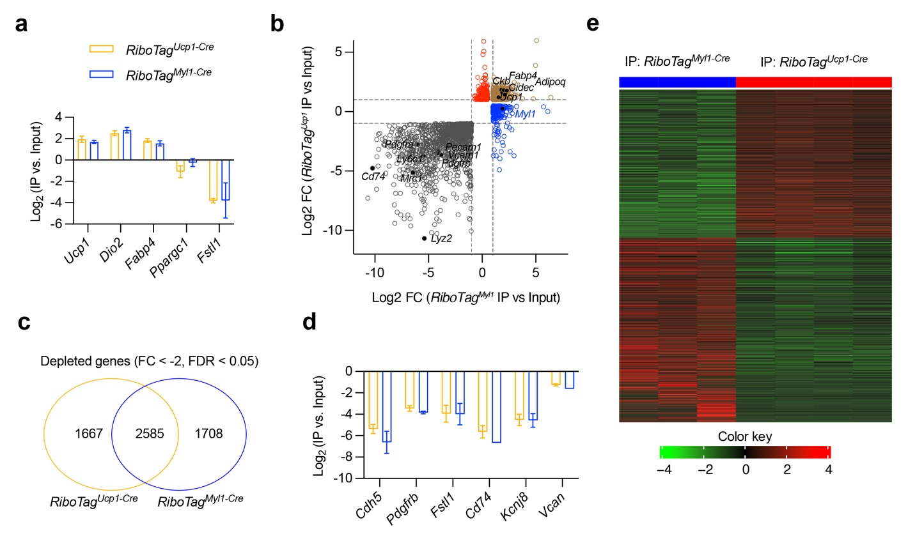
a, RT-qPCR quantification of relative expression (log2FC) of selected genes in ribosomal IP normalized to input, demonstrating the efficient enrichment of adipocyte ribosomes. b, 4-way plot for genes enriched in RiboTag^{Myl1-Cre} ribosomes (blue), RiboTag^{Ucp1-Cre} ribosomes (red), commonly enriched (tan), and commonly depleted (grey). c, Venn diagram showing numbers of significantly depleted genes in RiboTag^{Myl1-Cre} and RiboTag^{Ucp1-Cre} BAT. d, Depletion of selected stromal genes in ribosomal IP compared to total input. e, Heatmap of differentially expressed genes between RiboTag^{Myl1-Cre} and RiboTag^{Ucp1-Cre} ribosomes. Data are mean ± SEM. P values were calculated by a two-tailed unpaired Student’s t-test.

Fig. S6 Re-analysis of publicly available BAT snRNA-seq data
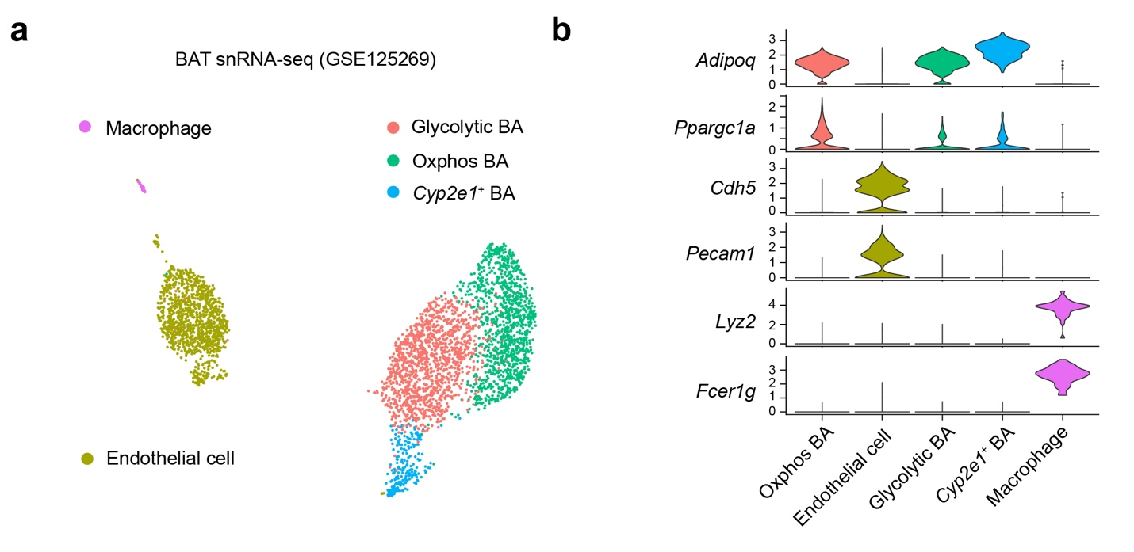
a, UMAP plot of cell populations identified from GSE125269. b, Violin plot of mark genes for adipocytes, endothelial cells, and macrophages.
Fig. S7 Characterization of old female Pparg^{ΔMyl1} mice
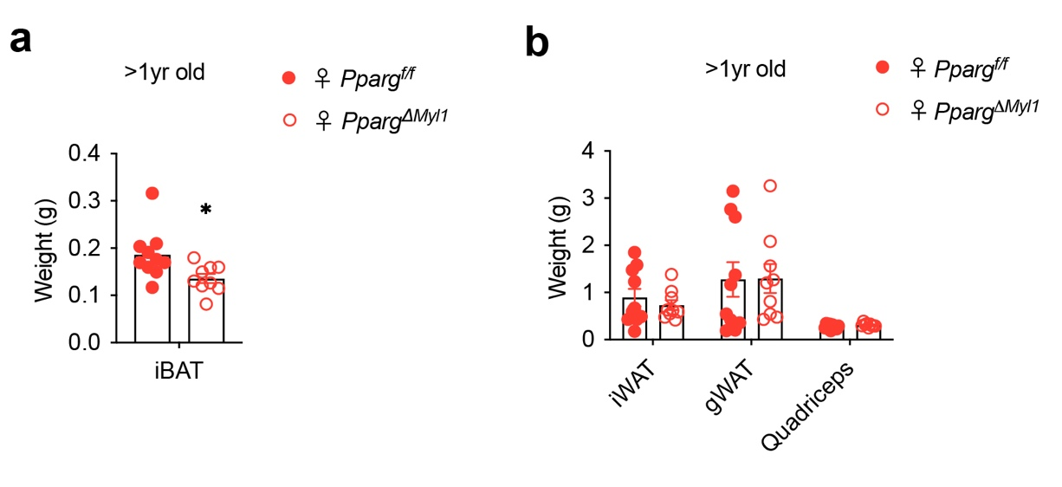
a, Body weight of 11-18 months old Pparg^{f/f} and Pparg^{ΔMyl1} female mice (n = 9-10). b, Weight of iWAT, gWAT, and quadriceps of 11-18-month-old Pparg^{f/f} and Pparg^{ΔMyl1} female mice (n = 9-10). Data are mean ± SEM. P values were calculated by a two-tailed unpaired Student’s t-test. *P < 0.05.

