Supplementary Information

Table S1 Definitions and units of the 43 environmental covariates used in this study, with summary statistics of the observed values from 910,112 sample plots.
Variable |  | Definition | Unit | Mean | Std. | Source
Stand Structure
D | Diameter-at-breast height |  | cm | 16.66 | 12.49 | Ground-measured
N | The total number of live trees per hectare |  | trees·ha⁻¹ | 473.32 | 417.53 | Ground-measured
B | Basal area, total cross-sectional area of live trees measured at 1.3-m above ground |  | m²·ha⁻¹ | 87.79 | 102.89 | Ground-measured
S₁ | Structural diversity in Shannon’s index |  | unitless | 1.14 | 0.57 | Ground-measured
S₂ | Structural diversity in Simpson’s index |  | unitless | 0.39 | 0.24 | Ground-measured
Bioclimate Conditions
C₁ | Annual mean temperature |  | 0.1°C | 91.24 | 61.16 | WorldClim v.1¹
C₂ | Mean diurnal range |  | 0.1°C | 111.48 | 25.11 | WorldClim v.1
C₃ | Isothermality, the ratio of the mean diurnal temperature range to the annual range, multiply by 100 |  | unitless | 34.01 | 10.38 | WorldClim v.1
C₄ | Temperature seasonality |  | 0.01sd | 7879.67 | 2530.88 | WorldClim v.1
C₅ | Max temperature of warmest month |  | 0.1°C | 261.38 | 46.26 | WorldClim v.1
C₆ | Min temperature of coldest month |  | 0.1°C | -75.45 | 94.15 | WorldClim v.1
C₇ | Temperature annual range |  | 0.1°C | 336.83 | 80.45 | WorldClim v.1
C₈ | Mean temperature of wettest quarter |  | 0.1°C | 141.71 | 72.70 | WorldClim v.1
C₉ | Mean temperature of driest quarter |  | 0.1°C | 47.62 | 113.78 | WorldClim v.1
C₁₀ | Mean temperature of warmest quarter |  | 0.1°C | 189.18 | 43.90 | WorldClim v.1
C₁₁ | Mean temperature of coldest quarter |  | 0.1°C | -13.49 | 89.80 | WorldClim v.1
C₁₂ | Annual Precipitation |  | mm | 960.98 | 360.37 | WorldClim v.1
C₁₃ | Precipitation of wettest month |  | mm | 122.76 | 58.55 | WorldClim v.1
C₁₄ | Precipitation of driest month |  | mm | 46.89 | 25.95 | WorldClim v.1
C₁₅ | Precipitation seasonality |  | unitless | 31.90 | 22.50 | WorldClim v.1
C₁₆ | Precipitation of wettest quarter |  | mm | 338.03 | 153.87 | WorldClim v.1
C₁₇ | Precipitation of driest quarter |  | mm | 158.74 | 82.48 | WorldClim v.1
C₁₈ | Precipitation of warmest quarter |  | mm | 280.42 | 118.27 | WorldClim v.1
C₁₉ | Precipitation of coldest quarter |  | mm | 208.62 | 130.31 | WorldClim v.1
C₂₀ | Indexed annual aridity |  | unitless | 10777.8 | 5251.95 | CGIAR-CSI
C₂₁ | Global potential evapotranspiration |  | mm·yr⁻¹ | 964.21 | 317.44 | CGIAR-CSI²
Topography
I | Plot elevation |  | m | 15.06 | 16.42 | G/SRTM³
T₁ | Aspect Cosine |  | unitless | -1.91 | 137.40 | EarthEnv⁴
T₂ | Aspect Sine |  | unitless | -1.89 | 137.40 | EarthEnv
T₃ | First order partial derivative (E-W slope) |  | unitless | 0.00 | 0.07 | EarthEnv
T₄ | Second order partial derivative (E-W slope) |  | unitless | 0.00 | 0.00 | EarthEnv
T₅ | First order partial derivative (N-S slope) |  | unitless | 0.00 | 0.07 | EarthEnv
T₆ | Second order partial derivative (N-S slope) |  | unitless | 0.00 | 0.00 | EarthEnv
T₇ | Profile curvature |  | unitless | 0.00 | 0.00 | EarthEnv
T₈ | Roughness |  | unitless | 46.36 | 51.31 | EarthEnv
T₉ | Slope |  | degree | 3.93 | 4.47 | EarthEnv
T₁₀ | Tangential curvature |  | unitless | 0.00 | 0.00 | EarthEnv
T₁₁ | Topographic Position Index |  | unitless | 0.14 | 4.03 | EarthEnv
T₁₂ | Terrain Ruggedness Index |  | unitless | -1.91 | 137.40 | EarthEnv
Soil
O₁ | Bulk density |  | g·cm⁻³ | 1.20 | 0.52 | WISE30sec v.1⁵
O₂ | pH measured in water |  | unitless | 5.81 | 1.19 | WISE30sec v.1
O₃ | Electrical conductivity |  | dS·m⁻¹ | 0.71 | 0.72 | WISE30sec v.1
O₄ | C/N ratio |  | unitless | 13.48 | 3.25 | WISE30sec v.1
O₅ | Total nitrogen |  | g·kg⁻¹ | 2.54 | 3.13 | WISE30sec v.1
Anthropogenic Influences
H₁ | The Human Footprint (HF), a measure of the cumulative impact of direct human pressure on nature |  | unitless | 8.23 | 8.44 | Venter et al.⁶
H₂ | HF change from 1993 to 2009 |  | unitless | -0.61 | 3.27 | Venter et al.⁶
H₃ | Roadless areas |  | km² | 31231.47 | 259363.2 | Ibisch et al.⁷
H₄ | Protected areas |  | km² | 35.8×10⁶ | 136×10⁶ | UNEP-WCMC⁸

Table S2 Summary of datasets used in this study.

Dataset | Origin | Country/Region | Sample size (the number of plots) | References
North, Central, and South America
102 | US2 | Alaska-US | 2,013 | Malone and Liang (2009)⁹
NA82 | CA1 | Canada | 131,358 | Searle & Chen (2017)¹⁰
NA83 | JM1 | Jamaica | 175 | E.V.J. Tanner (1980)¹¹
NA84 | MX1 | Mexico | 1,269 | Unpublished
NA85 | MX2 | Mexico | 172758 | NFI
NA87 | US4 | USA | 2 | Unpublished
NA89 | CA2 | Canada | 360,767 | Ministère des Ressources naturelles et des Forêts (2022)¹²
SA105 | BR1 | Brazil | 6 | Pyle et al. (2008)¹³
SA108 | BR2 | Brazil | 4 | TEAM Network. (2010)¹⁴
SA104 | BR3 | Brazil | 90 | Souza et al. (2021)¹⁵
SA112 | BR4 | Brazil | 8 | Unpublished
SA113 | BR5 | Brazil | 108 | Unpublished
SA114 | NI1 | Nicaragua | 24 | Unpublished
SA115 | AR1 | Argentina | 200 | Unpublished
SA116 | BR6 | Brazil | 18 | Unpublished
SA118 | CR1 | Costa Rica | 148 | Uriarte et al. (2016)¹⁶
SA121 | ForestPlots | Peru | 15 | ForestPlots.net et al. (2021)¹⁷, Lopez-Gonzalez et al. (2011)¹⁸
SA122 | ForestPlots | Bolivia | 22 | ForestPlots.net et al. (2021)¹⁷, Lopez-Gonzalez et al. (2011)¹⁸
SA125 | ForestPlots | Venezuela | 30 | ForestPlots.net et al. (2021)¹⁷, Lopez-Gonzalez et al. (2011)¹⁸
SA124 | ForestPlots | Colombia | 33 | ForestPlots.net et al. (2021)¹⁷, Lopez-Gonzalez et al. (2011)¹⁸
SA126 | BR7 | Brazil | 24 | Unpublished
SA127 | ForestPlots | Guyana | 8 | ForestPlots.net et al. (2021)¹⁷, Lopez-Gonzalez et al. (2011)¹⁸
SA129 | ForestPlots | Peru | 61 | ForestPlots.net et al. (2021)¹⁷, Lopez-Gonzalez et al. (2011)¹⁸
Eurasia
47 | CN1 | China | 66 | Zhu et al. (2019)¹⁹
EU125 | CZ1 | Czech Republic | 32 | Unpublished
EU126 | ES1 | Spain | 3 | Unpublished
EU139 | IT1 | Italy | 3 | Unpublished
EU140 | IT2 | Italy | 1 | Unpublished
EU141 | JP1 | Japan | 4 | Unpublished
EU142 | MY1 | Malaysia | 4 | Unpublished
EU143_1 | MY2 | Malaysia | 109 | Unpublished
EU144 | RS1 | Serbia | 3 | Unpublished
EU147 | RU1 | Russia | 3 | Unpublished
EU152 | RU3 | Russia | 1 | Unpublished
EU154 | RU2 | Russia | 19 | Unpublished
EU157 | JP3 | Japan | 1 | Unpublished
EU158 | JP2 | Japan | 59 | Biodiversity Center of Japan²⁰
EU159 | CN2 | China | 4 | Unpublished
EU160 | LK1 | Sri Lanka | 8 | ForestGEO
EU161 | SK1 | Slovakia | 2,872 | NFI
EU162 | RU5 | Russia | 6 | Unpublished
EU163 | RU4 | Russia | 2 | Moskalyuk & Kuprin (2020)²¹
EU164 | PL2 | Poland | 69,995 | NFI
EU165 | PL1 | Poland | 884 | Unpublished
EU166 | IN2 | India | 50 | Unpublished
EU168 | IT3 | Italy | 12,370 | NFI
EU169 | RU6 | Russia | 47 | Unpublished
EU181 | RU7 | Russia | 6 | Unpublished
EU182 | RU8 | Russia | 2 | Unpublished
EU183 | PL3 | Poland | 3,264 | Unpublished
EU185 | IN1 | India | 243 | Unpublished
EU188 | DK1 | Denmark | 1,594 | NFI
EU193 | PL4 | Poland | 680 | Unpublished
EU194 | KH1 | Cambodia | 40 | Unpublished
CN-NFI | NFI | China | 145,272 | Unpublished
Africa
AF116 | SN1 | Senegal | 36 | Unpublished
AF117 | CG1 | Republic of the Congo | 32 | Unpublished
AF119 | BF1 | Burkina Faso | 40 | Unpublished
AF125 | CI1 | Ivory Coast | 6 | Unpublished
AF126 | CM1 | Cameroon | 48 | Unpublished
AF130 | BJ1 | Benin | 48 | Unpublished
AF131 | TZ1 | Tanzania | 88 | Unpublished
AF133 | ForestPlots | Cameroon | 106 | ForestPlots.net et al. (2021)¹⁷, Lopez-Gonzalez et al. (2011)¹⁸
Oceania
OC85 | PG1 | Papua New Guinea | 9 | Unpublished
OC87 | NZ1 | New Zealand | 2,694 | Wiser et al. (2001)²²
OC89 | AU1 | Australia | 20 | Unpublished
OC90 | TO1 | Tonga | 18 | Franklin (2003)²³
OC91 | AS1 | American Samoa | 4 | Webb et al. (2011)²⁴
OC92 | AU2 | Australia | 175 | Unpublished

Table S3 | Linear model of residual annual ΔAGB as a function of plot design and ecozone
Model: Residual ΔAGB ~ log(Plot Area) + Minimum DBH + Ecozone (GEZ), n = 626,624 plots
Predictor | Estimate  (Mg C ha⁻¹ yr⁻¹) | Std. Error | t value | p value | Significance
Intercept | −0.215 | 0.205 | −1.05 | 0.295 | n.s.
log(Plot Area) (ha) | −0.121 | 0.006 | −18.56 | < 2×10⁻¹⁶ | ***
Minimum DBH (cm) | 0.0106 | 0.0011 | 9.82 | < 2×10⁻¹⁶ | ***
GEZ
AF_12 | −0.362 | 0.366 | −0.99 | 0.323 | n.s.
AF_13 | −0.384 | 0.376 | −1.02 | 0.306 | n.s.
AF_14 | −0.100 | 0.771 | −0.13 | 0.896 | n.s.
AF_16 | −2.825 | 0.657 | −4.30 | 1.7×10⁻⁵ | ***
AF_22 | 0.305 | 0.232 | 1.32 | 0.188 | n.s.
AF_23 | 0.462 | 0.250 | 1.85 | 0.064 | ·
AF_25 | 0.180 | 0.240 | 0.75 | 0.455 | n.s.
EA_11 | 0.461 | 0.246 | 1.88 | 0.060 | ·
EA_13 | −0.686 | 0.285 | −2.41 | 0.016 | *
EA_21 | 1.370 | 0.209 | 6.54 | 6.1×10⁻¹¹ | ***
EA_31 | −0.893 | 0.207 | −4.32 | 1.6×10⁻⁵ | ***
EA_32 | −1.325 | 0.207 | −6.40 | 1.5×10⁻¹⁰ | ***
EA_35 | −1.904 | 0.207 | −9.20 | < 2×10⁻¹⁶ | ***
EA_41 | 0.816 | 0.210 | 3.88 | 1.0×10⁻⁴ | ***
NA_12 | 0.889 | 0.208 | 4.27 | 2.0×10⁻⁵ | ***
NA_13 | 0.768 | 0.210 | 3.66 | 2.5×10⁻⁴ | ***
NA_21 | −0.528 | 0.206 | −2.56 | 0.010 | *
NA_25 | 0.552 | 0.207 | 2.67 | 0.0076 | **
NA_31 | −0.955 | 0.221 | −4.32 | 1.5×10⁻⁵ | ***
OC_21 | 1.904 | 0.216 | 8.80 | < 2×10⁻¹⁶ | ***
OC_23 | 1.479 | 0.328 | 4.52 | 6.3×10⁻⁶ | ***
OC_31 | 1.469 | 0.236 | 6.23 | 4.8×10⁻¹⁰ | ***
OC_35 | 0.888 | 0.229 | 3.89 | 1.0×10⁻⁴ | ***
(Other GEZ levels) |  |  |  |  | n.s.
Model diagnostics |  | Value
Residual standard error |  | 2.57 Mg C ha⁻¹ yr⁻¹
Adjusted R² |  | 0.05
F statistic |  | 607.4
Degrees of freedom |  | 55, 626568

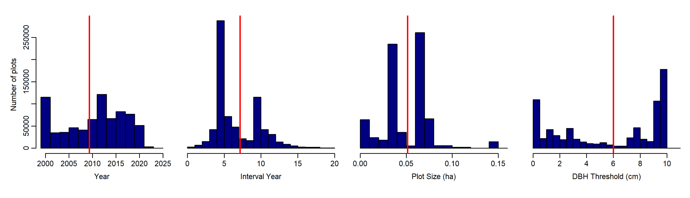
Fig S1 | Histograms of plot-level attributes across 910,112 sample plots. Panels show (from left to right): survey Year, Interval Year, Plot Size (ha), and DBH threshold (cm). Bars indicate the number of plots; all panels share the same y-axis scale. Red vertical lines mark the mean of each distribution. See §2 Data & §4 Time- and Space-Standardization for the standardization of these attributes.

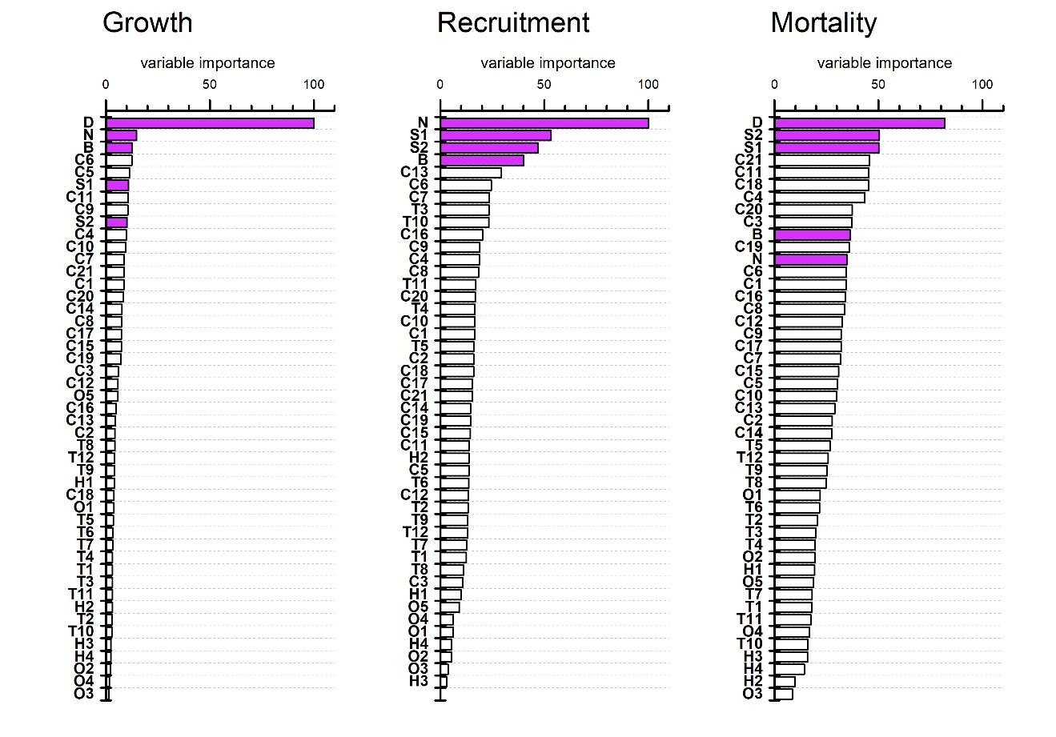
Fig. S2 | Relative importance of predictor variables for explaining demographic components of net forest biomass change. Variable importance was quantified using Random Forest models separately for growth, recruitment, and mortality, and standardized to a 0–100 scale for comparability. Predictors include stand structure, climate, topography, soil, and anthropogenic variables (definitions provided in Table S1). Demographic variables—those describing stand structure such as diameter at breast height (D), density (N), basal area (B), and size diversity (S1 & S2)—are highlighted in purple.

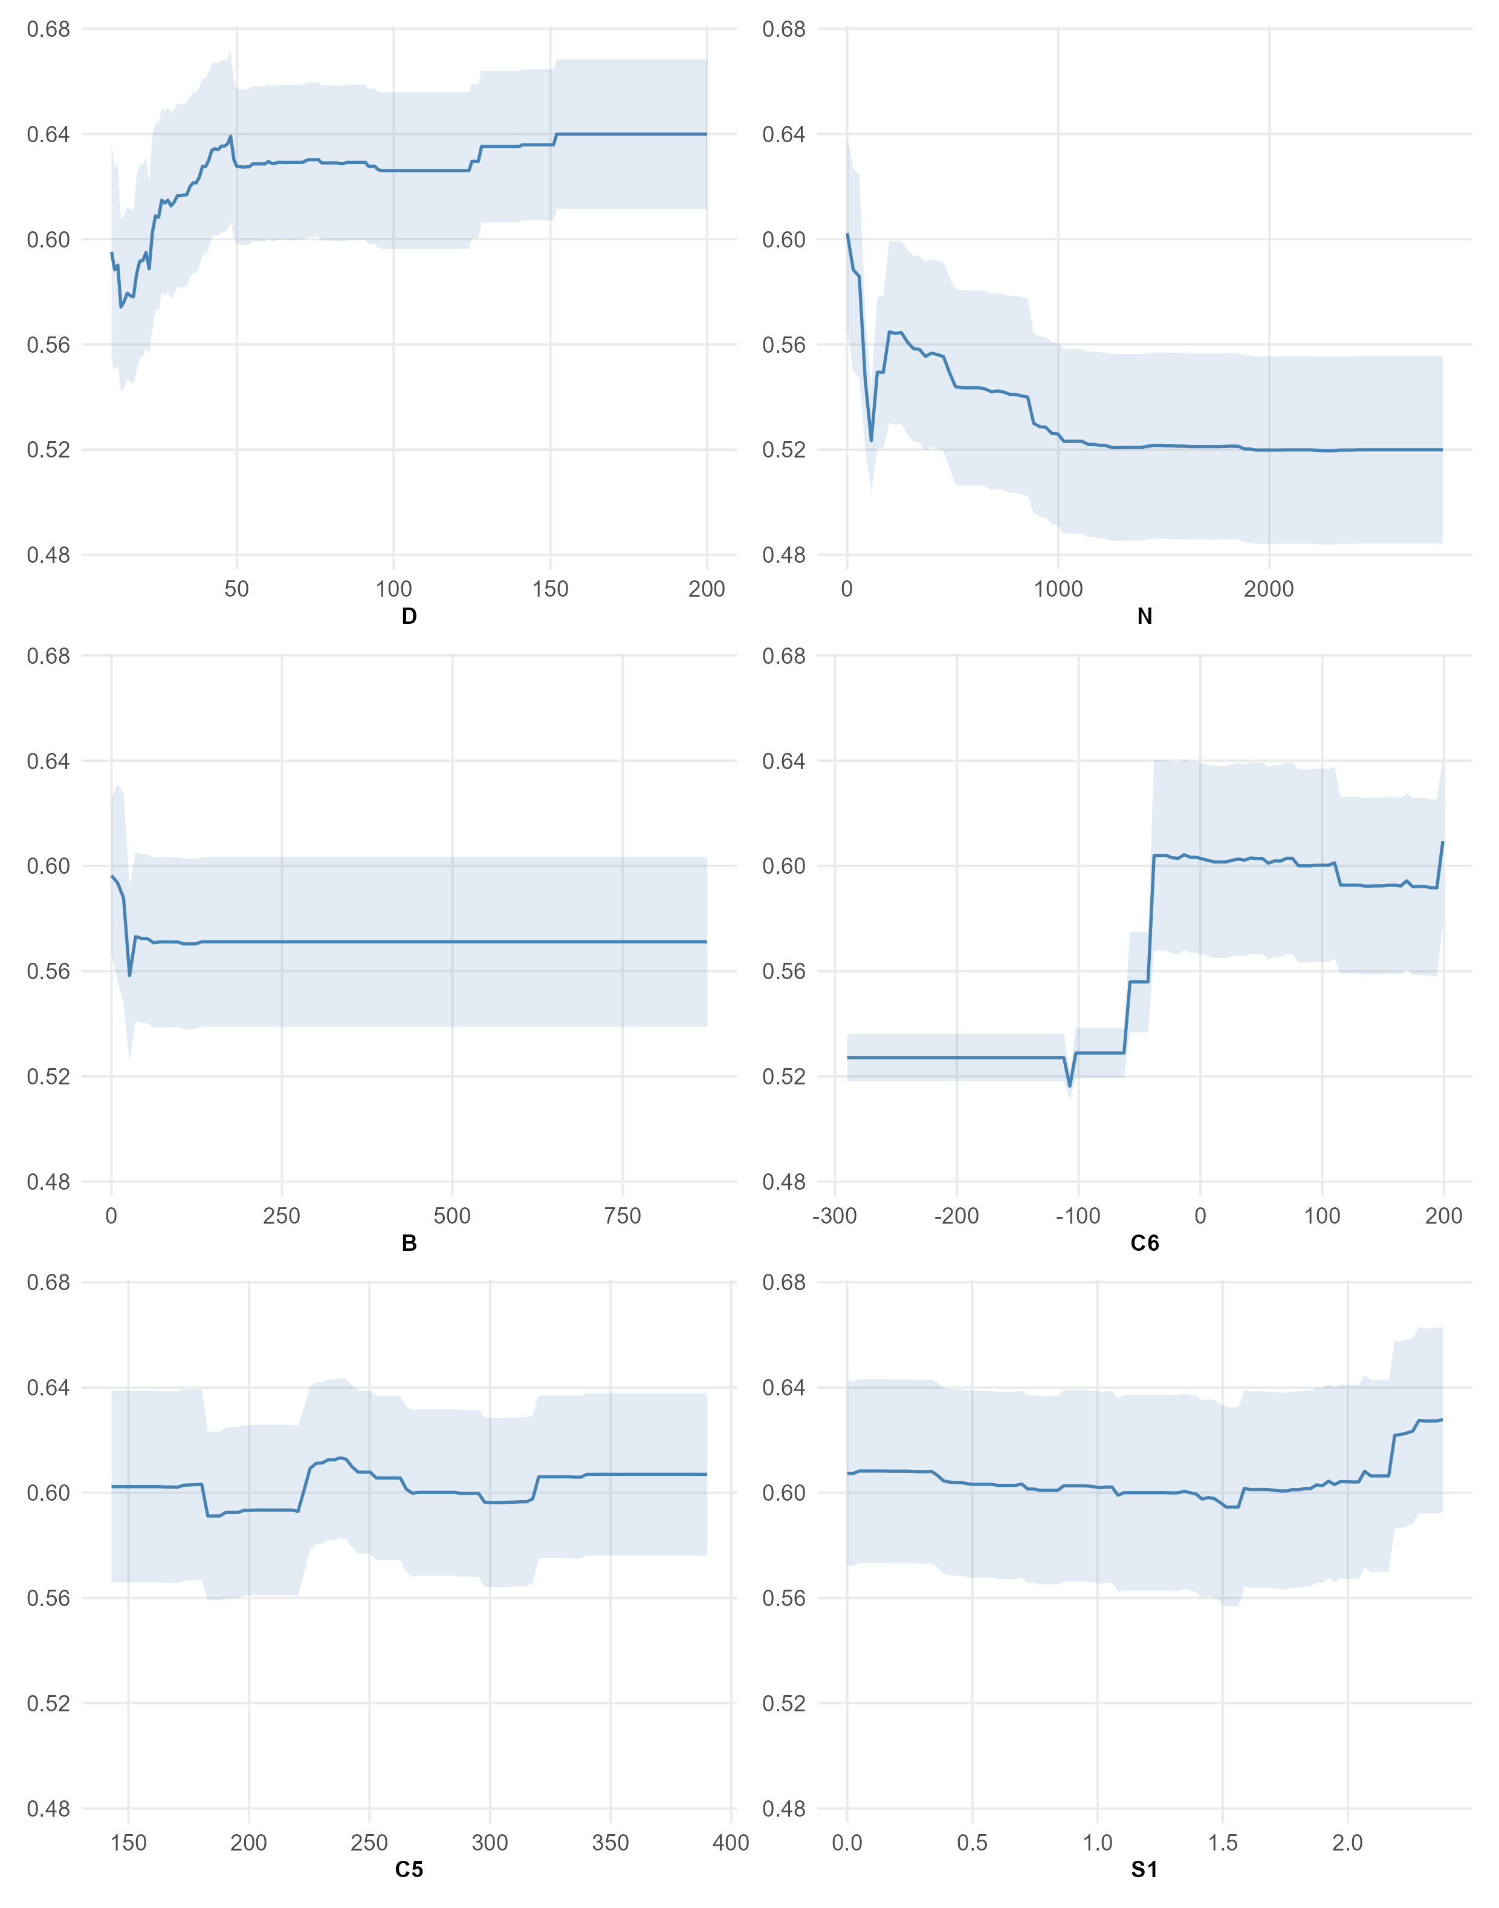
Fig. S3 | Partial dependence plots for the top six predictors of forest biomass growth. These plots show the marginal effect of each of the six most important predictors identified in Fig. S5 on tree growth rates, expressed as Mg ha⁻¹ yr⁻¹. Solid lines represent mean predicted values from the Random Forest model when other variables are held constant at their means, and shaded bands indicate 95% confidence intervals based on continent–ecozone variance. For simplicity, diameter at breast height (DBH) is abbreviated as “D.”
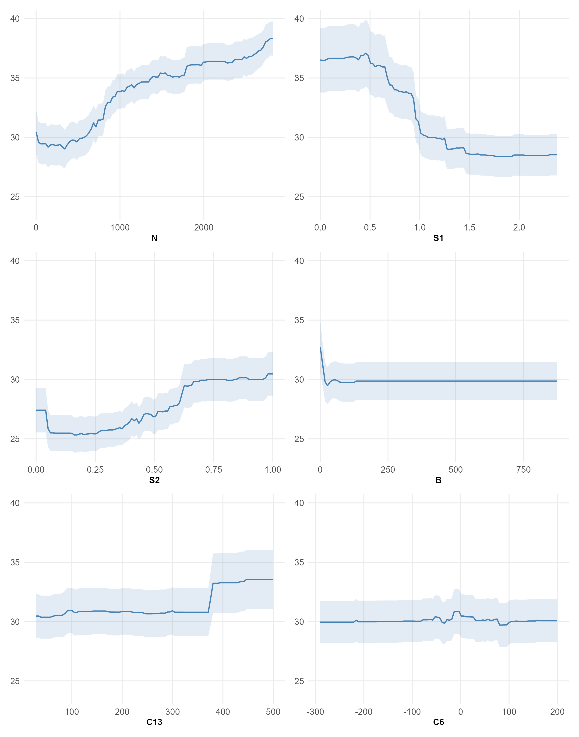
Fig. S4 | Partial dependence plots for the top six predictors of forest recruitment. These plots depict the marginal effects of the six most influential predictors—identified in Fig. S5—on tree recruitment rates, expressed as the number of stems per hectare per year. Solid lines represent mean predicted values from the Random Forest model with other variables held at their means, and shaded bands show the 95% confidence intervals derived from continent–ecozone variance.
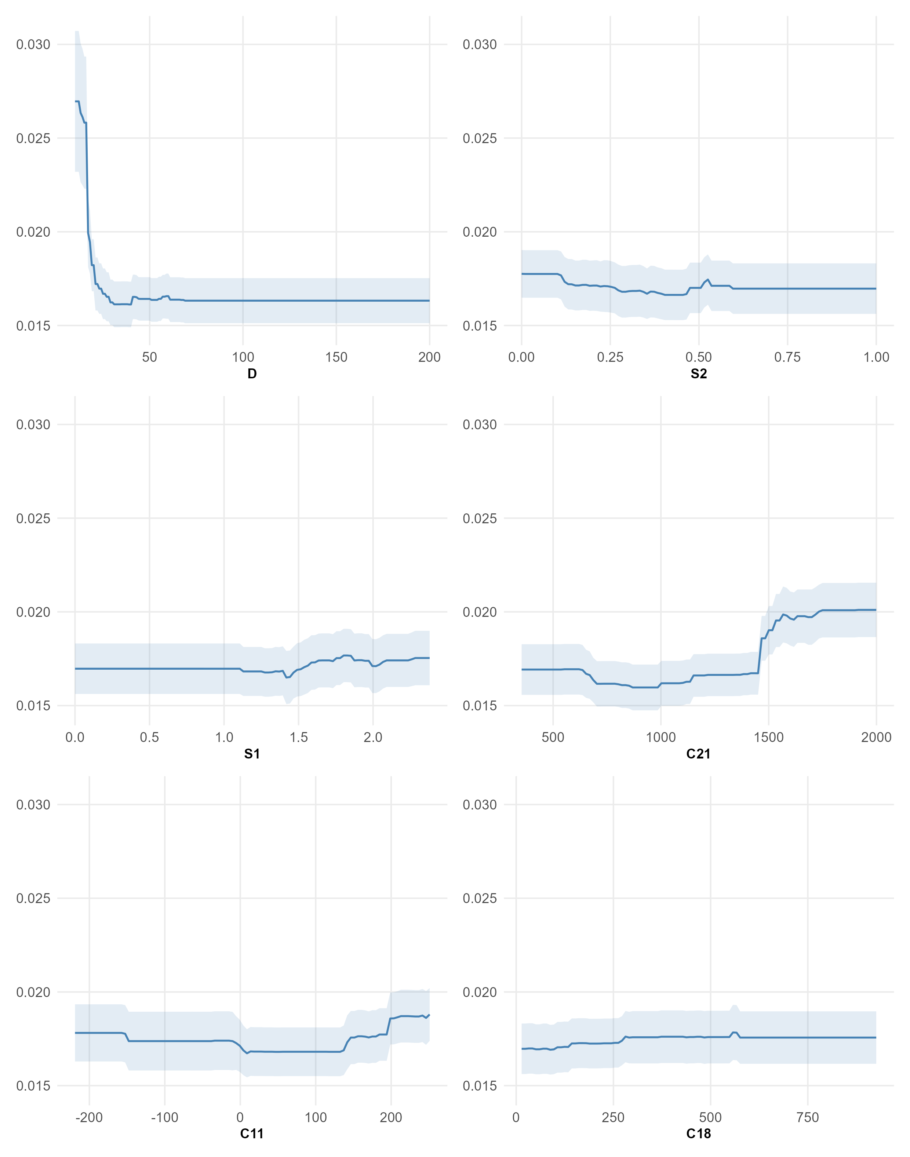
Fig. S5 | Partial dependence plots for the top six predictors of forest mortality. These plots depict the marginal effects of the six most influential predictors—identified in Fig. S5—on tree mortality rates, expressed as biomass loss (Mg/ha/year). Solid lines represent mean predicted values from the Random Forest model with other variables held at their means, and shaded bands show the 95% confidence intervals derived from continent–ecozone variance. For simplicity, mortality values are reported as absolute magnitudes rather than negative numbers. For simplicity, diameter at breast height (DBH) is abbreviated as “D.”
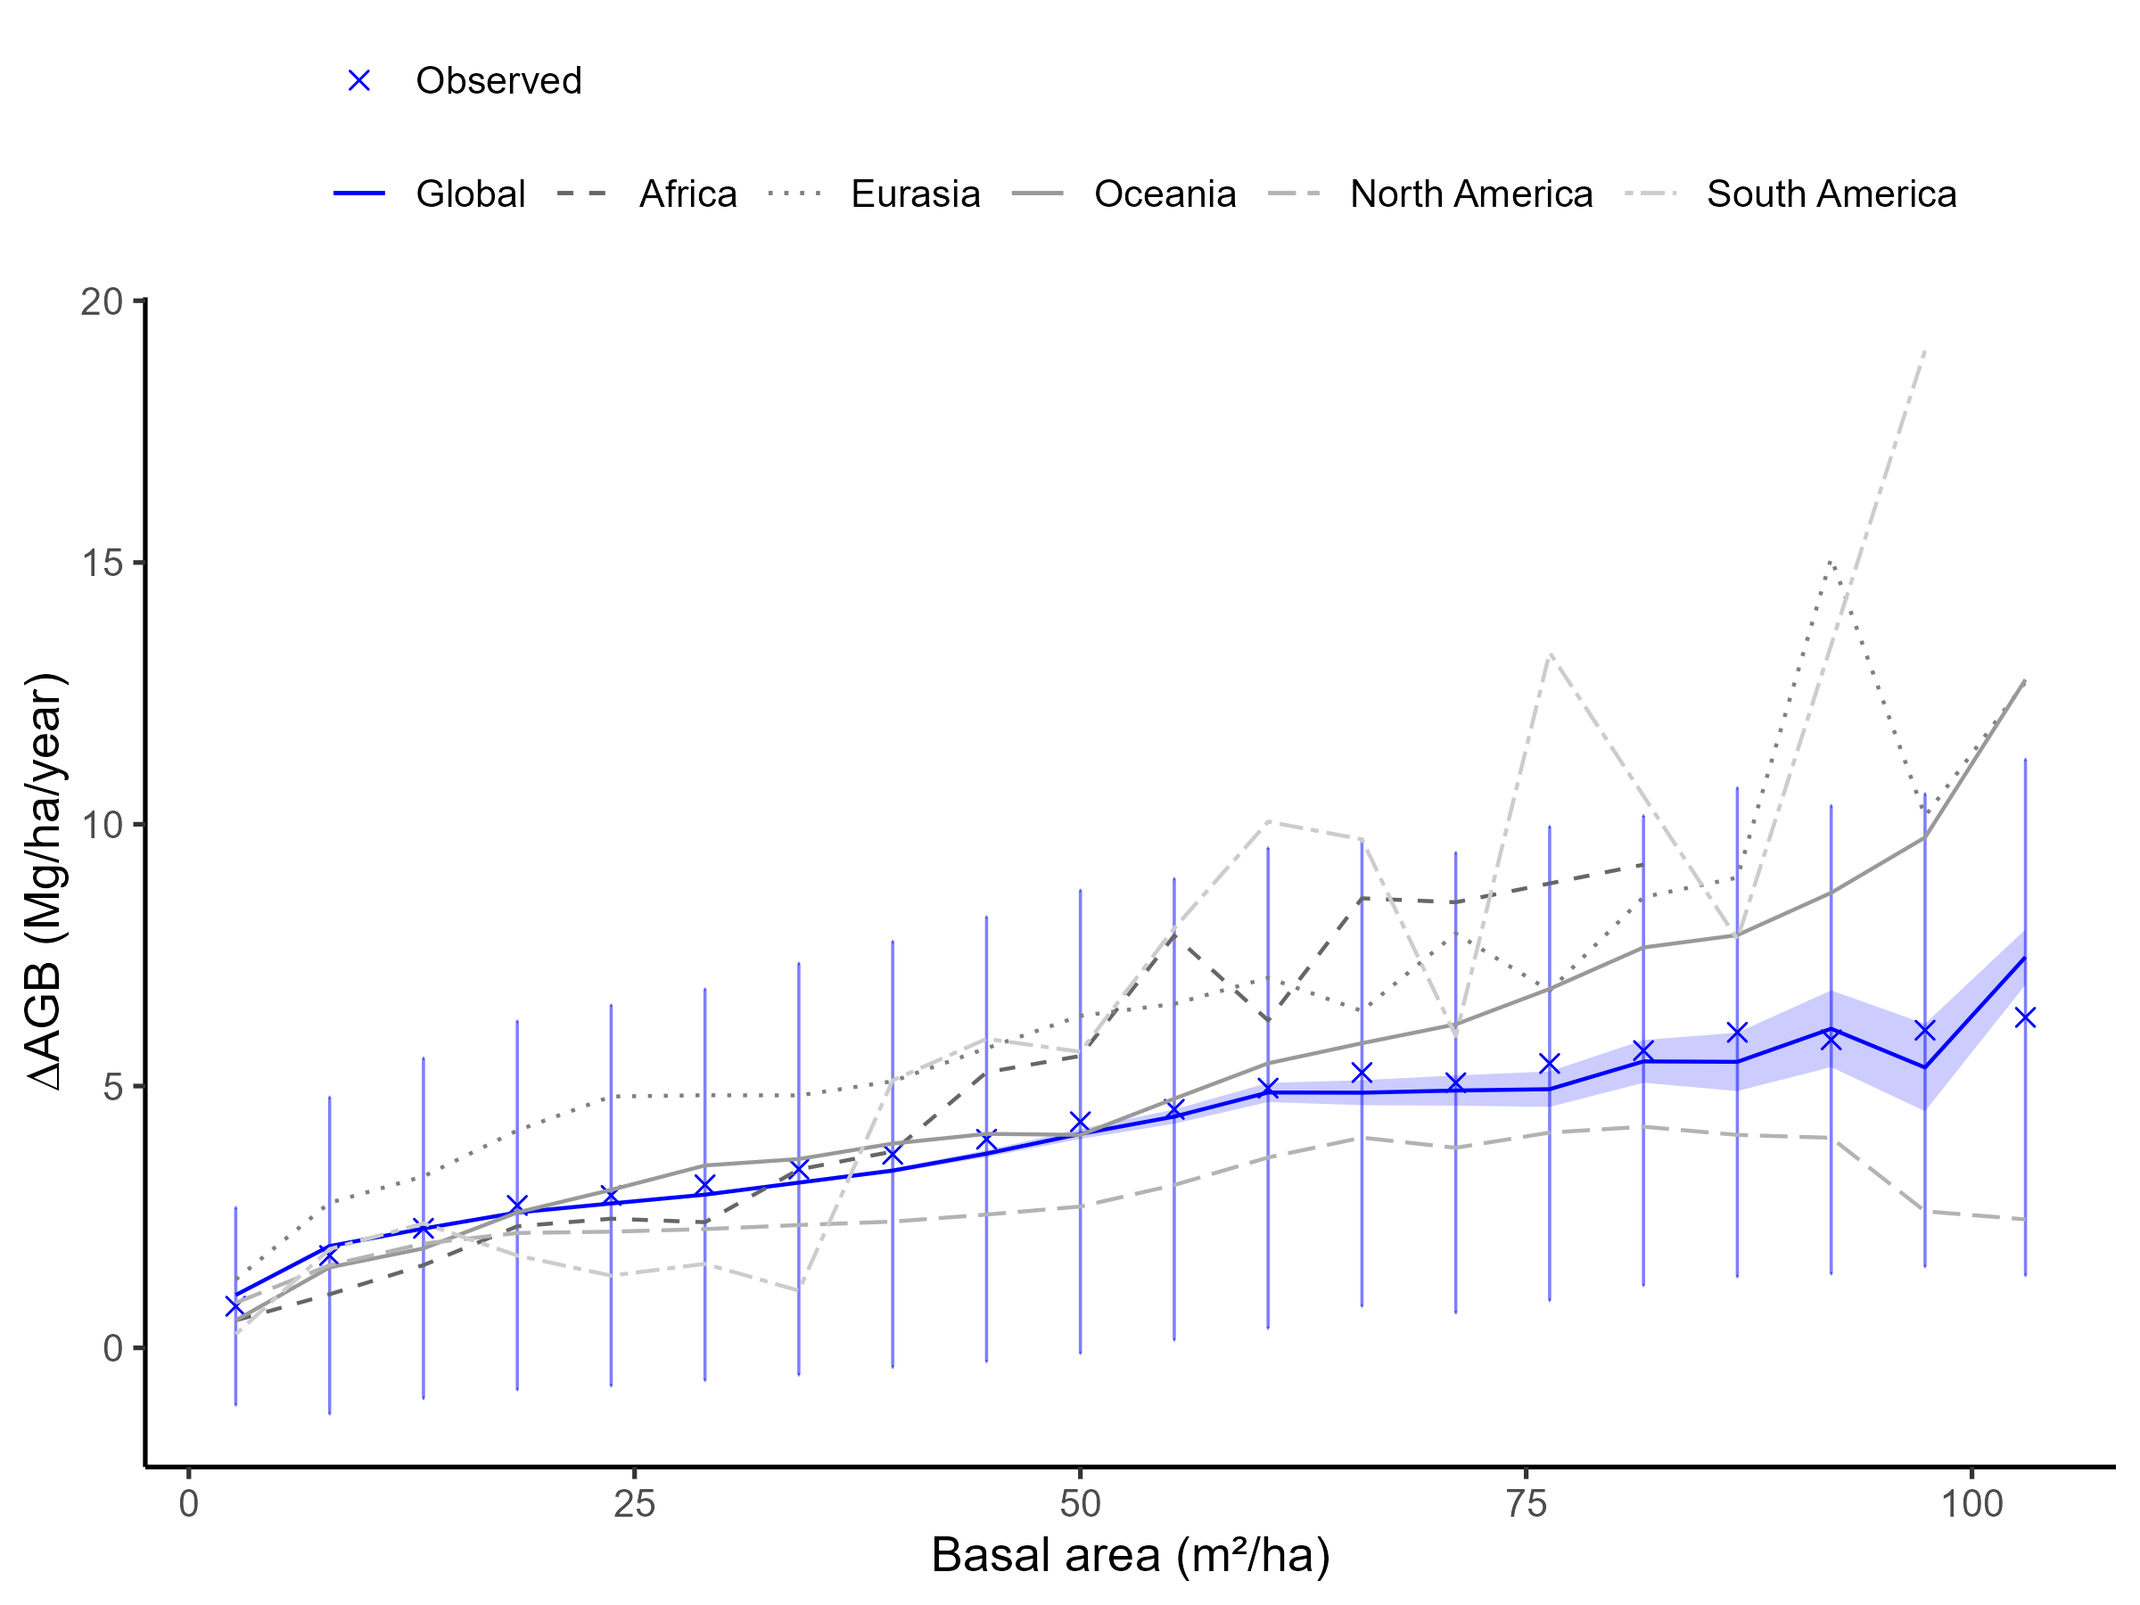
Fig. S6 | Validation of MATRIX-predicted net aboveground biomass change (∆AGB) across gradients of stand basal area at global and continental scales. Observed ∆AGB (blue crosses) and associated standard deviations (vertical lines) are binned by basal area into 20 equal-width classes, and compared with MATRIX-predicted ∆AGB across the same bins. The solid blue line shows global model predictions with 95% confidence intervals (shaded area), while dashed and dotted lines represent predictions for six continental regions. This spatially aggregated comparison is part of our broader validation framework for regions where complete plot-level testing was not feasible due to data limitations.

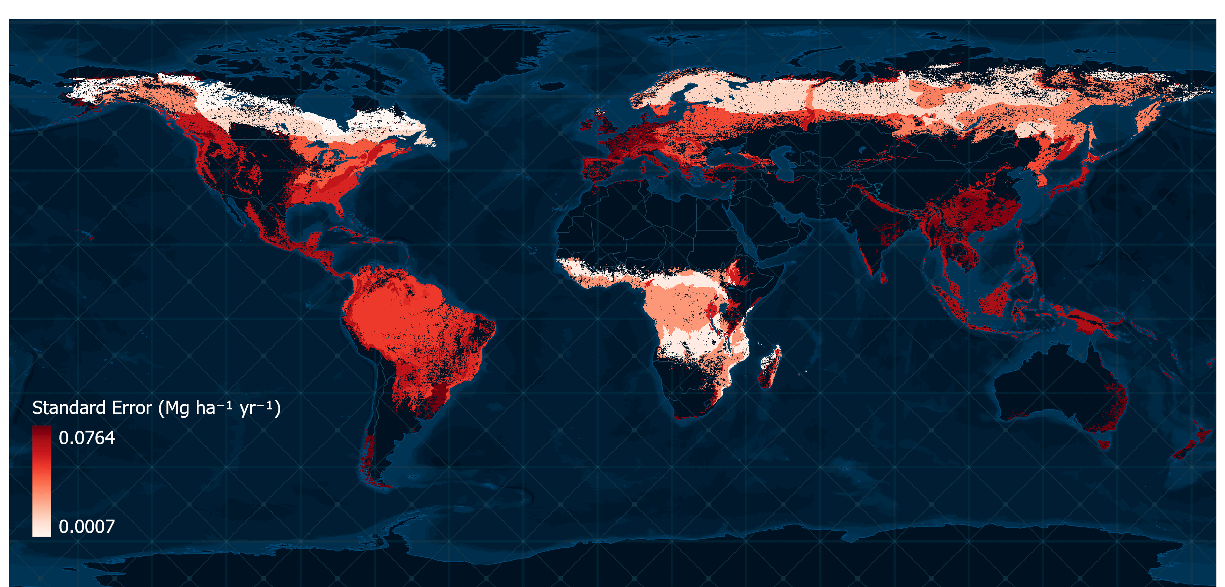
Fig. S7 | Global distribution of the standard error of modeled net aboveground biomass change (∆AGB). We calculated the standard error of estimated pixel means at the biome level, as a tractable, transparent measure of uncertainty with clear interpretability at the scales emphasized.

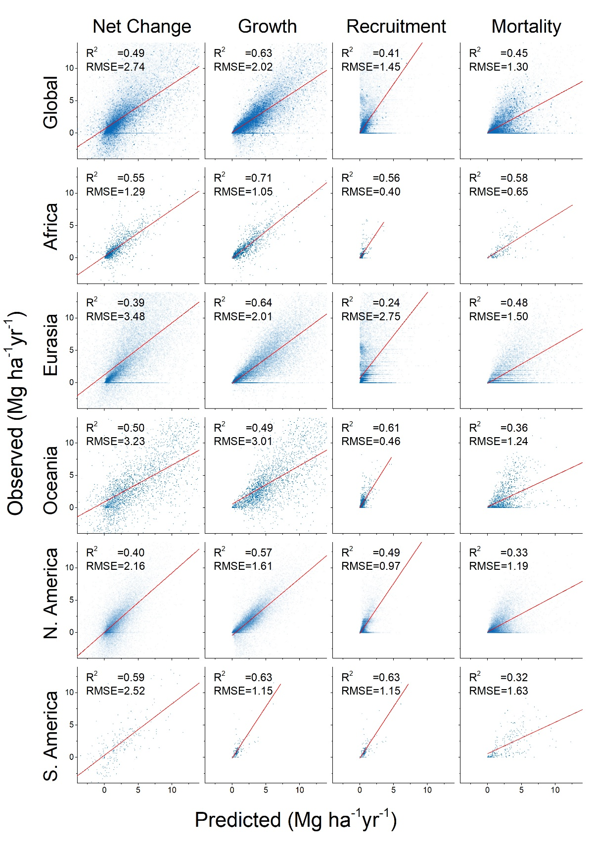
Fig. S8 | Forward simulation validation with independent temporal aggregation for six continents, based on 20,000 disturbance-filtered plots per continent. Simulations were initialized with observed first-inventory structure and run to the second inventory, predicting growth, recruitment, mortality, and net ∆AGB. Observed vs. predicted plot-level aggregates are shown with regression fits and R²/RMSE statistics. Validation targets are independent in temporal aggregation from the single-tree, single-year training data.
References

1 Hijmans, R. J., Cameron, S. E., Parra, J. L., Jones, P. G. & Jarvis, A. Very high resolution interpolated climate surfaces for global land areas. International Journal of Climatology 25, 1965-1978 (2005).
2 Trabucco, A. & Zomer, R. J. in CGIAR Consortium for Spatial Information (2009).
3 Wheeler, Q. D. et al. Mapping the biosphere: exploring species to understand the origin, organization and sustainability of biodiversity. Systematics and Biodiversity 10, 1-20, doi:10.1080/14772000.2012.665095 (2012).
4 Amatulli, G. et al. A suite of global, cross-scale topographic variables for environmental and biodiversity modeling. Scientific data 5, 180040 (2018).
5 Batjes, N. World soil property estimates for broad-scale modelling (WISE30sec). (ISRIC-World Soil Information, Wageningen, 2015).
6 Venter, O. et al. Global terrestrial Human Footprint maps for 1993 and 2009. 3, 160067, doi:10.1038/sdata.2016.67 (2016).
7 Ibisch, P. L. et al. A global map of roadless areas and their conservation status. Science 354, 1423-1427, doi:10.1126/science.aaf7166 (2016).
8 UNEP-WCMC. World Database on Protected Areas User Manual 1.4 (UNEP-WCMC, Cambridge, UK, 2016).
9 Malone, T., Liang, J. & Packee., E. C. Cooperative Alaska Forest Inventory. 42 (Gen. Tech. Rep. PNW-GTR-785, USDA Forest Service, Pacific Northwest Research Station, Portland, OR, 2009).
10 Searle, E. B. & Chen, H. Y. Tree size thresholds produce biased estimates of forest biomass dynamics. Forest Ecology and Management 400, 468-474 (2017).
11 Tanner, E. V. J. Studies on the biomass and productivity in a series of montane rain forests in Jamaica. Journal of Ecology 68, 573-588 (1980).
12 du Québec, G. Ministère des Ressources naturelles et des Forêts. Direction du Dévloppement et de L’innovation de L’industrie: Québec, QC, Canada, 138 (2022).
13 Pyle, E. H. et al. Dynamics of carbon, biomass, and structure in two Amazonian forests. Journal of Geophysical Research: Biogeosciences 113 (2008).
14 TEAM Network. Vegetation Protocol Implementation Manual, v.1.5, Tropical Ecology, Assessment and Monitoring Network. 90 (Center for Applied Biodiversity Science, Conservation International, Arlington, VA, USA, 2010).
15 Souza, A. F., de Ávila, A. L., Araújo, M. M. & Longhi, S. J. Long-lasting effects of unplanned logging on the seed rain of mixed conifer-hardwood forests in southern South America. Journal of Forestry Research 32, 1409-1418 (2021).
16 Uriarte, M., Lasky, J. R., Boukili, V. K. & Chazdon, R. L. A trait‐mediated, neighbourhood approach to quantify climate impacts on successional dynamics of tropical rainforests. Functional Ecology 30, 157-167 (2016).
17 ForestPlots.net et al. Taking the pulse of Earth's tropical forests using networks of highly distributed plots. Biological Conservation 260, 108849, doi:https://doi.org/10.1016/j.biocon.2020.108849 (2021).
18 Lopez-Gonzalez, G., Lewis, S. L., Burkitt, M. & Phillips, O. L. ForestPlots. net: a web application and research tool to manage and analyse tropical forest plot data. Journal of Vegetation Science 22, 610-613 (2011).
19 Zhu, Z.-X., Nizamani, M. M., Sahu, S. K., Kunasingam, A. & Wang, H.-F. Tree abundance, richness, and phylogenetic diversity along an elevation gradient in the tropical forest of Diaoluo Mountain in Hainan, China. Acta Oecologica 101, 103481 (2019).
20 Biodiversity Center of Japan. Monitoring Sites 1000 Project 2020).
21 T.A., M. & A.V., K. (Zenodo: https://doi.org/10.5281/zenodo.4319092, 2020).
22 Wiser, S. K., Bellingham, P. J. & Burrows, L. E. Managing biodiversity information: development of New Zealand's National Vegetation Survey databank. New Zealand Journal of Ecology, 1-17 (2001).
23 Franklin, J. Regeneration and growth of pioneer and shade‐tolerant rain forest trees in Tonga. New Zealand Journal of Botany 41, 669-684 (2003).
24 Webb, E. L., Seamon, J. O. & Fa’aumu, S. Frequent, low‐amplitude disturbances drive high tree turnover rates on a remote, cyclone‐prone Polynesian island. Journal of Biogeography 38, 1240-1252 (2011).

