Supplementary material
Title: Site specific probabilistic seismic hazard model for Isfahan, Iran: estimates and uncertainties
Authors: Mohsen Kohrangi¹, Homayon Safaei², Laurentiu Danciu³, Hossein Tajmir-Riahi⁴, Rassoul Ajalloeian⁵, Paolo Bazzurro⁶

¹ RED, Risk Engineering + Development, Pavia; email: mohsen.kohrangi@redrisk,com; ORCID: 0000-0001-9151-0361
² Department of Geology, University of Isfahan, Isfahan, Iran; email: homayon_safaei@yahoo.com; ORCID: 0000-0002-5298-1440
³ Department of Earth Science, ETH Zurich, Sonneggstrasse 5, 8092 Zurich, Switzerland; email: laurentiu.danciu@sed.ethz.ch; ORCID: 0000-0003-4086-8755.
⁴ Department of civil engineering, University of Isfahan, Isfahan, Iran. email: tajmir@eng.ui.ac.ir; ORCID: 0000-0001-9770-1695.
⁵ Department of Geology, University of Isfahan, Isfahan, Iran. email: rasajl@sci.ui.ac.ir; ORCID: 0000-0001-9770-1695.
⁶ IUSS, Pavia, Italy; email: paolo.bazzurro@iusspavia.it; ORCID: 0000-0001-6107-9451

S1. Full database of identified faults
Using remote sensing techniques and field studies that was conducted in the context of various studies in recent years, in addition to identifying new faults, improvements were made in the location and mechanism of the previously introduced faults. Herein, 125 main faults within a radius of 200 km from the site have been identified and their characteristics such as attitude, mechanism, amount of slip and their activity potential have been determined to the extents possible. Figure S1 shows the surface delineation of 125 faults classified in terms of the activity and importance within a radius of 200 km from the Isfahan (Landsat data, ETM+, RGB=741). A full database of the identified faults together with their characteristics is provided in the excel file in the supplementary material of this manuscript.
The fault databases and the individual fault characterizations have been compiled and evolved over the last 17 years through the efforts of the second author. This has been in the form of multiple local research projects, graduate dissertations and scientific articles. In the following, descriptions about the different features of the faults in terms of (i) attitude and mechanism; (ii) Seismogenic depth, fault activity and slip rates; and (iii) Uncertainty levels are provided:

(i) Aattitude and mechanism
Based on the fault database, we can categorize the faults into six major classes in terms of their attitude and mechanism as follows:
Category 1: Faults with a direction of 120 to 130 degrees
These faults are parallel to the Zagros orogeny and are the most important faults in the region. These faults with tens and even up to several hundred kilometers in length control the overall orientation of the altitudes as well as the morphology of the Zagros region. In general, the thrust mechanism with the right lateral component is seen in most of these faults. Majorities have a dip angle towards northeast, and the dip angle of a few of them is towards southwest or they are vertical.
Category 2: Fault with direction of 150 degrees
The direction of this group of faults is close to the direction of the first category. For this reason, they should be more carefully separated from the first category. Also, due to the similarity in the mechanism of these faults with the first category, it is difficult to separate them. In general, their strike can be considered 150 degrees while their dip angle is often towards northeast. The dip of these faults ranges between 50–90 degrees. Due to the rake of faults in different areas, movements with components of right-lateral and thrust can be considered for these faults.
Category 3: Faults with 70 degree direction
The lengths of this group of faults has reached tens of kilometers and are in the form of faults with a steep dip to the southeast to almost vertical, which have a significant left-lateral component.
Category 4: Fault with north-south direction
Some of these faults with tens or hundreds of kilometers have caused incisions in the heights so that by cutting the general direction of the heights of the region which is northwest-southeast have caused the plains to be located between the heights. In general, these faults can be considered as normal faults with a slope to the east, which also have a right-lateral component.
Category 5: East-west direction faults
These faults can be considered with an approximately east-west direction and with two different dips to the north or to the south. These faults are of little importance in the area and can be observed Compression and left -lateral mechanism for them.
Category 6: Fault with 35 degree direction
These faults are the least important in terms of number and length in the study area. In general, the strike changes of these faults are from about 25 to 45 degrees. The dip of these faults also varies from 50 to 90 degrees. Their dip is taken both to the northwest and to the southeast. Some faults in this category have a normal mechanism and some have a left lateral mechanism.

(ii) Seismogenic depth, activity and slip rates
Due to the predominant depth of the hypo-center of instrumental recorded events ranging between 5–40 km, except for zone Z7, and given the absence of better data to characterize the seismic depth of the faults, herein we assumed that seismic depth of the faults ranges between 5–25 km. In order to determine the activity potential of each fault, in addition to their attitude and mechanism, both seismicity records and the concentration of micro-earthquakes near each fault have been considered. Accordingly, we considered four classes (i.e., 1–4) in terms of the fault activity with descending activity potentials. The last column in the fault database table shows this classification. Note that we did not classify any fault inactive (i.e., Class 4), still as mentioned in the manuscript, we only used the faults of class 1 in our Faults and background seismicity model.
To determine the slip rate of the faults, paleo-seismology and trench excavation are often required. Due to the complexity of such studies and unavailability of funding in the current study, unfortunately, these studies have not yet been performed on faults in the study area. However, considering the morphotectonics evidence and the amount of displacement of alluvial and rocky units on both sides of the faults, we considered three groups to assign reasonable slip rate slip rate values. The first group of faults has a slip rate of half a millimeter to two millimeter per year, the second group has a slip rate of half a millimeter per year and the third group has a slip rate of 0.25 mm per year. Figure S2 shows the three fault classes on the digital elevation model.

(iii) Uncertainty level
We emphasize that an accurate knowledge of the mechanism, slip rate, seismic depth, etc. of a fault requires detailed field studies, trenching and paleo-seismology, geodetic measurements and geophysical studies. While for our fault characterization process, most of these tools have been available for a major part of the database, still all of them have not been available for every single fault. As such, to provide an understanding of the level of certainty on the fault properties, we herein considered three uncertainty levels including A, B and C with descending certainty. Uncertainty class A corresponds with the highest certainty on the reported fault properties while class C means the lowest certainty and B is an intermediate certainty level. Given that no trenching and GPS measurements have been available, we did not classify the information of any fault in Class A.
More details about the identification process and characteristics of each individual fault is available in Safaei et al. (2021). Figure S2 shows the three fault classes in terms of their activity on the digital elevation model.
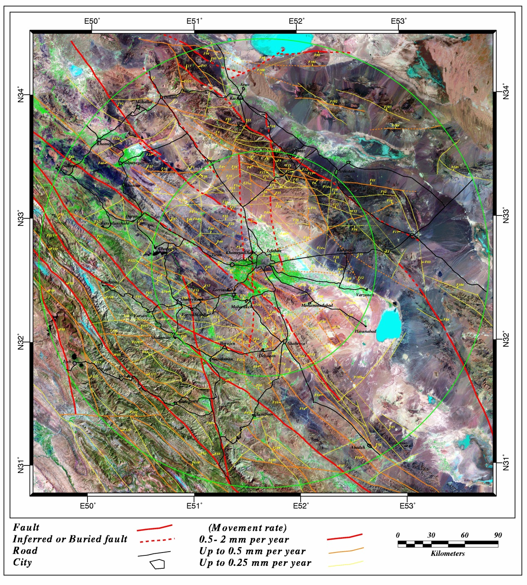
Figure S1. Surface delineation of 125 faults classified in terms of the activity and importance within a radius of 200 km from the Isfahan urban area (Landsat data, ETM+, RGB=741).

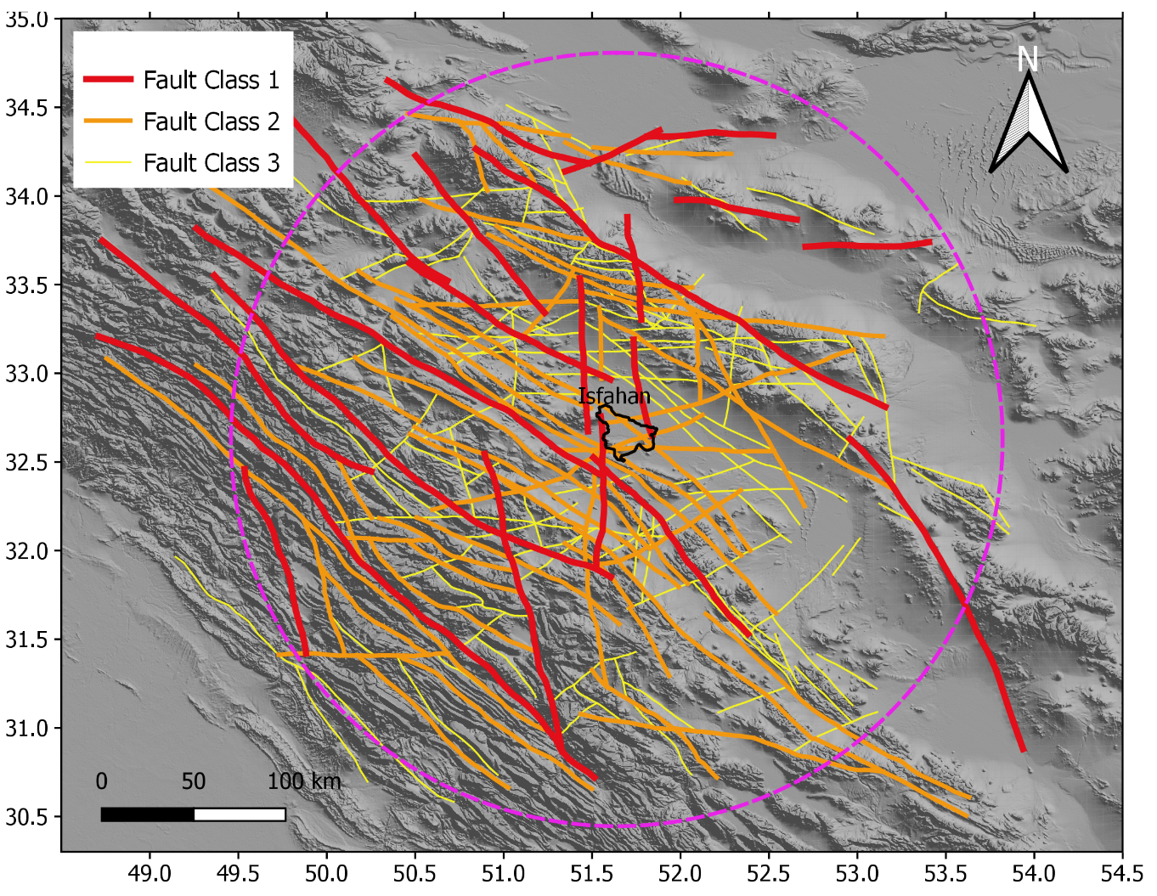
Figure S2. Showing three fault classes in terms of activity potentials on a digital elevation model. Note that in our calculations we only used class 1 faults.

S2. Vs₃₀ map generation
In order to generate a Vs₃₀ map for the entire region of interest, we used two resources including: (i) the available data from the past earthquakes; and (ii) the slope-based Vs₃₀ estimates. Figure S3 shows the spatial distribution of the Vs₃₀ estimates using the slope-based approach as well as the location and type of the geotechnical test data. While the Vs measurements based on downhole experimental tests are directly used in generation of the map, the results of SPT (i.e., N60) and the stratigraphic logs were used based on engineering judgement on the geology and providing analogy between the like locations worldwide (Wair et al. 2012). Figure S2 shows the histogram of the Vs₃₀ values obtained from the test data.
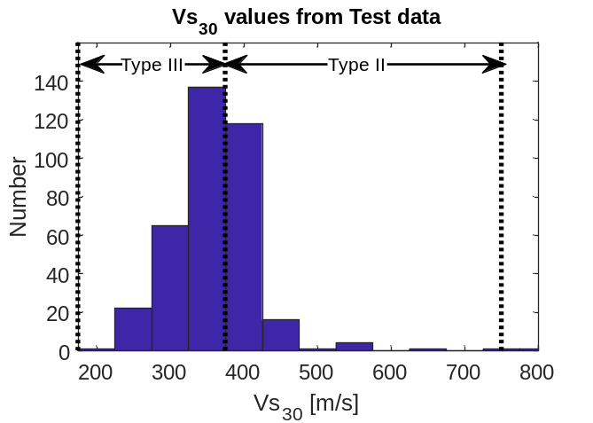
Figure S3. Histogram of the Vs₃₀ values obtained from the geotechnical test data

Based on the following procedure the results of two Vs₃₀ resources are combined to obtain a hybrid Vs₃₀ map.
- We first considered a grid of points spatially distributed over the entire space with spacing of 500×500 m.
- At each grid point, we do have the values of slope-based Vs₃₀ from Wald and Allen (2007) herein called ${Vs}_{30,slope}$.
- For each grid point, we used the isotropic smoothing kernel method to compute the value of the Vs₃₀ based on the database of 369 geotechnical tests herein called ${Vs}_{30,test}$. Note that this will provide reasonable estimates for the grid points where test data are available within a close by distance.
- For each grid point, we combine the results of step (ii) and (iii) using equation S1 to obtain the hybrid Vs₃₀ value, ${{Vs}_{30,}}_{hybrid}$:

$${{Vs}_{30,}}_{hybrid}=W×{Vs}_{30,slope}+(1-W)×{Vs}_{30,test}$$ | S1
Where $W$ is the combination weight value defined as follows. For grid points where we had at least one ${Vs}_{30,test}$ in a distance closer than 0.5 km, then we assumed a W=0.1, and W=0.8 otherwise. This allows providing higher weights for the grids where we have test based measurements and using the slope-based estimates mainly where no geotechnical test has been available. Figure S5 shows the final hybrid Vs₃₀ map used in the PSHA computations.

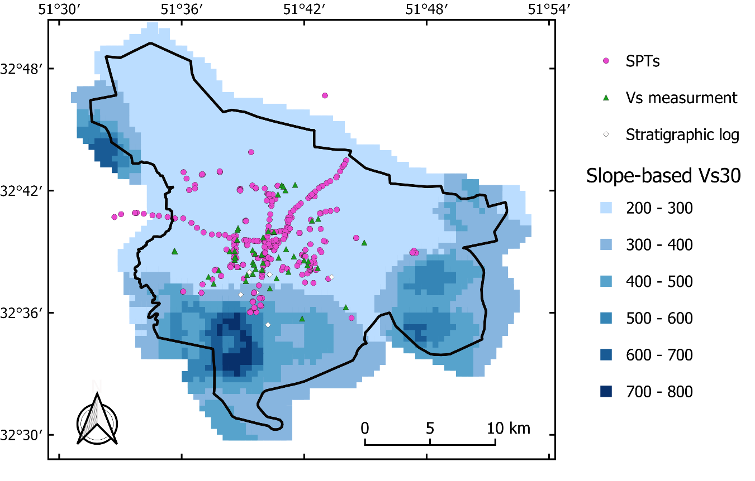
Figure S4. Map of Isfahan showing the Vs₃₀ estimates based on the slope-based approach adopted from Wald and Allen (2007). Note: The location and type of the geotechnical test data can also be seen on the map.

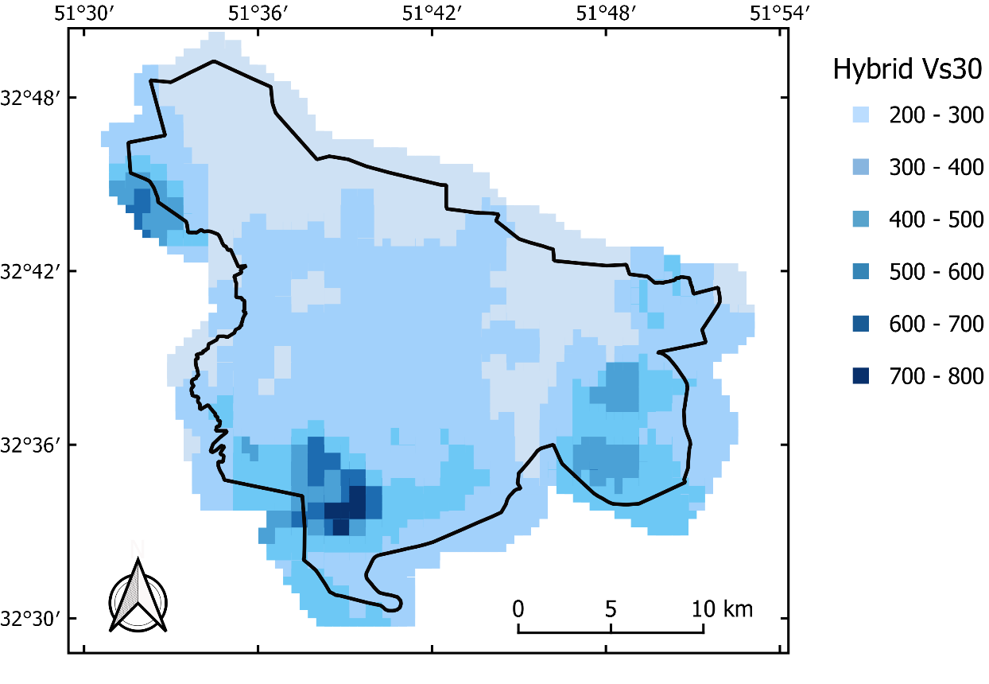
Figure S5. Map of Isfahan showing the Vs₃₀ estimates based on the hybrid approach. Note that this Vs₃₀ map was used in the PSHA of this study.

S3. GMPE trellis plots
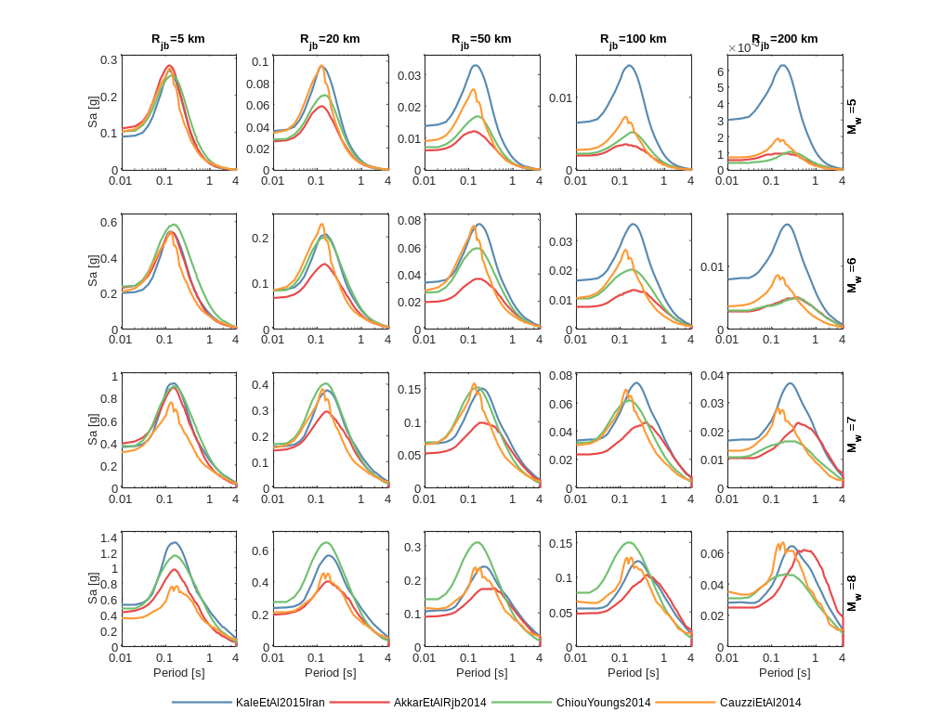
Figure S6. Active shallow crustal
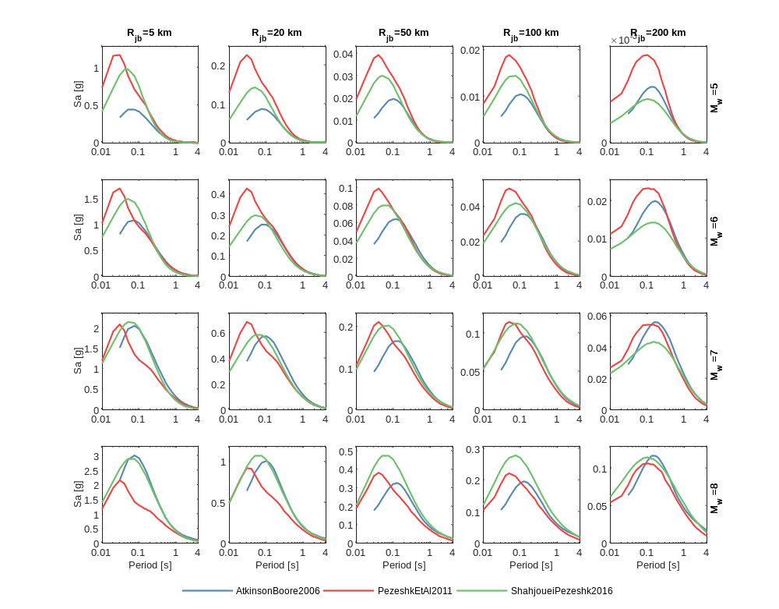
Figure S7. Stable contintental
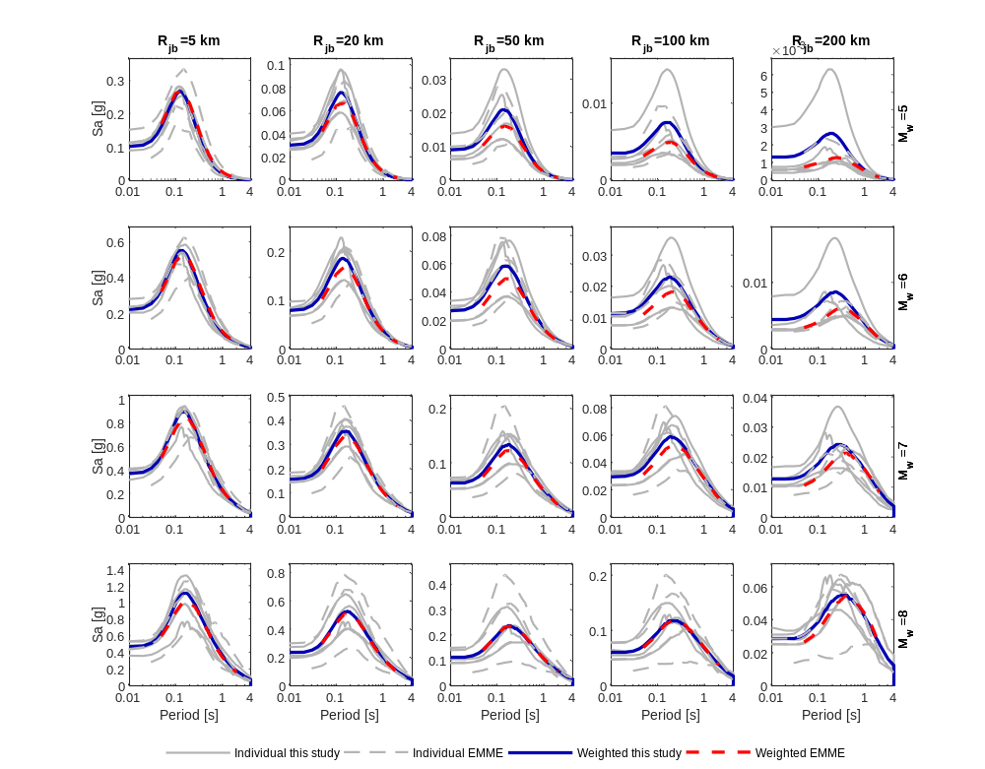
Figure S8. Active shallow crustal. Comparison between EMME14 and this study.

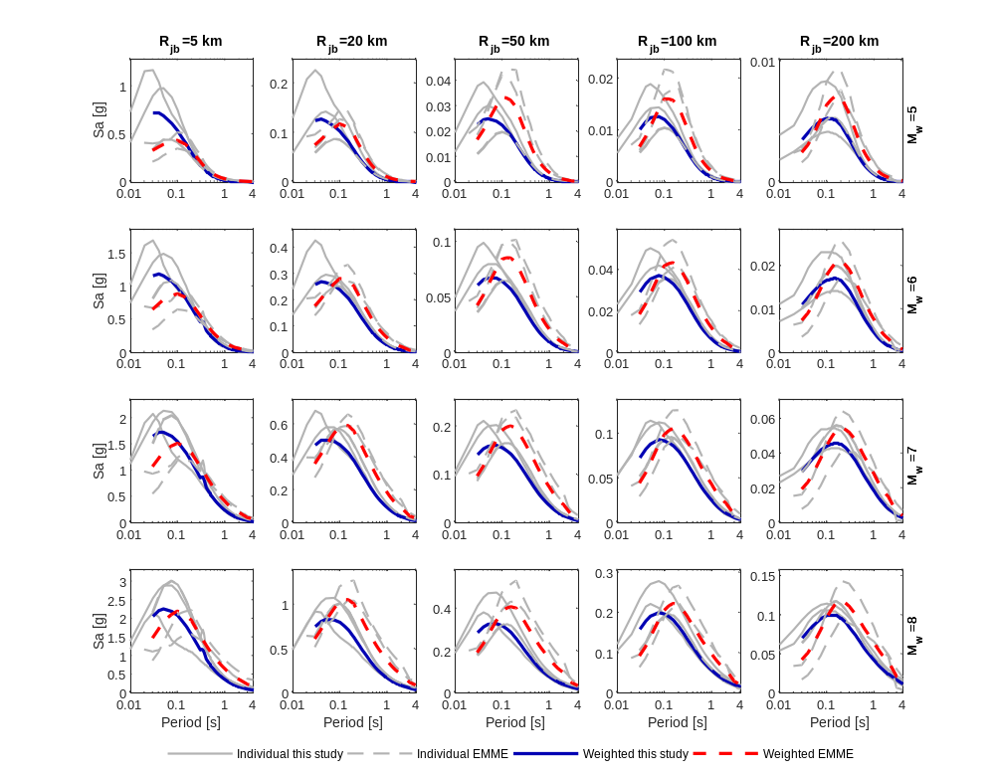
Figure S8. Stable

References
Safaei H, Kohrangi M, Tajmir Riahi H, Ajalloeian R (2021) Seismic micro-zonation of Isfahan urban area, Deputy of Research and Technology, Isfahan university, for Municipality of Isfahan, (in Farsi).
Wair B, DeJong JT, Shantz T (2012) Guidelines for Estimation of Shear Wave Velocity Profiles. PEER 2012/08.
Wald DJ, Allen TI (2007) Topographic Slope as a Proxy for Seismic Site Conditions and Amplification Bulletin of the Seismological Society of America 97:1379-1395 doi:10.1785/0120060267

