Supplementary Information
Low-Viscosity Hydrophobic Deep Eutectic Solvents as Sustainable Lubricants for Ball Screws
Yibiao Wang¹, Changguang Zhou¹, Tianyu Gao¹, Nan Kang², Mohamed EL Mansori², Michel Fillon³, Wentao Bi^{4,*}, Wenling Zhang^{1,*}
1 School of Mechanical Engineering, Nanjing University of Science and Technology, Nanjing 210094, China.
2 Arts et Metiers Institute of Technology, MSMP, F-51006, Châlons-en-Champagne, France
3 Pprime Institute, CNRS-University of Poitiers, Mechanical Engineering and Complex Systems Dept., SP2MI-H1, 11 Bd Marie et Pierre Curie, TSA 41123, 86073 Poitiers, France
4 Jiangsu Collaborative Innovation Center of Biomedical Functional Materials, Jiangsu Key Laboratory of Biomedical Materials, College of Chemistry and Materials Science, Nanjing Normal University, 1 Wenyuan Road, Nanjing 210023, China
* Corresponding author. E-mail addresses:
wlzhang@njust.edu.cn, biwentao@njnu.edu.cn.

Table. S1. Compositions, Chemical Structures, and Reagent Abbreviations of the synthesized six types of DESs.
Abbreviation |  | HBA | HBD |  | DES | Molar Ratio  (HBA:HBD)
DES-LT1 | 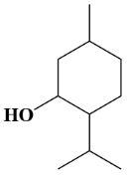 |  |  | 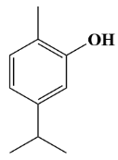 | 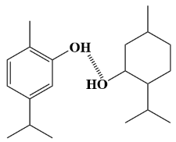 |  | 1:2
DES-LT2 |  |  |  |  |  |  | 1:1
DES-LT3 |  |  |  |  |  |  | 2:1
DES-LC1 |  |  |  | 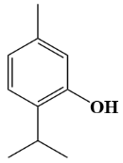 | 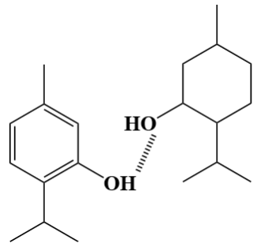 |  | 1:2
DES-LC2 |  |  |  |  |  |  | 1:1
DES-LC3 |  |  |  |  |  |  | 2:1
Table. S2. Hydrogen bond strength of pure liquids comprising DES feedstock
Compounds for calculation |  | Molecular 3D model | ΔE(kcal/mol)
L-Menthol+ L-Menthol |  | 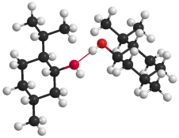 | 7.17
Thymol+ Thymol | 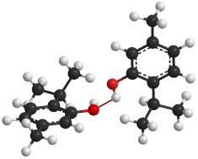 |  | 33.57
Carvacrol+ Carvacrol | 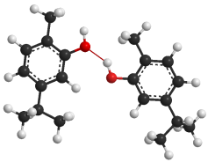 |  | 32.42
DES-LT2 | 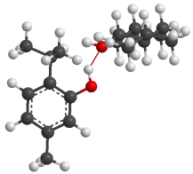 |  | 8.23
DES-LC2 | 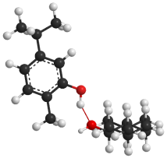 |  | 8.98
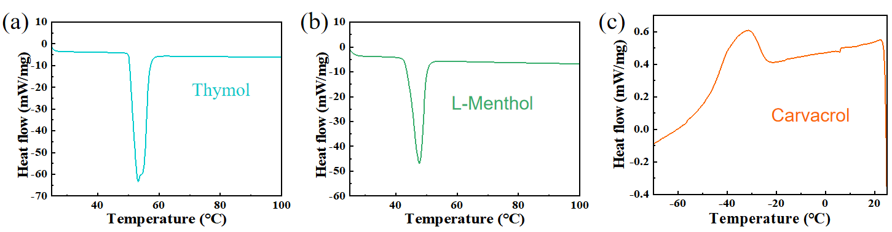
Fig. S1. DSC Results of (a)Thymol, (b)Menthol, and(c) Carvacrol.
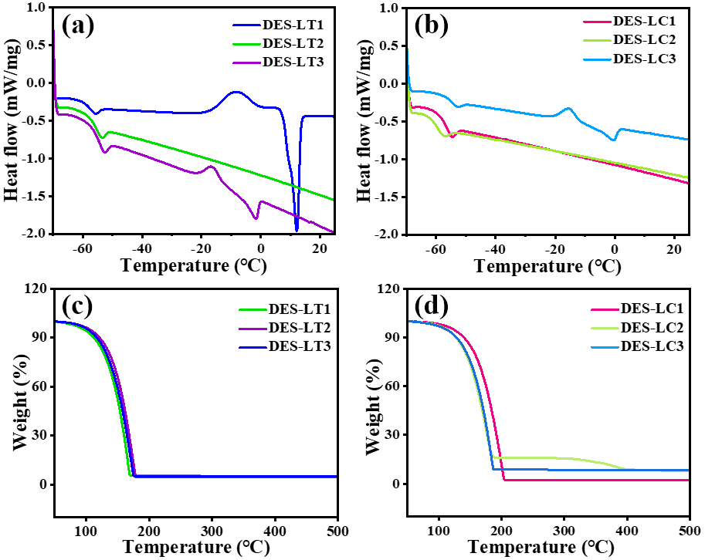
Fig. S2. Thermal analysis curves of DESs with different molar ratios: (a) DSC curves of DES-LT, (b) DSC curves of DES-LC, (c) TGA curves of DES-LT, (d) TGA curves of DES-LC.
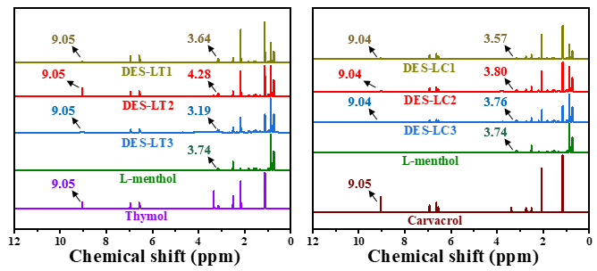
Fig. S3. The ¹H NMR spectra of the raw materials (L-menthol, thymol, carvacrol) and (a1-3) DES-LTs, (b1-3) DES-LCs.
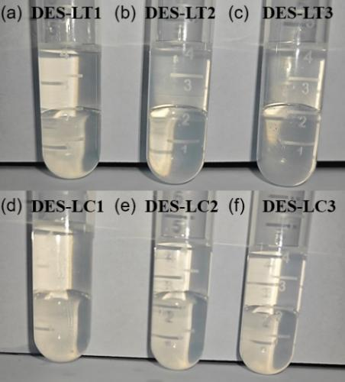
Fig. S4. Images of six DESs mixed with water and allowed to stand
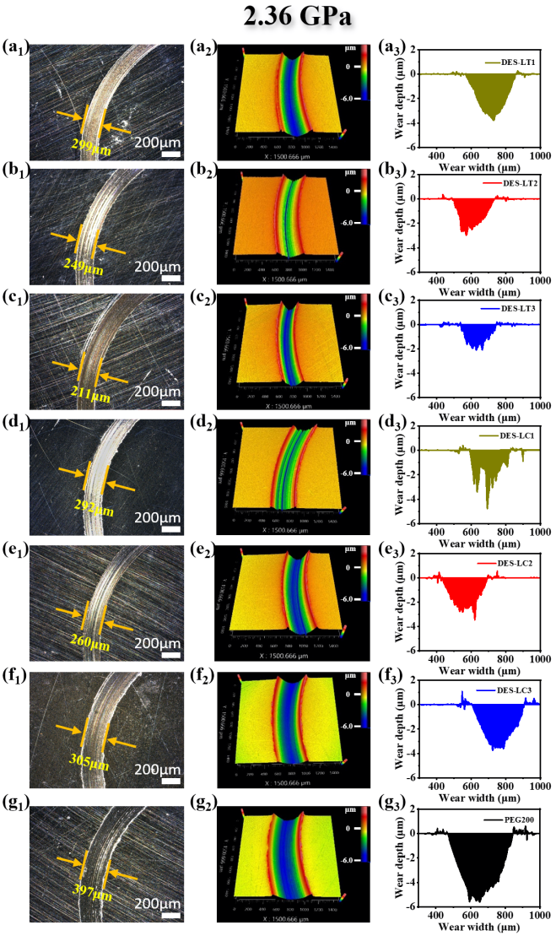
Fig. S5. 2D optical micrographs, 3D morphology and cross-sectional dimensions of wear tracks: (a₁-a₃) PEG200, (b₁-b₃) DES-LT1, (c₁-c₃) DES-LT2, (d₁-d₃) DES-LT3, (e₁-e₃) DES-LC1, (f₁-f₃) DES-LC2, (g₁-g₃) DES-LC3 under 2.36 GPa.
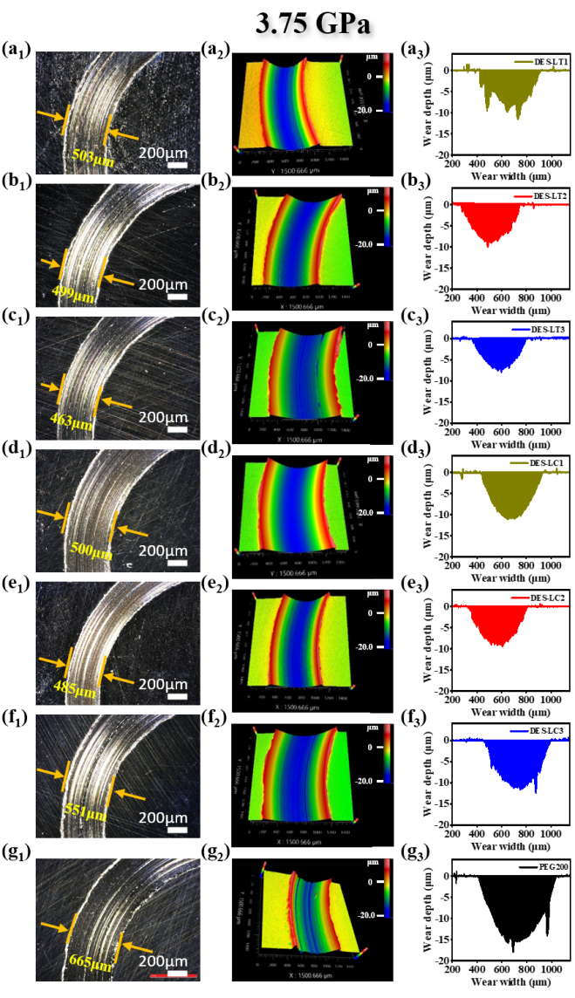
Fig. S6. 2D optical micrographs, 3D morphology and cross-sectional dimensions of wear tracks: (a₁-a₃) PEG200, (b₁-b₃) DES-LT1, (c₁-c₃) DES-LT2, (d₁-d₃) DES-LT3, (e₁-e₃) DES-LC1, (f₁-f₃) DES-LC2, (g₁-g₃) DES-LC3 under 3.75 GPa.

