Appendix A: Reflection prompt
2023 cohort:
Using the SP rating scale, assess your own interpersonal skills.
Discuss one specific strategy you can use to improve your interpersonal skills in the future.
If you could repeat the encounter now, what one new element would you like to address?

2024 cohort:
Using the SP interpersonal skills rating scale, assess your own interpersonal skills.
Discuss one specific strategy you can use to improve your performance in the future.

Appendix B: Interpersonal skills checklist
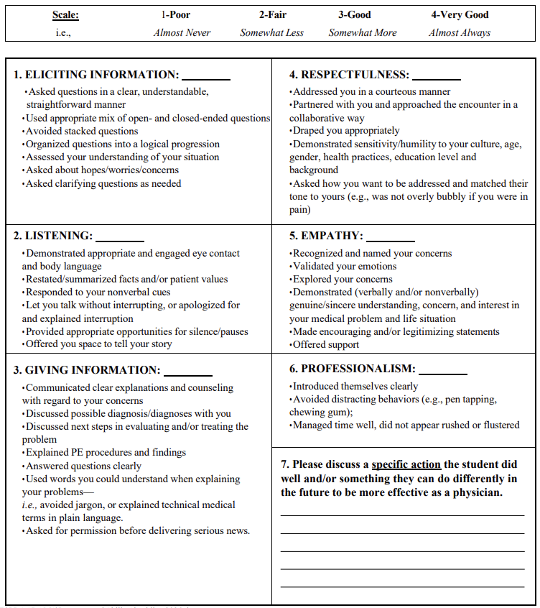
Appendix C: Codebook and representative quotations

Interpersonal | Definition | Representative quotations
Eliciting Information | How student asked questions/guided the conversation in search of specific information; description of questions (open- vs. close-ended, clear/understandable, clarifying questions, not stacking questions, logical progression); asking about patient concerns/questions/hopes/goals for the visit, assessing patient understanding (e.g. teach-back) | “I would ask shorter questions instead of combining multiple questions into one, which likely would be overwhelming for the patient.” (#7)  “If I were to restart these interactions, I would... be more cognizant of asking more open-ended questions.” (#58)  “I feel I could have asked more about what concerns the patient had regarding this issue. I could word this as: ‘What do you hope to get out of our time together today?’ or ‘What are you most worried about with this?’” (#148)
Listening – Verbal | Summarizing what patient has expressed; letting patient talk without interrupting (or apologizing for and explaining interruption); leaving room for silence/pauses; allowing patient to tell their story | “One strategy that I could implement when I need to interrupt a patient is to wait for them to finish their sentence, then interject.” (#106)  “I feel like I can be long winded or accidentally interrupt the patient, so those are areas of which I am trying to be more cognizant.” (#133)  “I was jumping in and acknowledging what the patient was saying too early; if I had backed off and been more comfortable with a half-second of silence, I am sure that she would have been able to more easily raise her true concerns earlier, rather than having to wait for me to probe those concerns directly.” (#136)
Listening – Nonverbal | Facial expressions; gestures (nodding, hand movements); eye contact; body position/lean; body language; making the patient feel heard | “One thing I could do is watch a video of myself taking a history and physical to be better [aware] of my involuntary facial expressions.” (#5)  “If I could repeat the encounter now, a new element I would like to address is the body language. I think that as I am processing what the patient is saying, I sometimes glance away, or look like I have follow-up question on the tip of my tongue, and that makes the SP feel unheard or rushed. I would like to change that by maintaining firmer eye contact and taking pauses before responding.” (#130)
Giving Information – Verbal | Explaining medical information clearly, with appropriate level of detail, not being condescending/patronizing while doing so; providing patient education (general reference, not specific topics); summarizing what was discussed, addressing next steps generally (not referencing specific steps); answering questions clearly; using plain language/avoiding medical jargon; providing rationale for questions, particularly sensitive topics | “One of the SPs remarked that when I paused, this caused the patient to fear what I was going to say next. Next time, I will try to say – “I’m just taking a moment to gather my thoughts” to keep the patient informed.” (#82)  “I struggle to allow myself to offer information to my SPs out of fear that my information (diagnoses, medication side effects, etc.) may be wrong or incomplete. As I continue to progress in my understanding, I need to remind myself to feel more confident sharing what I do know and being more comfortable explicitly acknowledging my limitations and letting them know I will be sure to ask more senior members of the care team for answers to those questions.” (#189)
Giving Information – Paraverbal | Use of additional filler words such as "um" and "uh"; speaking clearly vs. mumbling; voice characteristics such as pace, tone, volume, articulation | “I learned that I need to consciously focus on slowing down the cadence of the conversation at times in order to allow the patients to gather their thoughts, process information, and feel less overwhelmed about everything being discussed.” (#89)  “One way I could improve for the future would be working on my enunciation to make sure what I am saying is comprehensible and not mumbled.” (#169)  “I need to work on speaking at a more reasonable rate and rhythm to not overwhelm my patients.” (#275)
Respect/  Empathy – Verbal | Being courteous and curious toward the patient; partnering/collaborating with the patient; asking patient how they want to be addressed; being nonjudgmental and sensitive to age/culture/gender/educational level/health practices/background; connecting with the patient on a personal level; using empathic/encouraging statements, words of support/reassurance; validating emotions; exploring patient concerns; asking about patient's mental/emotional/psychological state | “I like trying to be personable and joking around with patients, but sometimes something doesn’t land, can always improve catering how I speak to the specific patient as some will appreciate that approach and others won’t.” (#6)  “I think in terms of empathy I should make more of an effort to interject with statements like ‘I’m sorry to hear about that’ to really show my patient that I’m not just listening to their symptoms but also validating them and their emotions.” (#33)  “I think something I would try to do differently would be to take an additional few minutes to calm and reassure a patient if they are concerned about a potential diagnosis and really make sure they have a sense of comfort.” (#153)  “It is definitely valuable to affirm patients in certain ways, like praising them for quitting smoking or being on top of their medical care, but for situations that are more neutral or where I am not 100% sure what the patients’ own opinions are, I will focus on providing more neutral responses that do not express any prejudices or personal assessments.” (283)
Respect/  Empathy – Nonverbal | Draping patient appropriately; matching tone/affect to patient's; demonstrating genuine understanding/concern, trust, patience; being interested in patient as a person; highlighting the patient's emotions and own emotions they perceive; creating rapport with the patient; understanding each patient is different | “I would prepare myself to react appropriately to the patient’s primary concerns, and maintain a better level of emotional neutrality (while remaining empathetic) to validate the patient’s concern/condition and avoid inadvertently making them feel embarrassed or ashamed of their state of health.” (#45)  “I would like to focus on the strategy of using radical listening to meet the patient where they’re at.... If I could repeat the encounter now, I would use this practice to improve the patient’s feeling that I am fully empathizing with them.” (#57)  “Next time, I will make sure that the door is closed before I start the encounter to respect the patient’s privacy.” (#158)  “This experience highlighted the importance of balancing empathy with patience, ensuring I provide space for the patient to release their emotions before moving forward in the conversation.” (#228)
Professionalism | Displaying appropriate behavior, keeping a level of formality with patients; displaying confidence in oneself/the medical team vs. nervousness, managing uncertainty appropriately; managing time well and appropriately pacing the encounter; organizing visit intentionally; adequate preparation beforehand (taking time to organize thoughts, mental list of must-ask questions) | “If I could repeat the encounter now, I would manage my time better to ensure there’s enough time left in the visit to provide the counseling pointers without feeling rushed.” (#12)  “As I continue to progress in my understanding, I need to remind myself to feel more confident sharing what I do know and being more comfortable explicitly acknowledging my limitations and letting them know I will be sure to ask more senior members of the care team for answers to those questions.” (#189)  “In my first encounter I was a little flustered because the scenario didn’t fit very nicely into a regular patient visit and I think it made my history taking come off rigidly, so I will work on being more flexible and responsive to the current situation I’m in in the future.” (#199)  “During future encounters, I will try to maintain a clear professional boundary, especially for patients that are close in age to me. This boundary should be clear in my language and actions.” (#242)
Professionalism – Verbal | Appropriate introductions/wrap-up; professional word choice (e.g. not using colloquialisms, joking around); logical order to the questions asked/topics brought up (vs. jumping around to different topics), using a systematic approach, agenda-setting, signposting, smooth transitions | “I would work on the organization of the encounter – not only organizing the conversation in my mind but also letting the patient know where we are going.” (#143)  “I believe that moving forward, having fewer rigid expectations for my interactions with patients will help me avoid being taken aback during patient interviews, allowing me to create a more fluid dialogue with the patient.” (#222)  “I will have a plan about how to attack certain aspects of the conversation prior to entering the room. I haven’t had to do many encounters like this in the past, so it was slightly difficult to navigate the conversation and have a good line of questioning. Throughout the interaction, I found myself fumbling for what to say, so I went in circles until finding a point to pivot off.” (#258)
Professionalism – Nonverbal | Avoiding distracting behaviors/unpurposive movements such as fidgeting; laughing/chuckling in response; note-taking; appropriate mannerisms/behaviors/dress; engaging fully/being present with the patient (vs. focusing on what to ask next); demonstrating humility and a growth mindset; appearing rushed/flustered | “I felt a bit flustered and nervous during the encounter, which made me lose my train of thought and feel a little confused about what to ask next.” (#41)  “I’ve been told that sometimes I nervously laugh in patient encounters, so this is something that I can work on.” (#171)  “I shouldn’t necessarily have a poker face, but at the very least be conscientious of what my face is doing during encounters.” (#269)
Content | Definition
Medical Knowledge | Discussion of basic/clinical sciences, medical details about exam findings, possible diagnoses, next steps/plan; information about medications; diet/nutrition | “If I can repeat the encounter, I would ask more specific questions about the patient’s medications specifically the dosage, frequency, and when the last time they took each medication. I was also not familiar with a lot of the medication’s generic names and was not sure how to write my note efficiently and correctly, which is something I need to spend more time to familiarize myself.” (#44)  “If I could repeat the encounter now, I think I would have liked to address the patent’s nutritional habits more thoroughly to get a full sense of what he is eating generally.” (#81)  “A strategy I can use in the future to improve my performance in the future includes thinking through a streamlined framework for doing a medical reconciliation the same way I’ve repeatedly practiced the other aspects of a patient history and physical for it go smoother.” (#252)
Patient Care | Topics and level of detail in the history/physical (social history, mental health history, how they deal with their condition); following instructions for the encounter (e.g., taking time to read door sign beforehand); creating a mental checklist of topics to address; coming up with a differential diagnosis; writing the note afterward; sharing discharge instructions, follow-up information, specific next steps after the appointment | “I could repeat the encounter, I would also have liked to address the patient’s drug/ alcohol usage more, as this was a topic I didn’t totally get to dive into with the SPs but is crucially important.” (#37)  “If I could repeat the encounter, I would delve more into some of the social history, asking more about living situation and work situation.” (#111)  “I think I need to spend more time reading the prompt given at the beginning of the case. Since this OSCE was different than the practice patient encounters we’ve had in the past, my flow of data collection was slightly thrown off.” (#238)  “I should remember that just because the instruction sheet says one thing, I need to approach each case with an open mind.” (#250)
Systems-Based Practice | Social and structural determinants of health, barriers to care (transportation, financial barriers, insurance, health literacy, other reasons for missing appointments); offering resources (e.g. social work, nutrition) | “It is important to be prepared with resources for our patients. We should know specific interventions we could offer to help address social determinants of health.” (#74)  “If I could repeat the encounter now, I would survey the patient for additional socioeconomic needs like food security due to finances being a primary concern.” (#125)  “I think that knowing what resources and services the hospital can offer to patients outside of medicine would be most helpful- even if I don’t know what medical recommendations to offer them, helping address their SDOH or other aspects of life they need help with can also be incredibly impactful to both their health and their life.” (#240)
Miscellaneous | Definition
Student perception misaligned with SP | Student action had an unintended negative effect, or student's perceived negative action actually did not affect SP negatively | "Even though I felt a bit rushed internally, I asked the SP about this, and he told me he did not feel rushed by me during the interaction.” (#17)  “There were times when my affect was very animated in an attempt to show that I was actively listening and to demonstrate empathy. However, my SP let me know that this strategy did not always hit the mark. In fact, they mentioned that it can come across as condescending at times.” (#41)
Greater context of medical training | Situating this OSCE in their broader medical training; how it relates to/prepares them for future practice (short-term: clerkships; long-term: career), noting that skills come with experience/practice | "I do believe I am much better at taking histories than I was about a year ago, so it is great to see the progress I have made before starting clerkships. That said, I know there’s a lot to improve upon and I am excited to learn next year." (#33)  "Upon reviewing the video recording of my OSCE, I found a sense of pride in the significant progress I've made over the past 18 months. I've grown more at ease when engaging with standardized patients." (#103)  "At this point, I feel more comfortable with conducting a history, so I stayed calm and didn’t rush through any parts of the encounter." (#116)  "I felt that my history taking skills have improved over time and I’m now capable of eliciting information and covering important clinical information while coming off as a personable physician." (#160)  "Watching my recording again, I feel very impressed at how much I have grown since my first standardized patient encounter. I definitely see myself being more confident in the way I approach these encounters and, thanks to my growing repertoire of medical knowledge, I also feel more confident in the questions that I am asking." (#248)

