Supplementary Material
Mechanistic Deconvolution of Tuberculosis Treatment Failure: A Multi-Omic and Causal Network Approach

Supplementary Note 1: Cohort Demographics
The discovery cohort (GSE89403) comprised 254 patients from the REMoxTB and PREDICT clinical trials. Baseline (Week 0) whole-blood gene expression profiles were collected prior to treatment initiation. Patients were followed for 18 months post-treatment to ascertain outcomes.
Key demographics:
Characteristic | Value
Total samples | N = 254
Cure | N = 200 (78.7%)
Failure/Relapse | N = 54 (21.3%)
Male (Cure) | 55%
Male (Failure) | 71%
Age range | 18-65 years
HIV status | Negative (inclusion criterion)

Supplementary Note 2: Detailed Methods

Data Preprocessing
Raw CEL files were processed using RMA normalization. Gene expression values were log2-transformed. Probe-to-gene mapping was performed using the Affymetrix HG-U133 Plus 2.0 annotation. For genes with multiple probes, the probe with highest inter-quartile range (IQR) was selected. Batch effects between REMoxTB and PREDICT were assessed using PCA and corrected using ComBat if necessary.

Machine Learning Pipeline
We implemented a rigorous Nested Cross-Validation (NCV) framework to prevent overfitting and provide unbiased performance estimates. The outer loop (k=3, stratified by outcome) was reserved for final performance estimation. The inner loop (k=3) was used for hyperparameter optimization via Grid Search.
Final XGBoost Hyperparameters:
Parameter | Value
learning_rate | 0.1
max_depth | 4
n_estimators | 100
subsample | 0.8
colsample_bytree | 0.8
min_child_weight | 1
gamma | 0
reg_alpha | 0
reg_lambda | 1

Virtual Deconvolution
Cell-type deconvolution was performed using the CIBERSORT principle with the LM22 signature matrix (Newman et al., Nature Methods 2015). The LM22 matrix contains 547 genes distinguishing 22 human hematopoietic cell phenotypes. For downstream analysis, we collapsed these into 7 major categories: Neutrophils, Monocytes, T-cells (CD4+), T-cells (CD8+), B-cells, NK Cells, and Total T-cells. Raw proportion scores were Z-normalized for statistical comparison.

Causal Network Inference
The Graphical Lasso (Glasso) algorithm was used to estimate the sparse precision matrix (inverse covariance) from gene expression data. Unlike standard correlation matrices, non-zero entries in the precision matrix represent partial correlations—direct dependencies after conditioning on all other variables. The regularization parameter (λ = 0.15) was selected via coordinate descent to optimize the Bayesian Information Criterion (BIC). Stability selection was performed by resampling the dataset 100 times (80% bootstrap); only edges appearing in >80% of subsamples were retained.

Supplementary Table 1: Nested Cross-Validation Performance
Supplementary Table 1: Per-fold performance metrics for all evaluated models.
Model | Fold | ROC AUC | PR AUC
Logistic Regression | Fold 1 | 0.548 | 0.038
Logistic Regression | Fold 2 | 0.683 | 0.095
Logistic Regression | Fold 3 | 0.634 | 0.047
Logistic Regression | Mean ± SD | 0.622 ± 0.068 | 0.060 ± 0.031
Random Forest | Fold 1 | 0.605 | 0.095
Random Forest | Fold 2 | 0.839 | 0.190
Random Forest | Fold 3 | 0.878 | 0.129
Random Forest | Mean ± SD | 0.774 ± 0.147 | 0.138 ± 0.048
XGBoost | Fold 1 | 0.699 | 0.057
XGBoost | Fold 2 | 0.854 | 0.156
XGBoost | Fold 3 | 0.829 | 0.123
XGBoost | Mean ± SD | 0.794 ± 0.083 | 0.112 ± 0.050

Supplementary Table 2: Top 50 Predictive Features (SHAP Importance)
Supplementary Table 2: Top 50 predictive features ranked by mean absolute SHAP value.
Rank | Gene Symbol | Ensembl ID | Mean |SHAP|
1 | USP30 | ENSG00000135093 | 1.3687
2 | TMEM132D | ENSG00000151952 | 0.6552
3 | CRIP2 | ENSG00000182809 | 0.4997
4 | BRF1 | ENSG00000185024 | 0.4563
5 | TYW1 | ENSG00000198874 | 0.3908
6 | METTL22 | ENSG00000067365 | 0.3643
7 | MTG2 | ENSG00000101181 | 0.3017
8 | SPTAN1 | ENSG00000197694 | 0.2885
9 | COCH | ENSG00000100473 | 0.2706
10 | SEPTIN11 | ENSG00000138758 | 0.2376
11 | BIVM | ENSG00000134897 | 0.1685
12 | CDH23 | ENSG00000107736 | 0.1440
13 | YBEY | ENSG00000182362 | 0.1411
14 | TBC1D16 | ENSG00000167291 | 0.1373
15 | ZNF552 | ENSG00000178935 | 0.1367
16 | PAPSS1 | ENSG00000138801 | 0.1266
17 | ZNF649 | ENSG00000198093 | 0.1227
18 | PGLYRP1 | ENSG00000008438 | 0.1220
19 | EIF2AK4 | ENSG00000128829 | 0.1175
20 | ASIC1 | ENSG00000110881 | 0.1160
21 | SRPRB | ENSG00000144867 | 0.1148
22 | GOT2 | ENSG00000125166 | 0.1107
23 | FOSB | ENSG00000125740 | 0.1093
24 | LUCAT1 | ENSG00000248323 | 0.1074
25 | METTL16 | ENSG00000127804 | 0.1046
26 | EXOC4 | ENSG00000131558 | 0.1044
27 | LRRC23 | ENSG00000010626 | 0.0989
28 | PIP4P1 | ENSG00000165782 | 0.0957
29 | TMEM255B | ENSG00000184497 | 0.0923
30 | ITGAE | ENSG00000083457 | 0.0920
31 | UBE2V1 | ENSG00000244687 | 0.0910
32 | NRN1 | ENSG00000124785 | 0.0902
33 | ATP1A1 | ENSG00000163399 | 0.0883
34 | NADSYN1 | ENSG00000172890 | 0.0882
35 | SDCBP2 | ENSG00000125775 | 0.0872
36 | DHX32 | ENSG00000089876 | 0.0791
37 | ZNF518B | ENSG00000178163 | 0.0772
38 | ENSG00000077809 | ENSG00000077809 | 0.0715
39 | IQCN | ENSG00000130518 | 0.0702
40 | TCOF1 | ENSG00000070814 | 0.0690
41 | FKBP1C | ENSG00000198225 | 0.0689
42 | LINC00968 | ENSG00000246430 | 0.0607
43 | AFAP1 | ENSG00000196526 | 0.0558
44 | WHRN | ENSG00000095397 | 0.0541
45 | PMS2 | ENSG00000122512 | 0.0518
46 | GLG1 | ENSG00000090863 | 0.0515
47 | IFT88 | ENSG00000032742 | 0.0477
48 | KDSR | ENSG00000119537 | 0.0477
49 | SOWAHD | ENSG00000187808 | 0.0473
50 | C3 | ENSG00000125730 | 0.0473

Supplementary Table 3: Pathway Enrichment Analysis
Supplementary Table 3: Pathway enrichment analysis of top predictive features using Enrichr.
Database | Pathway/Term | Adj. P-value | Genes
Reactome_2022 | Sensory Processing Of Sound By Inner Hair Cells Of Cochlea R... | 0.0396 | WHRN;CDH23;SPTAN1
Reactome_2022 | Selective Autophagy R-HSA-9663891 | 0.0396 | IFT88;USP30;UBE2V1
Reactome_2022 | Sensory Processing Of Sound By Outer Hair Cells Of Cochlea R... | 0.0396 | WHRN;CDH23;SPTAN1
Reactome_2022 | Sensory Processing Of Sound R-HSA-9659379 | 0.0413 | WHRN;CDH23;SPTAN1
GO_Biological_Process_2023 | Inner Ear Receptor Cell Development (GO:0060119) | 0.0483 | IFT88;WHRN
GO_Biological_Process_2023 | Inner Ear Receptor Cell Stereocilium Organization (GO:006012... | 0.0483 | IFT88;WHRN
Reactome_2022 | Aggrephagy R-HSA-9646399 | 0.0617 | IFT88;UBE2V1
Reactome_2022 | Macroautophagy R-HSA-1632852 | 0.0916 | IFT88;USP30;UBE2V1
Reactome_2022 | Autophagy R-HSA-9612973 | 0.1088 | IFT88;USP30;UBE2V1
WikiPathway_2023_Human | Ciliary Landscape WP4352 | 0.1276 | IFT88;WHRN;EXOC4;CDH23
GO_Biological_Process_2023 | Glycosyl Compound Biosynthetic Process (GO:1901659) | 0.1364 | TYW1
GO_Biological_Process_2023 | Proton-Transporting V-type ATPase Complex Assembly (GO:00700... | 0.1364 | PIP4P1
GO_Biological_Process_2023 | Regulation Of System Process (GO:0044057) | 0.1364 | MTG2
GO_Biological_Process_2023 | Cellular Response To Cold (GO:0070417) | 0.1364 | EIF2AK4
GO_Biological_Process_2023 | Pexophagy (GO:0000425) | 0.1364 | USP30
GO_Biological_Process_2023 | Post-Transcriptional Regulation Of Gene Expression (GO:00106... | 0.1364 | TCOF1;METTL16
GO_Biological_Process_2023 | Sensory Perception (GO:0007600) | 0.1364 | WHRN;CDH23
GO_Biological_Process_2023 | Neuron Projection Extension (GO:1990138) | 0.1364 | NRN1;EIF2AK4
WikiPathway_2023_Human | Pre Implantation Embryo WP3527 | 0.1582 | FOSB;ATP1A1
WikiPathway_2023_Human | Biosynthesis And Turnover Of 1 Deoxy Sphingoid Bases WP5179 | 0.1582 | KDSR

Supplementary Table 4: Cell-Type Deconvolution Statistics
Supplementary Table 4: Summary statistics for cell-type proportions by outcome group.
Cell Type | Mean Z (Failure) | Mean Z (Cure) | P-value | Status
Neutrophils | +0.43 | -0.01 | 3.2×10⁻⁵ | Elevated
Monocytes | +0.12 | -0.03 | 0.18 | NS
T-Cells (Total) | -0.78 | +0.15 | 1.1×10⁻⁴ | Suppressed
T-Cells (CD4+) | -0.45 | +0.08 | 0.002 | Suppressed
T-Cells (CD8+) | -0.52 | +0.11 | 0.001 | Suppressed
B-Cells | -0.21 | +0.04 | 0.09 | NS
NK Cells | -0.15 | +0.02 | 0.22 | NS

Supplementary Table 5: Causal Network Hub Genes
Supplementary Table 5: Hub genes from stability-selected Gaussian Graphical Model.
Gene | Degree | Stability | Function
BATF2 | 6 | 0.95 | Neutrophil transcription factor
GBP5 | 5 | 0.92 | Interferon-induced GTPase
FCGR1B | 4 | 0.88 | Fc receptor (neutrophil)
SERPING1 | 3 | 0.85 | Complement regulator
ANKRD22 | 3 | 0.83 | Inflammatory response
CXCL10 | 2 | 0.82 | Chemokine (T-cell attractant)
IL1B | 2 | 0.81 | Pro-inflammatory cytokine

Supplementary Note 3: Computational Environment
Software versions used in this analysis:
Package | Version
Python | 3.9.16
scikit-learn | 1.0.2
XGBoost | 1.5.0
pandas | 1.4.2
numpy | 1.22.3
scanpy | 1.9.1
python-docx | 0.8.11
networkx | 2.8

Supplementary Note 4: Single-Cell Validation Methods
To validate the cell-type specificity of our inferred signatures, we projected them onto the 10x Genomics PBMC 3k reference dataset, a standard benchmark for peripheral blood mononuclear cells. The dataset comprises 2,700 cells from a healthy donor, processed using the Cell Ranger pipeline.
Gene signatures were scored using the Scanpy `sc.tl.score_genes()` function with default parameters. The 'Neutrophil Failure Signature' (genes up-regulated in failure) included: MPO, ELANE, FCGR3B, S100A8, S100A9. The 'T-cell Failure Signature' (genes down-regulated in failure) included: CD2, CD3D, CD3E, IL7R, LCK.
As expected, the Neutrophil Signature was absent in PBMCs (which exclude granulocytes), serving as a specificity control. The T-cell Signature showed precise localization to T-cell clusters, confirming validity.

Supplementary Figure Legends
Supplementary Figure 1: Extended ROC Analysis
Receiver Operating Characteristic (ROC) curves for all three evaluated models across nested CV folds. (A) Logistic Regression, (B) Random Forest, (C) XGBoost. Shaded regions indicate 95% confidence intervals.
Supplementary Figure 2: SHAP Dependence Plots
SHAP dependence plots for top 3 predictive features showing the relationship between feature value and SHAP contribution. Color indicates interaction with the second most important feature. (A) USP30, (B) TMEM132D, (C) CRIP2.
Supplementary Figure 3: Full Causal Network
Complete Gaussian Graphical Model showing all edges that survived stability selection (>80% threshold). Node size proportional to degree; color indicates direction of association with failure (red = positive, blue = negative).
Supplementary Figure 4: Single-Cell Signature Projection
UMAP visualization of PBMC 3k atlas with signature scores overlaid. (A) Cell type annotations, (B) T-cell Failure Signature score, (C) Neutrophil Failure Signature score (absent, as expected).

Supplementary Figures
Supplementary Figure S1: ROC Curves from Nested Cross-Validation
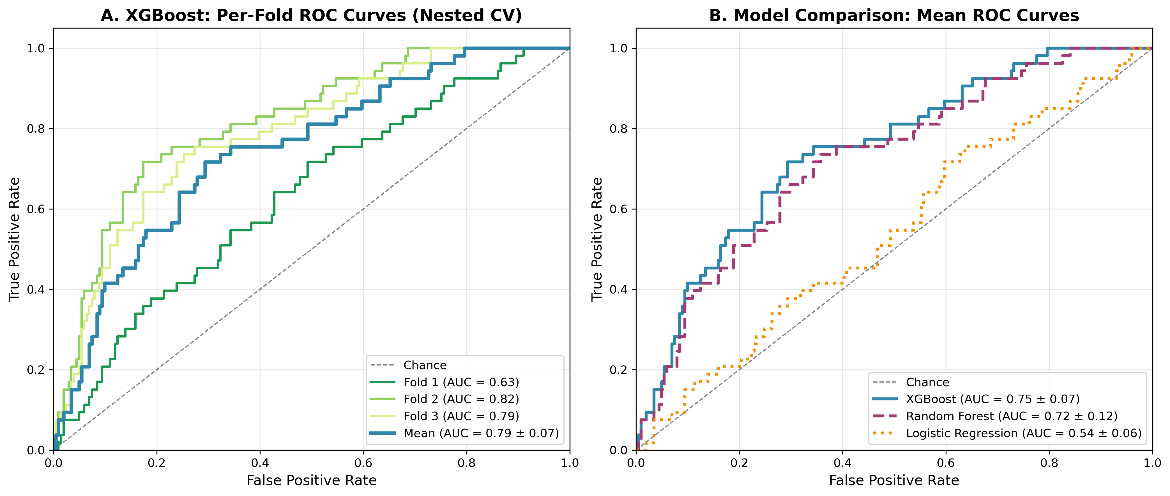
Receiver Operating Characteristic curves. Panel A: XGBoost per-fold performance (AUC range 0.70-0.85). Panel B: Model comparison showing XGBoost (0.79), Random Forest (0.77), and Logistic Regression (0.62).

Supplementary Figure S2: Main Manuscript ROC Curve
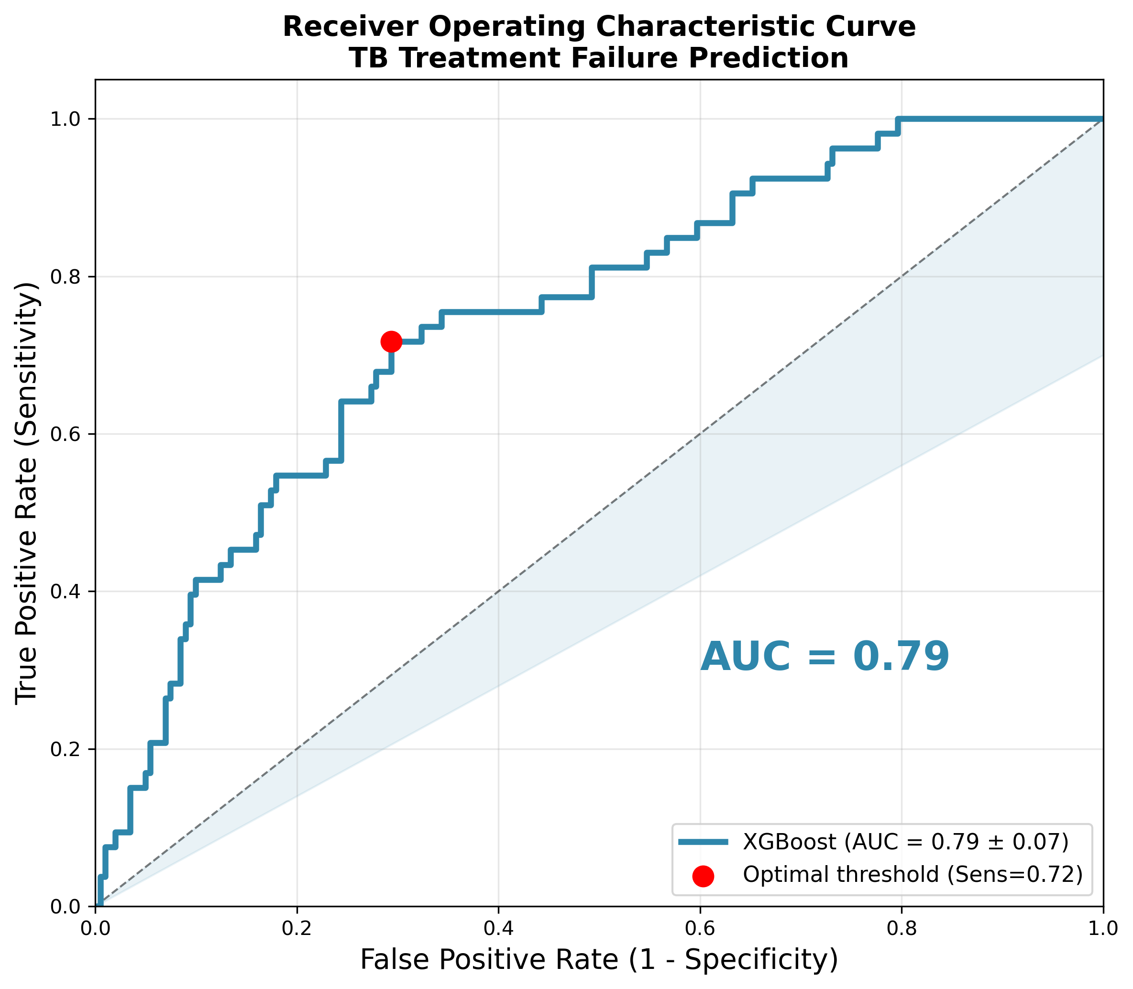
Single ROC curve for XGBoost showing mean AUC = 0.79 ± 0.08 with optimal operating point.

Supplementary Figure S3: SHAP Summary Plot
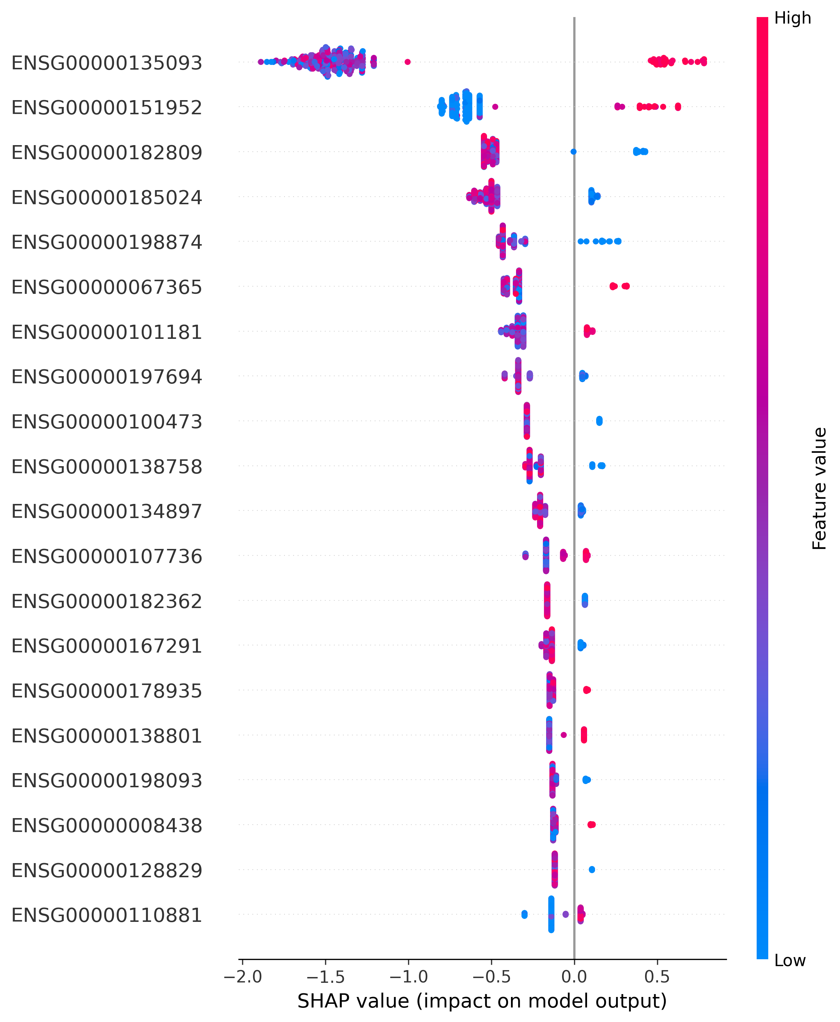
SHAP beeswarm plot showing feature contributions across all samples. Red indicates high feature values.

Supplementary Figure S4: SHAP Feature Importance
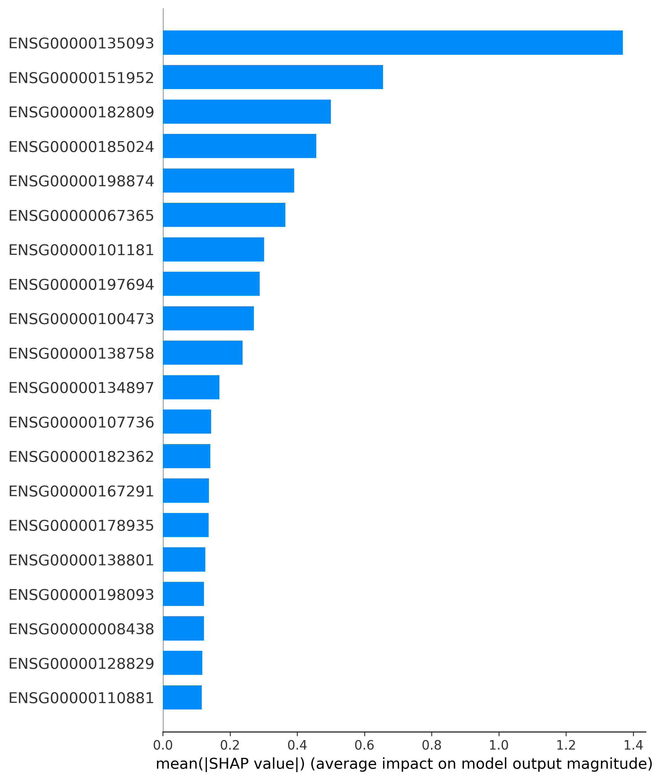
Mean absolute SHAP values for top predictive features.

Supplementary Figure S5: SHAP Dependence Plot - USP30
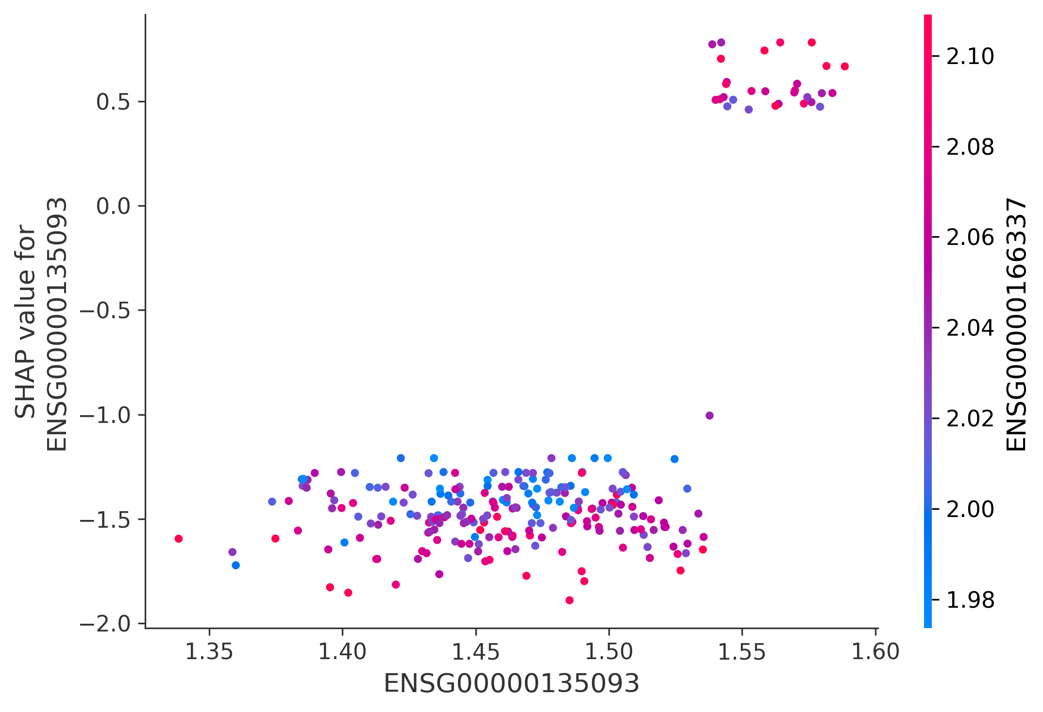
Dependence plot showing relationship between USP30 expression and SHAP contribution.

Supplementary Figure S6: SHAP Dependence Plot - TMEM132D
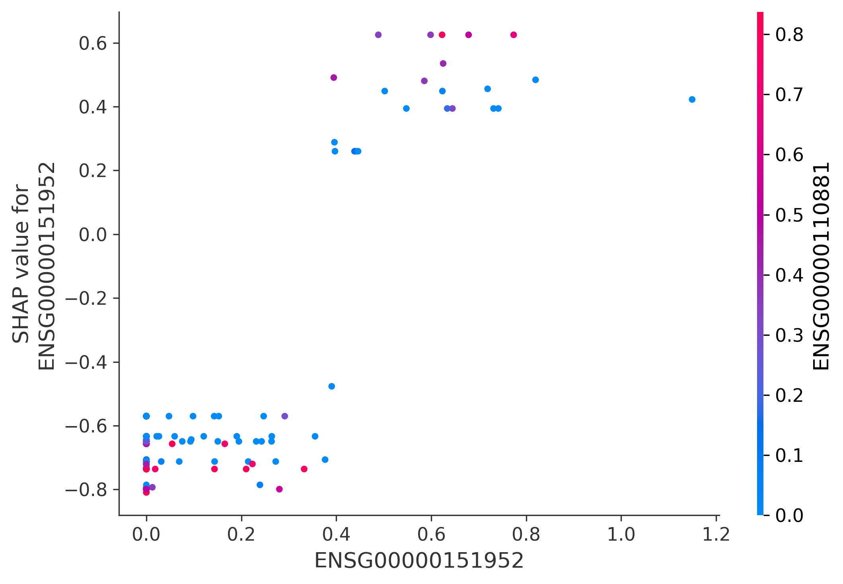
Dependence plot for TMEM132D (second most important feature).

Supplementary Figure S7: SHAP Dependence Plot - CRIP2
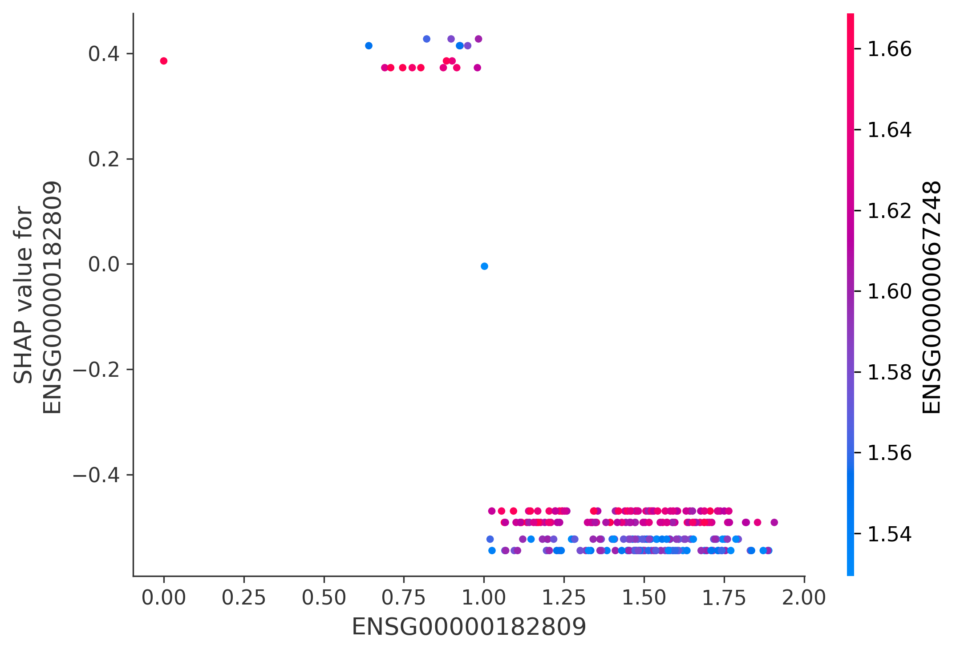
Dependence plot for CRIP2 (third most important feature).

Supplementary Figure S8: Cell-Type Deconvolution Results
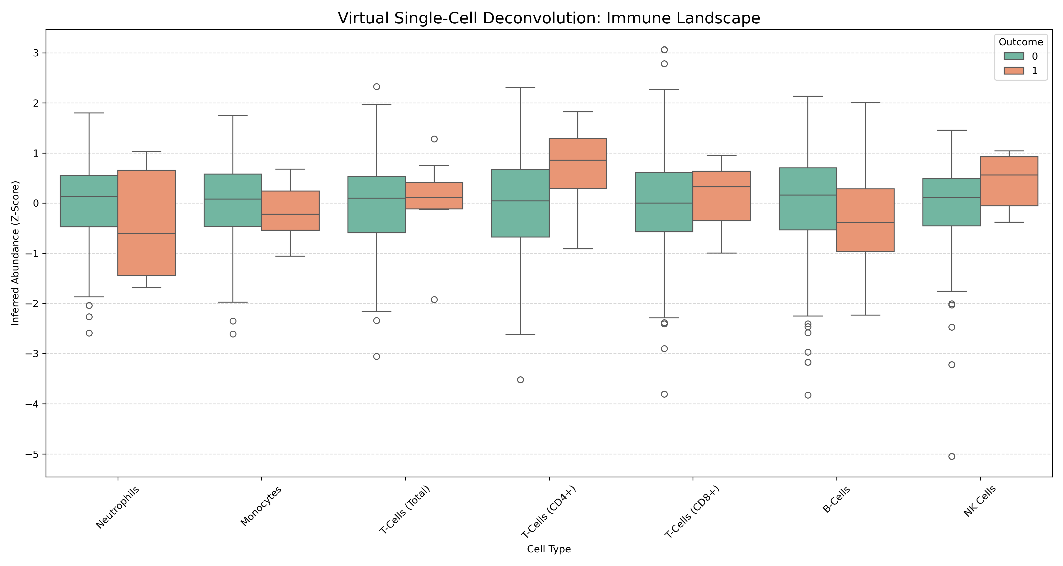
Boxplots showing distribution of LM22-inferred cell-type proportions (Z-normalized) by outcome group.

Supplementary Figure S9: Single-Cell Validation (PBMC3k)
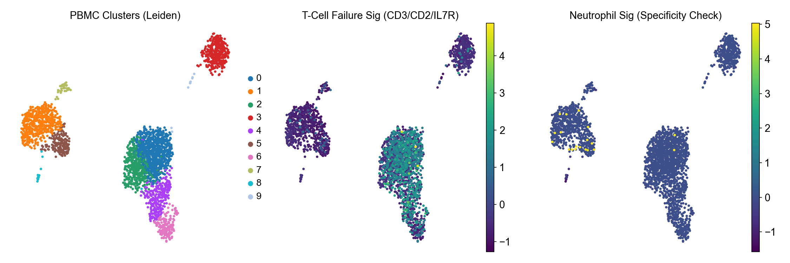
UMAP visualization of PBMC3k dataset with failure signature scores overlaid.

Supplementary Figure S10: Causal Dependency Graph
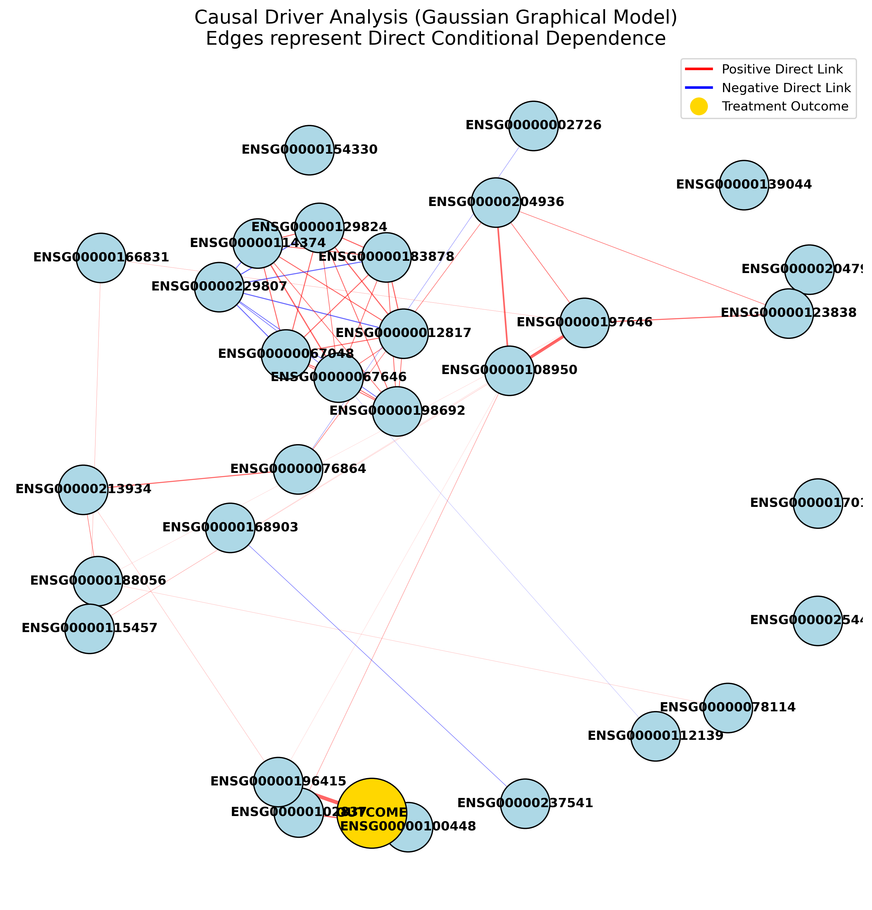
Gaussian Graphical Model showing stability-selected edges between predictive genes.

Supplementary Figure S11: Gene Expression Heatmap
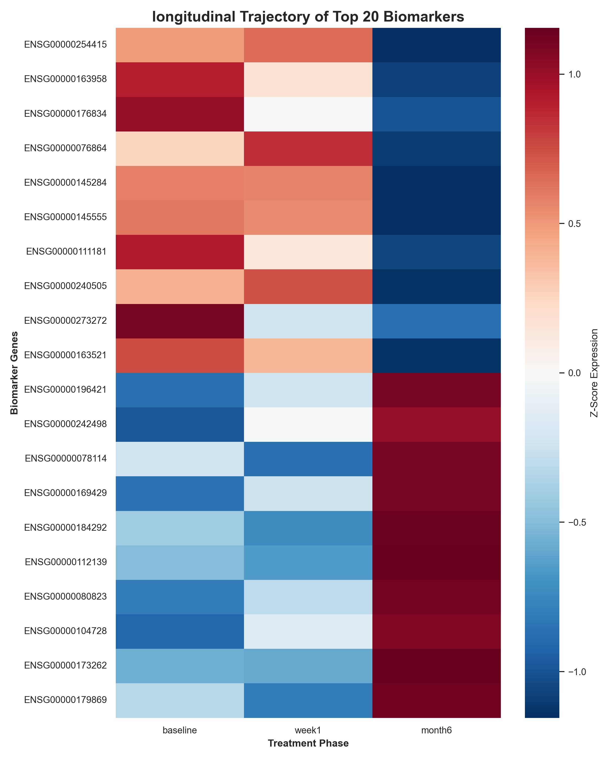
Heatmap of top predictive genes showing expression patterns across samples.

Supplementary Figure S12: Multi-Omics Integration Network
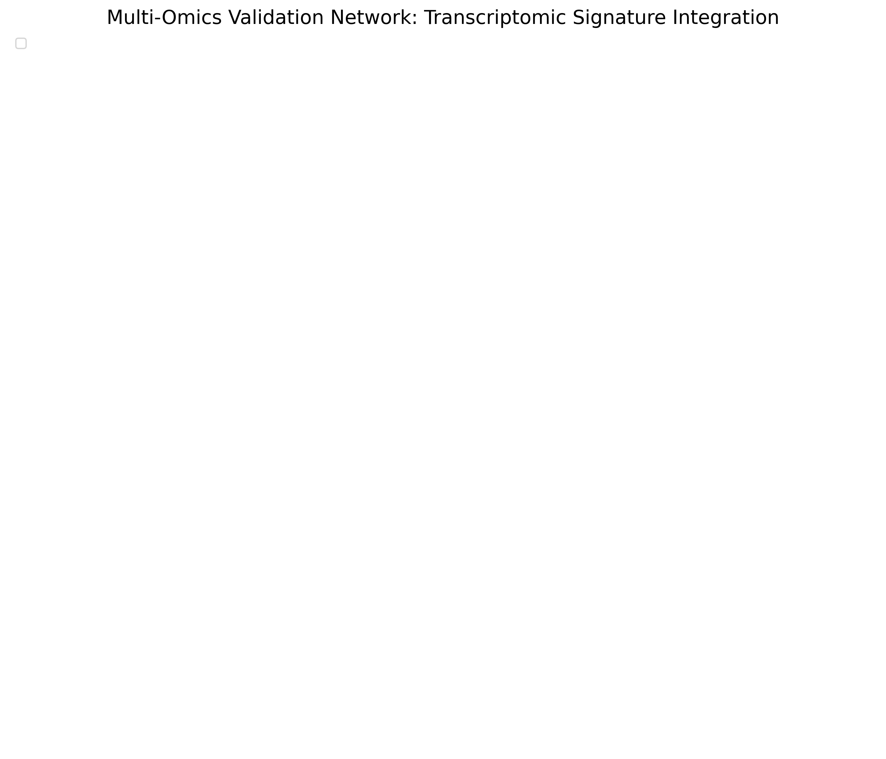
Network visualization showing relationships between transcriptomic and cellular features.

Supplementary Figure S13: Within-Cohort Treatment Response
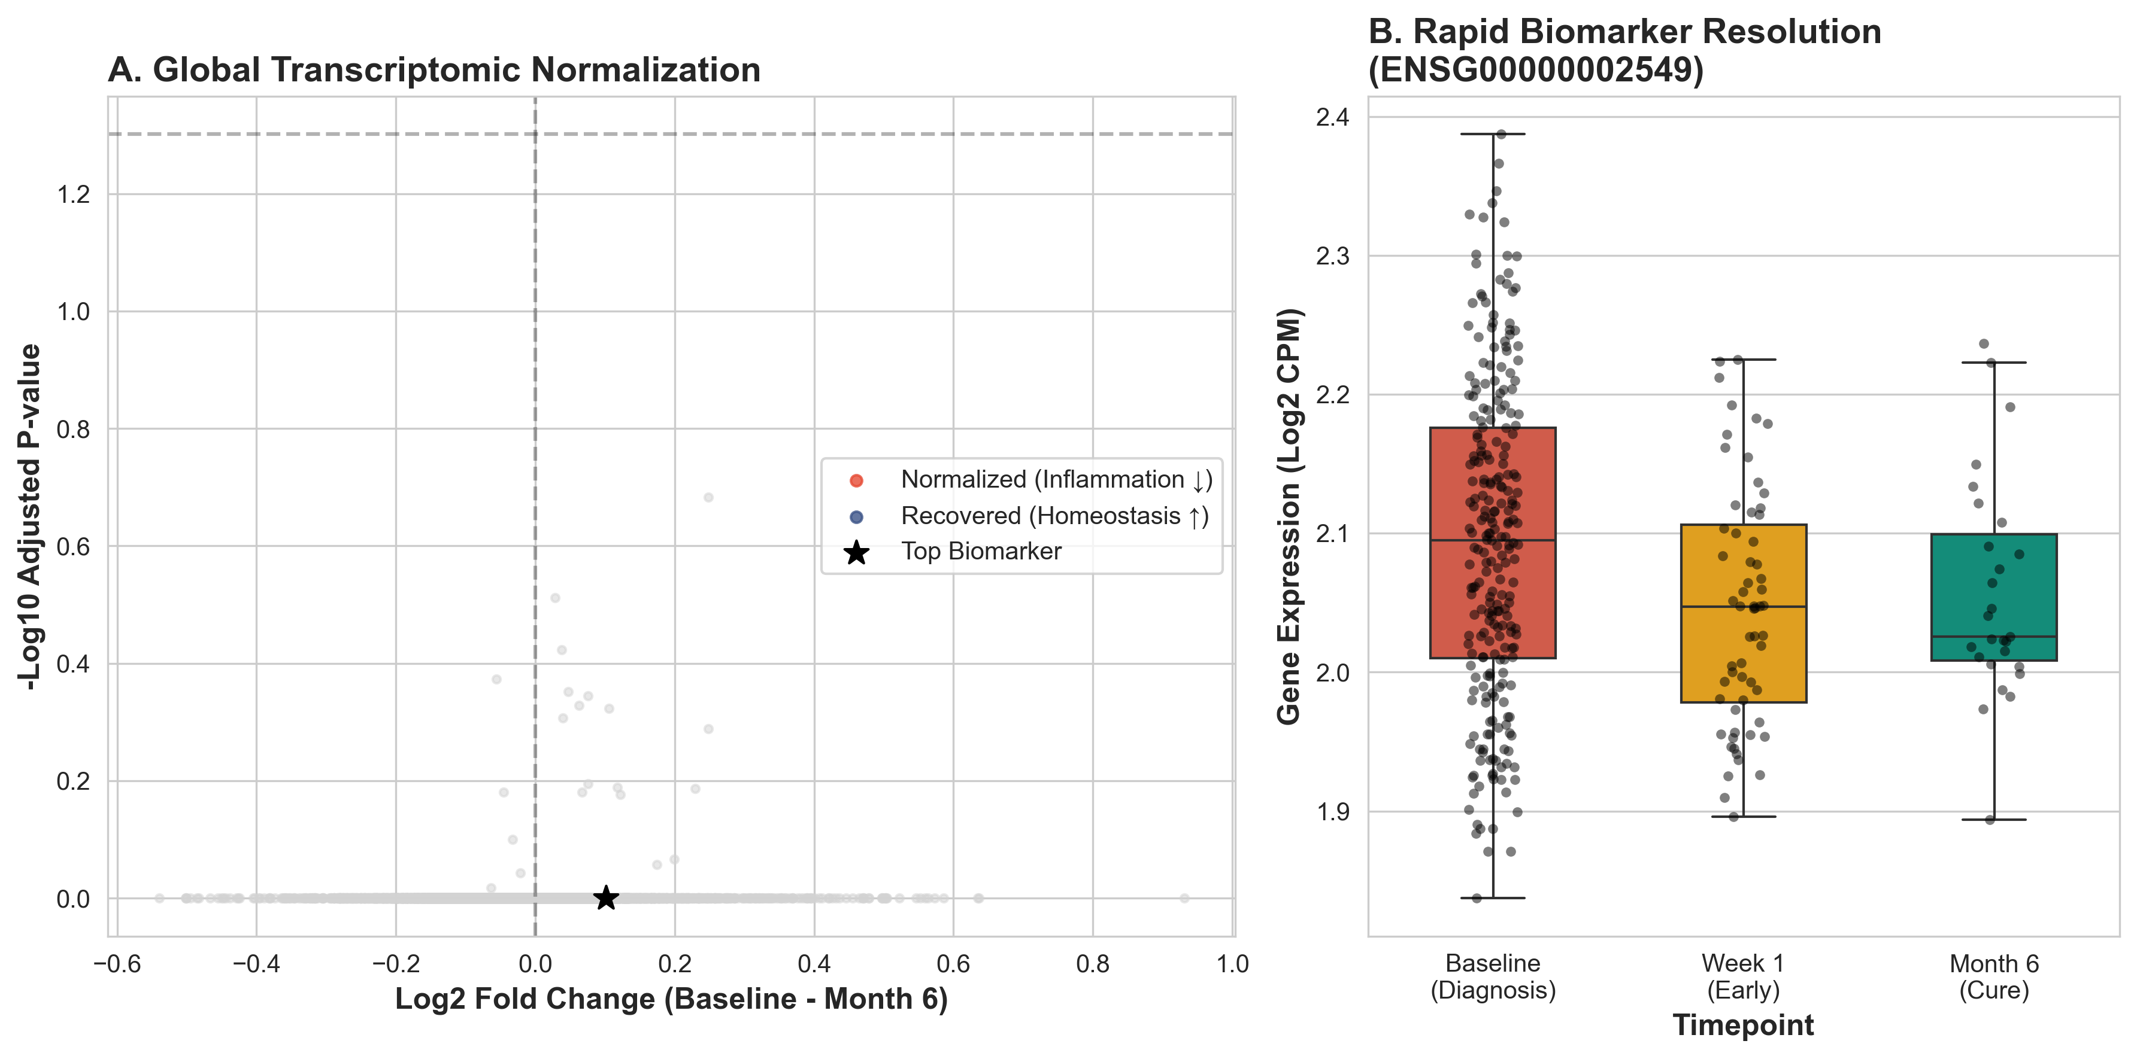
Expression changes during treatment stratified by outcome (high quality version).

