Supplementary Data
Analysis of Transcriptome and Metabolome Reveals the Regulatory Mechanism of DHA Synthesis in Aurantiochytrium sp. YHPM1
Shuxian Pang ª, Prabhakaran, Pranesha^{b}, Wu Yang^{c}, Fanyue Li ª, Xiuwen Wangª,
Muhammad Tariq Saeed ª, Yuanda Song ^{a,c,}
ª Colin Ratledge Center for Microbial Lipids, School of Agricultural Engineering and Food Science, Shandong University of Technology, Zibo 255000, Shandong, China
^{b} College of Food Science and Engineering, Shandong Agricultural University, Taian 271018, China
^{c} School of Public Health, Qilu Medical University, Zibo 255300, Shandong, China
^{d} School of Basic Medicine, Qilu Medical University, Zibo 255300, Shandong, China
* Corresponding author
Email address: ysong@sdut.edu.cn (Y. Song)

Table S1 Summary of RNA-seq sequencing quality for Aurantiochytrium sp. SW1 and YHPM1 at 48 h and 108 h
Sample | Clean reads (million) | Clean data (Gb) | Clean reads (%) | Clean data (%) | Q20 (%) | Q30 (%) | N (%) | GC content (%)
SW48_1 | 50.89 | 7.64 | 98.86 | 98.34 | 98.64 | 96.00 | 0.049 | 46.8
SW48_2 | 42.06 | 6.31 | 99.20 | 98.57 | 98.41 | 95.34 | 0.0013 | 47.2
SW48_3 | 37.84 | 5.69 | 99.34 | 98.87 | 98.58 | 95.79 | 0.0013 | 46.9
SW108_1 | 41.56 | 6.24 | 99.28 | 98.79 | 98.55 | 95.71 | 0.0014 | 47.6
SW108_2 | 40.97 | 6.16 | 99.20 | 98.83 | 98.51 | 95.60 | 0.0013 | 46.5
SW108_3 | 47.01 | 7.07 | 99.24 | 98.81 | 98.51 | 95.57 | 0.0014 | 47.0
YH48_1 | 42.01 | 6.31 | 99.29 | 98.73 | 98.56 | 95.70 | 0.0014 | 49.5
YH48_2 | 44.96 | 6.75 | 99.23 | 98.71 | 98.50 | 95.57 | 0.0014 | 50.1
YH48_3 | 40.78 | 6.13 | 99.25 | 98.77 | 98.51 | 95.59 | 0.0013 | 50.3
YH108_1 | 41.91 | 6.31 | 99.27 | 99.00 | 98.47 | 95.44 | 0.0014 | 50.8
YH108_2 | 48.26 | 7.26 | 98.97 | 98.64 | 98.49 | 95.52 | 0.0260 | 49.9
YH108_3 | 49.13 | 7.39 | 98.86 | 98.51 | 98.73 | 96.19 | 0.0321 | 50.5

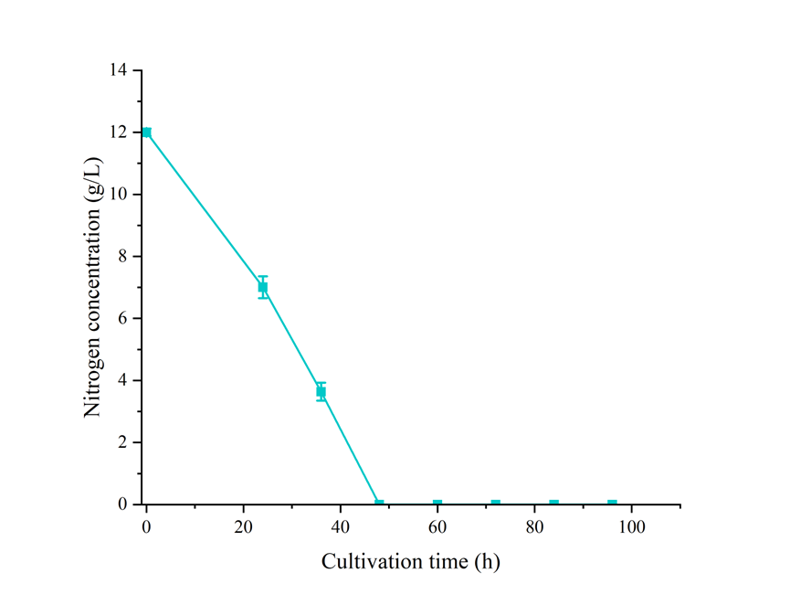
Supplementary Figure S1. The temporal progression of nitrogen depletion during the cultivation of Aurantiochytrium sp. YHPM1. Nitrogen was nearly depleted at 48 h, which was defined as the nitrogen depletion point for subsequent omics analyses.

