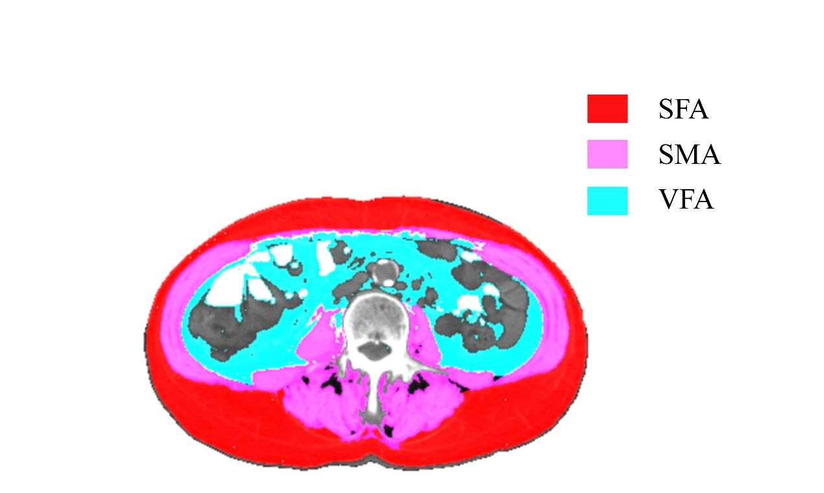
Supplementary Figure 1A. Measurement of skeletal muscle and fat cross-sectional area at the L3 vertebral level in CT scans of CRC patients without LNM. LNM = lymph node metastasis, CRC = colorectal cancer.

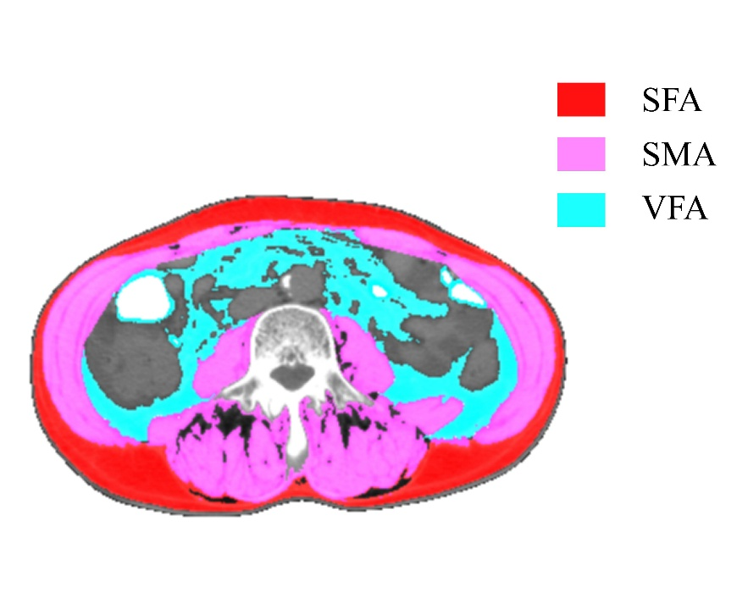
Supplementary Figure 1B. Measurement of skeletal muscle and fat cross-sectional area at the L3 vertebral level in CT scans of CRC patients with LNM. LNM = lymph node metastasis, CRC = colorectal cancer.

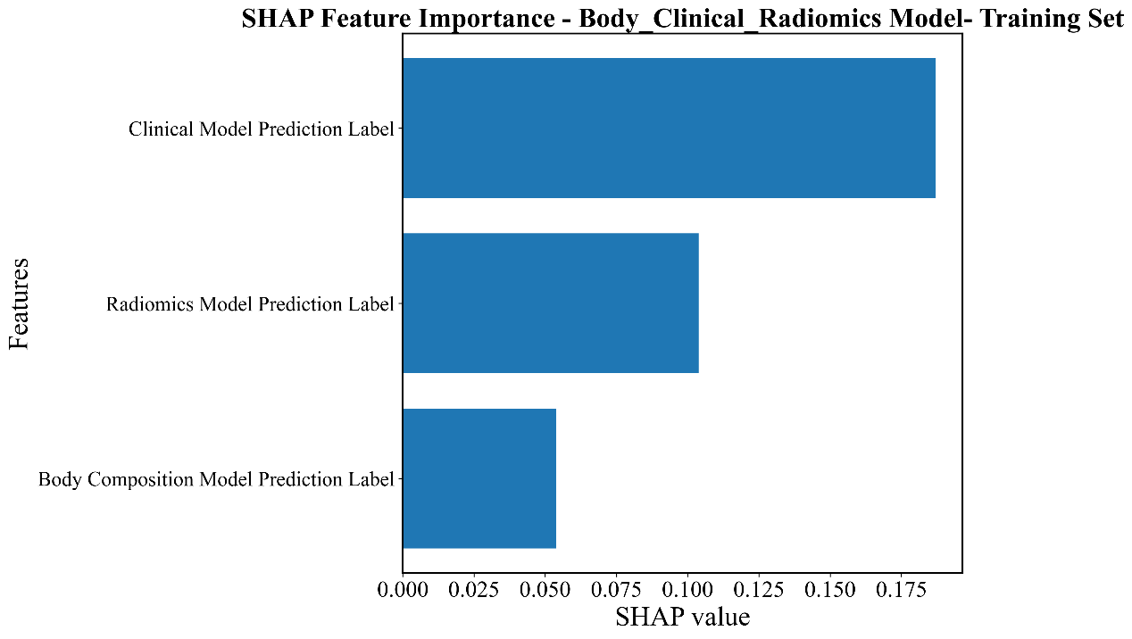
Supplementary Figure 2A. Histogram of SHAP values for the Body_Clinical_Radiomics model in the training set. This Figurer displays the global feature importance of the Body_Clinical_Radiomics model, sorted by absolute SHAP values. SHAP = Shapley Additive Property.

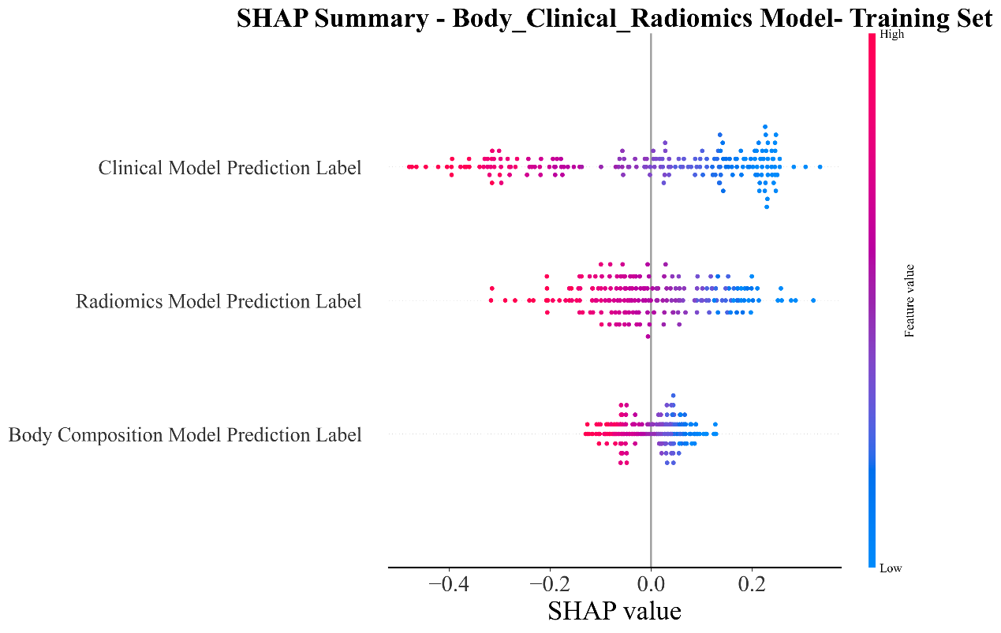
Supplementary Figure 2B. Summary plot of SHAP values for the Body_Clinical_Radiomics model in the training set. This Figure displays the distribution of SHAP values across all samples in the Body_Clinical_Radiomics model. SHAP = Shapley Additive Property.

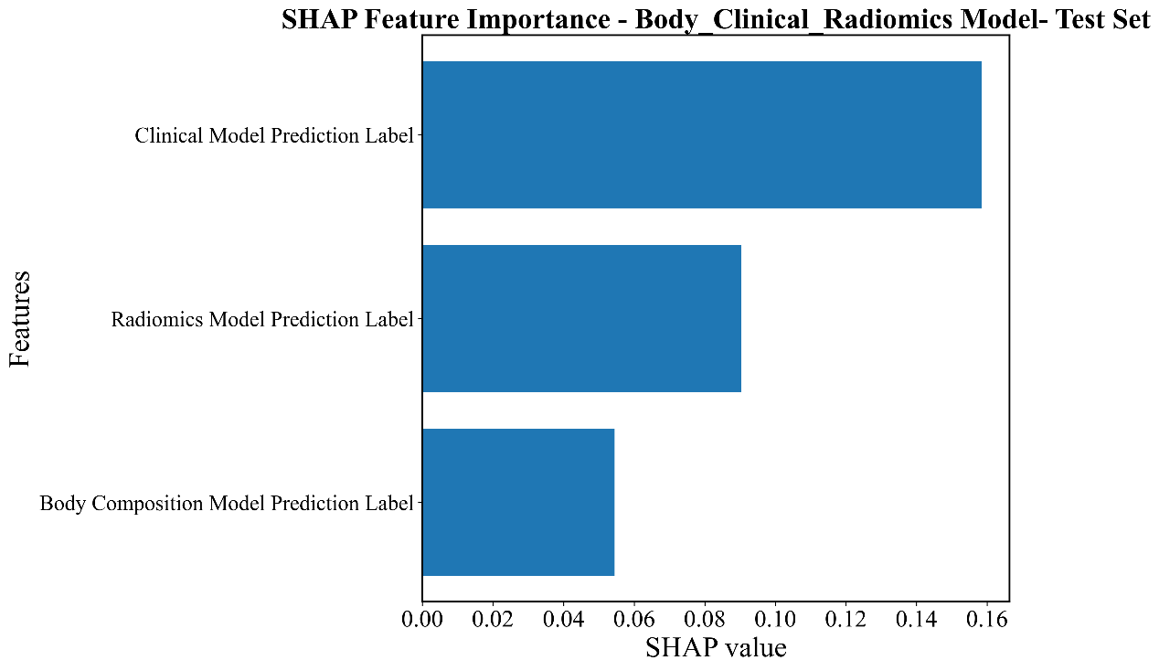
Supplementary Figure 2C. Histogram of SHAP values for the Body_Clinical_Radiomics model in the test set. This Figure displays the global feature importance of the Body_Clinical_Radiomics model, sorted by absolute SHAP values. SHAP = Shapley Additive Property.

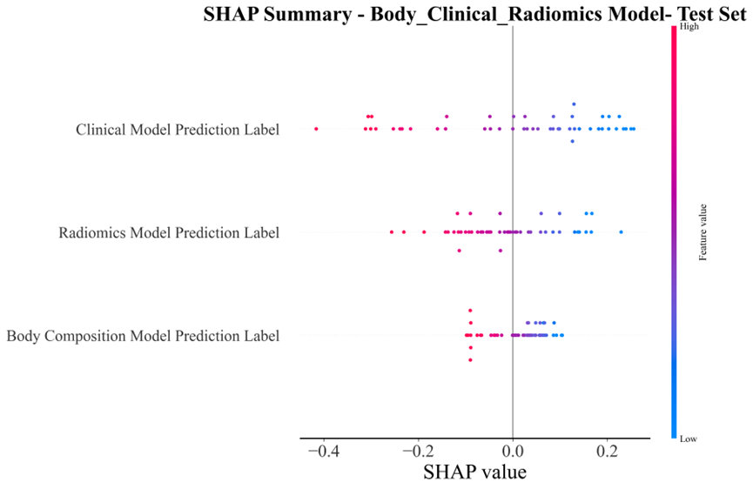
Supplementary Figure 2D. Summary plot of SHAP values for the Body_Clinical_Radiomics model in the test set. This Figure displays the distribution of SHAP values across all samples in the Body_Clinical_Radiomics model. SHAP = Shapley Additive Property.

