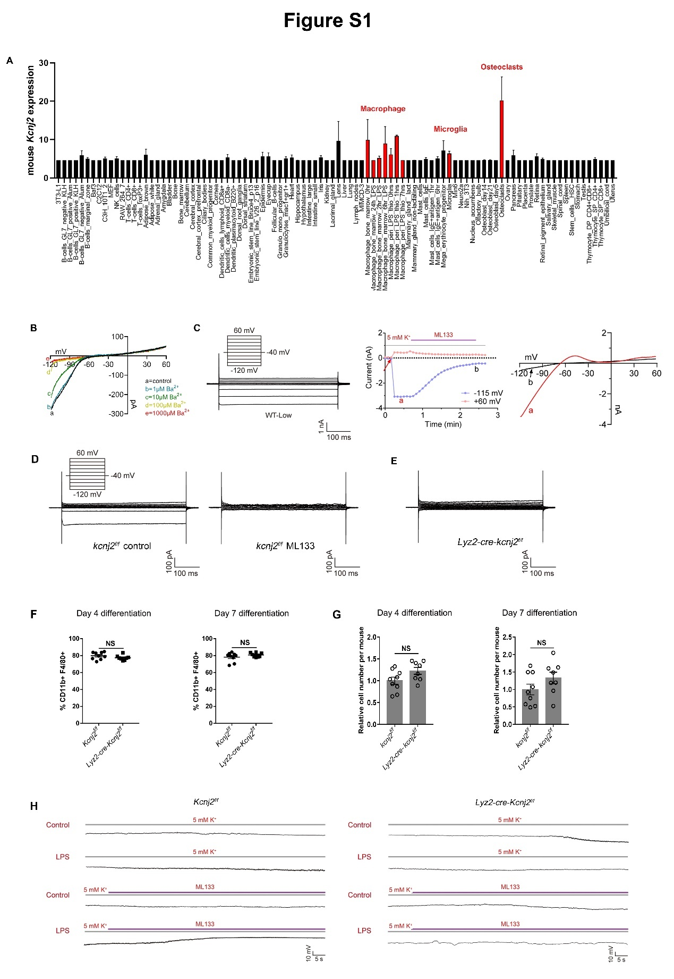
Figure S1. Kir2.1 is highly expressed and regulates the membrane potential in primary macrophages
(A) Kcnj2 expression levels in different mouse tissues and cell types. Expression patterns in macrophages and other specialized macrophages were annotated and showed in red. Data was downloaded from BioGPS (http://ds.biogps.org/?dataset=GSE10246&gene=16518).
(B) Electrophysiological properties of mouse peritoneal macrophages using patch-clamp. Thioglycolate elicited mouse peritoneal macrophages were isolated and seeded onto cover slip to adhere, then subjected to patch-clamp experiments. Whole cell patch clamp was performed and ramp from -120mV to +60 mV in 500 ms under physiological condition (5 mM K⁺ outside, 140 mM K⁺ inside) in the presence or absence of different concentration of Ba²⁺.
(C) Electrophysiological properties of HEK293 cells transfected with Kir2.1. The representative traces are shown in the left when applying voltage steps from -120 mV to +60 mV with 20 mV increments for 500 ms under physiological condition (5 mM K⁺ outside, 140 mM K⁺ inside). Inset represents the stimulation protocol. The current-time curves at -115 mV and +60 mV with 50 μM ML133 treatments are shown in the middle. The representative traces of the I-V relationship at two time points of ‘a’ (before ML133) and ‘b’ (after ML133) as indicated in the middle are shown in the right, respectively.
(D) Electrophysiological properties of mouse peritoneal macrophages. The representative traces are shown in the left when applying voltage steps from -120 mV to +60 mV with 20 mV increments for 500 ms under physiological condition (5 mM K⁺ outside, 140 mM K⁺ inside). Shown in the right was the representative traces under the inhibition condition of 50 μM ML133 treatment.
(E) Electrophysiological properties of Kir2.1 knockout mouse peritoneal macrophages. The representative traces are shown when applying voltage steps from -120 mV to +60 mV with 20 mV increments for 500 ms under physiological condition (5 mM K⁺ outside, 140 mM K⁺ inside).
(F and G) Quantification of percentages (F) and numbers (G) of BMDMs on days 4 and 7 after ex vivo differentiation from bone marrow cells from control and Lyz2-cre-Kcnj2^{f/f} mice. For each mouse, bone marrow cells were flushed from tibias and femurs with cold DMEM, then cultured in 6-well plate with 1/10 of the cells in each well (2 wells were used for further detection in day 4 and day 7) in DMEM supplemented with 10% fetal bovine serum (FBS), 1% penicillin/streptomycin, and 10 ng/ml macrophage colony-stimulating factor (PeproTech) to generate BMDMs. In day 4 and 7, cells were harvested and the number and percentage of macrophages (CD11b⁺ F4/80⁺) were analyzed by FACS. Last, these data were normalized as “relative cell number/mouse” (control, n=9; Lyz2-cre-Kcnj2^{f/f}, n=8; mean ± SEM).
(H) Dynamic membrane potential traces of WT and Kir2.1 knockout mouse peritoneal macrophages. Mouse peritoneal macrophages were isolated and seeded onto cover slip to adhere, then cells were subjected to patch-clamp experiments directly or followed by 500 ng/ml LPS treatment for 1 h. Then the membrane potential was dynamically detected by patch clamp under conditions of 5 mM K⁺ or 50 μM ML133 in 5 mM K⁺.
NS, p >0.05 (two-tailed unpaired Student’s t-test).

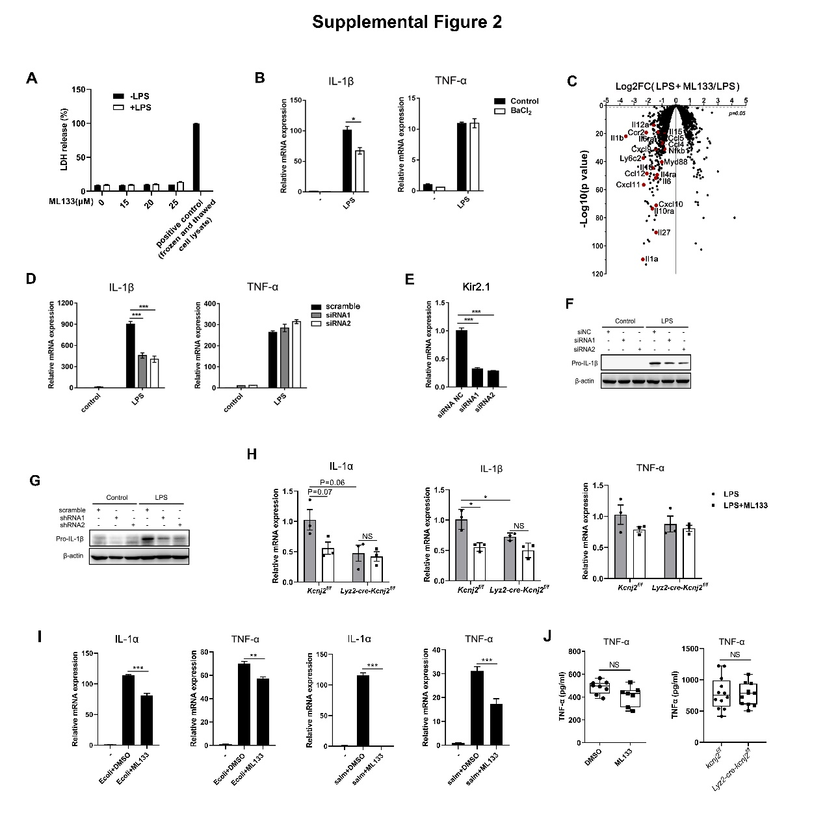
Figure S2. Kir2.1 promotes LPS- and infection-induced inflammatory cytokines and pathological inflammation
(A) LDH release of mouse peritoneal macrophages treated with or without 500 ng/ml LPS in the presence or absence of different concentrations of ML133 as indicated. For positive control, cells were frozen and thawed to totally release the intracellular LDH.
(B) IL-1β and TNF-α mRNA transcription assay. Mouse peritoneal macrophages treated with 500 ng/ml LPS for 6 h in the presence or absence of BaCl₂ (1 mM), then mRNA expression levels were analyzed by qPCR (mean ± SD).
(C) Volcano plot showing the downregulation of inflammatory genes. BMDMs were treated with 500 ng/ml LPS for 6 h in the presence or absence of ML133 (25 μM), then RNA was extracted for RNA-sequencing.
(D-F) IL-1β, TNF-α (D), Kir2.1 (E) mRNA transcription of and pro-IL-1β protein expression (F) assay. BMDMs transfected with scrambled control or Kcnj2-specific siRNAs and treated with 500 ng/ml LPS for 6 h followed by qPCR and western blot analysis. (mean ± SD).
(G) Pro-IL-1β protein expression assay. iBMDMs stably transfected with scrambled control or Kcnj2-specific shRNAs were treated with 500 ng/ml LPS for 6 h followed by western blot analysis.
(H) IL-1α, IL-1β, and TNF-α mRNA transcription assay. Mouse peritoneal macrophages from WT or Lyz2-cre-Kcnj2^{f/f} mice treated with 500 ng/ml LPS for 6 h in the presence or absence of ML133 (25 μM) followed by qPCR analysis (n=3, mean ± SEM).
(I) IL-1α and TNF-α mRNA transcription levels detected by qPCR. Peritoneal macrophages infected with E.coli or salmonella SL1344 for 6h in the presence or absence of ML133 (25 μM), then mRNA expression levels were analyzed by qPCR (mean ± SD).
(J) TNF-α levels in serum from sepsis mice. 8-week-old WT or Lyz2-cre-Kcnj2^{f/f} mice were intraperitoneally infected with E.coli in the presence or absence of ML133 (30 mg/kg) for 4 h, then mice were sacrificed and IL-1β levels in serum were measured by ELISA (DMSO, n=8; ML133, n=7; Kcnj2^{f/f}, n=12, Lyz2-cre-Kcnj2^{f/f}, n=11; mean ± SEM).
*p <0.05, **p <0.01,***p <0.001 (two-tailed unpaired Student’s t-test). The qPCR and western blot data are representative of three independent experiments.
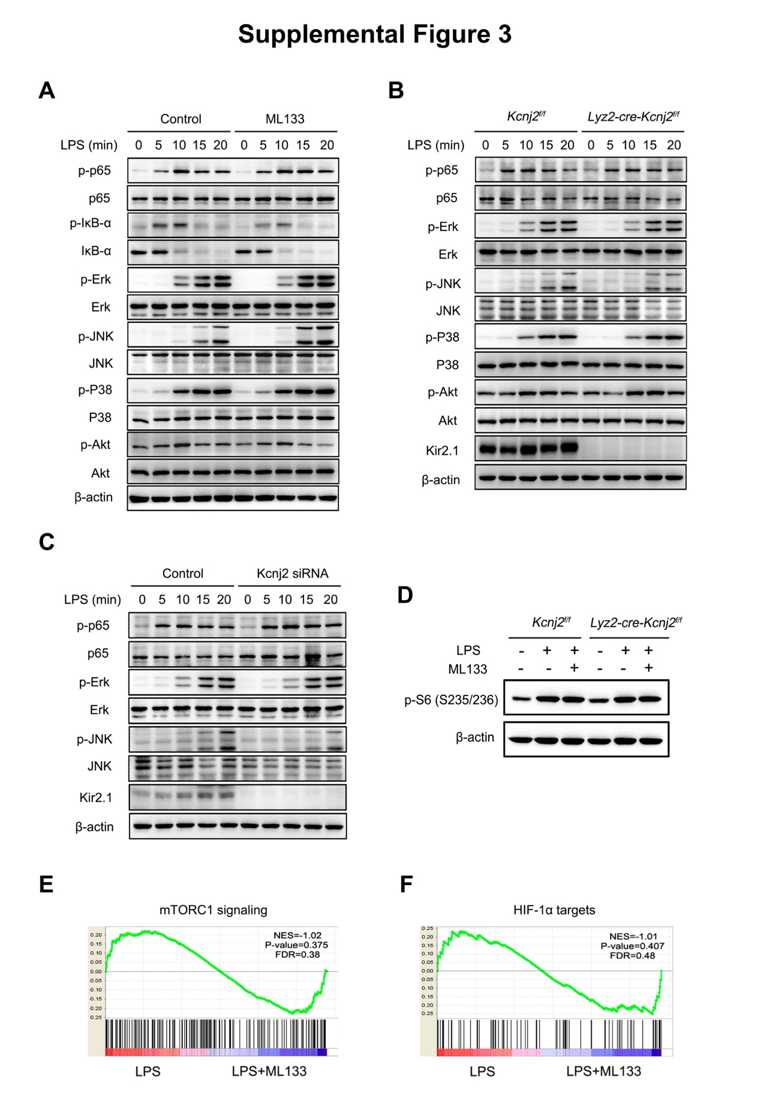Figure S3. Kir2.1 promotes glucose uptake and consumption in inflammatory macrophages
(A) Activation of TLR4-mediated downstream signaling pathways in 500 ng/ml LPS-treated peritoneal macrophages in the presence or absence of ML133 (25 μM).
(B-D) Activation of TLR4-mediated downstream signaling pathways in 500 ng/ml LPS-treated peritoneal macrophages from control and Lyz2-cre-Kcnj2^{f/f} mice (B and D), and from BMDMs transfected with scrambled control or Kcnj2-specific siRNAs (C).
(E and F) GSEA showing no significant enrichment of mTORC1 signaling and HIF-1α targets (n=3). BMDMs were treated with 500 ng/ml LPS for 6 h in the presence or absence of ML133 (25 μM), then RNA was extracted for RNA-sequencing. NES, normalized enrichment score. FDR, false discovery rate.
The western blot data are representative of three independent experiments.

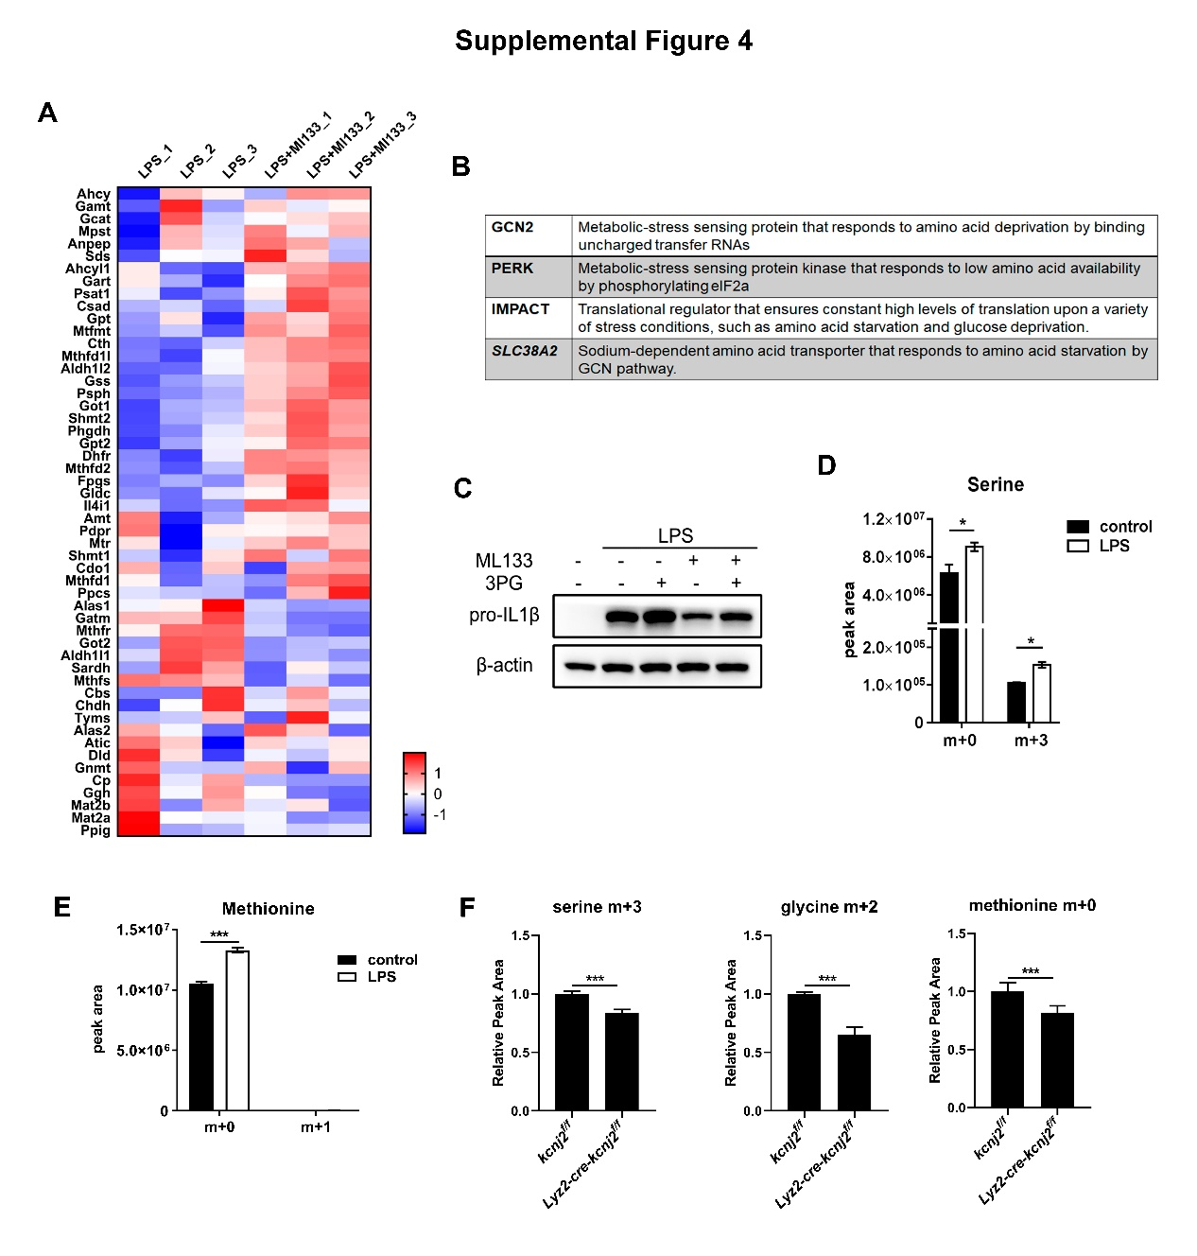
Figure S4. Kir2.1 loss-of-function leads to blunted glycolysis offshoots and SGOC metabolism in LPS-stimulated macrophages
(A) Heatmap showing the expression of genes involved in SGOC metabolism. BMDMs were treated with 500 ng/ml LPS for 6 h in the presence or absence of ML133 (25 μM), then RNA was extracted for RNA-sequencing.
(B) Brief descriptions of the four overlapped genes upregulated by both ML133 (25 μM) and Kir2.1 genetic-deficiency in macrophages.
(C) Pro-IL-1β Expression levels analyzed by western blot. Mouse peritoneal macrophages were treated with or without 500 ng/ml LPS and 25 μM ML133 for 6 h in the presence or absence of 3-PG (1.5 mM).
(D and E) Mass isotopomer distribution analysis of metabolites derived from glucose. Mouse peritoneal macrophages treated with 500 ng/ml LPS for 6 h in medium containing U-[¹³C]-glucose (25 mM), then metabolites were extracted and the labeled serine and methionine were analyzed by LC-MS (n=5, mean ± SEM).
(F) Mass isotopomer distribution analysis of metabolites derived from serine. Mouse peritoneal macrophages from control and Lyz2-cre-Kcnj2^{f/f} mice were treated with 500 ng/ml LPS for 6 h in medium containing U-[¹³C]-serine (0.4 mM), then metabolites were extracted and the labeled serine, glycine and methionine were analyzed by LC-MS. (n=4, mean ± SEM).
*p <0.05, **p <0.01, ***p <0.001 (two-tailed unpaired Student’s t-test). The western blot data are representative of three independent experiments.

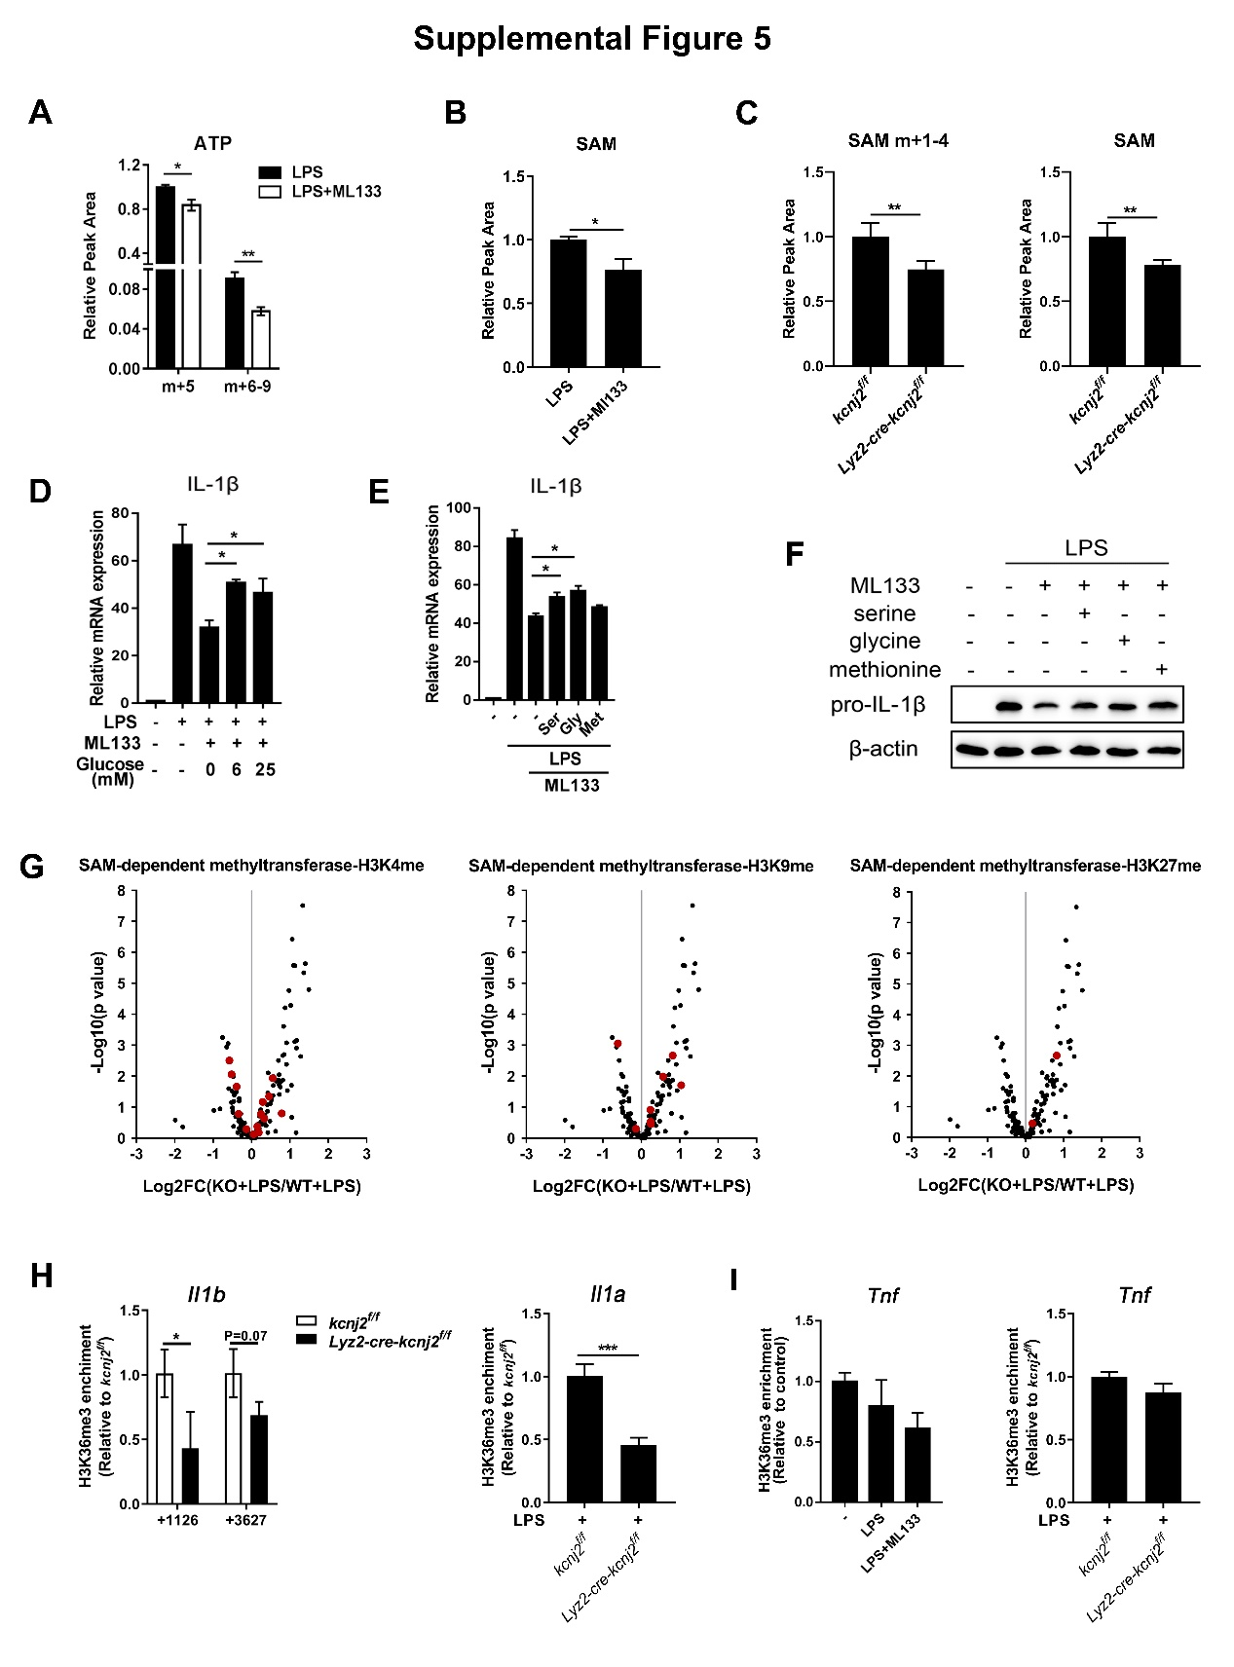
Figure S5. Kir2.1 supports S-adenosylmethionine generation and configures histone methylation in inflammatory macrophages
(A) Mass isotopomer distribution analysis of ATP derived from glucose. Mouse peritoneal macrophages treated with 500 ng/ml LPS for 6 h with or without ML133 (25 μM) in medium containing U-[¹³C]-glucose (25 mM), then metabolites were extracted and the labeled ATP was analyzed by LC-MS (n=5, mean ± SEM).
(B) Mass isotopomer distribution analysis of SAM derived from glucose. Mouse peritoneal macrophages treated with 500 ng/ml LPS for 6 h with or without ML133 (25 μM) in medium containing U-[¹³C]-glucose (25 mM), then metabolites were extracted and the total amount of SAM was analyzed by LC-MS (n=5, mean ± SEM).
(C) Mass isotopomer distribution analysis of SAM derived from serine. Mouse peritoneal macrophages from control and Lyz2-cre-Kcnj2^{f/f} mice treated with 500 ng/ml LPS for 6 h in medium containing U-[¹³C]-serine (0.4 mM), then metabolites were extracted and the labeled and total amount of SAM were analyzed by LC-MS (n=5, mean ± SEM).
(D-F) IL-1β mRNA transcription analyzed by qPCR and pro-IL-1β expression levels analyzed by western blot. Mouse peritoneal macrophages treated with 500 ng/ml LPS and 25 μM ML133 for 6 h in the presence of additional glucose (D) or serine (0.4 mM), glycine (0.4 mM), or methionine (0.4 mM) (E and F) (mean ± SD).
(G) Methyltransferase genes expression levels analyzed by RNA-sequencing. Volcano plots showing the expression of methyltransferase genes for H3K4me, H3K9me, and H3K27me among 183 annotated SAM-dependent methyltransferase genes (Kottakis et al., 2016).
(H and I) ChIP-qPCR analysis of H3K36me3 enrichment in the Il1b, Il1a, Tnf genes. Mouse peritoneal macrophages from control and Lyz2-cre-Kcnj2^{f/f} mice were treated with 500 ng/ml LPS in the presence or absence of ML133 (25 μM) for 6 h, then cells were subjected to ChIP-qPCR analysis (mean ± SD).
*p <0.05, **p<0.01 (two-tailed unpaired Student’s t-test). The PCR and western blot data are representative of three independent experiments.
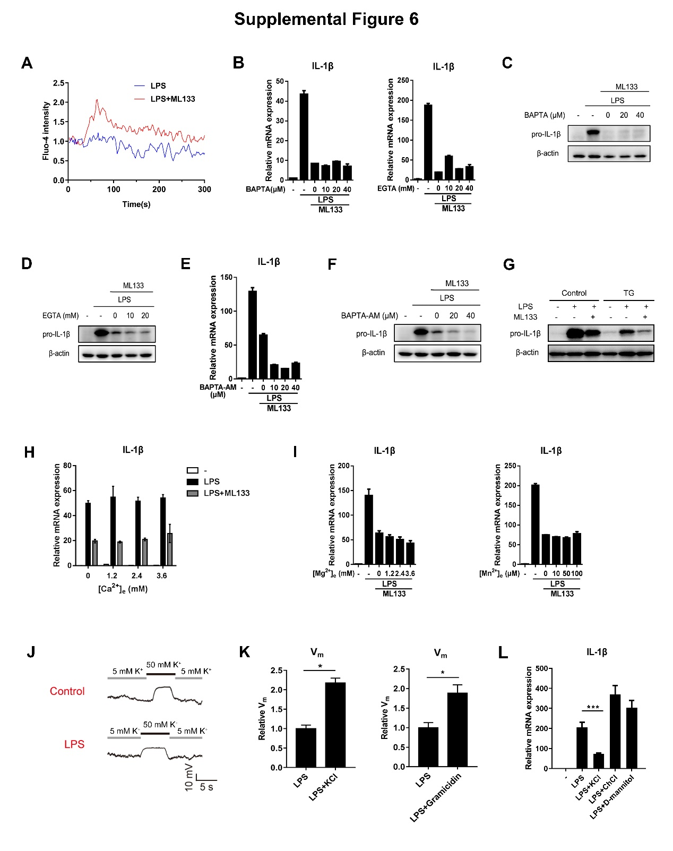
Figure S6. Kir2.1-mediated regulation of membrane potential orchestrates metabolic-epigenetic reprogramming in inflammatory macrophages
(A) Relative changes in the fluorescence of Fluo-4 AM-loaded mouse peritoneal macrophages, reflecting changes in intracellular Ca²⁺ concentration. cells were treated as indicated.
(B-F) IL-1β mRNA (B and E) transcription and pro-IL-1β protein expression levels (C, D, and F) of macrophages. Mouse peritoneal macrophages treated with 500 ng/ml LPS with 25 μM ML133 in the presence of BAPTA (B and C), EGTA (B and D), and BAPTA-AM (E and F) for 6 h followed by qPCR and western blot analysis.
(G) Pro-IL-1β protein expression levels of macrophages. Mouse peritoneal macrophages treated with 500 ng/ml LPS and 25 μM ML133 in the presence or absence of 1 μM TG as indicated for 6 h followed by western blot analysis.
(H and I) IL-1β mRNA transcription levels of macrophages. Mouse peritoneal macrophages treated with 500 ng/ml LPS and 25 μM ML133 in the presence of different concentrations of extracellular Ca²⁺ (H), Mg²⁺ (I), and Mn²⁺ (I) for 6 h followed by qPCR analysis (mean ± SD).
(J) Membrane potential assay of mouse peritoneal macrophages by patch clamp experiments. Mouse peritoneal macrophages treated with or without 500 ng/ml LPS for 1 h followed by dynamic membrane potential assay in different concentration of extracellular K⁺ by patch clamp experiments.
(K) Membrane potential assay of mouse peritoneal macrophages by the membrane potential sensitive fluorochrome DiBAC4(3). Mouse peritoneal macrophages treated with or without 500 ng/ml LPS for 1 h in the presence or absence of 50 mM KCl or 2 μM gramicidin followed by membrane potential assay with membrane potential sensitive fluorochrome DiBAC4(3) (mean ± SD).
(L) IL-1β mRNA transcription levels of macrophages. Mouse peritoneal macrophages treated with 500 ng/ml LPS in the presence of elevated [K⁺]_{e} (50 mM), choline chloride (50 mM), or D-mannitol (50 mM) for 6 h followed by qPCR analysis (mean ± SD).
*p <0.05, ***p <0.001 (two-tailed unpaired Student’s t-test). The qPCR, western blot and FACS data are representative of three independent experiments.

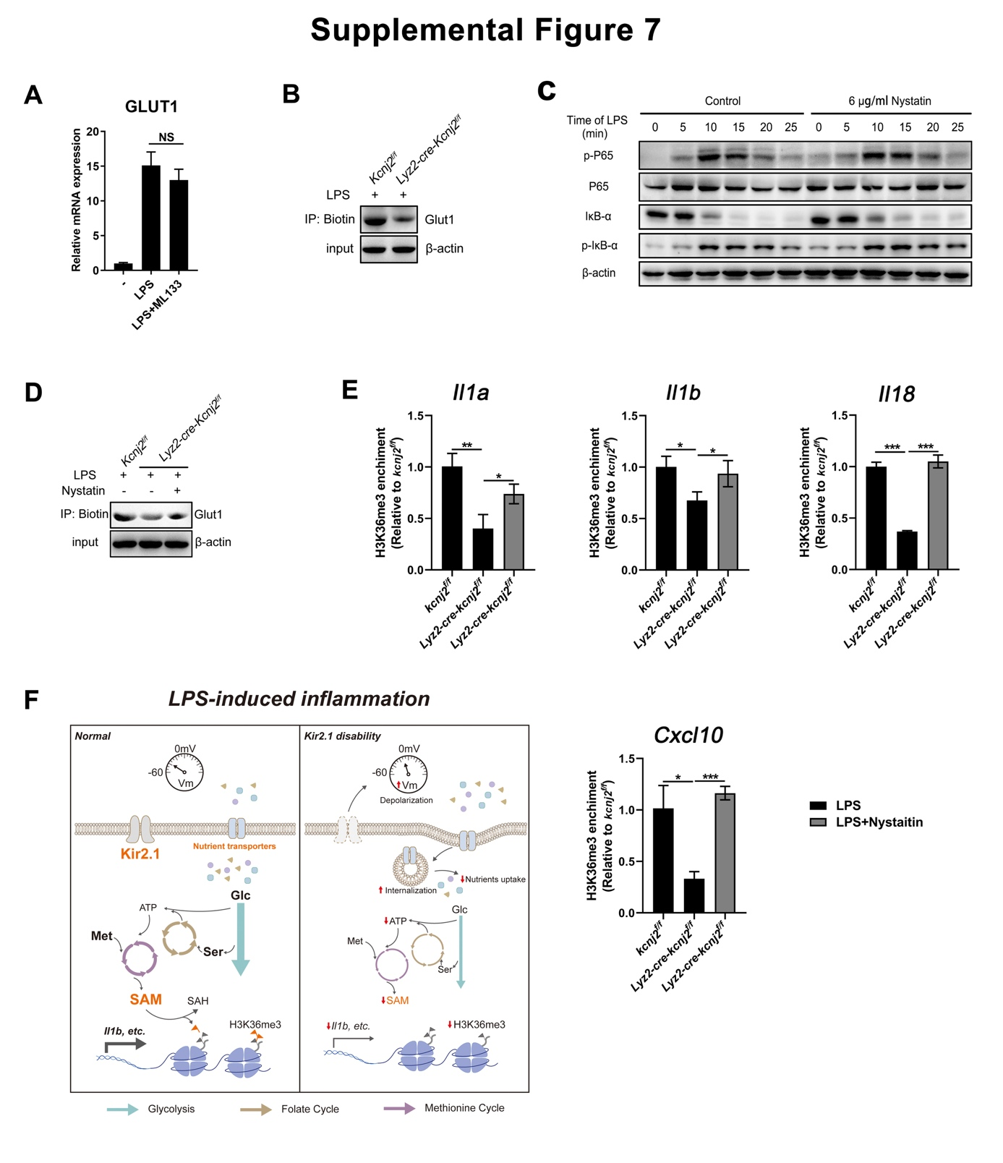Figure S7. Kir2.1 supports nutrient supply by promoting the surface expression of nutrient transporters in LPS-stimulated macrophages
- Glut1 mRNA transcription levels of macrophages. Mouse peritoneal macrophages treated with 500 ng/ml LPS in the presence or absence of ML133 (25 μM) for 6 h followed by qPCR analysis (mean ± SD).
- Membrane Glut1 expression assay. Peritoneal macrophages from control and Lyz2-cre-Kcnj2^{f/f} mice treated with 500 ng/ml LPS for 2 h, then Membrane Glut1 expression were detected by western blot of biotinylated membrane Glut1.
- Activation of TLR4-mediated downstream signaling pathways in 500 ng/ml LPS-treated peritoneal macrophages in the presence or absence of 6 μg/ml Nystatin.
- Membrane Glut1 expression assay. Peritoneal macrophages from control and Lyz2-cre-Kcnj2^{f/f} mice treated with 500 ng/ml LPS for 2 h in the presence or absence of 6 μg/ml Nystatin, then membrane Glut1 expression were detected by western blot of biotinylated membrane Glut1.
- ChIP-qPCR analysis of H3K36me3 enrichment in the Il1a, Il1b, Il18, and Cxcl10 genes. Mouse peritoneal macrophages from control and Lyz2-cre-Kcnj2^{f/f} mice were treated with 500 ng/ml LPS in the presence or absence of 6 μg/ml Nystatin for 6 h, then cells were subjected to ChIP-qPCR analysis (mean ± SD).
- Schematic of the role of Kir2.1 in driving LPS-induced inflammation by linking nutrient availability to the metabolic and epigenetic coordination in inflammatory macrophages.
*p <0.05, **p <0.01,***p <0.001 (two-tailed unpaired Student’s t-test). The qPCR and western blot data are representative of three independent experiments.

