Figure 1 Uncropped images of figure 1J

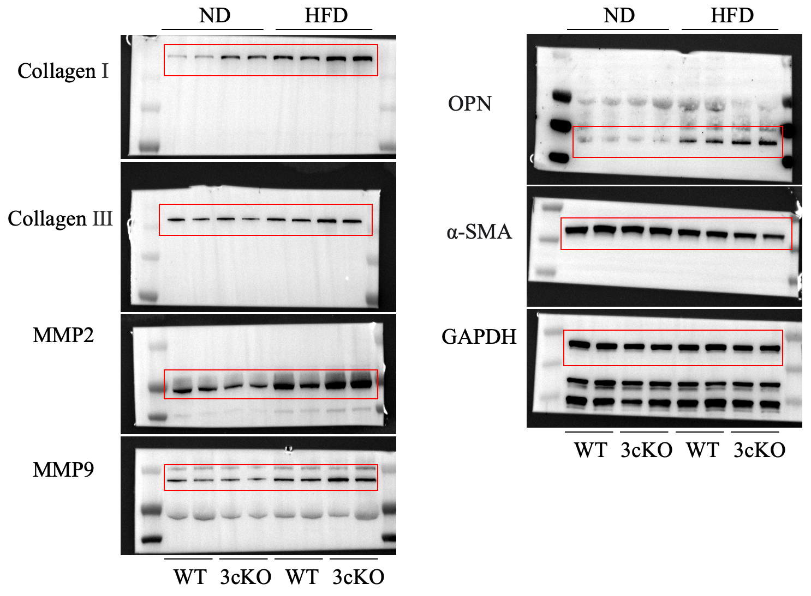

Figure 2 Uncropped images of figure 2I

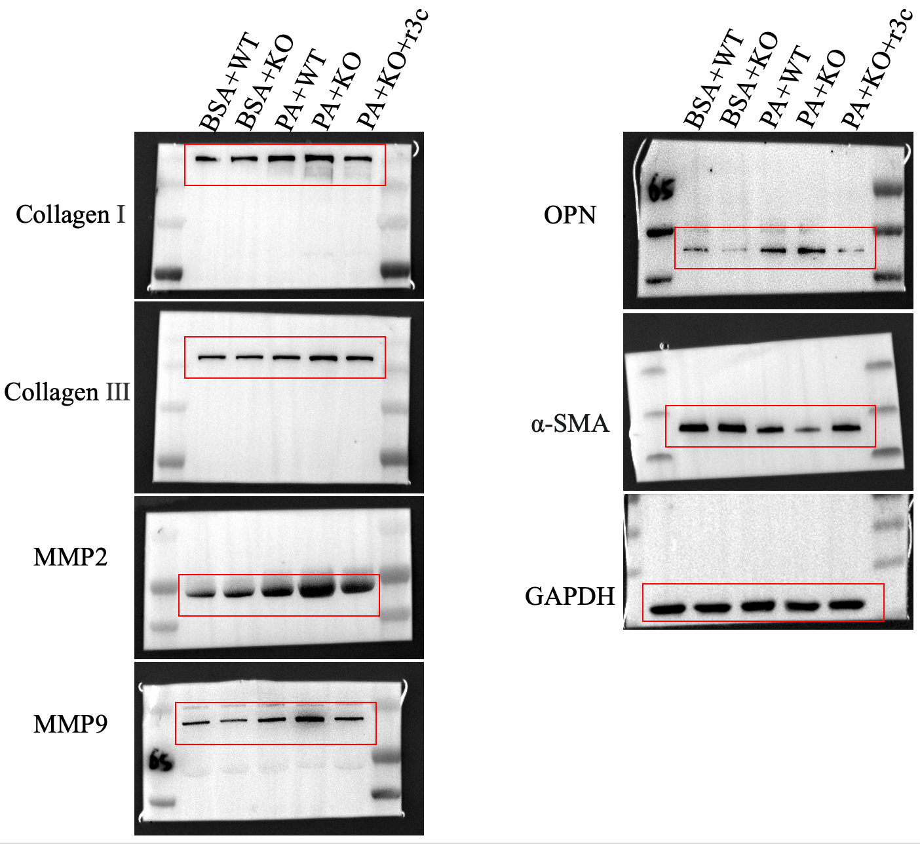

Figure 3 Uncropped images of figure 3
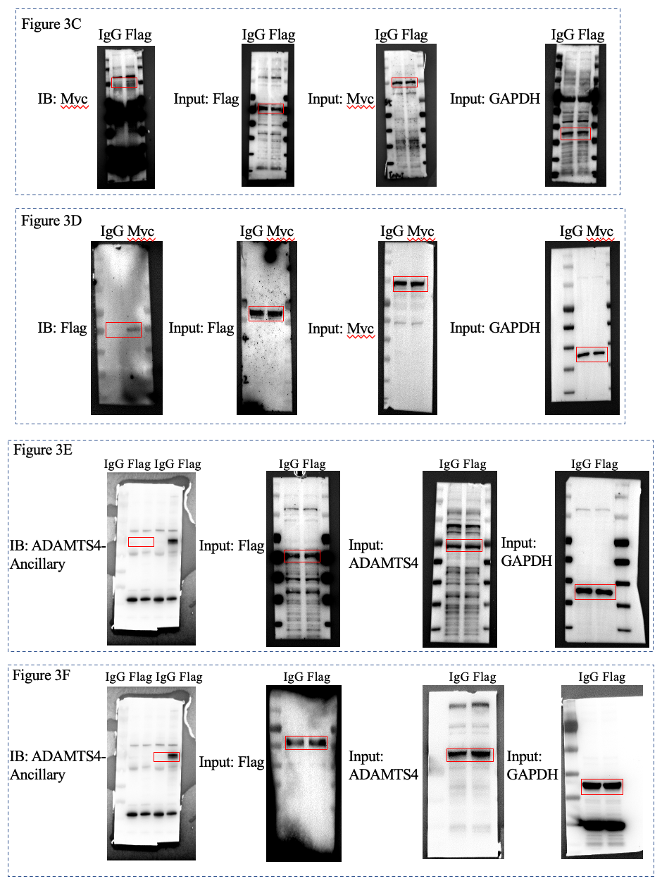
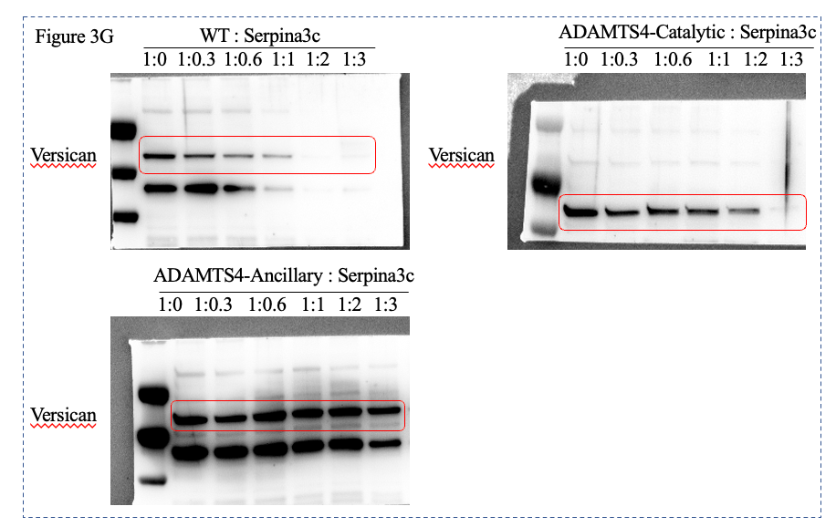

Figure 4 Uncropped images of figure 4
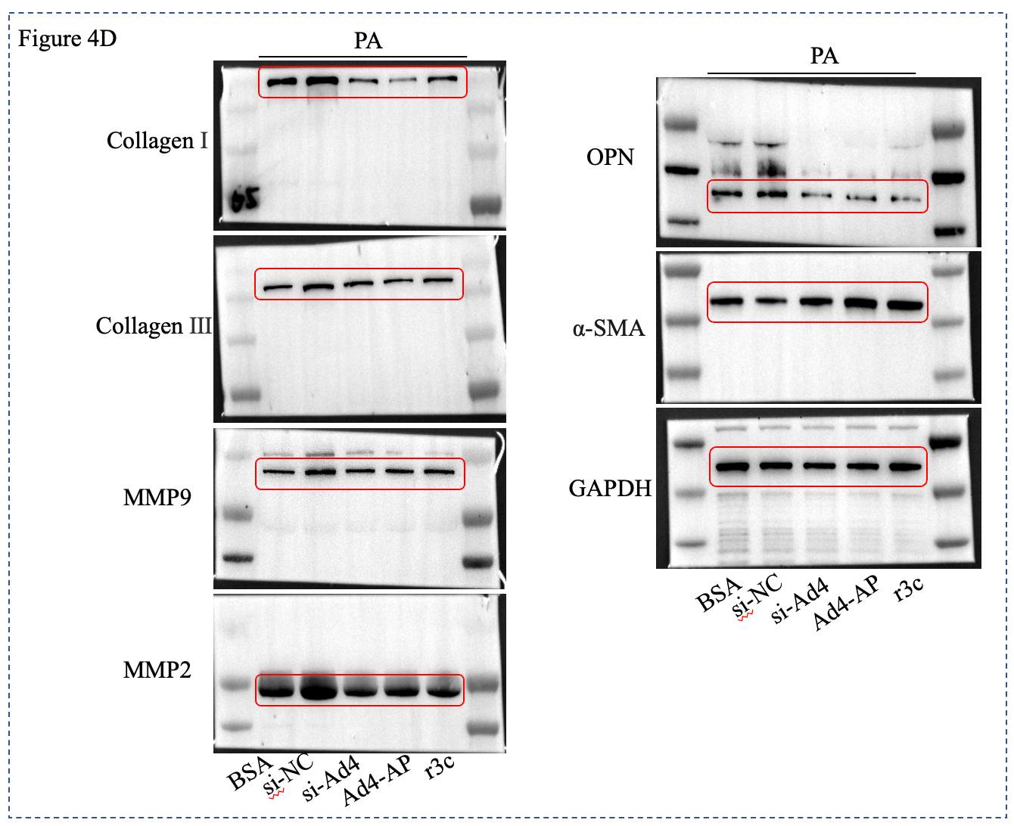

Figure 5 Uncropped images of figure 5
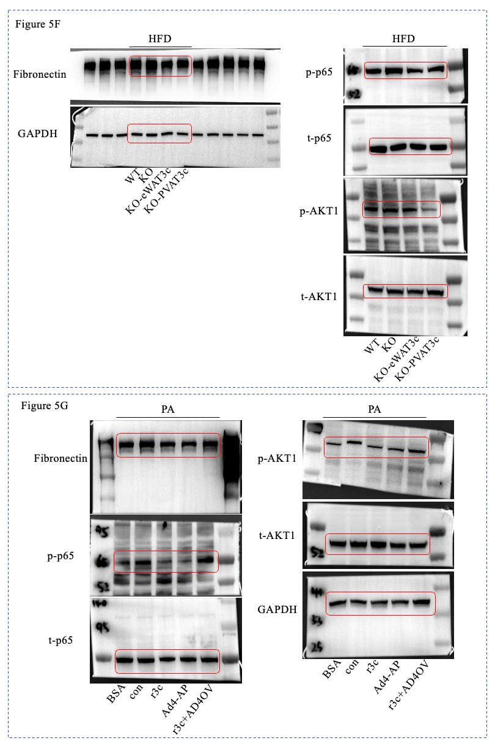

Figure 6 Uncropped images of figure 6
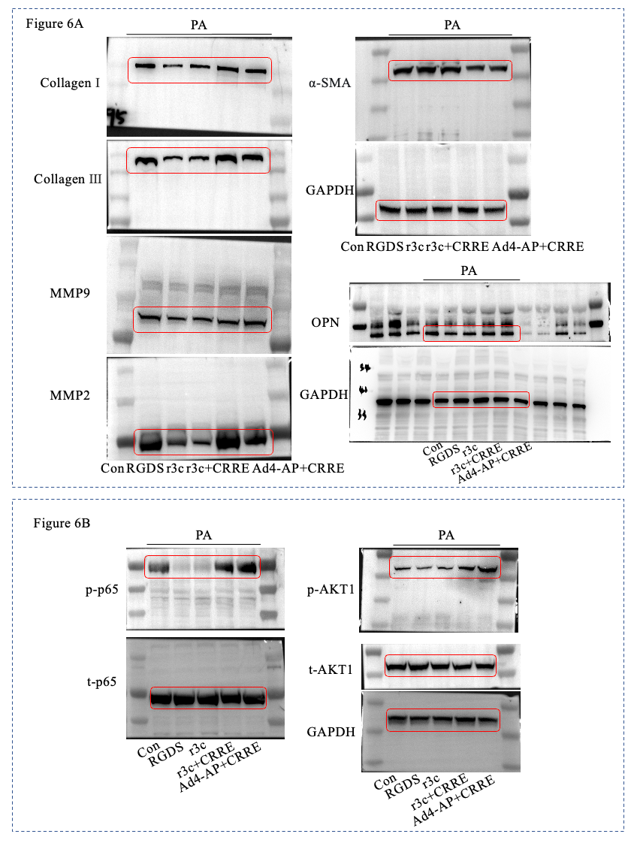
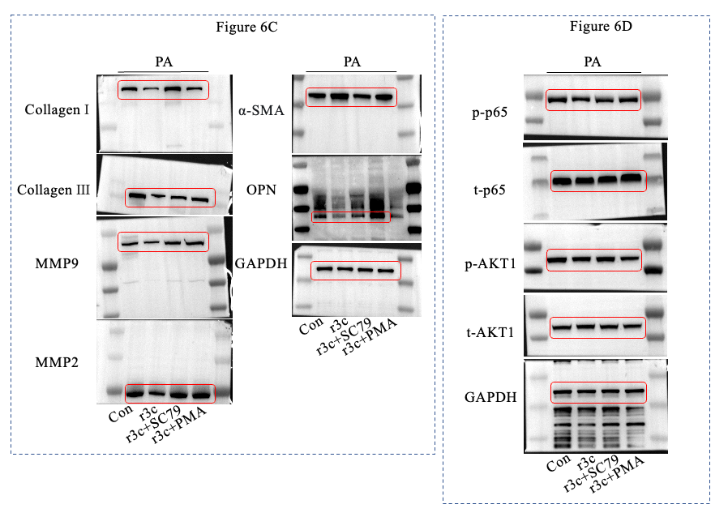

Figure 7 Uncropped images of Supplementary figure 3
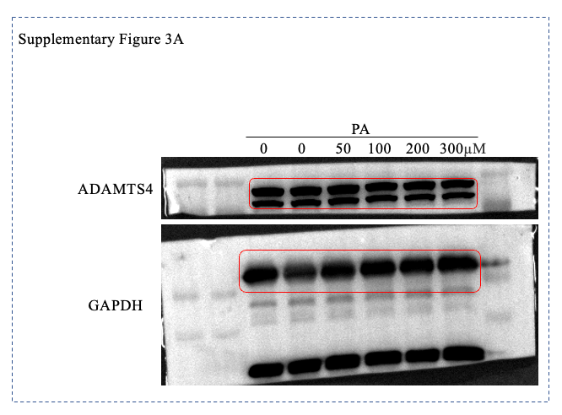

Figure 8 Uncropped images of Supplementary figure 4

