Table S1 The information of clinical strains uesd in this study
No. | Species | Strain Name | Source
1 | Staphylococcus aureus | 2021014 | Isolated from a porcine lung tissue
2 | Staphylococcus aureus | 2021031 | Isolated from a porcine nasal swab
3 | Staphylococcus aureus | 2021047 | Isolated from the brain tissue of the pig with neurological symptoms
4 | Staphylococcus aureus | 2021052 | Isolated from a porcine lung tissue
5 | Staphylococcus aureus | 2021164 | Isolated from a porcine rectal swab
6 | Staphylococcus aureus | 2021189 | Isolated from a chicken liver
7 | Staphylococcus aureus | 2021192 | Isolated from a chicken spleen
8 | Escherichia coli | 2021022 | Isolated from a porcine nasal swab
9 | Escherichia coli | 2021024 | Isolated from a porcine nasal swab
10 | Escherichia coli | 2021025 | Isolated from a porcine nasal swab
11 | Escherichia coli | 2021026 | Isolated from a porcine nasal swab
12 | Escherichia coli | 2021027 | Isolated from a porcine nasal swab
13 | Escherichia coli | 2021030 | Isolated from a porcine nasal swab
14 | Escherichia coli | 2021032 | Isolated from a porcine nasal swab
15 | Escherichia coli | 2021034 | Isolated from a porcine nasal swab
16 | Escherichia coli | 2021044 | Isolated from the brain tissue of the pig with neurological symptoms
17 | Escherichia coli | 2021048 | Isolated from the brain tissue of the pig with neurological symptoms
18 | Escherichia coli | 2021053 | Isolated from a porcine lung tissue
19 | Escherichia coli | 2021054 | Isolated from a porcine fecal sample
20 | Escherichia coli | 2021057 | Isolated from the brain tissue of the pig with neurological symptoms
21 | Escherichia coli | 2021058 | Isolated from the brain tissue of the pig with neurological symptoms
22 | Escherichia coli | 2021059 | Isolated from the brain tissue of the pig with neurological symptoms
23 | Escherichia coli | 2021060 | Isolated from the brain tissue of the pig with neurological symptoms
24 | Escherichia coli | 2021062 | Isolated from a porcine fecal sample
25 | Escherichia coli | 2021063 | Isolated from a porcine fecal sample
26 | Escherichia coli | 2021066 | Isolated from a porcine rectal swab
27 | Escherichia coli | 2021067 | Isolated from a porcine rectal swab
28 | Escherichia coli | 2021068 | Isolated from a porcine rectal swab
29 | Escherichia coli | 2021069 | Isolated from a porcine rectal swab
30 | Escherichia coli | 2021070 | Isolated from a porcine rectal swab
31 | Escherichia coli | 2021071 | Isolated from a porcine rectal swab
32 | Escherichia coli | 2021072 | Isolated from a porcine rectal swab
33 | Escherichia coli | 2021077 | Isolated from a porcine rectal swab
34 | Escherichia coli | 2021078 | Isolated from a porcine rectal swab
35 | Escherichia coli | 2021079 | Isolated from a porcine rectal swab
36 | Escherichia coli | 2021080 | Isolated from a porcine rectal swab
37 | Escherichia coli | 2021082 | Isolated from a porcine rectal swab
38 | Escherichia coli | 2021084 | Isolated from a porcine fecal sample
39 | Escherichia coli | 2021085 | Isolated from a porcine fecal sample
40 | Escherichia coli | 2021086 | Isolated from a porcine fecal sample
41 | Escherichia coli | 2021227 | Isolated from a porcine rectal swab
42 | Escherichia coli | 2021228 | Isolated from a porcine rectal swab
43 | Salmonella | ST1 | Isolated from a chicken fecal sample
44 | Salmonella | ST2 | Isolated from a chicken fecal sample
45 | Salmonella | ST3 | Isolated from a chicken fecal sample
46 | Salmonella | ST4 | Isolated from a chicken fecal sample
47 | Salmonella | ST5 | Isolated from a chicken fecal sample
48 | Salmonella | ST6 | Isolated from a chicken fecal sample
49 | Salmonella | ST7 | Isolated from a chicken fecal sample
50 | Salmonella | ST8 | Isolated from a chicken fecal sample
51 | Salmonella | ST9 | Isolated from a chicken fecal sample
52 | Salmonella | ST10 | Isolated from a chicken fecal sample
53 | Salmonella | ST11 | Isolated from a chicken fecal sample
54 | Salmonella | ST12 | Isolated from a chicken fecal sample
55 | Streptococcus spp. | 2021015 | Isolated from a porcine lung tissue
56 | Streptococcus spp. | 2021019 | Isolated from a porcine lung tissue
57 | Streptococcus spp. | 2021162 | Isolated from a porcine rectal swab
58 | Streptococcus spp. | 2021220 | Isolated from a porcine fecal sample
59 | Streptococcus spp. | 2021221 | Isolated from a porcine fecal sample
60 | Streptococcus spp. | 2021223 | Isolated from a porcine fecal sample
61 | Streptococcus spp. | 2021224 | Isolated from a porcine fecal sample
62 | Streptococcus spp. | 2021226 | Isolated from a porcine fecal sample
63 | Streptococcus spp. | 2021232 | Isolated from a porcine fecal sample
64 | Streptococcus spp. | 2023001 | Isolated from a porcine lung tissue
65 | Streptococcus spp. | 2023002 | Isolated from a porcine lung tissue

Table S2 Prediction of secondary metabolite biosynthetic gene clusters in B.velezensis BVLY028
Region | From | To | Types | Most similar known cluster | Product class | Similarity（%）
Region 1 | 323,409 | 387,386 | NRPS | surfactin | NRP:Lipopeptide | 86
Region 2 | 924,056 | 965,300 | PKS-like | butirosin A/ butirosin B | Saccharide | 7
Region 3 | 1,050,179 | 1,067,587 | terpene | / | / | /
Region 4 | 1,188,577 | 1,217,465 | lanthipeptide-class-ii | / | / | /
Region 5 | 1,384,085 | 1,471,920 | transAT-PKS | macrolactin H | Polyketide | 100
Region 6 | 1,691,499 | 1,792,014 | transAT-PKS，T3PKS，NRPS | bacillaene | Polyketide + NRP | 100
Region 7 | 1,865,756 | 2,000,066 | NRPS，transAT-PKS，betalactone | fengycin | NRP | 100
Region 8 | 2,028,704 | 2,050,587 | terpene | / | / | /
Region 9 | 2,113,905 | 2,155,005 | T3PKS | / | / | /
Region 10 | 2,282,381 | 2,376,173 | transAT-PKS | difficidin | Polyketide + NRP | 100
Region 11 | 3,000,877 | 3,052,665 | NRPS，RiPP-like | bacillibactin | NRP | 100
Region 12 | 3,588,978 | 3,630,396 | other | bacilysin | Other | 100

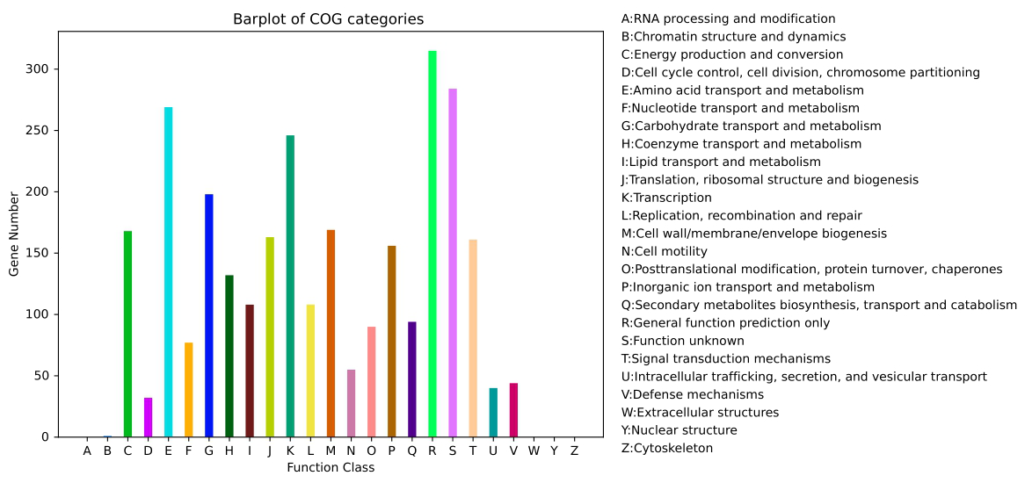
Fig. S1 Functional annotation of the LYBV028 strain. COG annotation. The x-axis represents COG categories (A–Z), with each category corresponding to a distinct biological function, such as RNA processing, energy production, and signal transduction. The y-axis indicates the number of genes assigned to each category.
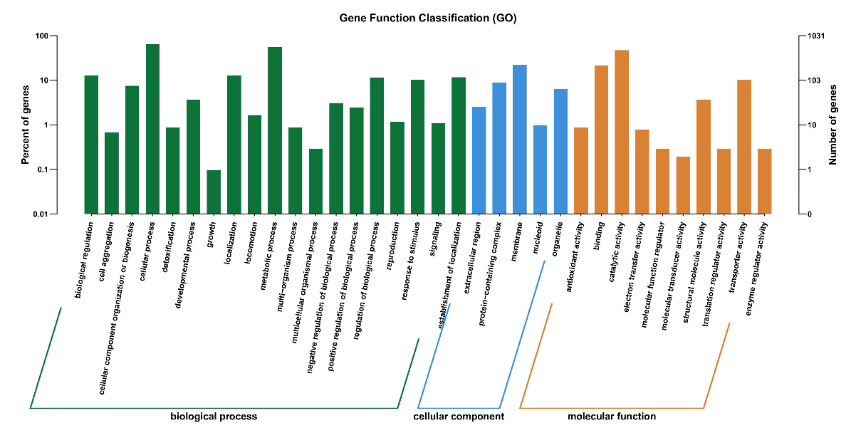
Fig. S2 Functional annotation of the LYBV028 strain. GO functional annotation. The 20 most significantly enriched GO terms in the biological process, cellular component, and molecular function categories are presented. The y-axis represents the number of genes associated with each GO category, and the x-axis lists the corresponding GO terms.

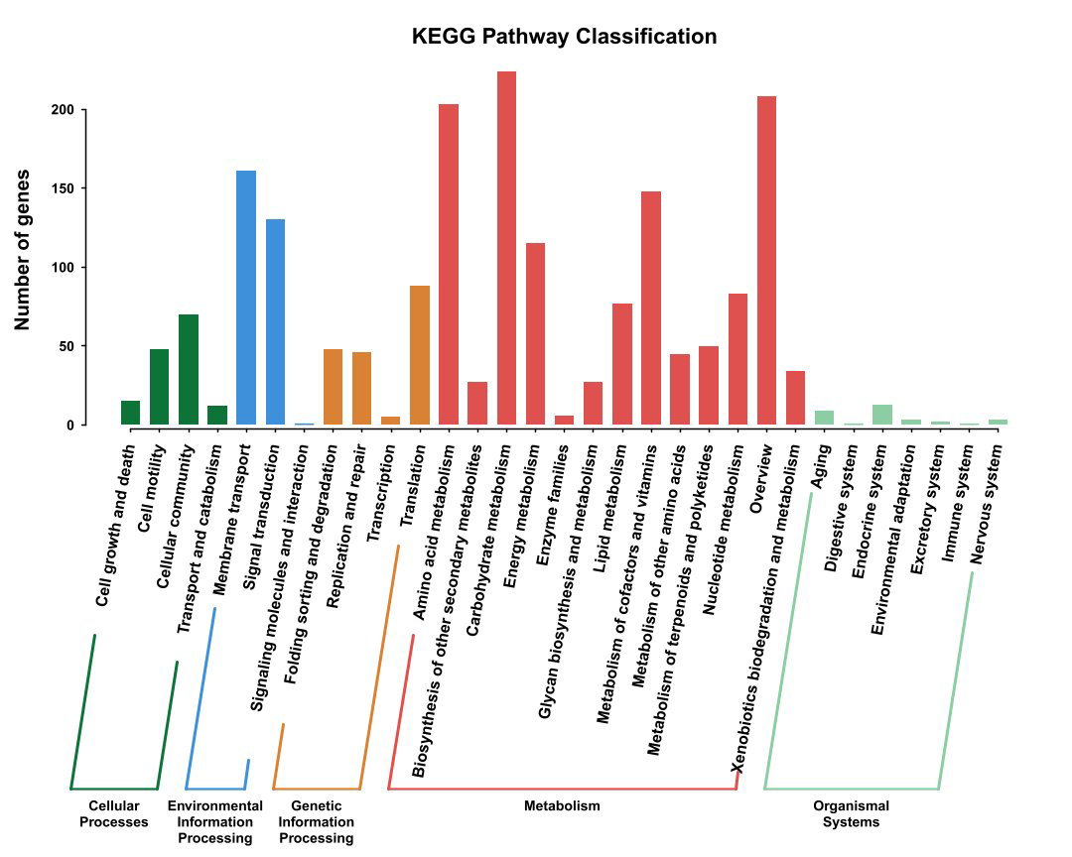
Fig. S3 Functional annotation of the LYBV028 strain. KEGG pathway annotation. The six most significantly enriched functional categories are displayed on the x-axis, while the y-axis indicates the number of genes assigned to each category. Pathway analysis was performed using the KEGG database (Kanehisa et al., 2025).

