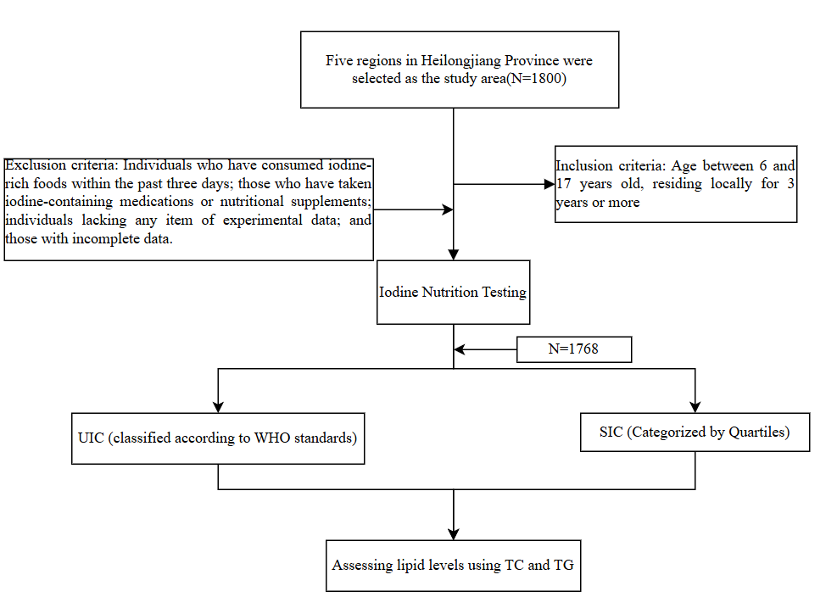
Figure abstract

Supplementary Table 1 Effects of UIC and SIC on TC and TG Levels in Study Subjects Stratified by Gender, Age, and BMI
 |  | UIC<100µg/L | UIC=100-299µg/L | UIC≥300µg/L | P | P
 |  | AOR(95%CI) | Reference | AOR(95%CI) | P | P
Elevated TC | Male | 0.694(0.391,1.233) | 1.000 | 1.375(1.017,1.806) | 0.213 | 0.039
Elevated TC | Female | 1.071(0.674,1.702) | 1.000 | 1.605(1.177,2.190) | 0.722 | 0.003
Elevated TC | Age<10 years | 0.578(0.305,1.093) | 1.000 | 1.530(1.035,2.263) | 0.092 | 0.033
Elevated TC | Age≥10 years | 1.173(0.761,1.810) | 1.000 | 1.430(1.104,1.852) | 0.470 | 0.007
Elevated TC | Underweight | 1.602(0.389,6.600) | 1.000 | 6.120(2.208,16.961) | 0.514 | <0.001
Elevated TC | Normal weight | 1.294(0.800,2.092) | 1.000 | 1.352(1.006,1.816) | 0.293 | 0.046
Elevated TC | Overweight and above | 0.536(0.296,0.971) | 1.000 | 1.342(0.960,1.876) | 0.040 | 0.085

 |  | SIC<63.50 | 63.50-72.62/72.62-82.28µg/L | SIC≥82.28µg/L | P | P
 |  | AOR(95%CI) | Reference | AOR(95%CI) | P | P
Elevated TG | Male | 1.276(0.897,1.817) | 1.000 | 1.535(1.082,2.178) | 0.176 | 0.016
Elevated TG | Female | 1.290(0.917,1.816) | 1.000 | 1.477(1.054,2.070) | 0.143 | 0.023
Elevated TG | Age<10 years | 1.250(0.777,2.012) | 1.000 | 1.519(1.002,2.304) | 0.357 | 0.049
Elevated TG | Age≥10 years | 1.335(1.001,1.781) | 1.000 | 1.479(1.094,1.999) | 0.049 | 0.011
Elevated TG | Underweight | 2.268(0.714,1.472) | 1.000 | 2.690(0.960,7.535) | 0.165 | 0.060
Elevated TG | Normal weight | 1.044(0.741,1.472) | 1.000 | 1.266(0.908,1.767) | 0.806 | 0.165
Elevated TG | Overweight and above | 1.542(1.060,2.243) | 1.000 | 1.709(1.162,2.513) | 0.024 | 0.006

Supplementary Table 2 Mediation analysis of UIC with elevated TC levels.
Effect | Estimate(β)
Effect | Elevated TC
UIC ≥ 300 μg/L
Indirect effect | -0.002(-0.040,0.001)
Direct effect | 0.160(0.070,0.260)
Total effect | 0.150(0.060,0.240)

