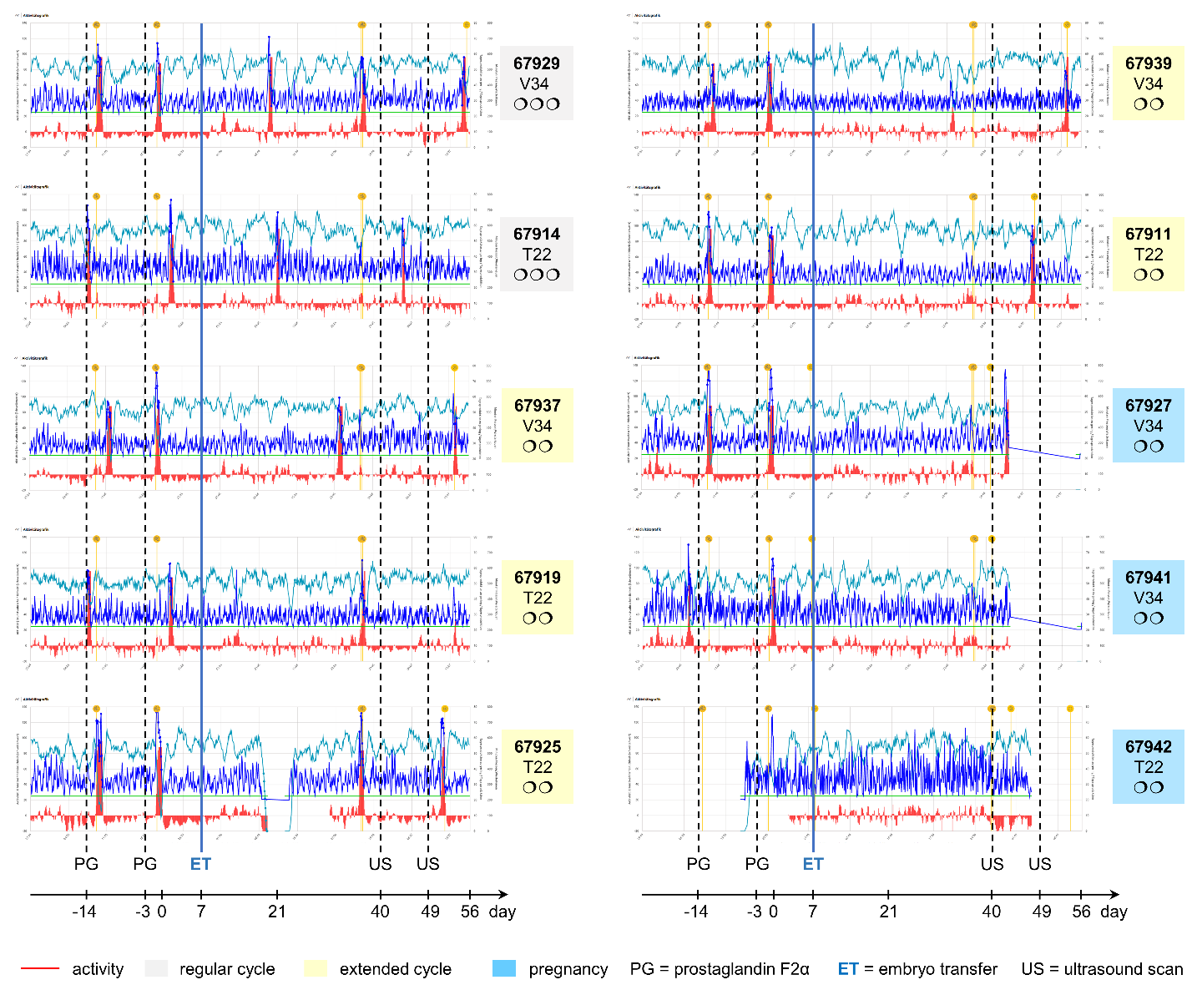

Extended Data Fig. 1 | Estrous cycle profiles and pregnancy outcomes following transfer of IFNT-KO embryos. Recipient heifers were synchronized with two injections of prostaglandin F₂α (PG) on days −14 and −3, with day 0 defined as the day of estrus. SCNT-derived IFNT-KO blastocysts were transferred transcervically on day 7 of the estrous cycle. Two recipients (67929 and 67914) received three blastocysts each (n = 2), while the remaining recipients received two blastocysts (n = 8). Estrus activity was continuously monitored and plotted as individual time-series profiles. Eight of ten recipients exhibited prolonged estrous cycles relative to expected cycle length, whereas two recipients (67929 and 67914) returned to estrus at the expected interval. Pregnancy diagnosis by transrectal ultrasonography at gestational days 40 and 49 identified twin pregnancies in three recipients (67927, 67941, and 67942).

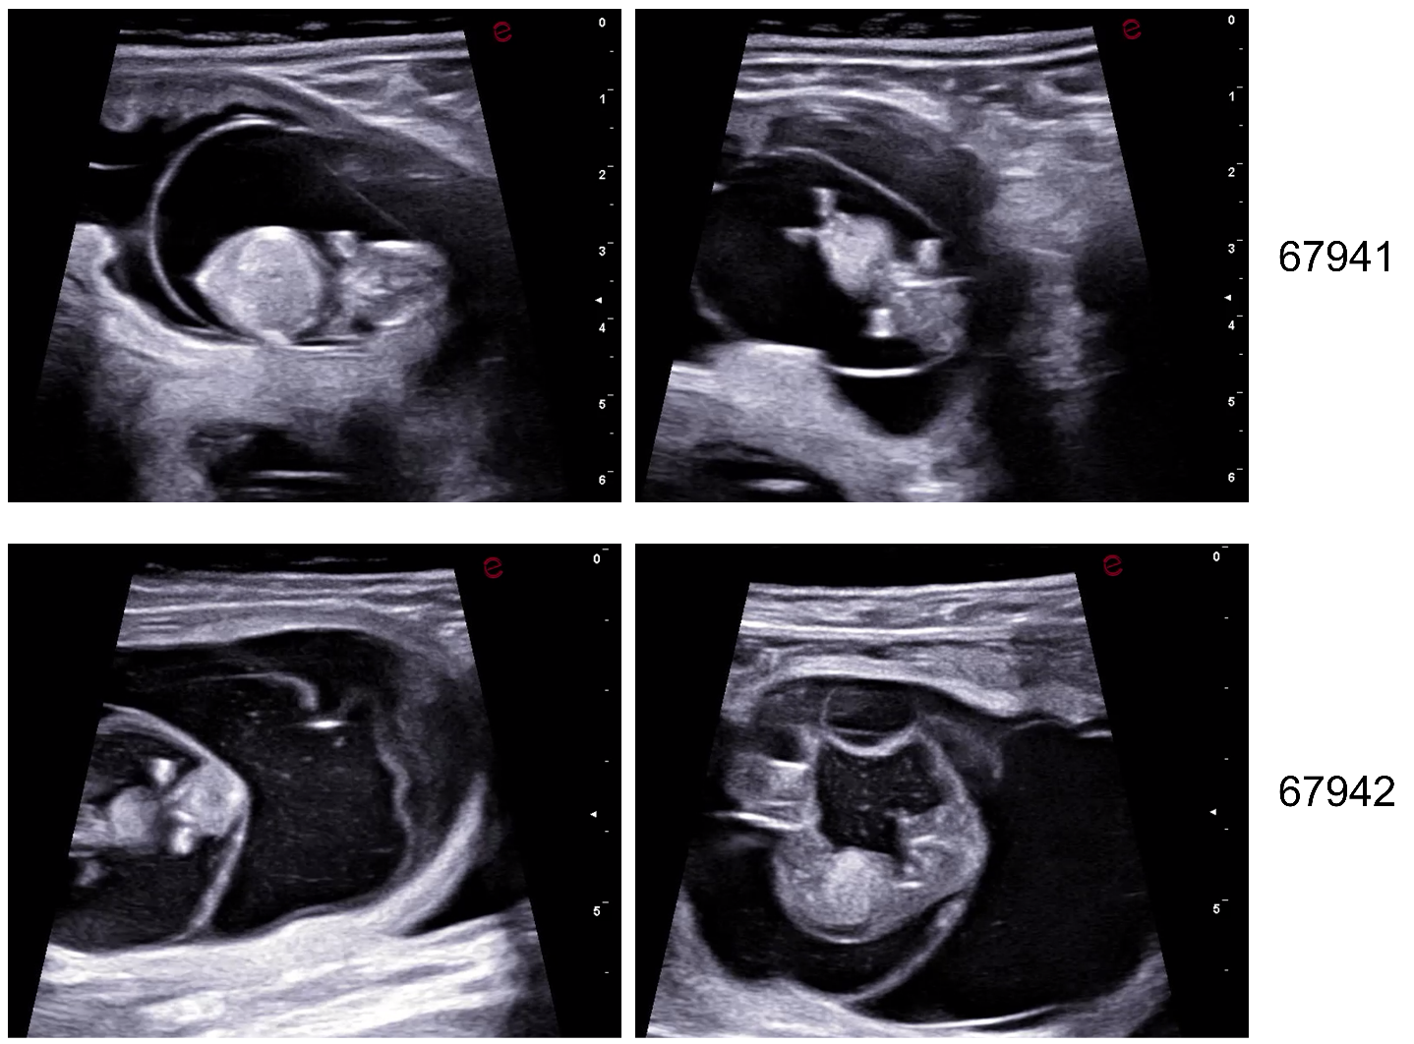
Extended Data Fig. 2 | Ultrasound confirmation of twin pregnancies following transfer of IFNT-KO embryos. Transrectal ultrasonography performed at gestational day 49 identified twin pregnancies in recipients 67941 and 67942. Representative ultrasound images demonstrate the presence of two viable conceptuses in each recipient.

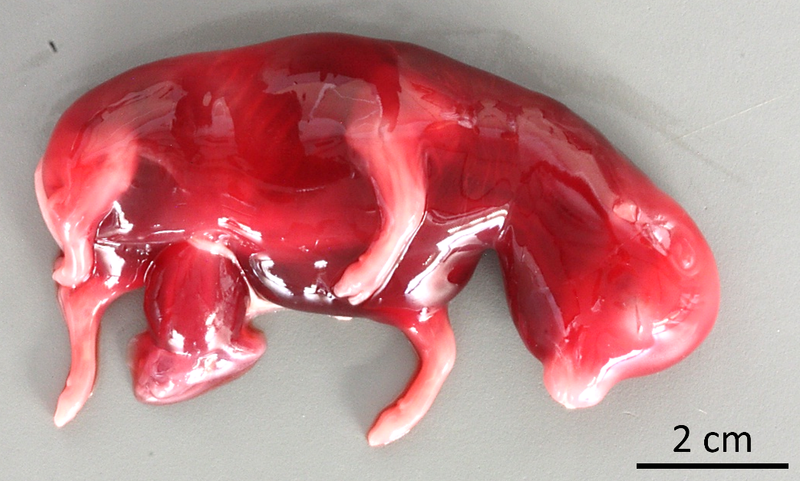

Extended Data Fig. 3 | IFNT-knockout fetus recovered at gestational day 75 exhibiting cloning-associated abnormalities. The fetus, derived from SCNT and carrying a complete IFNT KO, is a clone sibling of the fetus shown in Fig. 4g and was carried by recipient 67941. Although normal in overall size for gestational age, the fetus exhibited generalized hydrops fetalis, a developmental abnormality commonly associated with SCNT.

