Trends in Self-Reported Migraine or Frequent Headache in Spain between 2006 and 2023: The Role of Sociodemographic Factors
Supplementary Information
Miguel Á. Huerta^{a,b} MSc, Jose A. Moral-Munoz^{c,d,e}* PhD, Masahito Katsuki^{f,g} MD PhD,
Yasuhiko Matsumori^{h} MD PhD, Alejandro Salazar^{d,e,i} PhD

ª Department of Pharmacology and Neurosciences Institute (Biomedical Research Center), University of Granada.
^{b} Biosanitary Research Institute ibs.GRANADA, Granada, Spain.
^{c} Department of Nursing and Physiotherapy, University of Cadiz, Cadiz, Spain.
^{d} Biomedical Research and Innovation Institute of Cadiz (INiBICA), Cadiz, Spain.
^{e} Observatory of Pain, Grünenthal Foundation-University of Cadiz, Cadiz, Spain.
^{f} Insight Science Foundation Ireland Research Centre for Data Analytics, School of Human and Health Performance, Dublin City University, Dublin, Ireland.
^{g} Physical Education and Health Center, Nagaoka University of Technology, Niigata, Japan.
^{h} Sendai Neurology and Headache Clinic, Sendai, Miyagi, Japan.
^{i} Department of Statistics and Operational Research, University of Cadiz, Cadiz, Spain.

*Corresponding author: Jose A. Moral-Munoz. Address: Av. Ana de Viya, 52, 11009 Cádiz, Cádiz (Spain). Email: joseantonio.moral@uca.es

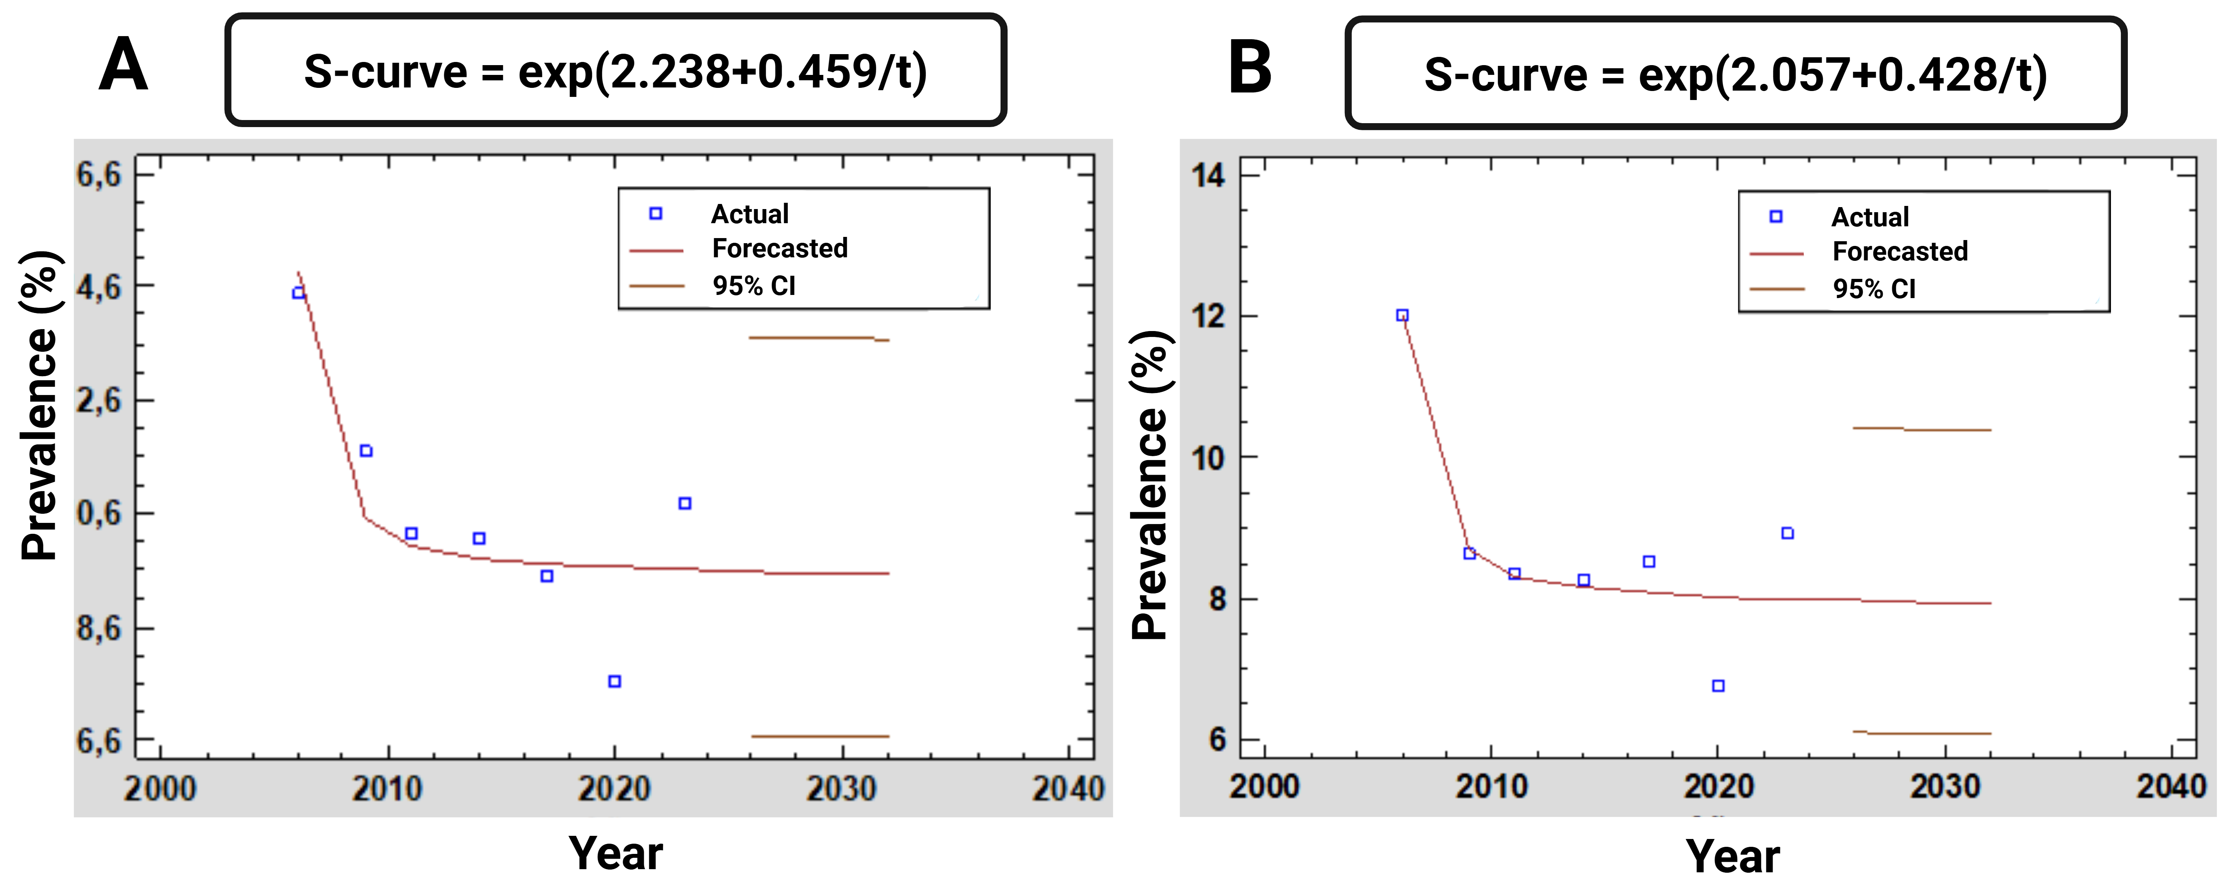
Figure S1. Run chart and time-series plot showing the evolution of the prevalence of self-reported migraine or frequent headache in the general Spanish population. Observed data points are plotted alongside an exponential trend line with 95% confidence intervals for forecasted estimates of total (A) and diagnosed (B) self-reported migraine or frequent headache

