Supplementary Figures
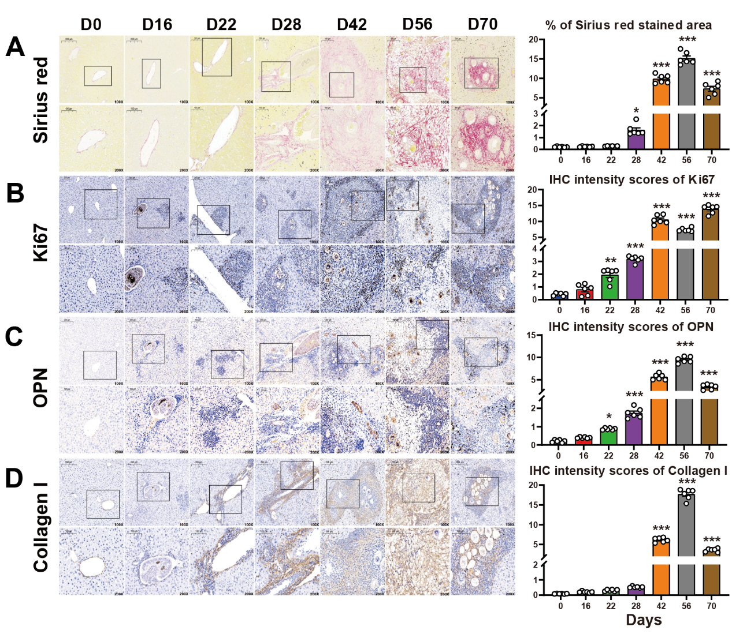
Figure S1 Infection with S. japonicum can lead to hepatic fibrosis in mice. (A) Sirius red staining showed collagen depositions of the liver in mice infected with S. japonicum. (B-D) The expression of Ki67, Osteopontin (OPN), and collagen I in mouse livers infected with S. japonicum. The highlighted area indicates the positive cells. The positive areas in the livers of non-infected and infected mice were quantitated by Image J. The values were expressed as mean ± SEM. Compared with indicated groups, *P < 0.05, **P < 0.01, ***P < 0.001.

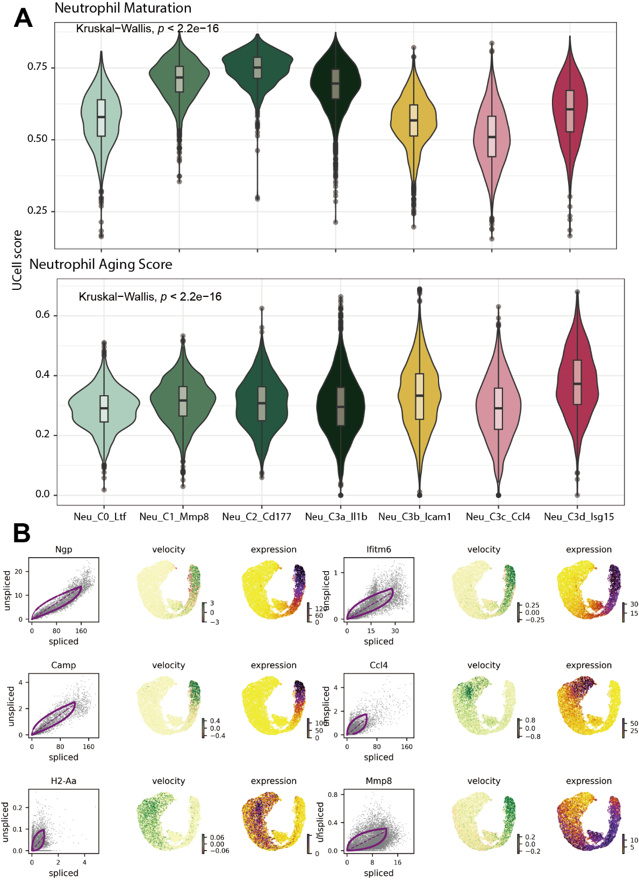
Figure S2 Directional changes of individual cells and intercellular transition processes within neutrophil subsets. (A) Score of neutrophil maturation and degree of aging. (B) Velocity visualization of the top 6 driver genes.

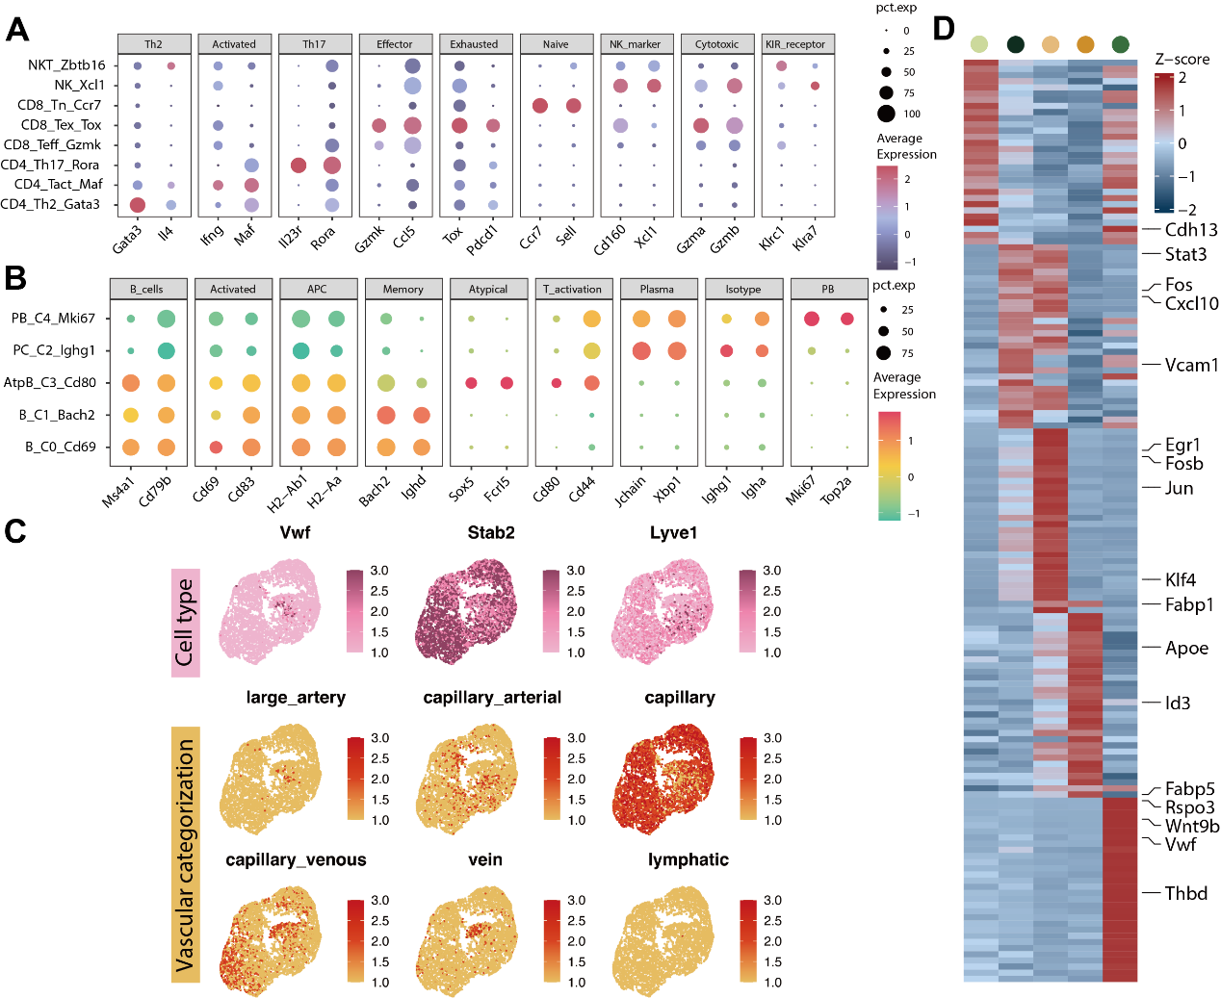
Figure S3 Dynamic alterations in T cells, B cells, and endothelial cells during the progression of liver fibrosis in S. japonicum-infected mice. (A) Bubble plots of T cells for the top 2 marker genes expressed for each cluster. (B) Bubble plots of B cells for the top 2 marker genes expressed for each cluster. (C) Subsets of endothelial cells related to the formation of vascular types. (D) Gene expression heatmap (marker gene expressed) in endothelial cells subsets.

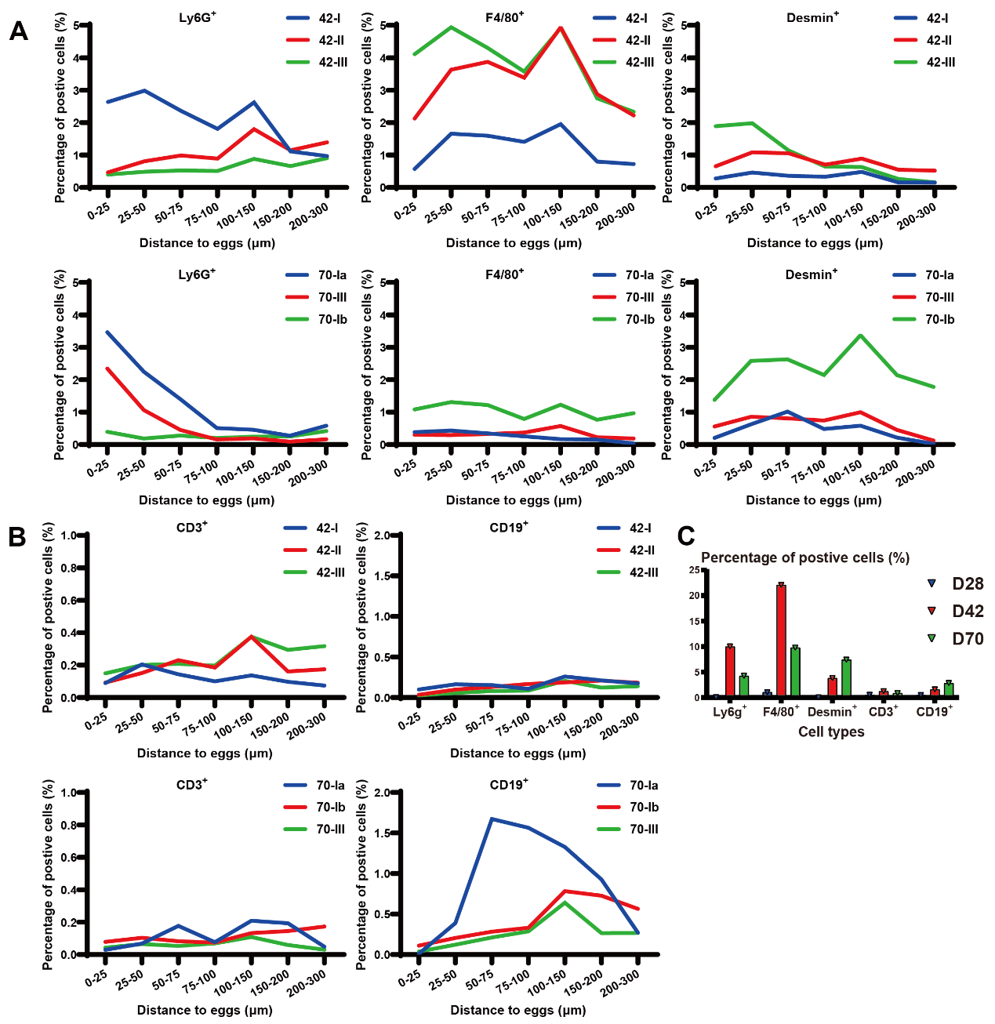
Figure S4 The proportion of Ly6g⁺, F4/80⁺, Desmin⁺, CD3⁺, and CD19⁺ cells at different distances from eggs. (A) Ly6g⁺, F4/80⁺, and Desmin⁺ cells at 42 and 70 d.p.i. (B) CD3⁺ and CD19⁺ cells at 42 and 70 d.p.i. (C) The proportions of Ly6g⁺, F4/80⁺, Desmin⁺, CD3⁺, and CD19⁺ cells in the liver tissues of mice at 28, 42, and 70 d.p.i.

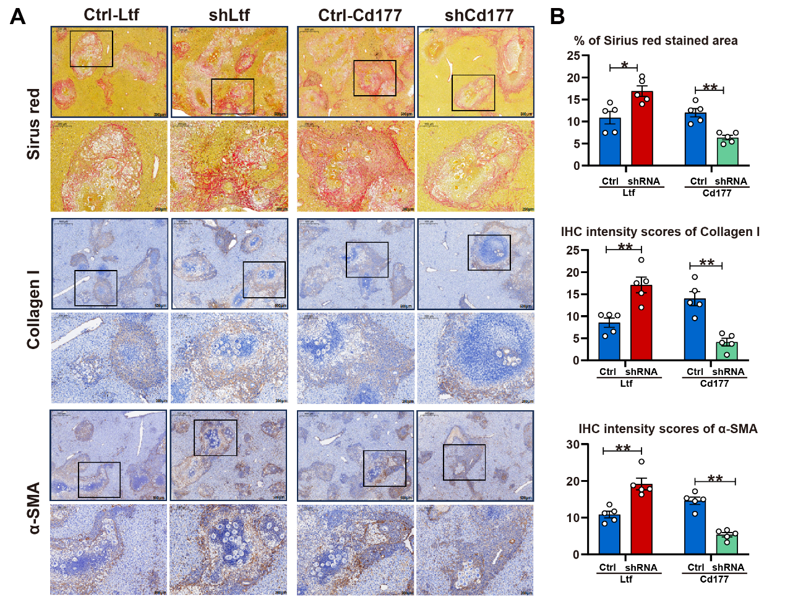
Figure S5 Assessment of fibrosis in S. japonicum-infected mice following knockdown of Ltf and Cd177. (A) Representative images of Sirius red staining, collagen I, and α-SMA immunohistochemistry. (B) The positive areas in the liver of control and shRNA group were quantitated by Image J (N=5 per group). The values were expressed as mean ± SEM. *P < 0.05, **P < 0.01, ***P < 0.001 when compared with control groups.

