Supplementary information
Thermally responsive poly(ethylene oxide)-based polyrotaxanes bearing hydrogen-bonding pillar[5]arene rings

Kenichi Kato,¹ Katsuto Onishi,^{1,‡} Koki Maeda,^{1,‡} Masafumi Yagyu,² Shixin Fa,¹ Takahiro Ichikawa,⁴ Motohiro Mizuno,² Takahiro Kakuta,^{2,3} Tada-aki Yamagishi² and Tomoki Ogoshi^{1,3}*

¹Department of Synthetic Chemistry and Biological Chemistry, Graduate School of Engineering, Kyoto University, Nishikyo-ku, Kyoto, 615-8510, Japan
²Graduate School of Natural Science and Technology and ³WPI Nano Life Science Institute, Kanazawa University, Kakuma-machi, Kanazawa, 920-1192, Japan
⁴Department of Biotechnology, Faculty of Engineering, Tokyo University of Agriculture and Technology, Nakacho, Koganei, Tokyo, 184-8588, Japan

‡These authors contributed equally.
Correspondence and requests for materials should be addressed to T.O.
(email: ogoshi@sbchem.kyoto-u.ac.jp)

Table of Contents

- Synthetic procedures
- NMR spectra
- GPC charts
- PXRD analysis
- CO₂ adsorption measurements
- DSC
- TGA
- Supplementary references
S2–S5
S6–S14
S15
S16–17
S18
S19–S20
S21–S22
S22

1. Synthetic procedures

Supplementary Table 1 Poly(ethylene oxide)s (PEOs) used in this study
Types of PEOs | Product Name | Product Number
PEO2k-OH | Polyethylene Glycol 2,000 | Wako (165-09105)
PEO4k-OH | Polyethylene Glycol 4,000 | Wako (162-09115)
PEO6k-OH | Polyethylene Glycol 6,000 | Wako O (169-09125)
PEO20k-OH | Polyethylene Glycol #20,000 | Nacalai Tesque (28223-85)
PEO100k-OH | Polyethylene Oxide, M.W. 100,000 | Aldrich (42236)
PEO500k-OH | Polyethylene Glycol 500,000 | Wako (160-18521)
PEO2k-NH₂ | Poly (ethylene glycol) diamine | Aldrich (753084-1G)
PEO2k-OMe | Poly (ethylene glycol) dimethyl ether | Aldrich (445908-50G)
PEO2k-OTs | PEG-ditosylate | Aldrich (719080-5G)

1.1 Effect of the amount of PEO2k-OH
10 mL (10 mmol/L) of P5OH solution in methanol and water [1/1 (v/v)] was mixed with a varying amount (20 μL, 30 μL, 50 μL, 100 μL, 200 μL, 500 μL, 1,000 μL) of PEO2k-OH solution (833 mmol/L) in the same solvent. Then, the resulting pseudopolyrotaxanes were obtained by following the procedure described in the main text. The molar ratios of EO units to P5OH were determined by ¹H NMR spectroscopy (Supplementary Table 2 and Supplementary Fig. 1).
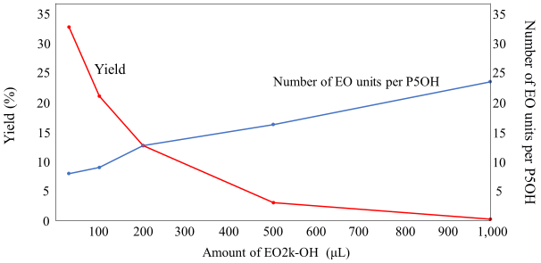
Supplementary Fig. 1 PEO amount-dependent changes in yield (left) and number of EO units per P5OH (right) of pseudopolyrotaxane P5OH•PEO2k-OH

Supplementary Table 2 Effect of the amount of PEO2k-OH solution
Added PEO solution | Yield (%) | Number of EO units per P5OH
30 μL | 33 | 8
100 μL | 21 | 11
200 μL | 13 | 13
500 μL | 3 | 16
1000 μL | <1 | 23

1.2 Effect of the molecular weight and terminal groups of PEOs
10 mL (10 mmol/L) of P5OH solution in methanol and water [1/1 (v/v)] was mixed with 0.60 mL of PEO4k-OH, 6k-OH, 20k-OH, 100k-OH, and 500k-OH solution (42 mmol/L) in the same solvent. The resulting pseudopolyrotaxanes were obtained by following the procedure described in the main text. The molar ratios of ethylene oxide units to P5OH were also determined by ¹H NMR spectroscopy. Further, the effect of PEO’s terminal groups was studied using solutions of Poly (ethylene glycol) diamine (PEO2k-NH₂), Poly (ethylene glycol) dimethyl ether (PEO2k-OMe), and PEG-ditosylate (PEO2k-OTs), on the basis of the same method.

Supplementary Table 3 Effect of the molecular weight and terminal groups of PEOs
Types of PEOs | Yield (%) | Number of EO units per P5OH
PEO2k-OH | 32 | 8
PEO4k-OH | 32 | 12
PEO6k-OH | 74 | 15
PEO20k-OH | 70 | 19
PEO100k-OH | 45 | Unmeasurable*
PEO500k-OH | 76 | Unmeasurable*
PEO2k-NH₂ | 28 | 2.5
PEO2k-OMe | 12 | 9
PEO2k-OTs | 41 | 8
PEO20k-COOH | 19 | 4.2
PEO500k-COOH | 18 | 14
*These pseudopolyrotaxanes could not be dissolved in deuterated solvents enough for NMR studies.

1.3 Competition with adiponitrile
10 mL (10 mmol/L) of P5OH solution in methanol and water [1/1 (v/v)] was mixed with 0.60 mL of PEO2k-OH solution (42 mmol/L) in the same solvent and adiponitrile (0.050 mL, 0.45 mmol). The resulting mixture was vigorously sonicated for 1 h. The mixture was allowed to stand overnight and then centrifuged. The resulting supernatant was removed to give crude pseudopolyrotaxane as a precipitate, which was washed with water. Removal of water in vacuo afforded pseudopolyrotaxane (0.004 g, 3.2%). The molar ratio of EO units to P5OH was determined to be 27.

1.4 Effect of pH
P5OH (0.075 g, 0.10 mmol) was dissolved in a NaOH solution in a mixed solvent of methanol and water (10 mL, 1/1 (v/v), pH = 12). PEO2k-OH (0.500 g, 0.25 mmol) was also dissolved in the same NaOH solution (6.0 mL, 42 mmol/L, pH = 12) in another vial. The PEO2k-OH solution (0.60 mL) was added to the P5OH solution (10 mL) and the resulting mixture was vigorously sonicated for 1 h. The mixture was allowed to stand overnight and then centrifuged. The resulting supernatant was removed to give crude pseudopolyrotaxane as a precipitate. The precipitate was washed with water and dried in vacuo, affording pseudopolyrotaxane (0.011 g, 8.8%). The molar ratio of EO units to P5OH was determined to be 193.

1.5 COOH-terminated PEO (PEO20k-COOH)^{S1}
PEO20k-OH (10 g), 2,2,6,6-tetramethylpiperidine-1-oxyl (TEMPO, 100 mg, 0.640 mmol), and NaBr (100 mg, 0.9.72 mmol) were suspended in water (100 mL), to which aqueous NaClO solution (available chlorine > 5.0%, 10 mL) was added. After stirring at room temperature for 30 min, the mixture was quenched with ethanol and acidified with dilute aqueous HCl solution to become pH < 2. The mixture was extracted with 100 mL of CH₂Cl₂ three times and the combined organic layers were evaporated under reduced pressure. The residue was dissolved in hot ethanol, followed by precipitation in a freezer overnight to yield PEO20k-COOH (9.10 g, 91%) as a white solid.
Following the same method, PEO500k-OH (10 g) was converted to PEO500k-COOH (7.57 g, 76%).

1.6 Effect of solvents used in capping reactions
1-Adamantanamine (16 mg, 0.11 mmol), BOP reagent (48 mg, 0.11 mmol), and EDIPA (0.019 mL, 0.12 mmol) were dissolved in various solvents (10 mL). The solution was cooled to 0 °C with an ice bath, to which P5OH•PEO20k-COOH (ca. 150 mg) were added. The reaction mixture was allowed to warm up to room temperature and stirred overnight at that temperature. After the solvent was removed under reduced pressure, the residue was washed with acetone to yield polyrotaxanes as brown solids. The yield and molar ratios of ethylene oxide units to P5OH were displayed in Supplementary Table 4.

Supplementary Table 4 Effect of solvents used in capping reactions
Dry solvent | P5OH•PEO20k-COOH  (mg) | Yield  (%) | Number of EO units  per P5OH
Acetonitrile | 154 | 32 | 34
DMF | 150 | 28 | 28
THF | 163 | 38 | 20
Acetone | 152 | 43 | 9

1.7 Polyrotaxanes of α-CD and PEO (α-CD•PEO500k-CONHAd)^{S1}
PEO500k-COOH (3.0 g, 6.0 μmol) and α-cyclodextrin (α-CD, 12 g, 12 mmol) were dissolved in water (100 mL) and kept in a refrigerator overnight, giving a white paste-like inclusion complex. The solution was cooled to 0 °C with an ice bath, to which 1-Adamantanamine (0.16 g, 1.1 mmol), BOP reagent (0.48 g, 1.1 mmol), and EDIPA (0.19 mL, 1.2 mmol) dissolved in dehydrated DMF (100 mL) were added. The slurry-like mixture was allowed to react at 4 °C overnight, followed by washing with DMF/methanol [1/1 (v/v)] and methanol. Precipitation of the DMSO solution (80 mL) of the obtained solid into water (800 mL), repeated washing with water to yield α-CD•PEO20k-CONHAd as a white solid (10.3 g, yield 98%, EO-to-α-CD ratio: 7).

1.8 Polyrotaxanes of P5OEt and PEO (P5OEt•PEO20k-CONHAd)
PEO20k-COOH (2.9 g, 0.145 mol) was melted at 80 °C, to which P5OEt (640 mg, 0.72 mmol) was immersed for 2.5 h. The complex was left at room temperature overnight, followed by washing with water to remove uncomplexed PEO20k-COOH to yield P5OEt•PEO20k-COOH as a white solid (510 mg, yield 14% EO-to-P5OEt ratio: 17).^{S2}
1-Adamantanamine (16 mg, 0.11 mmol), BOP reagent (48 mg, 0.11 mmol), and EDIPA (0.019 mL, 0.12 mmol) were dissolved in super dehydrated acetone, chloroform or THF (10 mL). The solution was cooled to 0 °C with an ice bath, to which P5OEt•PEO20k-COOH (150 mg) was added. The reaction mixture was allowed to warm up to room temperature and stirred overnight at that temperature. Removal of the solvent under reduced pressure gave crude materials as pale orange solids, which were characterized by ¹H NMR spectroscopy and GPC analysis. No signals assigned to the threaded P5OEt were detected, which suggested that polyrotaxanes were not contained in the solids.

2. NMR spectra
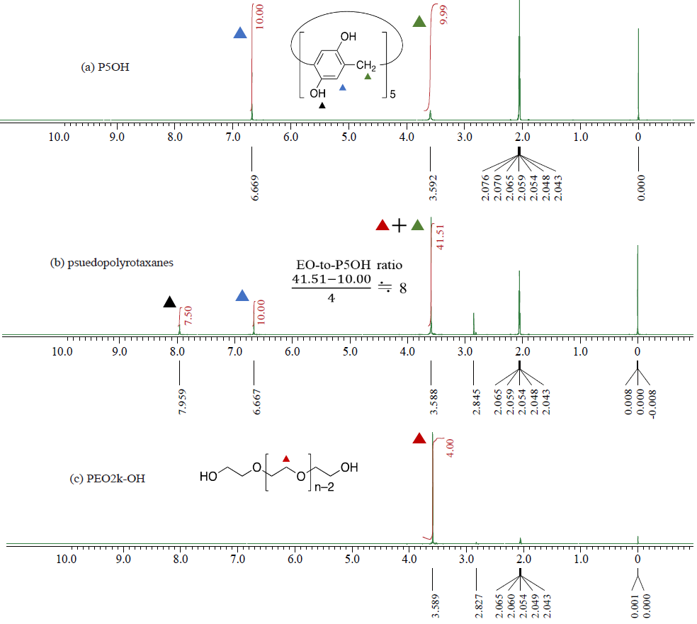
Supplementary Fig. 2 ¹H NMR spectra of a P5OH, b P5OH•PEO2k-OH (de-threading gave free P5OH and PEO2k-OH), and c PEO2k-OH (acetone-d₆, 25°C)

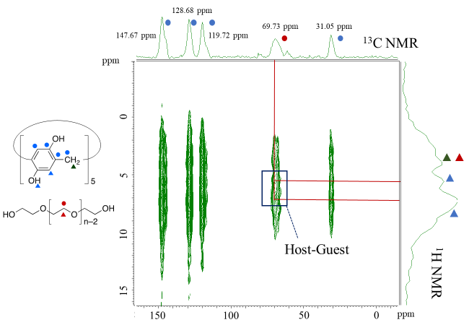
Supplementary Fig. 3 Solid-state 2D ¹H/¹³C hetero-correlated NMR spectrum of P5OH•PEO2k-OH

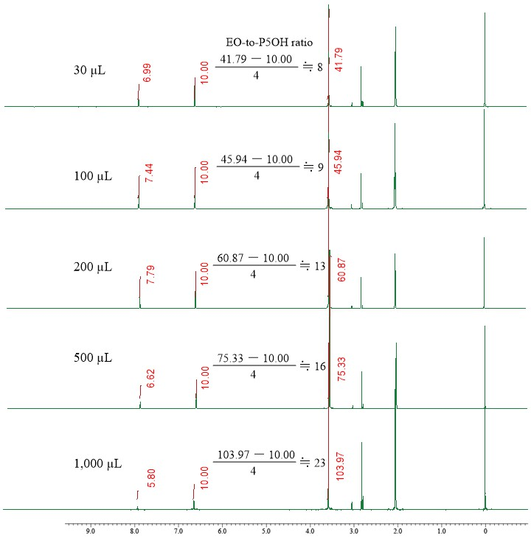
Supplementary Fig. 4 ¹H NMR spectra of pseudopolyrotaxanes prepared in 1.1 (acetone-d₆, 25°C)

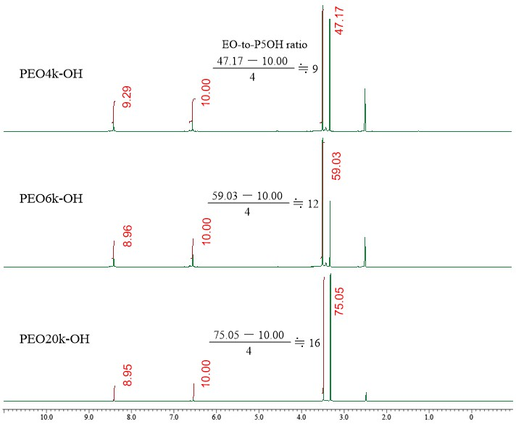
Supplementary Fig. 5 ¹H NMR spectra of pseudopolyrotaxanes with various PEO molecular weight (DMSO-d₆, 25 °C)

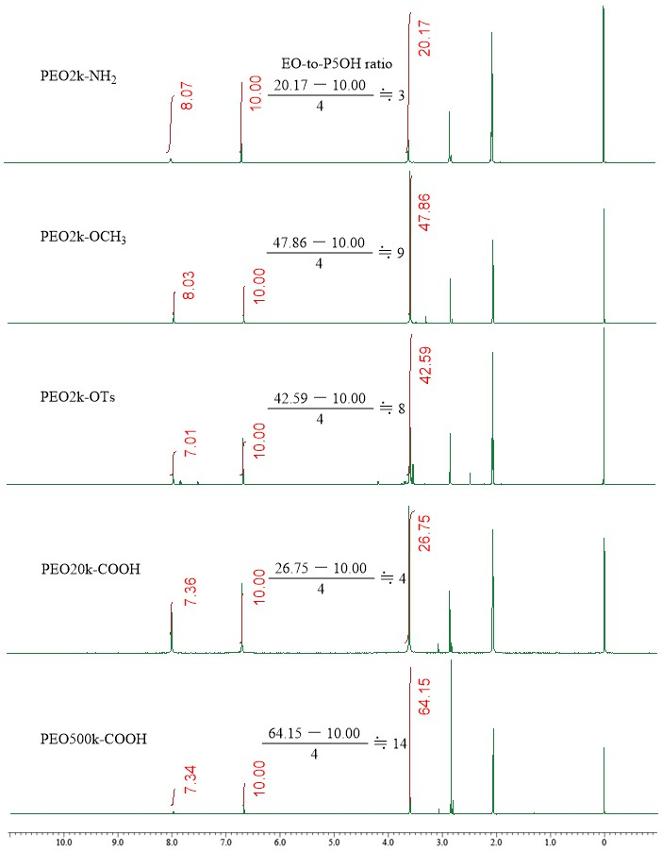
Supplementary Fig. 6 ¹H NMR spectra of pseudopolyrotaxanes with different terminal groups (acetone-d₆, 25°C)

Supplementary Fig. 7 ¹H NMR spectrum of P5OH•PEO20k-CONHAd (DMSO-d₆, 25°C)

Supplementary Fig. 8 ¹H NMR spectrum of polyrotaxanes prepared in 1.6 using acetonitrile as the reaction solvent (DMSO-d₆, 25°C)

Supplementary Fig. 9 ¹H NMR spectrum of polyrotaxanes prepared in 1.6 using DMF as the reaction solvent (DMSO-d₆, 25°C)

Supplementary Fig. 10 ¹H NMR spectrum of polyrotaxanes prepared in 1.6 using THF as the reaction solvent (DMSO-d₆, 25°C)

Supplementary Fig. 11 ¹H NMR spectrum of polyrotaxanes prepared in 1.6 using acetone as the reaction solvent (DMSO-d₆, 25°C)

Supplementary Fig. 12 ¹H NMR spectrum of P5OH•PEO500k-CONHAd (DMSO-d₆, 25°C)

Supplementary Fig. 13 ¹H NMR spectrum of α-CD•PEO500k-CONHAd (DMSO-d₆, 25°C)

3. GPC charts
Supplementary Fig. 14 GPC-UV traces of P5OH, PEO20k-OH, and P5OH•PEO20k-CONHAd using DMF (10 mM LiBr) as the eluent
Supplementary Fig. 15 GPC-UV traces of P5OEt and crude materials prepared in 1.8 using acetone, chloroform and THF as the reaction solvent. For GPC-UV measurements, THF was used as the eluent

4. PXRD analysis
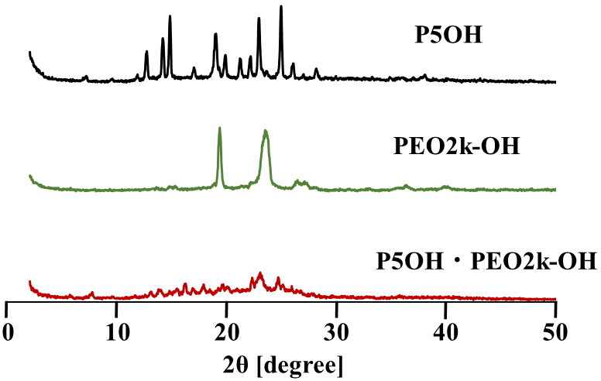
Supplementary Fig. 16 PXRD patterns of P5OH (top), PEO2k-OH (middle), and P5OH•PEO2k-OH (bottom)

Supplementary Fig. 17 Variable-temperature PXRD patterns of a,b PEO500k-COOH and c,d P5OH•PEO500k-CONHAd. a,c Heating from 30 °C to 100 °C and b,d cooling from 100 °C to 30 °C

5. CO₂ gas adsorption measurements
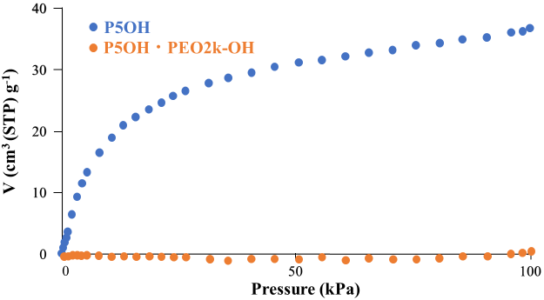
Supplementary Fig. 18 CO₂ adsorption curvilinear diagrams of P5OH (blue) and P5OH•PEO2k-OH (orange)
Supplementary Fig. 19 CO₂ adsorption curvilinear diagrams of P5OH (blue) and P5OH•PEO20k-CONHAd (green)

6. DSC
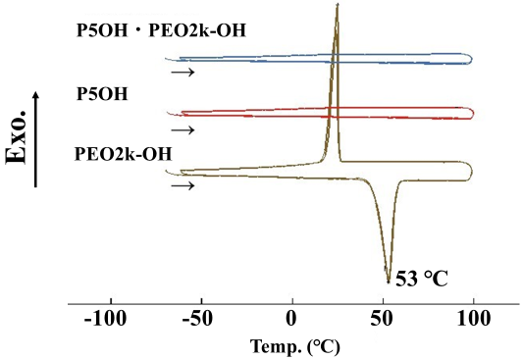
Supplementary Fig. 20 DSC graphs of P5OH•PEO2k-OH (top), P5OH (middle), and PEO2k-OH (bottom). Samples were heated from –70 °C to 100 °C and cooled back to –70 °C under N₂. This cycle was repeated twice at the heating/cooling rate of 10 °C/min

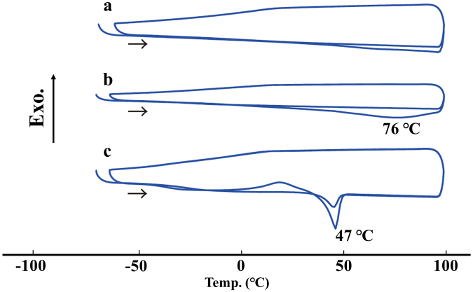
Supplementary Fig. 21 DSC graphs of pseudopolyrotaxanes prepared in 1.1. The molar ratios of EO units to P5OH were a 8, b 13, and c 15. Scanning conditions were the same as those for Supplementary Fig. 20
Supplementary Fig. 22 DSC graphs of a PEO500k-OH, b P5OH•PEO500k-CONHAd, and c α-CD•PEO500k-CONHAd. Samples were heated from 0 °C to 160 °C and cooled back to 0 °C under N₂. This cycle was repeated twice at the heating/cooling rate of 10 °C/min. For all materials, no peaks were detected in the regions of 0 °C to 20 °C and 70 to 160 °C

7. TGA
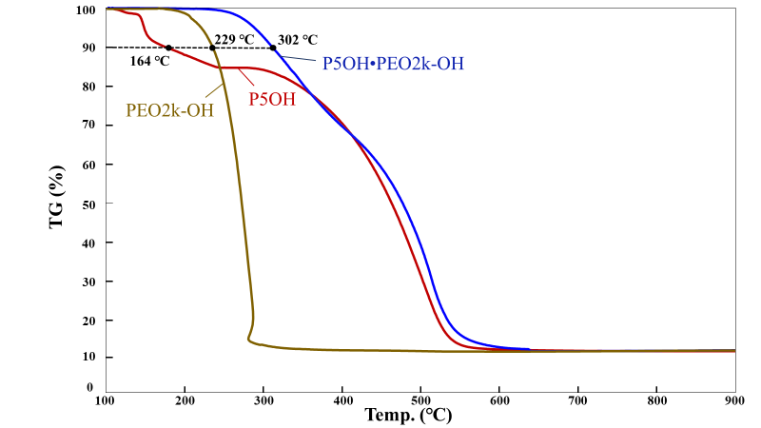
Supplementary Fig. 23 TGA traces of PEO2k-OH, P5OH, and P5OH•PEO2k-OH. Before the measurement, samples were heated to 100 °C and kept this temperature for 60 min to release the residual solvent under air. Then, the samples were heated from 100 °C to 700 °C at the rate of 10 °C/min under air
Supplementary Fig. 24 TG traces of polyrotaxanes prepared in 1.6 using various reaction solvents. After heating at 100 °C for 15 min under N₂, the samples were heated from 100 °C to 300 °C at the rate of 1.0 °C/min and from 300 °C to 900 °C at the rate of 10 °C/min under N₂. The molar ratio of EO units to P5OH and their 10% weight loss temperature were 34 and 270 °C (acetonitrile), 28 and 273 °C (DMF), 20 and 253 °C (THF), and 9 and 198 °C (acetone), respectively. These values were between those of uncomplexed P5OH (125 °C) and PEO20k-OH (371 °C)
Supplementary Fig. 25 TG traces of P5OH•PEO500k-CONHAd and α-CD•PEO500k-CONHAd. After being heated at 100 °C for 15 min under N₂, the samples were heated from 100 °C to 300 °C at the rate of 1.0 °C/min and from 300 °C to 900 °C at the rate of 10 °C/min under N₂

8. Supplementary references

- Araki, J., Zhao, C. & Ito, K. Efficient Production of Polyrotaxanes from α-Cyclodextrin and Poly(ethylene glycol). Macromolecules 38, 7524–7527 (2005).
- Ogoshi, T. et al. Molecular weight fractionation by confinement of polymer in one-dimensional pillar[5]arene channels. Nat. Commun. 10, 479 (2019).

