Machine Learning-Enhanced Engineering of Ultrahigh-Loading Polymer-Drug Assemblies with Programmable ROS-Triggered Release for Tumor Elimination

Richard d’Arcy, Sarah P. Hall, Steve Wilson, Mariah Bezold, Patrick Gerber, Marcus Bernard, Jean Jerome, Nora Francini, Natalie Bennett, Patricia Poley, Amelia Soltes, Fang Yu, Carlisle DeJulius, Shrusti S. Patel, Kristopher Castillo, Justin Lo, Julie (Rhoades) Sterling, Rebecca Cook, Christopher Muhich, Craig L. Duvall

Supporting information

Materials and Methods
Polymers were characterized using ¹H nuclear magnetic resonance (NMR) spectroscopy (Bruker, 400 MHz) and gel permeation chromatography (GPC) analysis. GPC was performed using a EcoSEC Elite GPC System with LenS MALS and refractive index (RI) detectors (Tosoh, Japan) comprising of a TSKgel Alpha-M 13 μm column. DMF with 0.01 M LiBr was used as the mobile phase at a flow rate of 0.6 mL.min⁻¹ and a temperature of 50 °C. The calibration was performed using polymethylmethacrylate (PMMA) standards of known molecular weight and dn/dc. Dynamic Light Scattering (DLS) measurements were performed on dispersions at 1 mg/mL using a Zetasizer Ultra (Malvern Instruments Ltd., UK) at 20 °C.
Monomer Synthesis of Thioglycidyl Benzyl Ether (Bz).
25.0 g of glycidyl benzyl ether (152.25 mmol), 23.2 g of thiourea (304.5 mmol, 2 eq.s) and 8.1 g of NH₄Cl were introduced into the reaction flask with 250 mL of MeOH. The reactor was transferred to at heating bath set at 60°C and the reaction was stirred under a nitrogen atmosphere for 1.5 hours or until starting material had been fully consumed (followed by TLC – note a significant amount of side products form if allowed to react for too long). Volatiles are removed by rotary evaporation and the multiphasic residues are dissolved into a biphasic mixture diethyl ether and water, transferred to a separating funnel and 250 mL of ether is extracted against 50 mL of water three times, followed by brine two times. The organic phase is collected, dried over Na₂SO₄, filtered, and concentrated in vacuo. The faintly yellow oil is then purified through a short column of silica using hexane as the eluent. The hexane is removed by rotary evaporation to give 22.3 g of a colorless oil product (81.3% yield).
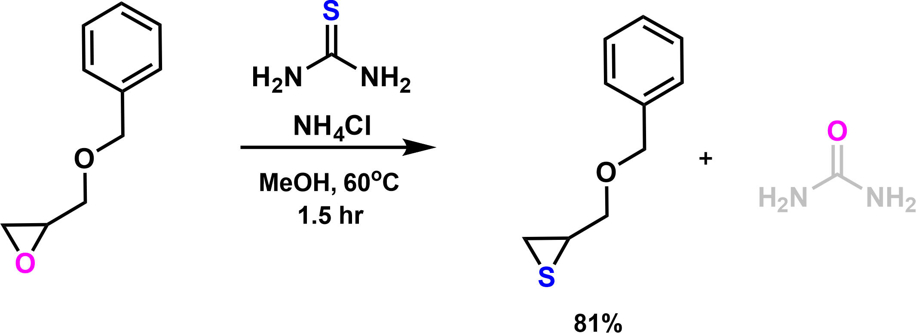
Figure S1 Synthetic scheme for the synthesis of benzyl thioglycidyl ether monomer.
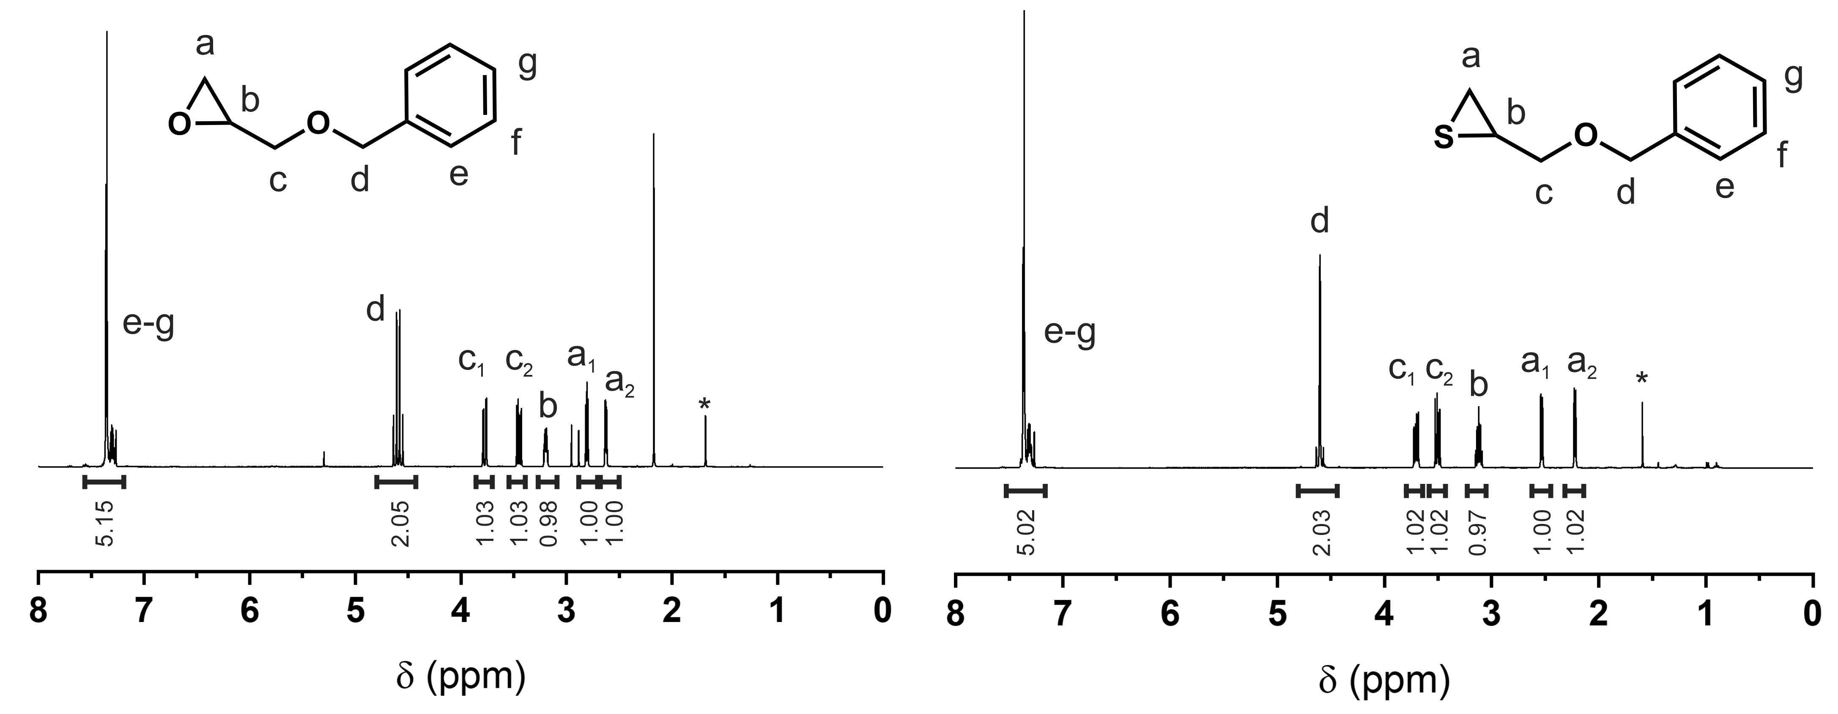
Figure S2 ¹H NMR spectra of commercially purchased benzyl glycidyl ether starting material (left) and synthesized benzyl thioglycidyl ether (right) in CDCl₃. Letters correspond to the protons as assigned in the chemical structure; sharp CHCl₃ NMR solvent peak is overlapped with e-g peaks. Asterisk denotes H₂O proton signal.
Monomer Synthesis of Tert-Butyldimethylsilyl Thioglycidyl Ether (TBTE).
Tert-butyldimethylsilyl thioglycidyl ether was synthesized using an identical procedure as thioglycidyl benzyl ether. Briefly, 25.0 g of tert-butyldimethylsilyl glycidyl ether (132.74 mmol), 20.21 g of thiourea (265.48 mmol, 2 eq.s) and 8.1 g of NH₄Cl were introduced into the reaction flask with 250 mL of MeOH. The reactor was transferred to at heating bath set at 60°C and the reaction was stirred under a nitrogen atmosphere for 1.5 hours or until starting material had been fully consumed (followed by TLC – note a significant amount of side products form if allowed to react for too long). Volatiles are removed by rotary evaporation and the multiphasic residues are dissolved into a biphasic mixture diethyl ether and water, transferred to a separating funnel and 250 mL of ether is extracted against 50 mL of water three times, followed by brine two times. The organic phase is collected, dried over Na₂SO₄, filtered, and concentrated in vacuo. The faintly yellow oil is then purified through a short column of silica using hexane as the eluent. The hexane is removed by rotary evaporation to give 20.8 g of a colorless oil product (76.7% yield).

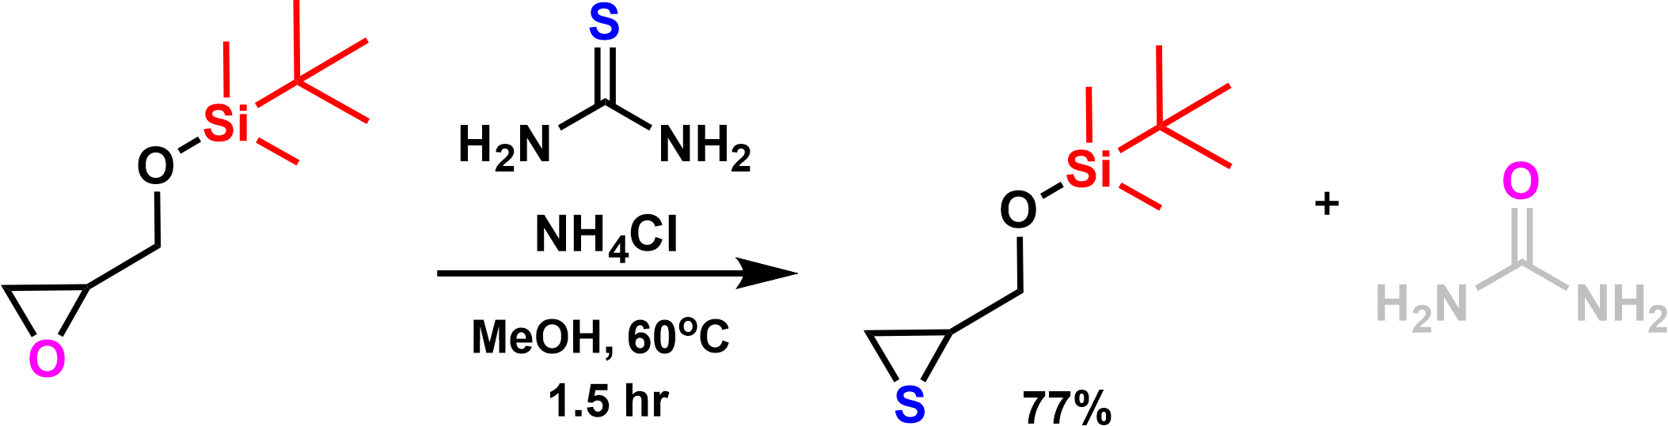
Figure S3Synthetic scheme for the synthesis of tertbutyldimethylsilyl thioglycidyl ether (protected thiogylcidol) monomer.
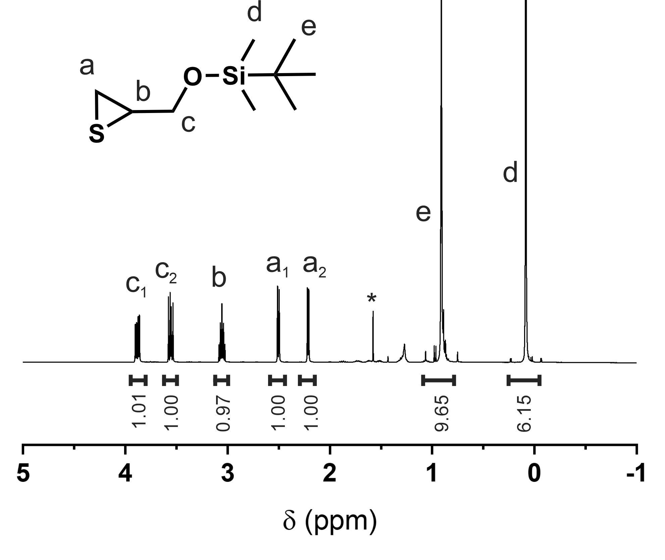
Figure S4 ¹H NMR spectra of synthesized tertbutyldimethylsilyl thioglycidyl ether in CDCl₃. Letters correspond to the protons as assigned in the chemical structure. Asterisk denotes H₂O proton signal.

Synthesis of Protected COOH/Amide Monomer.
Synthesis of epoxide tertbutyl ester.

24.5 g of tert-butyl-3-butenoate (173 mmol) was dissolved into 400 mL of dry DCM and placed into an ice bath. mCPBA was added as a powder over 1 hr and was allowed to stir for 24 hours. To the mixture was added aqueous solution of sodium carbonate and sodium sulfate and the biphasic mixture was allowed to (gently) stir for 10 minutes then added to a separating funnel. The organic phase was separated then extracted 2x against sat. sodium carbonate and 2x against sodium sulfite. DCM phases were dried over sodium sulfate and concentrated in vacuo to yield 27.0 g of a colorless oil (99.1%).
Note: original attempts to convert commercially available epoxides with the ester group in α-position to the epoxide ring underwent an unexpected side-reaction/elimination when converting to a thiirane necessitating the synthesis of epoxides with the ester in the β-position.
Synthesis of thiirane tertbutyl ester (TTBE).
25.0 g of tert-butyl ester epoxide (158 mmol), 24.1 g of thiourea (316 mmol, 2 eq.s) and 8.45 g of NH₄Cl (123 mmol, 1 eq.) were introduced into the reaction flask with 275 ml of MeOH. The reactor was transferred to at heating bath set at 60°C and the reaction was stirred under a nitrogen atmosphere for ~1.5 hours or until starting material had been fully consumed (followed by TLC – note significant side products form if allowed to react for too long). Volatiles were removed by rotary evaporation to leave an oil in a white precipitate (NH₄Cl). 50 mL of deionized water followed by 150 mL of diethyl ether was added to dissolve the contents of the flask which was then transferred as a biphasic mixture into a separating funnel; the water phase was separated, then discarded and the organic ether phase was extracted against three-times again brine water, then deionized water (once). The organic was separated, dried over Na₂SO₄ and concentrated in vacuo. The oil was added to a short silica column and filtered under gravity flow using hexane as the mobile phase and the filtrate concentrated by rotary evaporation to yield 22.017 g of a colorless oil (80.0%).
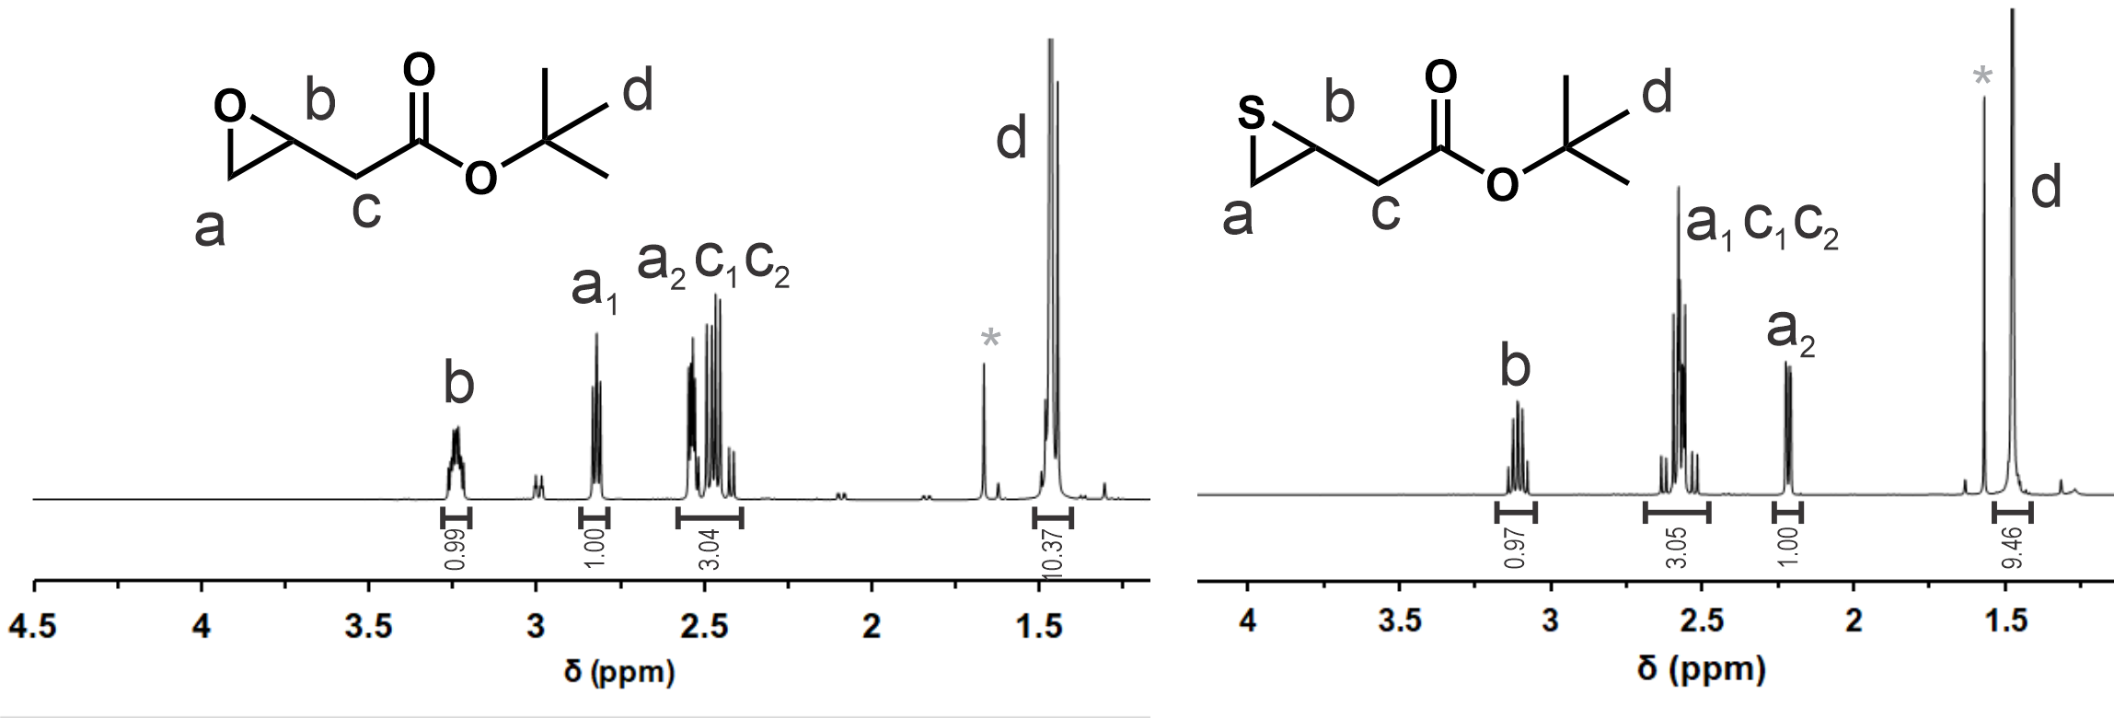
Figure S5 ¹H NMR spectra of synthesized epoxide tertbutyl ester (left) and thiirane butyl ester (right) in CDCl₃. Letters correspond to the protons as assigned in the chemical structure. Asterisk denotes H₂O proton signal.
Synthesis of Difunctional Initiator (DODTA)
10 g (54.85 mmol) of 2,2′-(Ethylenedioxy)diethanethiol and 45 mL of triethylamine (329.12 mmol, 6 equiv.s) were introduced into 400 mL of dried THF under an argon atmosphere. The reaction flask was transferred to an ice bath and a chilled solution of 19.57 mL of acetyl chloride (165.6 mmol, 5 equiv.s) in 50 mL of dry THF was added dropwise under vigorous stirring. The mixture was removed from the ice bath and allowed to react at room temperature for an additional 4 h, then filtered and volatiles removed by rotary evaporation. The resulting oil was diluted with 150 mL of dichloromethane, washed with brine (3x), dried over Na₂SO₄, filtered and concentrated by rotary evaporation. The residue was further purified by column chromatography using hexane:ethyl acetate (3:1) as the mobile phase and silica gel as the stationary phase to give 11.23 g of a colorless oil (76.9% yield).
Polymer Synthesis of 3kDa Poly(BzTG-co-TBTE) Dialkyne.
Polysulfides were synthesized via an anionic ring-opening polymerization. For 1 gram of monomer: 1 eq. of DODTA is added to 5 mL of degassed THF with 6 eq.s of tributylphosphine under a nitrogen atmosphere. 2.1 eq.s of sodium methoxide is then added as a 0.5 M methanolic solution, followed 5 minutes later by an appropriate amount of BzTG and TBTE; 16:0, 15:3, 13.3:6.7, 11.7:10, 10:13, 8.3:16.7, 6.1:20, 5:23.3 (BzTG:TBTE) respectively for the 100, 90, 80, 70, 60, 50, 40 and 30 wt.% BzTG (of final deprotected polysulfide). The reactants were allowed to react for 5 hours and quenched by the addition of 5 eq.s of propargyl bromide which was allowed a further 1 hour to react. The solution was diluted with 40 mL of dichloromethane and extracted against 5 mL of brine 3x, dried over Na₂SO₄, filtered and concentrated in vacuo. The oil was dissolved in a minimum amount of DCM and precipitated into 5 mL of methanol and centrifuged. Supernatant is removed and the oil is washed with 4 mL of fresh methanol once more. The resulting oil was dried in a vacuum oven for 48 hours to give the final product.
(For NMR, see Fig. S13 below)
Alcohol Deprotection of TBTE-containing Polysulfide Cores
For 1 mass of polysulfide, 1 mass of DOWEX 1x8 acid resin is weighted. DOWEX is first washed 2x with tetrahydrofuran (THF), 2x with methanol followed by activation with 1 M HCl (2x). The solution is aspirated and the polysulfide dissolved in THF:methanol 8:2 is added to the DOWEX resin and allowed to react for 24 hours at 45°C (no stirring). Additional methanol is added to bring the mixture to a 1:1 THF:methanol mixture and afforded a further 24 hours to react. The mixture is concentrated in vacuo and precipitated into cold methanol. The solvent is decanted, and the precipitate is placed in a vacuum oven for 48 hours to yield a clear colorless viscous oil.
(For NMR, see Fig. S13 below)
Polymer Synthesis of Polypropylene sulfide (PPS) Dialykne.
PPS-dialykne was synthesized in an analogous procedure as Poly(BzTG-co-TBTE) Dialkyne. Briefly, 89.8 mg of DODTA (0.33 mmol) is added to 5 mL of degassed THF with 0.5 mL of tributylphosphine (2.02 mmol, 6 eq.s) under a nitrogen atmosphere. 1.42 mL of sodium methoxide (0.71 mmol, 2.1 eq.s) is then added as a 0.5 M methanolic solution, followed 5 minutes later by 1.0 g of propylene sulfide (13.49 mmol, 40 eq.s). Reactants were allowed to react for 3 hours under a nitrogen atmosphere and was quenched with 200.5 mg of propargyl bromide (1.69 mmol, 5 eq.s) for 1 hour. The solution was diluted into 40 mL of dichloromethane and extracted against 5 mL of brine 3x, dried over Na₂SO₄, filtered and concentrated in vacuo. The oil was dissolved in a minimum amount of DCM and precipitated into 5 mL of methanol and centrifuged. Supernatant is removed and the oil is washed with 4 mL of fresh methanol twice more. The resulting oil was dried in a vacuum oven for 48 hours to give the final product as a clear, colorless oil.

Synthesis of tert-Butylester-containing Polysulfides (Poly(BzTG-co-TTBE)).
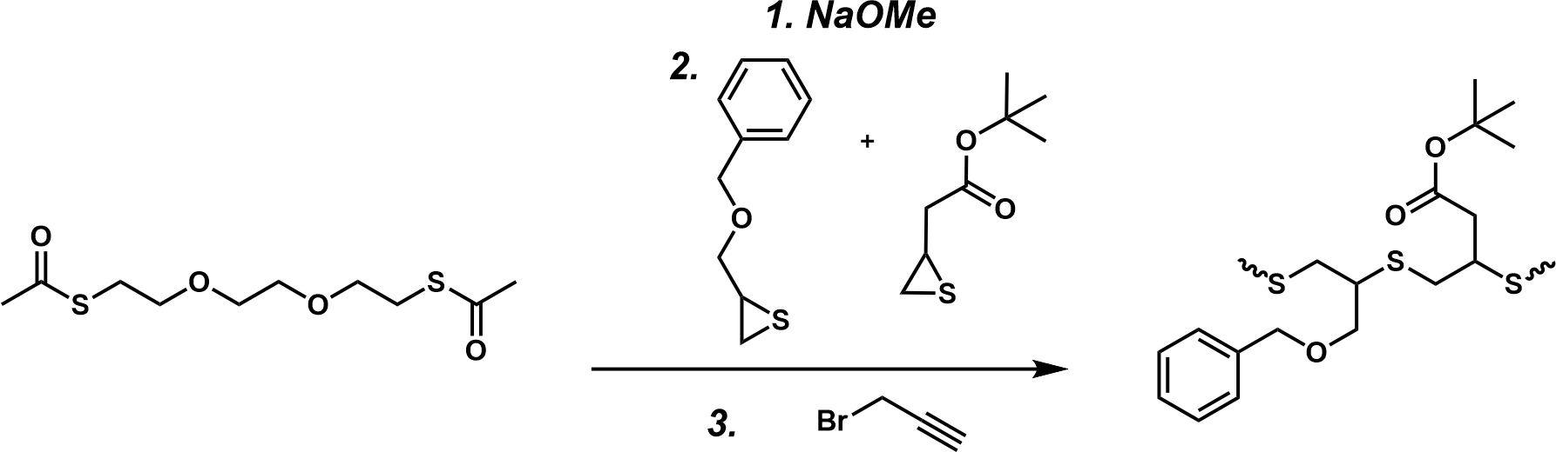
Poly(BzTG-co-TTBE) polymers were synthesized via an analogous procedure as the Poly(BzTG-co-TBTE) dialkyne. Briefly, 1 eq. of DODTA is added to degassed THF with 6 eq.s of tributylphosphine under a nitrogen atmosphere. 2.1 eq.s of sodium methoxide is then added as a 0.5 M methanolic solution, followed 5 minutes later by an appropriate amount of BzTG and thiirane tertbutyl ester (TTBE); 15.83:1.27, 15:2.54, 13.3:5.1, and 8.3:12.7 (BzTG:TBTE) respectively for the 95, 90, 80, and 50 wt.%Bz. The reactants were allowed to react for 5 hours and quenched by the addition of 5 eq.s of propargyl bromide which was allowed a further 1 hour to react. The solution was diluted with 40 mL of dichloromethane and extracted against 5 mL of brine 3x, dried over Na₂SO₄, filtered and concentrated in vacuo. The oil was dissolved in a minimum amount of DCM and precipitated into 5 mL of methanol and centrifuged. Supernatant is removed and the oil is washed with 4 mL of fresh methanol once more. The resulting oil was dried in a vacuum oven for 48 hours to give the final products as colourless oils.
Deprotection of tert-Butylester-containing Polysulfides into Carboxylic Acids.

The tert-butyl ester polysulfides were dissolved in dichloromethane and mixed with 4.0 M HCl in dioxane (Sigma-Aldrich) to give a 20-fold excess of HCl:ester and allowed to stir for 1 hour. Volatiles were evaporated and polymer was dried in a vacuum oven for 48 hrs to give colourless oils (≥ 99%).

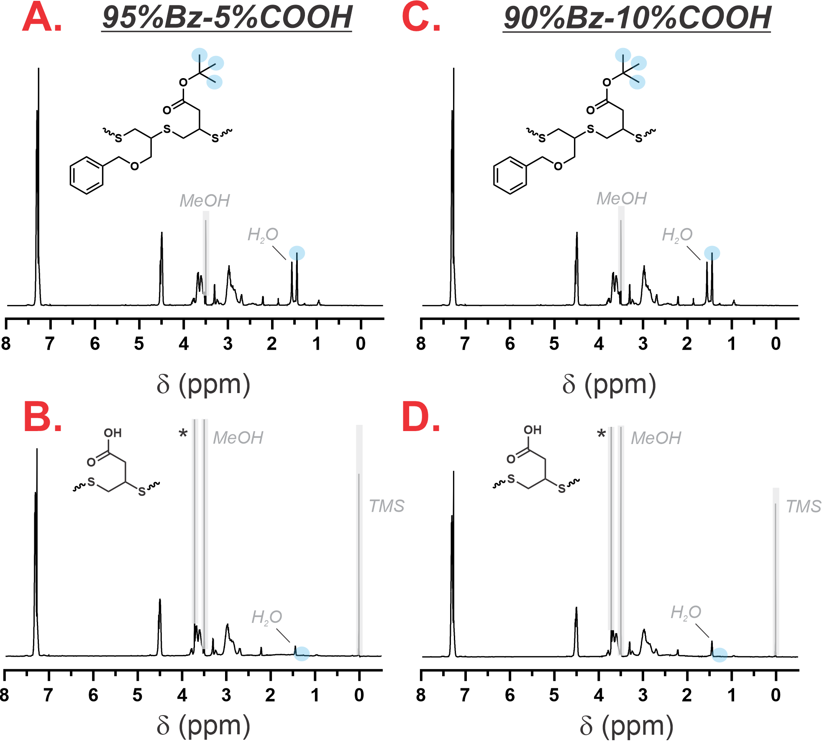
Figure S6 ¹H NMR spectra in CDCl₃ of A. 95%Bz-5%COOH(tert-butylester protected), B. 95%Bz-5%COOH (deprotected), C. 90%Bz-10%COOH(tert-butylester protected), and D. 90%Bz-10%COOH (deprotected). * denotes residual dioxane (from HCl reagent) and light-blue indicates the CH₃ protons from the tert-butyl functionality before (top) and after (bottom) deprotection.

Synthesis of 50%Bz-50%Amide Core
559 mg of 50%Bz-50%COOH-sulfide cores (0.186 mmol, 1.63 mmol COOH; amidated before conjugation with PDMA) was dissolved in 5 mL of dry DCM with 581 mg of pyrrolidine (8.17 mmol, 5 eq.s), 470 mg of NHS (4.09 mmol, 2.5 eq.s) and lastly 627 mg of EDC (3.27 mmol, 2 eq.s) and allowed to stir overnight. After 24 hr the solution was made to 30 mL of DCM and extracted against 5mL of 2M HCl 3x followed by sat. sodium carbonate (2x). The organic phase was dried of MgSO₄, filtered and concentrated in vacuo.
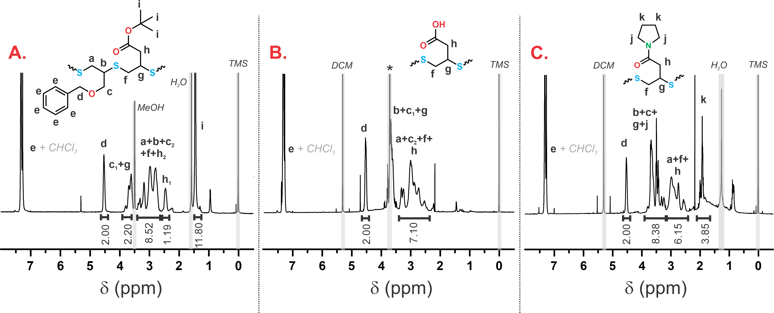
Figure S7 ¹H NMR spectra in CDCl₃ (containing 0.03% TMS) of 50/50 wt.% Bz/Amide copolymer and its intermediates of A) tertbutyl ester and B) deprotected COOH, and final amidated form in C. In B, * denotes residual dioxane (from HCl reagent).
Synthesis of 4-cyano-4-(ethylsulfanylthiocarbonyl) sulfanylpentanoic acid (ECT)
To a 100 mL solution of diethyl ether containing 5.0 g of ethanethiol (80.5 mmol) and 2.01 g of sodium hydride (83.7 mmol, 1.04 eq.s) was added 5.05 mL of carbon disulfide (83.7 mmol, 1.04 eq.s). The solution was allowed to react for 1 hour and the resulting sodiucm S-ethyl trithiocarbonate was further reacted with 6.74 g of iodine (26.6 mmol, 0.33 eq.s) to obtain bis(ethylsulfanythiocarbonyl) disulfide. This yellow solid was separated from the ether solution, dissolved into ethyl acetate and refluxed with 3.38 g of 4,4′-azobis(4-cyanopentanoic acid)(120.7 mmol, 1.5 eq.s) for 24 h. The volatiles were removed via rotary evaporation and the crude ECT purified by silica column chromatography using a 1:1 mobile phase of ethyl acetate and hexane. After evaporation of the mobile phase in vacuo, 15.983 g of an orange oil is formed that later becomes a yellow powder after storage at -20°C (75.2% yield).

Synthesis of 3-Azido-propylamine

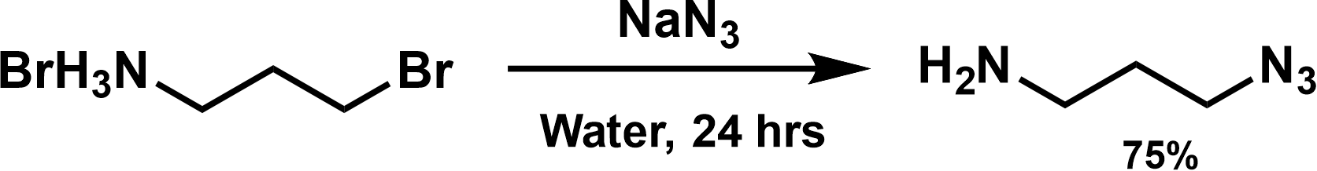
15.0 g of 3-bromopropylamine hydrobromide (68.52 mmol) and 17.8 g of sodium azide (274.1 mmol, 4 eq.s) were dissolved into 200 mL of deionized water and magnetically stirred at 80°C for 24 hours. The solution was allowed to cool to room temperature then placed in an ice bath, basified with 10.964 g of sodium hydroxide, saturated with sodium chloride and extracted against 75 mL of dichloromethane 5 times. The organic phases were collected, dried over anhydrous potassium carbonate, filtered, and concentrated in vacuo. 5.12 g of product was collected as a 40 wt.% in dichloromethane (74.5% yield).

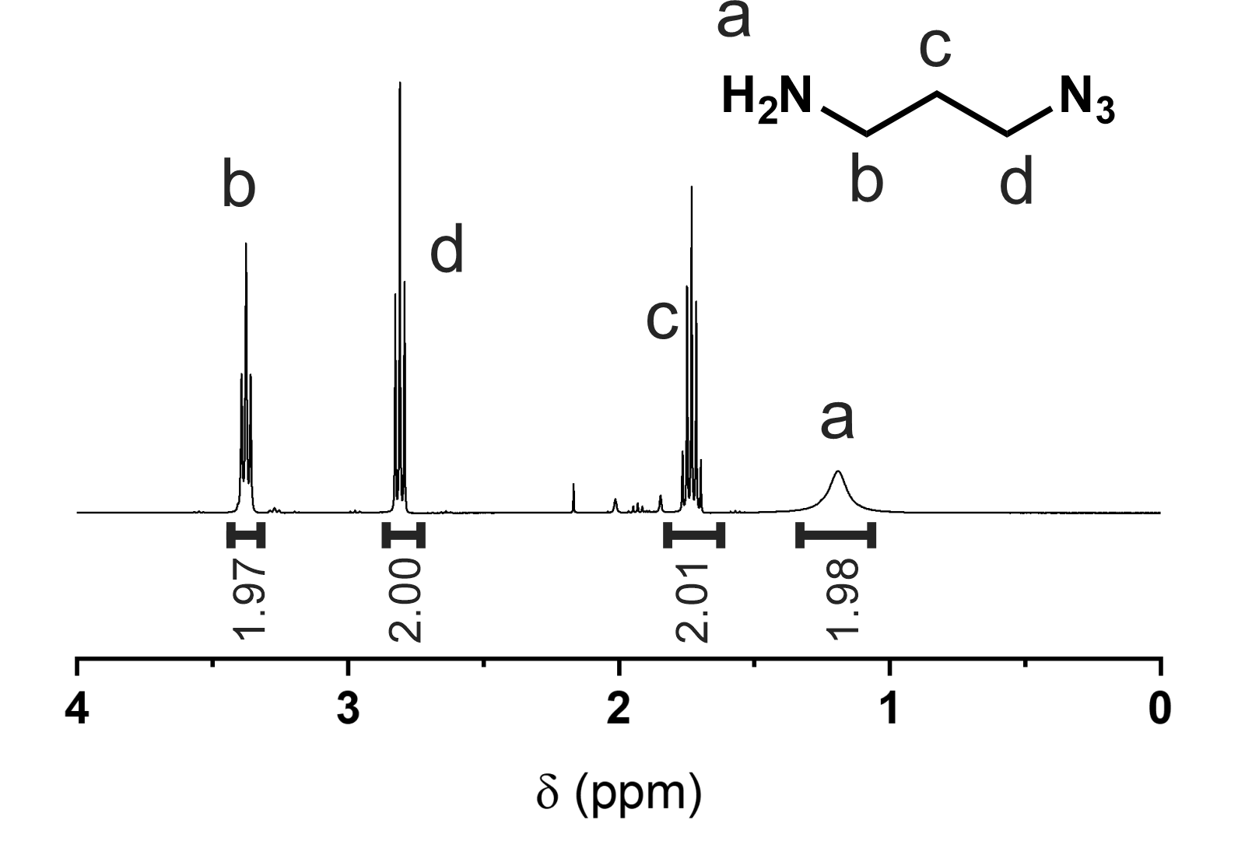
Figure S8 ¹H NMR spectra of synthesized 3-azidopropan-1-amine (right) in CDCl₃. Letters correspond to the protons as assigned in the chemical structure.

Synthesis of Azido-ECT RAFT Chain Transfer Agent (N₃-ECT)

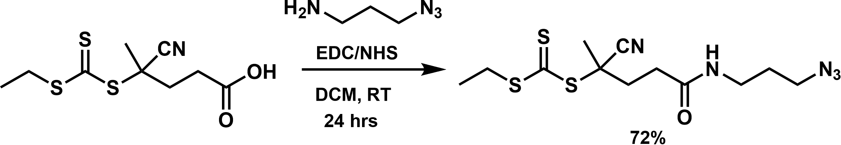
Figure S9 Synthetic scheme for the synthesis of N₃-ECT from 3-azidopropan-1-amine.
To an ice bath cooled solution containing 6.0 g of ECT (22.78 mmol) in 100 mL of dry ACN was added 2.28 g of azido-propyl-amine (22.78 mmol, 1 eq.) and 278 mg of DMAP (1.139mmol, 0.1 eq.s) in 10 mL of dry ACN followed immediately by 4.8 g of EDC (25.06 mmol, 1.1 eq.s). The reaction flask was removed from the ice-bath and allowed to react at room temperature for 24 hrs. The reaction solvent was evaporated in vacuo and redissolved into 150 mL of ethyl acetate and extracted against 35 mL of brine x3. The organic fraction was collected, dried over MgSO₄, filtered and concentrated by rotary evaporation. The resulting oil was purified by column chromatography using silica as a stationary phase and a 98:2 mixture of dichloromethane:methanol as the mobile phase. This yielded 5.651 g of a dark orange viscous oil (71.8% yield).
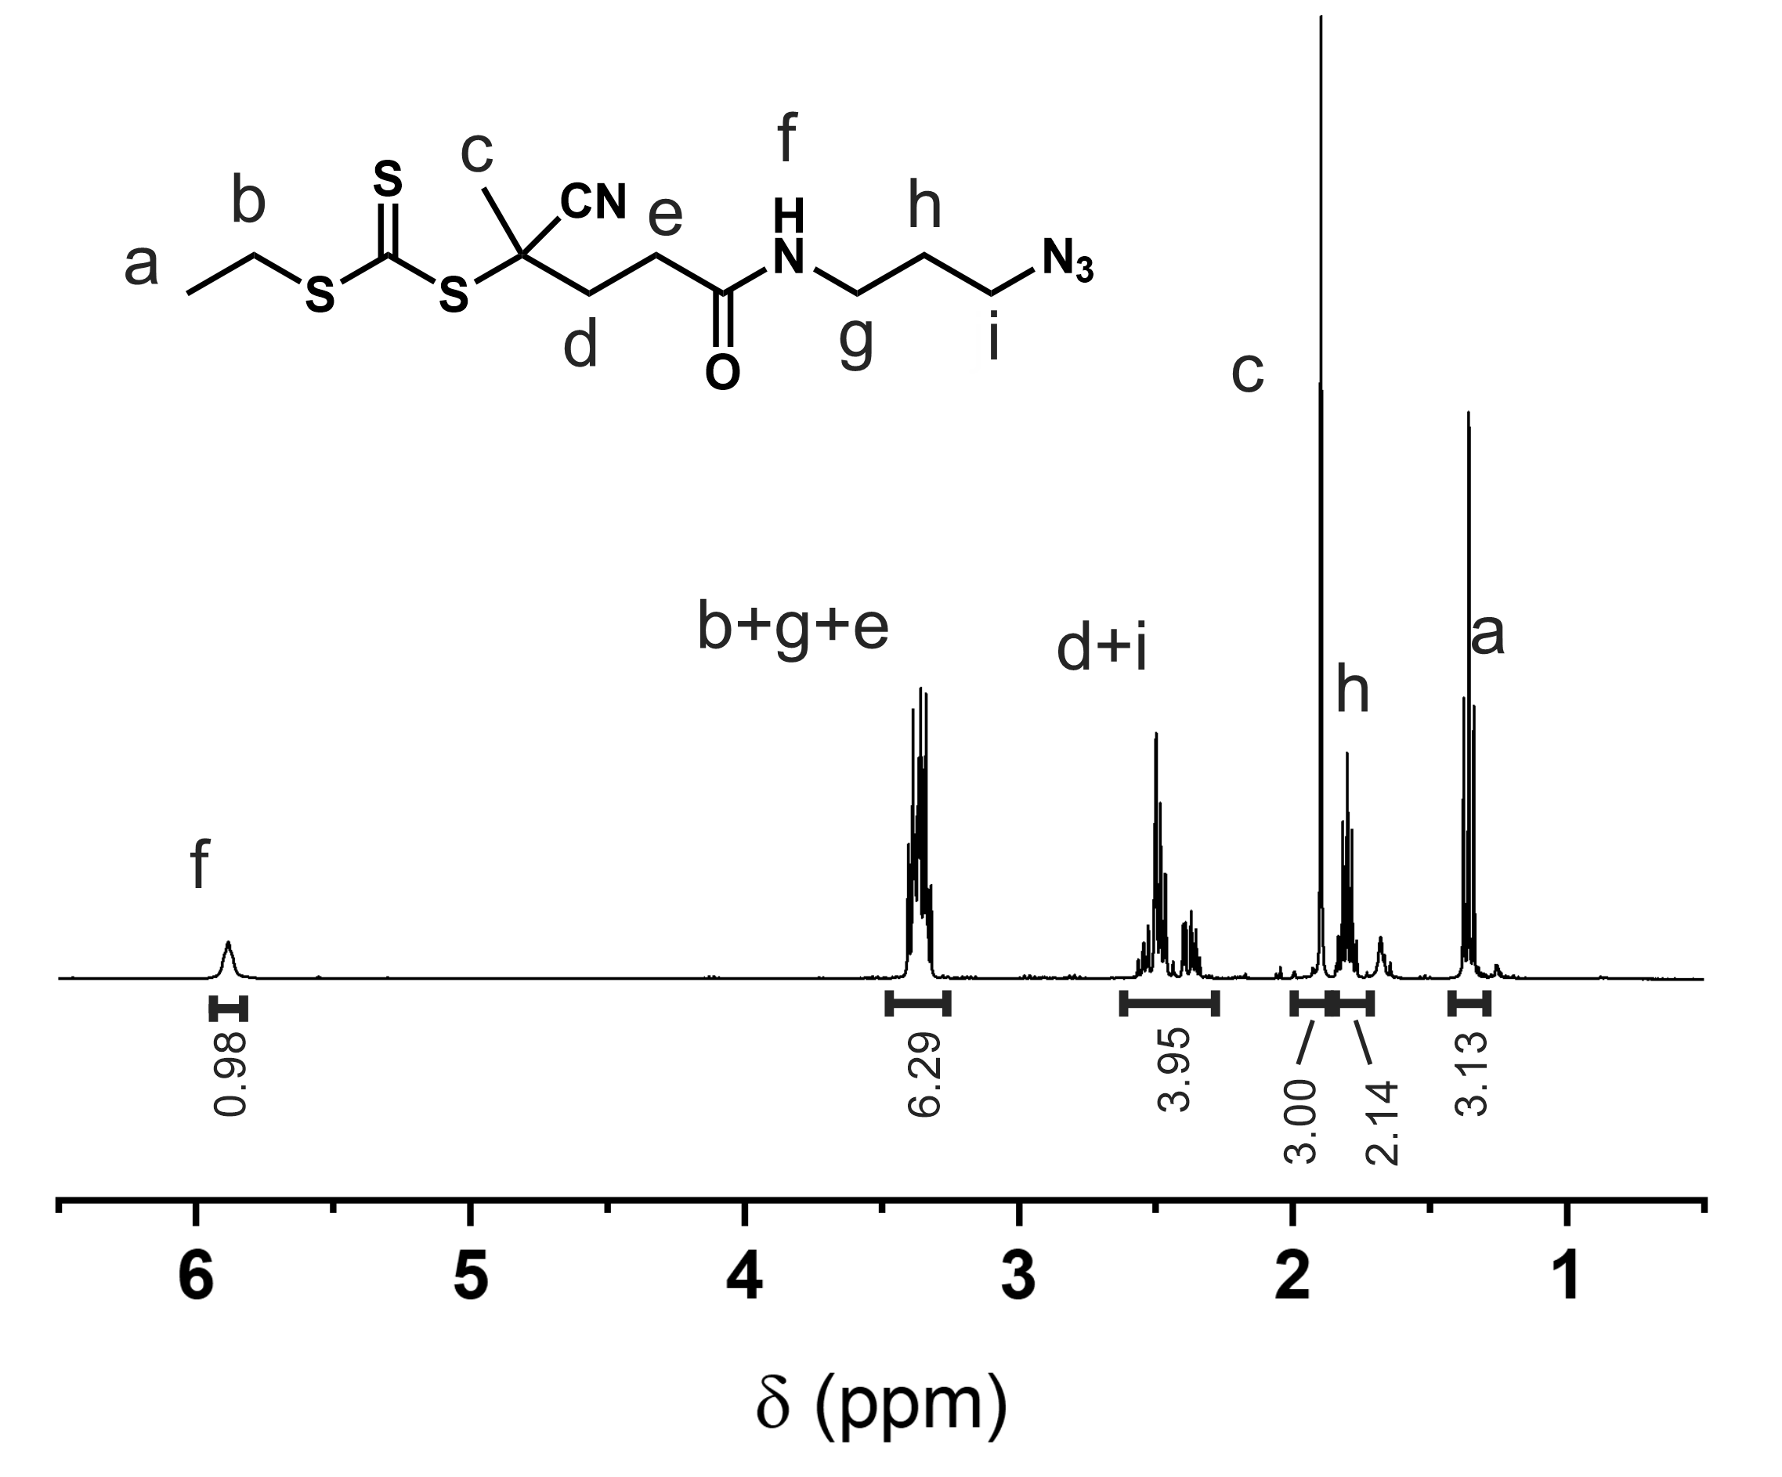
Figure S9 ¹H NMR spectra of N₃-ECT in CDCl₃. Letters correspond to the protons as assigned in the chemical structure.
Synthesis of 4.5 kDa N₃-Poly(Dimethylacrylamide)(N₃-PDMA)

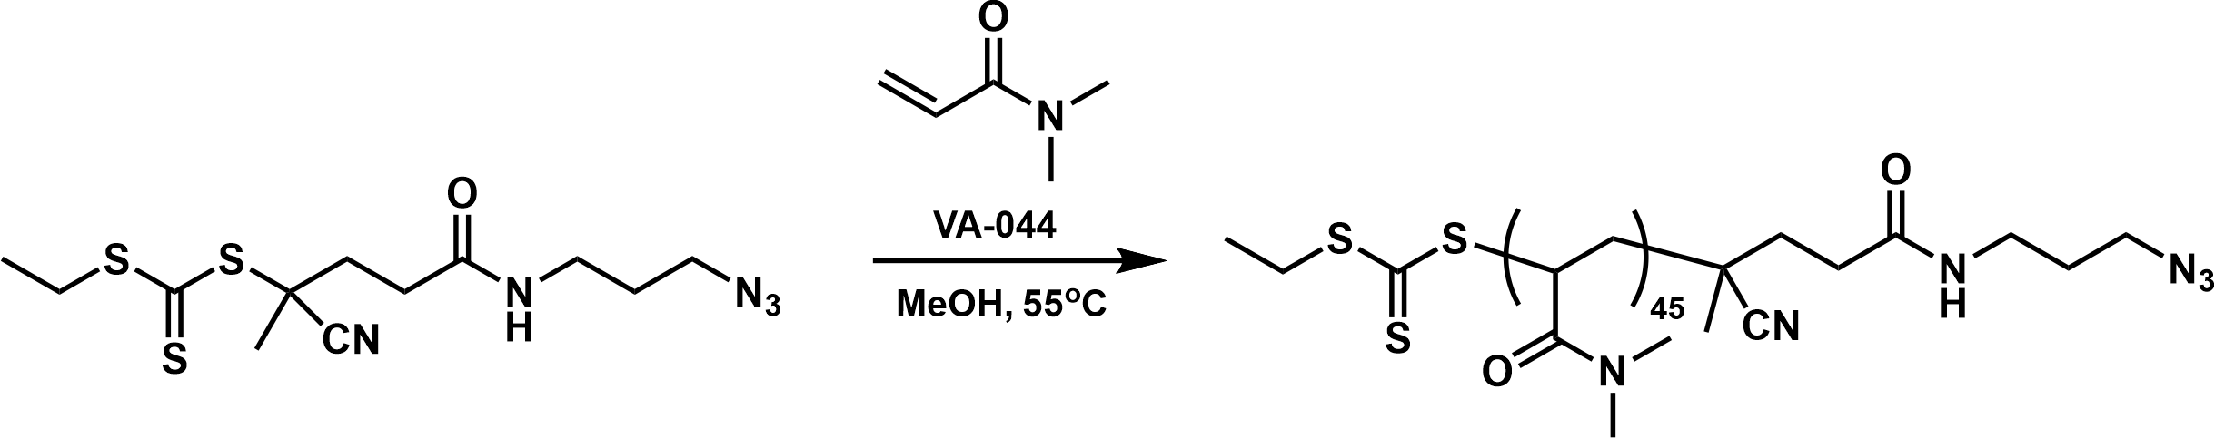
Figure S10 Synthesis of N₃-poly(dimethyl acrylamide)(PDMA) via RAFT polymerization.

873 mg of N₃-ECT (2.24 mmol), 10.0 g of dimethylacrylamide (100.9 mmol, 45 eq.s) and 108.7 mg of VA-044 (0.336 mmol, 0.15 eq.s) pre-dissolved in a minimum amount of water was added to 20 mL of methanol. The mixture was purged with nitrogen for 30 minutes, sealed, heated to 55°C and allowed to react for overnight. PDMA was purified by precipitation into diethyl ether from dichloromethane 3 times. The resulting viscous oil was placed in a vacuum oven overnight and yielded solid glassy yellow product.
Note: polymerization at this lower temperature preserves N₃ better than AIBN @ 70+°C.
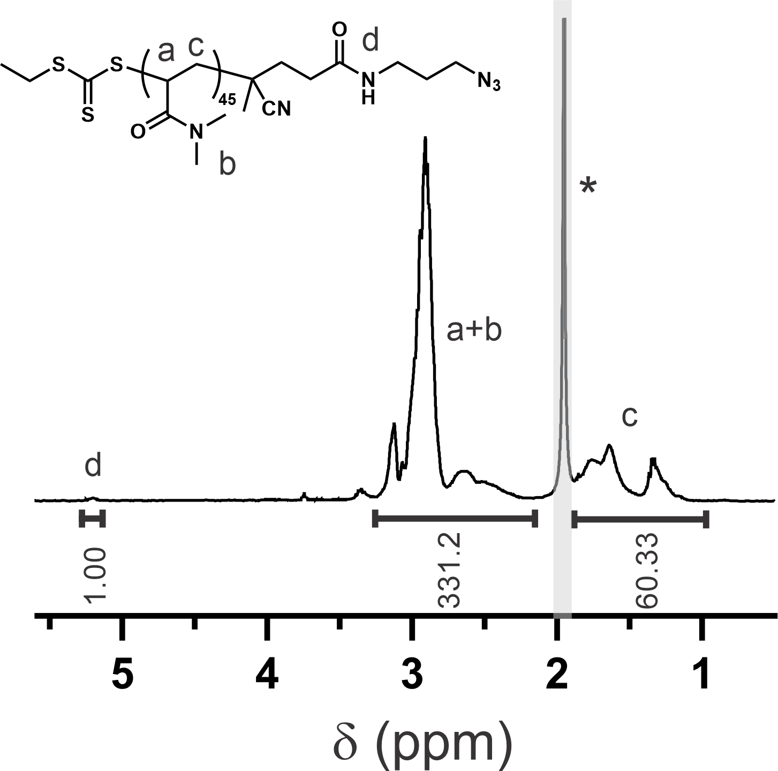
Figure S11 ¹H NMR spectrum of N₃-poly(dimethyl acrylamide)(PDMA) in CDCl₃. Asterisk denotes H₂O proton signal.

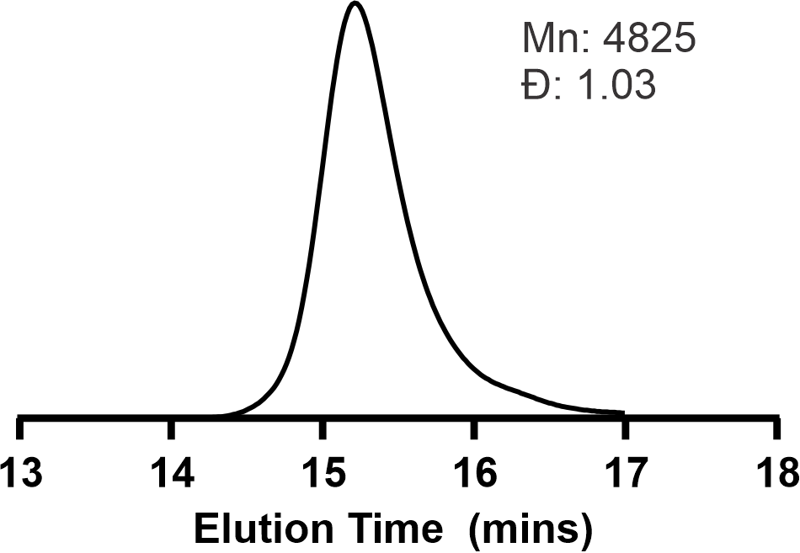
Figure S12 GPC chromatograph of N₃-poly(dimethyl acrylamide)(PDMA) synthesized by RAFT polymerization; GPC performed in DMF as mobile phase.

Synthesis of PDMA-Polysulfide-PDMA Triblock Copolymers
45 mg of a ~3 kDa polysulfide-dialykne (0.015 mmol) was dissolved in 4 mL of dimethylformamide (DMF) together with 180 mg of a ~ 4 kDa N3-PDMA (0.045 mmol, 3 eq.s [1.5 eq.s per alkyne]) and 9.6 mg of CuSO4.5H2O (0.06 mmol, 4 eq.s). The solution was purged with nitrogen gas for 10 minutes then under a nitrogen flow 16 μL of N′′,N′′-pentamethyldiethylenetriamine (PMDETA)(0.075 mmol, 5 eq.s) and 23 mg of sodium ascorbate (0.12 mmol, 8 eq.s) was added to the reaction mixture which was then magnetically stirred for 2 days under a nitrogen atmosphere. The reaction mixture was exposed to air and copper was allowed to oxidize overnight. The following day the mixture was saturated with ethylenediaminetetraacetic acid tetrasodium salt dihydrate (EDTA) and stirred for at least 6 hours. The mixture was diluted with 20 mL of dialysis buffer containing 0.1% EDTA and 10 mM of Na₂HPO₄ buffered to pH 7.5 with 1 M aqueous NaOH or HCl and placed into a dialysis bag with a 12-14 kDa molecular weight cut off (MWCO) pore size. The mixture was dialyzed in 4 L of dialysis buffer for 3 days, with the buffer changed every 2 hours during the day, then a further 2 days in deionized water. The resulting mixture was concentrated in a centrifugal spin filter (Amicon® Ultra-15 Centrifugal Filter Unit) with a MWCO of 10 kDa and 5 further volumes of deionized water was passed through the sample. The resulting solution was frozen and place in a lyophilizer for 3 days resulting in a white foamy powder.
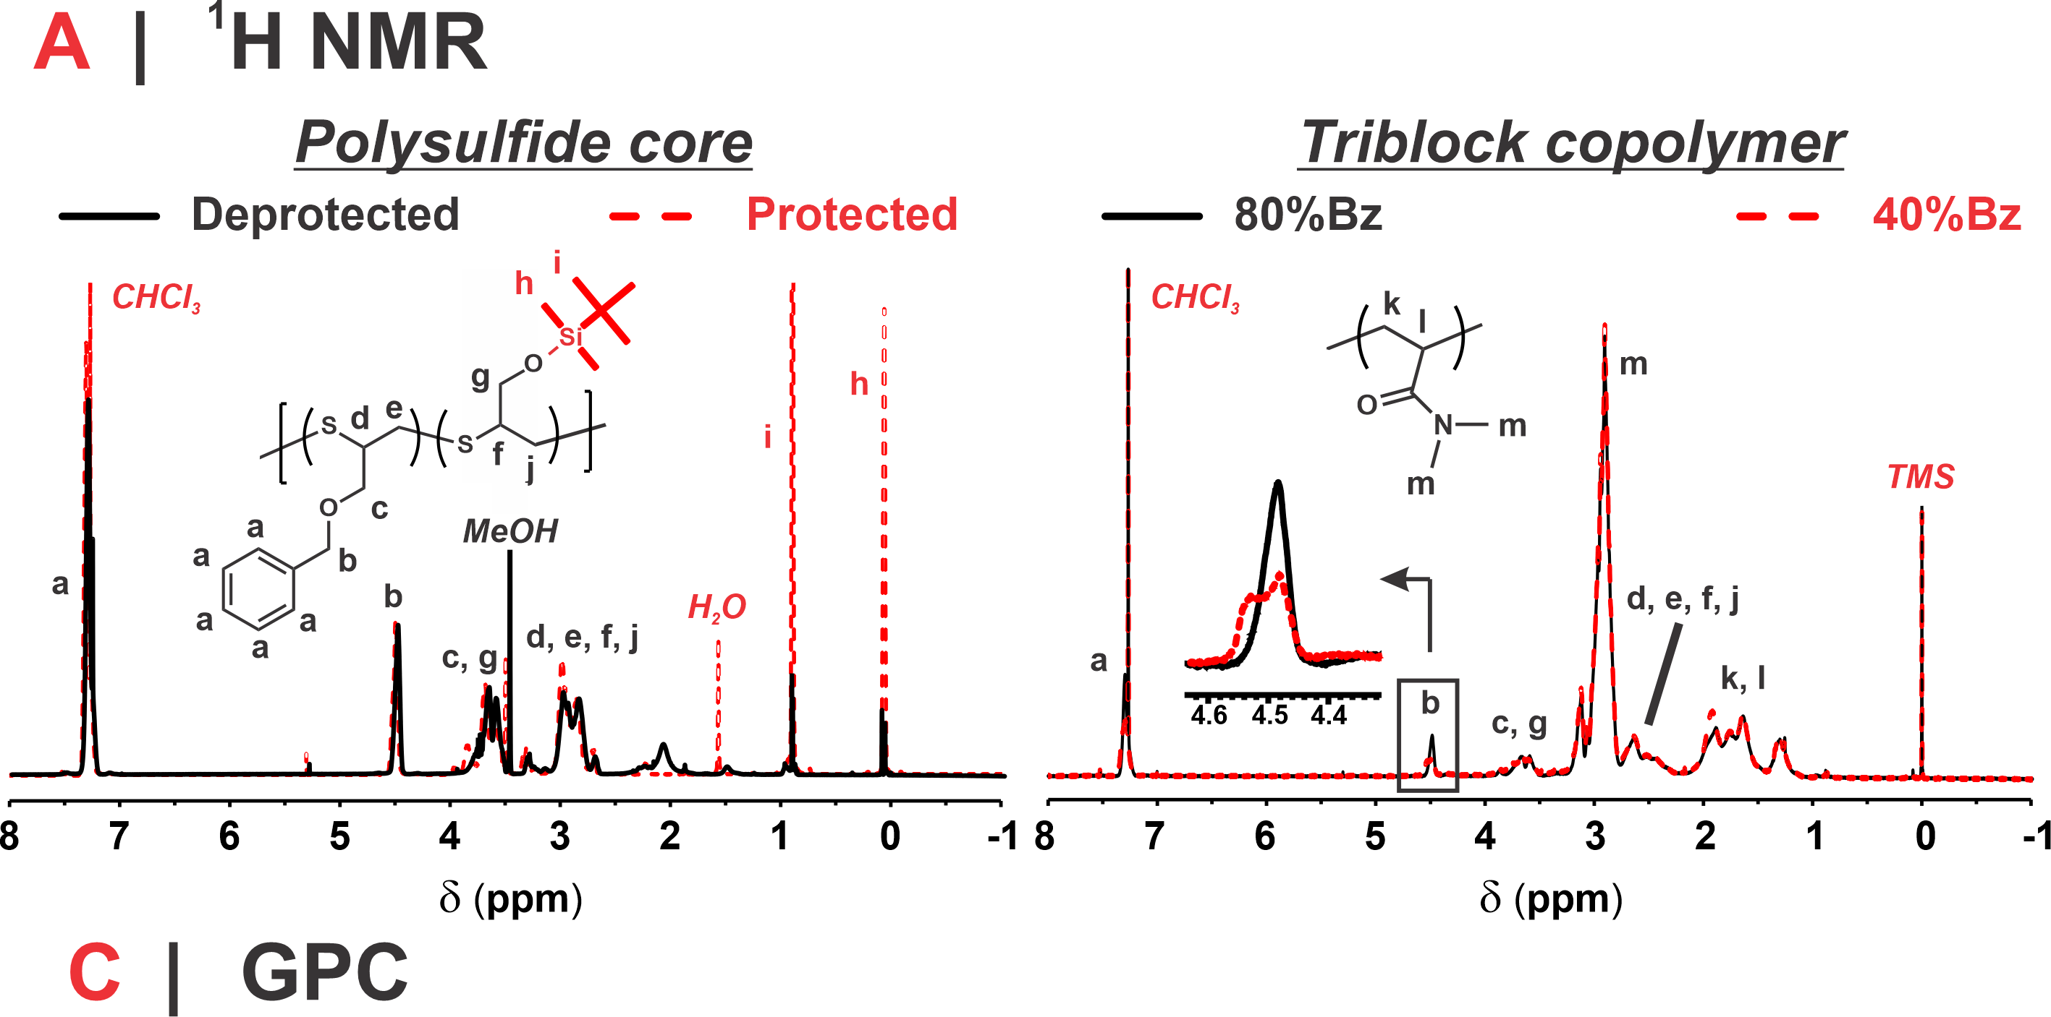
Figure S13. Left: ¹H NMR of protected (red) and deprotected (black) 80%Bz (P[Bz_{13.3}-TGG_{6.7}]) polysulfide cores performed in CDCl₃. Right: ¹H NMR of the 80%Bz (black) and 40%Bz (red) triblock-copolymers performed in CDCl₃. Note: deprotection of the TBDMS group proceeded to >98% completion in all cases.

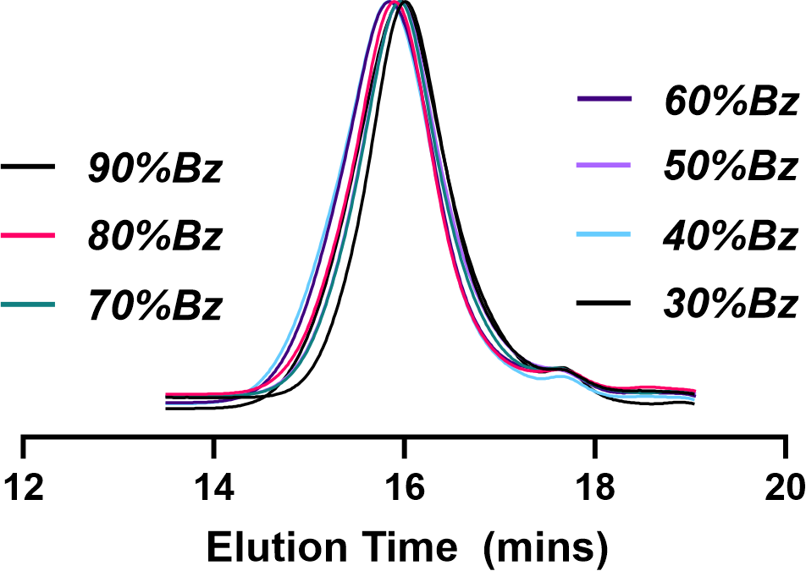
Figure S14 GPC Chromatographs of the PDMA-P(BzTG-TGG)-PDMA triblock copolymer series performed in DMF containing 0.01% LiBr.

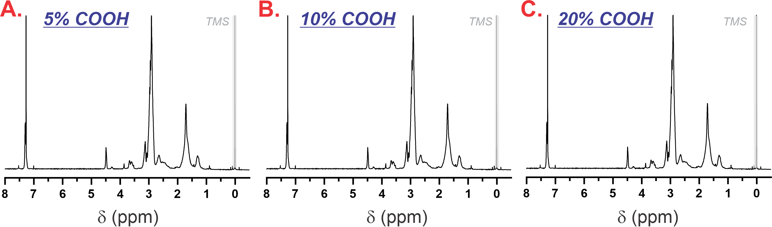
Figure S15. ¹H NMR of A) 5% COOH, B) 10% COOH, and C) 20% COOH PDMA triblock copolymers in CDCl₃.
Cy5 Labelling of PDMA-P(BzTG_{13.3}-TGG_{6.7})-PDMA (80%Bz) and PDMA-P(BzTG_{6.1}-TGG₂₀)-PDMA (40%Bz)
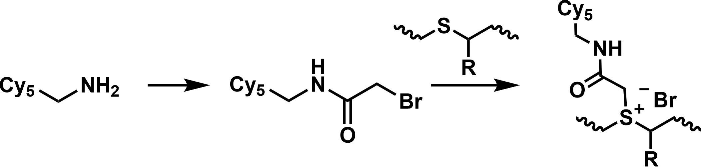
25 mg of Cyanine5-amine (0.038 mmol) was dissolved into 1 mL of dry DMF together with 6.7 µL of DIPEA (1 eq.) and stirred for 5 minutes (protected from light in foil). 3.3 µL of bromoacetyl bromide (1 eq.) was then added and allow to stir for 1 hour to produce Cy5-Br. Without any further purification, 140 µL of the Cy5-Br solution containing 3.5 mg of Cy5-Br was stirred with 50 mg of PDMA- P(BzTG_{13.3}-TGG_{6.7})-PDMA (80 wt.%Bz) or PDMA- P(BzTG_{6.1}-TGG₂₀)-PDMA (40 wt.% Bz) in 3 mL of DMF for 5 days at room temperature. The polymers were ‘nanoprecipitated’ into an aqueous phase and dialyzed against 40% DMSO/60% water for 2 days, 0.1 M NaCl water for 2 days and finally DI water for 1 day. The resulting solutions were lyophilized to give dark blue powders.
Synthesis Diblock and higher Mw Polysulfide Cores
In 5 mL of nitrogen purged THF either a mono- or di-functional thioacetate initiator (ethyl thioacetate or DODTA for the diblock or triblock polysulfide cores respectively) was added with 3 eq.s (per S of initiator) of tributylphosphine. Under a nitrogen atmosphere 1.05 eq.s (per S of initiator) was added as a 0.5 M solution in methanol, and the mixture was allowed to stir for 5 minutes. To the solution was then added 500 mg of BzTG (2.77 mmol) and 486 mg of TBTE (2.378 mmol); this corresponds to a 5.8:5, 11.7:10, 17.5:15 and 23.3:20 BzTG:TBTE eq.s (per S of initiator) respectively for the 1.5, 3, 4.5 and 6 kDa diblock polysulfide cores and 11.7:10, 23.3:20, 35:30 and 46:40 mol eq.s (per S of initiator) for the 3, 6, 9 and 12 kDa triblock copolymer cores. The monomers were allowed to react for 5 hours and quenched by the edition of 2.5 eq.s (per S of initiator) of propargyl bromide, which was allowed a further 1 hour to react. The solution was diluted with 40 mL of dichloromethane and extracted 3x against 5 mL of brine. The organic phase was separated, dried over Na₂SO₄, filtered and concentrated via rotary evaporation. The oil was precipitated into 5 mL of methanol and centrifuged. The supernatant was decanted and the oily pellet was washed once more with 4 mL of fresh methanol and centrifuged against. Supernatant was decanted and the resulting oil was placed in a vacuum oven for 48 hours yielding a clear colorless oil.
Synthesis of high MW N₃-Poly(Dimethylacrylamide)(N₃-PDMA)
N₃-ECT (1 eq.), VA-044 (0.15 eq.s, pre-dissolved in a minimum amount of water) and dimethylacrylamide corresponding to 45, 80, 120 and 160 eq.s were added to methanol (for the 4.5, 8, 12 and 16 kDa PDMA respectively). The mixture was purged with nitrogen for 30 minutes, sealed, heated to 55°C and allowed to react for overnight. PDMA was purified by precipitation into diethyl ether from dichloromethane 3 times. The resulting viscous oil was placed in a vacuum oven overnight and yielded solid glassy yellow product.
Synthesis of N₃-Poly(N-(2-Hydroxypropyl) methacrylamide)(N₃-PHPMA)
N₃-ECT (1 eq.), VA-044 (0.15 eq.s, pre-dissolved in a minimum amount of water) and 32 eq.s of N-(2-hydroxypropyl) methacrylamide were added to methanol. The mixture was purged with nitrogen for 30 minutes, sealed, heated to 55°C and allowed to react for overnight. PHPMA was purified from the reaction mixture by precipitation into acetone from methanol 3 times. The resulting viscous oil was placed in a vacuum oven overnight and yielded solid glassy yellow product.
Synthesis of N₃-Poly(Glycerol monomethacrylate)(N₃-PGMMA)
N₃-ECT (1 eq.), VA-044 (0.15 eq.s, pre-dissolved in a minimum amount of water) and 28 eq.s of glycerol monomethacrylate were added to methanol. The mixture was purged with nitrogen for 30 minutes, sealed, heated to 55°C and allowed to react for overnight. The mixture was precipitated into DCM 3x from methanol then placed in a vacuum oven for 48 hrs yielding a glassy yellow powder product.
Synthesis of N₃-Poly(2-methyl-2-oxazoline)(N₃-PMOX)
3.98 mL of methyl oxazoline (47 mmol, 53 equiv.s) was dissolved into 12 mL of dry acetonitrile, added to a Radley’s carousel parallel reactor vessel before addition of 0.1 mL (0.887 mmol, 1 equiv.) of MeOTrf. The vessel was heated to 80°C and stirred for 24 hours. 10 equiv.s of NaN₃ powder was added to the reactor which was allowed to react for a further 24 hours at 80°C. The reaction was neutralized with a slight excess of potassium carbonate, filtered and then dialyzed against deionized water. Samples were freezedried to give final product as a colorless glassy powder.
Synthesis of N₃-Poly(Sarcosine)(N₃-PSarc)
Synthesis of Sarcosine N-thiocarboxyanhydrid (NTA).
Synthesis of O-ethyl-S-(carboxymethyl)dithiocarbonate (XAA). To chilled distilled water (250 mL) in a round-bottom flask equipped with a magnetic stir bar was added sodium hydroxide (6.24 g, 0.156 mol). After complete dissolution, bromoacetic acid (21.7 g, 0.156 mol) was added, and the mixture was stirred until a clear solution was obtained. Potassium ethyl xanthogenate (25.0 g, 0.156 mol) was then added portionwise, and the resulting mixture was stirred at room temperature for 24 h. The reaction was acidified with 4 M aqueous hydrochloric acid until pH ~1 was reached. The mixture was extracted with dichloromethane (3 × 150 mL), and the combined organic layers were dried over anhydrous magnesium sulfate, filtered, and concentrated under reduced pressure to afford a brown residue. Precipitation into hexanes yielded XAA as a white solid (21.1 g, 75%).
Synthesis of N-(ethoxycarbonothioyl)sarcosine (ETCS). To a solution of sodium hydroxide (9.34 g, 0.234 mol) in distilled water (47 mL) was added sarcosine (10.4 g, 0.117 mol) followed by XAA (21.1 g, 0.117 mol). The resulting clear yellow solution was stirred at room temperature for 48 h, with reaction progress monitored by thin-layer chromatography (10% methanol in dichloromethane). Upon complete consumption of the starting material, the mixture was acidified dropwise with 4 M aqueous hydrochloric acid (ca. 31 mL) until precipitate formation ceased. The mixture was extracted with dichloromethane (3 × 30 mL), and the combined organic layers were washed with 1 M aqueous hydrochloric acid (2 × 15 mL) and brine (1 × 10 mL), dried over anhydrous sodium sulfate, filtered, and concentrated under reduced pressure to afford ETCS as a white solid (20.3 g, 98%), which was used in the next step without further purification.
Synthesis of N-(bromocarbonylmethyl)-N-methylthioformamide (SAR-NTA). To a solution of ETCS (18.5 g, 0.105 mol) in dry dichloromethane (132 mL) in an oven-dried round-bottom flask equipped with a magnetic stir bar and septum under a nitrogen atmosphere was added dropwise phosphorus tribromide (28.3 g, 9.83 mL, 0.105 mol) at 0 °C. The resulting pale yellow mixture was stirred at 0 °C for 15 min, then allowed to warm to room temperature and stirred for an additional 1 h. The mixture was transferred to a separatory funnel and washed carefully with saturated aqueous sodium bicarbonate (3 × 15 mL) followed by brine (1 × 15 mL). The organic layer was dried over anhydrous sodium sulfate, filtered, and concentrated under reduced pressure to afford the crude product as a yellow oil. Purification by silica gel column chromatography (1:1 hexane/ethyl acetate) yielded SAR-NTA as a light yellow oil (8.30 g, 61%).
Synthesis of PSarc-COOH.
1.5 g of SAR-NTA (11.43 mmol, 63 equiv.s) was dissolved into 8 mL of dry acetonitrile under a nitrogen atmosphere and stirred vigorously. 0.18 mL of dimethylamine (1 equiv. as a 1 M solution in THF) was added rapidly and allowed to stir overnight. 22 mg of succinic anhydride (0.217 mmol, 1.2 equiv.s) dissolved in dry DMF was then added to the mixture followed immediately by 38 uL of triethylamine (1.5 equiv.s) and allowed to react for a further 24 hours. The mixture was then precipitated into acetone 2x (from DCM) and centrifuged. The pellet was placed in the vacuum oven for 48 hours to give the final product.
Synthesis of N₃-PSarc.
1.0 g of PSarc-COOH (0.222 mmol) was dissolved in 10 mL of dry DMF with 77 uL of triethyl amine (0.555 mmol, 2.5 equiv.s), 64 mg of NHS (0.555 mmol, 2.5 equiv.s) and 56 mg of N,N'-diisopropylcarbodiimide (DIC, 0.444 mmol, 2 equiv.s) and allowed to stir for 30 minutes before the addition of 56 mg of 3-azido-propylamine (0.555 mmol, 2.5 equiv.s) which was allowed to stir overnight. The mixture was precipitated into acetone, centrifuged, then re-precipitated a further 3x (from DCM). The precipitate was transferred to a vacuum over for 48 hours to give final product.
Critical Micelle Concentration (CMC)
In a black 96-well plate, 200 μL of phosphate buffered saline (PBS) containing dispersions of PDMA-Polysulfide-PDMA triblock copolymers at 0.75, 0.5, 0.4, 0.25, 0.01, 0.075, 0.05, 0.025, 0.01, 0.0075, 0.005, and 0.0001 mg/mL were prepared. To each well was added 10 μL of a 0.1 mg/mL solution of Nile Red in acetone. The plate was covered in foil and acetone was allowed to evaporate overnight at room temperature. Nile Red fluorescence was measured using an excitation wavelength of 540 ± 20 nm and an emission wavelength of 620 ± 20 nm. Each condition was performed in triplicate and the CMC was defined as the inflection point between linear fittings of the average of low concentrations and the average of linear fittings of high concentrations.
Serum Stability Experiment
Serum stability was determined using the Förster Resonance Energy Transfer (FRET) pair DiO and DiI in a similar manner as Vanderburgh et al, ACS Nano 2020, 14, 1, 311–327.⁷ Briefly, triblock PDMA-polysulfide-PDMA polymers were dissolved in chloroform or a chloroform:methanol mixture with 2 mg of DiI and 2 mg of DiO and evaporated to dryness to form a thin-film. This thin film was protected from light and rehydrated in 0.4 mL of deionized water for 25 minutes under a vigorous stir (1100 rpm) at 50°C. The dispersion is then transferred into 2 mL Eppendorf and centrifuged at 8000 x g for 5 minutes in a ThermScientific Sorvall Legend Micro 21r centrifuge to remove unloaded fluorophore (note: for all polymers no pellet was detected). The fluorophore-loaded polymers were diluted to 0.1 mg/mL (of polymer) in 50% FBS serum (fetal bovine serum in PBS) and immediately added to a 96-well plate and sealed with a transparent film. In a plate reader the fluorescence was measured at 517 and 573 nm using an excitation wavelength of 480 nm over 24 hours at 37°C. The FRET efficiency was determined using the following equations: %FRET = [ I₅₇₃ ÷ (I₅₇₃ + I₅₁₇) ] x 100.
Oxidation Experiments
To each well of a 96-well plate was added 190 μL of a 0.25 mg/mL solution aqueous solution of PDMA-b-Polysulfide-b-PDMA triblock copolymers followed by 5 μL of a 0.2 mg/mL solution of Nile Red in acetone. Acetone was allowed to evaporate over 4 hours at room temperature. 10 μL of a 10 M H₂O₂ solution was then added to each well, sealed with transparent film and Nile Red fluorescence (ex. 540, em. 620) was read at intermittent time intervals over 48 hours. A control group without H₂O₂ addition was used to determine the bleaching of Nile Red overtime and fluorescence was normalized as in El Mohtadi et al, Biomacromolecules, 2020, 21, 2, 305–318 using the equation [emission intensity at a given time point] ÷ [emission intensity at time = 0 × the fraction of unbleached dye].
Drug Loading Experiments
4 mg of drug and 4 mg of polymer was dissolved into 0.3 mL of chloroform or a chloroform-methanol solvent mixtures, transferred to a 4 mL glass vial and evaporated to dryness to produce a drug-polymer thin-film. 0.4 mL of deionized water was added to the vial, sealed and vigorously stirred at 1100 rpm at 50°C for 25 minutes. The dispersion is then transferred into 2 mL Eppendorf tube placed in a sonication bath and sonicated for a further 15 minutes. The tubes are centrifuged at 8000 x g for 5 minutes in a ThermScientific Sorvall Legend Micro 21r centrifuge and supernatant is separated from any pellets. The drug concentration in the supernatant was determined using high performance liquid chromatography (HPLC; Shimadzu Prominence-i LC-2030C) using a 150 x 43 mm C18 column. Loading efficiency (%) was determined by dividing the final drug concentration in supernatant by the maximum concentration possible (10 mg/mL) x 100. Loading capacity (%) was determined by dividing the drug concentration in supernatant by the total concentration of solids (determined by lyophilizing the supernatant) x 100.
HPLC conditions. HPLC was ran as a binary mixture of acetonitrile (ACN) and water containing 0.1% TFA with the following mixture ratios and mixture gradients: 0-8 mins ACN 65%-35% Water, 8-10 mins ACN 65-100%, 10-12 min 100% ACN, 12-12.5 min 100-65% ACN, 12.5-18 min ACN 65%; flow rate: 0.2 mL/min; column oven temp: 50°C; rinsing volume: 500 µL. For Cyclosporin A, a mixture of water, ACN, tert-butyl methyl ether, and phosphoric acid was used at a ratio of 520:430:50:1 and an over temperature of 80°C.
Machine Learning Methods
We employ the python package Scikit-learn¹ to train a Random Forest Regressor² (RFR) model. RFR is a meta estimator that fits a number of decision tree regressors³ on various sub-samples of the dataset, called bagging, and uses averaging for reducing the variance of an estimated prediction function which works to prevent model over-fitting. The dataset is comprised of 68 features and 138 examples with two targets, loading efficiency (LE) and loading capacity (LC). We split the dataset into 80% test and 20% train sets and train a machine learned model through cross-validation⁴ (CV) sets. Every time we train or retrain our RFR models we optimize the hyper-parameters through Scikit-learn’s Bayesian search methods with a 5 Kfold CV.
Feature Selection
The common methodology of determining feature significance through fitting a RFR and relaying on the reported importance levels based on a fit utilizing all available features. We found this methodology fell short in accuracy, therefore, we have constructed a methodology of training on subsets of the feature space and measuring model performance (mean absolute error)⁵. For subset selection we take random combinations of 5 features from the available 68, resulting in a total of 10,424,128 models. We analyze which models outperform our base-model (the model trained on all 68 features) and enumerate the number of times a specific feature is included in the subsets that outperformed the base-model. The ranking created by this enumeration/feature frequency is the importance metric for each feature. Finally, in order to determine the ideal number of features needed for final model construction we use the Bayesian Information Criterion (BIC)⁶ by training models with an increasing number of features in the order of importance. BIC weights the accuracy of the model (MAE) versus the complexity of the model (number of features) to determine which model is best utilized.

Table S1. Theoretical Log P values of the BzOH series polysulfide were calculated via Chemaxon/Chemicalize and oxidation kinetic parameters were determined by fitting each oxidation curves in Extended Data Figure 1A to an exponential fitting with the equation $y=y0+A*e^{(-k*x)}$.
 |  | Log P |  |  |  | Log < 0 |  |  |  | From Exponential Fitting
 | wt.% S | Pristine | 50% Oxidized (S=O) | 100% Oxidized (S=O) |  | Ox % | No. S Ox |  | y0 |  | A | k
100%Bz | 19 | 35.6 | 22.2 | 8.5 |  | - | >16 of 16 |  |  | 0.7401 | 0.2560 | 0.0853
90%Bz | 21 | 33.0 | 18.3 | 2.6 |  | - | >18 of 18 |  |  | 0.6501 | 0.3060 | 0.1241
80%Bz | 23 | 27.6 | 12.3 | -5.7 |  | 90 | 18 of 20 |  |  | 0.4578 | 0.5154 | 0.0845
70%Bz | 25 | 24.7 | 7.0 | -11.6 |  | 73 | 16 of 22 |  |  | 0.2021 | 0.8590 | 0.0781
60%Bz | 27 | 19.8 | 1.6 | -18.1 |  | 61 | 14 of 23 |  |  | -0.0283 | 1.0435 | 0.0450
50%Bz | 29 | 14.5 | -5.7 | -24.9 |  | 44 | 11 of 25 |  |  | 0.0364 | 0.9776 | 0.0926
40%Bz | 31 | 11.4 | -8.3 | -28.4 |  | 26 | 7 of 27 |  |  | 0.0067 | 0.9880 | 0.1475
30%Bz | 32 | 6.4 | -14.8 | -38.7 |  | 18 | 5 of 28 |  |  | 0.0004 | 1.0873 | 0.2853
PPS | 45 | 37.0 | 6.2 | -28.7 |  | 58 | 23 of 40 |  |  | -0.0855 | 1.1689 | 0.0546

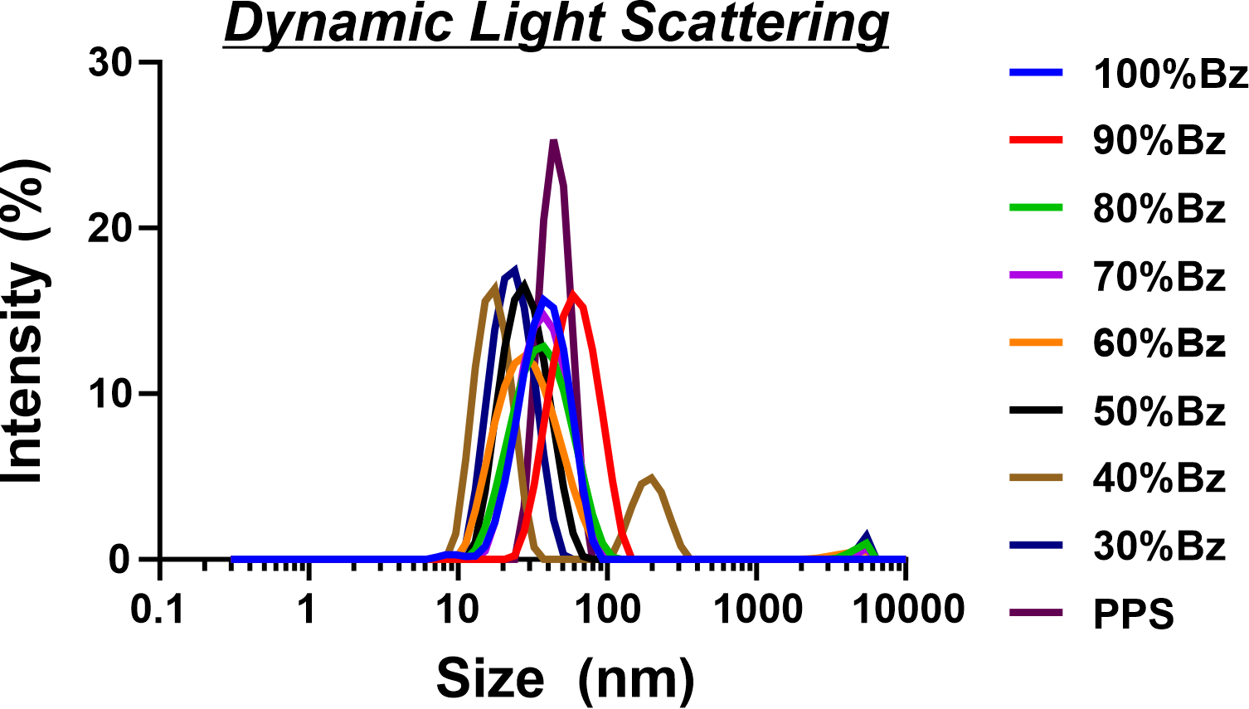
Figure S16. Dynamic light scattering (DLS) of each unloaded ABA BzOH polysulfide at 1 mg/mL in PBS.

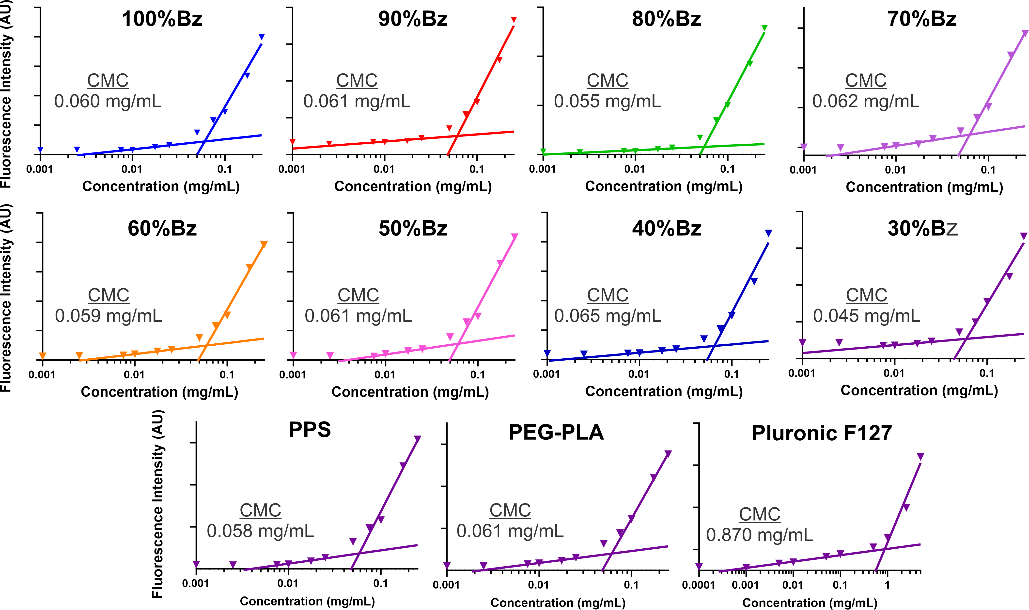
Figure S17 Critical micelle concentration (CMC) for each polymer measured using the Nile Red fluorescence method.
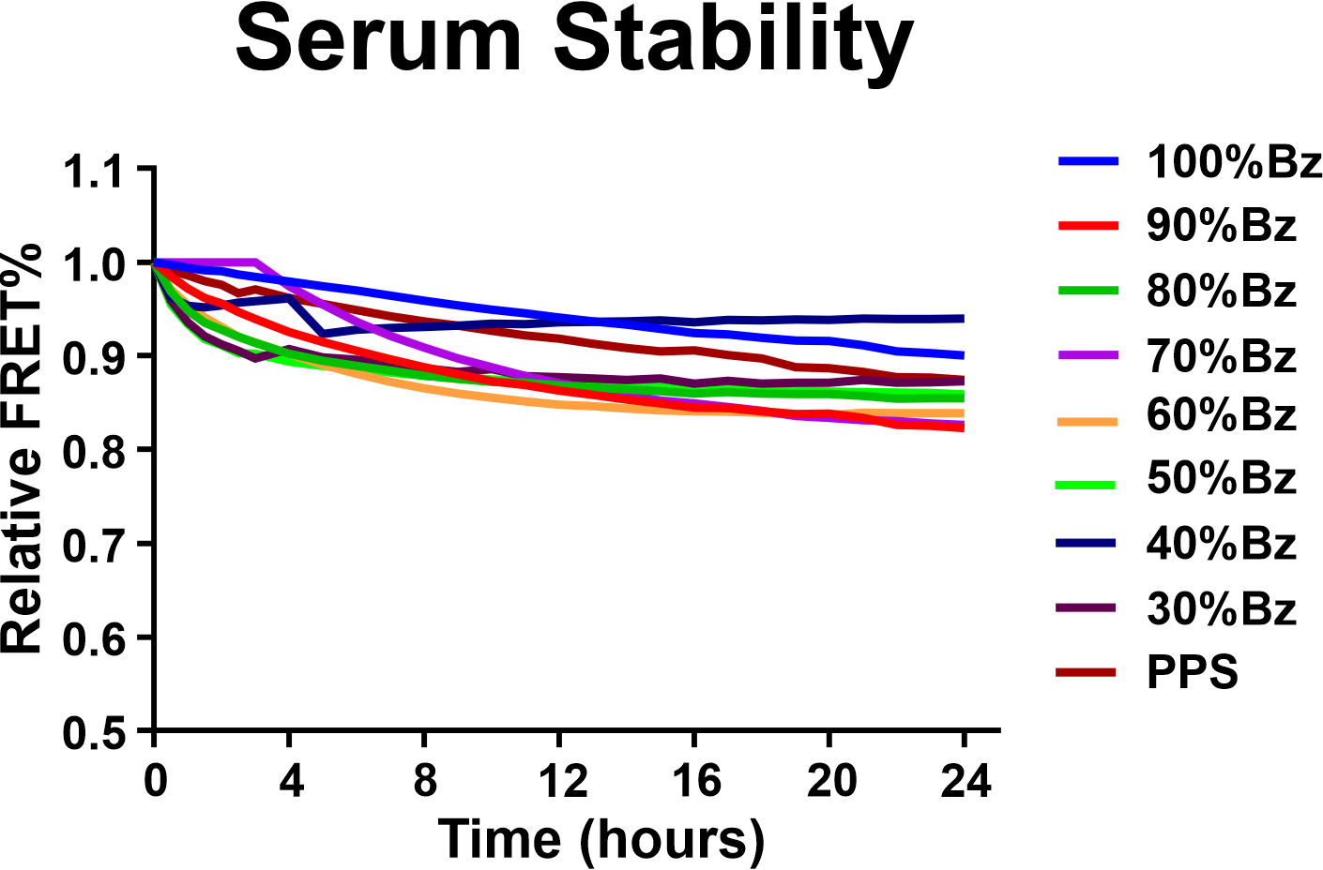
Figure S18. Serum stability of DiI and DiO co-loaded particles in high serum (50% FBS) measured by FRET signal decay over time.

Table S2. Effect of polymer molecular weight, architecture (diblock vs triblock pactliaxel loading), and corona chemistry (PDMA vs PHPMA).
 | Core Mn (kDa) | Corona | Type | Corona Mn | PTX-Loading
Core |  |  |  |  | LE (%) | LC (%)
P(BzTG_{5.8}-TGG₅) | 1.5 | PDMA | Diblock | 4.5 kDa | 38.9 | 35.87
P(BzTG_{11.7}-TGG₁₀) | 3 | PDMA | Diblock | 8 kDa | 48.89 | 45.70
P(BzTG_{17.5}-TGG₁₅) | 4.5 | PDMA | Diblock | 12 kDa | 35.17 | 36.82
P(BzTG_{23.3}-TGG₂₀) | 6 | PDMA | Diblock | 16 kDa | 41.01 | 40.61
P(BzTG_{5.8}-TGG₅) | 1.5 | PHPMA | Diblock | 4.5 kDa | 41.0 | 41.7
P(BzTG_{11.7}-TGG₁₀) | 3 | PHPMA | Diblock | 8 kDa | 35.35 | 38.64
P(BzTG_{17.5}-TGG₁₅) | 4.5 | PHPMA | Diblock | 12 kDa | 28.07 | 39.01
P(BzTG_{23.3}-TGG₂₀) | 6 | PHPMA | Diblock | 16 kDa | 37.13 | 39.71
P(BzTG_{11.7}-TGG₁₀) | 3 | PDMA | Triblock | 2x4.5 kDa | 65.0 | 38.3
P(BzTG_{23.3}-TGG₂₀) | 6 | PDMA | Triblock | 2x 8 kDa | 48.61 | 51.44
P(BzTG₃₅-TGG₃₀) | 9 | PDMA | Triblock | 2x 12 kDa | 39.57 | 42.54
P(BzTG₄₆-TGG₄₀) | 12 | PDMA | Triblock | 2x 16 kDa | 35.56 | 40.64
P(BzTG_{11.7}-TGG₁₀) | 3 | PHPMA | Triblock | 2x 4.5 kDa | 38.87 | 40.73
P(BzTG_{23.3}-TGG₂₀) | 6 | PHPMA | Triblock | 2x 8 kDa | 48.10 | 53.75
P(BzTG₃₅-TGG₃₀) | 9 | PHPMA | Triblock | 2x 12 kDa | 41.81 | 44.41
P(BzTG₄₆-TGG₄₀) | 12 | PHPMA | Triblock | 2x 16 kDa | 59.95 | 54.75

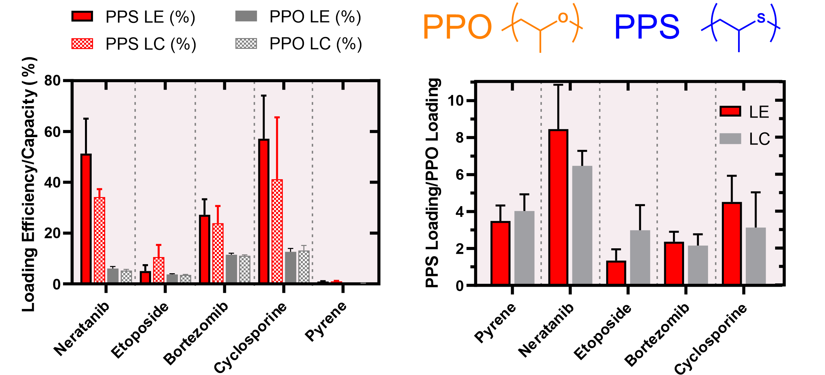
Figure S19 Drug loading into ABA-triblock copolymers where A block is poly(dimethyl acrylamide)(PDMA) and the B block is either a polyether (poly(propylene oxide)(PPO) or a polythioether (poly(propylene sulfide)(PPS)).

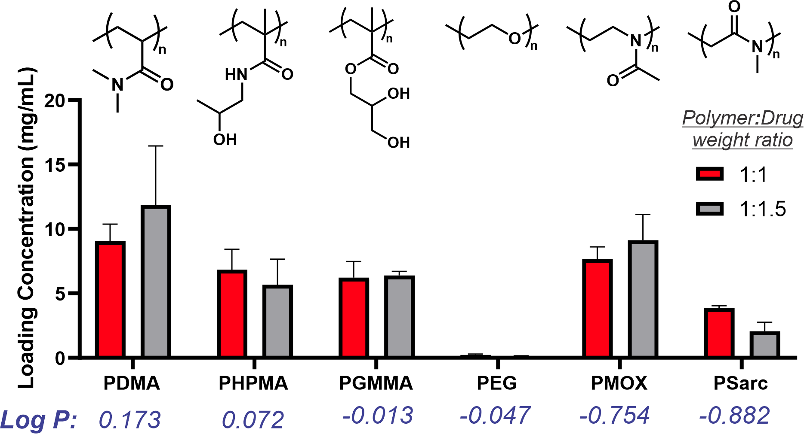
Figure S20 The effect of corona identity on neratinib loading in a A-B-A triblock copolymer where the A-blocks are the defined block (4 kDa) and the B-block is a 3 kDa 80%Bz polysulfide. Drugs were loading at 10 mg/mL of polymer and either 10 or 15 mg/mL of drug (1:1 or 1:1.5 Polymer:Drug weight ratio respectively).

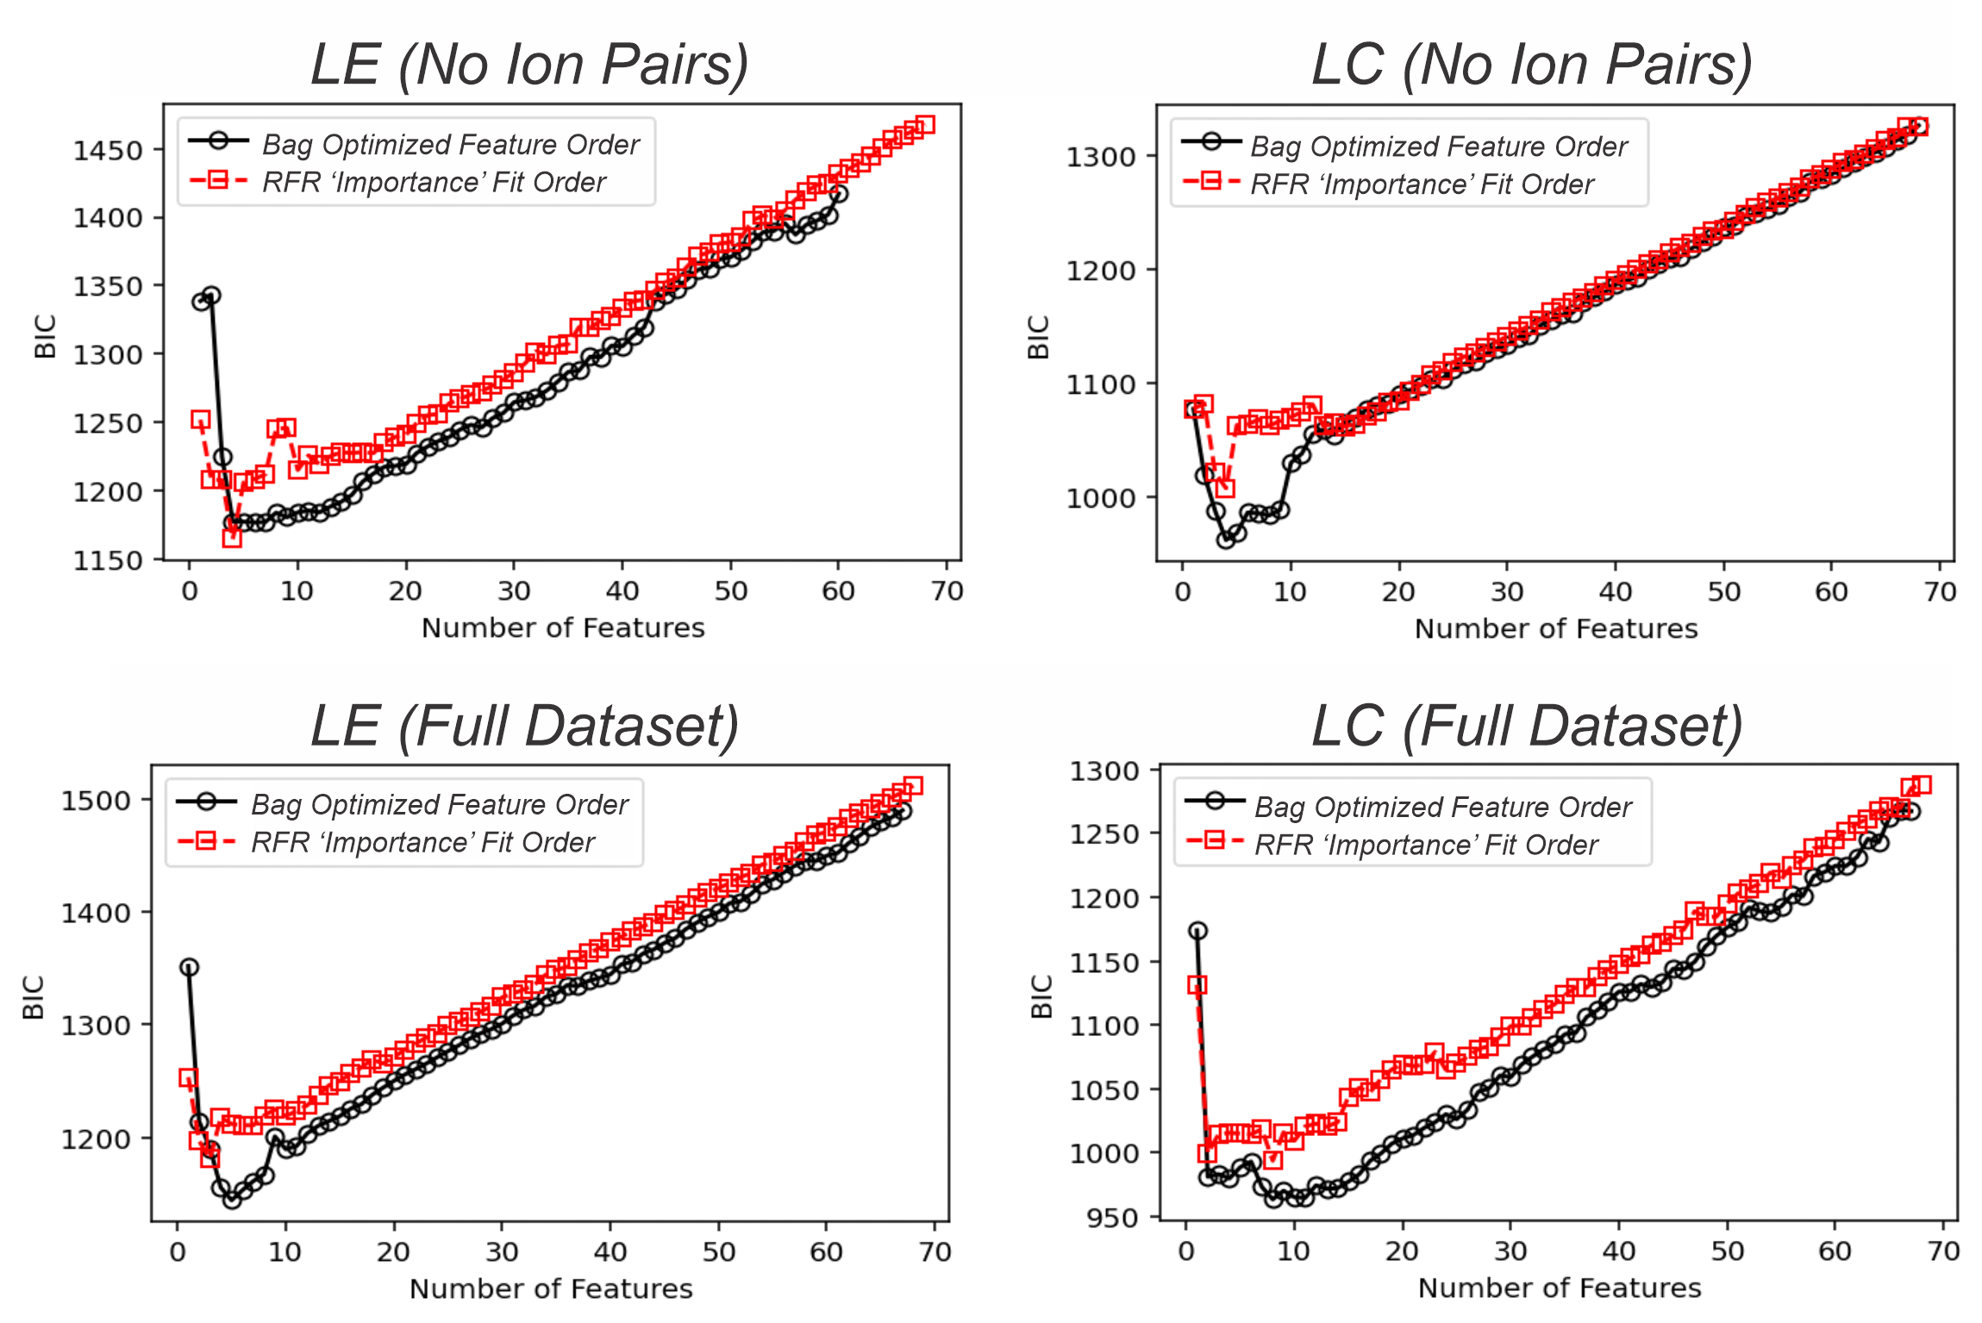
Figure S21. Bayesian Information Criterion (BIC) scores versus the number of features included in Random Forest Regressor (RFR) models trained to predict loading efficiency (LE) and loading capacity (LC). BIC scores were computed based on subsets of features ordered according to two different methodologies: the Bag Optimized Feature Order (black circles, solid lines), derived from the enumeration of features frequently appearing in high-performing (5 feature bag) models, and the standard Scikit-learn RFR-reported 'Importance' Fit Order (red squares, dashed lines), based on feature importance from a full-feature fit. Lower BIC scores indicate more optimal trade-offs between model complexity (number of features) and accuracy (mean absolute error). The Bag Optimized Feature Order methodology consistently yields more accurate and efficient models than the standard importance-based approach, demonstrating the value of systematic feature subset optimization.
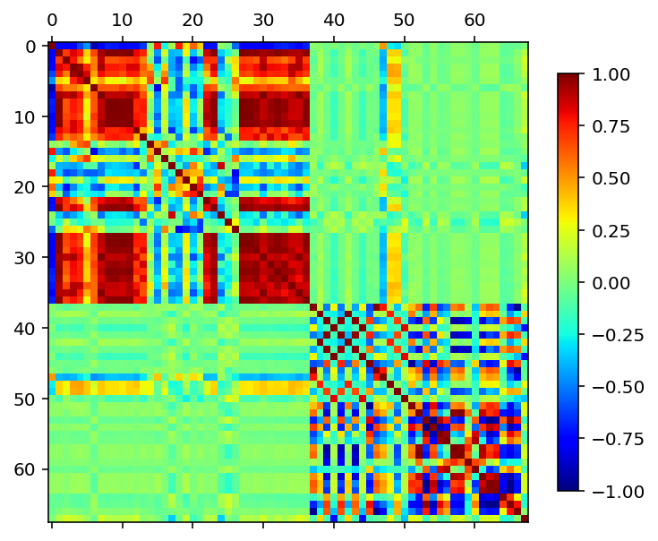
Figure S22. Full 66 feature correlation matrix (feature list and legend in supporting excel sheet)

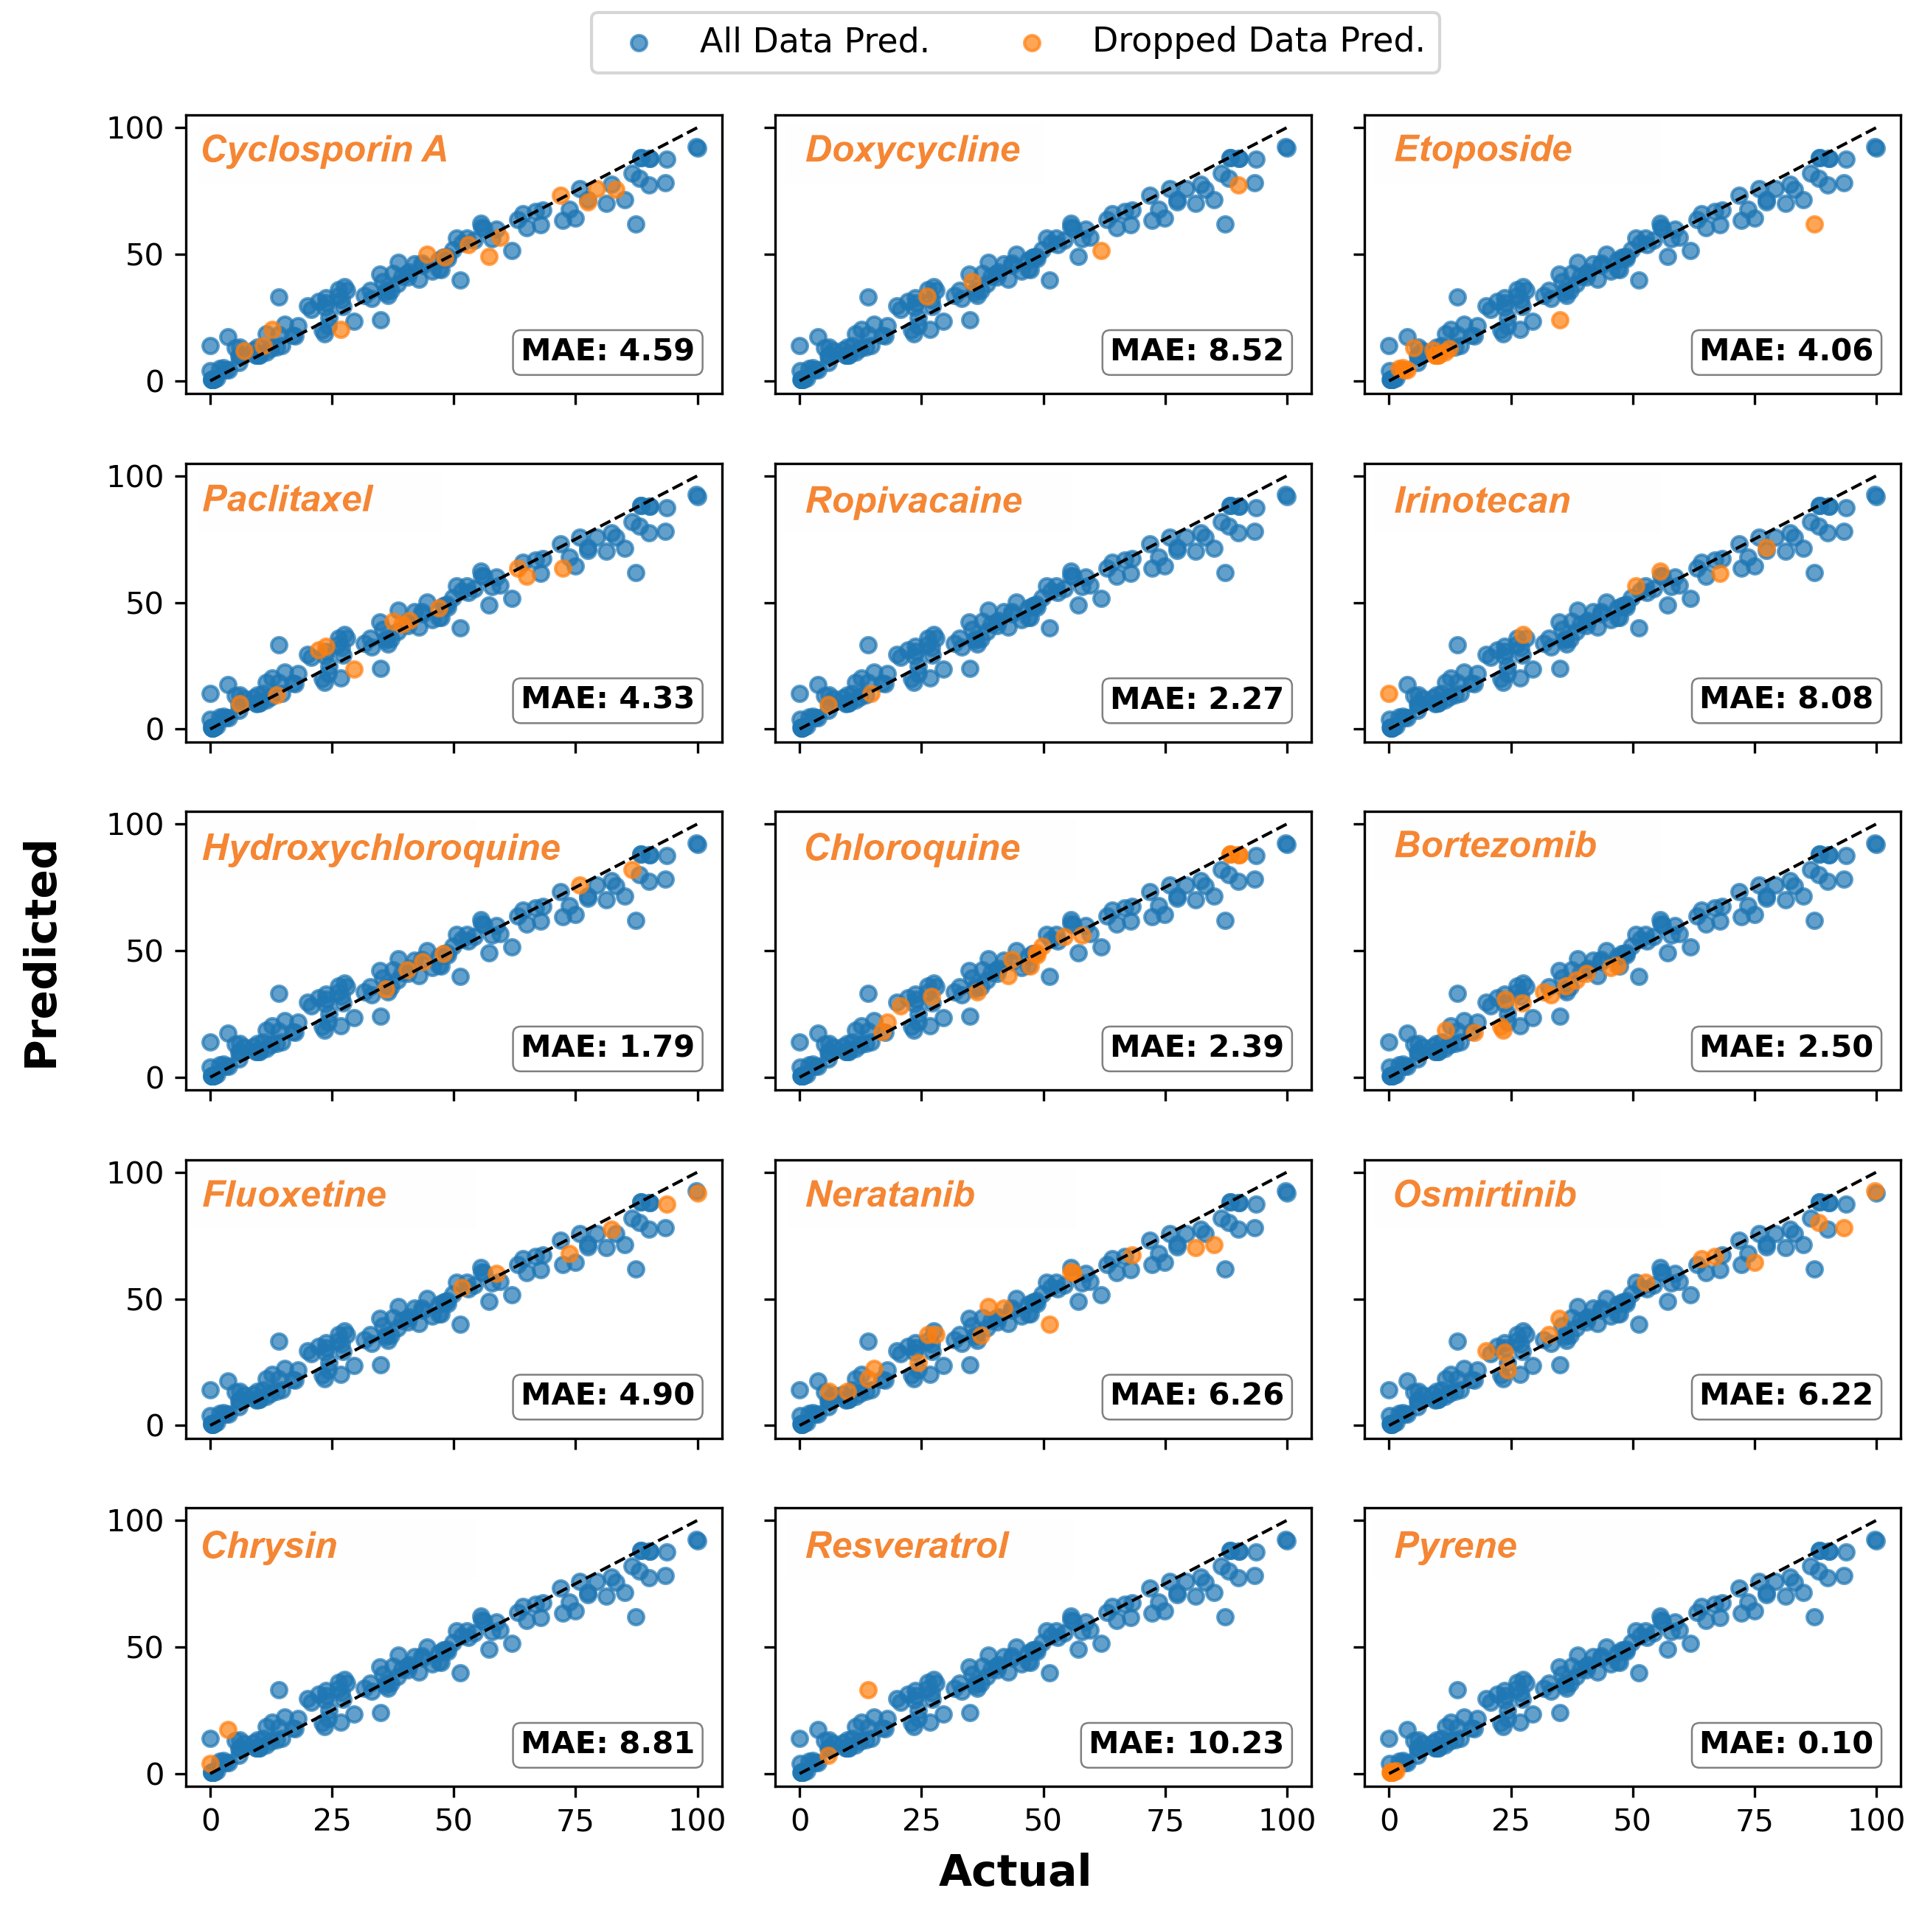
Figure S23. Accuracy (predicted vs actual) of Random Forrest Regressors prediction of each drug’s loading efficiency (LE) when it’s training data is dropped (dotted line is x=y slope).

TEM/STEM-EDS methods

Carbon-coated 400-mesh TEM grids (01822-F, Ted Pella, Inc.) were glow-discharged at 25 mA for 2 minutes to improve surface hydrophilicity. For sample preparation, 5 μL of the nanoparticle solution (1 mg/mL) was applied to the carbon films and allowed to sit for 1 minute before excess liquid was removed. Next, 5 μL of 3 wt% uranyl acetate was added for negative staining and incubated for 1 minute. After removing the stain, the grids were left to dry overnight at room temperature. Imaging was performed using a Tecnai Osiris TEM/STEM operated at 200 kV. For STEM-EDS, samples were prepped in the same manner as TEM. Imaging was performed using a Tecnai Osiris TEM/STEM operated at 200 kV with Bruker Esprit 1.9 EDS analysis software.
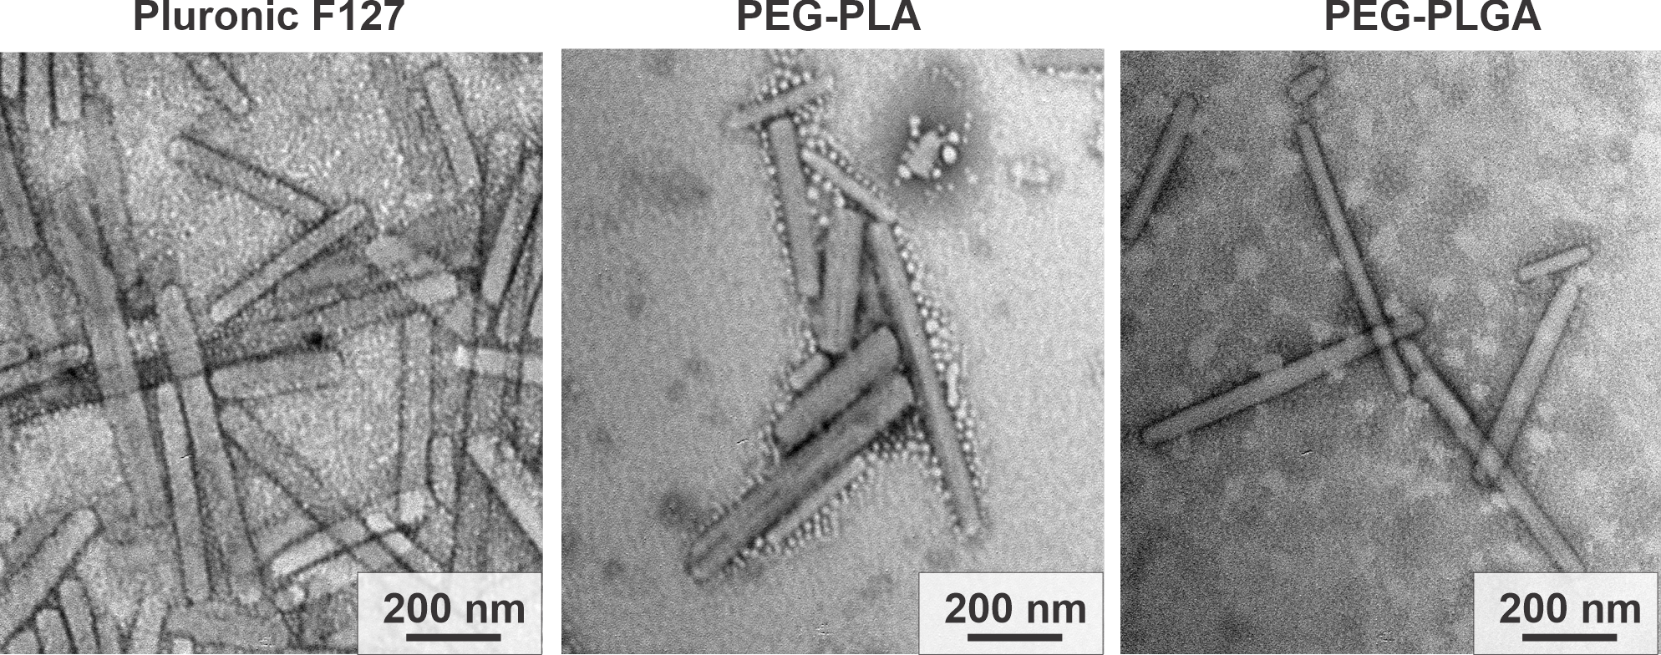
Figure S24. Morphological assessment of PTX-loaded control drug delivery polymers via TEM analysis.
Animal Studies
All animal experiments were approved by Vanderbilt University Institutional Animal Care and Use Committee (IACUC), and all studies followed the National Institutes of Health’s guidelines for the care and use of laboratory animals.
Maximum Tolerated Dose (MTD) Experiments
The MTD was determined in 6-8 week old BALB/c mice using an escalating dose of paclitaxel in either a PDMA-P(BzTG_{6.7}-TGG₂₀)-PDMA(40%Bz) or a PDMA-P(BzTG_{13.3}-TGG_{6.7})-PDMA (80%Bz) triblock formulation, either at a ‘ultra’high loading (40% loading capacity) or a low loading (10% loading capacity). In the low loading, mice were dosed with either 30, 60 or 90 mg/kg of paclitaxel in the PDMA-P(BzTG_{13.3}-TGG_{6.7})-PDMA (80%Bz) triblock formulation 2x per week (every 3 or 4 days). For the ultrahigh loading (both 40%Bz and 80%Bz formulations), mice were dosed 2x per week (every 3 or 4 days) with 100, 125, 150 and 175 mg/kg of paclitaxel. Mice body weight was measured daily and a drop below 85% of original body weight was considered a humane end-point and a non-tolerated dose. On day 11, one day after the final dose, mice were euthanized, and blood was collected for analysis of kidney and liver toxicity (ALT, AST and BUN) – values outside the healthy ranges of these parameters were also considered to be non-tolerated doses.
Polymer Pharmacokinetics (Fluorescence)
Female nude mice (4-5 weeks old) were allowed to acclimatize for 2 weeks before initiation of experiments. Mice were injected with ultrahigh loaded paclitaxel (40% loading capacity) formulated within the Cy-5 labeled PDMA-P(BzTG_{13.3}-TGG_{6.7})-PDMA polymer, at paclitaxel doses of 15, 30, 60 and 125 mg/kg. Mice were tail-nicked and ~5 µL of blood was drawn in a heparinized capillary tubes at 0.017, 0.25, 0.75, 1.5, 4.5, 24, and 48 hours post-injection. Blood was diluted into 0.1% Tween 20 and spectrofluorimetry analyzed on a plate-reader for Cy5 fluorescence (excitation 640 nm, emission 690 nm). (n=3)

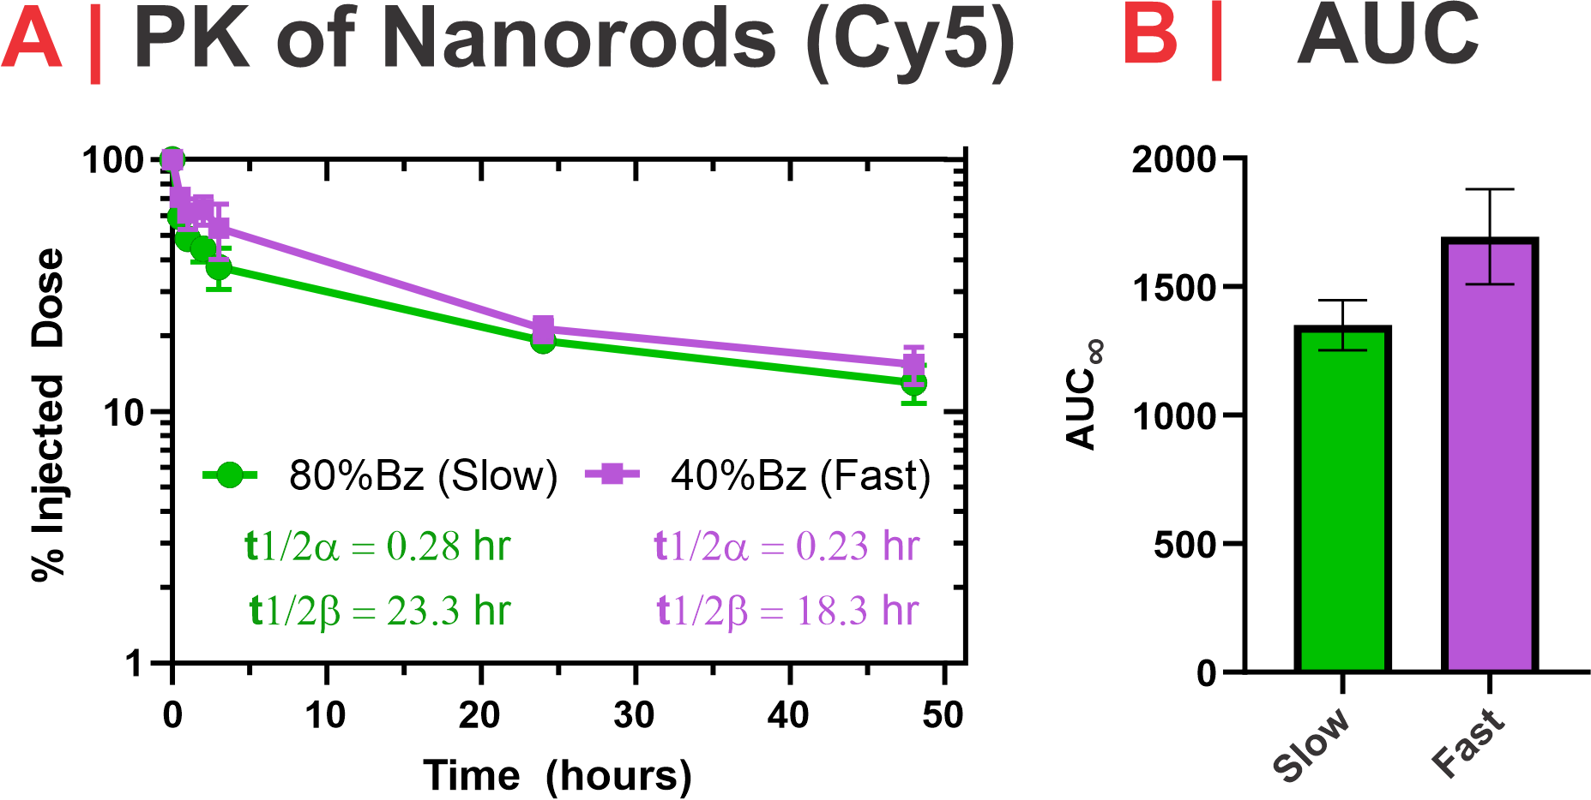
Figure S25 A. Plasma pharmacokinetic profile of Fast and Slow PTX-nanorod formulations (150 mg/kg) in BALB/c mice. Concentration determined via fluorescence of Cy5-conjugated 80%Bz or 40%Bz polymer. B. Area under curve values calculated from A.
Drug Pharmacokinetics (LC-MS/MS), Tumor Accumulation, and Biodistribution
Female athymic nude mice (4–6 weeks old; The Jackson Laboratory) were orthotopically inoculated with 10⁶ MDA-MB-231 human breast cancer cells suspended in a 1:1 (v/v) mixture of Matrigel:DMEM into the inguinal mammary fat pad. When tumors reached ~200 mm³ (designated as Day 0), animals were randomized into treatment and end-point groups (Days 1, 3, or 5 post-injection; n = 3 per group). Mice received a single tail-vein injection of one of the following formulations: (1) Slow-releasing formulation: Cy5-labeled PDMA-P(BzTG_{13.3}-TGG_{6.7})-PDMA (80 mol% Bz) ultrahigh paclitaxel-loaded micelles at their maximum tolerated dose (MTD; 150 mg kg⁻¹), (2) Fast-releasing formulation: Cy5-labeled PDMA-P(BzTG_{6.7}-TGG₂₀)-PDMA (40 mol% Bz) ultrahigh paclitaxel-loaded micelles at the MTD (150 mg kg⁻¹), (3) Clinical control formulation: Taxol® at its MTD (20 mg kg⁻¹) or (4) Saline vehicle control. For the 5-day cohorts, serial blood samples were collected via tail-nick into heparinized microcapillary tubes over 72 h to assess circulating drug and polymer levels. At designated end points, mice were euthanized, and tumors and major organs were harvested for immediate ex vivo imaging via IVIS using Cy5 fluorescence preset parameters to evaluate biodistribution.

Sample Preparation for LC-MS/MS. The above tumors were then homogenized with 2-fold weight of molecular grade water using 5 mm stainless steel beads and TissueLyser II system (QIAGEN, Hilden, Germany) for 10 mins at 30 Hz. 20 µL of homogenate or 5 µL of whole blood was transferred to a new tube, and 0.1 µg of PTX-d5 (internal standard) was added to all tubes. To isolate PTX from the samples, a liquid-liquid extraction method was used. To each sample tube containing blood/tumor homogenate and internal standard, 200 µL of 1 M HCl was added, followed by 300 µL methanol: methyl tert-butyl ether: chloroform (MMC, 1.3:1:1). Samples were vortexed for 1 min followed by centrifugation at 15,000x g for 3 mins. The top (aqueous) layer was removed, and 300 µL hexane was added to each tube. Samples were vortexed and centrifuged as mentioned above, and the top (organic) layer was transferred to a new tube. Extraction was repeated two more times for tumor samples. Solvent was evaporated under nitrogen gas to form a thin film. The films were rehydrated in 100 µL methanol + H₂O (75:25), vortexed, and transferred to autosampler vials.

LC-MS/MS conditions. The multiple reactions monitoring (MRM) analysis was performed using Waters Aquity UPLC system (Waters, Milford, MA) interfaced with a TSQ Vantage triple quadrupole mass spectrometer (Thermo Scientific, San Jose, CA). The TSQ Vantage was operated in positive heated electrospray ionization (HESI) mode. Chromatographic separation was conducted using a Kinetex 1.7 µm C8 100Å, LC Column 100 x2.1 mm (Phenomenex, Torrance, CA). The column oven was maintained at 50°C and the autosampler tray was maintained at 5°C. The mobile phase consisted of 0.2% HCOOH in H₂O + 10 mM ammonium formate (A) and 0.2% HCOOH in acetonitrile (ACN)/methanol/H₂O (60:30:10) (B). Gradient conditions were as follows: 0-1 min, B = 20%; 1-8 min, B = 20-100%; 8-10.5 min, B = 100%; 10.5-11 min, B = 100-20%; 11-15 min, B = 20%. The injection volume was 5 µL, the flow rate was set at 0.3 mL/min, and the total run time was 15 mins. Between sample injections, 1.0 mL of mobile phase A and 1.0 mL of mobile phase B were used to flush the autosampler injection valve and syringe needle. Eluent was transferred from 0-5.5 mins and 7.5-15.0 mins of each sample run to waste using a divert valve. To identify each analyte, m/z=854.2 and m/z=859.2 were used for PTX and PTX-d5 respectively (see Table S3 and Table S4 for PTX and PTX-d5 MRM transitions). The optimized source parameters were as follows: sheath gas pressure 40 psi; N2 auxiliary gas 5 psi; spray voltage 5.0 kV; capillary temperature 300 °C; declustering voltage 5 V. Data acquisition and analysis were performed using Xcalibur v.2.1.0, Vantage v.2.3.0, and LCQuan v.2.7.0 software (Thermo). A weighting factor of 1/X² was used in the linear least squares regression analysis, and percent error was ≤ 20% for all standards.

Table S3. Paclitaxel tandem mass spectrometric detection.
Parent (m/z) | Product (m/z)¹ | Collision Energy (V) | S-lens (V)
854.2 | 286 | 14 | 123
854.2 | 105 | 45 | 123
854.2 | 122 | 31 | 123
854.2 | 240 | 28 | 123
854.2 | 509 | 15 | 123
854.2 | 569 | 10 | 123
¹ Ar collision gas 2.0 mTorr; scan time 25 ms; scan width 1.0 m/z; Q1/Q3 full width at half maximum (FWHM) 0.7 m/z.
Table S4. Paclitaxel-d5 tandem mass spectrometric detection.
Parent (m/z) | Product (m/z) | Collision Energy (V) | S-lens (V)
859.2 | 291 | 14 | 123
859.2 | 105 | 45 | 123
859.2 | 110 | 45 | 123

Standard curve/internal standard. Paclitaxel-d5 (MedChemExpress, Monmouth Junction, NJ) was chosen as the internal standard for blood and tumor samples. A stock solution of 10 µg/mL PTX-d5 was made in ACN/H₂O (3:1). Primary stock solutions of PTX were prepared by weighing out 4 mg and dissolving in 4 mL ACN/H₂O (3:1) to make 1 mg/mL stock, followed by serial dilutions ranging from 0.15625 to 20 µg/mL. Tumor homogenate standards were prepared using 20 µL blank homogenate + 20 µL PTX standard + 10 µL internal standard (0.1 µg PTX-d5), followed by three liquid-liquid extractions as described above. The calibration curve was linear over the concentration range of 0.03125 - 4 µg/mL of PTX.
For blood samples, PTX standards were prepared by dissolving 4 mg PTX into 2 mL ACN/H₂O (3:1) to get a 2 mg/mL stock. Serial dilutions were performed, ranging from 0.0244-400 µg/mL. 5 µL blank blood was added to 5 µL of PTX standard and 10 µL internal standard (0.1 µg PTX-d5). A single liquid-liquid extraction was performed as described above. The calibration curve was linear over the concentration range of 0.00122 - 20 µg/mL.

In Vivo Efficacy of Nano-chemotherapy in an Orthotopic Mammary Fat Pad Model of Triple Negative Breast Cancer
Athymic nude mice (4-6 weeks, Jackson Laboratory) were inoculated with 10⁶ MDA-MB-231 cells in a 50:50 Matrigel:DMEM mixture within the inguinal mammary fat pad. Once tumors reached a volume of ~75 mm³ (Day 0), mice were split into treatment groups and tail-vein injected with either a slow releasing ultrahigh paclitaxel-loaded PDMA-P(BzTG_{13.3}-TGG_{6.7})-PDMA (80%Bz) formulation at their MTD (150 mg/kg), a fast releasing ultrahigh paclitaxel loaded PDMA-P(BzTG_{6.7}-TGG₂₀)-PDMA (40%Bz) formulation at the MTD (150 mg/kg), a Taxol formulation at the MTD (20 mg/kg) or Saline. One cohort received only a single dose at Day 0 and another cohort received 5 treatments spaced 10 days apart (at day 0, 10, 20, 30 and 40). Tumor volume was tracked using calipers three or more times per week by a treatment-blinded operator. Humane end-points included ulceration or tumor volumes exceeding 1000 mm³. 100 days after first treatment, the study was ended (n=8 per treatment group).

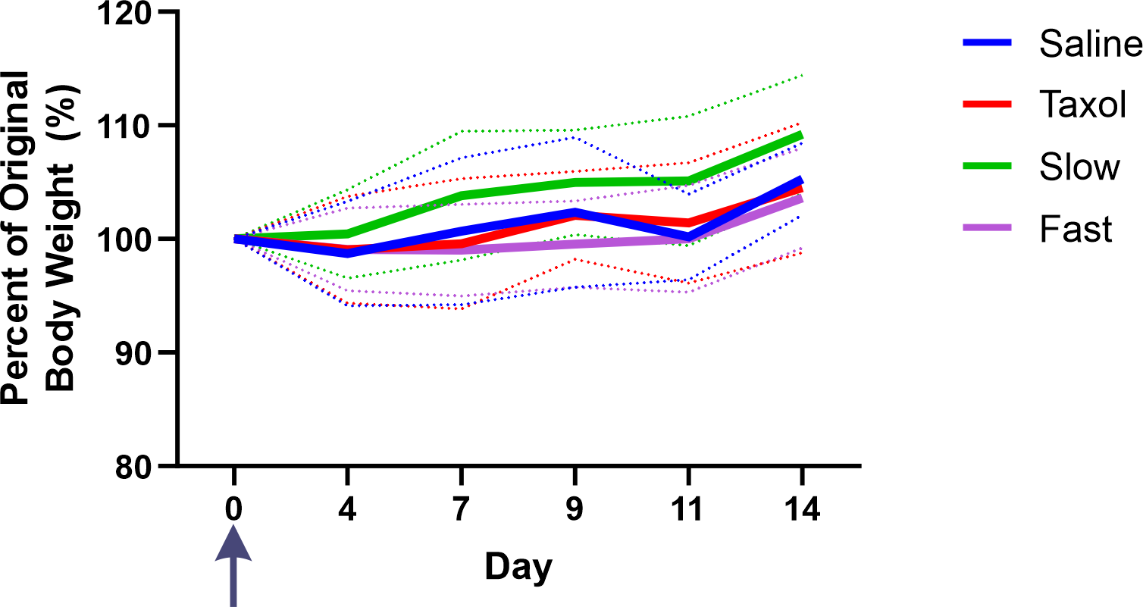
Figure S26. Weight (+/- standard deviation outline) of MDA-MB-231 tumor bearing nude mice over 14 days after a single dose of a paclitaxel therapeutic or saline control (arrow indicates injection day).

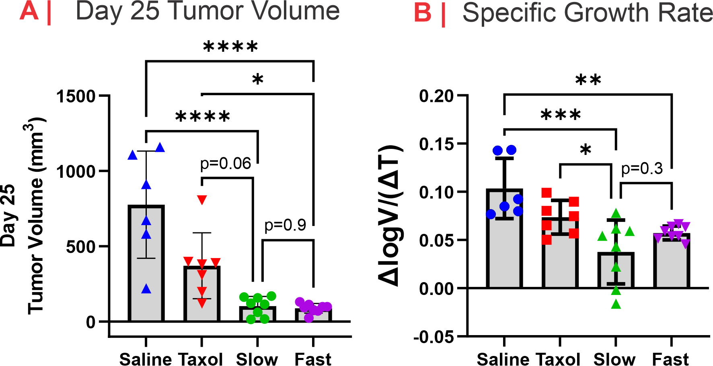
Figure S27 A. Analysis of tumor volume in MDA-MB-231 tumor bearing nude mice 25 days after a single dose treatment of PTX formulations or saline control. Note: saline-treated mouse group tumor volumes are underestimated because 2 saline mice were sacrificed before day 18. B. Tumor specific growth rates (calculated as ln(V₂/V₁)/(T₂-T₁) where V = tumor volume in mm³ and T= time in days). Statistical analyses are by a one-way ANOVA followed by a Tukey’s means comparisons test; ns; p > 0.05, *; p ≤ 0.05, **; p ≤ 0.01, ***; p ≤ 0.001, ****; p ≤ 0.0001.
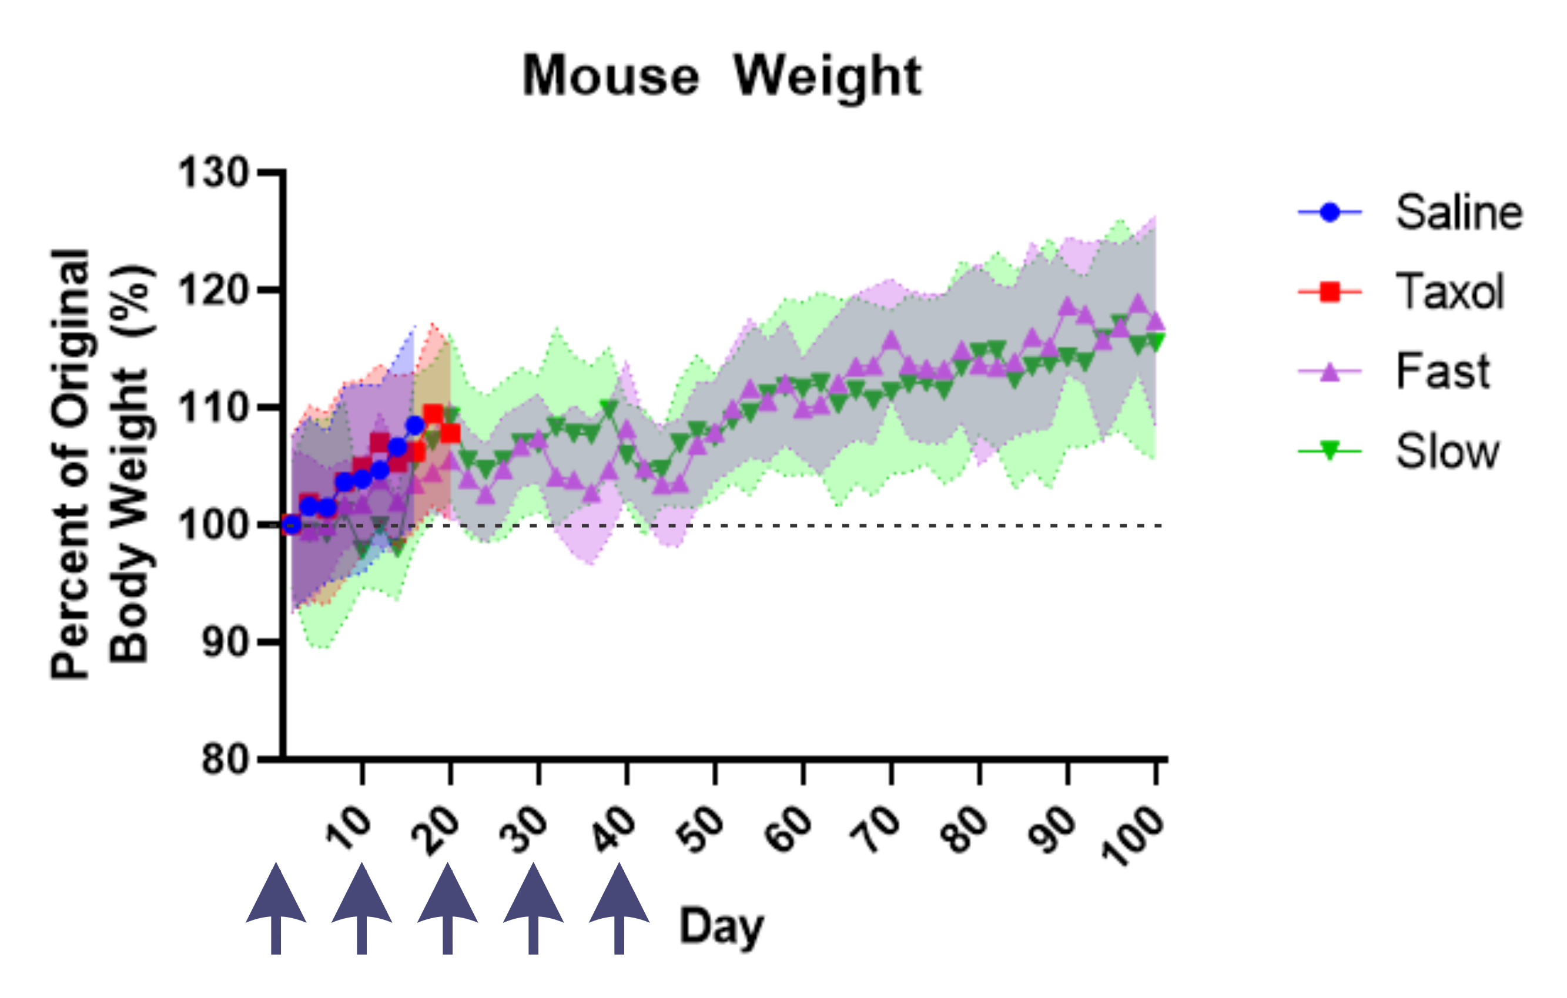
Figure S28. Weight (+/- standard deviation outline) of MDA-MB-231 tumor bearing nude mice during the q10d (x5) multidose study (arrows indicate injection days).

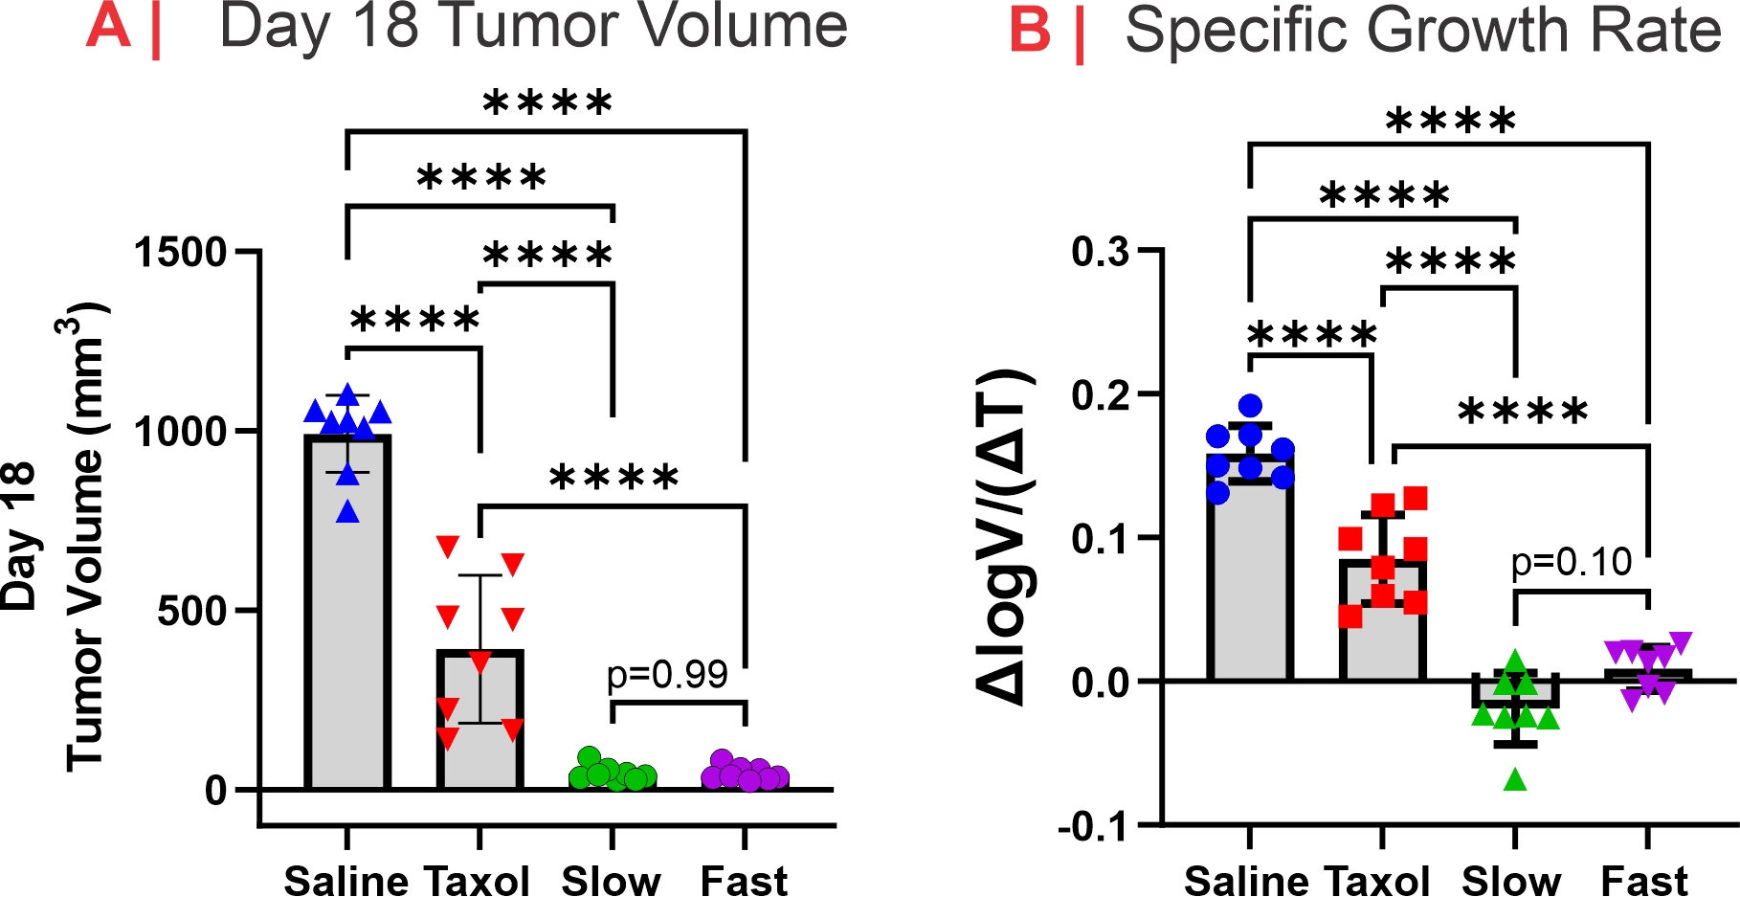
Figure S29 A. Analysis of tumor volume in MDA-MB-231 tumor bearing nude mice 18 days after a multidose treatment (q10d x5) of PTX-containing formulations and saline-treated control. Note: saline-treated mouse group tumor volumes are underestimated because 2 saline mice were sacrificed before day 18. B. Tumor specific growth rates (calculated as ln(V₂/V₁)/(T₂-T₁) where V = tumor volume in mm³ and T= time in days). Statistical analyses are by a one-way ANOVA followed by a Tukey’s means comparisons test; ns; p > 0.05, *; p ≤ 0.05, **; p ≤ 0.01, ***; p ≤ 0.001, ****; p ≤ 0.0001.

Table S5. Summary of treatment outcomes.
Outcome | Multi-dose |  | Single-dose
 | Fast | Slow | Fast | Slow
Survivors | 7/8 | 8/8 | 0/8 | 3/8
Stable Tumor Regression | 3/8 | 7/8 | 0/8 | 2/8
Relapse | (5/8) | (1/8) | (8/8) | (6/8)
Complete Tumor Elimination | 0/8 | 2-3/8 | 0/8 | 0/8

References
1. Fabian, P., Scikit-learn: Machine learning in Python. Journal of machine learning research 12 2011, 2825.
2. Hastie, T.; Tibshirani, R.; Friedman, J.; Hastie, T.; Tibshirani, R.; Friedman, J., Random forests. The elements of statistical learning: Data mining, inference, and prediction 2009, 587-604.
3. De Ville, B., Decision trees. Wiley Interdisciplinary Reviews: Computational Statistics 2013, 5 (6), 448-455.
4. Berrar, D., Cross-validation. 2019.
5. Misra, P.; Yadav, A., Improving the Classification Accuracy using Recursive Feature Elimination with Cross-Validation. 2020, 11, 659-665.
6. (a) Neath, A. A.; Cavanaugh, J. E., The Bayesian information criterion: background, derivation, and applications. WIREs Computational Statistics 2012, 4 (2), 199-203; (b) Schwarz, G., Estimating the Dimension of a Model. The Annals of Statistics 1978, 6 (2), 461-464, 4; (c) Wilson, S. A.; Muhich, C. L., A Bayesian method for selecting data points for thermodynamic modeling of off-stoichiometric metal oxides. Journal of Materials Chemistry A 2024, 12 (22), 13328-13337; (d) Wilson, S. A.; Stechel, E. B.; Muhich, C. L., Overcoming significant challenges in extracting off-stoichiometric thermodynamics using the compound energy formalism through complementary use of experimental and first principles data: A case study of Ba1-xSrxFeO3-δ. Solid State Ionics 2023, 390, 116115.
7. Vanderburgh, J.; Hill, J. L.; Gupta, M. K.; Kwakwa, K. A.; Wang, S. K.; Moyer, K.; Bedingfield, S. K.; Merkel, A. R.; d’Arcy, R.; Guelcher, S. A.; Rhoades, J. A.; Duvall, C. L., Tuning Ligand Density To Optimize Pharmacokinetics of Targeted Nanoparticles for Dual Protection against Tumor-Induced Bone Destruction. ACS Nano 2020, 14 (1), 311-327.

