Supplementary material
Table S 1 Availability and missingness by variable and wave
 | Missing (n) | Observed (n) | Missing (%)
Wave 1
Age | 10,409 | 11,991 | 46.5
Cognitive frailty | 10,479 | 11,921 | 46.8
Cognitive reserve | 22,400 | 0 | 100
Depression | 10,718 | 11,682 | 47.8
Education | 10,439 | 11,961 | 46.6
Ethnicity | 10,414 | 11,986 | 46.5
Index of multiple deprivation | 10,985 | 11,415 | 49
Loneliness | 22,400 | 0 | 100
Meaning in life | 11,708 | 10,692 | 52.3
Socioeconomic status | 10,616 | 11,784 | 47.4
Sex | 10,409 | 11,991 | 46.5
Social isolation | 10,409 | 11,991 | 46.5
Wave 2
Age | 13,058 | 9,342 | 58.3
Cognitive frailty | 13,105 | 9,295 | 58.5
Cognitive reserve | 13,143 | 9,257 | 58.7
Depression | 13,220 | 9,180 | 59
Education | 13,074 | 9,326 | 58.4
Ethnicity | 13,060 | 9,340 | 58.3
Index of multiple deprivation | 13,530 | 8,870 | 60.4
Loneliness | 14,165 | 8,235 | 63.2
Meaning in life | 14,338 | 8,062 | 64
Socioeconomic status | 13,180 | 9,220 | 58.8
Sex | 13,058 | 9,342 | 58.3
Social isolation | 13,058 | 9,342 | 58.3
Wave 3
Age | 12,781 | 9,619 | 57.1
Cognitive frailty | 12,838 | 9,562 | 57.3
Cognitive reserve | 12,899 | 9,501 | 57.6
Depression | 12,989 | 9,411 | 58
Education | 12,821 | 9,579 | 57.2
Ethnicity | 12,781 | 9,619 | 57.1
Index of multiple deprivation | 13,428 | 8,972 | 59.9
Loneliness | 14,273 | 8,127 | 63.7
Meaning in life | 14,342 | 8,058 | 64
Socioeconomic status | 12,993 | 9,407 | 58
Sex | 12,780 | 9,620 | 57.1
Social isolation | 12,781 | 9,619 | 57.1
Wave 4
Age | 11,524 | 10,876 | 51.4
Cognitive frailty | 11,607 | 10,793 | 51.8
Cognitive reserve | 14,718 | 7,682 | 65.7
Depression | 11,925 | 10,475 | 53.2
Education | 14,651 | 7,749 | 65.4
Ethnicity | 11,526 | 10,874 | 51.5
Index of multiple deprivation | 12,149 | 10,251 | 54.2
Loneliness | 13,217 | 9,183 | 59
Meaning in life | 13,287 | 9,113 | 59.3
Socioeconomic status | 11,771 | 10,629 | 52.5
Sex | 11,524 | 10,876 | 51.4
Social isolation | 11,525 | 10,875 | 51.5
Wave 5
Age | 12,308 | 10,092 | 54.9
Cognitive frailty | 12,404 | 9,996 | 55.4
Cognitive reserve | 15,287 | 7,113 | 68.2
Depression | 12,811 | 9,589 | 57.2
Education | 15,229 | 7,171 | 68
Ethnicity | 12,308 | 10,092 | 54.9
Index of multiple deprivation | 12,927 | 9,473 | 57.7
Loneliness | 13,511 | 8,889 | 60.3
Meaning in life | 13,569 | 8,831 | 60.6
Socioeconomic status | 12,487 | 9,913 | 55.7
Sex | 12,308 | 10,092 | 54.9
Social isolation | 12,311 | 10,089 | 55
Wave 7
Age | 13,869 | 8,531 | 61.9
Cognitive frailty | 13,869 | 8,531 | 61.9
Cognitive reserve | 17,180 | 5,220 | 76.7
Depression | 13,882 | 8,518 | 62
Education | 17,161 | 5,239 | 76.6
Ethnicity | 13,869 | 8,531 | 61.9
Index of multiple deprivation | 14,477 | 7,923 | 64.6
Loneliness | 15,686 | 6,714 | 70
Meaning in life | 14,696 | 7,704 | 65.6
Socioeconomic status | 14,041 | 8,359 | 62.7
Sex | 13,869 | 8,531 | 61.9
Social isolation | 13,869 | 8,531 | 61.9
Wave 8
Age | 14,920 | 7,480 | 66.6
Cognitive frailty | 14,920 | 7,480 | 66.6
Cognitive reserve | 17,822 | 4,578 | 79.6
Depression | 14,924 | 7,476 | 66.6
Education | 17,808 | 4,592 | 79.5
Ethnicity | 14,920 | 7,480 | 66.6
Index of multiple deprivation | 22,400 | 0 | 100
Loneliness | 16,500 | 5,900 | 73.7
Meaning in life | 15,618 | 6,782 | 69.7
Socioeconomic status | 15,009 | 7,391 | 67
Sex | 14,920 | 7,480 | 66.6
Social isolation | 14,920 | 7,480 | 66.6
Wave 9
Age | 13,664 | 8,736 | 61
Cognitive frailty | 13,824 | 8,576 | 61.7
Cognitive reserve | 17,897 | 4,503 | 79.9
Depression | 14,241 | 8,159 | 63.6
Education | 17,841 | 4,559 | 79.6
Ethnicity | 13,672 | 8,728 | 61
Index of multiple deprivation | 22,400 | 0 | 100
Loneliness | 16,093 | 6,307 | 71.8
Meaning in life | 15,010 | 7,390 | 67
Socioeconomic status | 13,821 | 8,579 | 61.7
Sex | 13,664 | 8,736 | 61
Social isolation | 13,664 | 8,736 | 61
Wave 10
Age | 15,629 | 6,771 | 69.8
Cognitive frailty | 15,629 | 6,771 | 69.8
Cognitive reserve | 19,733 | 2,667 | 88.1
Depression | 15,643 | 6,757 | 69.8
Education | 19,673 | 2,727 | 87.8
Ethnicity | 15,629 | 6,771 | 69.8
Index of multiple deprivation | 22,400 | 0 | 100
Loneliness | 16,267 | 6,133 | 72.6
Meaning in life | 16,288 | 6,112 | 72.7
Socioeconomic status | 22,400 | 0 | 100
Sex | 15,629 | 6,771 | 69.8
Social isolation | 15,630 | 6,770 | 69.8
Wave 11
Age | 15,547 | 6,853 | 69.4
Cognitive frailty | 15,451 | 6,949 | 69
Cognitive reserve | 19,863 | 2,537 | 88.7
Depression | 15,464 | 6,936 | 69
Education | 19,418 | 2,982 | 86.7
Ethnicity | 20,462 | 1,938 | 91.3
Index of multiple deprivation | 22,400 | 0 | 100
Loneliness | 15,920 | 6,480 | 71.1
Meaning in life | 15,962 | 6,438 | 71.3
Socioeconomic status | 22,400 | 0 | 100
Sex | 15,451 | 6,949 | 69
Social isolation | 15,452 | 6,948 | 69

Forest of the associations between meaning in life and cognitive frailty for each wave and the pooled effect.
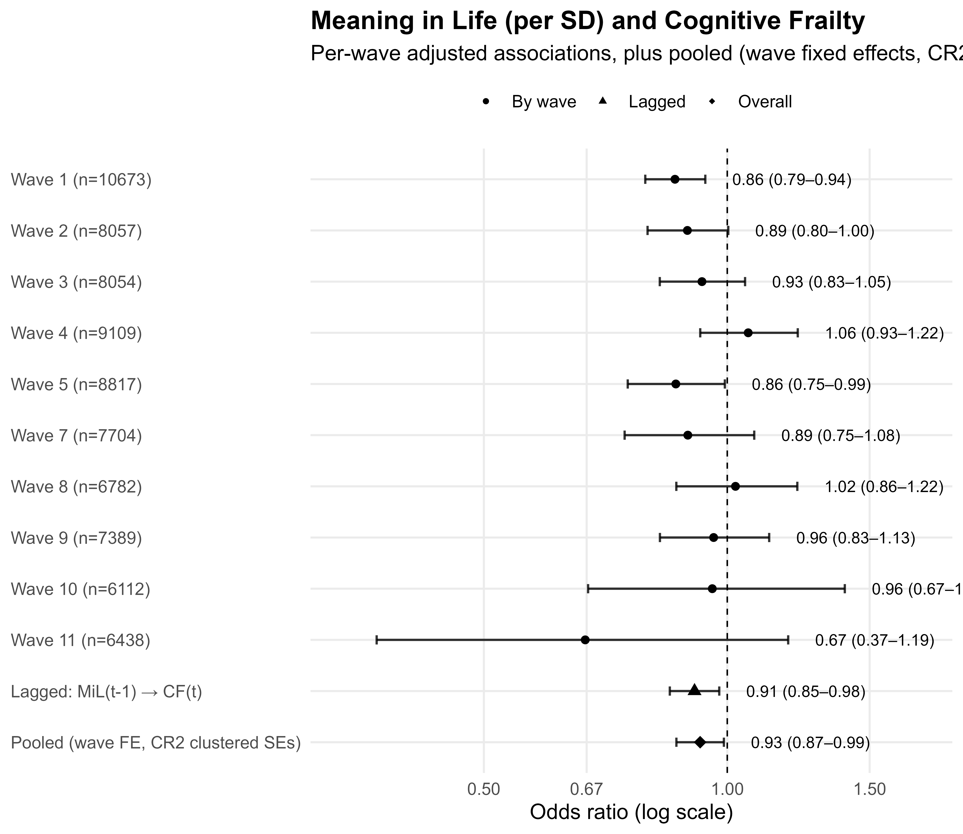
Figure S1 Associations between meaning in life (per SD increase) and cognitive frailty across waves, lagged models, and pooled analyses. Odds ratios (ORs) and 95% confidence intervals (CIs) are shown on a log scale. Per-wave estimates are adjusted for covariates, lagged models examine meaning in life at the prior wave predicting cognitive frailty at the subsequent wave, and pooled estimates include wave fixed effects with cluster-robust standard errors.

Table S 2. Test of nonlinearity in the association between meaning in life and cognitive frailty
Model | Residual df | Residual deviance | df | Deviance | χ² p
Linear (MiL as continuous) | 30,644 | 7287.2 | – | – | –
Nonlinear (MiL as spline, 3 df) | 30,642 | 7286.8 | 2 | 0.32 | .85

Table S 3 Interaction between meaning in life and sex in relation to cognitive frailty
Term | Estimate | SE | z | p
MiL × Sex (men) | –0.09 | 0.05 | –1.98 | .047
MiL × Sex (women) | –0.06 | 0.04 | –1.26 | .21

Table S 4 Interaction between meaning in life and age in relation to cognitive frailty
Term | Estimate | SE | z | p
MiL × Age (centred) | 0.001 | 0.003 | 0.52 | .61

Table S 5 Predicted probability of cognitive frailty by meaning in life (–1 sd, mean, +1 sd), stratified by sex
Sex | MiL (z) | Probability | 95% CI | SE
Men | –1 | 0.0282 | [0.0232, 0.0342] | 0.0028
 | 0 | 0.0257 | [0.0216, 0.0307] | 0.0023
 | +1 | 0.0235 | [0.0194, 0.0286] | 0.0024
Women | –1 | 0.0272 | [0.0224, 0.0329] | 0.0027
 | 0 | 0.0257 | [0.0216, 0.0307] | 0.0023
 | +1 | 0.0244 | [0.0202, 0.0295] | 0.0024

Table S 6 Summary mediation analysis of the association between meaning in life and cognitive frailty
Effect type | Log OR | OR
Total effect | –0.256 | 0.774
Direct effect | –0.124 | 0.884
Indirect effect | –0.133 | 0.876
Proportion mediated | 0.518 | –

