Supplementary Figures.
Supplementary Figure S1. Kaplan–Meier (KM) of fibrosis total volume.
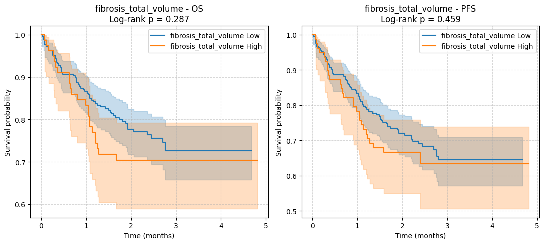
Legend: Kaplan–Meier curves for fibrosis total volume did not show significant separation and are therefore provided in the Supplementary Figures. Although not significant in KM analysis, fibrosis remained an independent predictor in Cox regression after adjustment, likely due to confounding and collinearity effects.
Supplementary Figure S2.Combined training accuracy, loss curve, and confusion matrix for Model 1.
.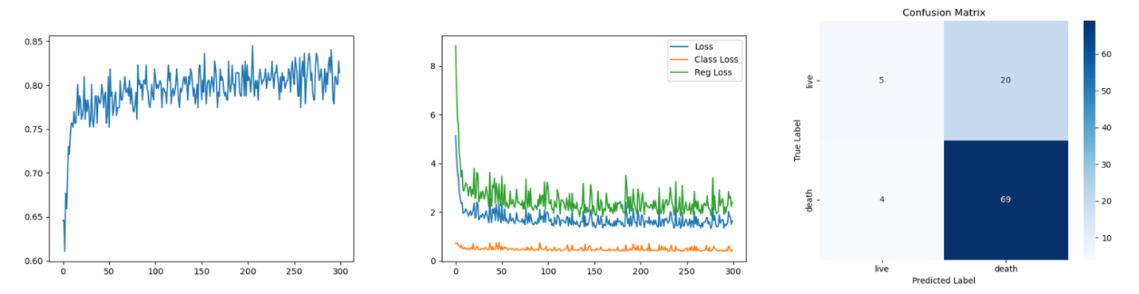
Supplementary Figure S3. Combined training accuracy, loss curve, and confusion matrix for Model 2.
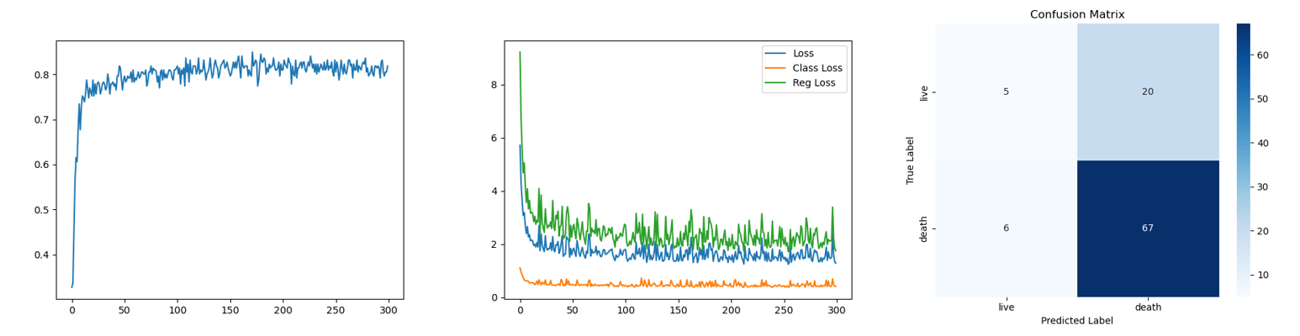
Supplementary Figure S4. Combined training accuracy, loss curve, and confusion matrix for Model 4.
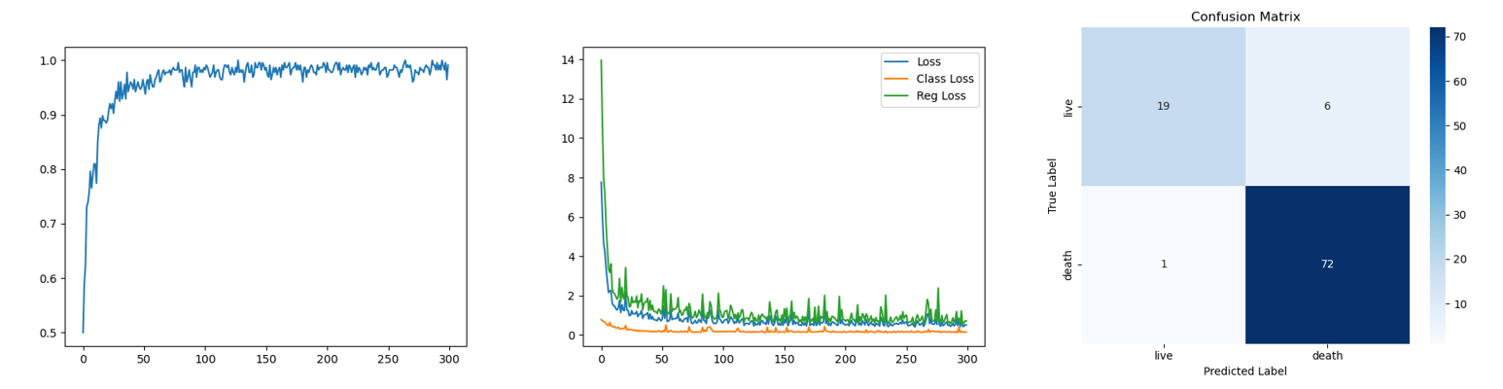
Supplementary Figure S5. Combined training accuracy, loss curve, and confusion matrix for Model 5.
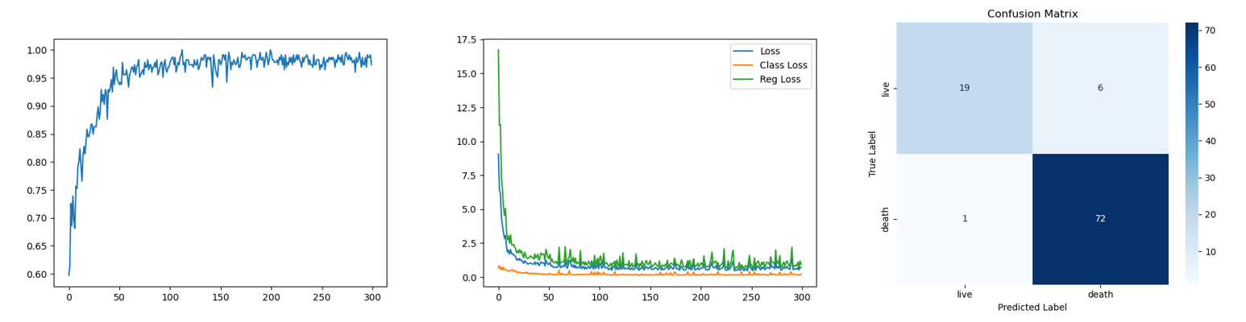
Supplementary Figure S6.Kaplan–Meier survival curves for Tumor Volume. Patients were stratified into high and low groups based on median values. Both overall survival (OS) and progression-free survival (PFS) are shown. Shaded areas represent 95% confidence intervals.
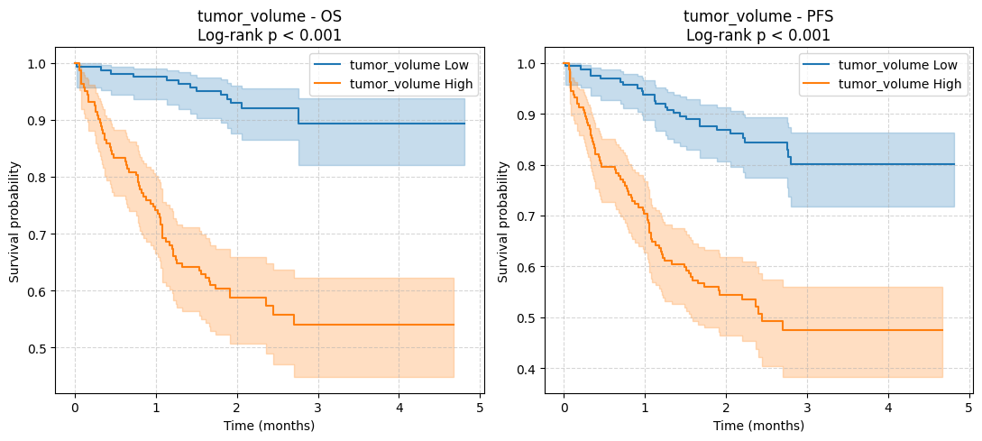
Supplementary Figure S7. ROC curves of Models 1–5 are shown in a combined panel. Each curve is labeled with its AUC value.
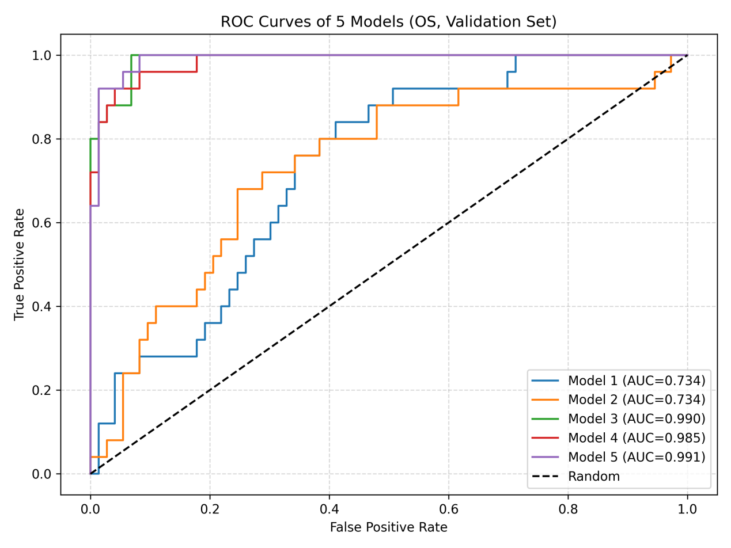

Supplementary tables.
Supplementary Table S1. Complete baseline characteristics including extended imaging features.
Characteristic | Full Cohort  (n=324) | Training (n=226) | Validation (n=98) | P value
Pack-years | 0.0 (0.0–25.0) | 4.8 (0.0–28.8) | 0.0 (0.0–20.0) | 0.07
Years since quitting (former only) | 0.0 (0.0–0.0) | 0.0 (0.0–0.0) | 0.0 (0.0–0.0) | 0.79
TTF1 status (Pos/Neg/Unknown) | Positive 239 (73.8%) / Negative 25 (7.7%) / Unknown 60 (18.5%) | Positive 166 (73.5%) / Negative 19 (8.4%) / Unknown 41 (18.1%) | Positive 73 (74.5%) / Negative 6 (6.1%) / Unknown 19 (19.4%) | 0.77
P40 status (Pos/Neg/Unknown) | Positive 196 (60.5%) / Negative 31 (9.6%) / Unknown 97 (29.9%) | Positive 141 (62.4%) / Negative 18 (8.0%) / Unknown 67 (29.6%) | Positive 55 (56.1%) / Negative 13 (13.3%) / Unknown 30 (30.6%) | 0.29
Ki67 (%) | 20.1 (5.0–41.0) | 22.0 (5.0–45.4) | 19.0 (5.0–40.0) | 0.12
Pleura involved | 4 (1.2%) / 320 (98.8%) | 4 (1.8%) / 222 (98.2%) | 0 (0.0%) / 98 (100.0%) | 0.32
Hilum involved | 7 (2.2%) / 317 (97.8%) | 5 (2.2%) / 221 (97.8%) | 2 (2.0%) / 96 (98.0%) | 1.00
Coronary heart disease | 75 (23.1%) / 249 (76.9%) | 48 (21.2%) / 178 (78.8%) | 27 (27.6%) / 71 (72.4%) | 0.25
Heart failure | 16 (4.9%) / 308 (95.1%) | 8 (3.5%) / 218 (96.5%) | 8 (8.2%) / 90 (91.8%) | 0.09
Renal failure | 6 (1.9%) / 318 (98.1%) | 3 (1.3%) / 223 (98.7%) | 3 (3.1%) / 95 (96.9%) | 0.37
Respiratory failure | 12 (3.7%) / 312 (96.3%) | 10 (4.4%) / 216 (95.6%) | 2 (2.0%) / 96 (98.0%) | 0.52
Stroke | 72 (22.2%) / 252 (77.8%) | 50 (22.1%) / 176 (77.9%) | 22 (22.4%) / 76 (77.6%) | 1.00
Initial metastasis | 70 (21.6%) / 254 (78.4%) | 48 (21.2%) / 178 (78.8%) | 22 (22.4%) / 76 (77.6%) | 0.88
Brain | 10 (3.1%) / 314 (96.9%) | 8 (3.5%) / 218 (96.5%) | 2 (2.0%) / 96 (98.0%) | 0.73
Bone | 21 (6.5%) / 303 (93.5%) | 16 (7.1%) / 210 (92.9%) | 5 (5.1%) / 93 (94.9%) | 0.63
Liver | 8 (2.5%) / 316 (97.5%) | 7 (3.1%) / 219 (96.9%) | 1 (1.0%) / 97 (99.0%) | 0.44
Lung | 13 (4.0%) / 311 (96.0%) | 10 (4.4%) / 216 (95.6%) | 3 (3.1%) / 95 (96.9%) | 0.76
Lymph nodes | 38 (11.7%) / 286 (88.3%) | 21 (9.3%) / 205 (90.7%) | 17 (17.3%) / 81 (82.7%) | 0.06
Pleura | 17 (5.2%) / 307 (94.8%) | 13 (5.8%) / 213 (94.2%) | 4 (4.1%) / 94 (95.9%) | 0.79
Obstructive pneumonia | 20 (6.2%) / 304 (93.8%) | 12 (5.3%) / 214 (94.7%) | 8 (8.2%) / 90 (91.8%) | 0.32
Surgery | 232 (71.6%) / 92 (28.4%) | 155 (68.6%) / 71 (31.4%) | 77 (78.6%) / 21 (21.4%) | 0.08
Chemotherapy | 44 (13.6%) / 280 (86.4%) | 30 (13.3%) / 196 (86.7%) | 14 (14.3%) / 84 (85.7%) | 0.86
Radiation | 17 (5.2%) / 307 (94.8%) | 8 (3.5%) / 218 (96.5%) | 9 (9.2%) / 89 (90.8%) | 0.05
Immunotherapy | 17 (5.2%) / 307 (94.8%) | 14 (6.2%) / 212 (93.8%) | 3 (3.1%) / 95 (96.9%) | 0.29
Targeted therapy | 23 (7.1%) / 301 (92.9%) | 16 (7.1%) / 210 (92.9%) | 7 (7.1%) / 91 (92.9%) | 1.00
Emphysema volume, 10cm³ | 0.0 (0.0–77154.5) | 0.0 (0.0–86805.6) | 38.5 (0.0–64097.1) | 0.92
Ground-glass volume, 10cm³ | 0.0 (0.0–0.0) | 0.0 (0.0–0.0) | 0.0 (0.0–0.0) | 0.97
Honeycomb volume, 10cm³ | 0.0 (0.0–0.0) | 0.0 (0.0–0.0) | 0.0 (0.0–0.0) | 0.59
Tumor volume, 10cm³ | 7.6 (2.1–30.4) | 7.6 (2.2–33.1) | 8.1(1.9–28.9) | 0.82
Fibrosis volume, 10cm³ | 0.0 (0.0–0.0) | 0.0 (0.0–0.0) | 0.0 (0.0–0.0) | 0.40
Emphysema ratio | 0.0 (0.0–0.0) | 0.0 (0.0–0.0) | 0.0 (0.0–0.0) | 0.90
Ground-glass ratio | 0.0 (0.0–0.0) | 0.0 (0.0–0.0) | 0.0 (0.0–0.0) | 0.98
Honeycomb ratio | 0.0 (0.0–0.0) | 0.0 (0.0–0.0) | 0.0 (0.0–0.0) | 0.53
Tumor ratio | 0.0 (0.0–0.0) | 0.0 (0.0–0.0) | 0.0 (0.0–0.0) | 0.74
Fibrosis ratio | 0.0 (0.0–0.0) | 0.0 (0.0–0.0) | 0.0 (0.0–0.0) | 0.36

Note: Supplementary table includes all extended imaging-derived features and less frequent clinical variables. Abbreviations: ILD, interstitial lung disease.

Supplementary Table S2. Univariable Cox regression analysis for OS and PFS.
Variable | OS HR (95% CI) | OS p-value | PFS HR (95% CI) | PFS p-value
age | 1.05 (1.02-1.08) | 0.001 | 1.03 (1.00-1.06) | 0.03
bmi | 0.92 (0.88-0.96) | <0.001 | 0.93 (0.90-0.97) | 0.001
doctor_score_mean |  |  | 1.30 (1.01-1.68) | 0.04
ki67 | 1.02 (1.01-1.02) | <0.001 | 1.02 (1.01-1.02) | <0.001
Squamous cell carcinoma | 7.01 (2.19-22.49) | 0.001 | 5.45 (1.71-17.36) | 0.004
Large cell carcinoma | 2.38 (1.10-5.16) | 0.03
smoking_index | 1.01 (1.00-1.02) | 0.01 | 1.01 (1.00-1.02) | 0.01
smoking_status | 1.38 (1.05-1.83) | 0.02 | 1.29 (1.00-1.66) | 0.05
tx_chemotherapy |  |  | 1.75 (1.07-2.84) | 0.03
tx_immunotherapy |  |  | 4.47 (2.49-8.03) | <0.001
tx_radiation |  |  | 2.08 (1.08-3.99) | 0.03
tx_surgery | 0.12 (0.07-0.19) | <0.001 | 0.17 (0.11-0.24) | <0.001
fb_visual | 1.97 (1.18-3.29) | 0.01 | 1.68 (1.04-2.71) | 0.03
Adenocarcinoma | 2.76 (1.79–4.25) | <0.001 | 1.94 (1.04–2.87) | <0.001

Note: Univariable Cox regression analysis was performed for OS and PFS. Variables with P < 0.05 are shown. HR = Hazard Ratio; CI = Confidence Interval.

Supplementary Table S3. Univariable Cox Regression Analysis of Volume and Ratio Features.
Variable | OS HR (95% CI) | OS p-value | PFS HR (95% CI) | PFS p-value
emphysema_ratio | 0.98 (0.09-10.80) | 0.99 | 1.78 (0.25-12.56) | 0.56
emphysema_volume(10cm3) | 1.01 (0.99-1.02) | 0.85 | 1.01(0.99-1.01) | 0.47
fibrosis_total_ratio | 1.25 (1.09-1.44) | 0.002 | 1.21 (1.05-1.39) | 0.01
fibrosis_total_volume(10cm3) | 1.04(1.01-1.07) | 0.01 | 1.03(1.01-1.06) | 0.04
ggo_ratio | 1.01 (0.94-1.08) | 0.81 | 1.00 (0.93-1.07) | 0.96
ggo_volume(10cm3) | 1.02 (0.99-1.05) | 0.24 | 1.01 (0.99-1.04) | 0.43
honeycomb_ratio | 1.26 (1.09-1.45) | 0.001 | 1.22 (1.06-1.40) | 0.004
honeycomb_volume(10cm3) | 1.04(1.01-1.07) | 0.01 | 1.03(1.01-1.06) | 0.03
lung_volume(mm3) | 0.99(0.99-1.00) | 0.39 | 0.99(0.99-1.01) | 0.85
tumor_ratio | 1.06 (1.04-1.08) | <0.001 | 0.59 (0.41-0.84) | 0.004
tumor_volume(10cm3) | 1.05(1.04-1.06) | <0.001 | 1.04(1.03-1.06) | <0.001

Note：HR = Hazard Ratio; CI = Confidence Interval.
Supplementary Table S4. Performance comparison of individual models and ensemble approaches in the validation set (OS prediction).
Model | ROC AUC | PR AP
Random Forest (RF) | 0.824 | 0.565
XGBoost (XGB) | 0.735 | 0.447
DL1 | 0.753 | 0.518
DL2 | 0.705 | 0.505
DL3 | 0.991 | 0.976
DL4 | 0.985 | 0.964
DL5 | 0.990 | 0.972
Mean Blend | 0.980 | 0.964
Logistic Blend | 0.994 | 0.985

